> # Differencing Needs
> ndiffs(train)
[1] 1
> nsdiffs(train)
[1] 0
> # Create differenced series
> diff_train <- diff(train, differences = 1)
> # Stationarity
> adf.test(diff_train)

Augmented Dickey-Fuller Test

data: diff_train
Dickey-Fuller = -7.2353, Lag order = 5, p-value = 0.01
alternative hypothesis: stationary

Warning message:
In adf.test(diff_train) : p-value smaller than printed p-value
> kpss.test(diff_train)

KPSS Test for Level Stationarity

data: diff_train
KPSS Level = 0.039629, Truncation lag parameter = 4, p-value = 0.1

Warning message:
In kpss.test(diff_train) : p-value greater than printed p-value
> autoplot(diff_train) +
+ ggtitle("First Differenced Series") +
+ ylab("Differenced Quantity")
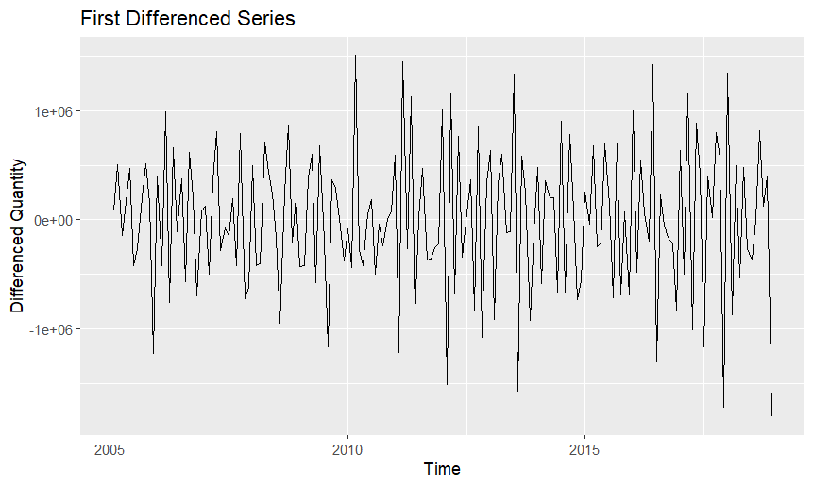
> ggAcf(diff_train) + ggtitle("ACF of Differenced Series")
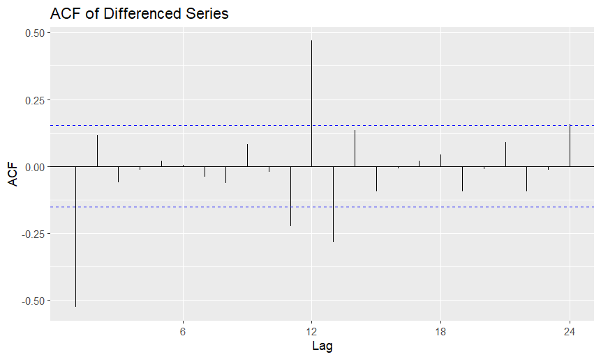
> ggPacf(diff_train) + ggtitle("PACF of Differenced Series")
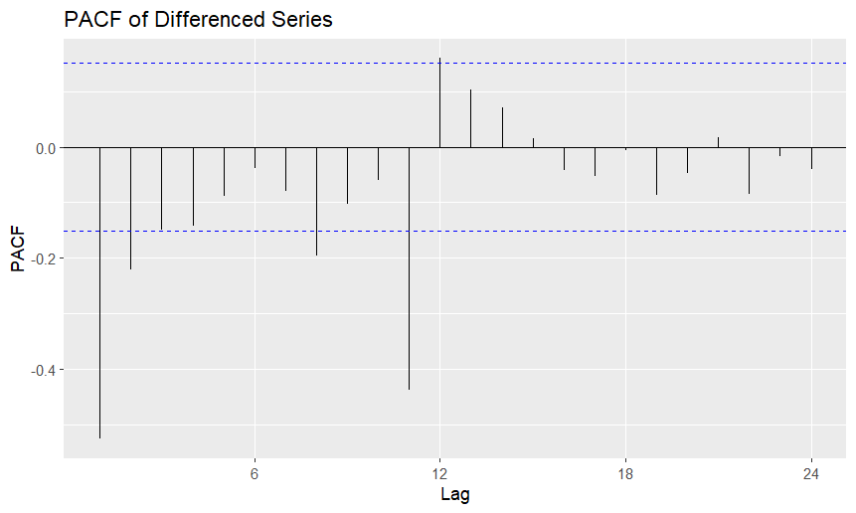
> # Automated SARIMA selection
> auto_arima <- auto.arima(train, d = 1, D = 0, stepwise=FALSE, approximation=FALSE, trace=TRUE)

ARIMA(0,1,0) : 4948.956
ARIMA(0,1,0) with drift : 4951
ARIMA(0,1,0)(0,0,1)[12] : 4910.798
ARIMA(0,1,0)(0,0,1)[12] with drift : 4912.87
ARIMA(0,1,0)(0,0,2)[12] : 4904.851
ARIMA(0,1,0)(0,0,2)[12] with drift : 4906.948
ARIMA(0,1,0)(1,0,0)[12] : 4905.046
ARIMA(0,1,0)(1,0,0)[12] with drift : 4907.117
ARIMA(0,1,0)(1,0,1)[12] : 4906.34
ARIMA(0,1,0)(1,0,1)[12] with drift : 4908.437
ARIMA(0,1,0)(1,0,2)[12] : 4906.871
ARIMA(0,1,0)(1,0,2)[12] with drift : 4908.994
ARIMA(0,1,0)(2,0,0)[12] : 4906.334
ARIMA(0,1,0)(2,0,0)[12] with drift : 4908.431
ARIMA(0,1,0)(2,0,1)[12] : 4908.412
ARIMA(0,1,0)(2,0,1)[12] with drift : 4910.536
ARIMA(0,1,0)(2,0,2)[12] : 4908.962
ARIMA(0,1,0)(2,0,2)[12] with drift : 4911.112
ARIMA(0,1,1) : 4862.688
ARIMA(0,1,1) with drift : 4861.153
ARIMA(0,1,1)(0,0,1)[12] : 4835.667
ARIMA(0,1,1)(0,0,1)[12] with drift : 4835.666
ARIMA(0,1,1)(0,0,2)[12] : 4828.233
ARIMA(0,1,1)(0,0,2)[12] with drift : Inf
ARIMA(0,1,1)(1,0,0)[12] : 4826.096
ARIMA(0,1,1)(1,0,0)[12] with drift : Inf
ARIMA(0,1,1)(1,0,1)[12] : 4826.694
ARIMA(0,1,1)(1,0,1)[12] with drift : 4826.704
ARIMA(0,1,1)(1,0,2)[12] : Inf
ARIMA(0,1,1)(1,0,2)[12] with drift : Inf
ARIMA(0,1,1)(2,0,0)[12] : 4827.125
ARIMA(0,1,1)(2,0,0)[12] with drift : 4826.931
ARIMA(0,1,1)(2,0,1)[12] : 4829.146
ARIMA(0,1,1)(2,0,1)[12] with drift : Inf
ARIMA(0,1,1)(2,0,2)[12] : Inf
ARIMA(0,1,1)(2,0,2)[12] with drift : Inf
ARIMA(0,1,2) : 4864.295
ARIMA(0,1,2) with drift : 4862.549
ARIMA(0,1,2)(0,0,1)[12] : 4836.536
ARIMA(0,1,2)(0,0,1)[12] with drift : Inf
ARIMA(0,1,2)(0,0,2)[12] : 4828.733
ARIMA(0,1,2)(0,0,2)[12] with drift : Inf
ARIMA(0,1,2)(1,0,0)[12] : 4826.885
ARIMA(0,1,2)(1,0,0)[12] with drift : Inf
ARIMA(0,1,2)(1,0,1)[12] : 4827.997
ARIMA(0,1,2)(1,0,1)[12] with drift : Inf
ARIMA(0,1,2)(1,0,2)[12] : Inf
ARIMA(0,1,2)(1,0,2)[12] with drift : Inf
ARIMA(0,1,2)(2,0,0)[12] : 4828.229
ARIMA(0,1,2)(2,0,0)[12] with drift : Inf
ARIMA(0,1,2)(2,0,1)[12] : 4830.196
ARIMA(0,1,2)(2,0,1)[12] with drift : Inf
ARIMA(0,1,3) : 4862.346
ARIMA(0,1,3) with drift : Inf
ARIMA(0,1,3)(0,0,1)[12] : 4831.399
ARIMA(0,1,3)(0,0,1)[12] with drift : Inf
ARIMA(0,1,3)(0,0,2)[12] : 4825.323
ARIMA(0,1,3)(0,0,2)[12] with drift : Inf
ARIMA(0,1,3)(1,0,0)[12] : 4822.467
ARIMA(0,1,3)(1,0,0)[12] with drift : Inf
ARIMA(0,1,3)(1,0,1)[12] : 4824.321
ARIMA(0,1,3)(1,0,1)[12] with drift : Inf
ARIMA(0,1,3)(2,0,0)[12] : 4824.399
ARIMA(0,1,3)(2,0,0)[12] with drift : Inf
ARIMA(0,1,4) : 4864.402
ARIMA(0,1,4) with drift : Inf
ARIMA(0,1,4)(0,0,1)[12] : 4833.124
ARIMA(0,1,4)(0,0,1)[12] with drift : Inf
ARIMA(0,1,4)(1,0,0)[12] : 4824.342
ARIMA(0,1,4)(1,0,0)[12] with drift : Inf
ARIMA(0,1,5) : 4866.533
ARIMA(0,1,5) with drift : Inf
ARIMA(1,1,0) : 4894.119
ARIMA(1,1,0) with drift : 4896.122
ARIMA(1,1,0)(0,0,1)[12] : 4853.836
ARIMA(1,1,0)(0,0,1)[12] with drift : 4855.912
ARIMA(1,1,0)(0,0,2)[12] : 4850.759
ARIMA(1,1,0)(0,0,2)[12] with drift : 4852.863
ARIMA(1,1,0)(1,0,0)[12] : 4848.691
ARIMA(1,1,0)(1,0,0)[12] with drift : 4850.767
ARIMA(1,1,0)(1,0,1)[12] : 4850.172
ARIMA(1,1,0)(1,0,1)[12] with drift : 4852.277
ARIMA(1,1,0)(1,0,2)[12] : Inf
ARIMA(1,1,0)(1,0,2)[12] with drift : Inf
ARIMA(1,1,0)(2,0,0)[12] : 4850.354
ARIMA(1,1,0)(2,0,0)[12] with drift : 4852.459
ARIMA(1,1,0)(2,0,1)[12] : Inf
ARIMA(1,1,0)(2,0,1)[12] with drift : Inf
ARIMA(1,1,0)(2,0,2)[12] : Inf
ARIMA(1,1,0)(2,0,2)[12] with drift : Inf
ARIMA(1,1,1) : 4864.133
ARIMA(1,1,1) with drift : 4862.286
ARIMA(1,1,1)(0,0,1)[12] : 4835.673
ARIMA(1,1,1)(0,0,1)[12] with drift : Inf
ARIMA(1,1,1)(0,0,2)[12] : 4827.929
ARIMA(1,1,1)(0,0,2)[12] with drift : Inf
ARIMA(1,1,1)(1,0,0)[12] : 4826.077
ARIMA(1,1,1)(1,0,0)[12] with drift : Inf
ARIMA(1,1,1)(1,0,1)[12] : Inf
ARIMA(1,1,1)(1,0,1)[12] with drift : Inf
ARIMA(1,1,1)(1,0,2)[12] : Inf
ARIMA(1,1,1)(1,0,2)[12] with drift : Inf
ARIMA(1,1,1)(2,0,0)[12] : 4827.656
ARIMA(1,1,1)(2,0,0)[12] with drift : Inf
ARIMA(1,1,1)(2,0,1)[12] : Inf
ARIMA(1,1,1)(2,0,1)[12] with drift : Inf
ARIMA(1,1,2) : 4866.427
ARIMA(1,1,2) with drift : Inf
ARIMA(1,1,2)(0,0,1)[12] : 4839.178
ARIMA(1,1,2)(0,0,1)[12] with drift : Inf
ARIMA(1,1,2)(0,0,2)[12] : 4825.184
ARIMA(1,1,2)(0,0,2)[12] with drift : Inf
ARIMA(1,1,2)(1,0,0)[12] : 4829.888
ARIMA(1,1,2)(1,0,0)[12] with drift : Inf
ARIMA(1,1,2)(1,0,1)[12] : 4830.874
ARIMA(1,1,2)(1,0,1)[12] with drift : 4831.021
ARIMA(1,1,2)(2,0,0)[12] : 4824.459
ARIMA(1,1,2)(2,0,0)[12] with drift : Inf
ARIMA(1,1,3) : 4864.389
ARIMA(1,1,3) with drift : Inf
ARIMA(1,1,3)(0,0,1)[12] : 4831.016
ARIMA(1,1,3)(0,0,1)[12] with drift : Inf
ARIMA(1,1,3)(1,0,0)[12] : 4821.766
ARIMA(1,1,3)(1,0,0)[12] with drift : Inf
ARIMA(1,1,4) : Inf
ARIMA(1,1,4) with drift : 4863.989
ARIMA(2,1,0) : 4886.058
ARIMA(2,1,0) with drift : 4888.018
ARIMA(2,1,0)(0,0,1)[12] : 4847.556
ARIMA(2,1,0)(0,0,1)[12] with drift : 4849.629
ARIMA(2,1,0)(0,0,2)[12] : 4843.387
ARIMA(2,1,0)(0,0,2)[12] with drift : 4845.494
ARIMA(2,1,0)(1,0,0)[12] : 4840.686
ARIMA(2,1,0)(1,0,0)[12] with drift : 4842.765
ARIMA(2,1,0)(1,0,1)[12] : 4842.649
ARIMA(2,1,0)(1,0,1)[12] with drift : 4844.757
ARIMA(2,1,0)(1,0,2)[12] : Inf
ARIMA(2,1,0)(1,0,2)[12] with drift : Inf
ARIMA(2,1,0)(2,0,0)[12] : 4842.704
ARIMA(2,1,0)(2,0,0)[12] with drift : 4844.812
ARIMA(2,1,0)(2,0,1)[12] : Inf
ARIMA(2,1,0)(2,0,1)[12] with drift : Inf
ARIMA(2,1,1) : 4862.383
ARIMA(2,1,1) with drift : Inf
ARIMA(2,1,1)(0,0,1)[12] : 4829.08
ARIMA(2,1,1)(0,0,1)[12] with drift : Inf
ARIMA(2,1,1)(0,0,2)[12] : 4823.44
ARIMA(2,1,1)(0,0,2)[12] with drift : Inf
ARIMA(2,1,1)(1,0,0)[12] : 4820.31
ARIMA(2,1,1)(1,0,0)[12] with drift : Inf
ARIMA(2,1,1)(1,0,1)[12] : 4822.398
ARIMA(2,1,1)(1,0,1)[12] with drift : Inf
ARIMA(2,1,1)(2,0,0)[12] : 4822.416
ARIMA(2,1,1)(2,0,0)[12] with drift : Inf
ARIMA(2,1,2) : 4864.508
ARIMA(2,1,2) with drift : Inf
ARIMA(2,1,2)(0,0,1)[12] : 4830.825
ARIMA(2,1,2)(0,0,1)[12] with drift : Inf
ARIMA(2,1,2)(1,0,0)[12] : 4821.71
ARIMA(2,1,2)(1,0,0)[12] with drift : Inf
ARIMA(2,1,3) : 4866.543
ARIMA(2,1,3) with drift : Inf
ARIMA(3,1,0) : 4883.524
ARIMA(3,1,0) with drift : 4885.443
ARIMA(3,1,0)(0,0,1)[12] : 4843.498
ARIMA(3,1,0)(0,0,1)[12] with drift : 4845.565
ARIMA(3,1,0)(0,0,2)[12] : 4838.331
ARIMA(3,1,0)(0,0,2)[12] with drift : 4840.427
ARIMA(3,1,0)(1,0,0)[12] : 4835.043
ARIMA(3,1,0)(1,0,0)[12] with drift : 4837.115
ARIMA(3,1,0)(1,0,1)[12] : 4837.141
ARIMA(3,1,0)(1,0,1)[12] with drift : 4839.243
ARIMA(3,1,0)(2,0,0)[12] : 4837.156
ARIMA(3,1,0)(2,0,0)[12] with drift : 4839.257
ARIMA(3,1,1) : 4864.508
ARIMA(3,1,1) with drift : Inf
ARIMA(3,1,1)(0,0,1)[12] : 4830.954
ARIMA(3,1,1)(0,0,1)[12] with drift : Inf
ARIMA(3,1,1)(1,0,0)[12] : 4822.055
ARIMA(3,1,1)(1,0,0)[12] with drift : Inf
ARIMA(3,1,2) : 4866.647
ARIMA(3,1,2) with drift : Inf
ARIMA(4,1,0) : 4882.256
ARIMA(4,1,0) with drift : 4884.147
ARIMA(4,1,0)(0,0,1)[12] : 4843.63
ARIMA(4,1,0)(0,0,1)[12] with drift : 4845.698
ARIMA(4,1,0)(1,0,0)[12] : 4833.95
ARIMA(4,1,0)(1,0,0)[12] with drift : 4836.023
ARIMA(4,1,1) : 4866.426
ARIMA(4,1,1) with drift : Inf
ARIMA(5,1,0) : 4883.097
ARIMA(5,1,0) with drift : 4884.988

Best model: ARIMA(2,1,1)(1,0,0)[12]

> summary(auto_arima)
Series: train
ARIMA(2,1,1)(1,0,0)[12]

Coefficients:
ar1 ar2 ma1 sar1
0.1324 0.2273 -0.9675 0.5087
s.e. 0.0803 0.0797 0.0218 0.0698

sigma^2 = 1.88e+11: log likelihood = -2404.97
AIC=4819.94 AICc=4820.31 BIC=4835.53

Training set error measures:
ME RMSE MAE MPE MAPE MASE ACF1
Training set 58745.99 427065.1 329658 0.3360814 9.311592 0.8037179 -0.03577714
> # Check residuals
> checkresiduals(auto_arima)
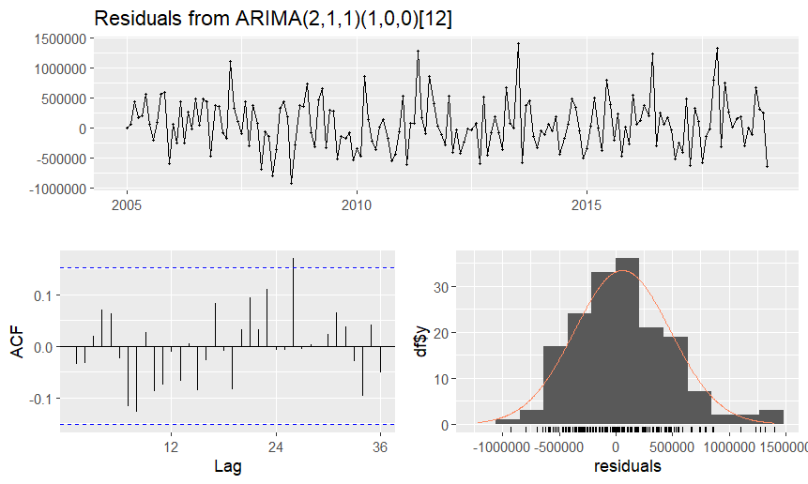
Ljung-Box test

data: Residuals from ARIMA(2,1,1)(1,0,0)[12]
Q* = 19.764, df = 20, p-value = 0.4728

Model df: 4. Total lags used: 24

> Box.test(residuals(auto_arima), type = "Ljung-Box")

Box-Ljung test

data: residuals(auto_arima)
X-squared = 0.2189, df = 1, p-value = 0.6399

> shapiro.test(residuals(auto_arima))

Shapiro-Wilk normality test

data: residuals(auto_arima)
W = 0.97981, p-value = 0.01501

> # Manual SARIMA based on ACF/PACF
> # Try a few models and compare AIC
> arima1 <- Arima(train, order=c(1,1,1), seasonal=c(0,1,1))
> arima2 <- Arima(train, order=c(0,1,1), seasonal=c(0,1,1))
> arima3 <- Arima(train, order=c(1,1,0), seasonal=c(1,1,0))
> # Compare AIC values
> AIC(auto_arima, arima1, arima2, arima3)
df AIC
auto_arima 5 4819.938
arima1 4 4493.111
arima2 3 4491.375
arima3 3 4533.910
Warning message:
In AIC.default(auto_arima, arima1, arima2, arima3) :
models are not all fitted to the same number of observations
> # Select best model based on AIC and residual diagnostics
> best_model <- auto_arima # or choose manually if better
> # Fit model to training data
> model_train <- Arima(train, order=best_model$arma[c(1,6,2)],
+ seasonal=best_model$arma[c(3,7,4)])
> # Forecast and compare with test set
> forecast_train <- forecast(model_train, h=length(test))
> accuracy(forecast_train, test)
ME RMSE MAE MPE MAPE MASE ACF1 Theil's U
Training set 58745.99 427065.1 329658.0 0.3360814 9.311592 0.8037179 -0.03577714 NA
Test set 237346.20 755179.3 582514.1 3.0381155 12.832222 1.4201898 -0.57672942 0.6445142
> autoplot(forecast_train) +
+ autolayer(test, series="Actual") +
+ ggtitle("SARIMA Forecast vs Actual") +
+ ylab("Quantity (kg)") + coord_cartesian(xlim = c(2018, 2020))
