PYSIDE6
START THE APP:
1) CREATE APP
app = QApplication(sys.argv)

2) CREATE MAIN WINDOW (or a class that extends QMainWindow)
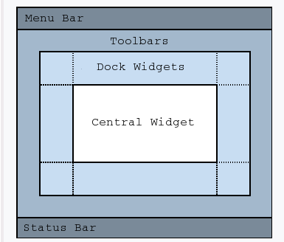

class PushButton(QMainWindow) #HERE I CAN APPLY setCentralWidget(), setWindowTitle() and so on…
window = PushButton() #hidden by default

3) SHOW WINDOW
window.show() #we show it

4) START EVENT LOOP (like wait)
app.exec()

