

[LSTM-Load-Forecasting/LSTMs/univariate_single_step.py at main · ki-ljl/LSTM-Load-Forecasting (github.com)](https://github.com/ki-ljl/LSTM-Load-Forecasting/blob/main/LSTMs/univariate_single_step.py)

结果：Mape：6.12%（csdn：5.77%）左图为复现 右图为csdn

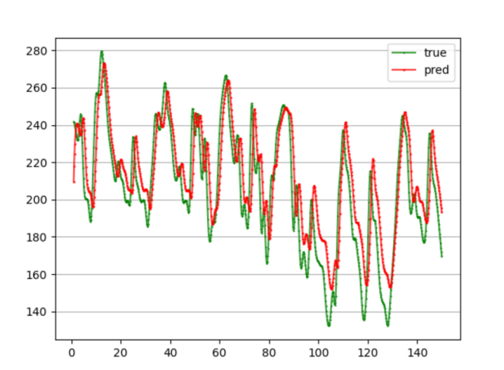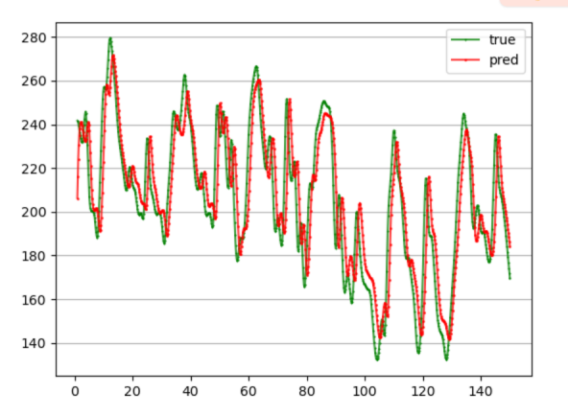



[LSTM-Load-Forecasting/LSTMs/multivariate_single_step.py at main · ki-ljl/LSTM-Load-Forecasting (github.com)](https://github.com/ki-ljl/LSTM-Load-Forecasting/blob/main/LSTMs/multivariate_single_step.py)

结果：Mape：6.23%（6.01%）左图为复现 右图为csdn

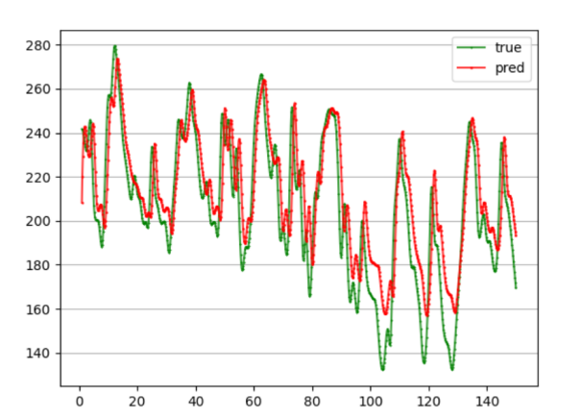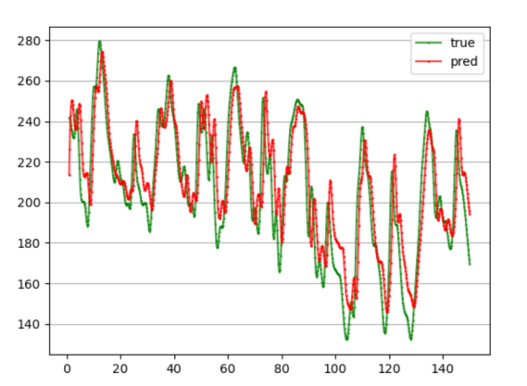



[LSTM-Load-Forecasting/LSTMs/multivariate_single_step.py at main · ki-ljl/LSTM-Load-Forecasting (github.com)](https://github.com/ki-ljl/LSTM-Load-Forecasting/blob/main/LSTMs/multivariate_single_step.py)

结果：Mape：7.09%（7.29%）图只有复现

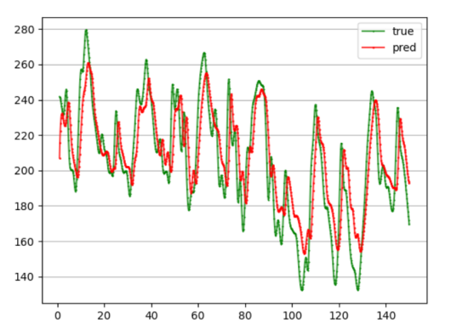



[GitHub - ki-ljl/LSTM-MultiStep-Forecasting: Implementation of Electric Load Forecasting Based on LSTM (BiLSTM). Including direct-multi-output forecasting, single-step-scrolling forecasting, multi-model-single-step forecasting, multi-model-scrolling forecasting, and seq2seq forecasting.](https://github.com/ki-ljl/LSTM-MultiStep-Forecasting/tree/main)

注：根据上述修改

结果：

Mape：8.38%（csdn：7.62%）左图为复现 右图为csdn

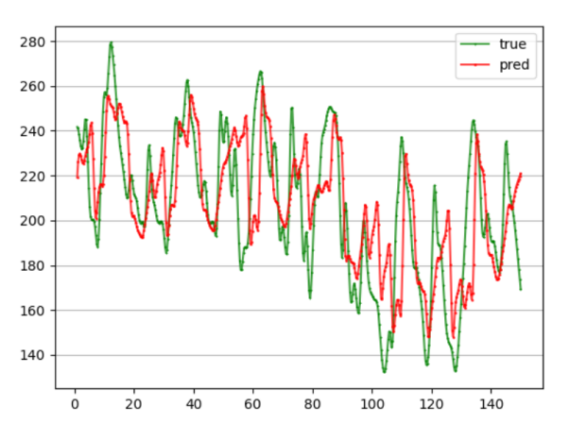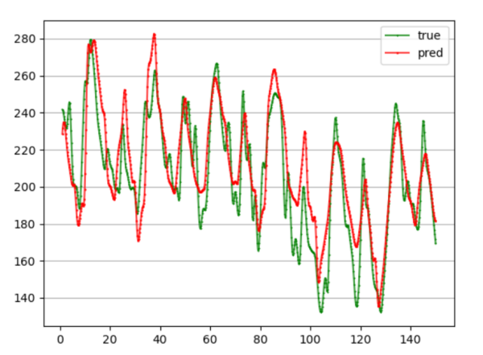





[GitHub - ki-ljl/LSTM-MultiStep-Forecasting: Implementation of Electric Load Forecasting Based on LSTM (BiLSTM). Including direct-multi-output forecasting, single-step-scrolling forecasting, multi-model-single-step forecasting, multi-model-scrolling forecasting, and seq2seq forecasting.](https://github.com/ki-ljl/LSTM-MultiStep-Forecasting/tree/main)

注：根据上述修改

结果：

Mape：9.25%（10.03%）左图为复现 右图为csdn

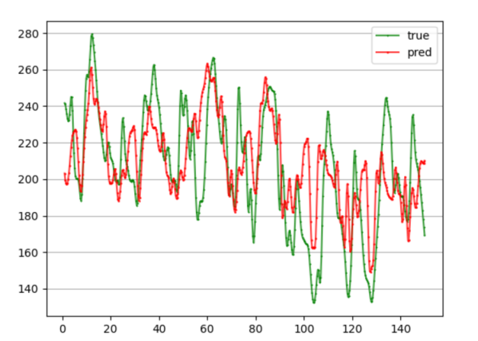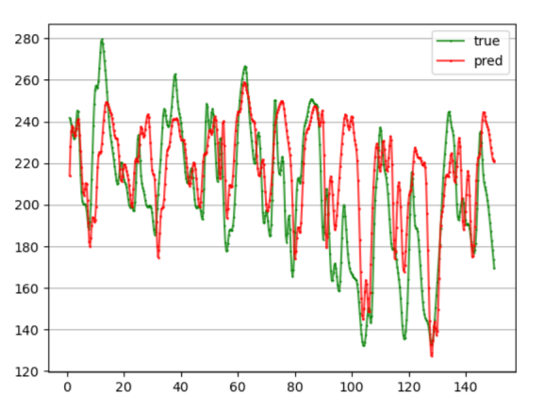





[GitHub - ki-ljl/LSTM-MultiStep-Forecasting: Implementation of Electric Load Forecasting Based on LSTM (BiLSTM). Including direct-multi-output forecasting, single-step-scrolling forecasting, multi-model-single-step forecasting, multi-model-scrolling forecasting, and seq2seq forecasting.](https://github.com/ki-ljl/LSTM-MultiStep-Forecasting/tree/main)

结果：

Mape：10.22%（csdn：9.09% 无图）

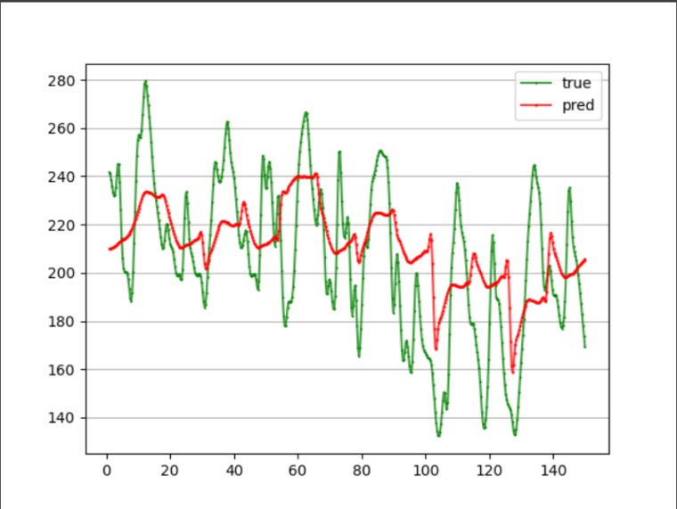



[GitHub - ki-ljl/LSTM-MultiStep-Forecasting: Implementation of Electric Load Forecasting Based on LSTM (BiLSTM). Including direct-multi-output forecasting, single-step-scrolling forecasting, multi-model-single-step forecasting, multi-model-scrolling forecasting, and seq2seq forecasting.](https://github.com/ki-ljl/LSTM-MultiStep-Forecasting/tree/main)

注：根据上述修改

1.mtl_data_1.csv

结果：

Mape：11.31%（csdn：9.76%）

5.41%（csdn：6.44%）

10.34%（csdn：8.49%）

左图为复现 右图为csdn

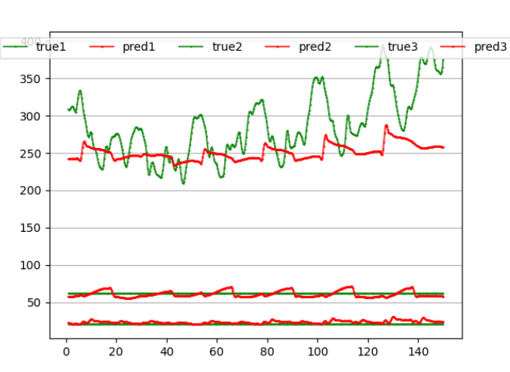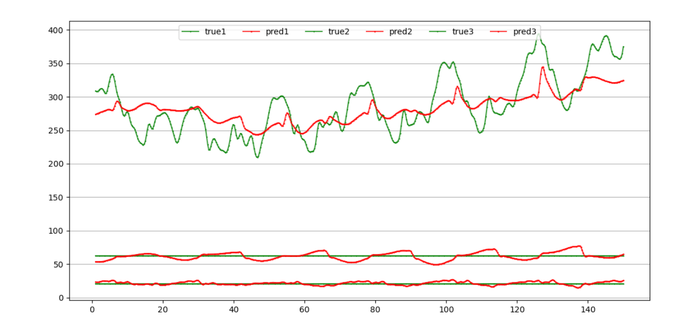

2.mtl_data_2.csv

结果：

Mape：7.24%（csdn：5.37%）

12.60%（csdn：8.89%）

9.81%（csdn：6.29%）

左图为复现 右图为csdn

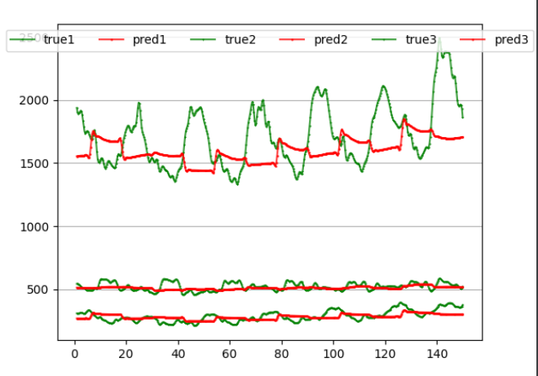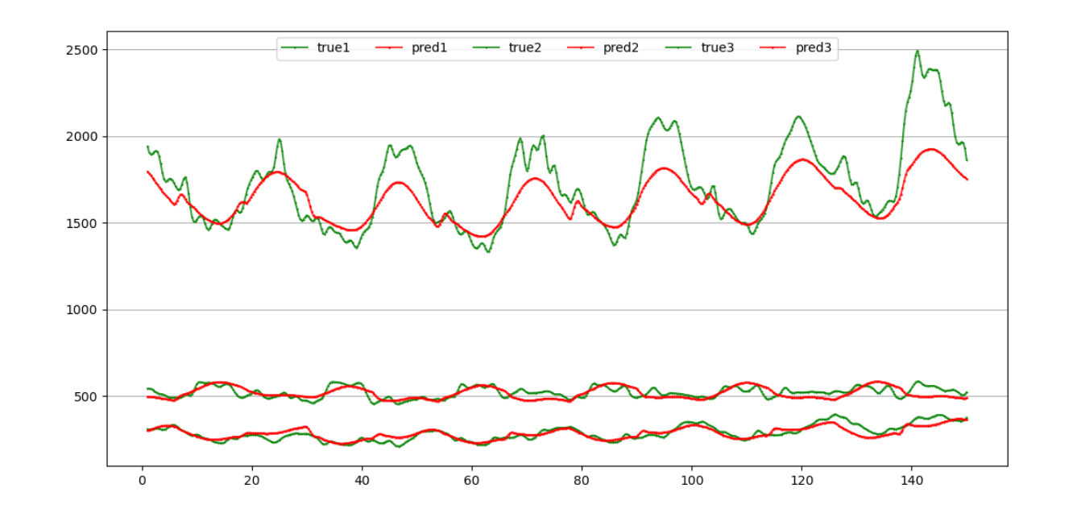



[CNN-Load-Forecasting/cnn.py at main · ki-ljl/CNN-Load-Forecasting (github.com)](https://github.com/ki-ljl/CNN-Load-Forecasting/blob/main/cnn.py)

注：源码中使用的是同上述几个的负载数据集。

结果：

Mape：20.21%

