In order to connect for the first time with the openBCI CYTON device, you can download the GUI available at <https://openbci.com/downloads> and then follow the instructions shown at <https://docs.openbci.com/GettingStarted/Boards/CytonGS/>

These instructions are also shown below.

### Switch your Cyton board to PC (not OFF or BLE)

Make sure to move the small switch on the right side of the board from "OFF" to "PC". As soon as you do, you should see a blue LED turn on. If you don't, press the reset (RST) button just to the left of the switch. If the LED still does not turn on, make sure you have full battery. If you're sure your batteries are fully charged, consult the [hardware section](https://openbci.com/forum/index.php?p=/categories/cyton) of our Forum.

**Note:** it's important to plug in your Dongle before you turn on your Cyton board. Sometimes, if the data stream seems broken, you may need to unplug your USB Dongle and power down your Cyton board. Make sure to plug your USB Dongle in first, then power up your board afterwards.

## IV. Connect to your Cyton board from the GUI

### 1. Select LIVE (from Cyton)

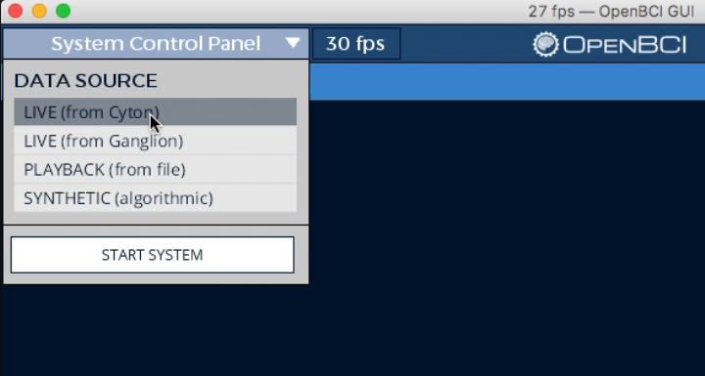

In order to connect to your Cyton, you must specify the data source to be LIVE (from Cyton) in the first section of the System Control Panel. Before hitting the START SYSTEM button, you need to configure your Cyton board (follow the steps below).

### 2. Select Serial Transfer Protocol

Next select Serial (from Dongle). If you want to use the WiFi Shield, please see the [WiFi Getting Started Guide](https://docs.openbci.com/GettingStarted/Boards/WiFiGS/)

### 3. Find your USB Dongle's Serial/COM port

In the first section of the LIVE (from Cyton) sub-panel, find your Dongle's Serial/COM port name. If you're using a Mac or Linux, its name will be in the following format:

**/dev/tty\***

If you're using Windows, it will appear as:

**COM#**

Your USB Dongle's port name will likely be at the top of the list. If you don't see it:

1. Make sure your dongle is plugged in and switched to GPIO 6 (not RESET)
2. Click the REFRESH LIST button in the SERIAL/COM PORT section of the sub-panel

If you're still having trouble finding your USB Dongle's port name, refer to the [Forum](https://openbci.com/forum/index.php?p=/categories/cyton) about debugging your hardware connection.

### 4. Select your channel count (8 or 16)

The CHANNEL COUNT setting is defaulted to 8. If you are working with an OpenBCI Daisy Module and Cyton board (16-channel) system, be sure to click the 16 CHANNELS button before starting your system.

### 5. Optional Settings

If you're comfortable using the GUI, use the optional settings in this dropdown section. Otherwise, skip to step 7!

### 7. Press "START SYSTEM"

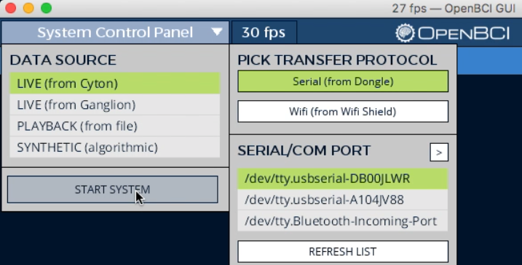

Now you're ready to start the system! Press the START SYSTEM button and wait for the OpenBCI GUI to establish a connection with your Cyton board. This usually takes ~5 seconds.

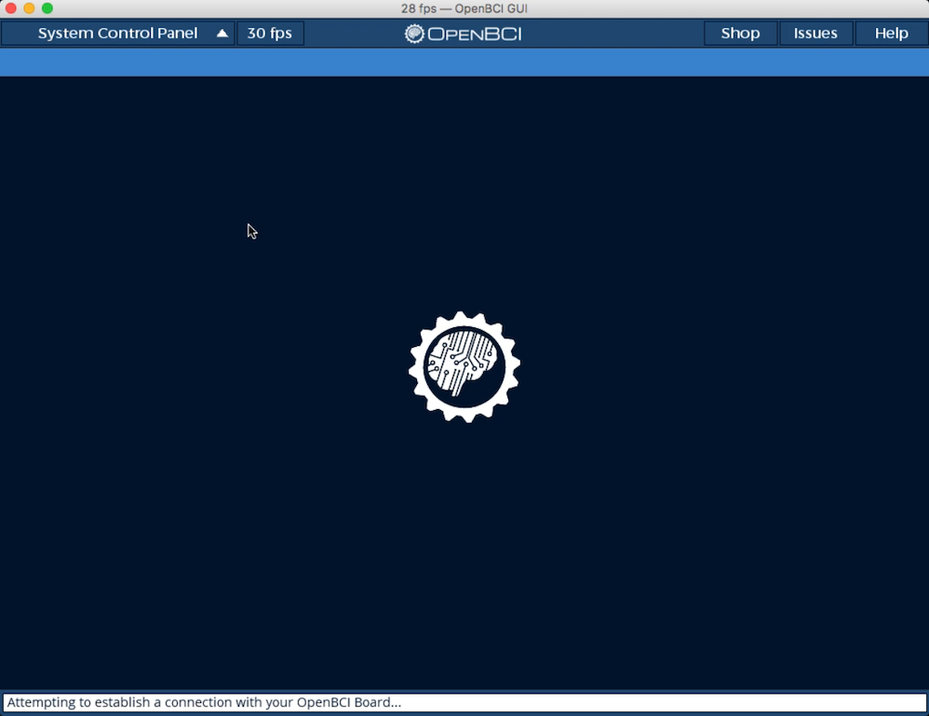

During this time, the help line at the bottom of the OpenBCI GUI should be blinking the words: "Attempting to establish a connection with your OpenBCI Board..."

**TROUBLESHOOTING**

If the initialization fails, try the following steps in order:

1. Making sure you've selected the correct serial/COM port
2. Power down your Cyton board and unplug your USB Dongle. Then, plug back in your USB Dongle and power up your Cyton board in that order. Then try restarting the system, but pressing the START SYSTEM button again.
3. If this does not work, try relaunching the OpenBCI GUI application and redo step 2 above. Then reconfigure the SYSTEM CONTROL PANEL settings, and retry START SYSTEM.
4. Make sure that your batteries are fully charged and then retry the steps above.
5. If the channel number is not being displayed, select "AUTOSCAN" from the RADIO CONFIGURATION settings.
6. If you are still having troubles connecting to your Cyton board, refer to the [Forum](https://openbci.com/forum/index.php?p=/categories/cyton) for extra troubleshooting advice.

### 8. Your Cyton is now live!

Now that the OpenBCI_GUI is connected to your Cyton you may press Start Data Stream in the upper left hand corner.

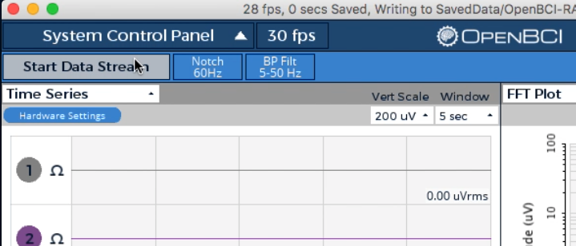

You should see data streaming into the GUI, try running your fingers along the electrode pins at the top of your board.

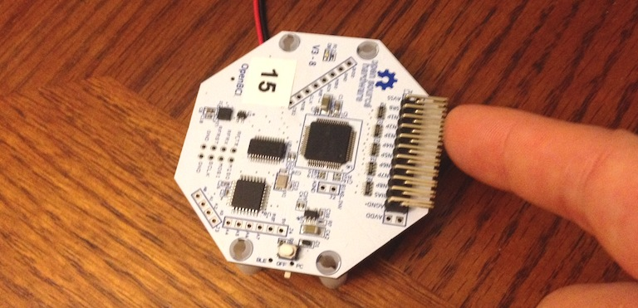

You should see the 8 (or 16 if you're using a Daisy module) channels on the Time Series widget behave chaotically in response to you touching the pins and all the traces of the FFT graph on the upper right should instantly shift upwards.

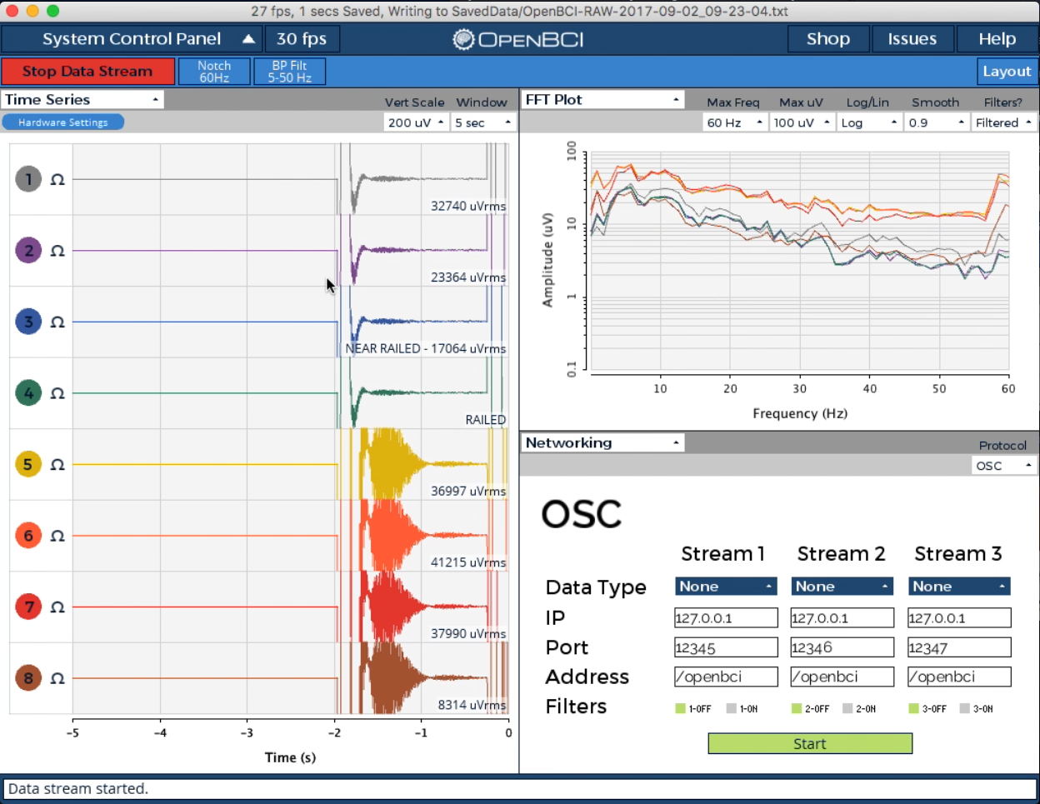

If this is the case, congratulations! You are now connected to your Cyton board. It's time to see some brain waves! Learn about the Time Series and other built-in widgets in the [GUI Widget Guide](https://docs.openbci.com/Software/OpenBCISoftware/GUIWidgets/).

info

**By default, the GUI stores all user data and raw EEG recordings in [USER]/Documents/OpenBCI_GUI and names each session with an autogenerated timestamp by default.**

Experts and those interested in communicating directly with the board can refer to the [Cyton Data Format Guide](https://docs.openbci.com/Cyton/CytonDataFormat/#binary-format) to learn how to interpret the raw data coming straight from the device. However this is already handled gracefully by [BrainFlow](https://docs.openbci.com/ForDevelopers/SoftwareDevelopment/#introducing-brainflow) for a number of programming languages and use cases.

## V. Connect yourself to OpenBCI

To learn how to connect yourself to OpenBCI using your newly set up board, see the following tutorials:

* [EEG Setup](https://docs.openbci.com/GettingStarted/Biosensing-Setups/EEGSetup/)
* [EMG Setup](https://docs.openbci.com/GettingStarted/Biosensing-Setups/EMGSetup/)
* [ECG Setup](https://docs.openbci.com/GettingStarted/Biosensing-Setups/ECGSetup/)

In the above setups, you may need to adjust the Hardware Settings of the ADS1299 chip, the core piece of technology in the Cyton. [Click here](https://docs.openbci.com/Software/OpenBCISoftware/GUIWidgets/#hardware-settings) for more info on Cyton Hardware Settings UI in the Time Series Widget. If you are an advanced user, you can look at the GUI console log after changing hardware settings and the [Cyton SDK Guide](https://docs.openbci.com/Cyton/CytonSDK/#channel-setting-commands) to learn how to send custom commands to the Cyton using [any BrainFlow binding](https://docs.openbci.com/ForDevelopers/SoftwareDevelopment/).

## VI. Fixing FTDI Buffering on Mac OS

On some Macs, you may have noticed that the data coming from your Cyton board is very choppy. Newer Macs (mid 2015 - present) may not have this issue and can connect flawlessly to the Cyton using the Dongle sold with each Cyton.

This is a result of the FTDI virtual com port (VCP) driver's default settings for macOS. Head over to the [FTDI Driver Fix Guide](https://docs.openbci.com/Troubleshooting/FTDI_Fix_Mac/) to see how to adjust the settings.

## VII. Fixing FTDI Buffering on Windows

The default FTDI latency is too large for EEG applications, making the incoming signal "choppy" and seem as if its accumulating packets for about a full second before releasing them all at the same time into the serial stream. Head over to the [FTDI Driver Fix Guide for Windows](https://docs.openbci.com/Troubleshooting/FTDI_Fix_Windows/) to see how to adjust the settings.