fMRI_Trailer_SNE

Luis A.

2024-05-07

# Add pairplots.

# Add combined com hor models.

# Loading libraries

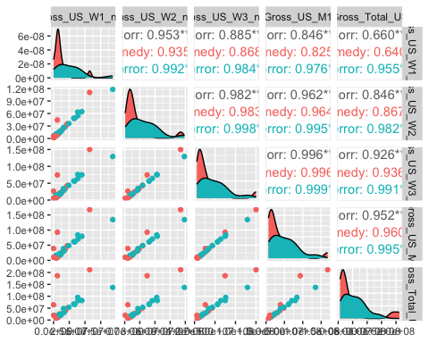

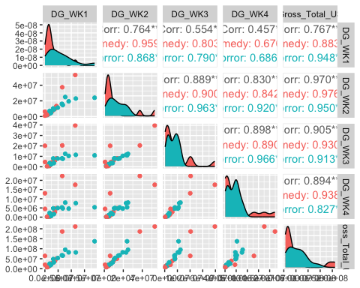

# Invididual Choice Comedy (IndCom) Trailers.

## IndCom: Sequence model.

Individual Choice (Comedy): Sequence Models.

|  | Affect | Neuro seq | Affect & Neuro seq |
| --- | --- | --- | --- |
| (Intercept) | 0.000 | 0.000 | 0.000 |
|  | t = 0.003 | t = −0.002 | t = 0.003 |
|  | s.e. = 0.091, p-val = 0.998 | s.e. = 0.125, p-val = 0.998 | s.e. = 0.091, p-val = 0.998 |
| scale(Pos_arousal_scaled) | 0.648*** |  | 0.645*** |
|  | t = 19.411 |  | t = 19.190 |
|  | s.e. = 0.033, p-val = <0.001 |  | s.e. = 0.034, p-val = <0.001 |
| scale(Neg_arousal_scaled) | −0.025 |  | −0.027 |
|  | t = −0.710 |  | t = −0.785 |
|  | s.e. = 0.035, p-val = 0.478 |  | s.e. = 0.035, p-val = 0.433 |
| scale(NAcc_seg2) |  | 0.072+ | 0.029 |
|  |  | t = 1.774 | t = 0.931 |
|  |  | s.e. = 0.041, p-val = 0.077 | s.e. = 0.031, p-val = 0.352 |
| scale(AIns_seg3) |  | −0.011 | 0.006 |
|  |  | t = −0.262 | t = 0.186 |
|  |  | s.e. = 0.042, p-val = 0.794 | s.e. = 0.032, p-val = 0.852 |
| scale(MPFC_seg5) |  | 0.066 | 0.024 |
|  |  | t = 1.571 | t = 0.767 |
|  |  | s.e. = 0.042, p-val = 0.117 | s.e. = 0.031, p-val = 0.443 |
| SD (Intercept Participant) | 0.386 | 0.395 | 0.384 |
|  | s.e. = , p-val = | s.e. = , p-val = | s.e. = , p-val = |
| SD (Intercept Trailer) | 0.196 | 0.376 | 0.201 |
|  | s.e. = , p-val = | s.e. = , p-val = | s.e. = , p-val = |
| SD (Observations) | 0.632 | 0.845 | 0.633 |
|  | s.e. = , p-val = | s.e. = , p-val = | s.e. = , p-val = |
| R2 Marg. | 0.415 | 0.009 | 0.415 |
| R2 Cond. | 0.602 | 0.300 | 0.602 |
| AIC | 1013.0 | 1288.6 | 1032.9 |
| BIC | 1038.0 | 1317.7 | 1070.3 |
| ICC | 0.3 | 0.3 | 0.3 |
| * p < 0.1, * p < 0.05, ** p < 0.01, *** p < 0.001 | | | |

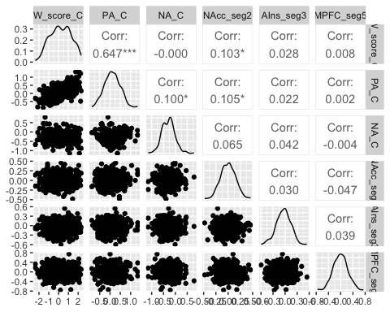

## IndCom: Modal Peak (MP) Model.

Individual Choice (Comedy): Modal Peaks Models.

|  | Affect | Neuro MP | Affect & Neuro MP |
| --- | --- | --- | --- |
| (Intercept) | 0.000 | −0.001 | 0.000 |
|  | t = 0.003 | t = −0.006 | t = 0.000 |
|  | s.e. = 0.091, p-val = 0.998 | s.e. = 0.118, p-val = 0.996 | s.e. = 0.089, p-val = 1.000 |
| scale(Pos_arousal_scaled) | 0.648*** |  | 0.598*** |
|  | t = 19.411 |  | t = 17.552 |
|  | s.e. = 0.033, p-val = <0.001 |  | s.e. = 0.034, p-val = <0.001 |
| scale(Neg_arousal_scaled) | −0.025 |  | −0.042 |
|  | t = −0.710 |  | t = −1.241 |
|  | s.e. = 0.035, p-val = 0.478 |  | s.e. = 0.034, p-val = 0.215 |
| scale(NAcc_avg_peak_yes_pos) |  | 0.241*** | 0.128*** |
|  |  | t = 6.375 | t = 4.233 |
|  |  | s.e. = 0.038, p-val = <0.001 | s.e. = 0.030, p-val = <0.001 |
| scale(AIns_avg_peak_yes_pos) |  | 0.160*** | 0.085** |
|  |  | t = 4.116 | t = 2.785 |
|  |  | s.e. = 0.039, p-val = <0.001 | s.e. = 0.031, p-val = 0.006 |
| scale(MPFC_avg_peak_yes_pos) |  | 0.104** | 0.033 |
|  |  | t = 2.710 | t = 1.094 |
|  |  | s.e. = 0.038, p-val = 0.007 | s.e. = 0.030, p-val = 0.274 |
| SD (Intercept Participant) | 0.386 | 0.389 | 0.377 |
|  | s.e. = , p-val = | s.e. = , p-val = | s.e. = , p-val = |
| SD (Intercept Trailer) | 0.196 | 0.346 | 0.197 |
|  | s.e. = , p-val = | s.e. = , p-val = | s.e. = , p-val = |
| SD (Observations) | 0.632 | 0.791 | 0.616 |
|  | s.e. = , p-val = | s.e. = , p-val = | s.e. = , p-val = |
| R2 Marg. | 0.415 | 0.104 | 0.437 |
| R2 Cond. | 0.602 | 0.375 | 0.619 |
| AIC | 1013.0 | 1228.2 | 1008.0 |
| BIC | 1038.0 | 1257.4 | 1045.5 |
| ICC | 0.3 | 0.3 | 0.3 |
| * p < 0.1, * p < 0.05, ** p < 0.01, *** p < 0.001 | | | |

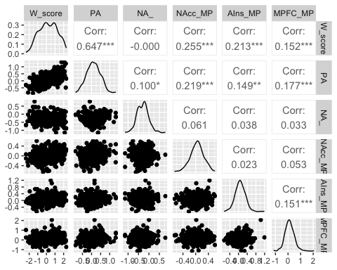

# Aggregate Results Comedy Trailers.

## AggCom: Seq Models.

|  | Affect GM1 | Choice GM1 | Neuro Seq GM1 | Affect Neuro Seq GM1 | Choice Neuro Seq GM1 |
| --- | --- | --- | --- | --- | --- |
| (Intercept) | 8.000*** | 8.000*** | 8.000*** | 8.000*** | 8.000*** |
|  | t = 6.979 | t = 6.836 | t = 7.576 | t = 7.546 | t = 7.299 |
|  | s.e. = 1.146, p-val = <0.001 | s.e. = 1.170, p-val = <0.001 | s.e. = 1.056, p-val = <0.001 | s.e. = 1.060, p-val = <0.001 | s.e. = 1.096, p-val = <0.001 |
| scale(Pos_arousal_scaled) | 0.919 |  |  | −1.528 |  |
|  | t = 0.771 |  |  | t = −0.938 |  |
|  | s.e. = 1.192, p-val = 0.455 |  |  | s.e. = 1.629, p-val = 0.373 |  |
| scale(Neg_arousal_scaled) | −1.422 |  |  | −1.372 |  |
|  | t = −1.193 |  |  | t = −1.136 |  |
|  | s.e. = 1.192, p-val = 0.256 |  |  | s.e. = 1.207, p-val = 0.285 |  |
| scale(W_score_scaled) |  | 0.960 |  |  | −0.749 |
|  |  | t = 0.793 |  |  | t = −0.459 |
|  |  | s.e. = 1.211, p-val = 0.442 |  |  | s.e. = 1.630, p-val = 0.656 |
| scale(NAcc_seg1) |  |  | 2.271+ | 2.264 | 2.376+ |
|  |  |  | t = 1.948 | t = 1.686 | t = 1.929 |
|  |  |  | s.e. = 1.166, p-val = 0.077 | s.e. = 1.343, p-val = 0.126 | s.e. = 1.232, p-val = 0.083 |
| scale(AIns_seg3) |  |  | 0.819 | 1.676 | 1.217 |
|  |  |  | t = 0.720 | t = 1.184 | t = 0.831 |
|  |  |  | s.e. = 1.137, p-val = 0.486 | s.e. = 1.416, p-val = 0.267 | s.e. = 1.464, p-val = 0.425 |
| scale(MPFC_seg5) |  |  | −0.716 | −1.873 | −1.150 |
|  |  |  | t = −0.592 | t = −1.239 | t = −0.732 |
|  |  |  | s.e. = 1.208, p-val = 0.566 | s.e. = 1.511, p-val = 0.247 | s.e. = 1.571, p-val = 0.481 |
| Num.Obs. | 15 | 15 | 15 | 15 | 15 |
| R2 | 0.155 | 0.046 | 0.343 | 0.458 | 0.356 |
| R2 Adj. | 0.015 | −0.027 | 0.164 | 0.157 | 0.099 |
| AIC | 91.9 | 91.8 | 90.2 | 91.3 | 91.9 |
| BIC | 94.8 | 93.9 | 93.7 | 96.2 | 96.1 |
| * p < 0.1, * p < 0.05, ** p < 0.01, *** p < 0.001 | | | | | |

## `geom_smooth()` using formula = 'y ~ x'

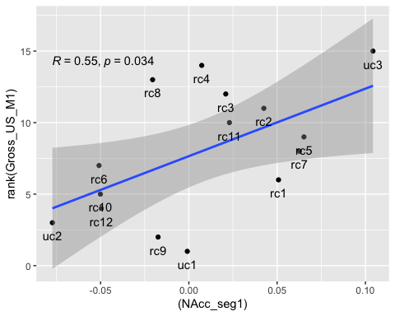

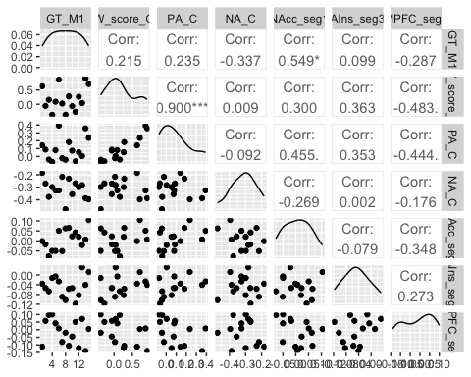

## AggCom: Modal Peak (MP) Models.

|  | Affect GM1 | Choice GM1 | Neuro MP GM1 | Affect Neuro MP GM1 | Choice Neuro MP GM1 |
| --- | --- | --- | --- | --- | --- |
| (Intercept) | 8.000*** | 8.000*** | 8.000*** | 8.000*** | 8.000*** |
|  | t = 6.979 | t = 6.836 | t = 7.581 | t = 7.263 | t = 7.235 |
|  | s.e. = 1.146, p-val = <0.001 | s.e. = 1.170, p-val = <0.001 | s.e. = 1.055, p-val = <0.001 | s.e. = 1.101, p-val = <0.001 | s.e. = 1.106, p-val = <0.001 |
| scale(Pos_arousal_scaled) | 0.919 |  |  | 0.246 |  |
|  | t = 0.771 |  |  | t = 0.172 |  |
|  | s.e. = 1.192, p-val = 0.455 |  |  | s.e. = 1.426, p-val = 0.867 |  |
| scale(Neg_arousal_scaled) | −1.422 |  |  | −1.180 |  |
|  | t = −1.193 |  |  | t = −1.010 |  |
|  | s.e. = 1.192, p-val = 0.256 |  |  | s.e. = 1.169, p-val = 0.339 |  |
| scale(W_score_scaled) |  | 0.960 |  |  | −0.193 |
|  |  | t = 0.793 |  |  | t = −0.132 |
|  |  | s.e. = 1.211, p-val = 0.442 |  |  | s.e. = 1.459, p-val = 0.898 |
| scale(NAcc_avg_peak_yes_pos2) |  |  | 2.614* | 2.347 | 2.716+ |
|  |  |  | t = 2.269 | t = 1.703 | t = 1.895 |
|  |  |  | s.e. = 1.152, p-val = 0.044 | s.e. = 1.378, p-val = 0.123 | s.e. = 1.433, p-val = 0.087 |
| scale(AIns_avg_peak_yes_pos2) |  |  | −0.449 | −0.570 | −0.458 |
|  |  |  | t = −0.410 | t = −0.487 | t = −0.398 |
|  |  |  | s.e. = 1.095, p-val = 0.690 | s.e. = 1.170, p-val = 0.638 | s.e. = 1.149, p-val = 0.699 |
| scale(MPFC_avg_peak_yes_pos2) |  |  | −1.410 | −1.249 | −1.373 |
|  |  |  | t = −1.226 | t = −0.988 | t = −1.110 |
|  |  |  | s.e. = 1.150, p-val = 0.246 | s.e. = 1.264, p-val = 0.349 | s.e. = 1.237, p-val = 0.293 |
| Num.Obs. | 15 | 15 | 15 | 15 | 15 |
| R2 | 0.155 | 0.046 | 0.344 | 0.415 | 0.345 |
| R2 Adj. | 0.015 | −0.027 | 0.165 | 0.090 | 0.083 |
| AIC | 91.9 | 91.8 | 90.2 | 92.4 | 92.1 |
| BIC | 94.8 | 93.9 | 93.7 | 97.4 | 96.4 |
| * p < 0.1, * p < 0.05, ** p < 0.01, *** p < 0.001 | | | | | |

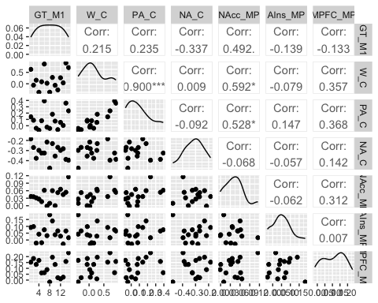

# Individual Results Horror Trailers.

## IndHor: Sequence models.

|  | Affect | Neuro seq | Affect & Neuro seq |
| --- | --- | --- | --- |
| (Intercept) | 0.000 | −0.001 | 0.000 |
|  | t = 0.002 | t = −0.007 | t = −0.001 |
|  | s.e. = 0.108, p-val = 0.998 | s.e. = 0.125, p-val = 0.994 | s.e. = 0.108, p-val = 1.000 |
| scale(Pos_arousal_scaled) | 0.489*** |  | 0.488*** |
|  | t = 12.857 |  | t = 12.847 |
|  | s.e. = 0.038, p-val = <0.001 |  | s.e. = 0.038, p-val = <0.001 |
| scale(Neg_arousal_scaled) | −0.135*** |  | −0.133** |
|  | t = −3.312 |  | t = −3.255 |
|  | s.e. = 0.041, p-val = <0.001 |  | s.e. = 0.041, p-val = 0.001 |
| scale(NAcc_seg2) |  | −0.039 | −0.040 |
|  |  | t = −1.004 | t = −1.194 |
|  |  | s.e. = 0.039, p-val = 0.316 | s.e. = 0.033, p-val = 0.233 |
| scale(AIns_seg3) |  | 0.068+ | 0.059+ |
|  |  | t = 1.697 | t = 1.729 |
|  |  | s.e. = 0.040, p-val = 0.090 | s.e. = 0.034, p-val = 0.085 |
| scale(MPFC_seg5) |  | 0.037 | 0.034 |
|  |  | t = 0.943 | t = 1.011 |
|  |  | s.e. = 0.039, p-val = 0.346 | s.e. = 0.034, p-val = 0.313 |
| SD (Intercept Participant) | 0.473 | 0.525 | 0.475 |
|  | s.e. = , p-val = | s.e. = , p-val = | s.e. = , p-val = |
| SD (Intercept Trailer) | 0.224 | 0.285 | 0.221 |
|  | s.e. = , p-val = | s.e. = , p-val = | s.e. = , p-val = |
| SD (Observations) | 0.697 | 0.808 | 0.695 |
|  | s.e. = , p-val = | s.e. = , p-val = | s.e. = , p-val = |
| R2 Marg. | 0.228 | 0.007 | 0.233 |
| R2 Cond. | 0.507 | 0.358 | 0.511 |
| AIC | 1094.9 | 1238.7 | 1110.4 |
| BIC | 1119.7 | 1267.8 | 1147.7 |
| ICC | 0.4 | 0.4 | 0.4 |
| * p < 0.1, * p < 0.05, ** p < 0.01, *** p < 0.001 | | | |

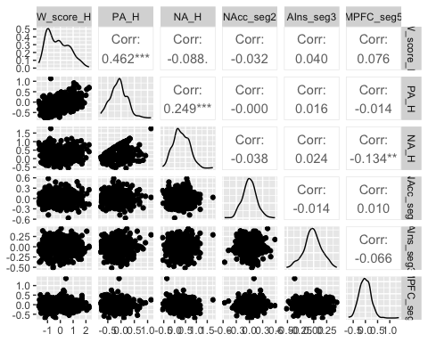

## IndHor: Modal Peak (MP) Model.

|  | Affect | Neuro MP | Affect & Neuro MP |
| --- | --- | --- | --- |
| (Intercept) | 0.000 | −0.001 | 0.000 |
|  | t = 0.002 | t = −0.007 | t = 0.001 |
|  | s.e. = 0.108, p-val = 0.998 | s.e. = 0.121, p-val = 0.994 | s.e. = 0.106, p-val = 0.999 |
| scale(Pos_arousal_scaled) | 0.489*** |  | 0.483*** |
|  | t = 12.857 |  | t = 12.571 |
|  | s.e. = 0.038, p-val = <0.001 |  | s.e. = 0.038, p-val = <0.001 |
| scale(Neg_arousal_scaled) | −0.135*** |  | −0.133** |
|  | t = −3.312 |  | t = −3.245 |
|  | s.e. = 0.041, p-val = <0.001 |  | s.e. = 0.041, p-val = 0.001 |
| scale(NAcc_avg_peak_yes_pos2) |  | 0.021 | 0.001 |
|  |  | t = 0.525 | t = 0.019 |
|  |  | s.e. = 0.041, p-val = 0.600 | s.e. = 0.035, p-val = 0.985 |
| scale(AIns_avg_peak_yes_pos2) |  | 0.001 | −0.007 |
|  |  | t = 0.029 | t = −0.192 |
|  |  | s.e. = 0.040, p-val = 0.977 | s.e. = 0.035, p-val = 0.848 |
| scale(MPFC_avg_peak_yes_pos2) |  | 0.101* | 0.053 |
|  |  | t = 2.437 | t = 1.467 |
|  |  | s.e. = 0.041, p-val = 0.015 | s.e. = 0.036, p-val = 0.143 |
| SD (Intercept Participant) | 0.473 | 0.508 | 0.467 |
|  | s.e. = , p-val = | s.e. = , p-val = | s.e. = , p-val = |
| SD (Intercept Trailer) | 0.224 | 0.274 | 0.216 |
|  | s.e. = , p-val = | s.e. = , p-val = | s.e. = , p-val = |
| SD (Observations) | 0.697 | 0.808 | 0.698 |
|  | s.e. = , p-val = | s.e. = , p-val = | s.e. = , p-val = |
| R2 Marg. | 0.228 | 0.012 | 0.232 |
| R2 Cond. | 0.507 | 0.345 | 0.502 |
| AIC | 1094.9 | 1236.3 | 1113.1 |
| BIC | 1119.7 | 1265.3 | 1150.5 |
| ICC | 0.4 | 0.3 | 0.4 |
| * p < 0.1, * p < 0.05, ** p < 0.01, *** p < 0.001 | | | |

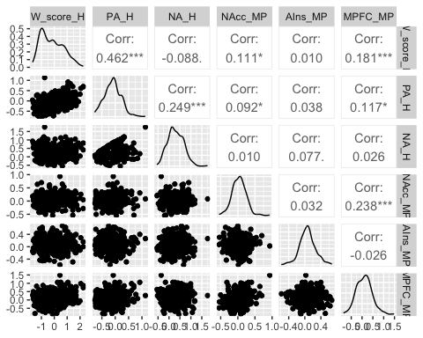

# Aggregate Results Horror Trailers.

## AggHor: Seq Models.

|  | Affect GT | Choice GT | Neuro Seq GT | Affect Neuro Seq GT | Choice Neuro Seq GT |
| --- | --- | --- | --- | --- | --- |
| (Intercept) | 7.500*** | 7.500*** | 7.500*** | 7.500*** | 7.500*** |
|  | t = 6.589 | t = 6.780 | t = 7.246 | t = 8.475 | t = 7.332 |
|  | s.e. = 1.138, p-val = <0.001 | s.e. = 1.106, p-val = <0.001 | s.e. = 1.035, p-val = <0.001 | s.e. = 0.885, p-val = <0.001 | s.e. = 1.023, p-val = <0.001 |
| scale(Pos_arousal_scaled) | −0.007 |  |  | −2.944+ |  |
|  | t = −0.006 |  |  | t = −2.167 |  |
|  | s.e. = 1.258, p-val = 0.996 |  |  | s.e. = 1.359, p-val = 0.062 |  |
| scale(Neg_arousal_scaled) | −1.464 |  |  | 0.459 |  |
|  | t = −1.163 |  |  | t = 0.375 |  |
|  | s.e. = 1.258, p-val = 0.269 |  |  | s.e. = 1.224, p-val = 0.717 |  |
| scale(W_score_scaled) |  | 1.298 |  |  | −2.330 |
|  |  | t = 1.131 |  |  | t = −1.112 |
|  |  | s.e. = 1.148, p-val = 0.280 |  |  | s.e. = 2.095, p-val = 0.295 |
| scale(NAcc_seg1) |  |  | −0.901 | −0.792 | −2.243 |
|  |  |  | t = −0.784 | t = −0.744 | t = −1.353 |
|  |  |  | s.e. = 1.150, p-val = 0.451 | s.e. = 1.065, p-val = 0.478 | s.e. = 1.657, p-val = 0.209 |
| scale(AIns_seg3) |  |  | 2.124+ | 3.381* | 3.395+ |
|  |  |  | t = 1.864 | t = 2.884 | t = 2.116 |
|  |  |  | s.e. = 1.139, p-val = 0.092 | s.e. = 1.172, p-val = 0.020 | s.e. = 1.604, p-val = 0.063 |
| scale(MPFC_seg5) |  |  | 1.650 | 2.932* | 3.258 |
|  |  |  | t = 1.509 | t = 2.381 | t = 1.805 |
|  |  |  | s.e. = 1.093, p-val = 0.162 | s.e. = 1.231, p-val = 0.044 | s.e. = 1.805, p-val = 0.105 |
| Num.Obs. | 14 | 14 | 14 | 14 | 14 |
| R2 | 0.123 | 0.096 | 0.341 | 0.614 | 0.420 |
| R2 Adj. | −0.037 | 0.021 | 0.143 | 0.374 | 0.163 |
| AIC | 84.9 | 83.3 | 82.9 | 79.4 | 83.1 |
| BIC | 87.5 | 85.3 | 86.1 | 83.9 | 87.0 |
| * p < 0.1, * p < 0.05, ** p < 0.01, *** p < 0.001 | | | | | |

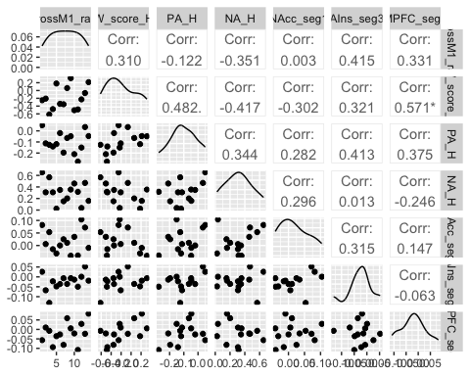

## AggHor: Modal Peak (MP) Models.

|  | Affect GT | Choice GT | Neuro MP GT | Affect Neuro MP GT | Choice Neuro MP GT |
| --- | --- | --- | --- | --- | --- |
| (Intercept) | 7.500*** | 7.500*** | 7.500*** | 7.500*** | 7.500*** |
|  | t = 6.589 | t = 6.780 | t = 7.359 | t = 7.406 | t = 7.879 |
|  | s.e. = 1.138, p-val = <0.001 | s.e. = 1.106, p-val = <0.001 | s.e. = 1.019, p-val = <0.001 | s.e. = 1.013, p-val = <0.001 | s.e. = 0.952, p-val = <0.001 |
| scale(Pos_arousal_scaled) | −0.007 |  |  | 1.158 |  |
|  | t = −0.006 |  |  | t = 0.733 |  |
|  | s.e. = 1.258, p-val = 0.996 |  |  | s.e. = 1.580, p-val = 0.484 |  |
| scale(Neg_arousal_scaled) | −1.464 |  |  | −1.642 |  |
|  | t = −1.163 |  |  | t = −1.396 |  |
|  | s.e. = 1.258, p-val = 0.269 |  |  | s.e. = 1.176, p-val = 0.200 |  |
| scale(W_score_scaled) |  | 1.298 |  |  | 1.760 |
|  |  | t = 1.131 |  |  | t = 1.570 |
|  |  | s.e. = 1.148, p-val = 0.280 |  |  | s.e. = 1.122, p-val = 0.151 |
| scale(NAcc_avg_peak_yes_pos2) |  |  | −1.117 | −1.879 | −1.122 |
|  |  |  | t = −0.810 | t = −1.227 | t = −0.871 |
|  |  |  | s.e. = 1.379, p-val = 0.437 | s.e. = 1.532, p-val = 0.255 | s.e. = 1.288, p-val = 0.406 |
| scale(AIns_avg_peak_yes_pos2) |  |  | −2.564* | −2.664+ | −2.632* |
|  |  |  | t = −2.321 | t = −2.231 | t = −2.549 |
|  |  |  | s.e. = 1.105, p-val = 0.043 | s.e. = 1.194, p-val = 0.056 | s.e. = 1.033, p-val = 0.031 |
| scale(MPFC_avg_peak_yes_pos2) |  |  | 0.095 | 0.364 | −0.751 |
|  |  |  | t = 0.069 | t = 0.228 | t = −0.538 |
|  |  |  | s.e. = 1.378, p-val = 0.946 | s.e. = 1.596, p-val = 0.825 | s.e. = 1.395, p-val = 0.604 |
| Num.Obs. | 14 | 14 | 14 | 14 | 14 |
| R2 | 0.123 | 0.096 | 0.361 | 0.495 | 0.498 |
| R2 Adj. | −0.037 | 0.021 | 0.169 | 0.180 | 0.275 |
| AIC | 84.9 | 83.3 | 82.5 | 83.2 | 81.1 |
| BIC | 87.5 | 85.3 | 85.7 | 87.7 | 84.9 |
| * p < 0.1, * p < 0.05, ** p < 0.01, *** p < 0.001 | | | | | |

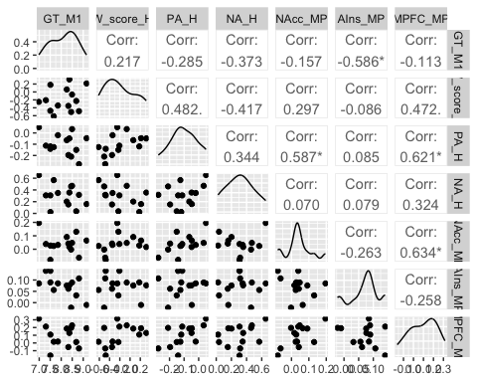

# Invididual Choice Both Trailers.

## IndBoth: Sequence models.

## Comedy  
## Horror -1  
## Comedy 1

|  | Affect | Neuro seq | Affect & Neuro seq |
| --- | --- | --- | --- |
| (Intercept) | 0.012 | −0.003 | 0.010 |
|  | t = 0.245 | t = −0.044 | t = 0.189 |
|  | s.e. = 0.051, p-val = 0.807 | s.e. = 0.065, p-val = 0.965 | s.e. = 0.051, p-val = 0.850 |
| TypeComedy | −0.091+ | 0.191** | −0.090+ |
|  | t = −1.780 | t = 2.929 | t = −1.753 |
|  | s.e. = 0.051, p-val = 0.075 | s.e. = 0.065, p-val = 0.003 | s.e. = 0.051, p-val = 0.080 |
| scale(Pos_arousal_scaled) | 0.582*** |  | 0.580*** |
|  | t = 20.583 |  | t = 20.450 |
|  | s.e. = 0.028, p-val = <0.001 |  | s.e. = 0.028, p-val = <0.001 |
| scale(Neg_arousal_scaled) | −0.167*** |  | −0.168*** |
|  | t = −4.381 |  | t = −4.376 |
|  | s.e. = 0.038, p-val = <0.001 |  | s.e. = 0.038, p-val = <0.001 |
| TypeComedy × scale(Pos_arousal_scaled) | 0.063* |  | 0.061* |
|  | t = 2.239 |  | t = 2.150 |
|  | s.e. = 0.028, p-val = 0.025 |  | s.e. = 0.028, p-val = 0.032 |
| TypeComedy × scale(Neg_arousal_scaled) | 0.043 |  | 0.039 |
|  | t = 1.128 |  | t = 1.005 |
|  | s.e. = 0.038, p-val = 0.259 |  | s.e. = 0.038, p-val = 0.315 |
| scale(NAcc_seg2) |  | 0.030 | 0.001 |
|  |  | t = 0.964 | t = 0.046 |
|  |  | s.e. = 0.031, p-val = 0.335 | s.e. = 0.026, p-val = 0.964 |
| scale(AIns_seg3) |  | 0.018 | 0.024 |
|  |  | t = 0.588 | t = 0.936 |
|  |  | s.e. = 0.031, p-val = 0.557 | s.e. = 0.026, p-val = 0.349 |
| scale(MPFC_seg5) |  | 0.060+ | 0.038 |
|  |  | t = 1.925 | t = 1.465 |
|  |  | s.e. = 0.031, p-val = 0.055 | s.e. = 0.026, p-val = 0.143 |
| TypeComedy × scale(NAcc_seg2) |  | 0.068* | 0.042 |
|  |  | t = 2.208 | t = 1.644 |
|  |  | s.e. = 0.031, p-val = 0.027 | s.e. = 0.026, p-val = 0.101 |
| TypeComedy × scale(AIns_seg3) |  | −0.008 | −0.007 |
|  |  | t = −0.271 | t = −0.265 |
|  |  | s.e. = 0.031, p-val = 0.786 | s.e. = 0.026, p-val = 0.791 |
| TypeComedy × scale(MPFC_seg5) |  | 0.013 | −0.004 |
|  |  | t = 0.426 | t = −0.172 |
|  |  | s.e. = 0.031, p-val = 0.670 | s.e. = 0.026, p-val = 0.864 |
| SD (Intercept Trailer) | 0.190 | 0.327 | 0.193 |
|  | s.e. = , p-val = | s.e. = , p-val = | s.e. = , p-val = |
| SD (Intercept Participant) | 0.000 | 0.000 | 0.000 |
|  | s.e. = , p-val = | s.e. = , p-val = | s.e. = , p-val = |
| SD (Observations) | 0.769 | 0.928 | 0.768 |
|  | s.e. = , p-val = | s.e. = , p-val = | s.e. = , p-val = |
| R2 Marg. | 0.378 | 0.051 | 0.381 |
| AIC | 2253.6 | 2636.5 | 2292.9 |
| BIC | 2297.2 | 2689.8 | 2365.6 |
| * p < 0.1, * p < 0.05, ** p < 0.01, *** p < 0.001 | | | |

## IndBoth: MP models.

## Comedy  
## Horror -1  
## Comedy 1

|  | Affect | Neuro seq | Affect & Neuro seq |
| --- | --- | --- | --- |
| (Intercept) | 0.012 | −0.001 | 0.012 |
|  | t = 0.245 | t = −0.011 | t = 0.236 |
|  | s.e. = 0.051, p-val = 0.807 | s.e. = 0.061, p-val = 0.991 | s.e. = 0.050, p-val = 0.813 |
| TypeComedy | −0.091+ | 0.190** | −0.088+ |
|  | t = −1.780 | t = 3.090 | t = −1.751 |
|  | s.e. = 0.051, p-val = 0.075 | s.e. = 0.061, p-val = 0.002 | s.e. = 0.050, p-val = 0.080 |
| scale(Pos_arousal_scaled) | 0.582*** |  | 0.560*** |
|  | t = 20.583 |  | t = 19.558 |
|  | s.e. = 0.028, p-val = <0.001 |  | s.e. = 0.029, p-val = <0.001 |
| scale(Neg_arousal_scaled) | −0.167*** |  | −0.171*** |
|  | t = −4.381 |  | t = −4.485 |
|  | s.e. = 0.038, p-val = <0.001 |  | s.e. = 0.038, p-val = <0.001 |
| TypeComedy × scale(Pos_arousal_scaled) | 0.063* |  | 0.056+ |
|  | t = 2.239 |  | t = 1.957 |
|  | s.e. = 0.028, p-val = 0.025 |  | s.e. = 0.029, p-val = 0.051 |
| TypeComedy × scale(Neg_arousal_scaled) | 0.043 |  | 0.037 |
|  | t = 1.128 |  | t = 0.978 |
|  | s.e. = 0.038, p-val = 0.259 |  | s.e. = 0.038, p-val = 0.328 |
| scale(NAcc_avg_peak_yes_pos2) |  | 0.124*** | 0.053* |
|  |  | t = 4.047 | t = 2.044 |
|  |  | s.e. = 0.031, p-val = <0.001 | s.e. = 0.026, p-val = 0.041 |
| scale(AIns_avg_peak_yes_pos2) |  | 0.080** | 0.043+ |
|  |  | t = 2.622 | t = 1.668 |
|  |  | s.e. = 0.031, p-val = 0.009 | s.e. = 0.026, p-val = 0.096 |
| scale(MPFC_avg_peak_yes_pos2) |  | 0.108*** | 0.056* |
|  |  | t = 3.421 | t = 2.105 |
|  |  | s.e. = 0.031, p-val = <0.001 | s.e. = 0.026, p-val = 0.036 |
| TypeComedy × scale(NAcc_avg_peak_yes_pos2) |  | 0.062* | 0.016 |
|  |  | t = 2.023 | t = 0.610 |
|  |  | s.e. = 0.031, p-val = 0.043 | s.e. = 0.026, p-val = 0.542 |
| TypeComedy × scale(AIns_avg_peak_yes_pos2) |  | 0.074* | 0.037 |
|  |  | t = 2.413 | t = 1.436 |
|  |  | s.e. = 0.031, p-val = 0.016 | s.e. = 0.026, p-val = 0.151 |
| TypeComedy × scale(MPFC_avg_peak_yes_pos2) |  | −0.005 | −0.027 |
|  |  | t = −0.172 | t = −1.023 |
|  |  | s.e. = 0.031, p-val = 0.864 | s.e. = 0.026, p-val = 0.307 |
| SD (Intercept Trailer) | 0.190 | 0.304 | 0.184 |
|  | s.e. = , p-val = | s.e. = , p-val = | s.e. = , p-val = |
| SD (Intercept Participant) | 0.000 | 0.000 | 0.000 |
|  | s.e. = , p-val = | s.e. = , p-val = | s.e. = , p-val = |
| SD (Observations) | 0.769 | 0.908 | 0.764 |
|  | s.e. = , p-val = | s.e. = , p-val = | s.e. = , p-val = |
| R2 Marg. | 0.378 | 0.095 | 0.389 |
| AIC | 2253.6 | 2593.7 | 2280.6 |
| BIC | 2297.2 | 2647.1 | 2353.3 |
| * p < 0.1, * p < 0.05, ** p < 0.01, *** p < 0.001 | | | |

# Aggregate Results Both Trailers.

## AggBoth: Seq Models.

## comedy  
## horror -1  
## comedy 1

|  | Affect GM1 | Choice GM1 | Neuro Seq GM1 | Affect Neuro Seq GM1 | Choice Neuro Seq GM1 |
| --- | --- | --- | --- | --- | --- |
| (Intercept) | 10.894* | 15.207*** | 15.452*** | 6.709 | 13.800*** |
|  | t = 2.085 | t = 8.703 | t = 10.653 | t = 1.223 | t = 6.112 |
|  | s.e. = 5.224, p-val = 0.048 | s.e. = 1.747, p-val = <0.001 | s.e. = 1.450, p-val = <0.001 | s.e. = 5.486, p-val = 0.238 | s.e. = 2.258, p-val = <0.001 |
| Typecomedy | −11.126* | −4.130* | −2.072 | −2.503 | −0.265 |
|  | t = −2.130 | t = −2.363 | t = −1.428 | t = −0.456 | t = −0.117 |
|  | s.e. = 5.224, p-val = 0.044 | s.e. = 1.747, p-val = 0.026 | s.e. = 1.450, p-val = 0.168 | s.e. = 5.486, p-val = 0.654 | s.e. = 2.258, p-val = 0.908 |
| scale(Pos_arousal_scaled) | 0.812 |  |  | −6.011* |  |
|  | t = 0.355 |  |  | t = −2.115 |  |
|  | s.e. = 2.288, p-val = 0.726 |  |  | s.e. = 2.842, p-val = 0.049 |  |
| scale(Neg_arousal_scaled) | −8.892 |  |  | −5.404 |  |
|  | t = −1.680 |  |  | t = −1.033 |  |
|  | s.e. = 5.293, p-val = 0.106 |  |  | s.e. = 5.232, p-val = 0.316 |  |
| Typecomedy × scale(Pos_arousal_scaled) | 1.945 |  |  | 3.828 |  |
|  | t = 0.850 |  |  | t = 1.347 |  |
|  | s.e. = 2.288, p-val = 0.404 |  |  | s.e. = 2.842, p-val = 0.196 |  |
| Typecomedy × scale(Neg_arousal_scaled) | −3.649 |  |  | −7.010 |  |
|  | t = −0.690 |  |  | t = −1.340 |  |
|  | s.e. = 5.293, p-val = 0.497 |  |  | s.e. = 5.232, p-val = 0.198 |  |
| scale(W_score_scaled) |  | 2.899 |  |  | −3.527 |
|  |  | t = 1.549 |  |  | t = −1.097 |
|  |  | s.e. = 1.871, p-val = 0.134 |  |  | s.e. = 3.214, p-val = 0.286 |
| Typecomedy × scale(W_score_scaled) |  | −0.137 |  |  | 3.279 |
|  |  | t = −0.073 |  |  | t = 1.020 |
|  |  | s.e. = 1.871, p-val = 0.942 |  |  | s.e. = 3.214, p-val = 0.320 |
| scale(NAcc_seg1) |  |  | 0.902 | 0.859 | −0.581 |
|  |  |  | t = 0.583 | t = 0.536 | t = −0.286 |
|  |  |  | s.e. = 1.547, p-val = 0.566 | s.e. = 1.603, p-val = 0.599 | s.e. = 2.027, p-val = 0.778 |
| scale(AIns_seg3) |  |  | 2.708+ | 4.569* | 4.119+ |
|  |  |  | t = 1.757 | t = 2.601 | t = 1.969 |
|  |  |  | s.e. = 1.541, p-val = 0.093 | s.e. = 1.756, p-val = 0.019 | s.e. = 2.092, p-val = 0.064 |
| scale(MPFC_seg5) |  |  | 1.301 | 2.124 | 3.392 |
|  |  |  | t = 0.796 | t = 1.076 | t = 1.322 |
|  |  |  | s.e. = 1.635, p-val = 0.435 | s.e. = 1.974, p-val = 0.297 | s.e. = 2.565, p-val = 0.202 |
| Typecomedy × scale(NAcc_seg1) |  |  | 3.204+ | 2.913+ | 4.720* |
|  |  |  | t = 2.071 | t = 1.818 | t = 2.328 |
|  |  |  | s.e. = 1.547, p-val = 0.051 | s.e. = 1.603, p-val = 0.087 | s.e. = 2.027, p-val = 0.031 |
| Typecomedy × scale(AIns_seg3) |  |  | −0.369 | −0.992 | −1.642 |
|  |  |  | t = −0.240 | t = −0.565 | t = −0.785 |
|  |  |  | s.e. = 1.541, p-val = 0.813 | s.e. = 1.756, p-val = 0.580 | s.e. = 2.092, p-val = 0.442 |
| Typecomedy × scale(MPFC_seg5) |  |  | −2.726 | −5.100* | −4.940+ |
|  |  |  | t = −1.667 | t = −2.584 | t = −1.926 |
|  |  |  | s.e. = 1.635, p-val = 0.110 | s.e. = 1.974, p-val = 0.019 | s.e. = 2.565, p-val = 0.069 |
| Num.Obs. | 29 | 29 | 29 | 29 | 29 |
| R2 | 0.280 | 0.195 | 0.416 | 0.588 | 0.456 |
| R2 Adj. | 0.123 | 0.099 | 0.221 | 0.322 | 0.198 |
| AIC | 210.0 | 209.2 | 207.9 | 205.8 | 209.9 |
| BIC | 219.6 | 216.0 | 220.2 | 223.6 | 224.9 |
| * p < 0.1, * p < 0.05, ** p < 0.01, *** p < 0.001 | | | | | |

## AggBoth: Modal Peak (MP) Models.

## comedy  
## horror -1  
## comedy 1

|  | Affect GM1 | Choice GM1 | Neuro MP GM1 | Affect Neuro MP GM1 | Choice Neuro MP GM1 |
| --- | --- | --- | --- | --- | --- |
| (Intercept) | 10.894* | 15.207*** | 15.536*** | 14.176* | 16.664*** |
|  | t = 2.085 | t = 8.703 | t = 11.338 | t = 2.821 | t = 10.192 |
|  | s.e. = 5.224, p-val = 0.048 | s.e. = 1.747, p-val = <0.001 | s.e. = 1.370, p-val = <0.001 | s.e. = 5.025, p-val = 0.012 | s.e. = 1.635, p-val = <0.001 |
| Typecomedy | −11.126* | −4.130* | −3.242* | −12.318* | −4.349* |
|  | t = −2.130 | t = −2.363 | t = −2.366 | t = −2.451 | t = −2.660 |
|  | s.e. = 5.224, p-val = 0.044 | s.e. = 1.747, p-val = 0.026 | s.e. = 1.370, p-val = 0.028 | s.e. = 5.025, p-val = 0.025 | s.e. = 1.635, p-val = 0.015 |
| scale(Pos_arousal_scaled) | 0.812 |  |  | 1.861 |  |
|  | t = 0.355 |  |  | t = 0.653 |  |
|  | s.e. = 2.288, p-val = 0.726 |  |  | s.e. = 2.850, p-val = 0.523 |  |
| scale(Neg_arousal_scaled) | −8.892 |  |  | −8.790+ |  |
|  | t = −1.680 |  |  | t = −1.783 |  |
|  | s.e. = 5.293, p-val = 0.106 |  |  | s.e. = 4.929, p-val = 0.092 |  |
| Typecomedy × scale(Pos_arousal_scaled) | 1.945 |  |  | −1.289 |  |
|  | t = 0.850 |  |  | t = −0.452 |  |
|  | s.e. = 2.288, p-val = 0.404 |  |  | s.e. = 2.850, p-val = 0.657 |  |
| Typecomedy × scale(Neg_arousal_scaled) | −3.649 |  |  | −2.732 |  |
|  | t = −0.690 |  |  | t = −0.554 |  |
|  | s.e. = 5.293, p-val = 0.497 |  |  | s.e. = 4.929, p-val = 0.587 |  |
| scale(W_score_scaled) |  | 2.899 |  |  | 2.322 |
|  |  | t = 1.549 |  |  | t = 1.180 |
|  |  | s.e. = 1.871, p-val = 0.134 |  |  | s.e. = 1.967, p-val = 0.252 |
| Typecomedy × scale(W_score_scaled) |  | −0.137 |  |  | −2.371 |
|  |  | t = −0.073 |  |  | t = −1.205 |
|  |  | s.e. = 1.871, p-val = 0.942 |  |  | s.e. = 1.967, p-val = 0.243 |
| scale(NAcc_avg_peak_yes_pos2) |  |  | 3.774+ | 2.765 | 3.793 |
|  |  |  | t = 1.869 | t = 1.202 | t = 1.649 |
|  |  |  | s.e. = 2.019, p-val = 0.076 | s.e. = 2.300, p-val = 0.246 | s.e. = 2.300, p-val = 0.115 |
| scale(AIns_avg_peak_yes_pos2) |  |  | −3.089* | −3.248+ | −3.166* |
|  |  |  | t = −2.089 | t = −2.059 | t = −2.151 |
|  |  |  | s.e. = 1.479, p-val = 0.049 | s.e. = 1.577, p-val = 0.055 | s.e. = 1.472, p-val = 0.045 |
| scale(MPFC_avg_peak_yes_pos2) |  |  | −0.981 | −0.445 | −1.619 |
|  |  |  | t = −0.555 | t = −0.231 | t = −0.881 |
|  |  |  | s.e. = 1.766, p-val = 0.585 | s.e. = 1.931, p-val = 0.820 | s.e. = 1.837, p-val = 0.389 |
| Typecomedy × scale(NAcc_avg_peak_yes_pos2) |  |  | 5.841** | 5.843* | 5.868* |
|  |  |  | t = 2.893 | t = 2.540 | t = 2.552 |
|  |  |  | s.e. = 2.019, p-val = 0.009 | s.e. = 2.300, p-val = 0.021 | s.e. = 2.300, p-val = 0.019 |
| Typecomedy × scale(AIns_avg_peak_yes_pos2) |  |  | 2.249 | 2.170 | 2.324 |
|  |  |  | t = 1.521 | t = 1.375 | t = 1.579 |
|  |  |  | s.e. = 1.479, p-val = 0.143 | s.e. = 1.577, p-val = 0.187 | s.e. = 1.472, p-val = 0.131 |
| Typecomedy × scale(MPFC_avg_peak_yes_pos2) |  |  | −0.953 | −0.998 | −0.302 |
|  |  |  | t = −0.540 | t = −0.517 | t = −0.164 |
|  |  |  | s.e. = 1.766, p-val = 0.595 | s.e. = 1.931, p-val = 0.612 | s.e. = 1.837, p-val = 0.871 |
| Num.Obs. | 29 | 29 | 29 | 29 | 29 |
| R2 | 0.280 | 0.195 | 0.459 | 0.561 | 0.516 |
| R2 Adj. | 0.123 | 0.099 | 0.278 | 0.278 | 0.287 |
| AIC | 210.0 | 209.2 | 205.7 | 207.6 | 206.5 |
| BIC | 219.6 | 216.0 | 218.0 | 225.4 | 221.5 |
| * p < 0.1, * p < 0.05, ** p < 0.01, *** p < 0.001 | | | | | |