Laboratory Activity No. 5

We had our professor briefly discuss the Dictionary type of data in Python. In this activity, our class got to add and multiply items of the Number type all stored as values of keys in a single given dictionary.

# Submission

## Output

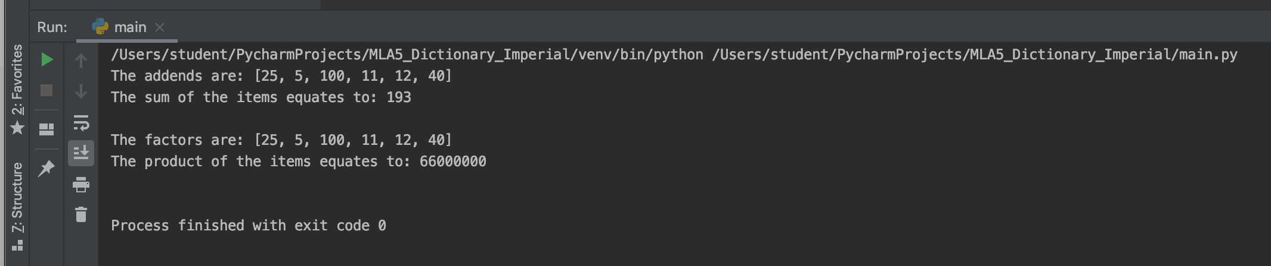

## Code Input

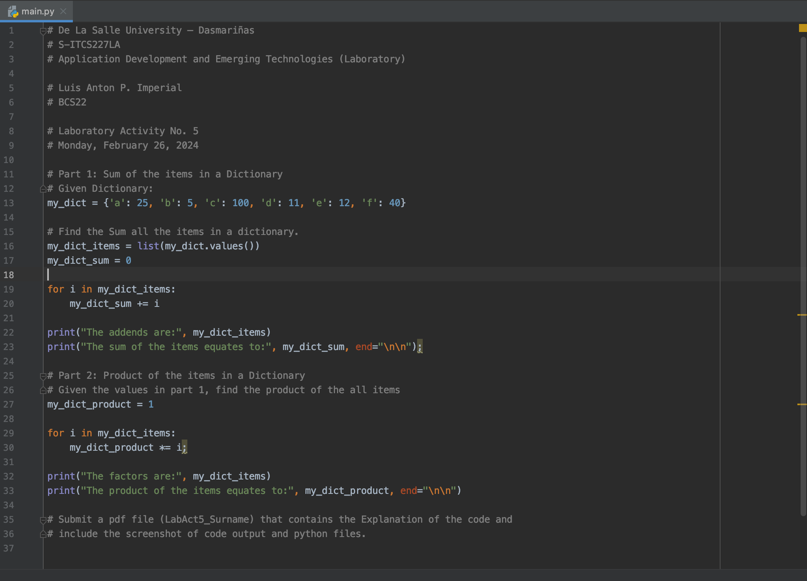

## Explanation

The given dictionary is first initialized as-is. It is named “my_dict”, as given, and its input is stored in a single line, containing single-character keys and integer values.

To manipulate the dataset we’re provided, extract the values of the given dictionary and place it in a list. This list is hereby named the same as that of the dictionary, but with a suffix of “items,” separated by an underscore.

Preparing a variable means also giving it a default value, which functions can start with to avoid unexpected incompatibilities. Our default sum is zero, for basic arithmetic teaches us that zero means naught.

We created a “for” loop to add each item in the “my dictionary items” list earlier to the value of said variable, which at first is nothing. This means that all that is added are those items, with each other.

The same is done for the next task given, which is to get the product of “the all items.”

Any number multiplied by 1 is equal to that any number, thus that specific operation serves to strengthen said number’s identity. This is similar to the addition of any number to zero that is done in the first part.

The for loop is initiated a second time, albeit this time for multiplication rather than addition.

The factors and the end result are both printed out to the terminal.

Voila! Our assessment is now complete.

# Appendix

## References

1. Estrobo, Deri. “Laboratory Activity No.5.” DLSU-D College/GS. Retrieved from <<https://dlsud.edu20.org/student_assignments/due/4527846?redirect_if_one=true>>.

## Code

# De La Salle University – Dasmariñas  
# S-ITCS227LA  
# Application Development and Emerging Technologies (Laboratory)  
  
# Luis Anton P. Imperial  
# BCS22  
  
# Laboratory Activity No. 5  
# Monday, February 26, 2024  
  
# Part 1: Sum of the items in a Dictionary  
# Given Dictionary:  
my_dict = {'a': 25, 'b': 5, 'c': 100, 'd': 11, 'e': 12, 'f': 40}  
  
# Find the Sum all the items in a dictionary.  
my_dict_items = list(my_dict.values())  
my_dict_sum = 0  
  
for i in my_dict_items:  
 my_dict_sum += i  
  
print("The addends are:", my_dict_items)  
print("The sum of the items equates to:", my_dict_sum, end="\n\n");  
  
# Part 2: Product of the items in a Dictionary  
# Given the values in part 1, find the product of the all items  
my_dict_product = 1  
  
for i in my_dict_items:  
 my_dict_product *= i;  
  
print("The factors are:", my_dict_items)  
print("The product of the items equates to:", my_dict_product, end="\n\n")  
  
# Submit a pdf file (LabAct5_Surname) that contains the Explanation of the code and  
# include the screenshot of code output and python files.

## Instructions

|  |  |
| --- | --- |
|  | Type: Dropbox  Max score: 50  Category: Enabling Asssessment  Start: Feb 26, 10:00 am  Due: Feb 26, 1:00 pm |
| Max. attempts: 2  Allow late submissions: ❌ |