***“UNIVERSIDADDE LAS FUERZAS ARMADAS” ESPE***

***SOFTWARE ENGINEER OOP***

***Proyect first partial SMC-STYLE-IRELIA***

***STUDENTS:***

*Joel Arguello Alex Bedón Luis Burbano Widinson Caiza*

***GROUP:***

*BettaCoders or first group*

***GUARDIAN IN CHARGE:***

*PHD. EDISON LASCANO*

***NRC:***

*4680*

***DELIVERY DATE:***

***SEDE MATRIZ SANGOLQUÍ***

*QUITO-ECUADOR 2022*

**SMC Stylist Irelia**

For the project we use the Java Language that helps us and facilitates us due to its object-oriented paradigm, with them we use basic concepts such as Inheritance, Polymorphism, Encapsulation, Abstraction that help us above all to reuse code and that the coding is efficient.

**Abstraction**

Representation through its properties and methods of a reality based on its characteristics.

abstraction allows me to more comfortably organize a model or a real problem by breaking down the global into smaller components and thus making it easier.

**Encapsulation**

Encapsulation manages to manage the properties and methods that are going to be exposed to the outside, Hiding the desired part of its implementation, this mechanism allows us to make modifications to a class without affecting the rest of the program

**Inheritance**

The concept is based on creating more detailed objects from other existing models, one or more classes benefit from the properties and methods of an existing class so that instead of starting from scratch, they can simply specialize in certain aspects. Inheritance is implemented by assigning to the prototype of a class (child class) an instance of the class from which it is desired to inherit (parent class).

**Polymorphism**

Polymorphism is related to inheritance and is based on the fact that 2 objects of different types can share the same interface so that you can work with that relationship regardless of the type of object being worked on, one of the possibilities that its implementation gives us in JavaScript is counting on so-called subtyped or classic polymorphism. This type of polymorphism allows us to work with an object at a certain level without having to worry about its exact type, thanks to working with it at a higher level (parent class) which guarantees that thanks to inheritance we always have the methods to the ones we call, either the originals in the parent class or the overridden versions in the child classes,

**GUI**

Java Swing is a lightweight graphical user interface (GUI) tool that includes a rich set of widgets. It includes a package that allows you to create GUI components for your Java applications and is platform independent.

For user facilities we can use various GUI options:

**Menus:**

Main Options of your system

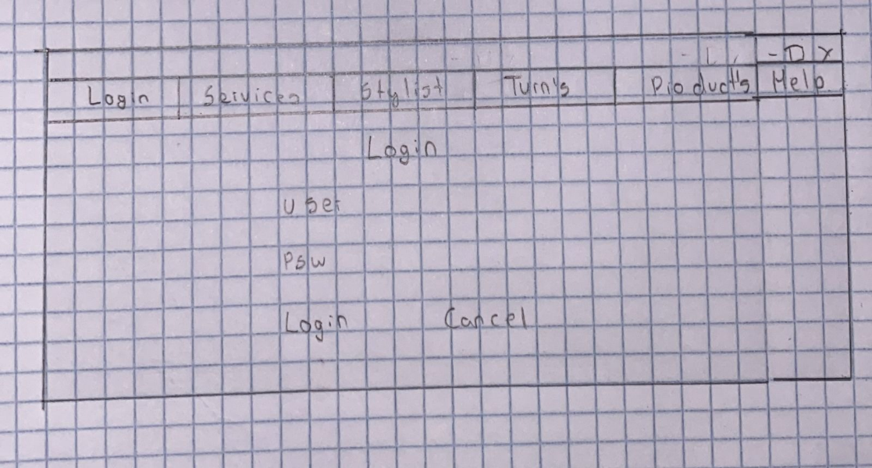

**TABLES:**

Component graphical to show tabulated information a list

**User input validation:**

Control what user enters before it is processed and saved in the database

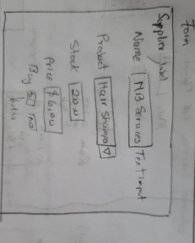

**MongoDB**

CONNECTION WITH THE DATABASE:

Insert a Single Document

[db.collection.insertOne()](https://www.mongodb.com/docs/manual/reference/method/db.collection.insertOne/#mongodb-method-db.collection.insertOne) inserts a single [document](https://www.mongodb.com/docs/manual/core/document/#std-label-bson-document-format) into a collection.

Update a document

MongoDB provides [update operators](https://www.mongodb.com/docs/manual/reference/operator/update/), such as [$set](https://www.mongodb.com/docs/manual/reference/operator/update/set/#mongodb-update-up.-set), to modify field values.

Delete Documents

This page uses the following [mongosh](https://www.mongodb.com/docs/mongodb-shell/#mongodb-binary-bin.mongosh) methods:

[db.collection.deleteMany()](https://www.mongodb.com/docs/manual/reference/method/db.collection.deleteMany/#mongodb-method-db.collection.deleteMany)

[db.collection.deleteOne()](https://www.mongodb.com/docs/manual/reference/method/db.collection.deleteOne/#mongodb-method-db.collection.deleteOne)

