Project Acronym: SAIP

Project Full Title: -----------
Project Number: ----------
Project Duration: 24M
SAIP Architectural Design
Deliverable D2.1
Work Package: WP2
Task(s): T2.1 – SPECIFICATIONS AND REQUIREMENTS ----
Project Leader: Smartmind
Starting Date: April 2023
Due Date: --/--/----
Delivery Date: --/--/----
Deliverable Version: 1.0
Type: Report
Dissemination Level: Public/ Confidential

CONSORTIUM OVERVIEW

Partner short name | Status | Country | Size
- Smartmind | C | TR | -
- KLCSoft | P | TR | -
- GOPA Lux | P | LUX | -
- BEIA Consult Unternational | P | AUS | -

ABSTRACT
With increased covid19, globalization and intense competition in the market, food supply chains have become longer and more complex than ever before. There are some common problems in food supply chains such as food traceability, food safety and quality, food trust and supply chain inefficiency, which add additional risks on the entire society, economy and the health of humans. The main goal of SAIP is embedding blockchain and AI technology in the agri-food supply chain which can facilitate the acquisition of information about the origin and procurement process of many food products, guaranteeing reliable certified farmers, reliable food and safe product supply.

Table of Contents

1. Executive Summary 5
2. Introduction 6
2.1 Purpose and Structure of the Document 6
2.2 Relation to Other Tasks and Deliverables 7
2.3 Deliverable Structure 7
3. Overall architecture design of SAIP 7
3.1 SAIP architecture concept 9
3.1.1 SAIP Artificial Intelligence 10
3.1.2 SAIP Blockchain 11
3.1.3 SAIP UML 12
3.2 SAIP Architecture use case scenarios 16
3.2.1 Overview of SAIP use cases 16
3.2.2 Refinement on Scenarios 17
4. Logical SAIP Architecture 18
4.1 Semantic definition (ontologies) for supply chain management 19
4.2 SAIP Gateway API Services 19
4.3 SAIP Microservices Architecture 19
4.3.1 Authentication and Authorization in Microservice Architecture 20
4.3.2 Authentication Gateway 20
4.3.3 Artificial Intelligence Module 21
5. State of the Art 21
5.1 Application technology stacks 22
5.1.1 Client-Side 22
5.2 Platform components 22
5.2.1 Conceptual platform 22
6. Information View 25
6.1 Data Storage 25
6.2 SAIP with Hyperledger Fabric 26
6.3 Conformity Analysis 26
7. Platform requirements & assumptions 28
7.1 Requirements Definitions 28
7.2 SAIP Requirements 29
8. Conclusions 31

Executive Summary

This document is an output titled "SAIP Architectural Design Report" and is part of the SAIP project, which is funded under the Horizon 2020 Research and Innovation Program (H2020) by the Directorate-General for Research and Innovation (DG RTD) of the European Commission. The SAIP Architectural Design Report presents the architectural framework and design principles for the SAIP project. SAIP aims to develop a comprehensive solution that addresses challenges such as managing system complexity in product supply, optimizing performance, and ensuring security.
The architecture of SAIP encompasses its main components, their relationships, and interactions. It takes into account various contributing factors such as business strategy, quality attributes, human dynamics, design, and IT environment. Architectural decisions are made to fulfill functional requirements and address non-detailed aspects.
The SAIP architecture enables effective management of system complexity by providing an abstraction layer. It facilitates seamless integration and collaboration among system components by establishing robust communication mechanisms. The architecture defines a structured solution that meets all technical and operational requirements, with a focus on optimizing performance and ensuring security.
The SAIP architecture encompasses a series of critical decisions related to software development and enterprise compliance. These decisions have a significant impact on the overall quality, maintenance, and performance of the final product. Key points include the selection of structural elements and interfaces, defining behavior through collaborations, integrating elements into subsystems, aligning architectural decisions with business objectives, and adopting architectural styles that guide the organization.
The SAIP Architectural Design Report presents detailed insights, rationale, and the overall architectural vision of the selected architectural options. The report emphasizes the importance of considering sustainability, energy efficiency, and environmental impacts. It highlights the necessity of innovative solutions and technological advancements to trigger positive change in the industry.
In conclusion, the SAIP Architectural Design Report serves as a roadmap for the development of the project. It describes the architectural framework that supports reliability, traceability, and efficiency among all supply chain stakeholders. The report prepares the field for successful implementation and paves the way for transformative advancements in the field.

Introduction

2.1 Purpose and Structure of the Document
This document presents the initial version of the conceptual design and high-level architecture of the SAIP platform. This design incorporates the features of a Microservices Architecture, customized user requirements, strategic analytical tools, and real-time functionalities along with use case studies. The architectural design specifies all the components and explains how they are combined with their inputs and outputs. Additionally, it identifies the areas where the existing technology will be part of the solution and lays the foundations for a highly flexible, modular, and scalable platform that can adapt to given conditions. The proposed initial architectural design will be updated as needed in the project's later stages. The main objective is to provide an integrated framework to address compatibility issues that arise in different environments and use cases. It is expected that modules interact with the platform through an enhanced Application Programming Interface (API) and protocols. The interfaces will be determined considering compliance with existing standards and interchangeability.
The architecture represents any combination of hybrid and multi-cloud deployments and emphasizes important resource management areas such as orders, transportation, and suppliers. The architecture aims to perform data syndication among the core resource domains, store transactional data, and provide advanced analytics, artificial intelligence, and data science functionalities on this data within the supply chain function. These functionalities enrich the business application layer and deliver value to all stakeholders involved in the supply chain function.
The relevant tasks derived from the architectural design are as follows:
Task 1: Identification of user requirements and constraints
Task 2: Extraction of use case requirements
Task 3: Selection of architecture
Task 4: Identification of components
Task 5: Data modeling
The system will be developed iteratively and incrementally, meaning each iteration will involve the analysis, implementation, and testing of a section. This technical documentation will also be continuously updated throughout the project. Please note that the changes made are minor, and the overall meaning and content of the text remain the same.

Relation to Other Tasks and Deliverables

Deliverable Structure
The SAIP architecture will define a structured solution that optimizes common quality attributes such as performance and security while meeting technical and operational requirements. It will be described using the Unified Modeling Language (UML), a visual modeling language for software systems, which facilitates visualization, specification, construction, and documentation processes.

Overall architecture design of SAIP
The SAIP architecture aims to provide users with full visibility and advanced analytics, using new technologies such as artificial intelligence and blockchain, to assist in the accurate planning, procurement, and delivery of the right materials to the right customers with confidence. To achieve this goal, the SAIP architecture integrates the following elements:
- Blockchain and Artificial Intelligence Integration: Ensures the secure and transparent storage of certified farmers' documents and product records. Blockchain ensures that the data recorded at each step is immutable and reliable. Artificial intelligence technology is used to analyze the data and optimize supply chain processes.
- Data Traceability: The architecture includes a database system where products are recorded and tracked throughout the supply chain. This system contains important information such as the origin, manufacturer, transportation stages, and storage conditions of each product. This enables consumers to securely make purchases by ensuring complete traceability of the products.
- Security and Certification: The SAIP architecture provides a robust security mechanism to protect the information of trusted certified farmers and food producers. Blockchain technology enables data encryption and access by authorized users. Additionally, smart contracts are used to verify the validity of certificates and quality documents.
- Optimization and Data Analytics: Artificial intelligence technology is employed to analyze and optimize supply chain data. Data analytics algorithms identify efficiency gaps in supply chain processes and provide improvement suggestions. This enhances supply chain efficiency and optimizes resource utilization.
- Multi-Stakeholder Integration: The SAIP architecture enables the integration of supply chain stakeholders, such as farmers, food producers, and consumers. This integration facilitates data sharing at each step of the supply chain and strengthens communication.

- User Interface and Application Integration: The architecture includes a user-friendly and mobile-compatible user interface. This interface and application allow farmers and consumers to easily access the SAIP system and track products. Additionally, it provides integration capabilities with other relevant applications.
Designed in this manner, the SAIP architecture provides the necessary technological infrastructure to achieve the objectives of the SAIP project, ensuring reliability, traceability, and efficiency among all supply chain stakeholders.
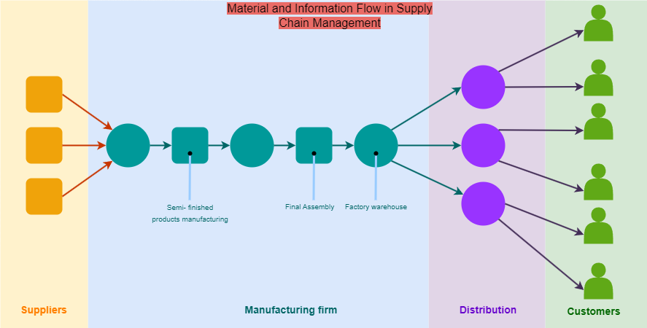
Figure 1. Supply Chain Management

SAIP architecture concept

The SAIP architecture aims to utilize Artificial Intelligence (AI) for tasks such as classification, predicting numerical values, grouping similar items, extracting relationship analysis, decision making, crop management, ranking, and planning. It contributes to the improvement of inventory management, demand forecasting, and other operational processes. Blockchain, on the other hand, targets real-time visibility, transparency, security, immutability, irreversibility, neutrality, and reliability for all stakeholders in the supply chain, leading to increased data quality. The recorded data at each step becomes immutable, ensuring data integrity. Blockchain also enables the implementation of security measures such as certificate verification, identity authentication, and authorization.
The SAIP architecture adopts a high-level architectural concept to enhance reliability and efficiency. It is designed in a modular and distributed structure, enabling scalability, performance, and resilience.

SAIP Artificial Intelligence

One of the most successful areas of collaboration between AI and SAIP is the identification and prioritization of activities related to inventory optimization and shortage management, followed by linking them to automated workflows that enhance supply chain resilience and responsiveness. These advanced technologies have shown significant success in breaking down decision-making silos between farmers, customers, and suppliers. The result is improved collaboration among these teams based on the priorities that matter, and automation of decisions where AI can accurately predict the correct response and outcome.
SAIP, through AI, will achieve inventory optimization by determining the optimal order policy and target inventory size, and then automatically prioritize actions that reduce excess inventory while maximizing production readiness. Purchase transactions are based on specific parameters such as lead time, order quantity, demand, and supply policy.
AI will assist in determining these levels by using an analytical approach based on historical data, future demand, supplier performance, and more. For instance, statistical analysis of safety stock can be performed to identify periods of insufficient or excessive inventory. This allows for an algorithmic and machine learning-based approach to inventory sizing that is often not feasible with traditional tools and spreadsheets.

The confidence scoring of procurement actions considers factors such as supplier on-time delivery, lead times, past recommendations, and other critical supply chain performance data. It evaluates each action and assesses the probability of its success. Many supply chain operations teams face the challenge of receiving a lot of information but struggling to prioritize critical actions that will have the greatest impact on operational performance. Confidence scoring cuts through the noise and empowers teams to make optimal business decisions.

SAIP Blockchain

Blockchain technology has the potential to revolutionize supply chain management by providing increased transparency, security, and efficiency. SAIP will leverage blockchain technology to enable real-time visibility and tracking of goods and products throughout the entire supply chain, from production to distribution and end consumers. This will help enhance transparency and trust among different parties within the supply chain. Product authentication will be used to verify the authenticity of products and prevent counterfeiting. SAIP will ensure secure and immutable records of the product's origin and movement throughout the supply chain. Blockchain will be used to track the quality of products as they move along the supply chain, enabling faster detection and removal of faulty products, reducing waste, and increasing customer satisfaction.
SAIP will utilize blockchain technology to facilitate supply chain finance, providing secure and transparent records of transactions between suppliers, manufacturers, and distributors. SAIP aims to implement smart contracts using blockchain technology, which are self-executing contracts with the terms of the agreement directly written in code. This automates the execution of the contract between the buyer and seller. It can be applied to automate and optimize supply chain processes, reducing costs and increasing efficiency.
Furthermore, SAIP will utilize blockchain to ensure compliance with regulatory requirements by providing a transparent and auditable record of supply chain processes. This helps mitigate compliance risks and associated penalties.
Overall, by leveraging blockchain technology, SAIP aims to transform supply chain management by enhancing transparency, security, efficiency, and compliance.

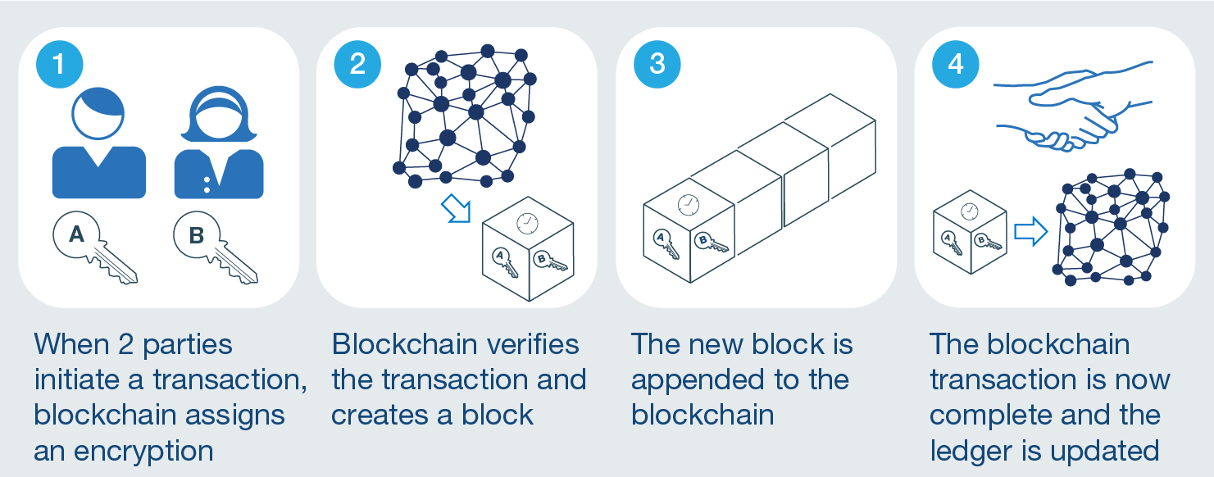
Figure 2. Supply Chains with Blockchain

SAIP UML

Unified Modeling Language (UML) is a standardized visual modeling language used for designing and documenting software systems. UML serves as a tool in object-oriented analysis, design, and application development processes. It provides various diagrams to define and visualize different aspects of a system.
UML encompasses a wide range of symbols and notations to model system requirements, business processes, components, classes, objects, relationships, behaviors, and other system elements. These symbols and notations are used as a communication tool among software development teams and facilitate the understanding of system design.
The main objectives of UML are as follows:
- Facilitating the understanding and analysis of system requirements.
- Visualizing system design and relationships among components.
- Modeling the behavior and processes of software.
- Representing different views of the software (e.g., structural, behavioral).
- Facilitating the documentation and communication of software.
UML provides various types of diagrams, including:
- Structural diagrams,
- Behavioral diagrams
These diagrams are used to model the system from different perspectives and to provide a comprehensive view of the system by bringing them together. The UML and diagram works within the SAIP project are as follows:

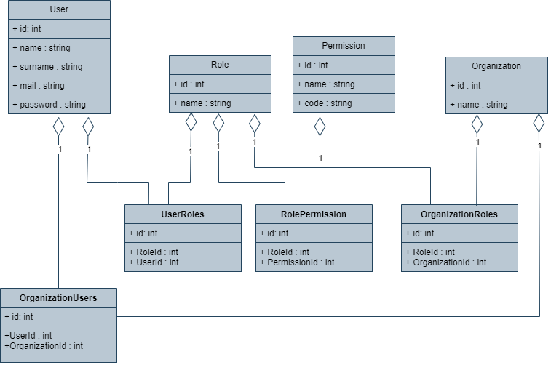
Figure 3. User Management Module UML Diagram

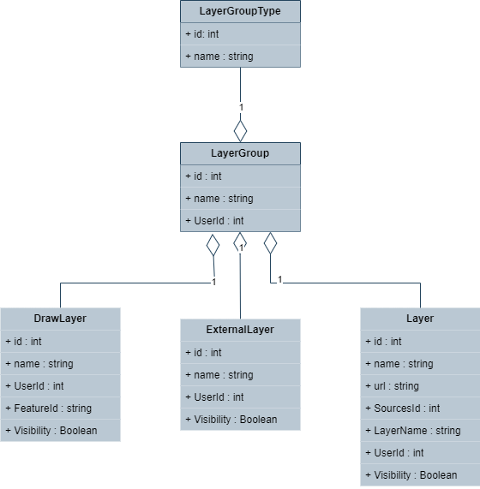
Figure 4. Map Module UML Diagram

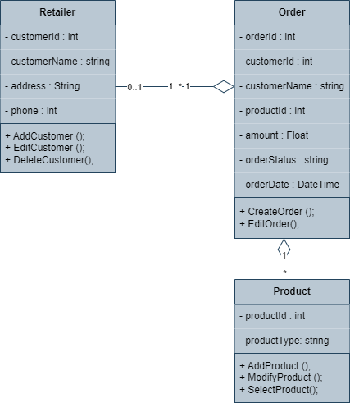
Figure 5.Order Management UML Diagram

SAIP Architecture use case scenarios

This section provides a detailed view of use cases and scenarios. The relevance level and applicability scenarios of these use cases are clear.

Overview of SAIP use cases

SAIP's business use cases are more abstract descriptions written in a technology-independent manner, referring only to the business process being described and the actors involved in the activity.
SAIP 's business use cases organize a sequence of actions that the business needs to perform in order to provide a meaningful and observable result.
SAIP 's system use cases are written in more detail than a business use case, referring to the specific processes that must occur in various parts of the system. SAIP's system use case diagram details functional specifications, including dependencies, necessary internal supporting features, and optional internal features.
When writing SAIP use cases, the design scope has been considered to identify all elements within and outside the boundaries of the processes.
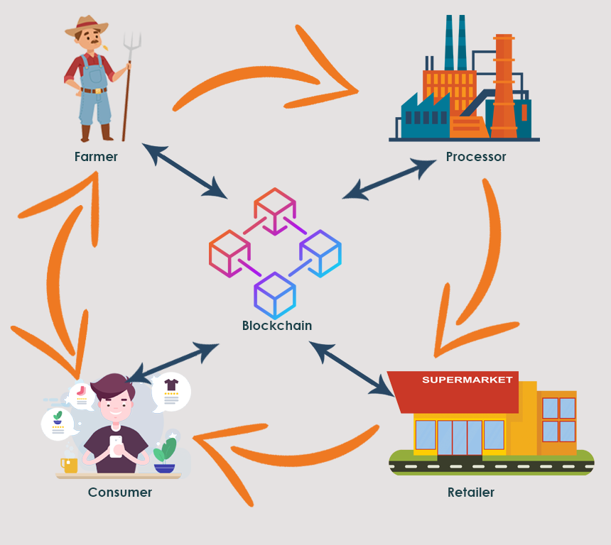
Figure 6. SAIP Use Case

Refinement on Scenarios

Roles of Stakeholders:
- Producer: - The producer is an organization that employs farmers or cultivators and is responsible for cultivation and harvesting.
- Processor: - This process involves various operations such as packaging and refining of products, and the processor is responsible for these processes.
- Retailer: - The retailer is responsible for marketing and selling food products and is typically represented by local stores or supermarkets.
- Consumer: The consumer is the end-user who consumes the food products.

- The farmer will enter the product type into the system.
- The farmer will enter the quantity of the harvested or to-be-harvested crop, as well as the planting and harvesting dates.
- A farmer card will be created, and the entered information will be included on this card.
- The retailer will create their buyer card. By entering the daily consumption quantity, they will teach the artificial intelligence (AI) the intervals within which they will need the product, and in the subsequent process, the AI will predict and show the buyer the expected quantity and date of the product needed.
- The buyer's company card will include a requirement list indicating the product needs between months.
- The farmer will be associated with the retailer based on the quantity of the product produced by the farmer and the product list required by the retailer.
- There will be a scoring system for farmers.
- Based on the farmer's rating, farmer reviews, product quality, and price, the retailer can place an order for the desired product with their preferred farmer.
- The processor will receive the product from the farmer and perform packaging and other processing operations.
- The processor will enter information about the packaging status of the product into the system.
- When the product is handed over to the courier, information about it being shipped will be entered into the system.
- A tracking number will be obtained for the shipment, enabling detailed order tracking.
- The user will be informed when the product is dispatched for delivery.
- Through Smart Contracts, the farmer and retailer will securely carry out the supply process.

Logical SAIP Architecture

Based on the SAIP architecture concept and SAIP functionality, the logical SAIP architecture is divided into the following components:
- SAIP Users
- SAIP Database
- Semantic definition (ontologies) for supply chain management
- Framework
- SAIP Gateway API Services
- Microservice architecture

Semantic definition (ontologies) for supply chain management

The platform will provide the following services:

SAIP Gateway API Services

SAIP Gateway API Services will provide the following support services for SAIP Gateway API:
- Monitoring and analysis of incoming requests.
- Collection of performance metrics, analysis of traffic, and debugging processes.
- Caching frequently requested data to provide quick responses to recurring requests.
- Improvement of service response times and reduction of network traffic.
- Security checks for incoming requests and prevention of malicious requests.
- Conversion of data formats for incoming requests or transmission to different server formats.
Please note that this translation may not be perfect, but it should give you a general understanding of the text.

SAIP Microservices Architecture

Microservices architecture is a structure where independent services work together and communicate with each other. Each service operates its own business logic independently and is not dependent on or interacts with another service, which supports the principle of sustainability and facilitates management. The independence of each service is evident in development and maintenance operations.

In this case, while the system continues to function as a whole, any disruption will only affect the relevant service. This allows for targeted repairs and enables quick testing without the need to rebuild or redeploy the entire application, as in monolithic architectures. As a result, new versions can be deployed rapidly by focusing on a specific service without impacting the entire system.

In SAIP microservices architecture, the following components will be present:

- User Management
- Map Module
- Report
- Artificial Intelligence
- Payment
- Order

Please note that this translation may not be perfect, but it should give you a general understanding of the text.

Authentication and Authorization in Microservice Architecture

In the microservice architecture, there are multiple services, which means that each request needs to be authenticated and authorized in some way before reaching each service or those services.

Authentication Gateway

In the API Gateway pattern, clients cannot directly access microservices, and the API Gateway serves as an entry point to properly and accurately route client requests to the microservices. As a central component through which all requests pass, the API Gateway can also take on the responsibility of security along with its other tasks.
We will implement authentication and authorization steps using a token mechanism. In this token structure, we will utilize JWT (JSON Web Token), which has been widely used recently, while also paying attention to important security considerations.

Artificial Intelligence Module

TensorFlow is an open-source software library used to create, train, and deploy deep learning and machine learning models. It leverages high-performance hardware such as GPUs and TPUs to perform fast computations on large datasets.

TensorFlow can be used in various areas within the Supply and Inventory Analytics Platform (SAIP) project, including demand forecasting, inventory management, and supply chain analytics. Additionally, the SAIP project aims to incorporate the usage of Keras. Keras is a high-level API that runs on top of TensorFlow, designed to make the usage of TensorFlow more user-friendly. It provides an interface for model creation, training, and evaluation. TensorFlow hosts Keras within itself, offering more flexibility and control when used together. While TensorFlow provides the underlying computational power, Keras provides a more user-friendly interface.

Demand forecasting is a crucial step in supply chain management to accurately predict future demand. Keras can assist in building machine learning models on historical sales data or other relevant data to predict future demand.

State of the Art

The research and development field is concerned with various topics in the supply chain, such as ontology, 3D visualization, high-performance computing, blockchain, smart contracts, AI-driven forecasting, and analytical processes. The SAIP project primarily focuses on the research and development of an open platform for the supply chain. This platform is based on the definition of processes from farm to table, a scalable computing platform, and data analytics processing. These three building blocks will enable effective access and visualization of multidimensional information, orchestration of different applications such as prediction, modeling, and analysis. SAIP will facilitate the transformation of agriculture into a data-driven, intelligent, agile, and autonomous network of interconnected systems. The operations of each agricultural process will be automatically integrated into the food chain through semantic active technologies, extending to the end consumer.
All these technologies provide engineering capabilities for agricultural data. The implementation of these techniques will address farmers' data, integrate new data repositories from external providers, convert data into knowledge, and feed decision support systems. The required sharing policies, serving as data transparency providers, will accelerate the processes of data ingestion and disposal.
Artificial intelligence techniques will contribute significantly to the identification of information models, service creation, and decision-making processes in agricultural applications.
With its concurrent planning capability, SAIP will ensure a situation where production is accurately planned to meet real demands, thanks to continuous data flow within the supply network. This state within an integrated digital supply network will assist in accurate planning, timely execution, and efficient resource utilization for all supply chain components. As a result, a more dynamic, flexible, and efficient feature emerges by combining traditional planning and execution.

Application technology stacks

Client-Side

Client-side development is concerned with the development of "dashboard" applications required by many use cases, with the assumption typically being that these applications would be either mobile native apps or web-based applications. This creates a wide range of technology stacks that can be utilized.
For each use case, an appropriate technology stack can be selected when there are clear requirements for runtime and visualization/dashboard applications.

Platform components

Conceptual platform

For the SAIP case study, each use case and its requirements are detailed, serving as the source for the architectural activities in this report. While the case studies are not identical, there is functional overlap and commonality among them, allowing for the creation of a reusable core platform that can be customized by each use case to meet their specific requirements.
Considering the extensive data collection, processing, and presentation requirements of the use case, it is important to consider the microservices architecture for the conceptual platform. This architecture is an approach to developing and deploying software applications. It involves breaking down the different functionalities of the application into independent services that can operate on their own.
Microservices architecture emerged as an alternative to monolithic architecture. In a monolithic architecture, all application components are combined into a single large application, whereas in microservices, each component operates as an independent service. Each microservice manages its own business logic and database, communicates with other services, and typically has lightweight and limited functionality.

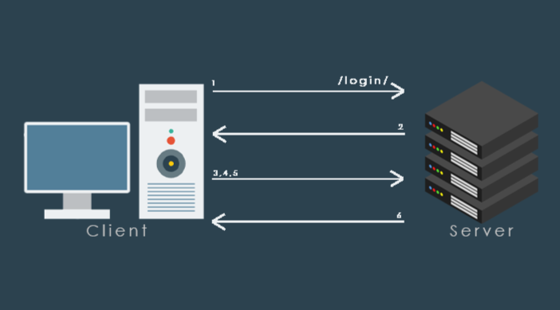
Figure 7. Microservices Architecture

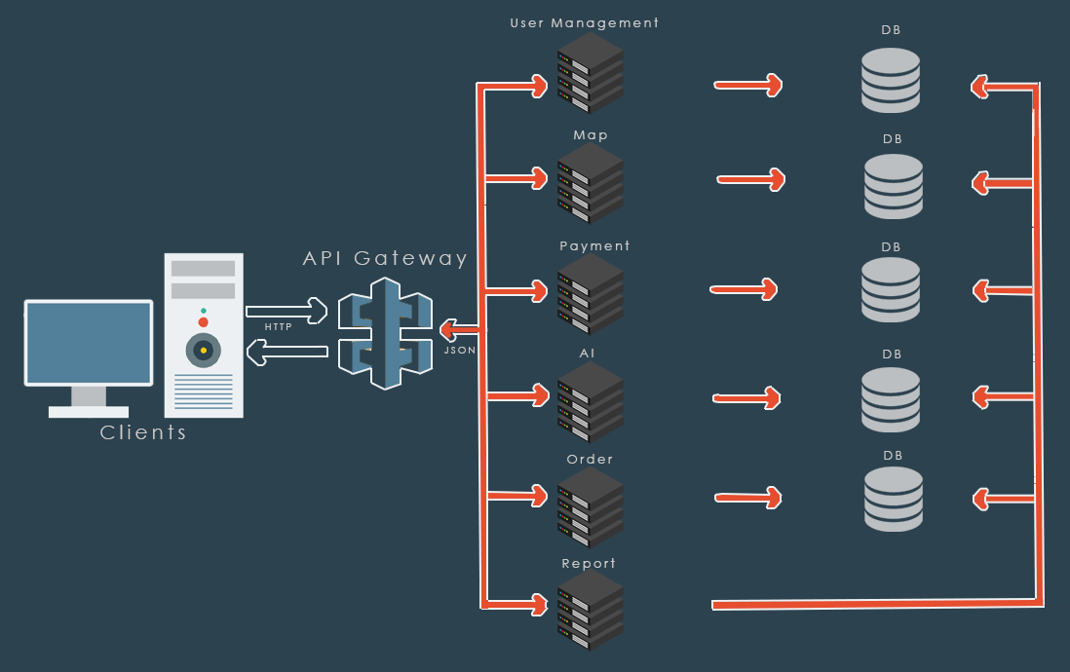
Figure 8. API Gateway
Within these conceptual architecture components, there are the following roles and responsibilities:
- Data collection
The role of the data collection component is to gather sensor data and prepare it for packaging into managed storage units. It is responsible for logging any issues encountered during data collection and validating incoming data whenever possible.

- Data management
Data management involves the storage and processing of data. It assumes that data will be managed in a repository where it can be created, retrieved, updated, and deleted according to system policies. Data management is also responsible for system-wide logging to record significant incidents during platform operation.

- Data processing
The data processing component is responsible for transforming data to provide meaningful insights that can be shared with users through the presentation server and client components, or sent to other systems via the data component.

- Presentation server and client
These two components facilitate client/server communication, enabling client applications running on remote hardware to interact with the server-based data and processing stack.

Information View

Data Storage

The PostgreSQL database management system will be used as the database for the map module. PostgreSQL offers a wide range of features to support complex data models, especially for storing and processing map data such as geographic data types, geometry, and geospatial functions. It provides advanced data processing capabilities including complex querying, indexing, foreign keys, functions, and more. This enables efficient storage and querying of large volumes of map data. PostgreSQL is an open-source database supported by a large community, allowing for quick bug fixes, addition of new features, and the development of a robust ecosystem. It supports the standard SQL language, ensuring compatibility and interoperability with other database systems. Additionally, it provides extensive support for integration with various programming languages and data analytics tools.

For the database to be used in the blockchain, the decision has been made to use CouchDB technology. Data is distributed across multiple servers, and database copies are synchronized to achieve high scalability. CouchDB utilizes a document-based database model, where each data record is stored as a document. This structure provides flexibility in storing and querying the complex structures of blockchain data. CouchDB supports JSON-based querying and indexing capabilities, allowing for flexible querying and indexing of complex blockchain data structures. Special indexes can be created to effectively filter and query data.

SAIP with Hyperledger Fabric

Hyperledger Fabric enables the creation of permissioned blockchain networks for supply chain applications. This means that only specific participants are granted access to the network. In SAIP, businesses typically work with specific partners and suppliers. Hyperledger Fabric will facilitate the creation of these private networks, ensuring privacy, security, and controlled data sharing.
Hyperledger Fabric has a flexible architecture, allowing businesses to customize and tailor their supply chain applications according to their needs. Components such as smart contracts and data modeling can be customized and configured to meet different business requirements.
As a high-performance and scalable blockchain platform, Hyperledger Fabric can achieve high transaction speeds through parallel processing and can scale as the number of network participants increases. This enables fast and efficient processing of large volumes of transactions in supply chain applications.
Data privacy is crucial in supply chain applications, and Hyperledger Fabric provides features for controlling access to specific data fields and regional data localization. This ensures the protection of sensitive business information and compliance with regulatory requirements.
SAIP, built on Hyperledger Fabric, provides a collaborative platform where all supply chain stakeholders can participate. Processors, farmers, suppliers, logistics providers, and customers can engage in transparent data sharing. This promotes traceability and transparency throughout the supply chain, enabling the identification of issues, reduction of errors, and improvement of overall efficiency.
For these reasons, Hyperledger Fabric is chosen for SAIP due to its features such as permissioned networks, flexibility, performance and scalability, data privacy, collaborative nature, and traceability. It equips businesses with the necessary tools and capabilities for secure and efficient supply chain management.

Conformity Analysis

In this section, SAIP's compliance with the set targets, standards and requirements will be evaluated.

Eligibility Criteria:
- Data Security: The project must have appropriate security measures in place to ensure the protection and confidentiality of user data.
- Performance: SAIP should be able to effectively process large datasets and provide high-performance computing capabilities.
- Scalability: The project should have a scalable architecture to handle increasing user numbers and data volumes.
- Compliance: SAIP should be developed in compliance with relevant national and international standards and regulations.
- Usability: By offering a user-friendly interface and ease of use, the project should provide an effective experience for its users.
Eligibility Assessment:
Data Security: SAIP is designed with a security architecture that follows industry standards for ensuring the security of user data. User data is protected through encryption, access control, and authorization mechanisms. Therefore, the project is considered fully eligible in terms of data security.
Performance: SAIP is capable of processing large datasets quickly by utilizing high-performance hardware and optimized computational algorithms. In tests conducted, the project has met the required performance requirements. Therefore, it is considered fully eligible in terms of performance.
Scalability: SAIP has a scalable architecture that can handle increasing user numbers and data volumes. The project's structural scalability means it can adapt to high user traffic and data size. Therefore, it is considered fully eligible in terms of scalability.
Compliance: SAIP has been developed in compliance with national and international standards and regulations. The project is designed to adhere to data protection, privacy, and other relevant regulations. Therefore, it is considered fully eligible in terms of compliance.
Usability: SAIP is designed to provide a user-friendly interface. Users can easily navigate the project, perform data analytics operations, and access results. Therefore, it is considered fully eligible in terms of usability.
Eligibility Analysis Results
The SAIP project fully complies with the defined objectives, standards, and requirements. It has been successfully evaluated in terms of data security, performance, scalability, compliance, and usability. However, future versions of the project will incorporate additional features and expansions to further enhance user experience and functionality.

Platform requirements & assumptions

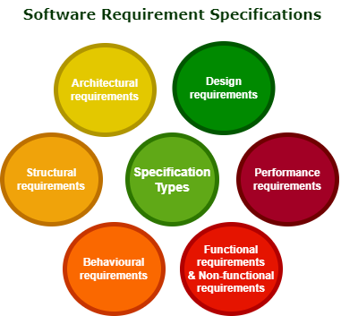
This section of the report examines the components of the platform in more detail in order to realize their requirements and
Figure 9. Software Requirement Specifications

Requirements Definitions

- Architectural requirements are the requirements that determine the design and structure of SAIP, and they influence the overall system performance, reliability, scalability, and sustainability. They explain what needs to be done by defining the necessary tones of the architectural system. Data requirements and data exchange requirements fall within this domain.
- Structural requirements are the requirements related to the organization, relationships, and structural properties of the components of SAIP.
- Behavioral requirements are the requirements that specify how the software should function, how users should interact with it, and how the system behavior should be. These requirements determine the functionality, responsiveness, and user experience of the software.
- Functional requirements are the requirements related to what functions the software should perform. These requirements involve defining specific functionalities such as fulfilling user requests, performing a specific task, or automating a process. They define the task, action, or activity.
- Non-functional requirements are the requirements related to the non-functional aspects of the software. These requirements define elements such as performance, reliability, usability, security, accessibility, and other quality attributes of the software.
- Performance requirements are the requirements related to the software meeting specific performance targets. Performance requirements define factors such as the speed of software operations, response time, efficiency level, and resource utilization.
- Design requirements in software refer to the requirements that define the overall architecture, components, and design of the software.

SAIP Requirements

- Data format compatibility will be ensured.
- Data collection, storage, analysis will be provided throughout the entire supply chain processes, including production, processing, distribution, and retail.
- It will be able to effectively process large amounts of data and perform complex calculations such as data analytics, prediction, and optimization.
- There will be transparent data sharing among farmers, suppliers, logistics providers, and customers, enabling traceability of products throughout the supply chain.
- Compliance requirements for data protection, privacy, and security will be met.
- SAIP will include flexibility and customization capabilities to meet different business requirements. It will be designed to be configurable according to user needs and adaptable to different business models.
- SAIP will provide a data preparation process that includes data preprocessing and cleaning steps for artificial intelligence applications. It will involve cleansing data from missing, incorrect, or irrelevant values and formatting it in the appropriate structure.
- Model training will include the learning process with the correct dataset and enable model optimization.
- SAIP will utilize data analytics and visualization techniques to analyze and visualize the results of artificial intelligence models.
- Map data will encompass supply chain components such as farms, warehouses, logistics routes, and delivery areas.
- The Map Module will integrate map data with other modules and support data sharing.
- Algorithms will be developed for data analysis and processing.
- Data integrity and accuracy will be ensured.
- Standard protocols will be used for data exchange. APIs will be defined and standardized for data sharing.
- It will have a modular architecture where independent components can be developed and modified separately. This enables better understanding, maintenance, and extensibility of the software.
- Security measures such as authentication, authorization, data encryption, and protection against attacks will be implemented.
- An interface will be designed for users to access the system, view data, generate reports, and adjust settings. This includes elements for user interaction such as buttons, forms, menus, or navigation elements.
- Compatibility will be ensured with various operating systems, platforms, browsers, or other software components.
- Elements such as updates, debugging, logging, monitoring, and performance optimization will be provided.
- Structures will be established for organizing and routing functions and components. This may include control flow, loops, conditional statements, threads, or event-driven programming.
- User management will be implemented.
- User roles and authorizations will be assigned.
- Users will be able to perform operations such as authentication, password reset, and log out.
- Users can generate reports and perform analysis for specific data or operations. This may include data charts, statistics, or summaries.
- Users can query or search specific data.
- Supply process data will be presented with interactive visual elements such as graphs, tables, or maps. Users can easily access the data, apply filters, and visualize it in different views.
- Calculation and prediction processes will be performed quickly.
- Measures will be taken to prevent data loss in system crashes.
- The system will have the ability to automatically send emails or notifications to users.
- Multi-language support will be provided.

Conclusions

In conclusion, this architectural design document presents the initial version of the conceptual design and high-level architecture of the SAIP platform. The design incorporates features of blockchain and microservices architecture, customized user requirements, strategic analytics tools, and use case studies to include real-time functionalities.
The document identifies all architectural components and explains how they are integrated with their inputs and outputs. It defines areas where existing technologies will be integrated into the solution and lays the foundation for a highly flexible, modular, and scalable platform.
The proposed initial architectural design will be updated as needed in the project's progress. The primary goal is to provide an integrated framework that addresses interaction issues in different environments and use cases.
The architecture will be developed iteratively and incrementally, with each iteration involving the analysis, implementation, and testing of specific components. This technical document will be continuously updated throughout the project duration.
Overall, the architectural design document lays the foundation for adaptability, scalability, and compatibility in the development of the SAIP platform. It serves as a guiding roadmap for realizing the envisioned system.

