StockMarket_Forecasting.R
Luis Cuevas
2026-02-27
# Package names
packages <- c("forecast","quantmod","tseries","timeSeries","xts")
# Install packages not yet installed
installed_packages <- packages %in% rownames(installed.packages())
if (any(installed_packages == FALSE)) {
install.packages(packages[!installed_packages])
}
# Packages loading
invisible(lapply(packages, library, character.only = TRUE))
## Loading required package: xts
## Loading required package: zoo
##
## Attaching package: 'zoo'
## The following objects are masked from 'package:base':
##
## as.Date, as.Date.numeric
## Loading required package: TTR
## Registered S3 method overwritten by 'quantmod':
## method from
## as.zoo.data.frame zoo
## Loading required package: timeDate
##
## Attaching package: 'timeSeries'
## The following object is masked from 'package:zoo':
##
## time<-
## The following objects are masked from 'package:graphics':
##
## lines, points
library("forecast")
library("quantmod")
library("tseries")
library("timeSeries")
library("xts")
# Declare Variables that allows choosing a stock
# symbol and start/end dates of downloaded history
NameOfStock = 'MSFT'
StartDate = '2020-01-01'
EndDate = '2020-12-31'
# Pull data from Yahoo finance and display it
Stock_Data = getSymbols(c(NameOfStock), src="yahoo", from=StartDate,
to=EndDate,auto.assign = FALSE)
summary(Stock_Data)
## Index MSFT.Open MSFT.High MSFT.Low
## Min. :2020-01-02 Min. :137.0 Min. :140.6 Min. :132.5
## 1st Qu.:2020-04-01 1st Qu.:174.2 1st Qu.:175.5 1st Qu.:170.9
## Median :2020-07-01 Median :200.2 Median :203.8 Median :197.6
## Mean :2020-07-01 Mean :192.8 Mean :195.4 Mean :190.3
## 3rd Qu.:2020-09-30 3rd Qu.:212.6 3rd Qu.:214.8 3rd Qu.:210.1
## Max. :2020-12-30 Max. :229.3 Max. :232.9 Max. :227.4
## MSFT.Close MSFT.Volume MSFT.Adjusted
## Min. :135.4 Min. :10550600 Min. :128.6
## 1st Qu.:174.3 1st Qu.:26264075 1st Qu.:165.3
## Median :201.6 Median :32804850 Median :192.0
## Mean :192.9 Mean :37725932 Mean :183.8
## 3rd Qu.:212.6 3rd Qu.:43915500 3rd Qu.:202.8
## Max. :231.6 Max. :97012700 Max. :221.2
# Omit all NA records and Display the Data
Stock_Data = na.omit(Stock_Data)
summary(Stock_Data)
## Index MSFT.Open MSFT.High MSFT.Low
## Min. :2020-01-02 Min. :137.0 Min. :140.6 Min. :132.5
## 1st Qu.:2020-04-01 1st Qu.:174.2 1st Qu.:175.5 1st Qu.:170.9
## Median :2020-07-01 Median :200.2 Median :203.8 Median :197.6
## Mean :2020-07-01 Mean :192.8 Mean :195.4 Mean :190.3
## 3rd Qu.:2020-09-30 3rd Qu.:212.6 3rd Qu.:214.8 3rd Qu.:210.1
## Max. :2020-12-30 Max. :229.3 Max. :232.9 Max. :227.4
## MSFT.Close MSFT.Volume MSFT.Adjusted
## Min. :135.4 Min. :10550600 Min. :128.6
## 1st Qu.:174.3 1st Qu.:26264075 1st Qu.:165.3
## Median :201.6 Median :32804850 Median :192.0
## Mean :192.9 Mean :37725932 Mean :183.8
## 3rd Qu.:212.6 3rd Qu.:43915500 3rd Qu.:202.8
## Max. :231.6 Max. :97012700 Max. :221.2
# Plot Chart time series
barChart(Stock_Data, theme="black", name=c(NameOfStock))
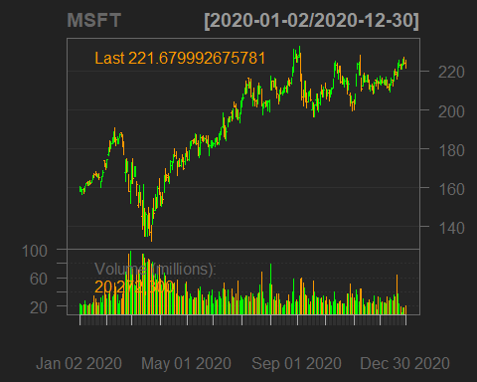
# Select the relevant close price series and display data
close_price = Stock_Data[,4]
summary(close_price)
## Index MSFT.Close
## Min. :2020-01-02 Min. :135.4
## 1st Qu.:2020-04-01 1st Qu.:174.3
## Median :2020-07-01 Median :201.6
## Mean :2020-07-01 Mean :192.9
## 3rd Qu.:2020-09-30 3rd Qu.:212.6
## Max. :2020-12-30 Max. :231.6
# ARIMA Model
# Decomposition is the foundation for building the ARIMA
# model by providing insight towards the changes in stock
# fluctuations. For more analysis, decompose the data
# into seasonal, and trend components and plot result
Stock_Data.ts = ts(close_price, start=2020-01-02, frequency=120)
Stock_Data.de = decompose(Stock_Data.ts)
# Plot decomposed data
plot(Stock_Data.de)
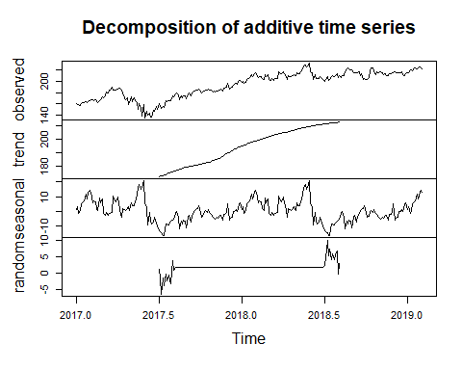
# To smoothen the data and stabilize variance, calculate the
# logarithmic returns and the square root values from the prices.
par(mfrow=c(1,1))
# Compute the log returns for the stock
close_price_log = log(close_price)
plot(close_price_log, type='l', xlab='Time', ylab='Log(close_price)',
main='Logarithmic Close Price Returns')
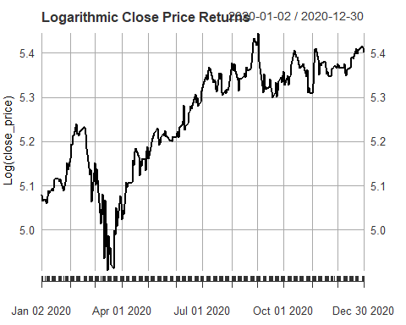
# Compute the sqrt returns for the stock
close_price_sqrt = sqrt(close_price)
plot(close_price_sqrt,type='l', xlab='Time', ylab='Sqrt(close_price)',
main='Square Root of Close Price Returns')
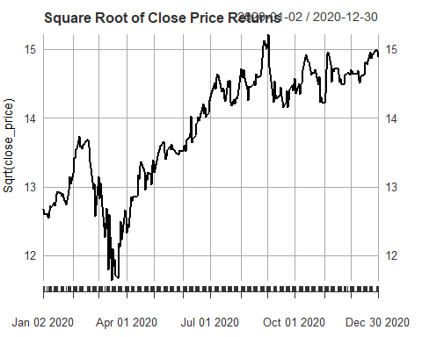
# A time series is stationary when its statistical properties such as
# mean, variance, autocorrelation, etc. are all constant over time.
# Stationarizing a time series through differencing (where needed)
# is an important part of the process of fitting an ARIMA model.
# Compute the difference of log returns for the stock and plot log returns
close_price_log_diff = diff(log(close_price),lag=1)
close_price_log_diff= close_price_log_diff[!is.na(close_price_log_diff)]
# Plot log returns
plot(close_price_log_diff,type='l', xlab='Time', ylab='Log(close_price)',
main='Difference of Log Close Price Returns')
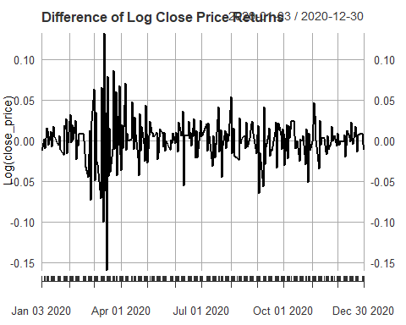
# Compute the square root of returns for the stock and plot sqrt returns
close_price_sqrt_diff = diff(sqrt(close_price),lag=1)
close_price_sqrt_diff = close_price_sqrt_diff[!is.na(close_price_sqrt_diff)]
# Plot sqrt returns
plot(close_price_sqrt_diff,type='l', xlab='Time', ylab='Sqrt(close_price)',
main='Difference of Square Root Close Price Returns')
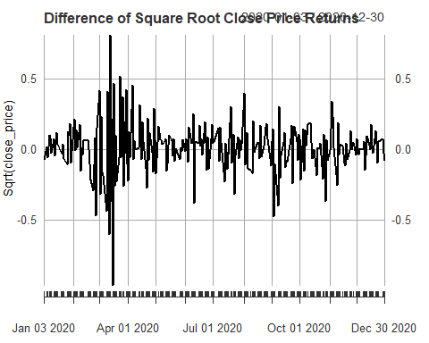
# Conduct Augmented Dickey Fuller (ADF) Test on log returns series
# to confirm that the stationarity of data to fit an ARIMA model
print(adf.test(close_price_log))
##
## Augmented Dickey-Fuller Test
##
## data: close_price_log
## Dickey-Fuller = -2.2071, Lag order = 6, p-value = 0.4886
## alternative hypothesis: stationary
print(adf.test(close_price_sqrt))
##
## Augmented Dickey-Fuller Test
##
## data: close_price_sqrt
## Dickey-Fuller = -2.2293, Lag order = 6, p-value = 0.4792
## alternative hypothesis: stationary
print(adf.test(close_price_log_diff))
## Warning in adf.test(close_price_log_diff): p-value smaller than printed p-value
##
## Augmented Dickey-Fuller Test
##
## data: close_price_log_diff
## Dickey-Fuller = -5.8286, Lag order = 6, p-value = 0.01
## alternative hypothesis: stationary
print(adf.test(close_price_sqrt_diff))
## Warning in adf.test(close_price_sqrt_diff): p-value smaller than printed
## p-value
##
## Augmented Dickey-Fuller Test
##
## data: close_price_sqrt_diff
## Dickey-Fuller = -6.0295, Lag order = 6, p-value = 0.01
## alternative hypothesis: stationary
# Apply the AutoCorrelation Function (ACF) and the Partial
# AutoCorrelation Function (PACF) to prepare data for the ARIMA model
par(mfrow = c(1,2))
acf.stock = acf(close_price_log , main='ACF Plot', lag.max=100)
pacf.stock = pacf(close_price_log , main='PACF Plot', lag.max=100)
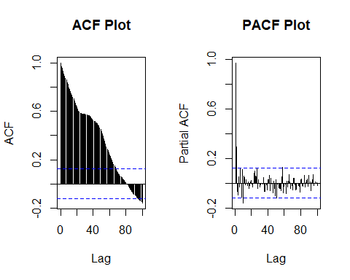
par(mfrow = c(1,2))
acf.stock = acf(close_price_sqrt, main='ACF Plot', lag.max=100)
pacf.stock = pacf(close_price_sqrt , main='PACF Plot', lag.max=100)
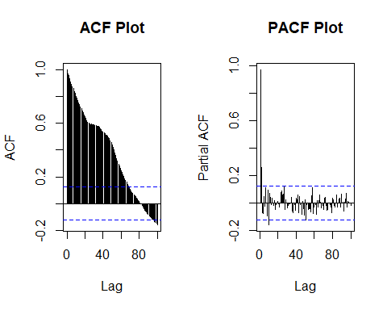
# Programming A Fitted Forecast
# Initialize real log returns via xts
realreturn = xts(0, as.Date("2020-11-25", "%Y-%m-%d"))
# Initialize forecasted returns via dataframe
Forecastreturn = data.frame(Forcasted = numeric())
# Split the dataset in two parts - training and testing
split = floor(nrow(close_price_log_diff)*(2.9/3))
# To compute a working model, loop to forecast returns for each data
# point, and return a time series for both real and forecast values:
for (s in split:(nrow(close_price_log_diff)-1)) {
stock_train = close_price_log_diff[1:s, ]
stock_test = close_price_log_diff[(s+1):nrow(close_price_log_diff), ]
# Summary of the ARIMA model using the determined (p,d,q) parameters
fit = arima(stock_train, order = c(2, 0, 2),include.mean=FALSE)
summary(fit)
# Forecasting the log returns
arima.forecast = forecast(fit, h = 1,level=99)
summary(arima.forecast)
Box.test(fit$residuals, lag=1, type = 'Ljung-Box')
# Creating a series of forecasted returns for the forecasted period
Forecastreturn = rbind(Forecastreturn,arima.forecast$mean[1])
colnames(Forecastreturn) = c("Forecasted")
Actual_series = close_price_log_diff[(s+1),]
realreturn = c(realreturn,xts(Actual_series))
rm(Actual_series)
}
# plotting am ACF plot of the residuals
acf(fit$residuals,main="Residuals plot")
# plotting the forecast
par(mfrow=c(1,1))
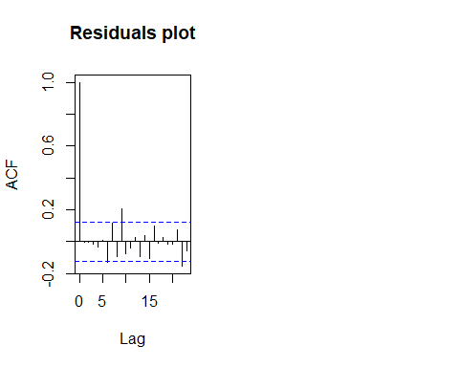
plot(arima.forecast, main = "ARIMA Forecast")
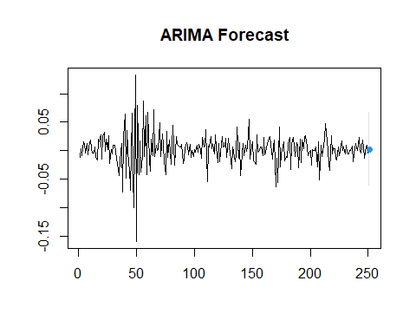
# Visualizing the Model Results
# Adjust the length of the Actual return series
realreturn = realreturn[-1]
# Create a time series object of the forecasted series
Forecastreturn = xts(Forecastreturn,index(realreturn))
# Function to add Actual and Forecasted at the same time
PlotBoth<-function(){
# Create a plot of the two return series - Actual versus Forecasted
plot(realreturn, type='l', main='Actual(Black) vs Forecasted(Red)')
# Add a line
lines(Forecastreturn, lwd=2, col='red')
}
PlotBoth()
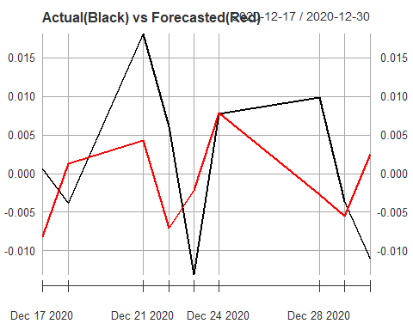
# Create a plot of the two return series - Actual versus Forecasted
plot(realreturn,type='l',main='Actual Returns Vs Forecasted Returns')
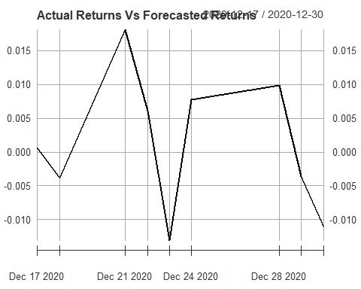
lines(Forecastreturn,lwd=1.5,col='red')
legend('bottomright',c("Actual","Forecasted"),lty=c(1,1),
lwd=c(1.5,1.5),col=c('black','red'))
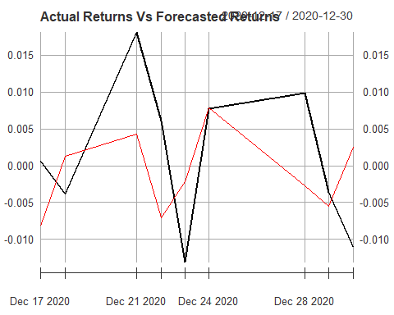
# Validating the Model Results
# Create a table for the accuracy of the forecast
realreturn
## [,1]
## 2020-12-17 0.0006382466
## 2020-12-18 -0.0037898808
## 2020-12-21 0.0181336855
## 2020-12-22 0.0060466720
## 2020-12-23 -0.0131249552
## 2020-12-24 0.0077968519
## 2020-12-28 0.0098725721
## 2020-12-29 -0.0036071951
## 2020-12-30 -0.0110805759
Forecastreturn
## Forecasted
## 2020-12-17 -0.008166631
## 2020-12-18 0.001327311
## 2020-12-21 0.004338779
## 2020-12-22 -0.007074568
## 2020-12-23 -0.002134137
## 2020-12-24 0.007853356
## 2020-12-28 -0.002740095
## 2020-12-29 -0.005499120
## 2020-12-30 0.002536904
comparsion = merge(realreturn,Forecastreturn)
comparsion$Accuracy = sign(comparsion$realreturn)==sign(comparsion$Forecasted)
print(comparsion)
## realreturn Forecasted Accuracy
## 2020-12-17 0.0006382466 -0.008166631 0
## 2020-12-18 -0.0037898808 0.001327311 0
## 2020-12-21 0.0181336855 0.004338779 1
## 2020-12-22 0.0060466720 -0.007074568 0
## 2020-12-23 -0.0131249552 -0.002134137 1
## 2020-12-24 0.0077968519 0.007853356 1
## 2020-12-28 0.0098725721 -0.002740095 0
## 2020-12-29 -0.0036071951 -0.005499120 1
## 2020-12-30 -0.0110805759 0.002536904 0
# Compute the accuracy percentage metric
Accuracy_percentage = sum(comparsion$Accuracy == 1)*100/length(comparsion$Accuracy)
print(Accuracy_percentage)
## [1] 44.44444

