Hybrid approach to teaching digital game development and programming
Luis Eduardo Reis
Dissertation made under the guidance of Prof. António Coelho
At Faculdade de Engenharia da Universidade do Porto

Motivação

The current perspective is that there is not a significant investment in teaching programming since high school and that it is desirable to promote the acquisition of such skills even before university.

It is notable, for instance, that a significant percentage of students admitted into MIEIC never had contact with programming activities.

Programming is also not only useful in the field of engineering. There are other areas that benefit and depend on introductory material to programming. For instance, the cases of Design and Multimedia courses.
These areas in particular benefit a lot from a digital game based approach, especially because in several courses a game development curricular unit is common.

Objectives
In essence, the goals of this project were:
- To define a hybrid introductory program to game development and programming.
- Develop a set of PBL activities to give a body to this program.
- Implement the set of contents needed to some of the defined activities.
- Validate the work with a set of experts.

Work Description

Structure
The document is composed of 6 chapters including the introduction.
- On chapter 2 the state of the art for the project’s context is introduced.
- On chapter 3 the learning method used, the planning of the developed contents and the activity plan are covered.
- On chapter 4 the set of contents of the work are described.
- On chapter 5 the topic of validation with experts is covered.
- On chapter 6 one can find the conclusions for this work.

Learning Method
This work deals with the development of a hybrid learning method for the teaching of Programming and Digital Game Development. The solution found for this was a PBL based approach in which the study plan was divided into problems that coincide with the development of small games. It was had as a goal during the development that this plan was adaptable to self-learning processes (e-learning).

Content Planning
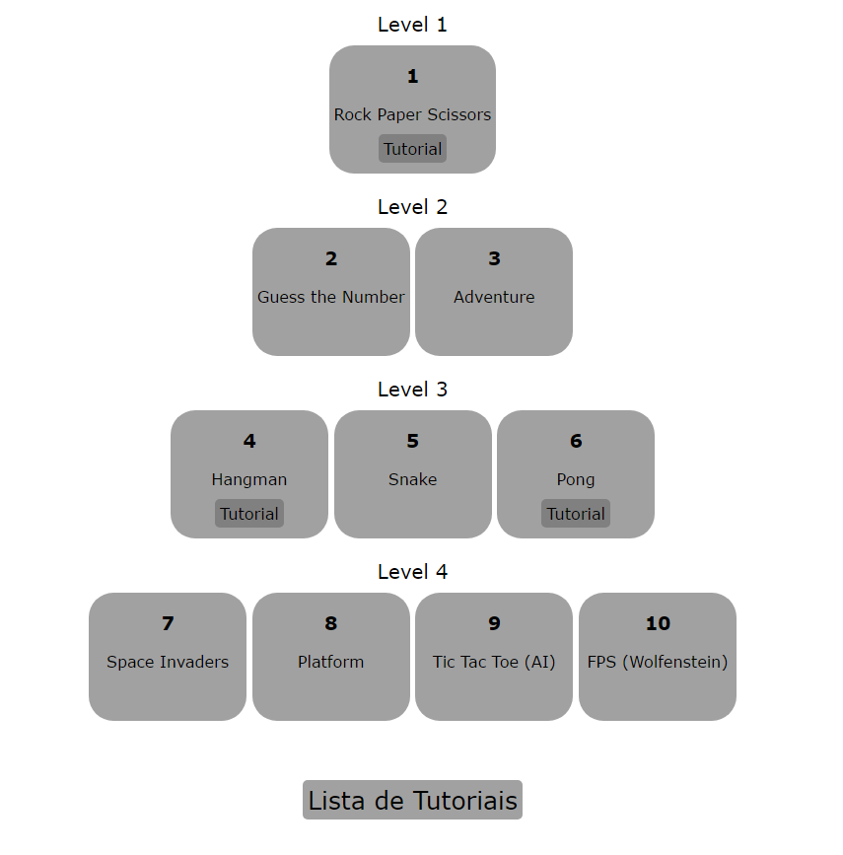Fig. 1 – Estrutura do plano de estudos desenvolvido.
The development of the study plan for this work had the following steps:
- Enumeration of a set of topics that the plan should approach, that is, all the needed concepts for an introductory course to programming and games.
- Choice of a set of short and appealing problems that approached these topics.
- Choice of a language and technology to use for the plan. In this case javascript and the graphical library p5.js were used.
- Development of an evaluation framework that allowed to assess each problem. A scale based on Bloom’s taxonomy was used.
- Creating of a non-linear activity plan based on 10 games divided into levels.

Validation
For validation purposes an analysis by experts was made, in this case, teachers of introduction to programming curricular units.
This analysis was made through an inquiry divided into two parts: An interview and an online survey sent by email.

Conclusions
It is considered that all the objectives of the work were achieved. Based on the validation made, the following results were observed:
- There is as consensus that the concept of an hybrid plan following a PBL methodology has its benefits both for informatics courses as for other areas.
- The list of topics of the study plan was received as complete.
- There was a general acceptance for the evaluation method and activity organization.
- The example tutorials were well received but several suggestions of improvement were made.

