<Preparation of Project/Dissertation Abstracts, MIEIC/FEUP, Year 2007/08, to be replaced by the project title>
<Student Name>
Project/Dissertation developed under supervising of <Prof. Name>
in <Institution Name>

Motivation
<...>

Main Goals
- <...>
- <...>
- <...>

Work Description
<...>

Subsection
<...>

Subsection
<...>

Subsection
<...>

Margins Dimensions
The margins are shown in Tab. 1.
Tab. 1 - Margins expressed in centimetres.
 | Measure
Top Margin | 3 cm
Bttom Margin | 3 cm
Left Margin | 3 cm
Right Margin | 3 cm
Between Columns | 1.2 cm

Text Body
See this subsection in the Portuguese document.

Subsection
<...>

Figures, Tables and Equations
Figures and tables must be centred, wherever possible, to its text column (Tab. 1 and Fig. 1). Whether their dimensions do not permit it, they must be centred to the page width.
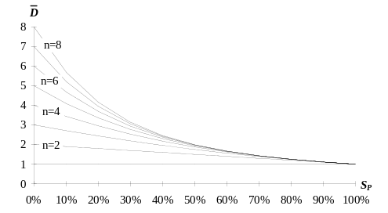
Fig. 1 - This legend is written with a font with size 9 and is centred to the column.
<...>
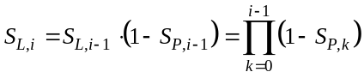 ()
Style of equations can be seen in equation ().

Pages Numbering
Pages must NOT be numbered.

MS Word Styles
<...>
Tab. 2 - MS Word Styles.
Título | Estagiário | Instituição
Orientadores | Normal | Heading 1
Heading 2 | Fig.Imagem | Fig.Legenda
Tabela.Legenda | Tabela.Células | Eq.

Conclusions
<...>

