Stochastic process:
- “[…] collection of random variables that evolve over time or space.”
- “[…] describes a system that changes unpredictably due to randomness.”
Diffusion process: type of stochastic process
- “Describes how a quantity evolves over timer under influence of both deterministic trends and random noise.”
Itô Equation: stochastic differential equation (SDE)
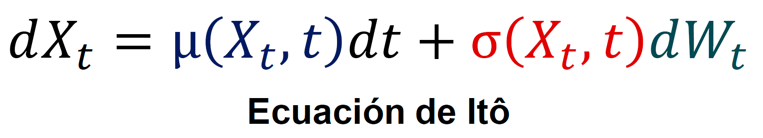
$μ$: deterministic trend
$σ$: controls the randomness

Wiener process $W_{t}$
It must satisfy 4 conditions.
The most interesting property (normally distributed increments)
$$dW_{t}\sim N\left(0,dt\right)$$
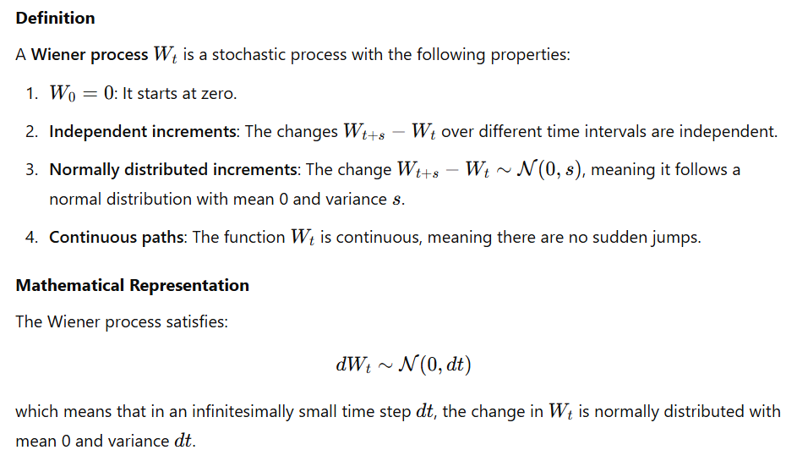

Adding noise
Deterministic part and stochastic part
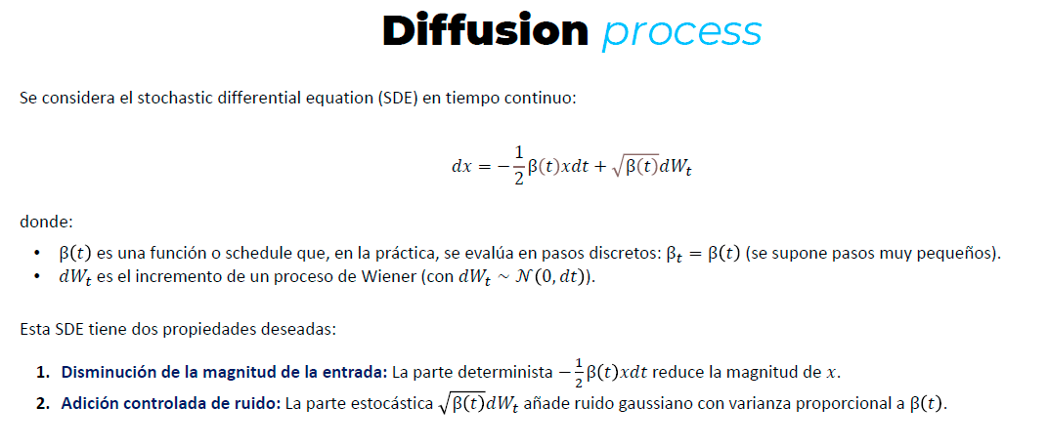

$$x_{t+1}=\sqrt{1-β_{t}}x_{t}+\sqrt{β_{t}}z_{t}$$
$$z_{t} \sim N\left(0,I\right)$$
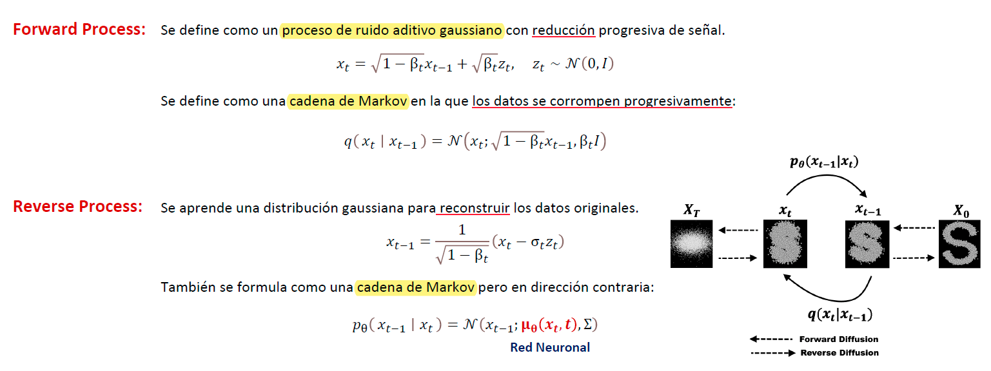

$p_{θ}\left(x_{t-1}|x_{t}\right)$: distribution modeled by the network.
$q\left(x_{t}|x_{t-1}\right)$: real inverse distribution (retrieved by the forward pass).
Training: minimize KL between these distributions.

Denoising Diffusion Probabilistic Models (DDPM)
Predict the noise $ϵ$ in $x_{t}$.
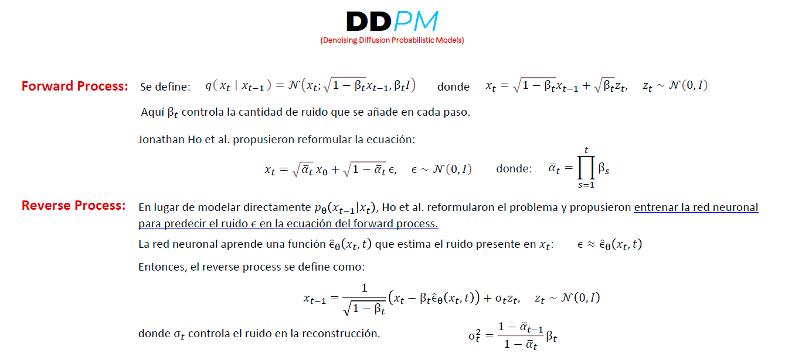

DALL-E

Latent diffusion

