**GANs**

Generative Adversarial Network

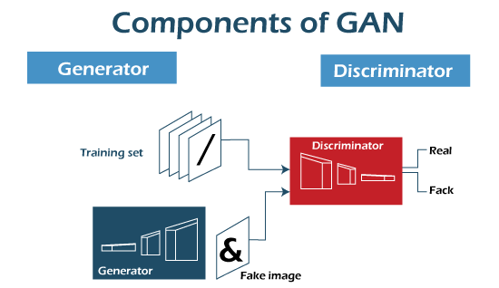

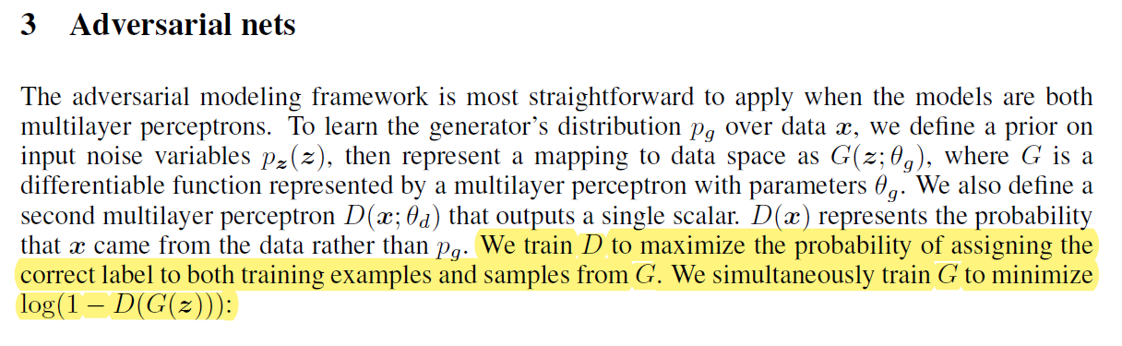

Two-player minimax

* To train **D**, we need to maximize the probability of assigning the correct label to both training examples $x\sim p_{data}$ and samples from $G$ $G\left(z\right), z\sim p_{z}.$
* To train **G**, we need to minimize $\log\left(1-D\left(G\left(z\right)\right)\right)$.

$$\min_{G}{\max_{D}{E_{x\sim p_{data}}\left[\log{D\left(x\right)}\right]+E_{z\sim p_{z}}\left[\log\left(1-D\left(G\left(z\right)\right)\right)\right]}}$$

Therefore, the following loss functions are defined:

$$L_{D}=-E_{x\sim p_{data}}\left[\log{D\left(x\right)}\right]-E_{z\sim p_{z}}\left[\log\left(1-D\left(G\left(z\right)\right)\right)\right]$$

$$L_{G}=E_{z\sim p_{z}}\left[\log\left(1-D\left(G\left(z\right)\right)\right)\right]≈-E_{z\sim p_{z}}\left[\log{D\left(G\left(z\right)\right)}\right]$$

Jensen Shannon Divergence

Symmetrized

Pseudocode done.

**Conditional GAN**

Context $y$

**Cycle GAN**

Write pseudocode

2 generators and 2 discriminators

A to B, B to A

**Wasserstein GAN**

It uses Wasserstein Distance instead of Jensen-Shannon Divergence. More stable and better properties.

Wasserstein Distance:

“It's a metric that measures how much "mass" from one probability distribution needs to be moved to transform it into another, while minimizing the transportation cost.”

Find 1-Lipschitz (bounded slopes $→$ stabilization)

Weight Clipping

Discriminator weights are limited [-c, c]

**Style GAN**

Introduces Mapping Network (maps noise z to intermediate latent space W)

"AdaIN" (Adaptive Instance Normalization) injects style information into each layer. Controls details.

Backbone network: sort latent space