Probability distribution:

* Mathematical function that gives the probabilities of occurrence of possible outcomes for an experiment.
* It specifies the likelihood of each possible outcome of a random variable.

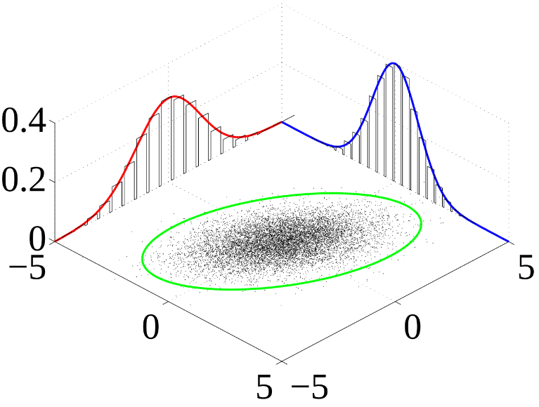

Joint probability distribution: probability distribution of all possible pairs of outputs of two random variables that are defined in the same probability space.

Variational inference: approximate the intractable posterior with another distribution .

Learn the parameters using optimization.

Reverse KL to measure their similarity

Log evidence

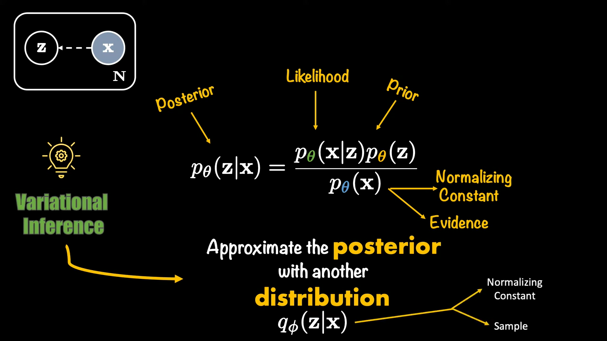 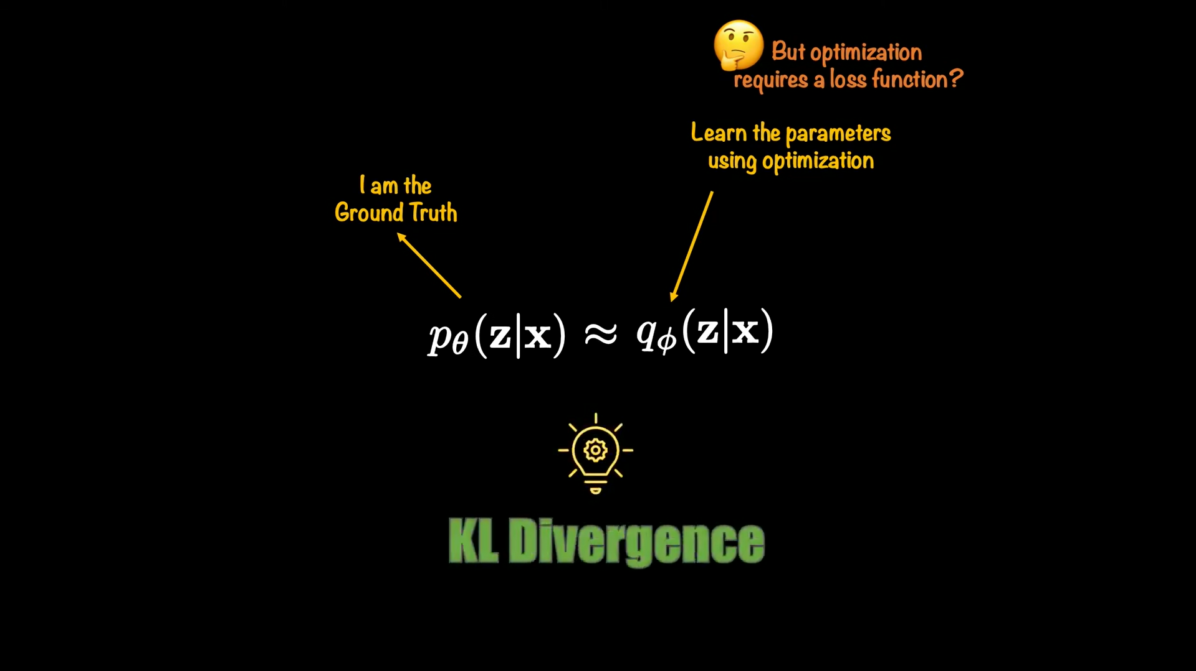

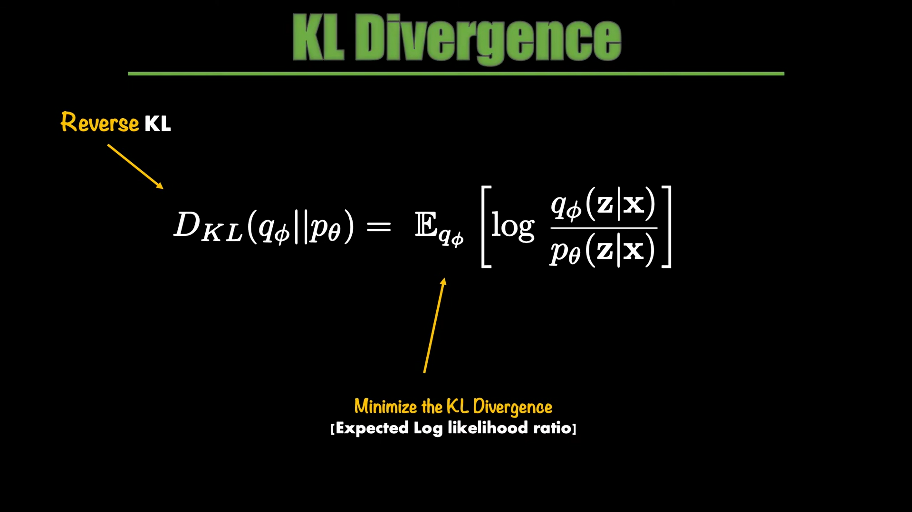 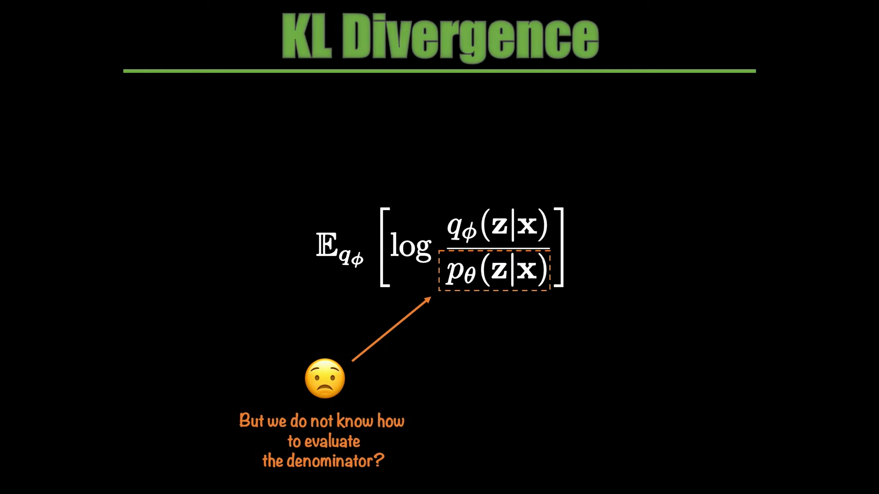

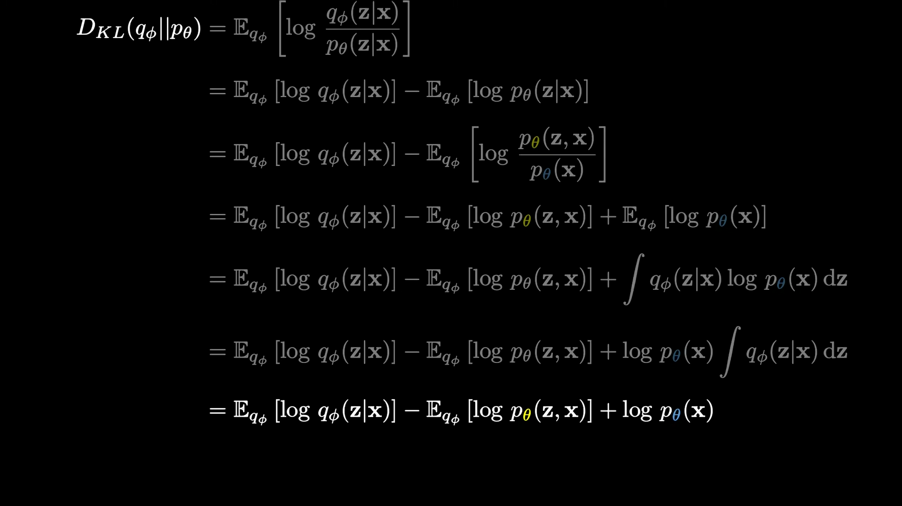 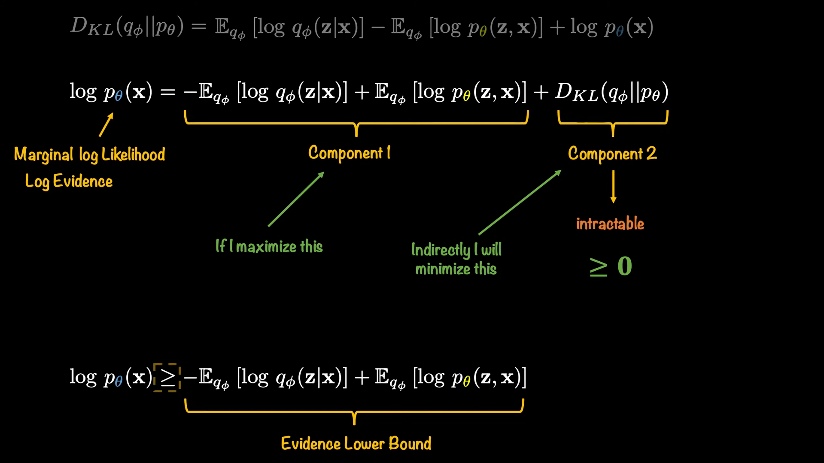

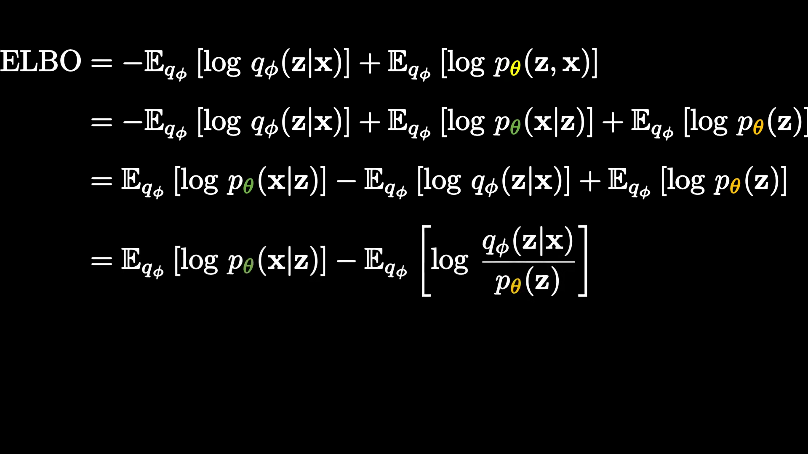 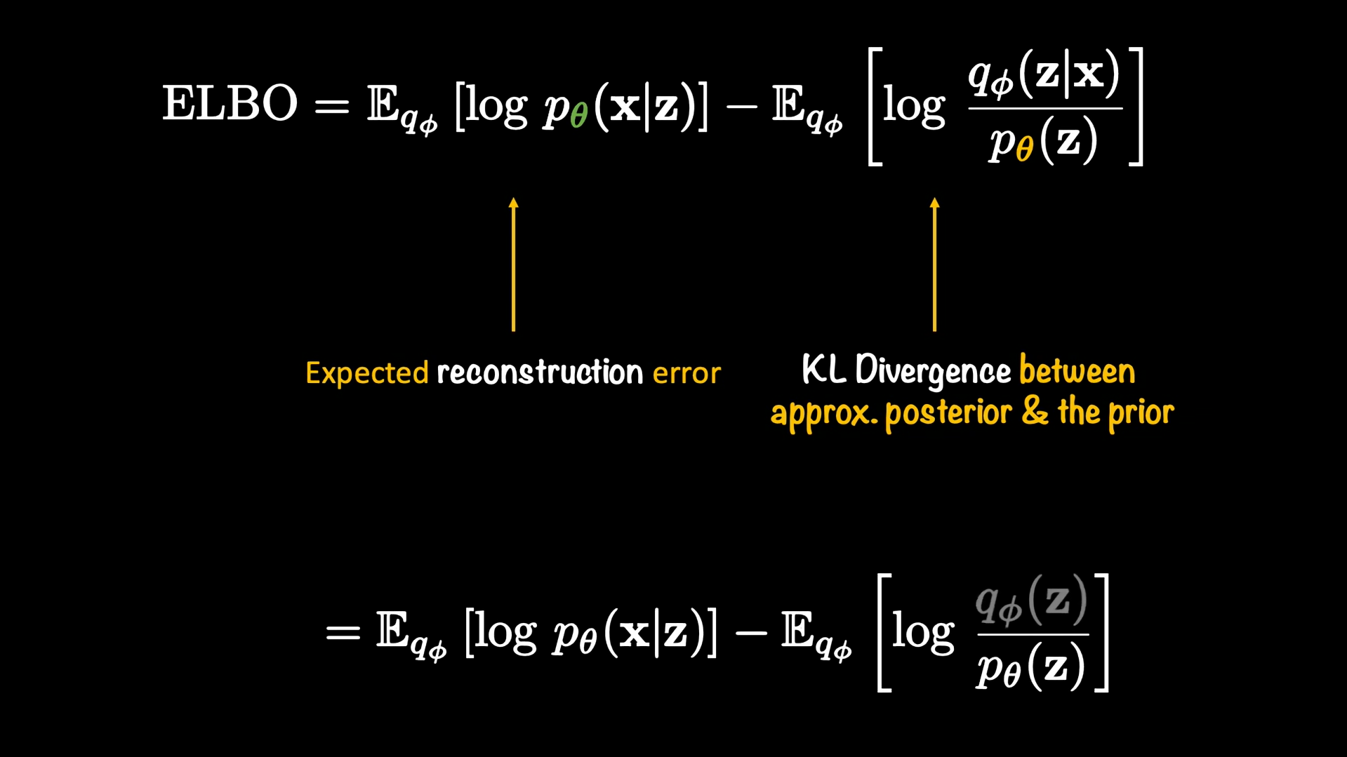

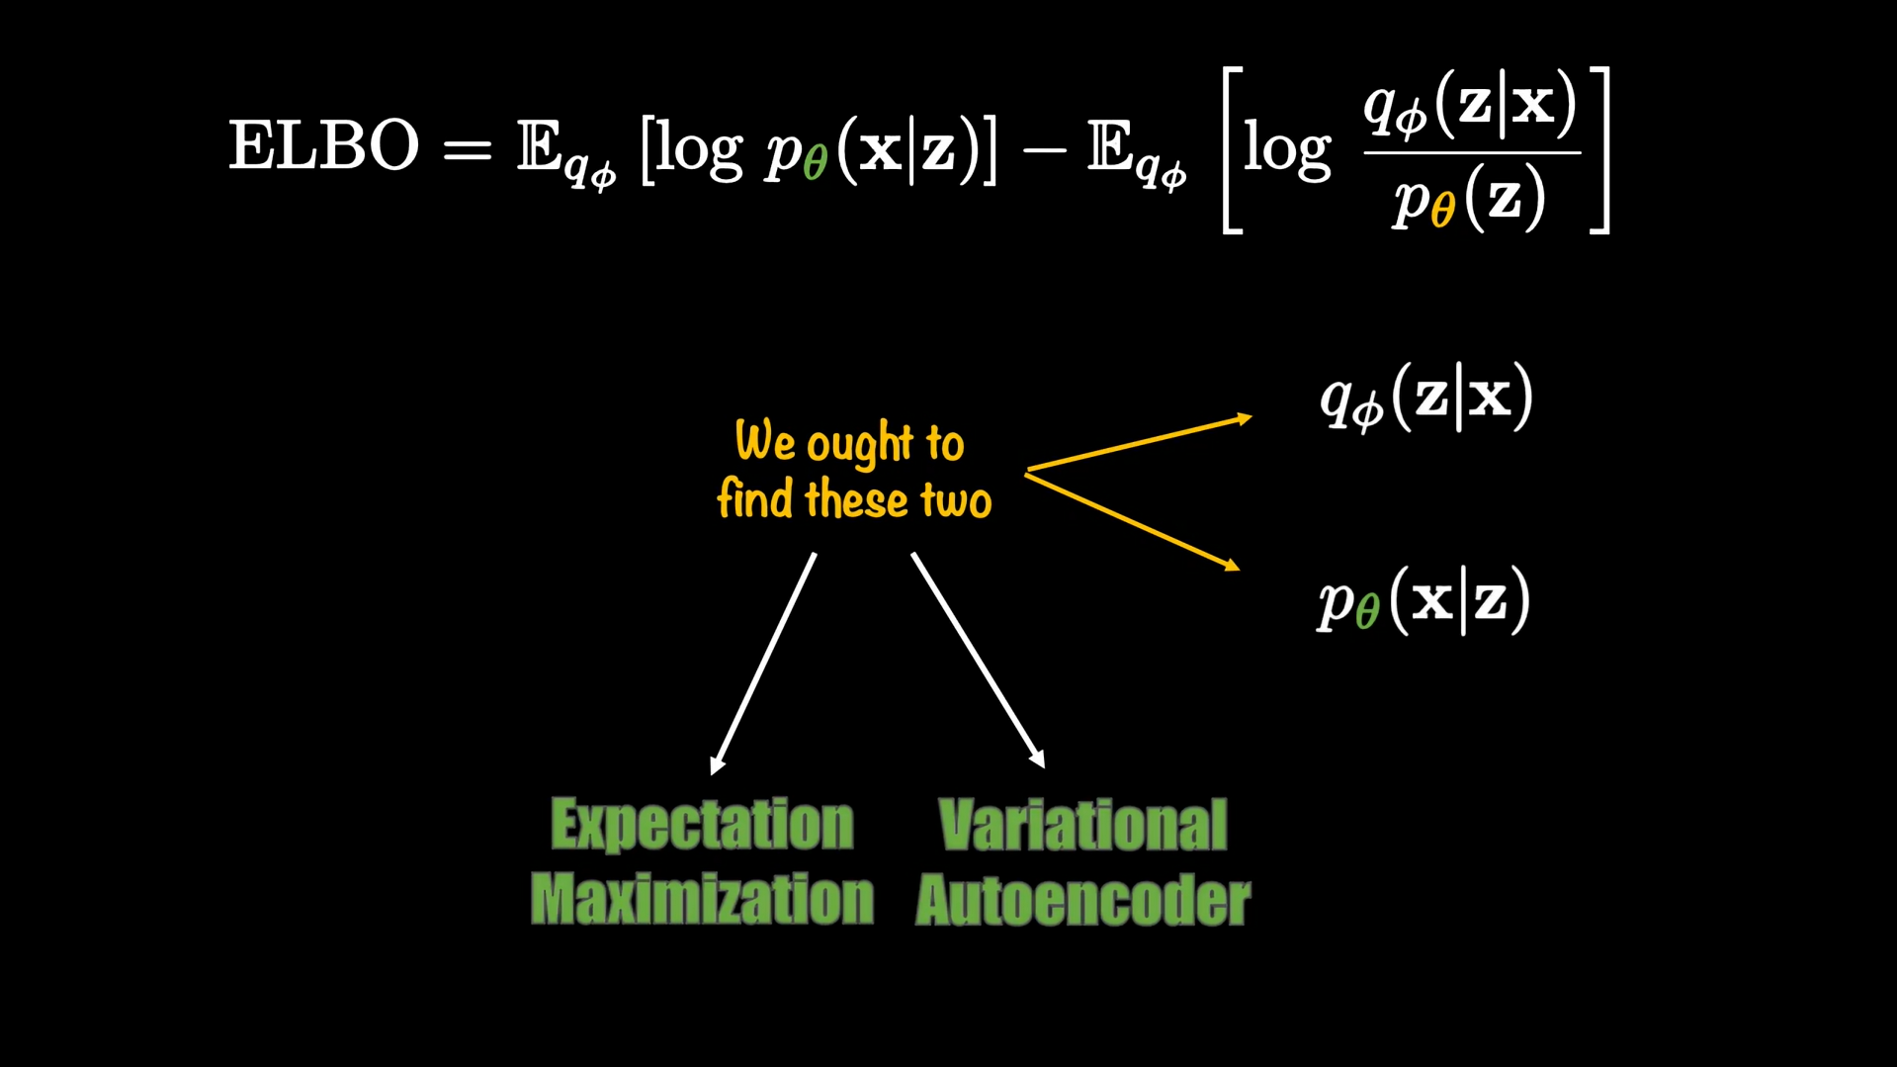



ELBO now is VAE loss function

Reparameterization trick

* random variable
* distribution
* vector containing the parameters of the distribution
* Given

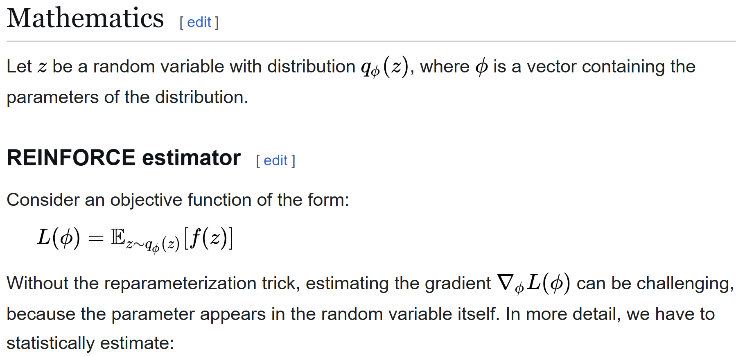

Log var:

Avoids negative values and improves numerical stability.

-VAE

Different channels share mutual information

The goal is to minimize mutual information among channels. Forces independency.

