REPOSITORY GIT:

**https://github.com/LuisFernandoAlvarez/MasGlobal.git**

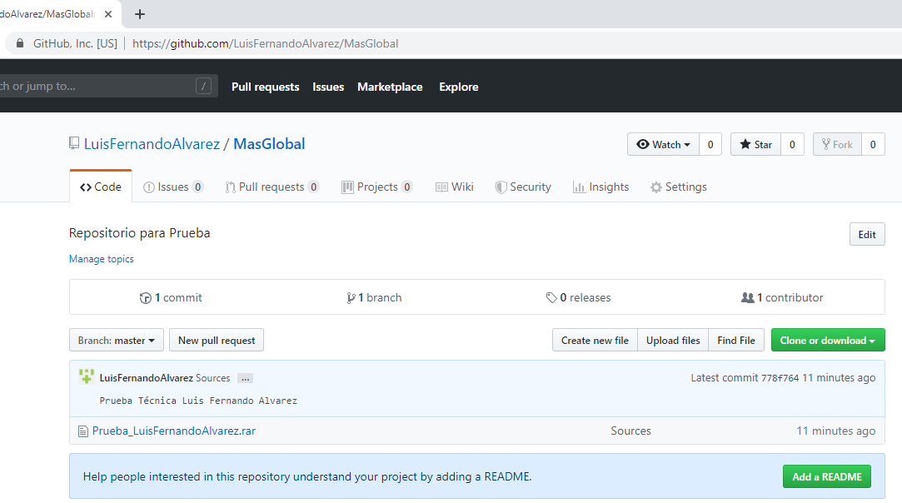

1. INSTALL PACKAGES (NO GIT):

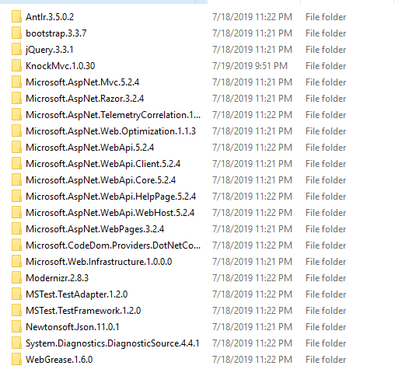

**MAIN FORMS:**

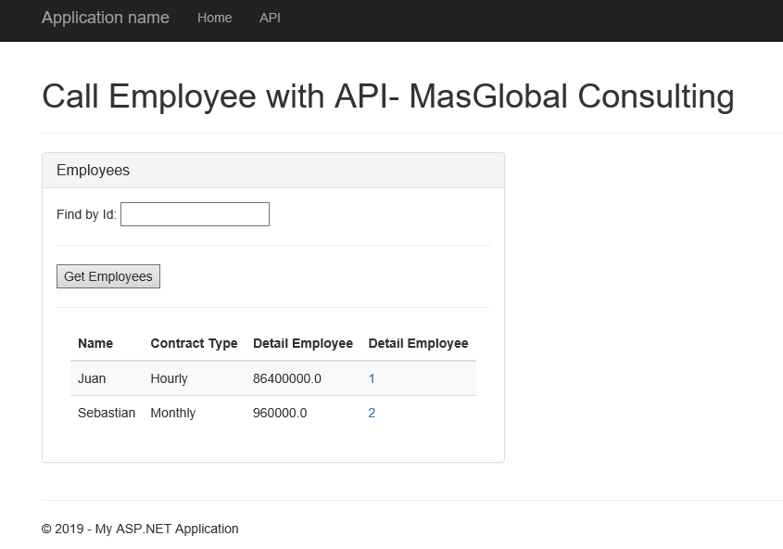

Employees Detai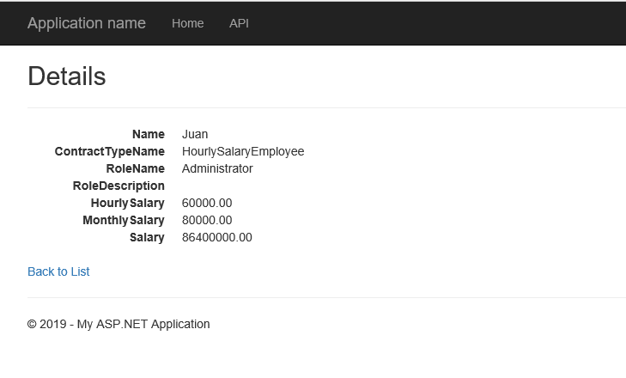

No Results:

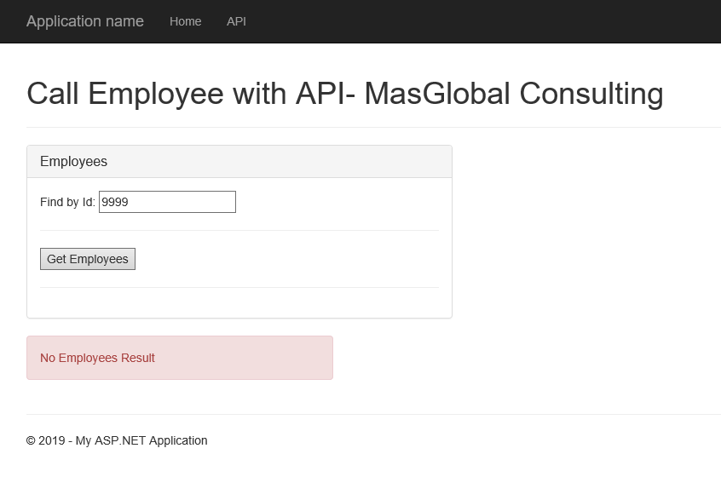

**UNIT TEST:**

