Due Date: 04/07/2017

Chapter #8

**Assignment Topic 8**

1. *Create a Trigger, for the SaleCo2 database, that will support:*
   * *Upon adding (Inserting) a new invoice into the Invoice table (simply disregard the need to update the Line table with invoice line item information).*
   * *The trigger should automatically Update the Customer in the Customer table by adding the new invoice onto the Customer Balance attribute.*
   * *Clarification:    No hard coding of the inserted invoice amount in the trigger.  The SQL should access the inserted amount in the Invoice table and add it to the customer balance attribute in the Customer table.*

* *HINT:  may be done in one SQL query with sub-queries,  OR  using separate queries and maybe a variable.*

CREATE TRIGGER UP_INVOICE AFTER INSERT ON INVOICE

FOR EACH ROW

UPDATE CUSTOMER SET CUS_BALANCE = (CUS_BALANCE + NEW.INV_TOTAL)

WHERE CUSTOMER.CUS_CODE = NEW.CUS_CODE;

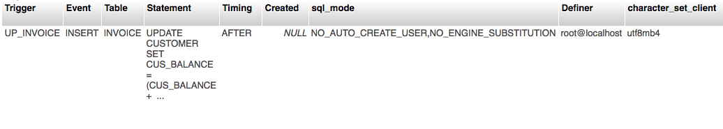

1. *Create a Stored Procedure, for the SaleCo2 database, that will:*

* *Delete a Customer from the Customer table by accepting the Cust_Code as a procedure parameter when you CALL the procedure to be executed in the SQL window/tab within PhP MySQL.*

CREATE PROCEDURE DEL_CUSTOMER( CUS_ID INT)

BEGIN

DELETE FROM LINE WHERE INV_NUM IN ( SELECT INV_NUM FROM INVOICE WHERE CUS_CODE = CUS_ID );

DELETE FROM INVOICE WHERE CUS_CODE = CUS_ID;

DELETE FROM CUSTOMER WHERE CUS_CODE = CUS_ID;

END

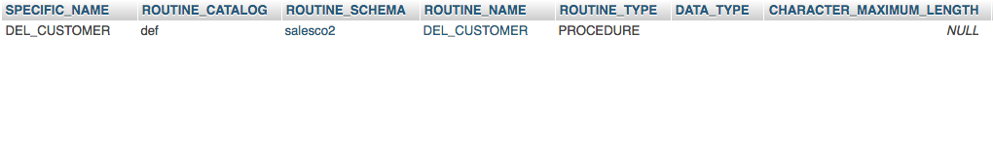

* *Delete all associated rows for this Customer in the tables  Invoice and Line.*

CREATE PROCEDURE DEL_ASSOC_ROW()

BEGIN

DELETE FROM CUSTOMER WHERE CUS_CODE = cust_code;

DELETE FROM INVOICE WHERE INVOICE.CUS_CODE = cust_code;

DELETE FROM LINE WHERE INV_NUMBER = invoice.INV_NUMBER AND invoice.CUS_CODE=cust_code;

END

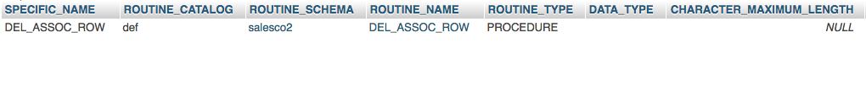

/*SELECT routine_definition

FROM information_schema.routines

WHERE

routine_name = 'del_customer' AND routine_schema = 'SalesCo2';

*/

//DROP PROCEDURE IF EXISTS procedureName;

//SHOW TRIGGERS