Multivariate data analysis

0.0 Introduction
Multivariate data are data with many variables numbering from minimum of six variables to millions; such data usually includes control variables (factors) and/or characteristics (responses). Most systems and processes are characterized by multivariate data. Multivariate data analysis techniques can be used to model factors and responses and find the relationship that exists between all factors and responses and can extract useful information from multivariate data. Information extracted from multivariate data are usually very helpful in understanding the characteristics of systems and processes and are useful in solving problems encountered as well as in research and development. SIMCA software is a very good tool for analyzing multivariate data.
Detail overview of multivariate data analysis techniques can be found at:
http://www-personal.umd.umich.edu/~williame/syllabi/OMDA.html
Detail overview of principal component analysis (PCA) can be found at:
http://www.statsoft.com/textbook/stfacan.html
Overview of elementary concepts statistics can be found at:
http://www.statsoft.com/textbook/esc.html
And overview of basic statistics can be found at:
http://www.statsoft.com/textbook/stbasic.html

The example in this report demonstrates how multivariate statistical process control can be used to follow a process. Dataset PROC1A (table 1 and the attached excel file) was analysed to determine what, causes a disturbance and when the disturbance occurred in a chemical production plant. ^{[1]}
The dataset, PROC1A contains 33 variables and 92 hourly observations. The measured variables are distributed as seven controlled process variables (x1in-x7in), 18 intermediate process variables (x8md-xpen), and eight output variables (y1-y8). The variables are coded due private and confidential policy of the company. ^{[2]}

Table 1: PROC1A Dataset
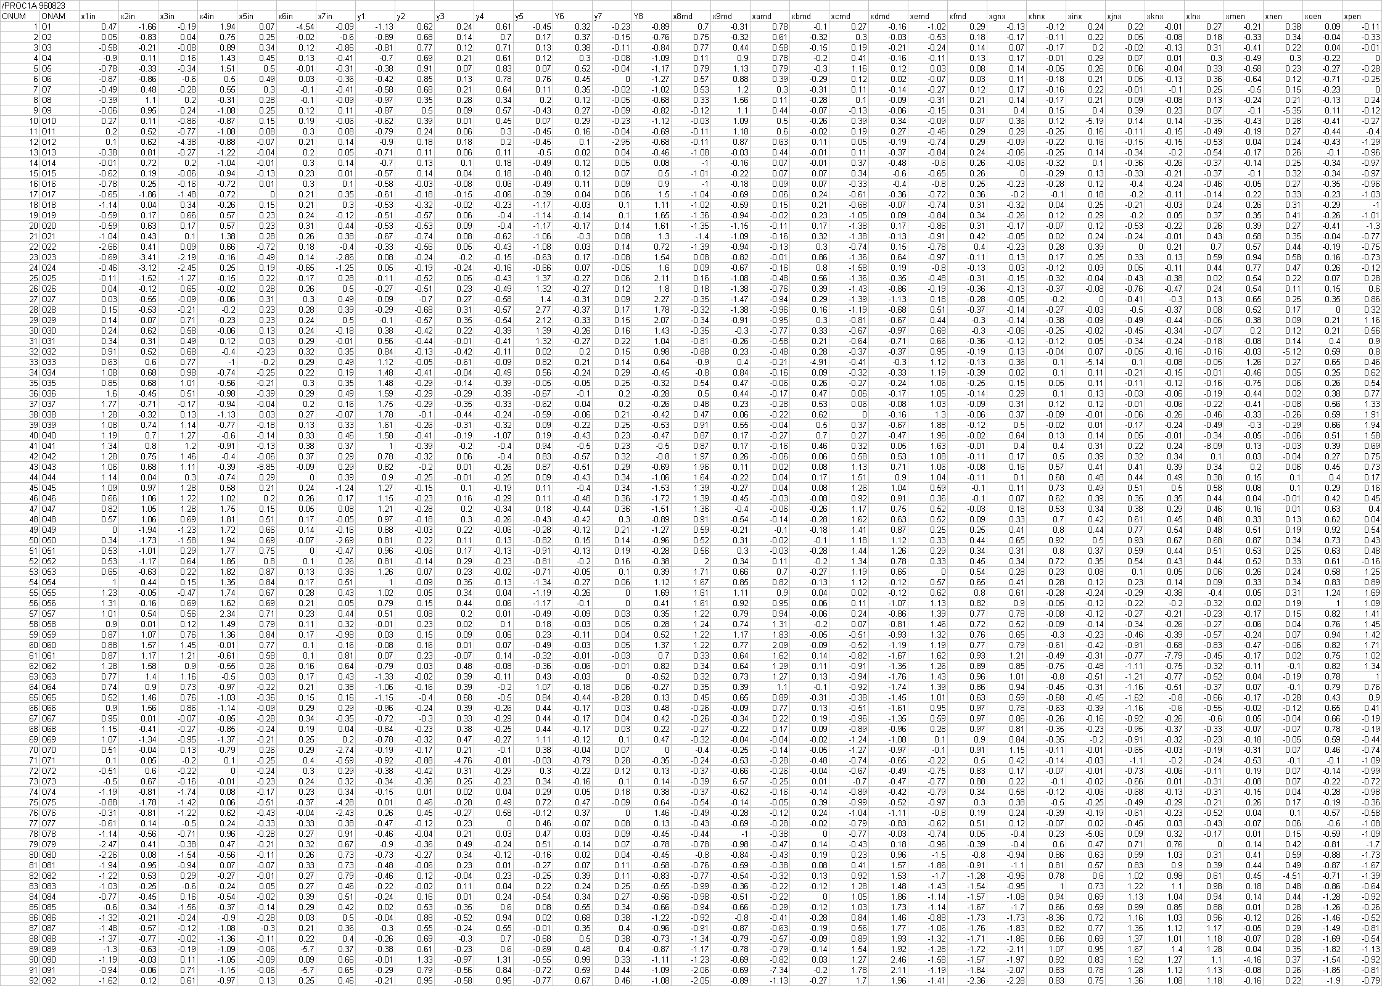
The dataset was analysed using basic statistics command in the data menu of SIMCA 10.5 to create the statistical report in table 2.
Table 2: Statistical report for PROC1A Dataset
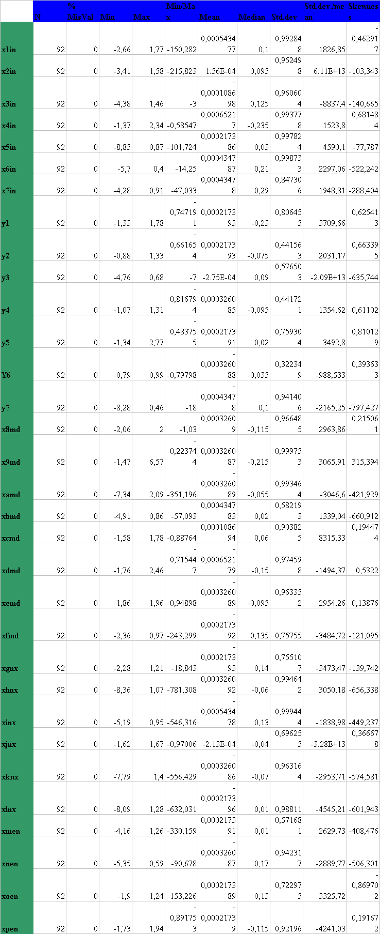
The dataset is not normally distributed with mostly negatively skewed data.

1.0 Overview.
When principal component analysis (PCA) auto-fit was computed on four components (R2X=0.554/Q2=0.332),using SIMCA software, the score scatter plot figure 1 and loading scatter plot figure 2 are shown below.

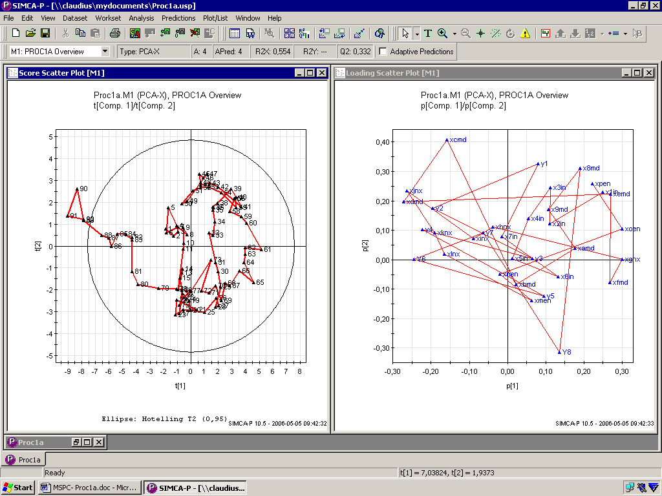
Figure 1: Score plot Figure 2: Loading plot

The score plot figure 1 above shows the positioning of the observations in three groups: observations up till 78 constitute one group lying from about the middle to the right hand side of the score plot, observations 79 to 88 are making another group lying on the immediate left hand side of the score plot while observations 89 to 92 lies outside the confidence limit.

Generally the score plot shows a clear trend in the data. The process moves steadily from the bottom of the graph towards the upper left-hand corner from observation 70; this movement is indicating some process upset. ^{[2]}

The loading plot figure 2 follows almost the same trend but the correlation is not very clear. However it could be observed that the product strength Y8 is down below on the right hand side while the side product Y6 is laying on the horizontal zero line on the left hand side of the plot.
0
,
5
0
1
,
0
0
1
,
5
0
2
,
0
0
0
1
0
2
0
3
0
4
0
5
0
6
0
7
0
8
0
9
0
DModX[2](Norm)
Num
Proc1a.M1 (PCA-X), PROC1A Overview
DModX[Comp. 2]
M1-D-Crit[2] = 1,295
1
2
3
4
5
6
7
8
9
10
11
12
13
14
15
16
17
18
19
20
21
22
23
24
25
26
27
28
29
30
31
32
33
34
35
36
37
38
39
40
41
42
43
44
45
46
47
48
49
50
51
52
53
54
55
56
57
58
59
60
61
62
63
64
65
66
67
68
69
70
71
72
73
74
75
76
77
78
79
80
81
82
83
84
85
86
87
88
89
90
91
92
D-Crit(0,05)
SIMCA-P 10.5 - 2006-04-26 13:07:59
Figure3: DModX plot

The horizontal red line indicates the model limit in the DModX plot figure 3 above, it shows that many of the observations are lying outside the model. Observations 89 and 92 are within the model here whereas in the score scatter plot figure 1 these values are outside the confidence limit, so we cannot say categorically that these observations are completely different at this stage but it is still clear that the process is upset from observation 70.
Proc1a.M1 (PCA-X), PROC1A Overview

0
,
0
0
0
,
2
0
0
,
4
0
0
,
6
0
0
,
8
0
1
,
0
0
x1in
x2in
x3in
x4in
x5in
x6in
x7in
y1
y2
y3
y4
y5
Y6
y7
Y8
x8md
x9md
xamd
xbmd
xcmd
xdmd
xemd
xfmd
xgnx
xhnx
xinx
xjnx
xknx
xlnx
xmen
xnen
xoen
xpen
Var ID (Primary)
R2VX [2] (cum)
Q2VX [2] (cum)
SIMCA-P 10.5 - 2006-04-26 13:08:15
Figure 4: Overview plot

The overview plot, figure 4 does not look so good as some of the values of Q2 and R2 are less than 0,5.

2.0 Detailed survey of variables in time series plots
.
0
2
4
6
8
1
0
0
1
0
2
0
3
0
4
0
5
0
6
0
7
0
8
0
9
0
Num
Proc1a.M1 (PCA-X), PROC1A Overview
T2Range[Comp. 1 - 2]
T2Crit(95%)
SIMCA-P 10.5 - 2006-04-26 13:55:49
Figure 5: Overview T2 range

Overview T2 range plot figure 5 shows that observations 1 to about 79 are inside the 95% tolerance limit. It is clear that something abnormal started happening between observations 80 to 90 with the peak at 90.

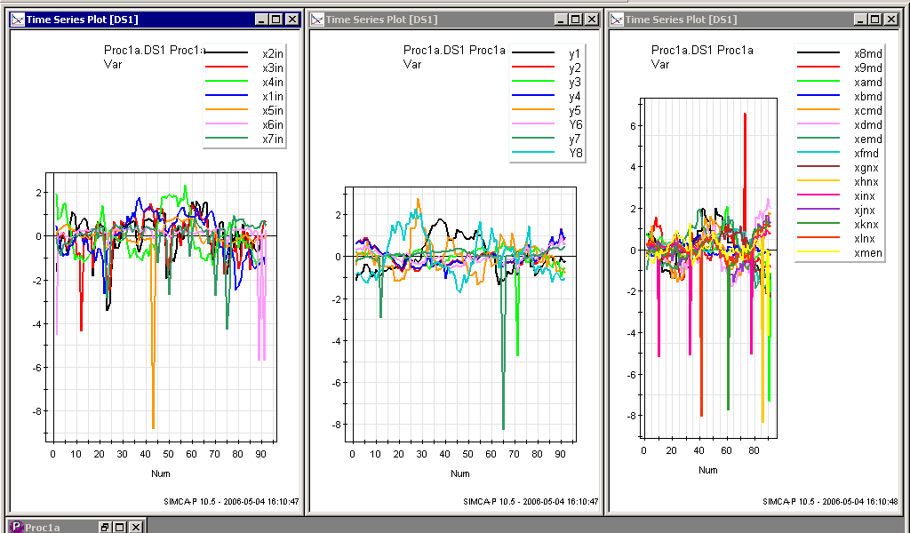
Figure 6: Control variables Figure 7: Responses Figure 8: Intermediate variables

The time series plots show that the observed values started changing between 70 and 80 hours. This is not very clear but visible. In the control variables, figure 6; it is obvious that the process deviates downwards about observation 70. In figure 7, responses; it is obvious that the process starts to diverge around observation 70 and figure 8, observations (Intermediate variables); shows some kind of shrinkage in the process around observation 70.

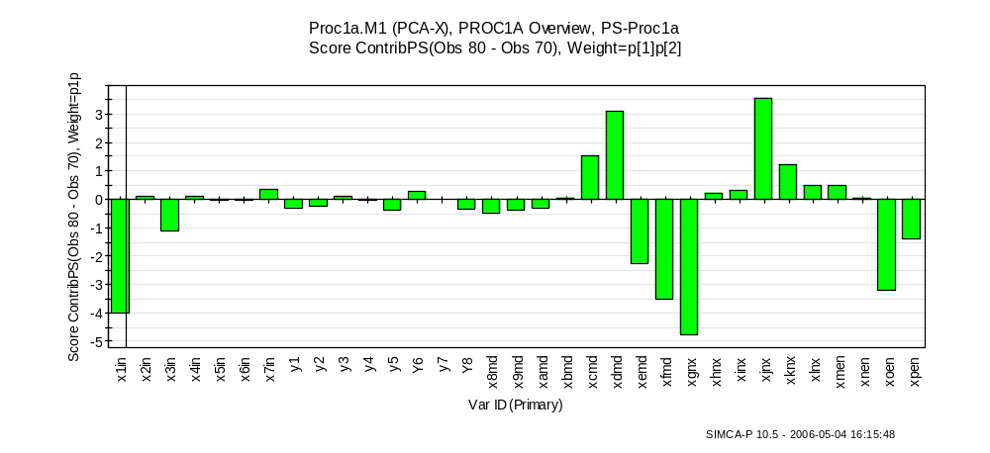
Figure 9: Variable contribution plot

The contribution plot figure 9 shows that the variables contributing to the observations between 70 and 80 are x1in, x3in, xemd, xfmd, xgnx, xoen and xpen. It could be observed that the observations have too low values in these variables. It should be noted that x1in and x3in are control variables.

3.0 Time series for object vectors
vectors
-
8
-
6
-
4
-
2
0
2
4
0
1
0
2
0
3
0
4
0
5
0
6
0
7
0
8
0
9
0
Num
Proc1a.M1 (PCA-X), PROC1A Overview
t
t[1]
t[2]
t[3]
t[4]
SIMCA-P 10.5 - 2006-04-26 15:46:10
Figure11: Time series for objects

From the time series plot above, it could be observed that t[1] reflects the process disturbance best. It shows that the disturbance starts at approximately 60hours.

4.0 Training model 1 excluding observations 71-92.

4.1
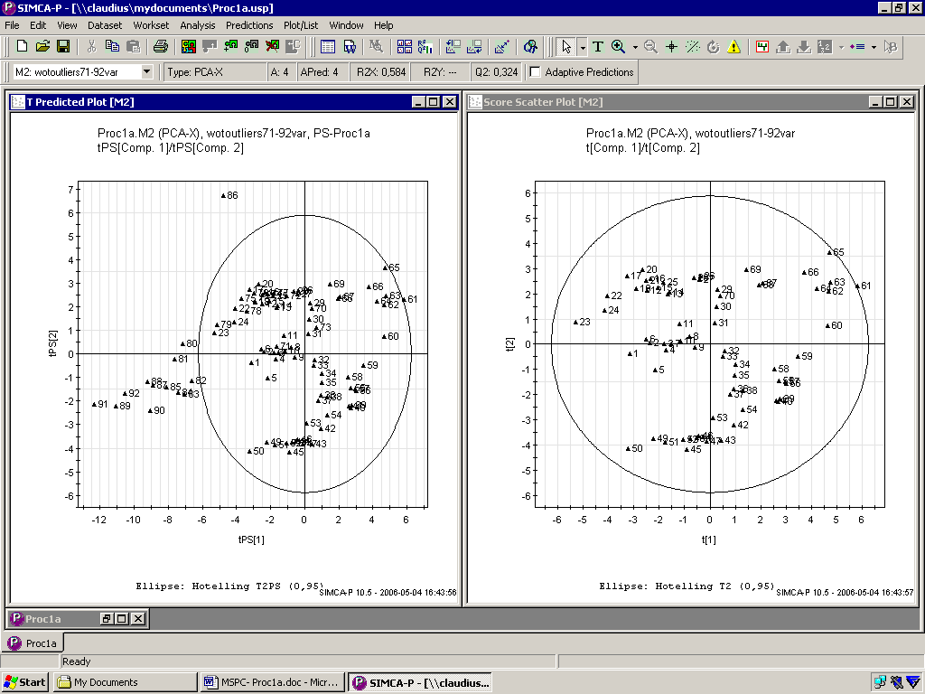
Figure12: T predicted scatter plot Figure13: normal score plot (less observation)

When a new PCA is computed with only observations 1-70: (R2X=0.584/Q2=0.324) The resultant T predicted and Score scatter plots are shown in figures 12 and 13 above: The T predicted scatter plot establishes the deviating observations clearly showing them falling outside the control limit. This indicates that observations 80-92 (outside) are fundamentally different from samples 1-69.[2] When observations 71 to 92 are removed then the plot shows that there are more missing values from the score plot.

4.2 Training model 2 observations 80-92 excluded
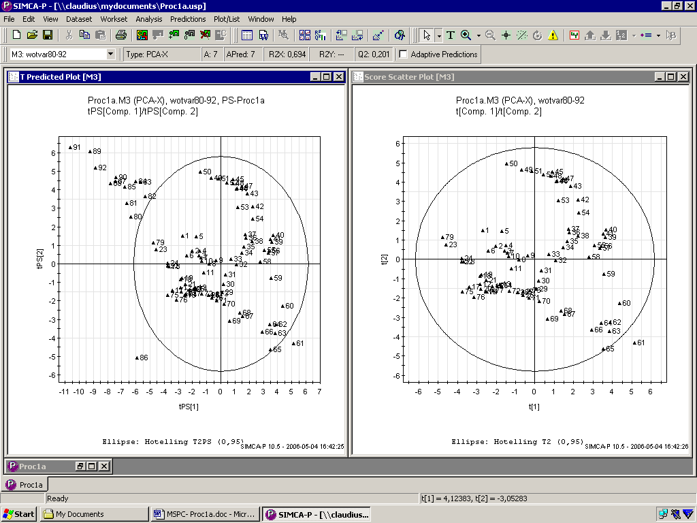
Figure14: T predicted scatter plot Figure15: normal score plot.

The PCA computed with exclusion of only observations 80-92 generated the T predicted scatter and score scatter plots in figures 14 and 15 respectively. (R2X=0.694/Q2=0.201). The observations 80 to 92 are outside the hotell.

5.0 Prediction contribution plot

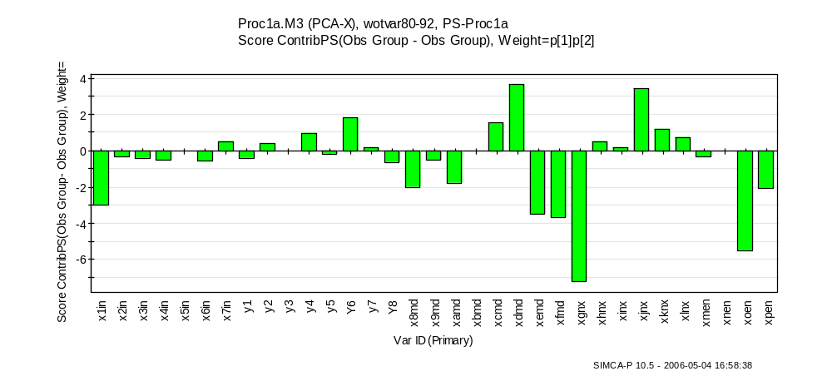
Figure 16: contribution plot.

By investigating the score contribution plot, figure16, it can be concluded that the control parameter that changes most between the average and observations 80- 92 is x1in.

6.0 Shewart diagrams
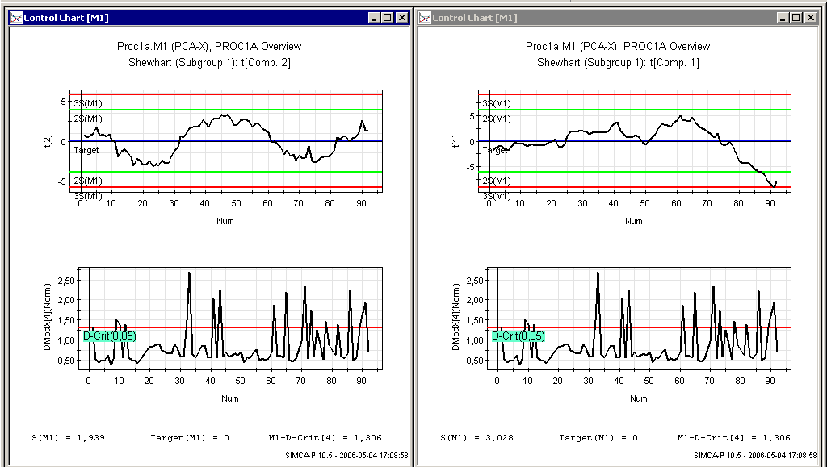
Figure 17: Shewart diagram comp2 Figure 18: Shewart diagram comp1
The Shewart diagram for component 1 figure 18 shows that the process go awry at about observation 80 cutting across the warning limit at about 85th hour. The DModX plot shows averagely the same trend. Shewart diagram for component 2, figure 17 shows averagely a normal process.
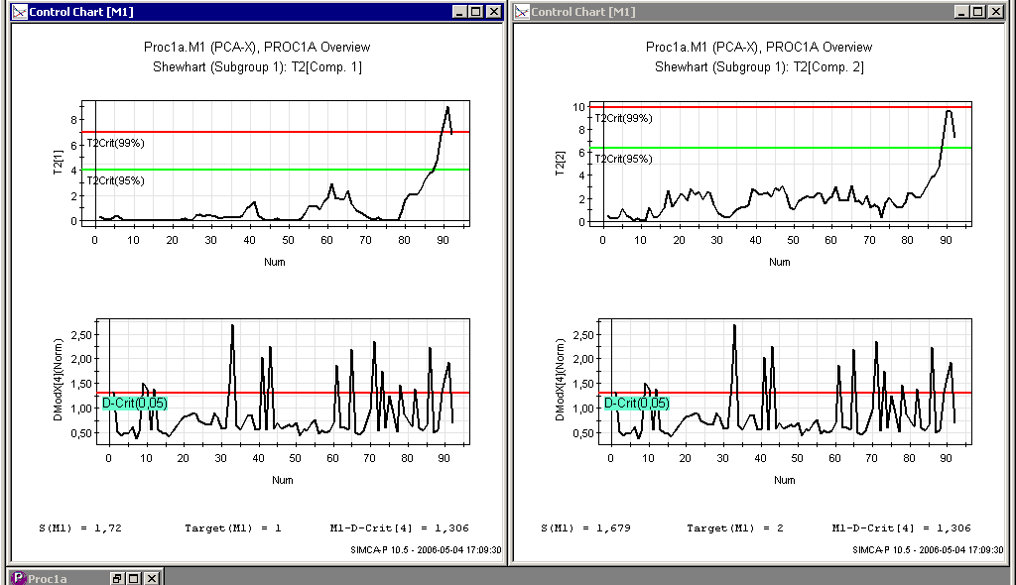
Figure 19: Shewart diagram.T2 comp1 Figure 20: Shewart diagram.T2 comp2

Both Shewart diagrams T2 Range for components 1 and 2 figures 19 and 20 respectively shows clearly that the process go awry at about observation 80 and the component1 showing that the process cut across the action limit at about 90th hour.

7.0 CuSum diagrams
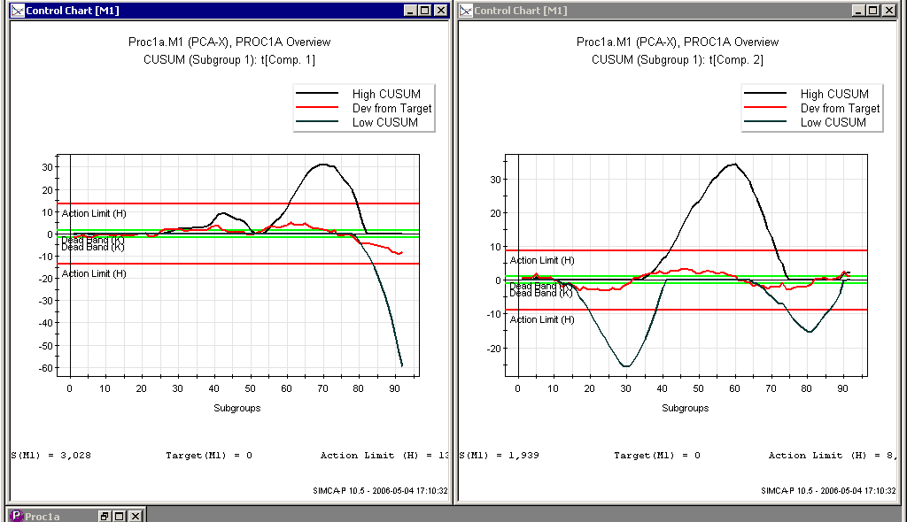
Figure 21: Cusum diagram. Comp1 Figure 22: Cusum diagram. Comp2

Cusum plots for components1 and 2 figures 21 and 22 respectively shows the lower cusum indicating abnormalty in the process at about 80th observation showing the process cutting across the action limit.

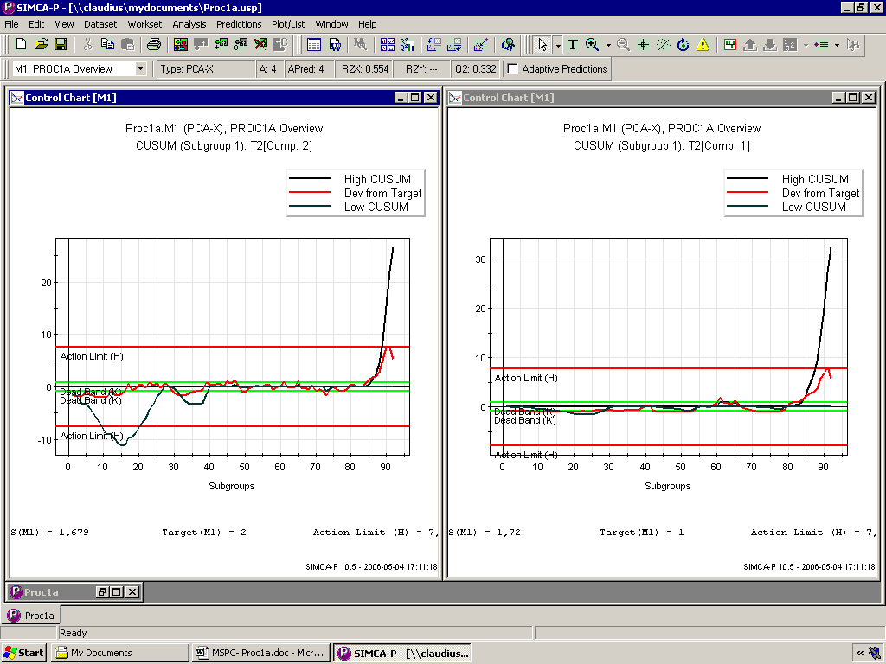
Figure 23: Cusum diagram.T2 comp2. Figure 24: Cusum diagram.T2 comp1.

Both Cusum diagrams T2 Range for components 1 and 2 figures 24 and 23 respectively shows clearly that the process go awry at about observation 85; High cusum is shown cutting permanently across the action limit in both plots..

8.0 Shewart/EWMA diagrams
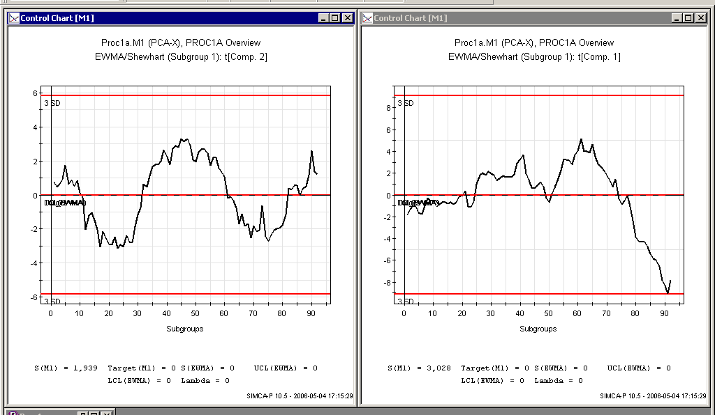
Figure 25: S/E diagram λ=0 comp2 Figure 26: S/E diagram λ=0 comp1

Combined Shewart/EWMA diagram with long memory λ=0 for component1 and 2 figure26 and 25 does not give cogent information about the anomalous behaviour of the process as the both lie within confidence limits.

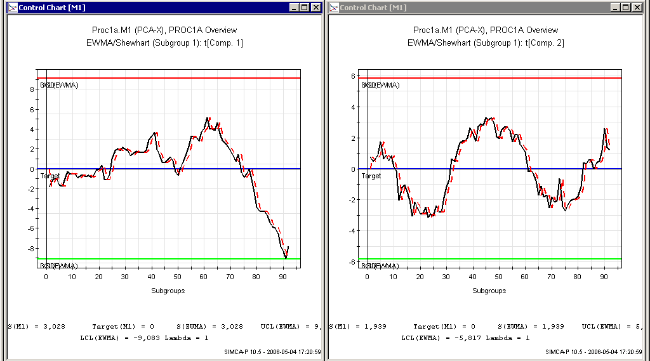
Figure 27: S/E diagram λ=1 comp1 Figure 28: S/E diagram λ=1 com2
Combined Shewart/EWMA diagram with short memory λ=1 for component1 and 2 figures 27 and 28 also does not give much information about the abnormal behaviour of the process.

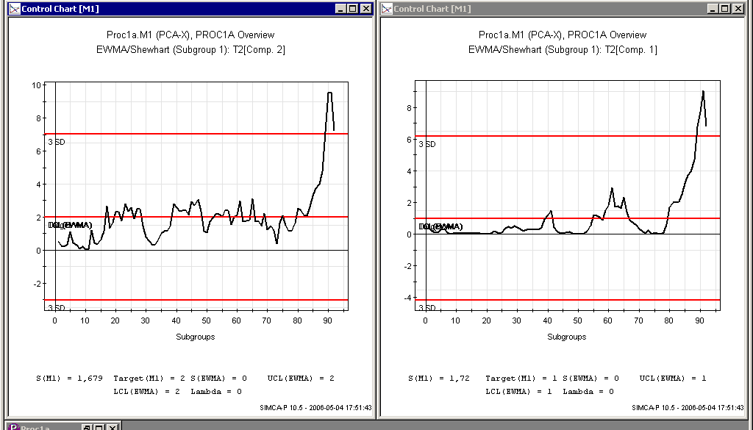
Figure 29: S/E diagram T2 λ=0 comp2 Figure 30: S/E diagram T2 λ=0 comp1

Both combined Shewart/EWMA diagrams T2 Range with long memory λ=0 for components 1 and 2 figures 30 and 29 respectively shows clearly that the process go awry at about observation 85 and that the process cut across the action limit at about 90th hour.

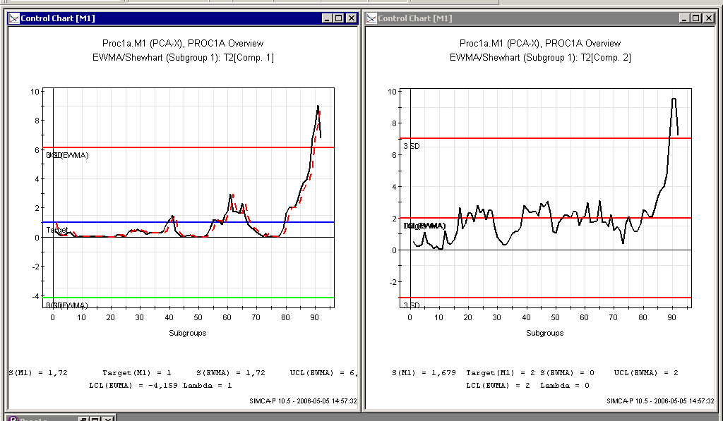
Figure 31: S/E diagram.T2 λ=1 comp1 Figure 32: S/E diagram.T2 λ=1 comp2

Both combined Shewart/EWMA diagrams T2 Range with short memory λ=1 for components 1 and 2 figures 31 and 32 respectively also shows clearly that the process go awry at about observation 85 and that the process cut across the action limit at about 90th hour.

Table 3: PROC1A summaries
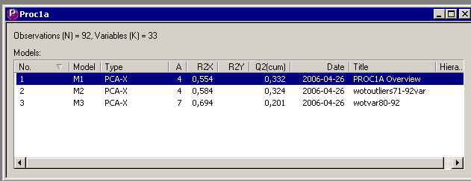

M3 have better degree of fitness (R2 = 0.69) but the worse predictability (Q2 = 0.20).

9.0 Cause of the process disturbance
The contribution plots figures 9 and 16 showed that the cause of the problem could be found in a number of variables, such as, x1in, xemd, xgnx, and xpen whose values are all too low.[2] However x1in is the only control variable that can influence the process among these variables. The variable is probably an important raw material which is deficient in the material batch starting from 60th hour in the process plant and if carefully looked into by the process engineer; rectification can be easily done.

10.0 Conclusion
Multivariate statistical process control (MSPC) have been shown to be capable of monitoring processes, in this example it has monitored a chemical production plant and have been able to pin-point what causes the process disturbance, when the disturbance start to occur; by over viewing historical process data, using principal component analysis and have shown the normal process operating conditions; the first 69 observations were identified as normal operating condition. Generally MSPC is a very useful tool which can easily hint warnings and helps in decision making in a production outfit.

References
[1] Process analysis Course Materials 2006 sets, Division of Chemical Technology, Luleå University of Technology.
[2] Multi- and Megavariate Data Analysis, Principles and Applications- L. Ericsson et al.
Umetrics Academy 1999-2001

