**Advanced Programming Project**

1. **Introduction.**

The purpose of this project is to develop an Application applying high-level Software development methods.

* 1. **Global Scope.**

The final objective Will be controlling actuators and sensors remotely from a web application. The following image Will show you an example of how a button on the web page application is linked to a physical actuator connected in RaspberryPi. Basically, when the button is clicked by the user on the user interface app, the led must be turned on or turned off depending of the state button.

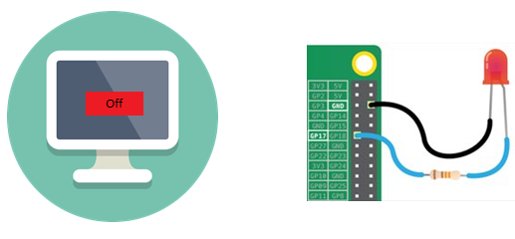

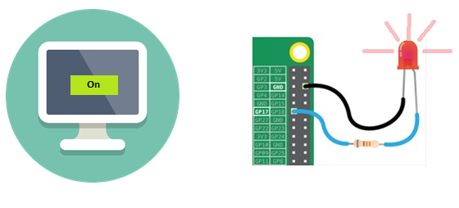

* 1. **Architecture**

This software Will develop using high programming techniques dividing by the following roles:

1. **BackEnd**

It is the logic and computational process to establish a channel communication between the database and RasberryPi.

1. **FrontEnd**

It is the necessary logic to show a friendly user interface able to control and manage data on the RaspberryPi remotely

**Web Application:** It is a graphic user interface with buttons and data information to control through instructions/query sensors and actuators on RasberryPi.

**API (application programming interface):** ​ Subtasks and functions that are programmed in a script in order to establish a channel communication between Database, RaspberryPi, and Web application.

**Data Base:** Store information that comes from Raspberry through API.

**Application on RasberryPi:** A script that is in charge of the control sensor and actuators. Also, it Will be connected to API to send information on Web App.

**Evaluation Unit1: Kick Off**

**Part I.**

**Instructions:**

**In teams of 5, create a study case of the sketch project defined above using the first 3 stages in the Software Development Life Cycle (SDLC). The grade of this first evaluation will be according:**

1. **Introduction:** *brief description about SDLC, brief description about the sketch project with your own words.*
2. **Development:** *With your own words, research, and consulting the customer (Professor) to document the following stages:*
   1. Planning
      1. Write about the project general scope
      2. Propose new features for the app
      3. Define a possible solution that the app could solve in the real world
      4. Time and cost developing for the project (Why do you think that)..
   2. Analysis
      1. Describe why we will use JavaScript/NodeJs/HTML
      2. Investigate similar applications in the market that offer these types of features.
   3. Design
      1. Describe Software in the APP.
      2. Describe why we will use a Raspberry Pi.
      3. Create a draft of the app.
      4. Research about: Web App, API, Databese, RaspberryPi)
3. **Conclusion (for each team member)**: *A brief description about the research.*

**Deliverables.**

* 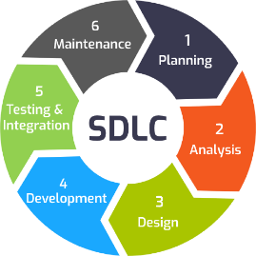A PDF file (3-5 pages).

**Evaluation Unit2: Development Scrum (In progress…)**

Key words: Scrum, User Stories, roles, repo on GitHub, research, modules, technologies.

Scrum methods, etc…