Numerical Laboratory Activity 2

Submitted to: Engr. Harold M. Ticzon

Submitted by:
Andrei Luis M. Monfero
Jun Michael C. Salvador
Gabriel Joseph M. Sia

BSCPE 2-B

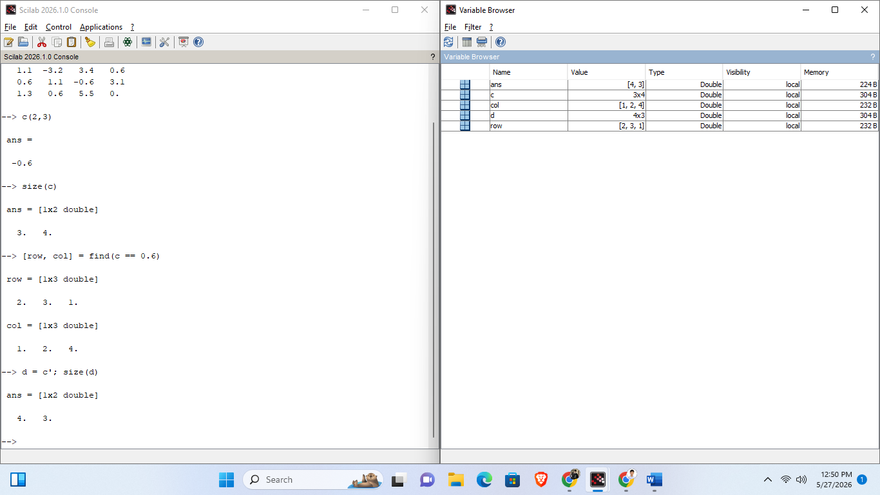
5-minutes Quiz
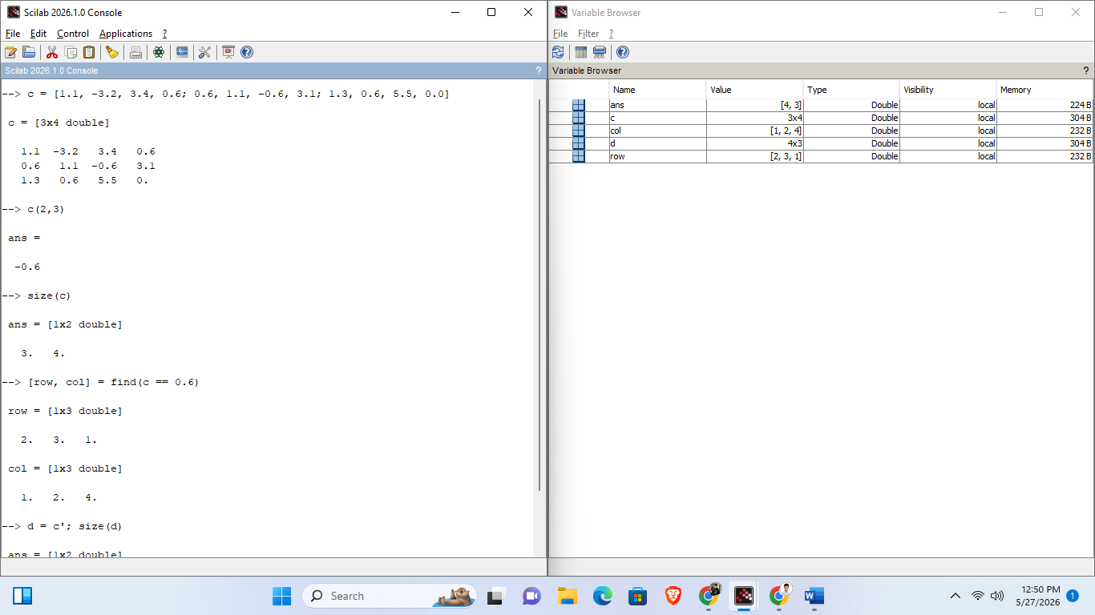

Exercise 1
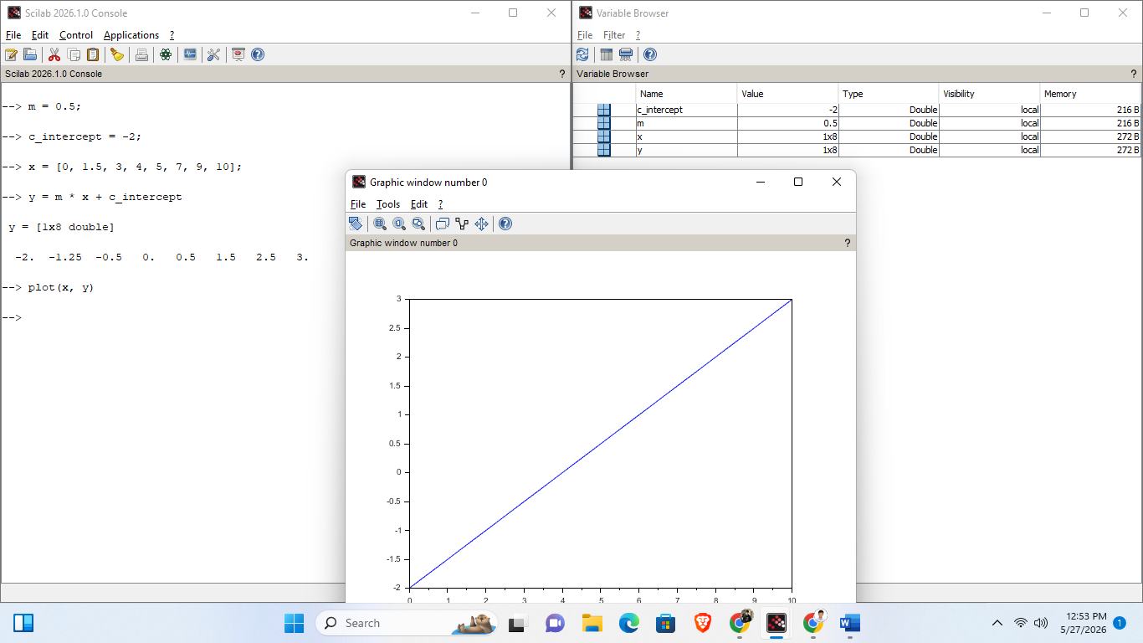
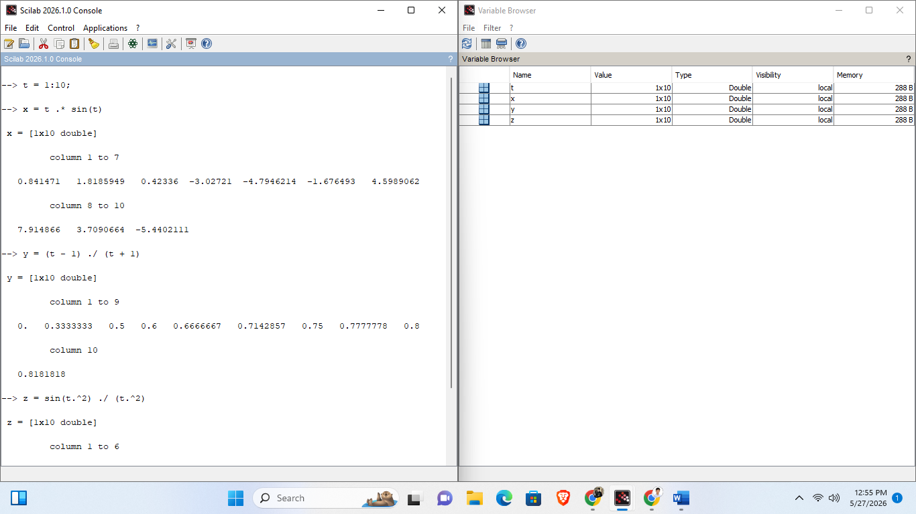
Exercise 2

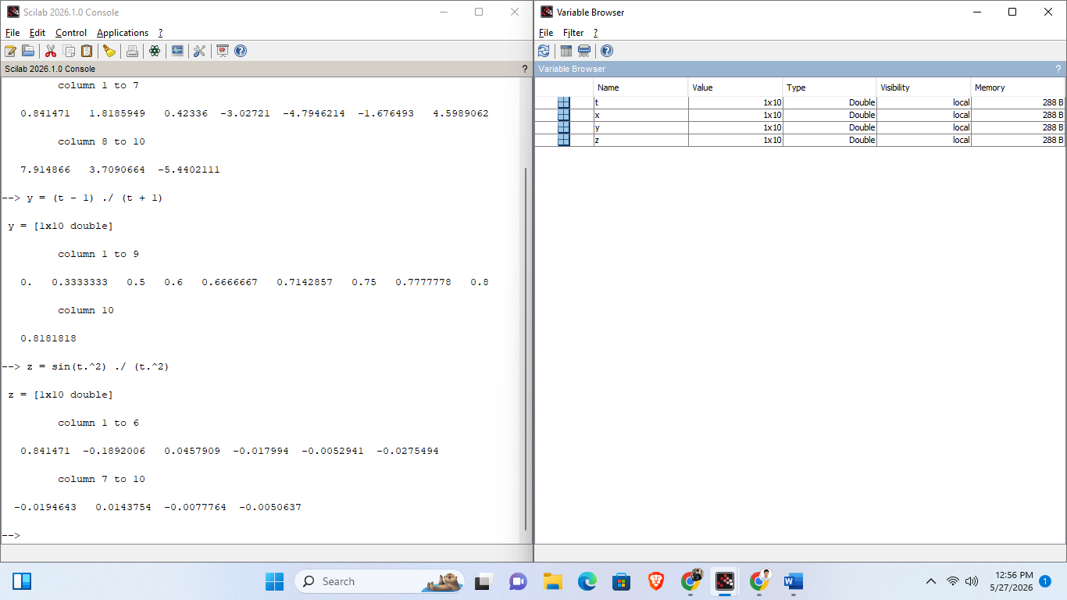

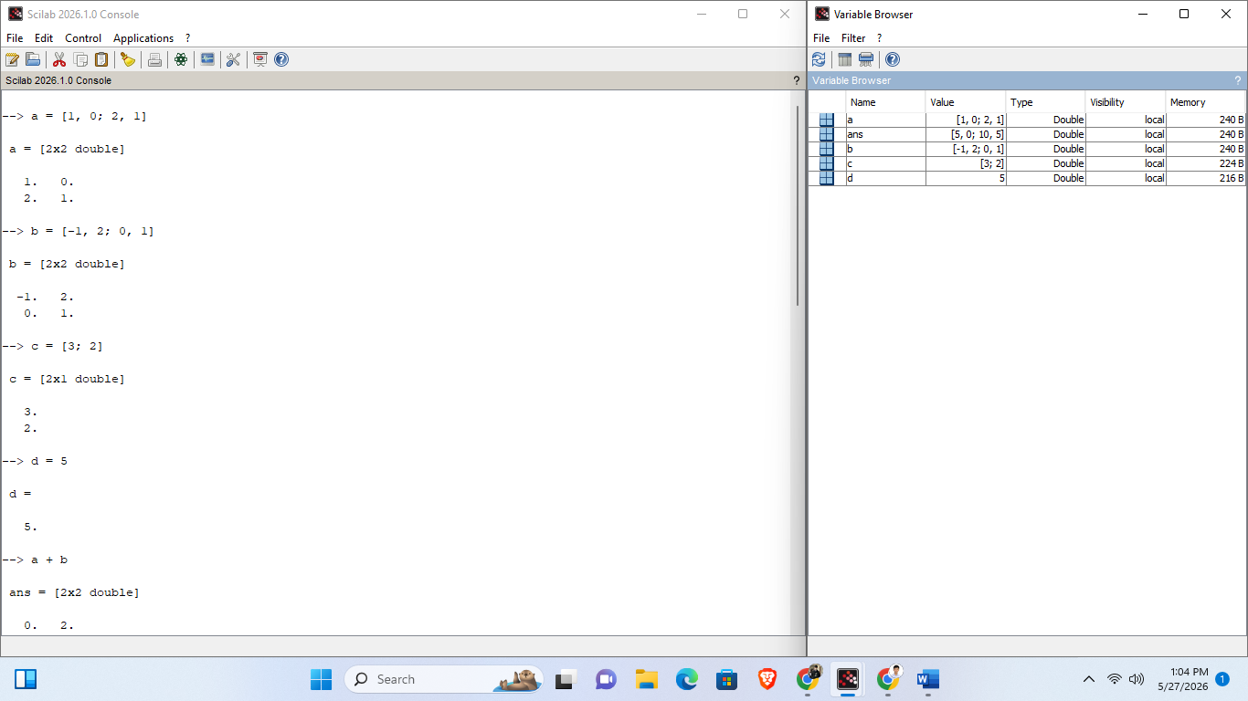
Exercise 3
