1. Use origin_ID and destination_ID to analyse the ODs, do not use the Origin Name and Destination Name since the web page assigns a different name. For example, for the browser “Edinburgh (City Centre)” it shows George Street as the stop.

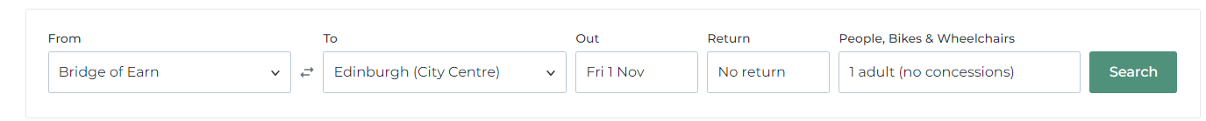

1. Some services between OD entails a multi-stage trip. For example, from Bridge of Earn to the Airport, there are services at some hours that includes a transfer to a tram which is already included and looks like this:

They are shown like the image below. For identify trips of a same journey, there is a column called service_id that allows to group multi-stage trips.

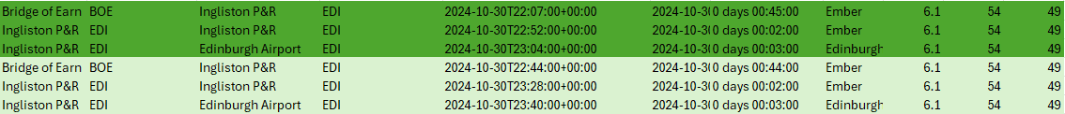

There are few routes like Edinburg Airport to Bridge of Earn in which the service_ID is located in the final stage of the trip as follows:



1. Some routes have on the web page services for certain dates and do not all.
2. Likewise, some pair ODs are shown for today and not for dates in the future.
3. Some ODs do not have services shown for the dates that were chosen.
4. For the Flixbus case we needed to update the Origin ID and the Destination ID so we can update the URL. In the excel sheet ‘O-D Fares’ we added the values for reference.