**Ilustración sobre remover elementos de una lista**

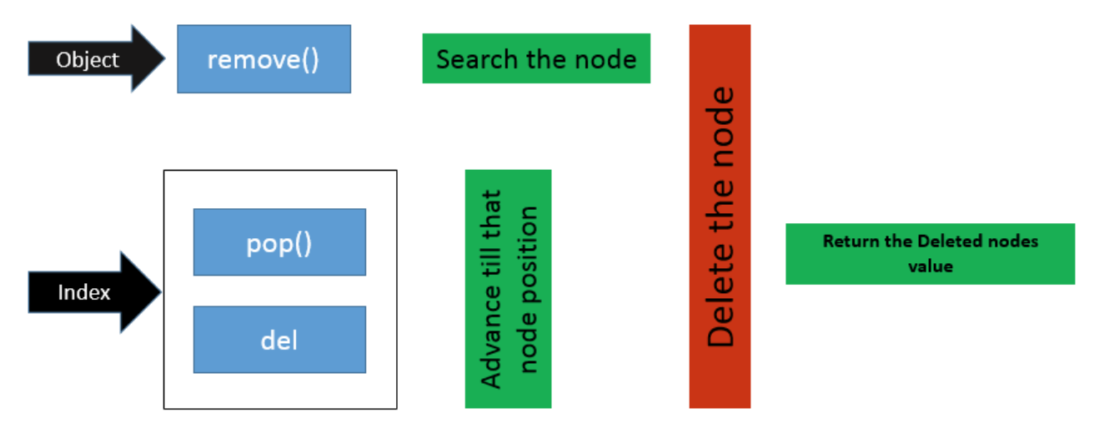

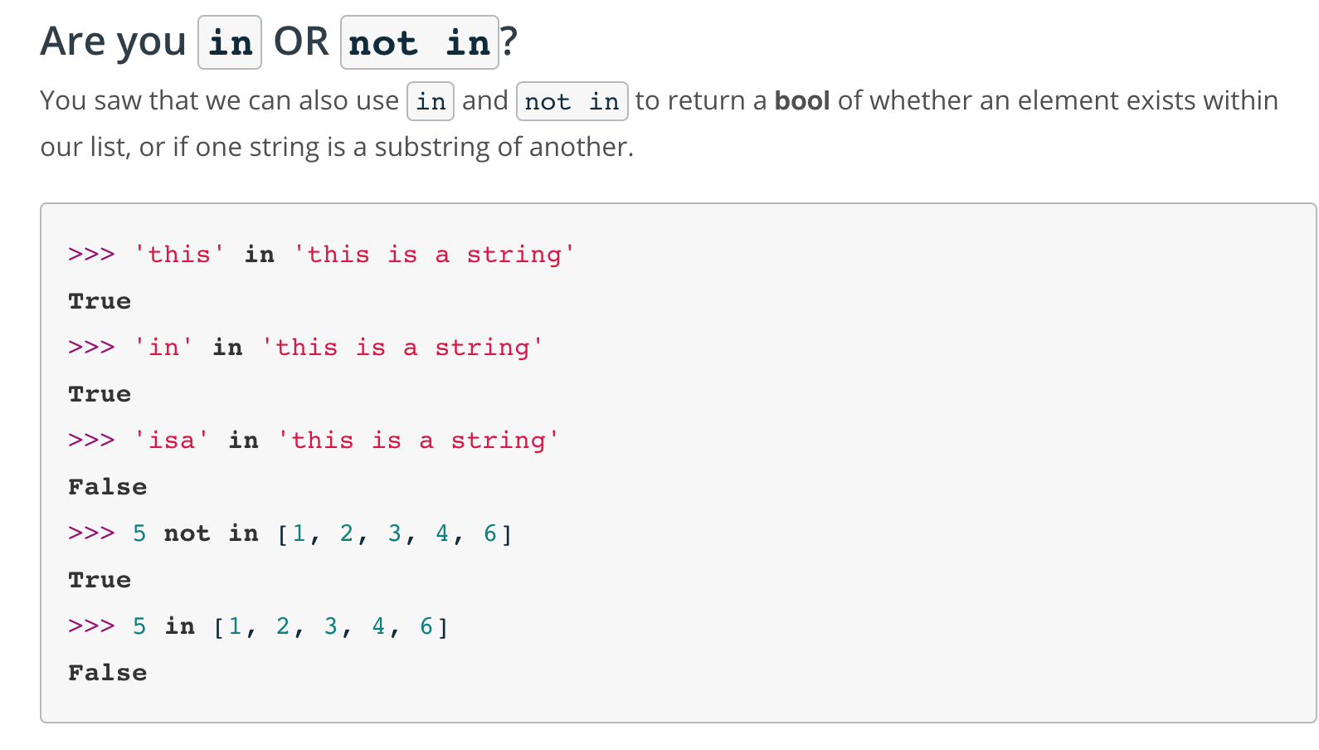**Ilustración sobre In clause y not in clause**

**Ilustración sobre formas de copier listas**

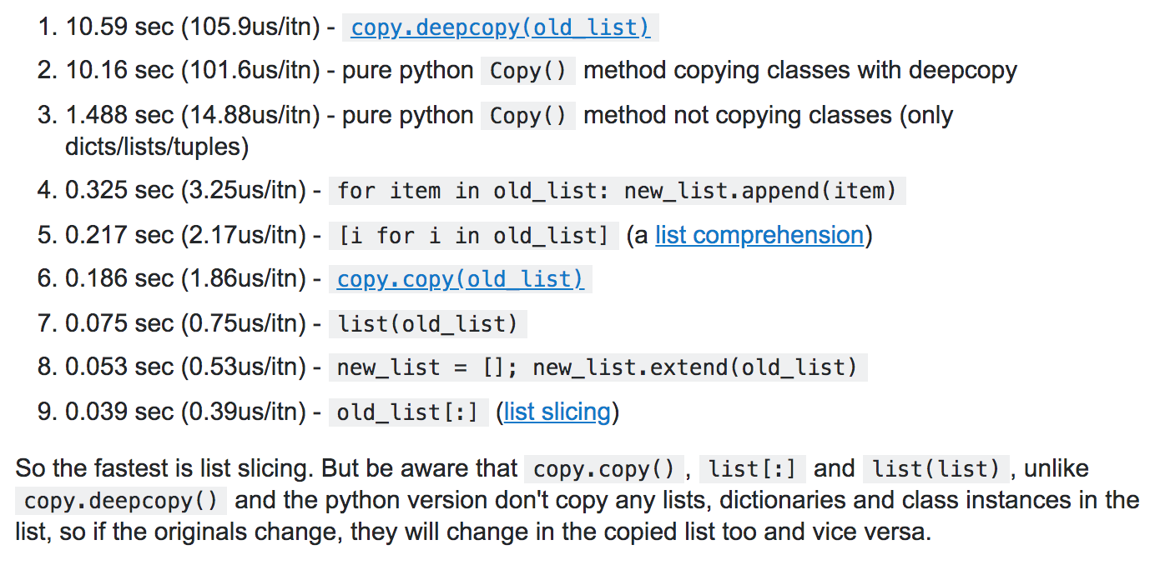

**Links recomendados**

<https://stackoverflow.com/questions/11520492/difference-between-del-remove-and-pop-on-lists/11520540>

<https://www.programiz.com/python-programming/methods/built-in/list>

<https://stackoverflow.com/questions/2612802/how-to-clone-or-copy-a-list>

<https://stackoverflow.com/questions/11520492/difference-between-del-remove-and-pop-on-lists/11520540>