**BMI Examples to Understand if, else and elif statements**

**BMI Simple Calculation Program**

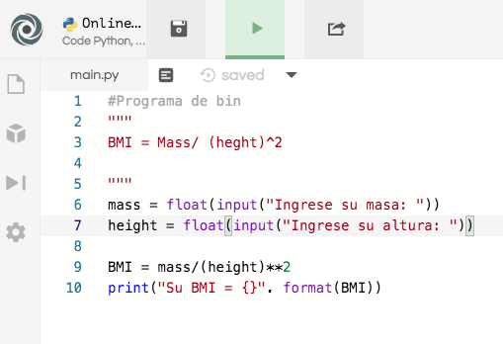

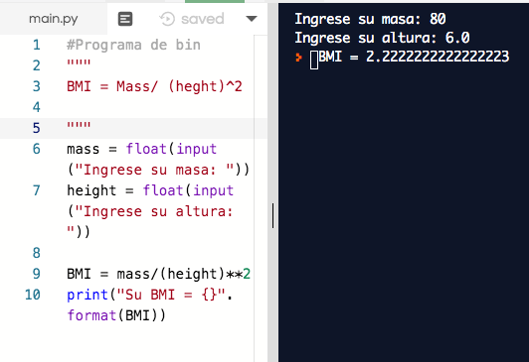

**Tienes que hacer ejercicio! (Using If statements)**

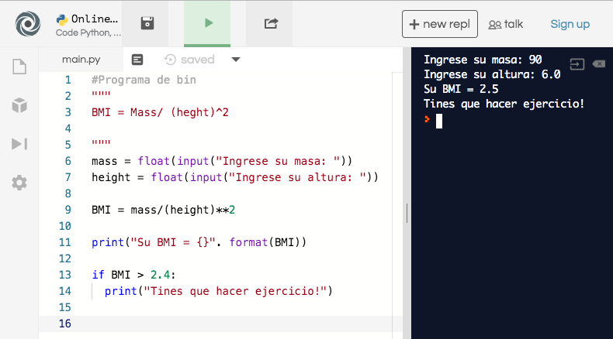

**BMI If Else Statement**

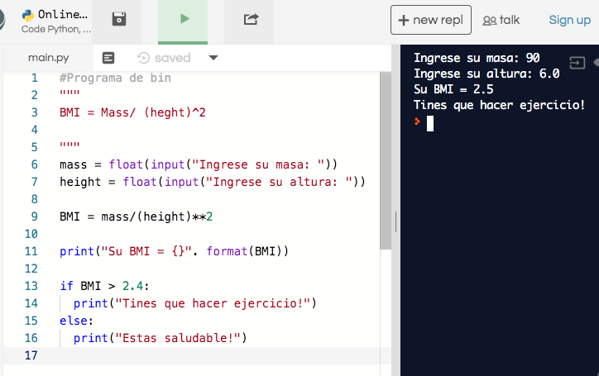

**BMI Elif statement**



