A Web-Based Supervised Machine Learning-Driven Skill Mapping and Job Referral Decision Support System for PESO CSJDM

A Capstone Project by

Alabado, Leandro M.
Nebereja, John Laurence R.
Nimbra, Luis Paolo L.
Poquiz, Lance Andrei P.
Referuga, Kristel

Submitted to the Faculty of Information Technology Bulacan State University-Sarmiento Campus

In Partial Fulfillment
of the Requirements for the Degree
Bachelor of Science in Information Technology

2026
CHAPTER I
INTRODUCTION
Background of the Study
International development research shows that technology driven job matching systems are becoming important in addressing challenges encountered by jobseekers and employers. Traditional job portals often only list or store market labor information, which can make it difficult to identify meaningful matches. In contrast, advanced job matching systems use automated and analytical methods to more effectively connect job seekers with suitable opportunities, helping to overcome information gaps and inefficiencies in referral processes (World Bank, 2023).
Research also highlights the importance of intelligent skill mapping and structured job matching systems as a key mechanism for improving labor market alignment. Data-driven matching systems, which analyze individual skill profiles and educational backgrounds, significantly reduce education–employment mismatches by recommending jobs and training pathways that best fit a person’s current competencies and career aspirations (Sanguino et al. 2025).
With advancements in artificial intelligence (AI), employment and career development systems are increasingly incorporating AI techniques to enhance skill assessment, job recommendation, and career guidance. A systematic review showing that AI tools are transforming workplace skill profiles by identifying emerging skill demands and enabling data-driven decision-making in talent alignment and job placements across industry sectors (Babashahi et al. 2024).
Research underscores the role of technology in career guidance systems that support continuous career development. Research found that although many existing systems excel at facilitating job placement, systems often lack integrated features for long-term career planning, skill gap analysis, and personalized guidance — areas that are critical for empowering individuals to navigate evolving careers over time (Bankins et al. 2024).
In the local context of City of San Jose del Monte (CSJDM), the Public Employment Service Office (PESO) continues to experience limitations in skill profiling accuracy, referral efficiency, and career guidance delivery. The current process relies heavily on manual screening and matching of applicants to job vacancies, which becomes inefficient as the volume of applicants increases, leading to delays, inconsistent referrals, and possible oversight of qualified candidates. Based on the reviewed literature, there remains a clear gap in implementing a unified, machine learning-driven information system that integrates skill mapping, mediated job referral, and career guidance tailored for localized government employment services. Addressing this gap offers the potential to improve PESO CSJDM’s ability to provide responsive, data-driven, and sustainable employment support that aligns skills with real job opportunities and fosters long-term career success.
To address these gaps, this study proposes the development of a Web-Based Supervised Machine Learning-Driven Skill Mapping and Job Referral Decision Support System for PESO. The system aims to improve the accuracy of skill-to-job matching, enhance the efficiency of job referrals, and provide data-driven career guidance to job seekers. By integrating machine learning-driven information systems, the proposed system seeks to support PESO CSJDM in delivering more effective, responsive, and data-informed employment services.
Objectives of the Study
The primary objective of this study is to design and develop a Web-Based Supervised Machine Learning-Driven that integrates skill mapping, mediated job referral, and career guidance to improve the effectiveness of employment services provided by the PESO CSJDM. Specifically, this study aims:
- To design and develop a Web-Based Supervised Machine Learning-Driven Skill Mapping and Job Referral Decision Support System for PESO.
- To integrate a Machine Learning-driven Job Matching module to predict the most suitable job titles, an Explanation Module to provide an organized visual summary of applicant suitability, and an Analytical Dashboard to support PESO staff in delivering personalized career guidance.
- Evaluate the effectiveness of the proposed system based on ISO 25010 software quality standards, particularly in terms of functional suitability, usability, and performance efficiency, in supporting PESO CSJDM’s employment facilitation and career development services.
Significance of the Study
This study is significant to various stakeholders as it addresses the growing need for data-driven and intelligent employment services, particularly within local government units.
PESO CSJDM
The system offers a modernized and efficient approach to employment facilitation. By integrating Supervised Machine Learning-enhanced skill mapping and mediated job referral, the office can improve the accuracy of job matching, reduce manual workload, and provide more responsive career guidance services. This supports PESO CSJDM’s mandate to deliver inclusive and sustainable employment assistance to the local workforce.

Job Seekers
Stand to benefit from more accurate job recommendations and personalized career guidance. The system helps them better understand their skills, identify potential career paths, and recognize skill gaps that may require further training. This empowers individuals to make informed career decisions and increases their chances of securing suitable employment.
Employers
Benefit from better-matched job referrals, as the system improves the alignment between job requirements and applicant competencies. This reduces recruitment time and increases the likelihood of hiring candidates who are well-suited to available positions.
Local Government and Policy Makers
This study provides evidence-based insights on how AI can be utilized to strengthen public employment services. The system may serve as a model for other PESO offices seeking to adopt technology-driven solutions for workforce development and labor market efficiency.
Future Researchers
This study contributes to the growing body of research on technological applications in employment services and career guidance. It may serve as a reference for future studies that aim to enhance or expand ML-based systems for labor market analysis, skill development, and employment facilitation.
Scope and Delimitations
Scope
This study focuses on the design and development of an information system that integrates Web-Based Supervised Machine Learning-Driven Skill Mapping and Job Referral Decision Support System features for the PESO CSJDM.
The System will collect and analyze job seeker profile data from PESO data storage and match it with available job opportunities using Supervised Machine Learning Algorithms to identify their skills and roles, provide job referrals to employers based on qualification matches, offer analytical dashboard to help personalized career guidance for applicants to specific job.
The study is limited to PESO CSJDM clients and registered job seekers who willingly provide accurate profile and skill information during the project period. The system will be tested by PESO staff in the city through simple user testing and surveys to check how easy it is to use and how helpful it is.

Limitations
This project focuses only on the design and implementation of a Web-Based Supervised Machine Learning-Driven Skill Mapping and Job Referral Decision Support System for PESO. The system focuses on processing data uploaded by PESO and will not collect data directly to employers and job seekers. As well as the system does not process unstructured data such as resume or any free text format file.
The system does not entirely automate the hiring process; final decisions are made by PESO workers and employers. The accuracy of the data submitted by users is essential to the ML-based matching and prediction findings, and wrong information can have an impact on the outcomes. The study also does not assess long-term employment outcomes, such as job retention or career advancement, following the referral procedure.
Definition of Terms
Artificial Intelligence (AI) | Refers to the use of computer-based techniques that enable the system to analyze data, identify patterns, and generate recommendations related to skill mapping, job matching, and career guidance.
AI-Enhanced Skill Mapping | The process of using artificial intelligence to analyze a job seeker’s skills, education, training, and work experience in order to create a structured and accurate skill profile for employment matching.
Applicant Scoring  and Ranking | A system feature that assigns weighted scores to job seekers based on their qualifications, skills, and experience, and ranks them according to their suitability for specific job opportunities.
Career Guidance | Refers to system-generated recommendations and insights that help job seekers understand possible career paths, identify skill gaps, and make informed decisions about employment and skill development.
Career Pathway Recommendation | A feature that suggests potential career directions or job roles based on a job seeker’s current skills, experience, and employment trends identified by the system.
Job Matching | The process of aligning a job seeker’s skill profile with employer job requirements using AI algorithms to identify suitable employment opportunities.
Job Referral | The process by which qualified job seekers are endorsed or recommended by PESO CSJDM to employers based on system-generated matching results.
Labor Market Recommendation | Data related to job demand, required skills, and employment opportunities that are used by the system to support accurate job matching and career guidance.
Machine Learning | Branch of artificial intelligence that enables computers to learn from data and improve their performance without being explicitly programmed. It uses algorithms to identify patterns in data and make predictions or decisions automatically.
Mediated Job  Referral | A job referral approach where AI-generated recommendations support, but do not replace, the decision-making of PESO staff and employers.
PESO CSJDM | The Public Employment Service Office of the City of San Jose del Monte, Bulacan, which serves as the primary beneficiary and implementation site of the proposed system
Predictive  Acceptance  Analysis | A system feature that estimates the probability of a job seeker being accepted for a job using historical employment and applicant data
Role-Based Dashboard | A user interface that displays system features and information based on the user’s role, such as job seeker, employer, or PESO staff.
Skill Gap  Analysis | The identification of missing or insufficient skills that prevent a job seeker from qualifying for certain job roles, as determined by system comparison.
Skill Mismatch | A condition where a job seeker’s skills do not align with the requirements of available job opportunities, often resulting in unemployment or underemployment.
Structured  Profile  Skill | A digitally organized representation of a job seeker’s skills, education, certifications, and experience generated by the system for analysis and matching.
User Testing | The process of evaluating the system’s usability, functionality, and usefulness through feedback from PESO staff and selected job seekers.

CHAPTER II
REVIEW OF RELATED LITERATURE AND SYSTEMS
The literature reviewed in this research and other related studies that were consulted to complete the study addressed the connection of Machine learning in skill mapping and job referral for the Public Employment Service Office (PESO). Data was acquired by the researcher from reliable websites and journal publications.
Review of Related Literature
Public Employment Service Offices (PESO) in the Philippines play a critical role in connecting job seekers with potential employers. Local PESOs, such as those in Davao de Oro, implement job matching programs to link applicants to suitable job vacancies, helping to reduce unemployment and improve access to employment opportunities. While these programs demonstrate the effectiveness of PESO in facilitating employment, the existing systems rely heavily on manual review and intervention by PESO staff, and the matching process is primarily based on basic profile and qualification comparison. Current platforms, including the PESO Employment Information System (PEIS), function as centralized databases that store applicant and employer information but do not provide advanced decision support features, such as automated ranking, predictive analytics, or intelligent job recommendations. Therefore, there is a clear research gap in the development of decision support systems tailored for PESO operations, which could enhance efficiency, provide analytical insights, and assist staff in making data-driven employment facilitation decisions (Michael L. Uy. 2025 and Public Employment Service Office, n.d.).
Research on automated job‑matching systems frequently applies natural language processing (NLP) based semantic similarity techniques to interpret the meaning behind resumes and job descriptions but stops short of using supervised machine learning models trained on actual hiring outcomes. For example, a recent study introduced a real‑time recruitment framework that integrates semantic similarity with NLP tools such as TF‑IDF vectorization and cosine similarity scoring to compute conceptual relevance between candidate resumes and job postings, improving upon traditional keyword‑based matching by capturing contextual meaning in text. However, this approach remains focused on similarity scoring between unstructured text rather than predicting the probability of successful placement or using historical decision data to inform recommendations, which limits its capacity as a true decision support tool. In contrast, the proposed research develops a supervised machine learning–driven decision support system that goes beyond text similarity to learn from labeled placement outcomes, making it better suited for supporting employment decisions in public employment services. This highlights a gap in the literature where ML for job matching has mostly centered on semantic similarity rather than predictive outcome‑oriented learning (Ajjam, M.‑H., & Al‑Raweshidy, H. S. 2025).
Many existing job matching and recommendation systems rely on similarity-based vector techniques to align candidate profiles with job descriptions. In such systems, textual content from resumes and job posts is preprocessed and transformed into numerical vectors using techniques like Term Frequency–Inverse Document Frequency (TF-IDF), and cosine similarity is computed between these vectors to assess how closely a candidate’s skills and experiences match job requirements. Candidates are then ranked based on their similarity scores, with higher scores indicating better matches. While effective for straightforward matching, this method primarily captures surface-level alignment and may not fully represent deeper or complex relationships between candidate competencies and job needs (Kotha et al., 2025).
Despite the increasing use of machine learning in job recommendation systems, many models operate as opaque “black box” systems that do not provide meaningful explanations for their predictions. This lack of explainability hinders users’ ability to understand, trust, and evaluate the recommendations produced, particularly in high-stakes contexts such as employment decisions. A systematic review of person–job recommendation systems found that most existing approaches focus on optimizing predictive accuracy but fail to offer transparent reasoning or interpretable outputs, highlighting explainability as an ongoing research challenge that must be addressed to improve trust, fairness, and user acceptance (Tang et al., 2025).
Many existing job recommendation systems are developed primarily to provide direct recommendations to job seekers rather than to assist intermediaries such as employment facilitators or human resource personnel in mediated job referral decisions. For example, one study proposed a job recommender based on job profile clustering and job seeker behavior, where job postings are collected and clustered, and job seekers receive highly personalized job recommendations according to their interactions and preferences. This approach focuses on enhancing the job seeker’s experience and efficiency in finding jobs, without incorporating mechanisms that support decision-making by employment facilitators or organizational recruiters. The lack of mediated support thus limits the applicability of such systems in institutional contexts where intermediaries evaluate and endorse candidate matches (Job Recommendation based on Job Profile (D. Mhamdi2020).
Improving Labor Market Information Systems (LMIS) is key to reducing skills mismatches and ensuring that workers' skills align with industry needs. Bayudan-Dacuycuy et al. (2024) looked at the Philippine LMIS and Technical Education and Skills Development Authority (TESDA) skills anticipation framework. Certain challenges are found, including scattered labor data, a lack of a standardized skills taxonomy, and poor coordination among platforms. These issues limit the effectiveness of job matching, workforce planning, and employment support services. The study highlights that well-structured and integrated labor market data is essential for predicting skill demand and offering useful career guidance. The findings also show that reliable datasets and organized systems can help develop predictive tools and data-driven algorithms. These improvements enhance job matching and generate targeted career advice. Overall, the research supports the need for systems that better link workforce skills with labor market needs. This connection can boost employment support and improve long-term workforce planning.
In order to determine whether the competencies available in the community workforce align with the skills required by local industries, this study carried out a labor market assessment (Bacay et al., 2025). The study looked at present and future skill needs in industries like skilled labor and engineering using a combination of quantitative data and qualitative focus group discussions. It discovered a persistent mismatch between workforce skills and job requirements (Bacay et al., 2025). The authors support the justification for systems that incorporate labor market insights into job matching and skills gap analysis by recommending focused skills development programs, increased cooperation between training providers and industry partners, and continuous labor market monitoring mechanisms.
The study presents a learning-based matched representation system that aims to improve the accuracy of job recommendations (Alsaif et al., 2022). Traditional job matching platforms often rely on simple keyword matching, which fails to capture the deeper relationship between a job seeker’s skills and job requirements. To address the limitation, the study proposes a content-based filtering approach that extracts and compares skills from resumes and job descriptions using text similarity measures such as cosine similarity and the Jaccard coefficient. The method enables more precise alignment between skills and job opportunities, especially in large-scale datasets.
Hakan Gülten and Hayri Baraçlı (2024) argue that when you spot potential leaders early on with a decision support model, you can actually build up skills through hands-on training and real-world experience as they move through their careers. They also point out that by digging into complex big data with advanced methods, it’s possible to come up with smarter, more effective ways to find future leaders.
People have started using intelligent job matching models beyond just commercial platforms. One team used a content-based filtering model to recommend jobs to vocational education graduates. Machine learning steered these job seekers toward careers that actually fit their skills and backgrounds. The researchers worked with structured frameworks like CRISP-DM for data mining and similarity checks. The results show that smart matching systems really do help graduates find jobs that suit them, making the whole job search smoother and offering better guidance for planning their next steps (Farell et al., 2024).
Review of Related Systems
BERT Embeddings System
Developed by Aram Khasro Jirjees et al. (2025), is a machine learning-based recruitment system designed to improve job-applicant matching accuracy. The system addresses the limitations of traditional keyword-based recruitment methods by using Bidirectional Encoder Representations from Transformers (BERT) embeddings to capture contextual meaning from job descriptions and candidate profiles (Aram Khasro Jirjees et al. (2025).
The extracted features were then classified using Support Vector Machine (SVM), Long Short-Term Memory (LSTM), and Multi-Layer Perceptron (MLP) models. Results showed that BERT and SVM achieved 94% accuracy, while LSTM reached 92% and MLP achieved 90%, demonstrating improved contextual job matching performance.
Similar to the proposed system, the study utilizes supervised machine learning to enhance recruitment accuracy. However, it mainly focuses on job title classification using large-scale datasets and does not implement a localized web-based decision support system tailored for a government employment office such as the Public Employment Service Office in the City of San Jose del Monte.
Job Recommendation System Model (JRS MODEL)
Developed by Suleiman Ali Alsaif et al. (2022), is a content-based job recommendation system designed to match job seekers’ resumes with job postings using natural language processing and similarity measurement techniques. The system addresses the limitations of traditional collaborative filtering approaches by implementing a learning-based matched representation model that extracts and compares skills from resumes and job descriptions. Job postings were collected from Indeed across major cities in Saudi Arabia, and similarity between resumes and job descriptions was computed using Jaccard Coefficient and Cosine Similarity (Suleiman Ali Alsaif et al. (2022).
Experimental results showed that Cosine similarity achieved 86 percent accuracy, outperforming Jaccard Coefficient with 61 percent accuracy, indicating better performance in skill-based job classification. The system was evaluated using decision support metrics such as precision, recall, and F1-score. Similar to the proposed system, it applies machine learning and natural language processing techniques to improve job matching accuracy. However, the system focuses on a general online job recommendation framework and does not implement a localized, government-integrated, web-based supervised machine learning decision support system specifically designed for a Public Employment Service Office such as the Public Employment Service Office of the City of San Jose del Monte.
Labor Market Matching System
Proposed by Sabrina Mühlbauer and Enzo Weber (2021) applies supervised machine learning techniques to improve the matching of job seekers with available vacancies. The system replaces traditional rule-based matching procedures by using predictive algorithms that analyze detailed worker characteristics, employment histories, and job requirements to estimate successful employment outcomes. Various machine learning models were evaluated using measures such as predictive accuracy and overall matching performance, demonstrating that data-driven approaches provide more precise and efficient matching results compared to conventional methods. Similar to the proposed study, the system utilizes supervised machine learning to enhance employment decision-making
However, the system focuses on large-scale labor market data analysis and institutional-level optimization rather than developing a localized, web-based skill mapping and job referral decision support system specifically intended for a government employment office such as the Public Employment Service Office of the City of San Jose del Monte.
NLP-Based Bi-Directional Recommendation System
Developed by Suleiman Ali Alsaif et al. (2022), the system was created to improve the job matching process between job seekers and recruiters through the use of natural language processing and machine learning. Instead of relying only on simple keyword searches, the system analyzes the actual content of resumes and job descriptions to better understand skills, qualifications, and job requirements. It uses techniques such as Named Entity Recognition (NER) and similarity computation to recommend suitable jobs to applicants while also suggesting potential candidates to employers. The study evaluated the system using standard performance measures like accuracy, precision, recall, and F1-score, and the results showed that it performed well, even when comparing job roles with similar or overlapping skills (Alsaif et al., 2022).
In comparison to our proposed Web-Based Supervised Machine Learning-Driven Skill Mapping and Job Referral Decision Support System for PESO, their system focuses more on general online recruitment platforms. While their research highlights two-way recommendations between applicants and recruiters, our proposed system is designed specifically to support PESO operations by providing structured skill mapping, supervised machine learning analysis, and decision support for job referrals within a local government employment setting.
Machine Learning-Based Skill Classification and Job Recommendation System
Developed by Paweena Chaiaroon et al. (2025), this study presents a machine learning-based system designed to improve digital job matching in Thailand. The researchers aimed to better understand which digital skills are most in demand and how these skills relate to specific job positions. The system collected thousands of job postings from major recruitment websites and applied Natural Language Processing (NLP) techniques to extract important skills from job descriptions. FastText was used/utilized to classify job titles into organized groups, then applied a Random Forest model to recommend job categories based on identified skills. Their findings showed that the Random Forest model performed better than the Decision Tree model, achieving 75% accuracy in recommending jobs across 20 digital job categories. The system was also deployed as a web-based application, allowing users to select at least four skills and receive job recommendations that match their skill profile (Chaiaroon et al., 2025).
In comparison to our proposed System, their research focuses specifically on Thailand’s digital labor market and general workforce development. While the system highlights skill extraction and classification within digital job sectors, our proposed system is more localized and tailored to PESO operations, aiming to support structured skill profiling and decision-making for job referrals in a government employment setting. Both studies emphasize the importance of machine learning in improving job matching, but our system is designed to directly assist public employment services in providing more targeted and data-driven job recommendations.
AI-Powered Automated Resume Screening
Developed by Vernika Khatri et al. (2025). The study proposed an AI-powered automated resume screening system utilizing NLP and machine learning for candidate matching and ranking. While the framework demonstrated strong performance in semantic similarity and classification tasks, the authors explicitly recommended that “Addition of a continuous learning mechanism through recruiter feedback would enable the system to learn and evolve based on actual hiring choices”.
This recommendation suggests the importance of integrating adaptive learning capabilities to improve long-term matching effectiveness. However, the proposed system did not implement this feedback-driven learning mechanism. Addressing this identified limitation, the present study incorporates a structured feedback component that records referral outcomes to support periodic model updating and enhance decision-support accuracy within PESO CSJDM.
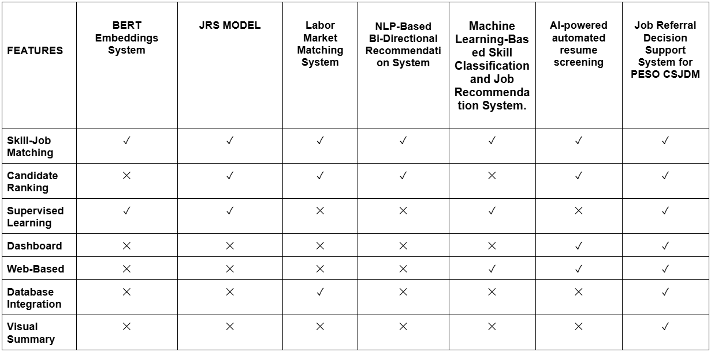
Comparison of Related Systems

Synthesis
Skills mismatch is a major challenge affecting employment efficiency, workforce alignment, and labor market outcomes when job seekers' competencies don't match the employers’ requirements. The studies utilized in the research highlighted that traditional methods of job matching rely on manual processes and incomplete data, which reduce efficiency and accuracy.
The studies collected for the research show that Artificial Intelligence (AI) and Machine Learning technologies can improve employment outcomes by analyzing the qualifications required in an employee, such as skills and other relevant factors. Additionally, these technologies can predict job compatibility and provide accurate job recommendation. Techniques such as supervised learning, Natural Language Processing, and recommendation algorithms enhance skill mapping and candidate ranking through data-driven analysis. Related systems demonstrates that Machine learning improves job matching and reduces manual workload. However, many existing systems lack an integrated platform that combines skill mapping, mediated job referral, predictive analysis, and career guidance, particularly for local public employment services. Therefore, the study proposes a web based supervised machine learning-driven skill mapping and job referral decision support system for PESO CSJDM to improve job matching, support data-driven decisions, and enhance employment services.

CHAPTER III
DESIGN AND METHODOLOGY
Requirement Analysis and Documentation
This section presents the functional and non-functional requirements of the system. This requirement defines the expected capabilities of the system to support the employment facilitation services of the Public Employment Service Office (PESO).
Functional Requirements
User Authentication | The system shall allow authorized users, particularly PESO staff, to securely log in and access the system using valid credentials. Also, shall include authentication mechanisms such as username and password verification to ensure that only authorized personnel can access sensitive applicants and job data.
Applicant Data Management | The system shall allow PESO staff to create, view, update, and manage applicant profiles. This includes storing personal information, educational background, skills, work experience, and other relevant data required for job matching.
Job Vacancy Data Management | The system shall allow PESO staff to manage job postings by adding, updating, viewing, and deleting job vacancy information. Each job entry shall include job requirements such as required skills, qualifications, and job descriptions.
Job Recommendation Processing | The system shall automatically generate job recommendations using a supervised machine learning model based on the applicant’s profile. The system shall analyze skills, education, and experience to match applicants with suitable job vacancies.
Applicant Ranking | The system shall rank applicants based on their suitability for a selected job vacancy. The ranking shall be generated using similarity scoring or model output to help PESO staff prioritize candidates for referral.
Explainable Recommendation | The system shall generate and display explanations for each job recommendation by identifying and presenting key factors such as matched skills, relevant experience, and qualifications that influenced the recommendation result.
Analytical Dashboard | The system shall provide a dashboard that displays summaries and visualizations such as applicant statistics, job matches, ranking results, and system analytics to assist PESO staff in decision-making.

Non-Functional Requirements
Performance | The system shall respond to user requests within an acceptable time frame. Job matching and recommendation results should be generated efficiently, even when processing multiple applicant records.
Security | The system shall implement security measures to protect sensitive data, including applicant personal information and system credentials. This includes secure login authentication, data validation, and protection against unauthorized access.
Usability | The system shall provide a user-friendly interface that is easy to navigate for PESO staff. The design shall ensure that users can efficiently perform tasks such as managing applicants, viewing job matches, and accessing analytics without requiring advanced technical skills.
Reliability | The system shall operate consistently and accurately without frequent failures. It shall ensure that data is correctly stored and retrieved, and that the machine learning model produces reliable job matching results.
Scalability | The system shall be capable of handling an increasing number of users, applicants, and job vacancies without significant degradation in performance. It should accommodate future expansion of data and functionalities.
Maintainability | The system shall be designed in a modular and organized manner to allow easy updates, debugging, and enhancements. This includes the ability to modify the machine learning model, update job matching logic, and maintain the database efficiently.

The system requirements for the proposed system were gathered through different methods to make sure the functions of the system will stay align with the operational needs of Public Employment Service Office (PESO).
Interview
The researcher will conduct interview with PESO staff to understand the current procedures in accepting applicant’s records, storing employer job vacancy information, and referring applicants to employers. Through these discussions, the researchers will be able to identify challenges such as manual evaluation of applicants, difficulty in identifying suitable applicants quickly, and limited analytical tool to support counselling sessions.
Observation
The researcher will conduct observation at PESO office to examine how staff handle applicant registration and how the referral process works. This helped the researchers understand the existing workflow and areas where automation and intelligent decision support could improve efficiency.

Dataset Profiling
The researcher will conduct dataset profiling to examine the structure, quality, and completeness of the historical applicant data obtain from Public Employment Service Office (PESO). This process is necessary to determine whether the available dataset is suitable for use in the proposed system.
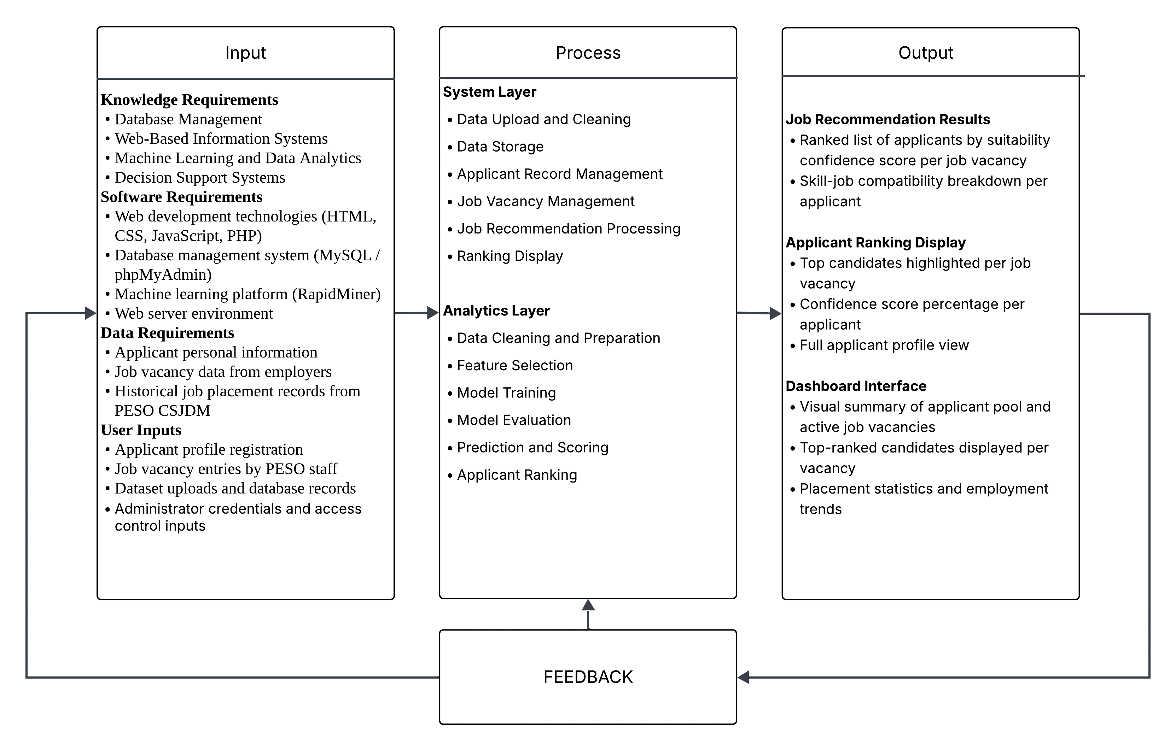
Conceptual Framework
Figure 1. Conceptual Framework
This figure shows the overall flow of the system using the Input-Process-Output model. To make everything work, the system relies on applicant records, job vacancy details, and historical placement data from PESO CSJDM, all built on top of web technologies like HTML, CSS, JavaScript, PHP, and MySQL, with RapidMiner used for developing the machine learning model. When PESO staff uploads a raw Excel file, the system automatically cleans and organizes the data, stores it in the database, and makes it ready for processing.
Once a job vacancy is entered, the analytics side kicks in, it identifies the most useful applicant features through Information Gain, runs them through three machine learning algorithms being Naïve Bayes, Decision Tree, and K-Nearest Neighbors, picks the best performing one, and uses it to score and rank every applicant based on how well they fit the job.
The output is a clean ranked list on the dashboard showing PESO staff exactly who among the applicants is the most qualified for the position, along with their confidence scores and profile details, making the referral process faster and far less guesswork. And as more placements get recorded and staff continue using the system, that feedback keeps feeding back into the model, making its recommendations sharper and more reliable over time.
Development Methodology
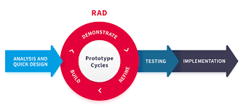
The researchers will use Rapid Application Development (RAD) as the software development methodology for building the web-based system, and the CRISP-DM (Cross-Industry Standard Process for Data Mining) framework for developing the machine learning model.
Figure 2. Rapid Application Development
RAD is a quick and iterative software development methodology that centers on continual user involvement through prototyping and feedback. Unlike the traditional Waterfall model, RAD allows developers to validate and refine requirements after each iteration based on product owner input before releasing the final version Khan, Fazal & Rasheed (2020).
For the analytics component, the researchers will adopt the CRISP-DM framework to guide the development of the machine learning model. CRISP-DM is the de-facto standard and an industry-independent process model for data mining projects, consisting of six iterative phases from business understanding to deployment. These six phases are Business Understanding, Data Understanding, Data Preparation, Modeling, Evaluation, and Deployment, will directly guide how the machine learning model for applicant ranking and job recommendation will be built, evaluated, and integrated into the web system Kruse and Gomez (2021).
Phase | RAD Activities | CRISP-DM Activities | Key Deliverable
Requirements Planning | Interviews, observation, data profiling, scope and user role definition | Define ML objective; identify target variable (Placed Position) | System requirements document, defined ML objective
User Design | System architecture, database schema (MySQL), UI wireframes, role-based access control | Collect historical PESO CSJDM placement records; analyze data types, distributions, and missing values | Database schema; UI wireframes, data profiling report
Construction | Develop frontend (HTML, CSS, JS), backend (PHP), MySQL database; build data cleaning module, applicant management, vacancy management, and recommendation display | Clean and structure dataset; apply Weight by Information Gain; train Naïve Bayes, Decision Tree, and K-Nearest Neighbors on 7 selected features | Functional system modules, trained ML models; feature weight results
Cutover | Unit testing, integration testing, user acceptance testing, system deployment on Apache via XAMPP | Evaluate models via 10-Fold Cross Validation; measure Accuracy, Precision, and Recall; integrate best model into web system backend | Deployed web system, final ML model, ranked applicant output

System Design
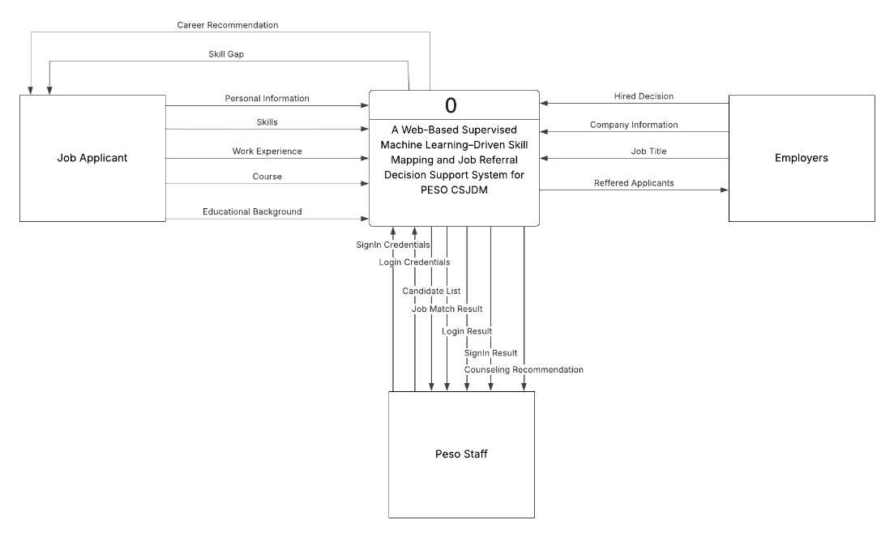
Context Diagram (Proposed)
Figure 3. Context Diagram (Proposed)
The Context Diagram shows the system as a unified entity interacting with external users, primarily PESO staff. It identifies the main inputs, which include applicant profiles and job vacancy information, and the outputs, such as job recommendations and ranked applicant lists. The diagram highlights how data enters the system, is processed through automated machine learning algorithms, and is presented on the dashboard, defining the overall boundary and scope of the system.
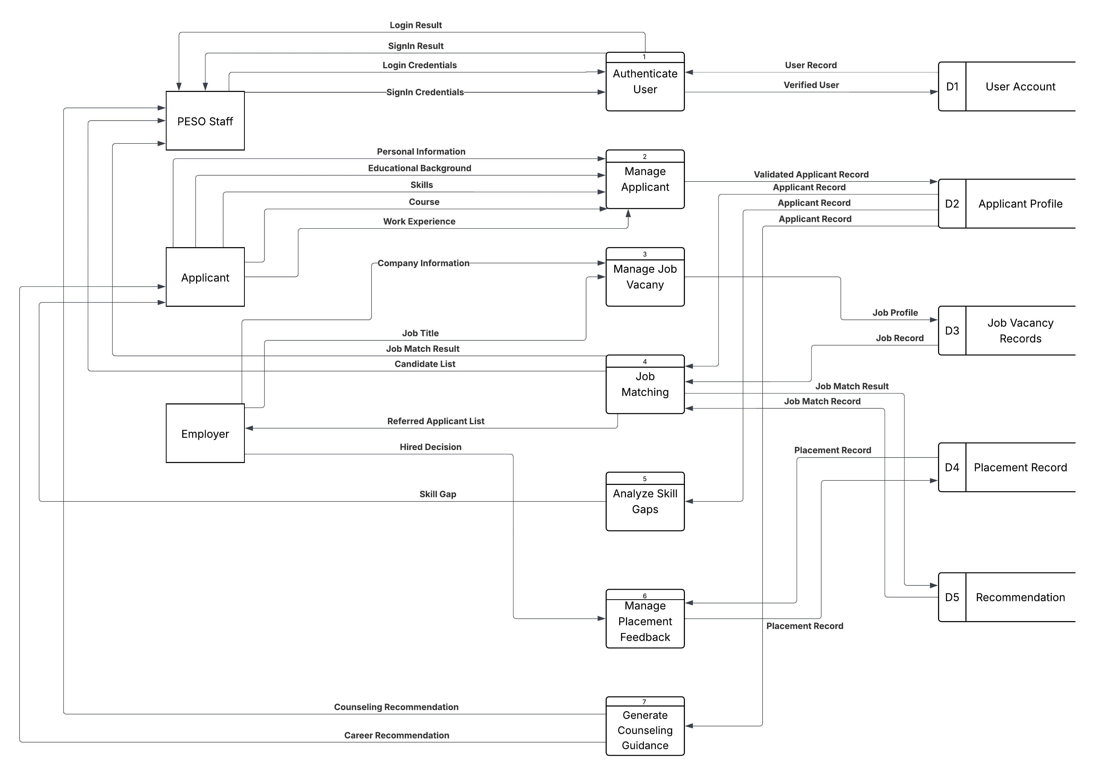
Data Flow Diagram – Level 1
Figure 4. Data Flow Diagram Level 1
The DFD Level 1 provides a detailed view of how data moves within the system. It decomposes the system into major processes, including applicant data management, job vacancy management, recommendation generation, and applicant ranking. It also illustrates how data is stored in the database and exchanged between these processes, demonstrating step-by-step the transformation of raw applicant and job data into actionable outputs for PESO staff.

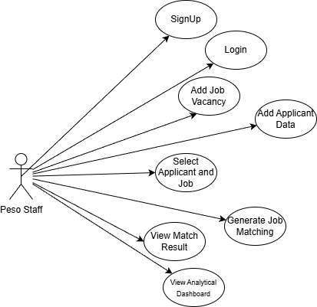
Use Case Diagram
Figure 5. Use Case Diagram
The Use Case Diagram presents the functionalities that PESO staff can access within the system. These include logging in securely, managing applicant profiles, managing job vacancies, generating job recommendations, and viewing the analytical dashboard. This diagram emphasizes the interactions between users and system functionalities, ensuring that all core operations required for employment facilitation are supported.
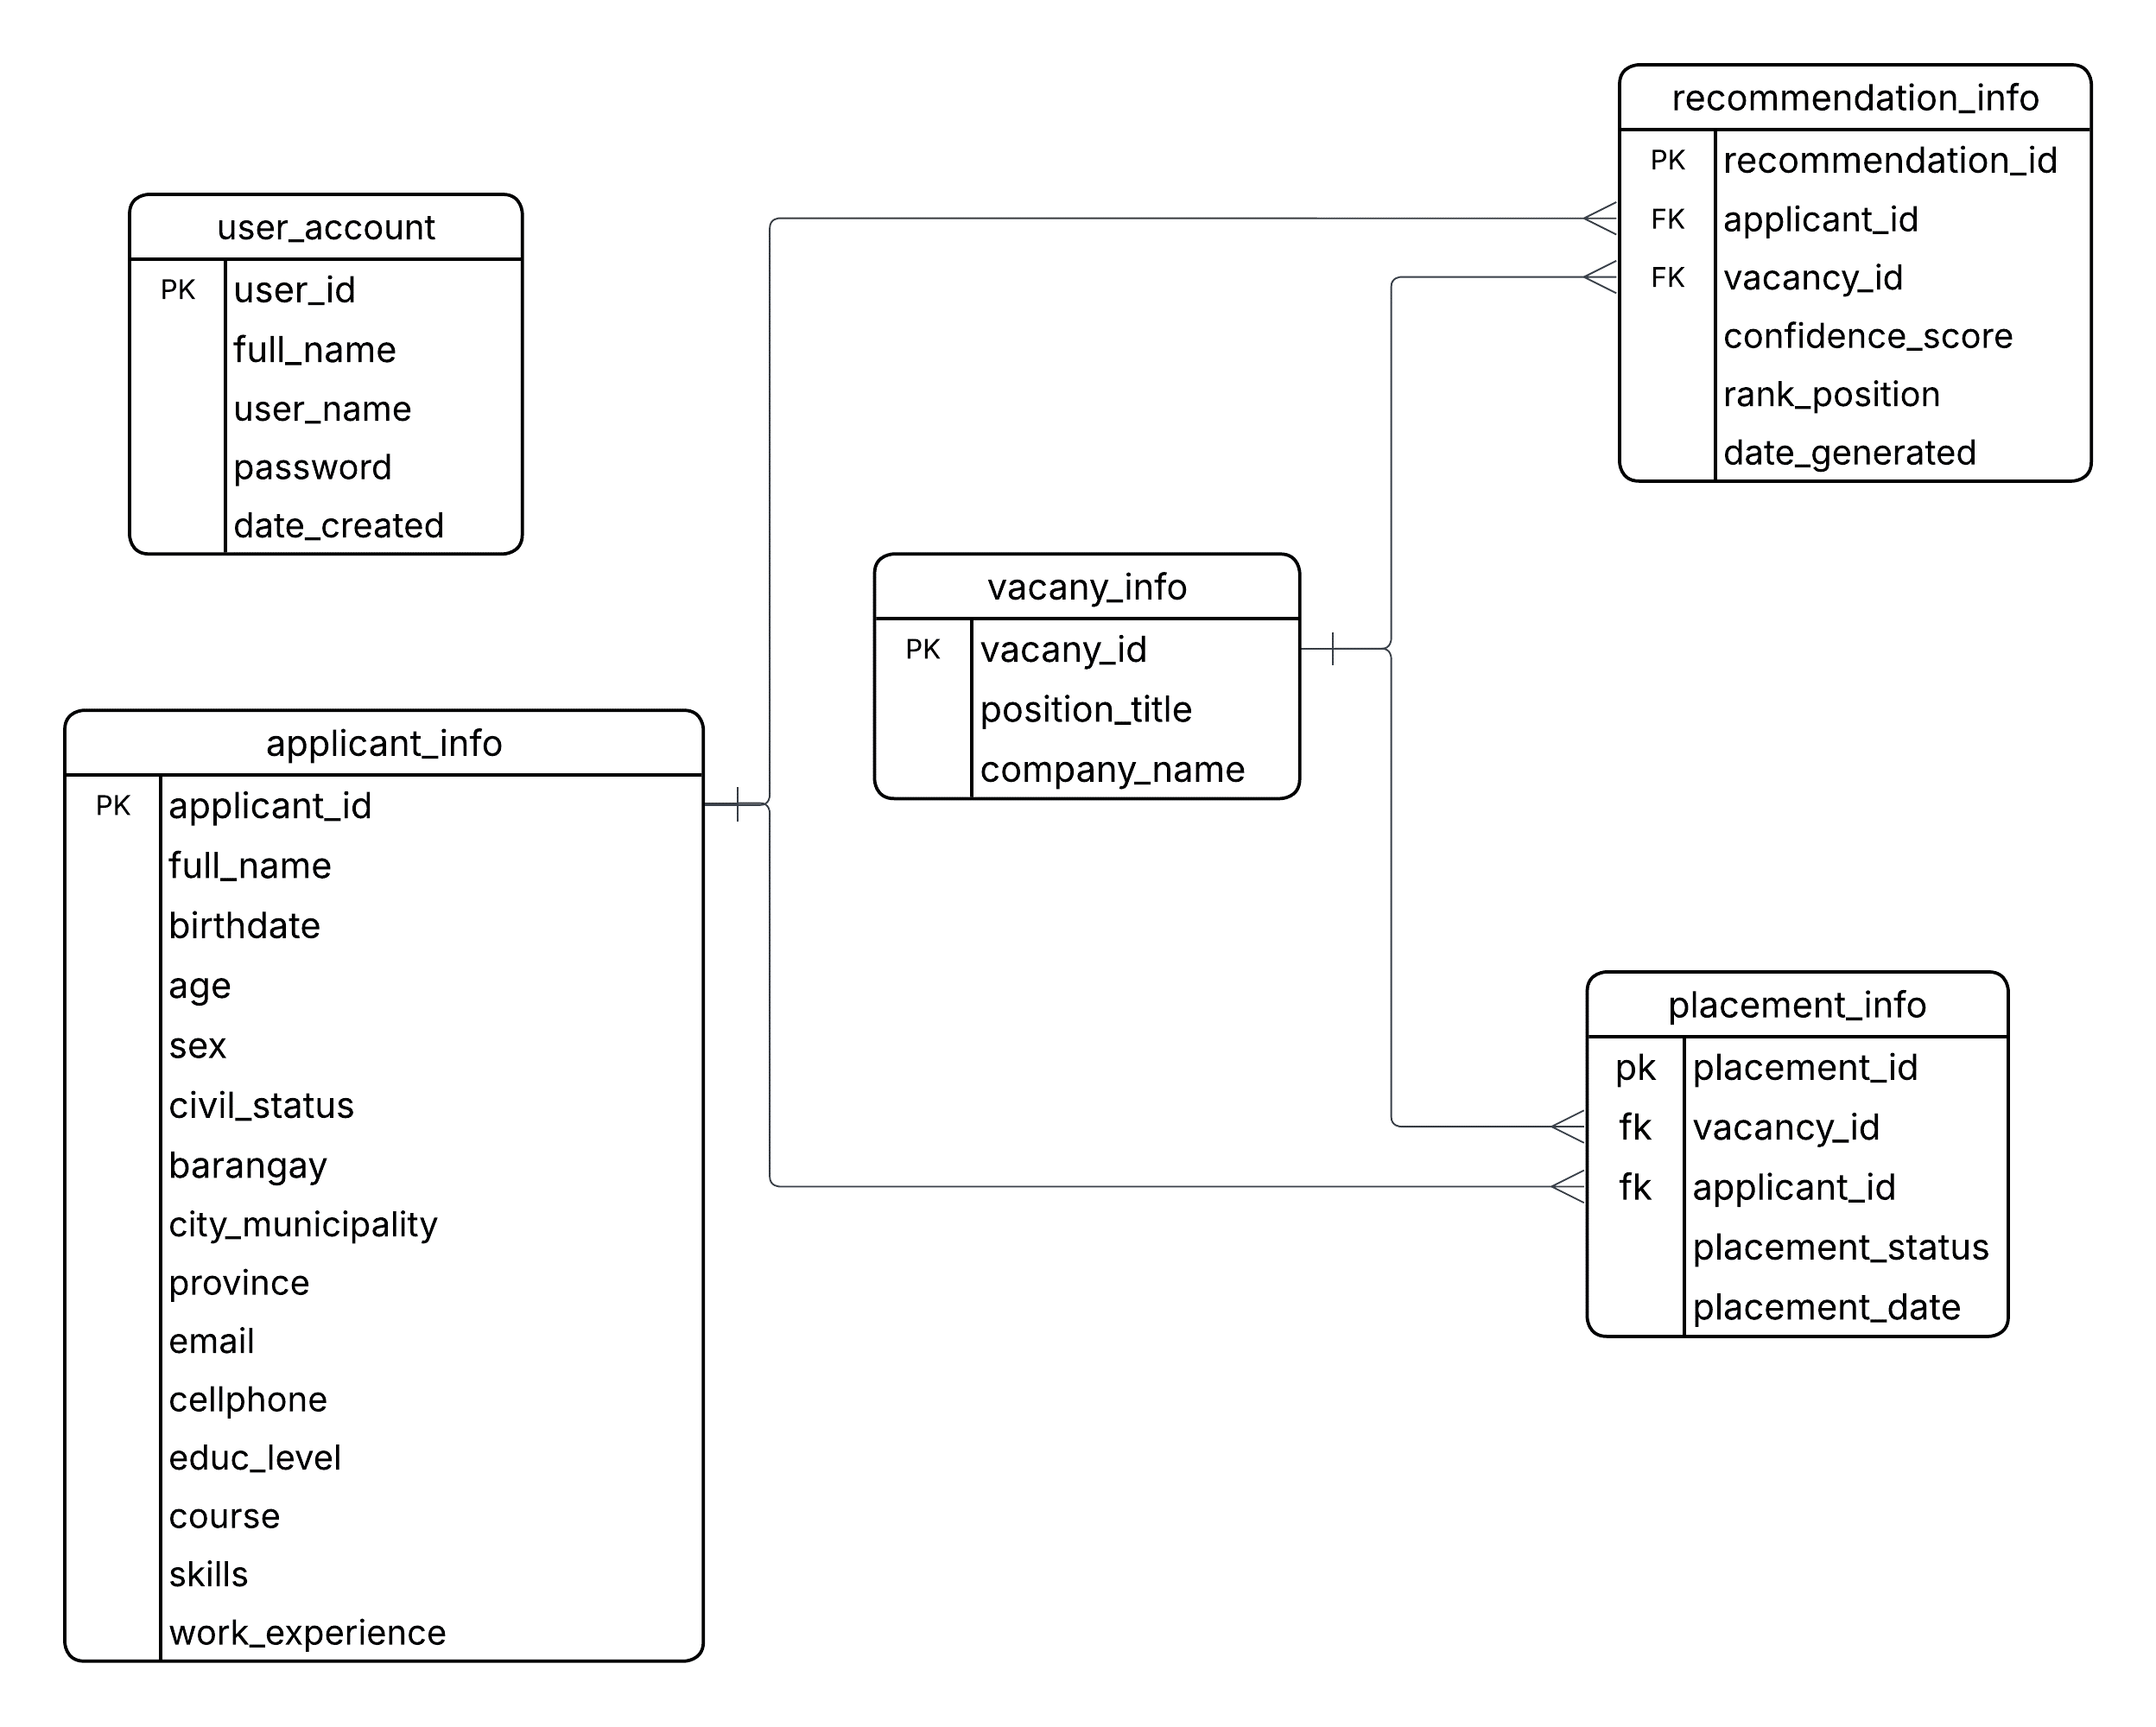
Entity Relationship Diagram (ERD)

Figure 6. Entity Relationship Diagram
The ERD depicts the database structure and relationships among entities such as Applicant, Job Vacancy, and Recommendation. Figure illustrates how applicant profiles are connected to job vacancies through the recommendation process, ensuring proper data organization, integrity, and retrieval. This design allows the system to efficiently store and process large volumes of applicant and job information for accurate matching.

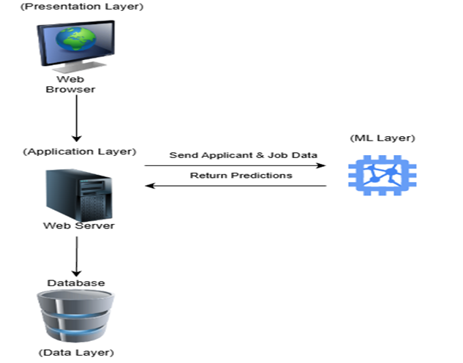
System Architecture Diagram
Figure 7. System Architecture Diagram
The System Architecture Diagram illustrates the technical components of the system, including the frontend (HTML, CSS, JavaScript), backend (PHP), database (MySQL), and the machine learning component (Python with Flask API). It shows how PESO staff interact with the user interface, how data is processed and stored, and how the machine learning model analyzes applicant and job data to produce reliable job recommendations.

Flowchart
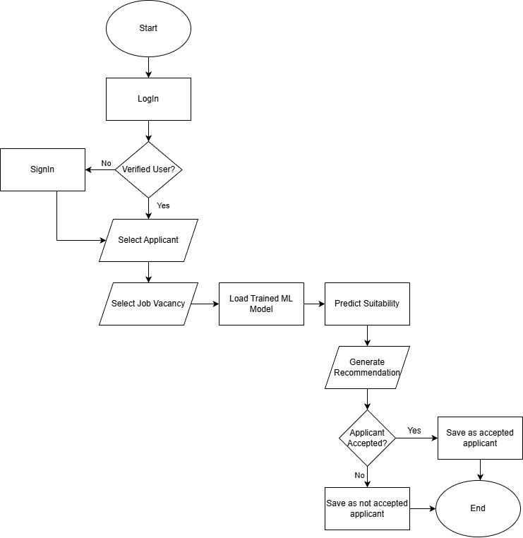
Algorithm Flowchart
Figure 8. Algorithm Flowchart
The Flowchart represents the sequential workflow of the system, starting from user login, followed by entering or updating applicant and job vacancy data, processing this information, generating job recommendations through the machine learning model, and displaying the results on the dashboard. This diagram ensures a clear understanding of the operational sequence and decision points in the system.
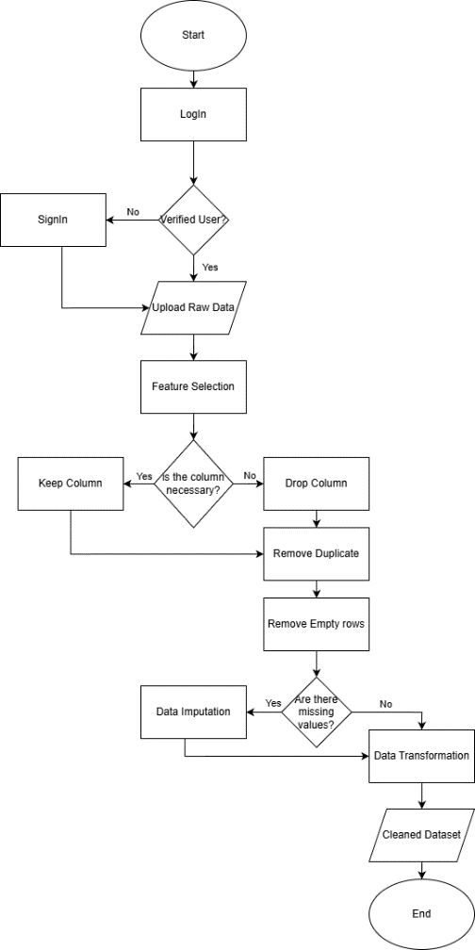
Data Pre-processing Flowchart

Figure 9. Data Pre-processing Flowchart
The Data Pre-Processing Flowchart focuses on preparing raw datasets for the machine learning component. Steps include uploading datasets, cleaning and organizing data, handling missing values, transforming data into the correct format, selecting relevant features using Information Gain, and preparing the data for model training. This ensures that the system’s machine learning algorithms can accurately and reliably generate applicant-job recommendations.
Mockups
- Homepage / Landing Page
Upon accessing the website, the homepage is the first interface presented to the user. It provides an option for PESO staff to log in, along with an overview of the system’s services available to PESO CSJDM users. Additionally, the page displays the organization’s contact information for accessibility and communication purposes.
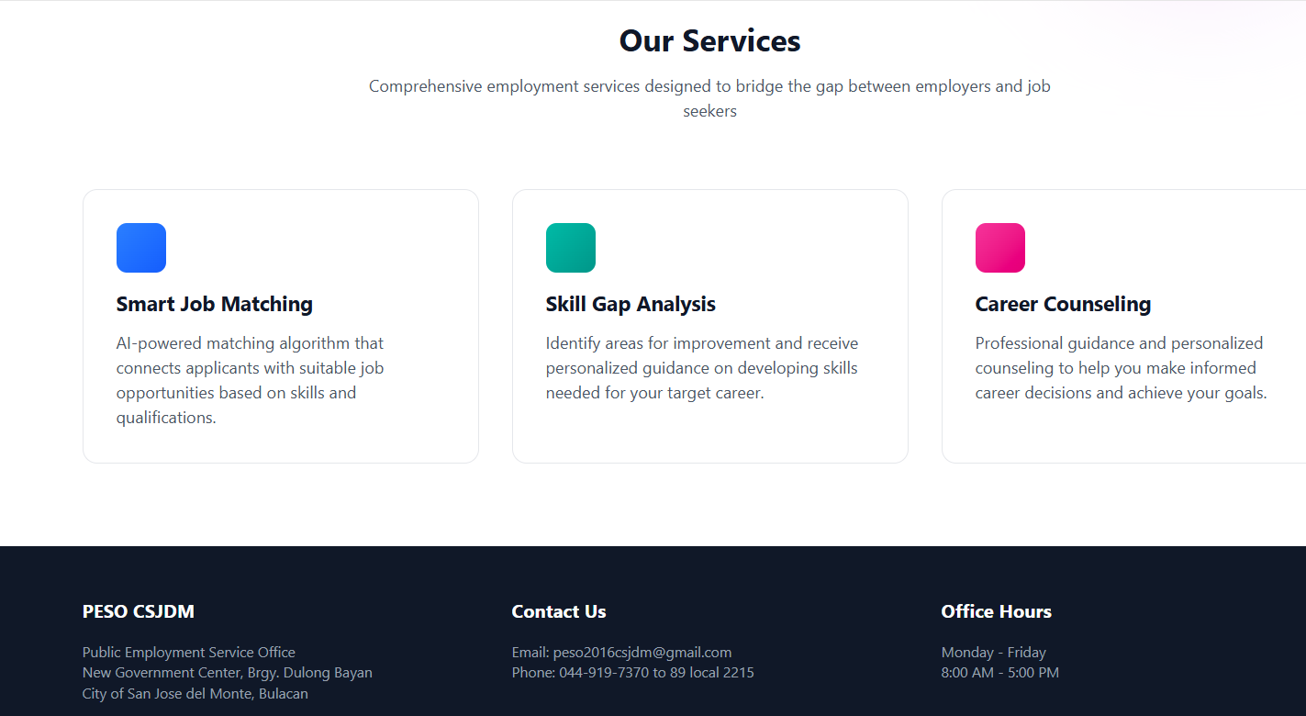

- Login Page
This page allows the PESO staff to securely access the system by entering their registered email and password. The system validates the credentials, and if incorrect information is entered, access will be denied to ensure security.

- Dashboard
The dashboard serves as the central interface where users can monitor and track system activities. It displays key data such as the total number of applicants, successful matches, active job vacancies, and pending reviews. It also includes graphical representations, such as charts, to illustrate monthly trends and overall system performance.
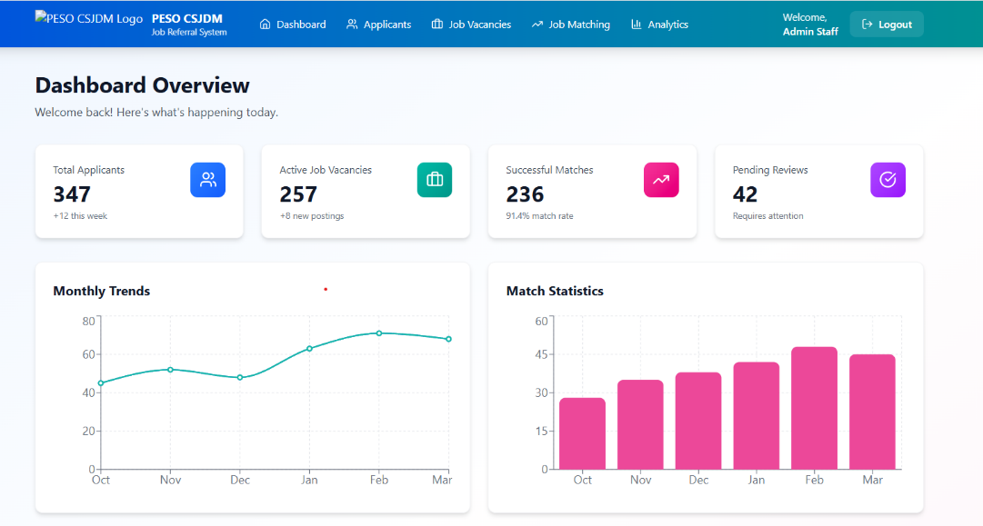
- Activity Logs and System Management Page
This section displays the user’s activity logs, showing all actions performed within the system. It also provides options for managing applicants, managing job postings, and generating job matches. Furthermore, it includes the system status, indicating whether the machine learning model is active, if the database is connected, and whether the system synchronization is functioning properly.
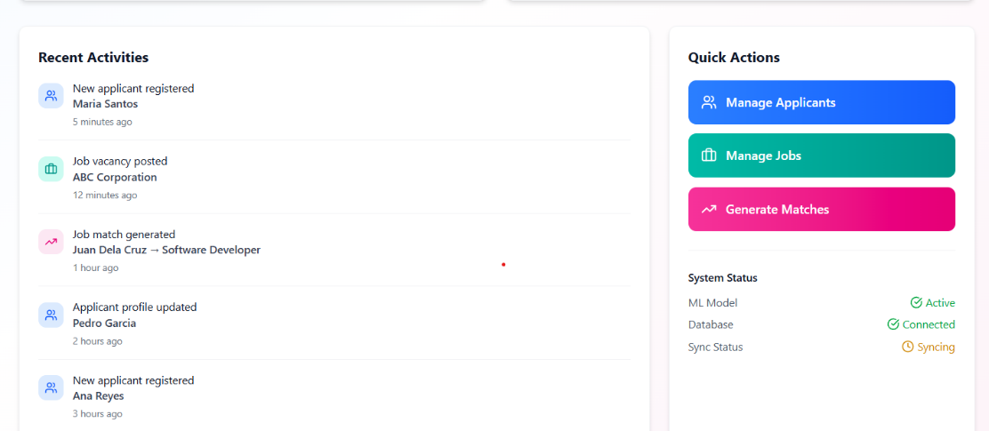

- Applicant Management Page
The Applicant Management page enables PESO staff to efficiently manage all registered job seekers within the system. It provides search and filtering tools to quickly locate applicants based on their name, email, or skills. The page also displays key summary data, including total applicants, active applicants, and successfully placed individuals. Additionally, detailed applicant information such as contact details, education, experience, and skills is presented, along with action options for viewing, editing, or deleting records.
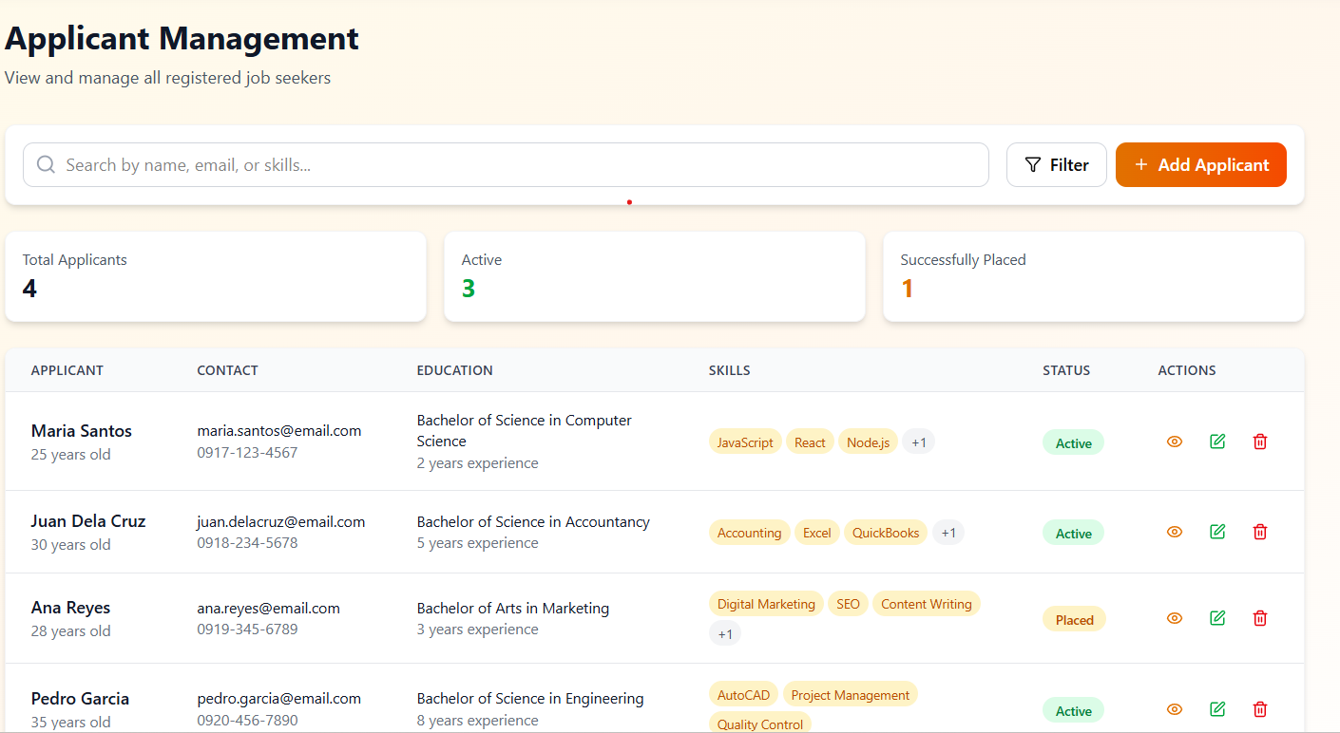
- Job Vacancy Management Page
The Job Vacancy Management page allows PESO staff to manage and monitor all job postings in the system. It includes a search function to easily find job listings based on specific criteria such as job title, company, or required skills. Summary information such as total vacancies, active postings, and filled positions is also displayed for quick reference. Each job listing contains essential details like job description, qualifications, salary range, and required skills, along with options to view, edit, delete, or generate matches for applicants.
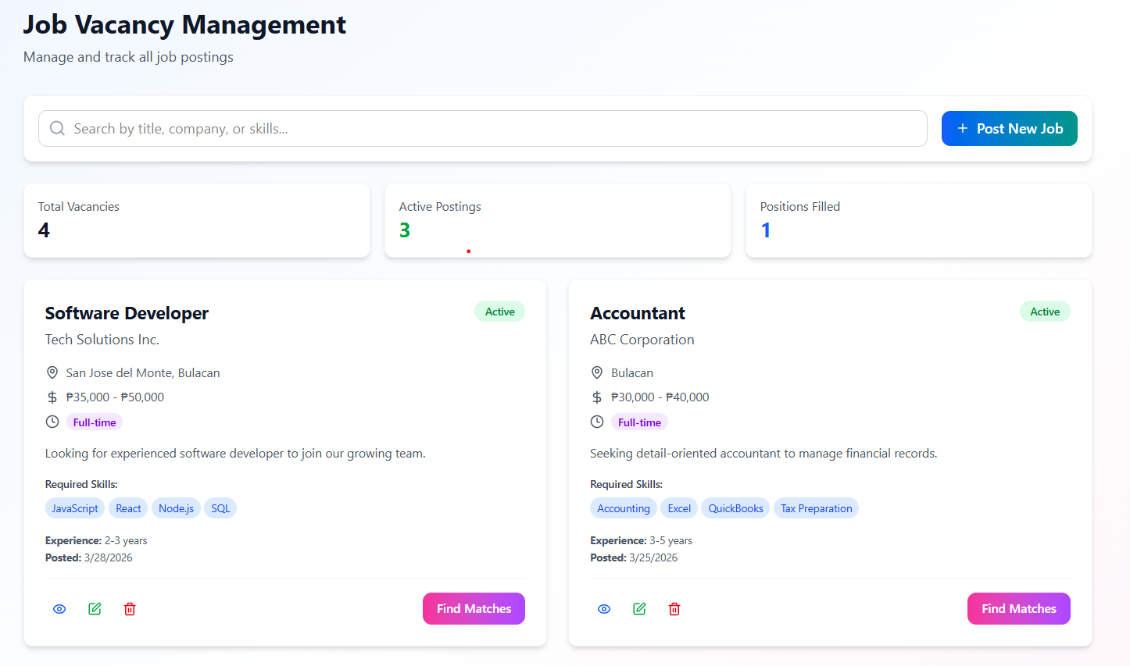
- AI-Powered Job Matching Page
The AI-Powered Job Matching page enables users to intelligently match applicants with available job vacancies based on their skills and qualifications. It provides a dual selection interface where users can browse and search applicants on one side and job postings on the other. Each applicant and job listing displays key details such as experience, education, and required skills to support accurate matching. The page also includes a “Generate Matches” feature that automatically identifies the most suitable candidates for a selected job, streamlining the recruitment process.
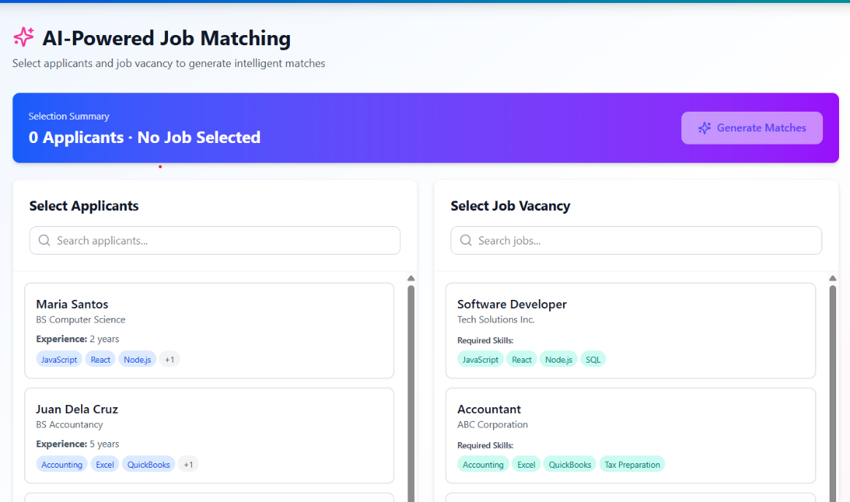
- Analytics Dashboard Page
The Analytics Dashboard page presents a comprehensive overview of the system’s data through visually organized summaries and charts. It displays key metrics such as total applicants, job postings, successful placements, and placement rates for quick performance monitoring. Additionally, it includes graphical representations of applicant demographics, such as sex distribution and civil status, to provide deeper insights. This page helps administrators analyze trends and make informed, data-driven decisions.
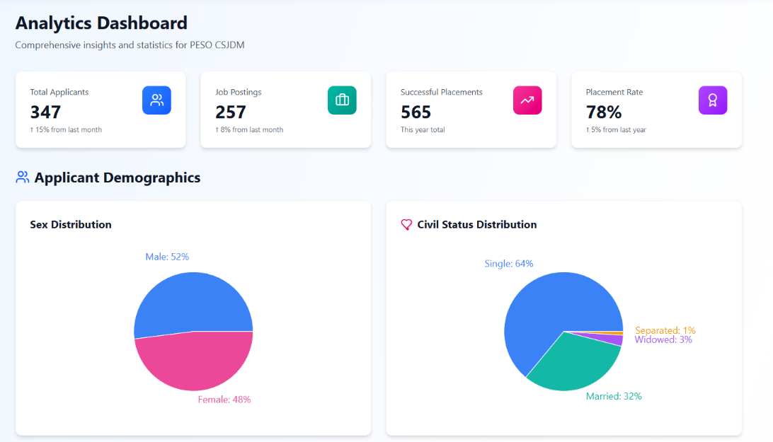
- Detailed Reports and Statistics Page
The Detailed Reports and Statistics page provides in-depth visual analysis of applicant data using various charts and graphs. It includes distributions of age groups and education levels, allowing users to understand the composition of applicants more clearly. Furthermore, it highlights the top course or degree programs, offering insights into the most common educational backgrounds. This page supports strategic planning by presenting detailed statistical information in a clear and accessible format.
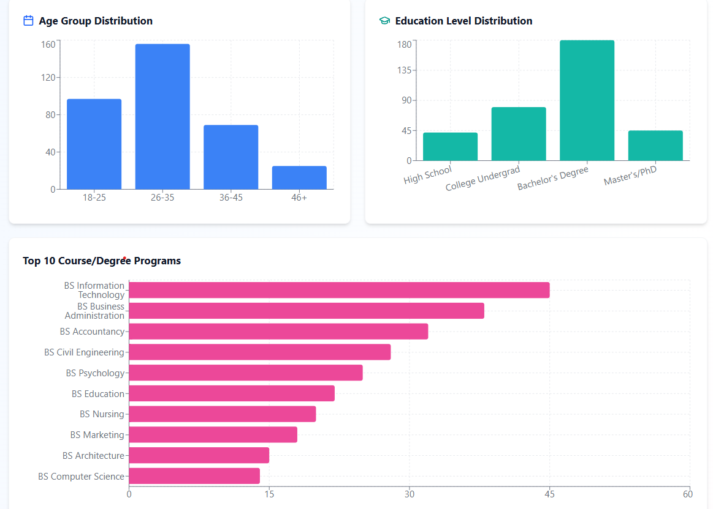
- Placement Analytics Dashboard
The Placement Analytics dashboard presents a comprehensive overview of employment outcomes through multiple data visualizations. It highlights top employers by placement count, allowing users to identify organizations with the highest hiring activity. Additionally, it showcases the most frequent job positions, providing insight into current labor market demands. The dashboard also includes a monthly placement trend, which illustrates fluctuations and growth in employment over time. Furthermore, the placement distribution by transaction type offers a clear understanding of the most effective recruitment channels.\
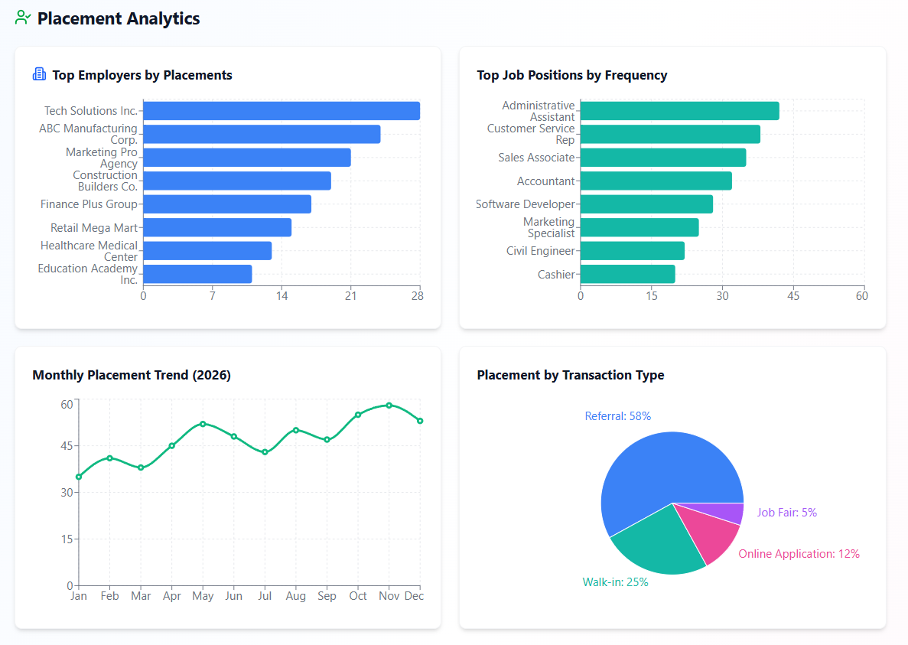
- Skills and Experience Analysis Page
The Skills and Experience Analysis page provides a detailed breakdown of the competencies and professional backgrounds of successfully placed applicants. It identifies the most common skills, such as technical and interpersonal abilities, which are highly valued by employers. The page also includes a work experience distribution chart, illustrating the range of experience levels among applicants. Additionally, it compares preferred job positions with actual placements, revealing alignment or gaps between applicant expectations and employment outcomes. This analysis supports better decision-making in training and career guidance initiatives.
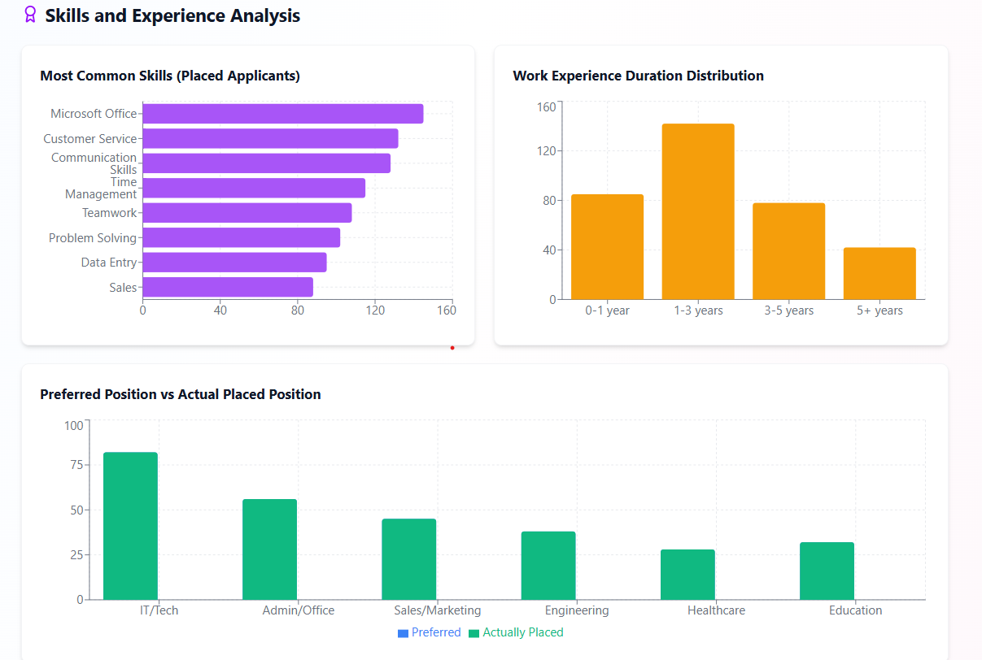
- Location Analytics
The Location Analytics page offers a geographic perspective on applicant placements within San Jose Del Monte, Bulacan. It features a barangay-level heat map that visually represents the concentration of successful placements across different areas. The intensity of the color coding indicates the volume of placements, enabling quick identification of high-performing locations. Moreover, the page summarizes key statistics such as the highest placement area, total barangays covered, and average placements per barangay. This geographic analysis aids in identifying priority areas for outreach and resource allocation.
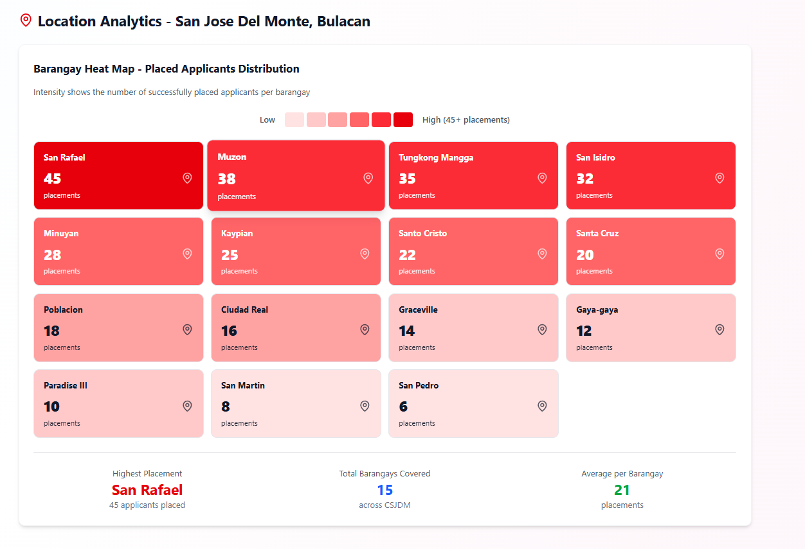
- Most In-Demand Jobs
The Most In-Demand Jobs section provides an overview of job positions with the highest applicant interest based on application volume. It highlights the top three most applied roles—Customer Service Representative, Administrative Assistant, and Sales Associate—along with their corresponding number of applications and average match scores. Additionally, a comprehensive bar chart presents all job roles ranked by application volume, offering a clear comparison of demand across positions. This feature enables users to quickly identify trending job opportunities and understand applicant preferences, supporting better decision-making for both job seekers and administrators in aligning skills with market demand.
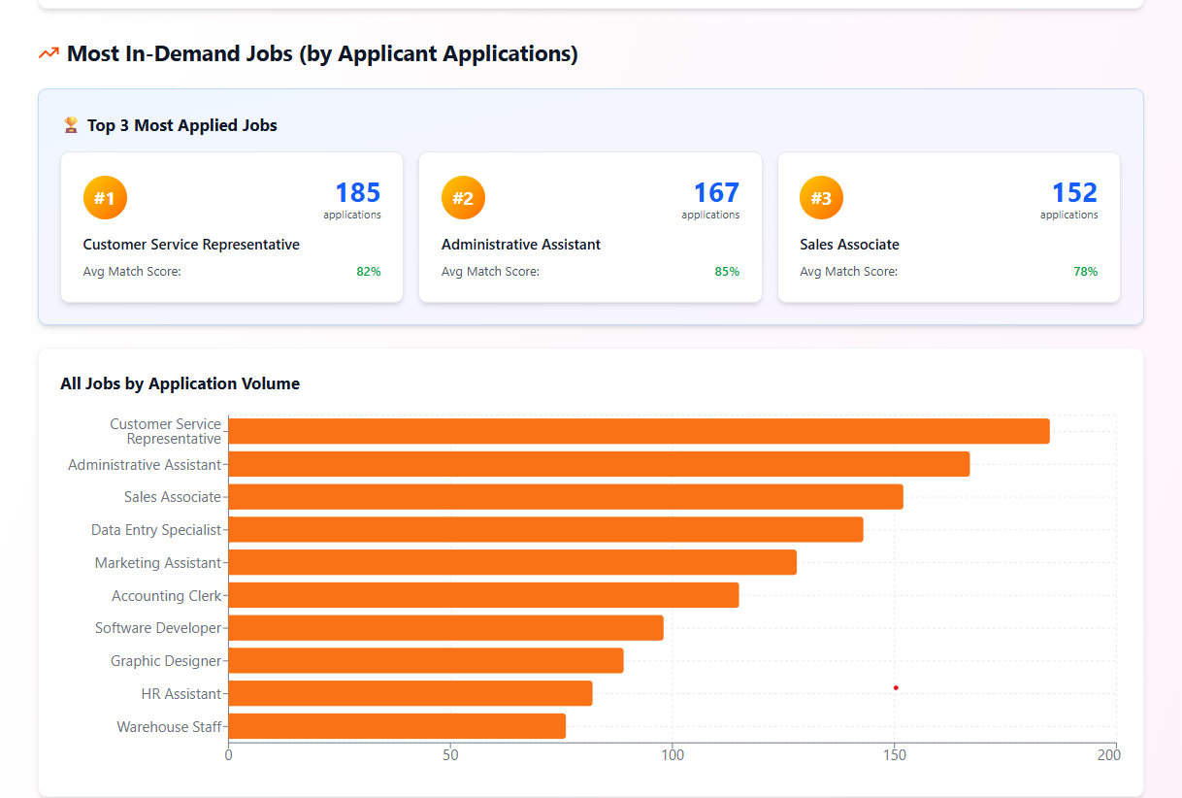
Tools, Technologies, and Development Environment
Category | Tool/Technology | Version | Justification
Frontend | HTML, CSS, JavaScript | Bootstrap 5 | Used to design a responsive and user-friendly interface for PESO staff. Bootstrap was chosen for its pre-built components and ease of use.
Backend | PHP | PHP 8+ | Handles server-side logic, data processing, and system functionalities. Chosen for its compatibility with MySQL and ease of integration in web systems.
Database | MySQL (phpMyAdmin) | MySQL 8+ | Used to store applicant data, job postings, and system records. Selected for its reliability, relational structure, and ease of management using phpMyAdmin.
Phyton / ML Libraries | Python, scikit-learn, Pandas, NumPy | Python 3.x | Used to develop the supervised machine learning model for job matching. Scikit-learn was chosen for its efficient classification algorithms.
Model Serving | Flask API | v2.3.3 | Used to connect the machine learning model with the web system. Enables real-time job matching predictions via API requests.
Jupyter Notebook | JupyterLab | V4.0.9 | Used for data preprocessing, model training, and testing. Chosen for its interactive environment and ease of visualization.
Data Visualization | Chart.js | v4.4.1 | Used to display charts and analytics (applicant ranking, matching results). Chosen for its simplicity and web compatibility.
Version Control | Git, GitHub | v2.43.0 | Used for tracking changes, collaboration, and backup of source code. GitHub provides remote repository management.
IDE / Code Editor | Visual Studio Code | v1.86+ | Used for coding and debugging. Chosen for its lightweight performance and extensive extension support.
Diagram Tools | draw.io | Web-based | Used to create system diagrams such as UML, DFD, and context diagrams. Chosen for its accessibility and ease of use.
UI/UX Design | Figma | Web-based | Used to design system interface prototypes and layouts before development.
Deployment | XAMPP | v8.2.12 | Used as a local server environment for testing (Apache, MySQL, PHP). Chosen for its all-in-one setup and ease of configuration.

Development Cost
MATERIAL COSTING
Materials | Description | Cost
Laptop/PC | Coding, Testing, ML Training | 32000
External Storage | For backup files and system files | 2000
Miscellaneous Supplies | Printing, Documentation, Etc. | 2000
Networking Equipment |  | 3000
PERSONNEL
1 System Analyst |  | 30000
1 Programmer |  | 27000
1 Project Manager |  | 30000
1 Quality Assurance |  | 24000
1 Documenter |  | 22260
SOFTWARE
Web Hosting Platform | /Year | 3000
Domain Name | /Year | 800
UTILITIES
Electricity |  | 1000
Internet |  | 1500
MAINTENANCE
System Maintenance | Weekly check-ups and remote support | 6000
Technical Support |  | 22000

Evaluation Methods
This section presents the evaluation procedures for the developed Web-Based Skill Mapping and Job Referral Decision Support System for PESO. The evaluation aims to determine both the technical quality of the system and its acceptability among users, particularly in the context of employment facilitation and job matching.
To ensure a comprehensive assessment, two evaluation models will be used, namely the ISO/IEC 25010 Software Product Quality Model and the Technology Acceptance Model (TAM)
Evaluation Using ISO/IEC 25010
The purpose of using the ISO/IEC 25010 model is to systematically evaluate the technical performance, efficiency, and overall quality of the developed Web-Based Supervised Machine Learning–Driven Skill Mapping and Job Referral Decision Support System for PESO. This ensures that the system meets acceptable standards in delivering accurate job matching, efficient processing, and reliable service to users.
The system will be evaluated based on the following seven (7) quality characteristics:
- Functional Suitability
This refers to the system’s ability to correctly perform its intended functions. For this study, it evaluates how accurately the system matches job applicants to appropriate job vacancies based on their skills, educational background, and work experience, and whether all required PESO functionalities are properly implemented.
- Performance Efficiency
These measures how efficiently the system processes data and responds to user actions. In this system, it focuses on the speed of generating job recommendations, loading applicant data, and handling multiple users without delays.
- Usability
This refers to how easy and user-friendly the system is for both PESO staff and job applicants. It evaluates the clarity of the interface, ease of navigation, and overall user experience, especially when submitting applicant data or reviewing job matches

- Reliability
This measures the system’s ability to perform consistently under specified conditions. For this system, it evaluates whether the platform can consistently generate accurate results, avoid crashes, and maintain stable operation during continuous use.
- Security
This refers to the system’s ability to protect user data and prevent unauthorized access. In this study, it evaluates how well the system secures applicant personal information, login credentials, and job-related data, ensuring confidentiality and data integrity.
- Maintainability
These measures how easy it is to modify, update, or improve the system. For this system, it focuses on the ease of updating the machine learning model, modifying system features, and maintaining the database structure.
- Portability
This refers to the system’s ability to run across different environments. In this study, it evaluates whether the system can be accessed through different web browsers and devices without performance issues.

Evaluators
The system will be evaluated by three (3) IT professionals with expertise in web development, database management, or machine learning systems.
A purposive sampling method will be used to ensure that the selected evaluators have sufficient technical knowledge and experience to properly assess the system.
Instrument
A structured evaluation questionnaire based on ISO/IEC 25010 quality characteristics will be used. Each item in the questionnaire will be rated using a 5-point Likert scale, defined as:
The instrument will include specific statements related to each quality characteristic of the system.
Process Overview
The evaluation process will be conducted as follows:
    - The system will be deployed and made accessible to the selected IT professional evaluators through a web-based interface.
    - Evaluators will be provided with test accounts and guided scenarios, such as:
      - Uploading and managing applicant profiles
      - Viewing and processing job vacancies
      - Generating job match recommendations
    - Each evaluator will interact with the system and assess its performance based on the given evaluation instrument.
    - After completing the evaluation, the responses will be collected, tabulated, and prepared for statistical analysis.
    - The results will be analyzed and presented in Chapter IV to determine the overall technical quality of the system
Evaluation Using Technology Acceptance Model (TAM)
The purpose of using TAM is to measure the user acceptance of the developed Web-Based Supervised Machine Learning–Driven Skill Mapping and Job Referral Decision Support System for PESO. Specifically, it evaluates how the system supports users in improving job matching processes and whether they are willing to adopt it for regular use in PESO operations
      - Perceived Usefulness (PU)
This refers to the degree to which users believe that the system enhances their performance. In this study, it evaluates whether the system helps:
    - PESO staff make better job referral decisions
    - Users quickly identify suitable job opportunities
    - Improve the efficiency and accuracy of applicant-job matching

      - Perceived Ease of Use (PEOU)
This refers to how easy the system is to use. In this study, it evaluates whether:
    - The system interface is clear and understandable
    - Users can easily input applicant data and navigate job recommendations
    - Minimal effort is required to learn and operate the system
      - Behavioral Intention to Use (BIU)
This refers to the likelihood that users will continue using the system. In this study, it evaluates whether:
- Users are willing to use the system regularly for job matching and referral
- PESO staff intend to integrate the system into their workflow
- Applicants are willing to rely on the system for job matching recommendations
Evaluators
The respondents will consist of 27 end users PESO staff who manage applicant data and job referrals.
A purposive sampling method will be used to ensure that only respondents with actual experience using the system are selected. This guarantees that feedback is based on real interaction rather than assumptions.
Instrument
A TAM-based questionnaire will be used to collect user responses. The instrument will contain statements aligned with the three TAM constructs (PU, PEOU, and BI), particularly focusing on the system’s job matching, skill mapping, and recommendation features.
Each item will be rated using a 5-point Likert scale:
- 5 – Strongly Agree
- 4 – Agree
- 3 – Neutral
- 2 – Disagree
- 1 - Strongly Disagree
The responses collected will be tabulated and analyzed in Chapter IV to determine the overall level of user acceptance of the system.
Data Handling and Analysis
Respondents and Population Description
The total population of the study (N) consists of two groups of respondents who will evaluate the system based on its technical quality and user acceptability.

- End-user respondents (TAM Evaluation):
A total of 27 respondents, composed solely of PESO staff, will be selected using purposive sampling. These respondents are personnel who directly interact with the system for applicant evaluation, skill mapping, and job referral decision-making, ensuring that the feedback is based on
- IT Professional Evaluators (ISO/IEC 25010 Evaluation):
A total of 3 IT professionals will be selected using purposive sampling. These evaluators must have expertise in web development, database systems, or machine learning, enabling them to assess the system’s technical quality.
Data Analysis
The collected data will be analyzed using a 5-point Likert scale, defined as follows:
- 5 – Strongly Agree
- 4 – Agree
- 3 – Neutral
- 2 – Disagree
- 1 – Strongly Disagree

Likert Scale Conversion Table
Rating Range | Interpretation
4.51 – 5.00 | Highly Acceptable
3.51 – 4.50 | Acceptable
2.51 – 3.50 | Moderately Acceptable
1.51 – 2.50 | Slightly Acceptable
1.00 – 1.50 | Not Acceptable

A rating of 4.51 to 5.00 indicates that the system is highly acceptable and effectively supports PESO operations, particularly in delivering accurate job matching, efficient applicant evaluation, and reliable decision support. Scores between 3.51 and 4.50 indicate that the system is acceptable and performs well with only minor improvements needed. Ratings from 2.51 to 3.50 suggest moderate acceptability, meaning that improvements are required in system features such as usability, performance, or matching accuracy. Scores between 1.51 and 2.50 indicate low acceptability, while 1.00 to 1.50 signify that the system does not meet the required standards for job matching and referral.
Statistical Treatment of Data
To analyze responses from both the ISO/IEC 25010-based questionnaire (technical evaluation) and the Technology Acceptance Model (TAM) questionnaire (user acceptance), the Arithmetic Mean (AM) will be used as the primary method of computation. This ensures that responses from Likert-scale surveys are quantified and summarized for interpretation.
Formula: $AM= \frac{\sum{(w_{i}f_{i})}}{n}$
Where:
        - $A M$= Arithmetic Mean
        - $w_{i}$= Likert scale weight (5 = Strongly Agree, 4 = Agree, 3 = Neutral, 2 = Disagree, 1 = Strongly Disagree)
        - $f_{i}$= Frequency of responses for each weight
        - $n$= Total number of respondents
Scope of Computation
The arithmetic mean will be computed for the following:
- Each questionnaire item
- Each ISO/IEC 25010 quality characteristic
- Each Technology Acceptance Model (TAM) construct
  - Perceived Usefulness
  - Perceived Ease of Use
  - Behavioral Intention
- The overall system evaluation score
Statistical Tools Used
The evaluation of the system will utilize statistical tools to analyze responses collected from both the ISO/IEC 25010-based questionnaire (for technical quality) and the Technology Acceptance Model (TAM)-based questionnaire (for user acceptance). These tools allow the researchers to quantify feedback from both technical evaluators and end users, enabling an objective assessment of the system’s overall quality, usability, and acceptance.
Frequency
This is used to count how many respondents selected each rating for every questionnaire item.
Percentage
This is used to determine the proportion of responses for each rating.
Formula: P = (F × 100) / N
Where:
    - P = Percentage of responses
    - F = Frequency of a particular rating
    - N = Total number of respondents
Weighted Mean
The weighted mean summarizes each questionnaire item into a single score by considering both the rating value and the number of respondents selecting it.

Algorithm Performance Metrics
The performance of the embedded algorithm will be evaluated independently from the system quality assessment conducted under ISO/IEC 25010 and the user acceptance evaluation conducted under TAM.
While ISO/IEC 25010 and TAM evaluate the system as a whole, the algorithm evaluation focuses specifically on how accurately and reliably the system performs skill mapping and job matching.
The system utilizes a classification-based machine learning algorithm (e.g., Random Forest, Decision Tree, or similar), as it predicts and ranks suitable job matches for applicants. The following metrics will be used:
    - Accuracy = (TP + TN) / (TP + TN + FP + FN)
    - Precision = TP / (TP + FP)
    - Recall (Sensitivity) = TP / (TP + FN)
    - F1-Score = 2 × (Precision × Recall) / (Precision + Recall)
Variable Definitions:
    - TP (True Positive): Correctly predicted job match
    - TN (True Negative): Correctly predicted non-match
    - FP (False Positive): Incorrectly predicted match (irrelevant job recommended)
    - FN (False Negative): Missed match (relevant job not recommended)
Only the metrics appropriate for the system’s algorithm type will be presented. Since the system uses a classification-based algorithm, only Accuracy, Precision, Recall, F1-Score, and the Confusion Matrix will be included in the analysis. The complete algorithm performance results, including evaluation tables and visualizations, will be presented and interpreted in Chapter IV.

REFERENCES
JOURNAL ARTICLES
Ajjam, M.‑H., & Al‑Raweshidy, H. S. (2025). AI‑driven semantic similarity‑based job matching framework for recruitment systems. Information Sciences. https://www.sciencedirect.com/science/article/pii/S0020025525008643
Alonso, R., Dessí, D., Meloni, A., & Recupero, D. R. (2025). A novel approach for job matching and skill recommendation using transformers and the O*NET database. Big Data Research, 39, 100509. https://doi.org/10.1016/j.bdr.2025.100509
Alsaif, S. A., Hidri, M. S., Eleraky, H. A., Ferjani, I., & Amami, R. (2022). Learning-based matched representation system for job recommendation. Computers, 11(11), 161. https://doi.org/10.3390/computers11110161
Alsaif, S. A., Hidri, M. S., Ferjani, I., Eleraky, H. A., & Hidri, A. (2022). NLP-based bi-directional recommendation system: Towards recommending jobs to job seekers and resumes to recruiters. Big Data and Cognitive Computing, 6(4), 147. https://doi.org/10.3390/bdcc6040147
Babashahi, L., Barbosa, C. E., Lima, Y., Lyra, A., Salazar, H., Argôlo, M., De Almeida, M. A., & De Souza, J. M. (2024). AI in the workplace: A systematic review of skill transformation in the industry. Administrative Sciences, 14(6), 127. https://doi.org/10.3390/admsci14060127
Babu, C., & Jafari, F. (2025). Empowering career development: A comprehensive AI-driven system for personalised guidance and recommendations. Cluster Computing, 28(16). https://doi.org/10.1007/s10586-025-05739-6
Bacay, J. B., Quiatchon-Legasp, R. P. I., Atienza, J. B., & Castro, C. (2025). Labor market assessment on skills and demand matching in Batangas City, Philippines. International Journal of Basic and Applied Sciences, 14(2), 665–677. https://doi.org/10.14419/kceqzm04
Bankins, S., Jooss, S., Restubog, S. L. D., Marrone, M., Ocampo, A. C., & Shoss, M. (2024). Navigating career stages in the age of artificial intelligence: A systematic interdisciplinary review and agenda for future research. Journal of Vocational Behavior, 153, 104011. https://doi.org/10.1016/j.jvb.2024.104011
Chaiaroon, P., Promrit, N., Sitdhisanguan, K., Waijanya, S., & Kanraweekultana, N. (2025). Digital workforce matching: A machine learning approach for skill-based job classification and recommendation. Journal of Current Science and Technology, 15(4), 137. https://doi.org/10.59796/jcst.v15n4.2025.137
D. Mhamdi2020. Job recommendation based on job profile clustering and job seeker behavior. Procedia Computer Science. https://www.sciencedirect.com/science/article/pii/S1877050920318020?utm_source
Faustino, G. M. A., Gabasa, M. L. G., & De Jesus, L. (2025). Systematic literature review on skill mismatch: Bridging the gap through educational leadership and industry collaboration. International Journal of Research and Innovation in Social Science, 9(5), 5151–5169. https://doi.org/10.47772/ijriss.2025.905000400
Farell, G., Latt, C. N. Z., Jalinus, N., Yulastri, A., & Wahyudi, R. (2024). Analysis of job recommendations in vocational education using the intelligent job matching model. JOIV: International Journal on Informatics Visualization, 8(1), 361. https://doi.org/10.62527/joiv.8.1.2201
Gülten, H., & Baraçlı, H. (2024). A machine learning-based forecast model for career planning in human resource management: A case study of the Turkish Post Corporation. Applied Sciences, 14(15), 6679. https://doi.org/10.3390/app14156679
Iorzua, J. T., Moses, T., Eke, C. I., Agushaka, O. J., Kwaghtyo, D. K., & Godswill, T. (2025). A machine learning-based approach to course and career recommendation system: A systematic literature review. Journal of Computing Theories and Applications, 3(1), 1–16. https://doi.org/10.62411/jcta.12603
Kamble, A., Tambe, S., Bansode, H., Joshi, S., & Raut, S. (2023). Job recommendation system for daily paid workers using machine learning. International Journal for Research in Applied Science and Engineering Technology, 11(4), 3086–3089. https://doi.org/10.22214/ijraset.2023.50876
Khatri, V., & Kumar, V. (2025). AI-powered automated resume screening and job matching system using NLP and machine learning. International Journal of Research in Engineering, Science and Management, 8(10), 58–62. https://journal.ijresm.com/index.php/ijresm/article/view/3367
Kotha, V. L. S., Varalakshmi, N., Prudhvi Raj, M., & Lakshmi Narayana, N. (2025). RESUME JOB MATCHER USING COSINE SIMILARITY. International Journal of Marketing Management, 13(4), 35–40. https://ijmm.in/index.php/ijmm/article/view/285?utm_so
Krishna Kumar, S., Ramaraj, E., Santhoshkumar, S., & Geetha, P. (2024). A decision tree with filter attribute selection model for designing an automated job recommender system for candidate matching through online recruitment. Journal of Theoretical and Applied Information Technology, 102(5). https://jatit.org/volumes/Vol102No5/30Vol102No5.pdf
Mendez, J. S., & Bulanadi, J. D. (2020). Job matcher: A web application job placement using collaborative filtering recommender system. International Journal of Research Studies in Education, 9(2). https://doi.org/10.5861/ijrse.2020.5810
Michael L. Uy (2025). Davao de Oro PESO bridges job seekers, employers. Philippine Information Agency. https://pia.gov.ph/news/davao-de-oro-peso-bridges-job-seekers-employers/
Mühlbauer, S., & Weber, E. (2026). Machine learning for labor market matching. Machine Learning With Applications, 23, 100861. https://doi.org/10.1016/j.mlwa.2026.100861
Public Employment Service Office. (n.d.).PESO Employment Information System (PEIS). https://peis.philjobnet.gov.ph/about.aspx
Sanguino, R., Uslu, N. Ç., Karahan-Dursun, P., Özdemir, C., Barroso, A., Sánchez-Hernández, M. I., & Gaga, E. O. (2025). Bridging the education–employment gap in Europe: An AI-driven approach to skill matching. World, 6(4), 143. https://doi.org/10.3390/world6040143
Soni, S., & Shah, S. (2025). Job recommendation systems through AI and machine learning. International Journal of Basic and Applied Sciences, 14(5), 735–742. https://doi.org/10.14419/pr5w2v12
Tang, F., Zhu, R., Yao, F., Wang, J., Luo, L., & Li, B. (2025). Explainable person–job recommendations: Challenges, approaches, and comparative analysis. Frontiers in Artificial Intelligence, 8, 1660548. https://www.frontiersin.org/journals/artificial-intelligence/articles/10.3389/frai.2025.1660548/full?utm
Yap, R. E., Haw, S. C., & Al-Juboori, S. (2025). A comprehensive review on machine learning-based job recommendation systems. International Journal on Robotics Automation and Sciences, 7(2), 36–55.https://doi.org/10.33093/ijoras.2025.7.2.5
PREPRINTS/WORKING PAPERS
Jirjees, A. K., Ahmed, A. M., Abdulla, A. A., Lu, J., Noori, E. M., Kareem, R. N., Hassan, B. A., Veisi, H., & Rashid, T. A. (2025). Machine learning for recruitment: Analyzing job-matching algorithms. TechRxiv. https://doi.org/10.36227/techrxiv.174240031.12397312/v1
Widodo, R. I. H., Herdiyanto, R. F., Thoriq, M., & Rahman, I. S. (2024). Job recommendation system combining collaborative filtering and content-based filtering. Preprints.org. https://doi.org/10.20944/preprints202407.1700.v1
Suleiman Ali Alsaif, Minyar Sassi Hidri, Hassan Ahmed Eleraky, Imen Ferjani, and Rimah Amami (2022). Learning-Based Matched Representation System for Job Recommendation. https://doi.org/10.3390/computers11110161
THESIS/INSTITUTIONAL REPORTS
Bayudan-Dacuycuy, C., Epetia, Ma. C. F., Vargas, A. R. P., Ocbina, J. J. S., & Philippine Institute for Development Studies. (2024). Inputs to the Philippine Labor Market Information System and TESDA’s skills anticipation and prioritization of skills requirements framework. https://pidswebs.pids.gov.ph/CDN/document/pidsdps2406.pdf
Pradhan, A. (2024). Employee–job profile matching challenges: AI/ML-based recommender systems solutions for knowledge workers (Doctoral dissertation, Macquarie University). https://doi.org/10.25949/25440139
World Bank. (2023). The use of advanced technology in job matching platforms: Recent examples from public agencies. https://thedocs.worldbank.org

