|  |
| --- |
| **Software Requirements Document**  Linea: Real-time production monitoring system that detects line stoppages, calculates losses, and alerts suppliers automatically |

|  |  |  |  |
| --- | --- | --- | --- |
| Software version this documentation corresponds to: | | | **Prelim** |
| S.E. in charge | *Luis M. Postigo*  ([lzp0040@auburn.edu](mailto:lzp0040@auburn.edu))  (postigolm@gmail.com) | Designer | Daniela F. Postigo  (danielaapostigoo@gmail.com) |
| Notes: | | | |
| Link to Project: <https://github.com/LuisPostigo/Linea> | | | |

# Introduction

## 1.1. Purpose

This document outlines the software requirements for Linea, a real-time production monitoring system designed to detect line stoppages, calculate associated financial losses, and automate the process of alerting responsible suppliers for potential liability. This system aims to enhance operational efficiency, reduce manual reporting overhead, provide real-time insights into production disruptions, and streamline the recovery of losses incurred due to supplier-related issues. This document serves as the definitive guide for the design, development, and testing of the Linea system.

## 1.2. Scope

Linea will encompass the monitoring of production lines through sensor data and manual operator input, real-time detection of stoppage events, automated calculation of financial losses (including material, production time, and potentially overhead), intelligent alerting of relevant stakeholders (internal teams and external suppliers), seamless integration with the existing SAP system for material cost data, comprehensive reporting and visualization of production performance and losses, and a robust supplier management and billing module. The initial scope will focus on cookie production lines but is designed with extensibility for future application across other product lines.

## 1.3. Intended Audience

This document is intended for the following stakeholders:

* **Development Team:** Provides the detailed requirements necessary for system design, implementation, and testing.
* **Product Management:** Defines the product vision, features, and priorities.
* **Quality Assurance Team:** Outlines the requirements for test planning and execution.
* **Operations Team:** Describes the system's operational aspects and integration with existing infrastructure.
* **Executive Stakeholders:** Provides a high-level understanding of the system's capabilities and business value.

# Overall Description

## 2.1. Product Perspective

Linea is envisioned as a critical, standalone yet integrated system within the company's operational technology (OT) and information technology (IT) landscape. It will interact with:

* **Production Line Hardware:** Sensors (PLCs, IoT devices) for real-time data acquisition.
* **Operator Interface Devices:** Tablets or dedicated terminals for manual event reporting.
* **SAP System:** For retrieving real-time material cost information.
* **Communication Infrastructure:** Email servers, SMS gateways for alerts.
* **User Interface:** Web-based application accessible to various user roles.
* **Potential Future Integrations:** Supplier portals, accounting systems.

Linea will operate continuously, providing real-time monitoring and event processing. Its modular design will allow for independent scaling and updates of individual components without impacting the entire system.

## 2.2. Product Functions

Linea will provide the following core functionalities:

* **Real-time Data Acquisition:** Securely ingest data from production line sensors and manual operator inputs.
* **Event Detection:** Intelligent identification of production line stoppages based on predefined rules and data analysis.
* **Event Logging:** Comprehensive and immutable logging of all production events with relevant details.
* **Loss Calculation:** Automated calculation of financial losses associated with each stoppage, incorporating downtime, production rate, material costs (from SAP), and potentially other configurable factors.
* **Alerting:** Real-time notification of stoppages and calculated losses to relevant internal teams and external suppliers based on configurable rules.
* **SAP Integration:** Seamless and secure retrieval of material cost data from the SAP system.
* **Reporting and Visualization:** Generation of customizable reports and interactive dashboards for analyzing production performance and losses.
* **Supplier Management:** Centralized management of supplier information and agreements.
* **Supplier Billing:** Automated generation and tracking of invoices for losses attributed to suppliers.
* **User Management and Authentication:** Secure role-based access control to all system features.
* 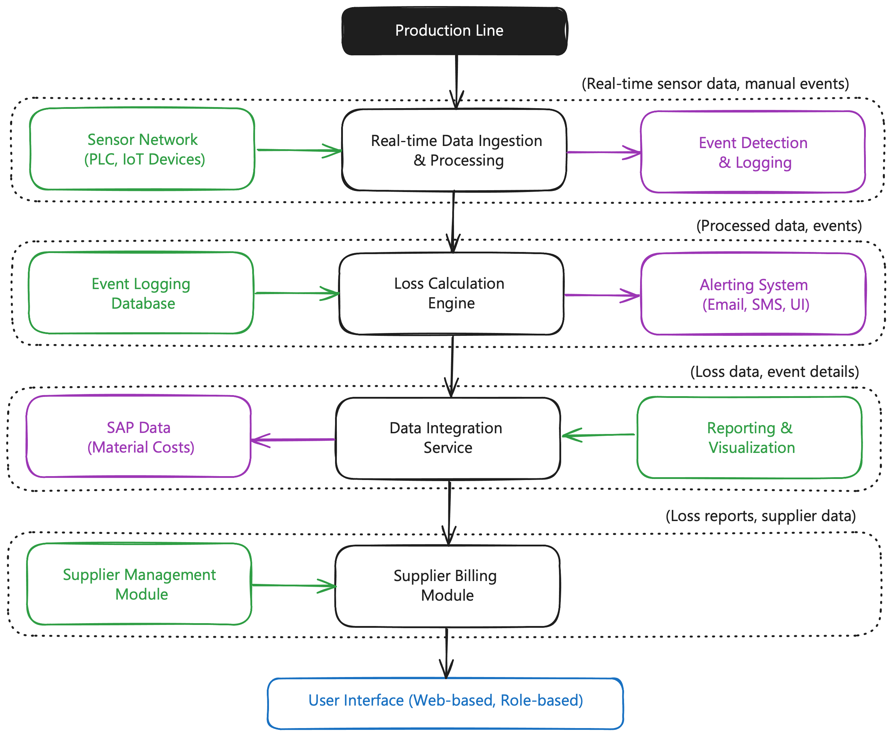**System Configuration:** Flexible configuration options for production lines, sensors, event detection rules, loss calculation parameters, alerting rules, and user roles.

**Figure 1**

Linea – Proposed Flow of events and functions

## 2.3. User Classes and Characteristics

* **Production Line Operators:** Require a simple and intuitive interface for reporting stoppage events and viewing real-time status. Minimal technical expertise expected.
* **Production Supervisors/Managers:** Need access to real-time dashboards, detailed event logs, and reporting capabilities to monitor line performance and identify issues. Moderate technical expertise expected.
* **Maintenance Personnel:** Require alerts and detailed information about machine-related stoppages for timely intervention. Moderate technical expertise expected.
* **Supply Chain Managers:** Need access to reports on supplier-related disruptions and the associated financial impact. Moderate technical expertise expected.
* **Accounting Personnel:** Require access to billing information and integration with financial systems. Moderate technical expertise expected.
* **System Administrators:** Responsible for system configuration, user management, security, and monitoring system health. High technical expertise required.

## 2.4. Operating Environment

Linea will be designed to operate in a distributed environment, potentially leveraging cloud infrastructure for scalability and reliability. Key aspects of the operating environment include:

* **Server Infrastructure:** Cloud-based (e.g., AWS, Google Cloud, Azure) or on-premise servers with sufficient computational resources and storage.
* **Network Connectivity:** Reliable and secure network connectivity between production lines, data ingestion points, servers, and user interfaces.
* **Database Systems:** High-performance and scalable database solutions.
* **Security Infrastructure:** Firewalls, intrusion detection systems, and secure authentication mechanisms.
* **SAP Connectivity:** Secure and reliable connection to the company's SAP system.

## 2.5. Design and Implementation Constraints

* **Modularity:** The system must be designed with a strong emphasis on modularity to allow for independent development, deployment, scaling, and maintenance of individual components.
* **Scalability:** The architecture must be horizontally scalable to handle increasing data volumes, event frequencies, and user loads without significant performance degradation.
* **Real-time Performance:** The system must process and react to production events in near real-time to provide timely alerts and accurate loss calculations.
* **Security:** Robust security measures must be implemented to protect sensitive production data, financial information, and prevent unauthorized access.
* **Data Integrity:** The system must ensure the accuracy and consistency of all recorded data, including event logs and calculated losses.
* **Integration with SAP:** Seamless and secure integration with the existing SAP system is mandatory.
* **User Experience:** The user interfaces must be intuitive, user-friendly, and tailored to the specific needs of each user role.
* **Technology Stack:** The technology stack should be chosen based on scalability, performance, security, and the team's expertise. Specific technology choices will be made during the architectural design phase.
* **Compliance:** The system must comply with relevant industry regulations and internal company policies regarding data privacy and security.

## 2.6. User Documentation

The following user documentation will be provided:

* **User Manual:** Comprehensive guide for all user roles, detailing system features and functionalities.
* **Operator Quick Start Guide:** Concise guide for production line operators on how to report events.
* **Administrator Guide:** Detailed instructions for system installation, configuration, user management, and maintenance.
* **API Documentation:** Documentation for any external APIs for integration purposes.

## 2.7. Assumptions and Dependencies

* Reliable network connectivity will be available across all production line locations.
* The SAP system will provide a stable and accessible API for retrieving material cost data.
* Accurate sensor data will be provided by the production line hardware.
* Production line operators will be adequately trained on how to use the manual event reporting interface.
* Supplier contact information and agreement details will be maintained in the Supplier Management Module or an integrated system.

# Specific Requirements

## 3.1.1. Real-time Data Acquisition (FR01)

* **FR01.01:** The system shall be capable of ingesting real-time data streams from various production line sensors (e.g., PLC data, IoT device readings) using industry-standard protocols (e.g., MQTT, OPC-UA, HTTP/S).
* **FR01.02:** The system shall provide a user interface for configuring and managing sensor connections and data mappings.
* **FR01.03:** The system shall allow authorized operators to manually input production stoppage events, including the start time, location (production line/machine), and a free-text description of the reason.
* **FR01.04:** The system shall record the timestamp of all ingested sensor data and manual events with millisecond precision.

## 3.1.2. Event Detection (FR02)

* **FR02.01:** The system shall be able to detect production line stoppages based on configurable rules applied to the real-time sensor data (e.g., prolonged periods of zero output, machine status changes).
* **FR02.02:** The system shall correlate manual operator-reported stoppages with sensor data to provide a comprehensive event record.
* **FR02.03:** The system shall allow administrators to define and manage event detection rules through a user-friendly interface. Rules should support various conditions (e.g., thresholds, durations, patterns).
* **FR02.04:** The system shall support the definition of different types of stoppage events (e.g., material blockage, mechanical failure, operator error) with associated severity levels.

## 3.1.3. Event Logging (FR03)

* **FR03.01:** The system shall persistently store all detected and manually reported production stoppage events in a secure and auditable log.
* **FR03.02:** Each event log entry shall include:
  + Unique event ID.
  + Start and end timestamps.
  + Production line and machine identifier.
  + Event type and reason (if available).
  + Operator who reported the event (if applicable).
  + Relevant sensor data snapshots before and during the event.
  + Status of the event (e.g., active, resolved).
* **FR03.03:** The system shall provide a query interface for authorized users to search and filter event logs based on various criteria (e.g., date range, production line, event type).

## 3.1.4. Loss Calculation (FR04)

* **FR04.01:** The system shall automatically calculate the duration of each production stoppage event.
* **FR04.02:** The system shall allow administrators to configure the standard production rate for each production line.
* **FR04.03:** The system shall calculate the number of lost production units based on the stoppage duration and the configured production rate.
* **FR04.04:** The system shall integrate with the SAP system (FR05) to retrieve the cost of the materials potentially lost or wasted during the stoppage, based on configurable parameters (e.g., material in process at the time of stoppage).
* **FR04.05:** The system shall allow administrators to configure optional cost factors to be included in the loss calculation, such as labor costs per minute of downtime and overhead rates.
* **FR04.06:** The system shall store the calculated loss amount (broken down by cost components) associated with each stoppage event.

## 3.1.5. SAP Integration (FR05)

* **FR05.01:** The system shall securely connect to the company's SAP system using appropriate authentication and authorization mechanisms.
* **FR05.02:** The system shall be able to query SAP for real-time or near real-time material cost information based on material codes or production order context.
* **FR05.03:** The system shall handle potential connectivity issues with the SAP system gracefully and provide appropriate error logging and notifications.
* **FR05.04:** The integration with SAP shall be configurable to adapt to changes in the SAP data structure or API.

## 3.1.6. Alerting (FR06)

* **FR06.01:** The system shall provide a configurable alerting mechanism to notify relevant internal users (e.g., production supervisors, maintenance) about detected production stoppages based on event type and severity.
* **FR06.02:** Alert notifications shall include key information about the stoppage, such as location, start time, duration (if resolved), and reason (if available).
* **FR06.03:** The system shall support multiple notification channels, including email, SMS, and in-app notifications.
* **FR06.04:** The system shall allow administrators to define alerting rules based on event type, severity, production line, and user roles.
* **FR06.05:** The system shall provide a mechanism to automatically alert designated suppliers about stoppages that are attributed to issues with their supplied materials (e.g., "High grain wheat blockage"). Supplier alerts shall include relevant details of the stoppage and the calculated losses.

## 3.1.7. Reporting and Visualization (FR07)

* **FR07.01:** The system shall provide a web-based interface for generating customizable reports on production performance and losses.
* **FR07.02:** Users shall be able to filter reports by various criteria, including date range, production line, event type, supplier, and loss amount.
* **FR07.03:** The system shall provide standard report templates (e.g., daily downtime summary, top loss-causing events, supplier performance report).
* **FR07.04:** The system shall support the export of reports in various formats (e.g., CSV, PDF).
* **FR07.05:** The system shall provide interactive dashboards displaying key performance indicators (KPIs) such as overall equipment effectiveness (OEE), total downtime, and total financial losses.
* **FR07.06:** The dashboards shall provide drill-down capabilities to view detailed information about specific events or trends.

## 3.1.8. Supplier Management (FR08)

* **FR08.01:** The system shall provide a module for managing supplier information, including contact details, material types supplied, and agreement terms.
* **FR08.02:** Authorized users shall be able to add, modify, and delete supplier records.
* **FR08.03:** The system shall allow associating specific materials or supply types with individual suppliers.

## 3.1.9. Supplier Billing (FR09)

* **FR09.01:** The system shall allow authorized users to attribute specific production stoppage events to responsible suppliers based on the reported cause.
* **FR09.02:** The system shall automatically generate invoices for suppliers based on the calculated losses associated with the attributed events, including details of the stoppage, lost production, and material costs.
* **FR09.03:** The system shall allow users to review and approve generated invoices before sending them to suppliers.
* **FR09.04:** The system shall track the status of generated invoices (e.g., sent, paid, overdue).
* **FR09.05:** The system shall support the export of billing information for integration with accounting systems.

## 3.1.10. User Management and Authentication (FR10)

* **FR10.01:** The system shall provide a secure user authentication mechanism with strong password policies.
* **FR10.02:** The system shall implement role-based access control (RBAC) to restrict user access to specific features and data based on their roles (e.g., operator, supervisor, administrator).
* **FR10.03:** The system shall maintain an audit log of all user logins and critical system actions.

## 3.1.11. System Configuration (FR11)

* **FR11.01:** The system shall provide an administrative interface for configuring various system parameters, including:
  + Production line definitions and associated sensors.
  + Event detection rules and thresholds.
  + Loss calculation parameters (production rates, labor costs, overhead rates).
  + Alerting rules and notification channels.
  + User roles and permissions.
  + SAP integration settings.

## 3.2. Non-Functional Requirements (NFR)

## 3.2.1. Performance Requirements (NFR01)

* **NFR01.01 (Real-time Data Processing):** The system shall process incoming sensor data and manual events with a latency of no more than 1 second under normal operating conditions.
* **NFR01.02 (Event Detection):** Production stoppage events shall be detected and logged within 5 seconds of the occurrence based on sensor data patterns.
* **NFR01.03 (Alerting):** Alert notifications shall be triggered and delivered to the appropriate recipients within 10 seconds of event detection.
* **NFR01.04 (Reporting):** Standard reports shall be generated within 30 seconds for typical data ranges.
* **NFR01.05 (Scalability):** The system shall be able to handle a 10x increase in the number of production lines and sensor data volume without a significant degradation in performance (latency within acceptable limits).

## 3.2.2. Security Requirements (NFR02)

* **NFR02.01 (Authentication):** The system shall enforce strong password policies (e.g., minimum length, complexity, regular changes) and support multi-factor authentication.
* **NFR02.02 (Authorization):** Role-based access control shall strictly enforce user permissions, ensuring that users can only access features and data relevant to their roles.
* **NFR02.03 (Data Encryption):** All sensitive data (e.g., financial information, user credentials) shall be encrypted both in transit (using TLS/SSL) and at rest (using industry-standard encryption algorithms).
* **NFR02.04 (Audit Logging):** All critical system actions, including logins, configuration changes, and data modifications, shall be logged in a secure and auditable manner.
* **NFR02.05 (Vulnerability Management):** The system shall be designed and developed following secure coding practices to mitigate common vulnerabilities (e.g., OWASP Top 10). Regular security audits and penetration testing shall be conducted.
* **NFR02.06 (SAP Security):** The integration with SAP shall adhere to the security protocols and best practices recommended by SAP and the company's IT security policies.

## 3.2.3. Reliability and Availability Requirements (NFR03)

* **NFR03.01 (Availability):** The system shall be designed for high availability, aiming for at least 99.9% uptime (excluding scheduled maintenance).
* **NFR03.02 (Fault Tolerance):** The system architecture shall incorporate fault-tolerant mechanisms to minimize the impact of component failures. Critical components should have redundancy.
* **NFR03.03 (Data Backup and Recovery):** A robust data backup and recovery strategy shall be implemented to prevent data loss in case of system failures. Recovery time objective (RTO) and recovery point objective (RPO) shall be defined.

## 3.2.4. Usability Requirements (NFR04)

* **NFR04.01 (Ease of Use):** The user interfaces shall be intuitive, user-friendly, and consistent across different modules.
* **NFR04.02 (Learnability):** The system should be easy for new users to learn and become proficient in using. Comprehensive user documentation and training materials shall be provided.
* **NFR04.03 (Accessibility):** The system should strive to meet accessibility standards (e.g., WCAG) to ensure usability for users with disabilities.
* **NFR04.04 (Error Handling):** The system shall provide clear and informative error messages to users.

## 3.2.5. Maintainability Requirements (NFR05)

* **NFR05.01 (Modularity):** The system's modular architecture shall facilitate independent development, testing, and deployment of individual components, making maintenance and updates easier.
* **NFR05.02 (Code Quality):** The codebase shall adhere to high coding standards, be well-documented, and follow best practices for maintainability.
* **NFR05.03 (Testability):** The system shall be designed to be easily testable at unit, integration, and system levels. Comprehensive test suites shall be developed and maintained.

## 3.2.6. Portability Requirements (NFR06)

* **NFR06.01 (Platform Independence):** While the initial deployment may target a specific cloud platform or on-premise infrastructure, the system architecture should strive for a degree of platform independence to facilitate potential future migrations.

# 4. External Interface Requirements

## 4.1. User Interfaces

* **Web-based UI:** A responsive web application accessible through standard web browsers for all user roles. The UI will provide role-specific views and functionalities as described in Section 2.3.
* **Operator Interface:** A simplified interface (potentially touch-screen based on tablets or dedicated terminals) for production line operators to report stoppage events.

## 4.2. Hardware Interfaces

* **Sensor Data Interface:** Interfaces for receiving data from various industrial sensors (PLCs, IoT devices) using protocols like MQTT, OPC-UA, or custom APIs. Specific hardware interface details will depend on the chosen sensor types.

## 4.3. Software Interfaces

* **SAP Integration API:** Secure API for communicating with the company's SAP system to retrieve material cost data. Details of the API endpoints and data formats will be defined in a separate integration specification.
* **Alerting Interfaces:** Interfaces for sending notifications via email (SMTP), SMS gateways (API), and potentially other communication channels.

# 5. System Evolution

The Linea system is envisioned to evolve over time with the following potential future enhancements:

* **Predictive Maintenance:** Integrating machine learning algorithms to predict potential equipment failures and prevent stoppages.
* **Advanced Analytics:** Implementing more sophisticated data analysis techniques to identify root causes of production issues and optimize processes.
* **Integration with other Enterprise Systems:** Connecting with MES (Manufacturing Execution Systems) or other relevant business applications.
* **Supplier Portal:** Providing a dedicated portal for suppliers to view performance data and manage billing information.
* **Mobile Applications:** Developing mobile apps for operators and supervisors to access real-time information and manage events remotely.

# 6. Glossary

* **API:** Application Programming Interface
* **KPI:** Key Performance Indicator
* **MES:** Manufacturing Execution System
* **OEE:** Overall Equipment Effectiveness
* **OPC-UA:** Open Platform Communications Unified Architecture
* **PLC:** Programmable Logic Controller
* **RPO:** Recovery Point Objective
* **RTO:** Recovery Time Objective
* **RBAC:** Role-Based Access Control
* **SAP:** Systems, Applications & Products in Data Processing
* **SMS:** Short Message Service
* **SMTP:** Simple Mail Transfer Protocol
* **TLS/SSL:** Transport Layer Security/Secure Sockets Layer
* **UI:** User Interface
* **WCAG:** Web Content Accessibility Guidelines

# 7. Appendix (To be added as needed)

* Data models
* API specifications
* Wireframes and mockups of user interfaces
* Security protocols in detail
* Performance testing plans