**Dismissible**

Se usa para deslizar de un lado a otro elementos de una lista y descartarlos.

Se le define un child, un background y un key:

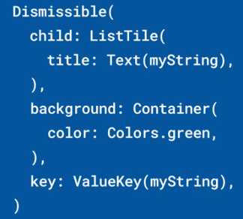

Si tenemos un widget con estado que crea un ListView, podemos usar el onDismissed para llamar a SetState y eliminar un elemento del Array que forma la lista:

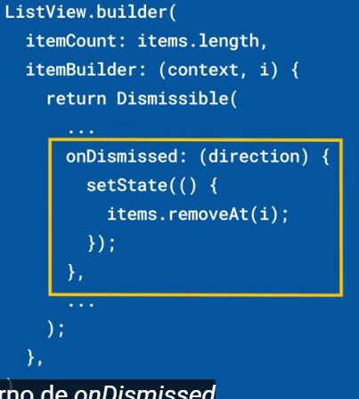

Con secondaryBackgroundpodemos descartar en varias direcciones

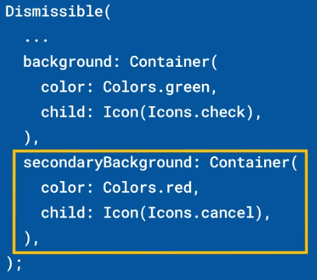

Con la propiedad direction podemos deslizar verticalmente:



|  |  |
| --- | --- |
| **Código** | **Comentarios** |
| final List<Map<String, dynamic>> people = [    {      "id": 1,      "first_name": "Malvin",      "last_name": "Allnutt",      "phone": "+7 (918) 739-5662",      "pinned": false    },    {      "id": 2,      "first_name": "Dorette",      "last_name": "Nisot",      "phone": "+256 (485) 646-6641",      "pinned": false    },    {      "id": 3,      "first_name": "Aliza",      "last_name": "Shuttleworth",      "phone": "+420 (884) 476-4943",      "pinned": true    },    {      "id": 4,      "first_name": "Nedi",      "last_name": "Wharmby",      "phone": "+66 (360) 381-1358",      "pinned": false    },    {      "id": 5,      "first_name": "Ambrosius",      "last_name": "Pierson",      "phone": "+62 (889) 685-2337",      "pinned": false    },    {      "id": 6,      "first_name": "Grant",      "last_name": "Hayley",      "phone": "+62 (313) 184-0649",      "pinned": true    },    {      "id": 7,      "first_name": "Caroljean",      "last_name": "Matthewman",      "phone": "+51 (738) 193-5505",      "pinned": false    },    {      "id": 8,      "first_name": "Layla",      "last_name": "Smardon",      "phone": "+86 (905) 328-9719",      "pinned": true    },    {      "id": 9,      "first_name": "Hamilton",      "last_name": "Jandac",      "phone": "+30 (679) 731-1705",      "pinned": false    },    {      "id": 10,      "first_name": "Baxter",      "last_name": "Minger",      "phone": "+86 (136) 506-6159",      "pinned": false    },    {      "id": 11,      "first_name": "Lammond",      "last_name": "Ruben",      "phone": "+62 (494) 976-9764",      "pinned": true    },    {      "id": 12,      "first_name": "Margeaux",      "last_name": "Trenaman",      "phone": "+55 (190) 103-4845",      "pinned": false    },    {      "id": 13,      "first_name": "Sergio",      "last_name": "Pomery",      "phone": "+7 (885) 600-6185",      "pinned": false    },    {      "id": 14,      "first_name": "Berke",      "last_name": "Tremmil",      "phone": "+48 (171) 521-2220",      "pinned": false    },    {      "id": 15,      "first_name": "Tamiko",      "last_name": "Tolmie",      "phone": "+237 (882) 151-7633",      "pinned": false    },    {      "id": 16,      "first_name": "Rafael",      "last_name": "McQuaide",      "phone": "+86 (341) 514-6779",      "pinned": false    },    {      "id": 17,      "first_name": "Jacquelin",      "last_name": "Waddingham",      "phone": "+234 (381) 866-6733",      "pinned": true    },    {      "id": 18,      "first_name": "Bard",      "last_name": "Semiras",      "phone": "+55 (114) 124-1441",      "pinned": false    },    {      "id": 19,      "first_name": "Griz",      "last_name": "Sunner",      "phone": "+86 (924) 267-8067",      "pinned": false    },    {      "id": 20,      "first_name": "Lezley",      "last_name": "Morriss",      "phone": "+86 (452) 484-8923",      "pinned": true    },    {      "id": 21,      "first_name": "Davidson",      "last_name": "Attwoull",      "phone": "+53 (428) 234-7645",      "pinned": true    },    {      "id": 22,      "first_name": "Bernie",      "last_name": "Oglethorpe",      "phone": "+677 (323) 480-1652",      "pinned": true    },    {      "id": 23,      "first_name": "Alyse",      "last_name": "Chesney",      "phone": "+7 (181) 327-1195",      "pinned": true    },    {      "id": 24,      "first_name": "Linn",      "last_name": "Josephi",      "phone": "+51 (232) 520-5454",      "pinned": true    },    {      "id": 25,      "first_name": "Alisun",      "last_name": "Wilkison",      "phone": "+86 (359) 139-4321",      "pinned": true    },    {      "id": 26,      "first_name": "Brynn",      "last_name": "Colquit",      "phone": "+62 (567) 480-9288",      "pinned": false    },    {      "id": 27,      "first_name": "Hi",      "last_name": "Bulward",      "phone": "+385 (686) 264-5540",      "pinned": true    },    {      "id": 28,      "first_name": "Meier",      "last_name": "Niese",      "phone": "+1 (512) 113-9285",      "pinned": true    },    {      "id": 29,      "first_name": "Iggie",      "last_name": "Leaman",      "phone": "+992 (909) 355-1048",      "pinned": true    },    {      "id": 30,      "first_name": "Carrie",      "last_name": "Toyne",      "phone": "+86 (212) 222-3023",      "pinned": true    },    {      "id": 31,      "first_name": "Joeann",      "last_name": "Ryhorovich",      "phone": "+1 (602) 169-2892",      "pinned": false    },    {      "id": 32,      "first_name": "Sawyer",      "last_name": "Dibb",      "phone": "+48 (716) 364-4895",      "pinned": true    },    {      "id": 33,      "first_name": "Tiffy",      "last_name": "Galliford",      "phone": "+249 (344) 803-3538",      "pinned": true    },    {      "id": 34,      "first_name": "Bartholomeo",      "last_name": "Bunson",      "phone": "+502 (977) 401-9323",      "pinned": true    },    {      "id": 35,      "first_name": "Kellen",      "last_name": "Lanaway",      "phone": "+63 (245) 893-5836",      "pinned": false    },    {      "id": 36,      "first_name": "Garwood",      "last_name": "Gerok",      "phone": "+86 (200) 175-4296",      "pinned": false    },    {      "id": 37,      "first_name": "Abby",      "last_name": "Blackston",      "phone": "+7 (703) 222-6771",      "pinned": true    },    {      "id": 38,      "first_name": "Kory",      "last_name": "Wilfing",      "phone": "+55 (215) 242-2671",      "pinned": false    },    {      "id": 39,      "first_name": "Lotti",      "last_name": "Chaulk",      "phone": "+7 (770) 243-8864",      "pinned": false    },    {      "id": 40,      "first_name": "Elana",      "last_name": "Styles",      "phone": "+86 (134) 626-3128",      "pinned": true    },    {      "id": 41,      "first_name": "Dacey",      "last_name": "Foulks",      "phone": "+387 (230) 677-2965",      "pinned": true    },    {      "id": 42,      "first_name": "Rozalie",      "last_name": "Folbig",      "phone": "+54 (189) 416-3367",      "pinned": true    },    {      "id": 43,      "first_name": "Guendolen",      "last_name": "Birtonshaw",      "phone": "+86 (734) 234-9235",      "pinned": true    },    {      "id": 44,      "first_name": "Ham",      "last_name": "Hullett",      "phone": "+51 (301) 547-4985",      "pinned": false    },    {      "id": 45,      "first_name": "Merrill",      "last_name": "Gascoine",      "phone": "+86 (272) 362-0809",      "pinned": false    },    {      "id": 46,      "first_name": "Kasey",      "last_name": "Jaggi",      "phone": "+86 (816) 233-7371",      "pinned": true    },    {      "id": 47,      "first_name": "Sella",      "last_name": "Jeckells",      "phone": "+57 (919) 183-1412",      "pinned": true    },    {      "id": 48,      "first_name": "Caty",      "last_name": "Romke",      "phone": "+62 (175) 686-3506",      "pinned": true    },    {      "id": 49,      "first_name": "Tamas",      "last_name": "Strangwood",      "phone": "+52 (502) 488-8391",      "pinned": false    },    {      "id": 50,      "first_name": "Luis",      "last_name": "Núñez",      "phone": "+54 (351) 681-4963",      "pinned": true    }  ]; |  |

|  |  |
| --- | --- |
| **Código** | **Comentarios** |
| import 'package:flutter/material.dart';  import 'package:widgetsoftheweek/data/people.dart';  class DismissibleScreen extends StatefulWidget {    const DismissibleScreen({Key? key}) : super(key: key);    @override    State<DismissibleScreen> createState() => _DismissibleScreenState();  }  class _DismissibleScreenState extends State<DismissibleScreen> {  //-------------------------------------------------------------------  //---------------------- Inicialización de variables  ---------------  //-------------------------------------------------------------------    List<Map<String, dynamic>> contacts = [...people];  //-------------------------------------------------------------------  //---------------------- Pantalla -----------------------------------  //-------------------------------------------------------------------    @override    Widget build(BuildContext context) {      return Scaffold(       appBar: AppBar(          title: const Text('Dismissible'),          centerTitle: true,        ),        body: ListView.separated(          itemCount: contacts.length,          separatorBuilder: (_, __) => const Divider(            color: Colors.black26,            height: 2,          ),          itemBuilder: (_, int index) => ListItem(            contact: contacts[index],            index: index,            onDeleteContact: onDeleteContact,            onTooglePinned: onTooglePinned,          ),        ),      );    }  //-------------------------------------------------------------------  //---------------------- onTooglePinned -----------------------------  //-------------------------------------------------------------------    void onTooglePinned(int index) {      setState(() {        contacts[index]['pinned'] = !contacts[index]['pinned'];      });    }  //-------------------------------------------------------------------  //---------------------- onDeleteContact ----------------------------  //-------------------------------------------------------------------    void onDeleteContact(int index) {      setState(() {        contacts.removeAt(index);      });    }  }  // ****************************** FIN DE LA CLASE *******************  //-------------------------------------------------------------------  //---------------------- class ListItem -----------------------------  //-------------------------------------------------------------------  class ListItem extends StatelessWidget {    const ListItem(        {Key? key,        required this.contact,        required this.index,        required this.onTooglePinned,        required this.onDeleteContact})        : super(key: key);    final Map<String, dynamic> contact;    final int index;    final Function onTooglePinned;    final Function onDeleteContact;    @override    Widget build(BuildContext context) {      return Dismissible(        key: UniqueKey(),        background: Container(          color: Colors.red[400],          child: const Icon(            Icons.delete_outline_rounded,            color: Colors.white,          ),          alignment: Alignment.centerLeft,          padding: const EdgeInsets.only(left: 10),        ),        secondaryBackground: Container(          color: Colors.blue[400],          child: const Icon(            Icons.push_pin_outlined,            color: Colors.white,          ),          alignment: Alignment.centerRight,          padding: const EdgeInsets.only(right: 10),        ),        onDismissed: (direction) {          if (direction == DismissDirection.startToEnd) {            onDeleteContact(index);          }        },        confirmDismiss: (direction) async {          //Pinned o Toggle          if (direction == DismissDirection.endToStart) {            onTooglePinned(index);            return false;          }          return true;        },        child: ListTile(          leading: Icon(contact['pinned']              ? Icons.push_pin_outlined              : Icons.circle_outlined),          title: Text('${contact['first_name']} ${contact['last_name']}'),          subtitle: Text(contact['phone']),          //dense: true,        ),      );    }  } |  |

Así se ve:

- - - - - - - - - - - - - - - - - - - - - - - - - - - - - - - - - - - - - - - - - - - - - - - - - - - - - - - - - - - - - - - - - - - - - - - - - - - - - - - - - - - - - - - - - - - - - - - - - - - - - - - -