**AnimatedCrossFade**

Hace un Fade entre dos widgets.

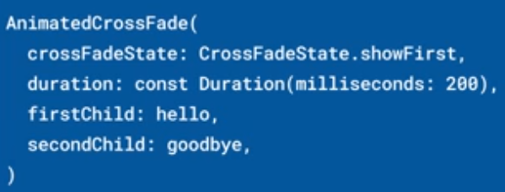 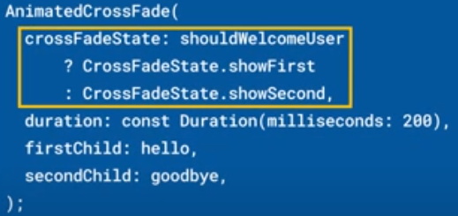

Si los widgets tienen tamaños iguales funciona muy bien.

Si los widgets tienen tamaños específicos hay que proporcionar un layoutBuilder personalizadopara evitar saltos en el diseño

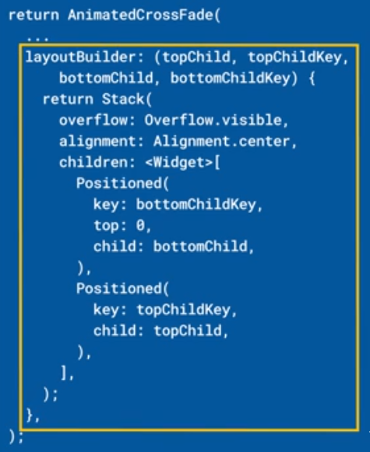

Se pueden configurar diferentes Curves, para tamaño y para desvanecimiento:

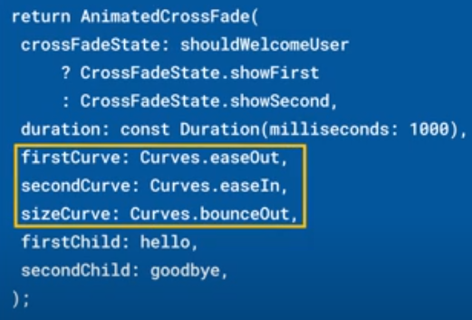

|  |  |
| --- | --- |
| **Código** | **Comentarios** |
| import 'package:flutter/material.dart';  class AnimatedCrossFadeScreen extends StatefulWidget {    const AnimatedCrossFadeScreen({Key? key}) : super(key: key);    @override    State<AnimatedCrossFadeScreen> createState() =>        _AnimatedCrossFadeScreenState();  }  class _AnimatedCrossFadeScreenState extends State<AnimatedCrossFadeScreen> {    bool state = true;    @override    Widget build(BuildContext context) {      return Scaffold(        appBar: AppBar(          title: const Text('AnimatedCrossFade'),          centerTitle: true,        ),        body: Center(          child: Column(            mainAxisAlignment: MainAxisAlignment.spaceEvenly,            children: [              AnimatedCrossFade(                crossFadeState:                    state ? CrossFadeState.showFirst : CrossFadeState.showSecond,                duration: const Duration(milliseconds: 1000),                firstCurve: Curves.easeOut,                secondCurve: Curves.easeIn,                sizeCurve: Curves.bounceOut,                firstChild: const MyWidget1(),                secondChild: const MyWidget2(),              ),              AnimatedCrossFade(                crossFadeState:                    state ? CrossFadeState.showFirst : CrossFadeState.showSecond,                duration: const Duration(milliseconds: 1000),                firstCurve: Curves.elasticOut,                secondCurve: Curves.elasticIn,                sizeCurve: Curves.bounceInOut,                firstChild: const MyWidget1(),                secondChild: const MyWidget3(),              ),            ],          ),        ),        floatingActionButton: FloatingActionButton(          onPressed: () {            state = !state;            setState(() {});          },          child: const Icon(Icons.play_arrow),        ),      );    }  }  //------------------------------------------------------------------------------------  class MyWidget1 extends StatelessWidget {    const MyWidget1({super.key});    @override    Widget build(BuildContext context) {      return const Cartel(        texto: "HOLA",        color: Colors.blue,        radio: 5,        alto: 100,      );    }  }  //------------------------------------------------------------------------------------  class MyWidget2 extends StatelessWidget {    const MyWidget2({super.key});    @override    Widget build(BuildContext context) {      return const Cartel(        texto: "CHAU",        color: Colors.red,        radio: 100,        alto: 100,      );    }  }  //------------------------------------------------------------------------------------  class MyWidget3 extends StatelessWidget {    const MyWidget3({super.key});    @override    Widget build(BuildContext context) {      return const Cartel(        texto: "ADIOS",        color: Colors.yellow,        radio: 100,        alto: 200,      );    }  }  //------------------------------------------------------------------------------------  class Cartel extends StatelessWidget {    final String texto;    final Color color;    final double radio;    final double alto;    const Cartel(        {super.key,        required this.texto,        required this.color,        required this.radio,        required this.alto});    @override    Widget build(BuildContext context) {      return Container(        height: alto,        width: 200,        decoration: BoxDecoration(          color: color,          borderRadius: BorderRadius.circular(radio),        ),        child: Center(          child: Text(texto,              style: const TextStyle(                  color: Colors.white,                  fontSize: 28,                  fontWeight: FontWeight.bold)),        ),      );    }  } |  |



                                                                                                       