**AnimatedPadding**

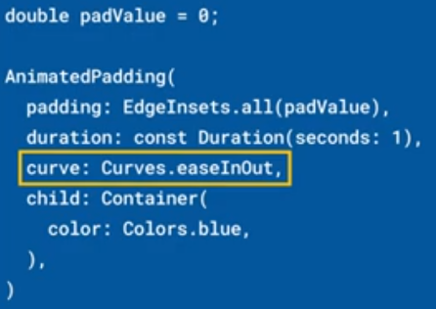 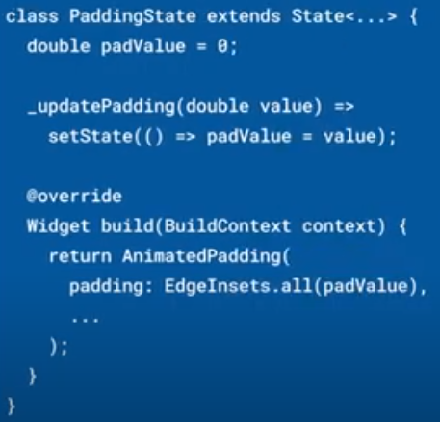

|  |  |
| --- | --- |
| **Código** | **Comentarios** |
| import 'package:flutter/material.dart';  class AnimatedPaddingScreen extends StatefulWidget {    const AnimatedPaddingScreen({Key? key}) : super(key: key);    @override    State<AnimatedPaddingScreen> createState() => _AnimatedPaddingScreenState();  }  class _AnimatedPaddingScreenState extends State<AnimatedPaddingScreen> {    double padValue = 0;    @override    Widget build(BuildContext context) {      return Scaffold(        appBar: AppBar(          title: const Text('AnimatedPadding'),          centerTitle: true,        ),        body: Center(          child: AnimatedPadding(            padding: EdgeInsets.all(padValue),            duration: const Duration(milliseconds: 300),            curve: Curves.easeInOut,            child: Container(              color: Colors.blue,            ),          ),        ),        floatingActionButton: FloatingActionButton(          backgroundColor: Colors.red,          onPressed: () {            if (padValue == 0) {              padValue = 150;              setState(() {});              return;            } else {              padValue = 0;              setState(() {});              return;            }          },          child: const Icon(Icons.play_arrow),        ),      );    }  } |  |

- - - - - - - - - - - - - - - - - - - - - - - - - - - - - - - - - - - - - - - - - - - - - - - - - - - - - - - - - - - - - - - - - - - - - - - - - - - - - - - - - - - - - - - - - - - - - - - - - - - - - - - -