**AnimatedPositioned**

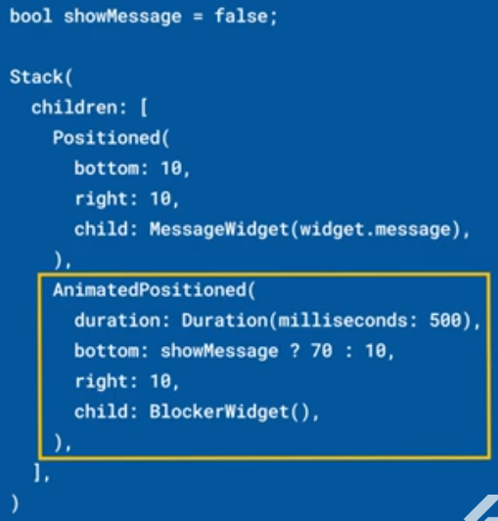

|  |  |
| --- | --- |
| **Código** | **Comentarios** |
| import 'package:flutter/material.dart';  class AnimatedPositionedScreen extends StatefulWidget {    const AnimatedPositionedScreen({Key? key}) : super(key: key);    @override    State<AnimatedPositionedScreen> createState() =>        _AnimatedPositionedScreenState();  }  class _AnimatedPositionedScreenState extends State<AnimatedPositionedScreen> {    bool isTop = true;    @override    Widget build(BuildContext context) {      return Scaffold(        appBar: AppBar(          title: const Text('AnimatedPositioned'),          centerTitle: true,        ),        body: Stack(          children: [            Container(              color: Colors.amber,            ),            AnimatedPositioned(              top: isTop ? 10 : 200,              left: 100,              duration: const Duration(milliseconds: 300),              curve: Curves.easeInOut,              child: Container(                width: 100,                height: 100,                color: Colors.purple,              ),            ),          ],        ),        floatingActionButton: FloatingActionButton(          backgroundColor: Colors.red,          onPressed: () {            isTop = !isTop;            setState(() {});          },          child: const Icon(Icons.play_arrow),        ),      );    }  } |  |

- - - - - - - - - - - - - - - - - - - - - - - - - - - - - - - - - - - - - - - - - - - - - - - - - - - - - - - - - - - - - - - - - - - - - - - - - - - - - - - - - - - - - - - - - - - - - - - - - - - - - - - -