**Connectivity**

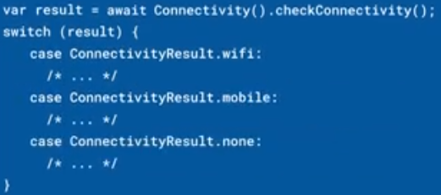

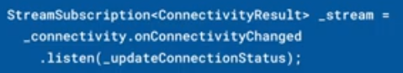

|  |  |
| --- | --- |
| **Código** | **Comentarios** |
| import 'package:connectivity/connectivity.dart';  import 'package:flutter/material.dart';  class ConnectivityScreen extends StatefulWidget {    const ConnectivityScreen({Key? key}) : super(key: key);    @override    State<ConnectivityScreen> createState() => _ConnectivityScreenState();  }  class _ConnectivityScreenState extends State<ConnectivityScreen> {    ConnectivityResult connection = ConnectivityResult.none;    @override    void initState() {      super.initState();      getConnection();    }    Widget build(BuildContext context) {      return Scaffold(        appBar: AppBar(          title: const Text('Connectivity'),          centerTitle: true,        ),        body: Center(          child: Text('La conexión es: $connection'),        ),        floatingActionButton: FloatingActionButton(          child: const Icon(Icons.refresh),          onPressed: () {            getConnection();            setState(() {});          },        ),      );    }    void getConnection() async {      connection = await Connectivity().checkConnectivity();      setState(() {});    }  } |  |

- - - - - - - - - - - - - - - - - - - - - - - - - - - - - - - - - - - - - - - - - - - - - - - - - - - - - - - - - - - - - - - - - - - - - - - - - - - - - - - - - - - - - - - - - - - - - - - - - - - - - - - -