**ExpansionPanel**

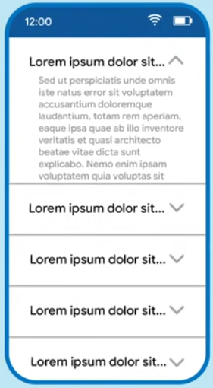

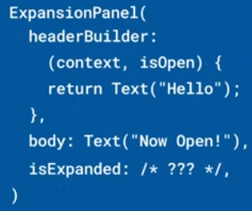

Los ExpansionPanel son hijos de ExpansionPanelList:

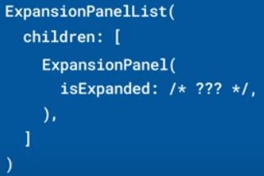 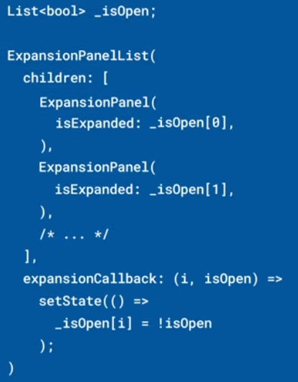

Se puede personalizar el aspecto:

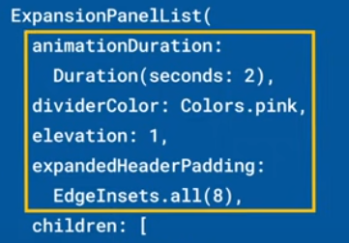 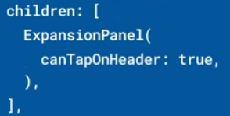

|  |  |
| --- | --- |
| **Código** | **Comentarios** |
| import 'package:flutter/material.dart';  class ExpansionPanelScreen extends StatefulWidget {    const ExpansionPanelScreen({Key? key}) : super(key: key);    @override    State<ExpansionPanelScreen> createState() => _ExpansionPanelScreenState();  }  class _ExpansionPanelScreenState extends State<ExpansionPanelScreen> {    final List<Item> _books = generateItems(30);    @override    Widget build(BuildContext context) {      return Scaffold(        appBar: AppBar(          title: const Text('ExpansionPanel'),          centerTitle: true,        ),        body: SingleChildScrollView(          child: Container(            child: _buildPanel(),          ),        ),      );    }  //---------------------------------------------------------------    Widget _buildPanel() {      return ExpansionPanelList(        animationDuration: Duration(milliseconds: 1000),        dividerColor: Colors.purple,        elevation: 1,        expandedHeaderPadding: EdgeInsets.all(8),        expansionCallback: (int index, bool isExpanded) {          setState(() {            _books[index].isExpanded = !isExpanded;          });        },        children: _books.map<ExpansionPanel>((Item item) {          return ExpansionPanel(            canTapOnHeader: true,            headerBuilder: (BuildContext context, bool isExpanded) {              return ListTile(                title: Text(item.headerValue),              );            },            body: ListTile(              title: Text(item.expandedValue),            ),            isExpanded: item.isExpanded,          );        }).toList(),      );    }  }  //---------------------------------------------------------------  class Item {    Item({      required this.expandedValue,      required this.headerValue,      this.isExpanded = false,    });    String expandedValue;    String headerValue;    bool isExpanded;  }  //---------------------------------------------------------------  List<Item> generateItems(int numberOfItems) {    return List.generate(numberOfItems, (int index) {      return Item(        headerValue: 'Book $index',        expandedValue: 'Details for Book $index goes here',      );    });  } |  |

- - - - - - - - - - - - - - - - - - - - - - - - - - - - - - - - - - - - - - - - - - - - - - - - - - - - - - - - - - - - - - - - - - - - - - - - - - - - - - - - - - - - - - - - - - - - - - - - - - - - - - - -