**RefreshIndicator**

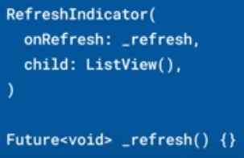 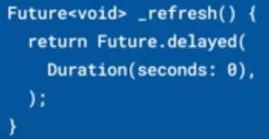

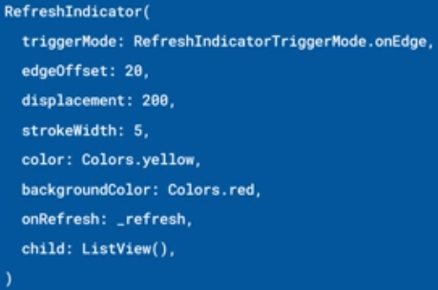

|  |  |
| --- | --- |
| **Código** | **Comentarios** |
| import 'package:flutter/material.dart';  class RefreshIndicatorScreen extends StatefulWidget {    const RefreshIndicatorScreen({Key? key}) : super(key: key);    @override    State<RefreshIndicatorScreen> createState() => _RefreshIndicatorScreenState();  }  class _RefreshIndicatorScreenState extends State<RefreshIndicatorScreen> {    List<int> list = List.generate(5, (i) => i);    @override    Widget build(BuildContext context) {      return Scaffold(          appBar: AppBar(            title: const Text('RefreshIndicator'),            centerTitle: true,          ),          body: RefreshIndicator(            onRefresh: onRefresh,            color: Colors.red,            backgroundColor: Colors.orange,            strokeWidth: 5,            //displacement: 400,            edgeOffset: 0,            triggerMode: RefreshIndicatorTriggerMode.anywhere,            child: ListView.builder(              itemCount: list.length,              itemBuilder: (BuildContext context, int index) {                return ListTile(                  title: Text('${list[index]}'),                  leading: const Icon(Icons.numbers),                );              },            ),          ));    }  //----------------------------------------------------------------------    Future<void> onRefresh() async {      await Future.delayed(const Duration(seconds: 2));      final lastId = list.last;      list.addAll(        [1, 2, 3, 4, 5].map((e) => lastId + e),      );      setState(() {});    }  } |  |



                                                                                                       