**SliverAppBar**

Sirve para que el Header de una Lista se oculte o se expanda

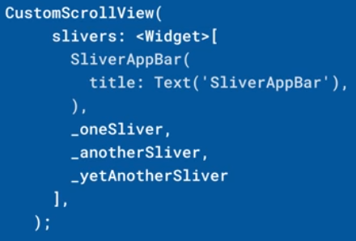 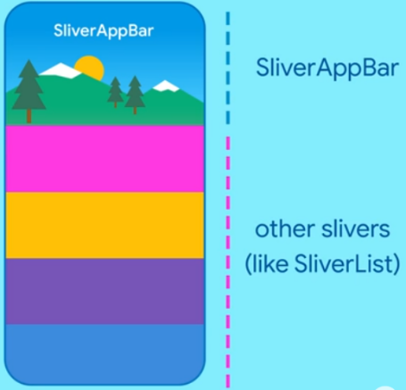 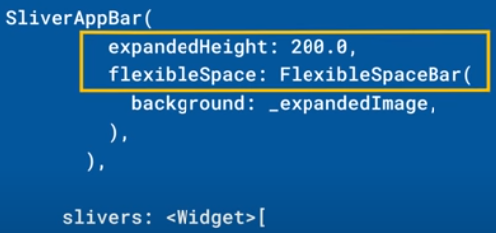



|  |  |
| --- | --- |
| **Código** | **Comentarios** |
| import 'dart:math';  import 'package:flutter/material.dart';  class SliverAppScreen extends StatelessWidget {    const SliverAppScreen({Key? key}) : super(key: key);    @override    Widget build(BuildContext context) {      return _MyHomeScreen();    }  }  //----------------------------------------------------------------------------  class _MyHomeScreen extends StatelessWidget {    _MyHomeScreen({      Key? key,    }) : super(key: key);    final rnd = Random();    final List<Color> colores = [      Colors.blue,      Colors.red,      Colors.yellow,      Colors.green,      Colors.orange,      Colors.brown,      Colors.purple,      Colors.cyan,      Colors.pink,      Colors.white,      Colors.grey,      Colors.black,      Colors.amber,      Colors.indigo,      Colors.redAccent,    ];    @override    Widget build(BuildContext context) {      final List<Widget> items = List.generate(          100,          (i) => Container(                width: double.infinity,                height: 150,                color: colores[rnd.nextInt(colores.length)],              ));      return Scaffold(        body: CustomScrollView(          slivers: [            SliverAppBar(              floating: true,              pinned: false,              title: const Text("SliverAppBar"),              expandedHeight: 200,              flexibleSpace: Image.network(                "https://www.globalnationalparks.com/es/wp-content/uploads/iguazu-parque-nacional-brasil.jpg",                fit: BoxFit.cover,              ),              centerTitle: true,            ),            SliverList(              delegate: SliverChildListDelegate(items),            ),          ],        ),      );    }  } | Todo debe estar dentro de un CustomScrollView  SliverAppBar  SliverList |

- - - - - - - - - - - - - - - - - - - - - - - - - - - - - - - - - - - - - - - - - - - - - - - - - - - - - - - - - - - - - - - - - - - - - - - - - - - - - - - - - - - - - - - - - - - - - - - - - - - - - - - -