**TabPageSelector**

**TabPageSelector** está emparejado con **TabBar**

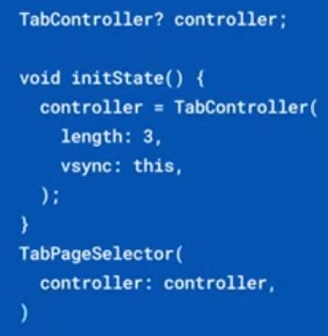 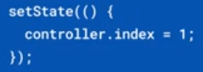 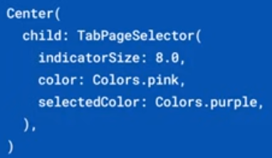

|  |  |
| --- | --- |
| **Código** | **Comentarios** |
| import 'package:flutter/material.dart';  class TabPageSelectorScreen extends StatefulWidget {    const TabPageSelectorScreen({Key? key}) : super(key: key);    @override    State<TabPageSelectorScreen> createState() => _TabPageSelectorScreenState();  }  class _TabPageSelectorScreenState extends State<TabPageSelectorScreen>      with SingleTickerProviderStateMixin {  //-----------------------------------------------------------------    late final TabController controller;    int _index = 0;    List<Widget> widgets = const [      Icon(Icons.home),      Icon(Icons.settings),      Icon(Icons.person),    ];  //-----------------------------------------------------------------    @override    void initState() {      super.initState();      controller = TabController(          length: widgets.length, initialIndex: _index, vsync: this);    }  //-----------------------------------------------------------------    @override    void dispose() {      super.dispose();      controller.dispose();    }  //-----------------------------------------------------------------    @override    Widget build(BuildContext context) {      return Scaffold(        appBar: AppBar(          title: const Text('TabPageSelector'),          centerTitle: true,        ),        body: Stack(          alignment: Alignment.center,          children: <Widget>[            TabBarView(controller: controller, children: widgets),            //Used Positioned widget to position TabPageSelector at the bottom of screen.            Positioned(              bottom: 40,              child: TabPageSelector(                color: Colors.black38,                controller: controller,              ),            ),          ],        ),        floatingActionButton: ButtonBar(          children: [            FloatingActionButton.small(              onPressed: () {                (_index != widgets.length - 1) ? _index++ : _index = 0;                controller.animateTo(_index);              },              child: Icon(Icons.navigate_next),              hoverElevation: 0,              elevation: 0,            )          ],        ),      );    }  } |  |



                                                                                                       