**LAB 12**

**Classes and its variables:**

**‘ + ‘ Operator:**

**Result:**

**‘ == ‘ Operator:**

**Result:**

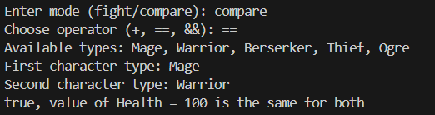

**‘ && ‘ Operator:**

**Result:**

