LAB 14  
  
Task 1  
  
Result

Task 2

Result:

Task 3:  
  
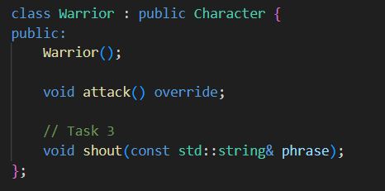

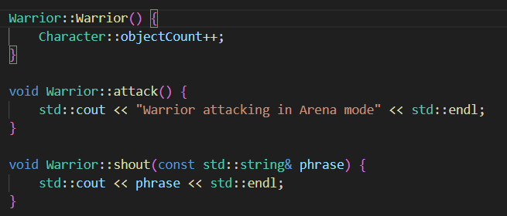

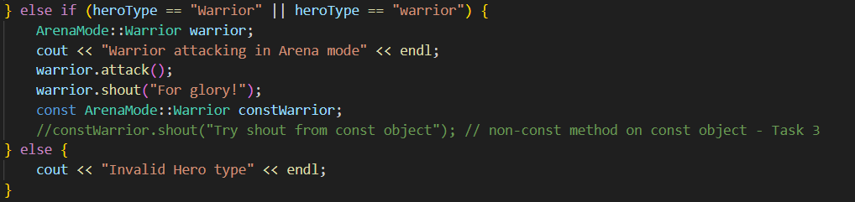

Result

Task 4:

