

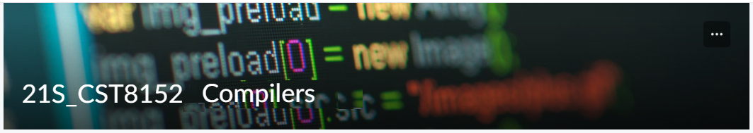

MODEL TASK FOR ASSIGNMENT 2.1 – JUANSCRIPT

Language: [JUANSCRIPT]
Team – Luis Resendiz - Id: 041060310

- Note: This task is part of the Assignment 2 from Compilers Course. Any problem, contact your lab professor.

PART 1: RE – Regular Expression (1.5 mark)

Lexeme Classes: Define the classes to be used in your regular expression:

Answer:

LL=[a-z] (Lowercase Letters)
UL=[A-Z] (Uppercase Letters)
D=[0-9] (Digits)
QM=? (Function Delimitator)
SQ=' (String Delimitator, single quote)
DQ=" (String Delimitator)
P=. (Period)
FS=/ (Forward Slash)
S=* (Star)
LT= < (Left Tag)
RT=> (Right Tag)
AO= [+,-,*,/] (Arithmetic Operators)
SC=; (Statement Delimitator)
CO= [==, !=, >, <, >=, <=] (Comparation Operators)
LO= [&&, ||, !] (Logical Operators)
AS=is (Assignment operator)

O = [^LDQMSQQPSFSLTRT] (Others)

Define the RE to be used for: variables, literals and keywords:

Answer:

* Comments (/* example */):
FS(S)[^FS(S)]*(FS(S))
* Variables (age, Name):
(LL|UL)+
* Methods:
QM(LL**4)(LL|UL)+
* Literals:
- Numbers
- Strings
Int
D+|D+P*D+|P*D+
SQ[^SQ]*SQ|DQ[^DQ]*DQ)
* Keywords:
KEY = (UL)+
KEY = {<?JUAN,JUAN?>,juan, JUAN, ?juan, juan?, JUANFULLHD, JUANBALCONY, JUANPQ, NAUJ, ENDNAUJ, JUANPRIMERO, JUANSEGUNDO}

PART 2: TD – Transition Diagram (1.5 marks)

Activity: Starting from the previous lexeme classes and obeying the RE, it is possible to define the automata for your language:

Answer (draw / copy image of the automata):

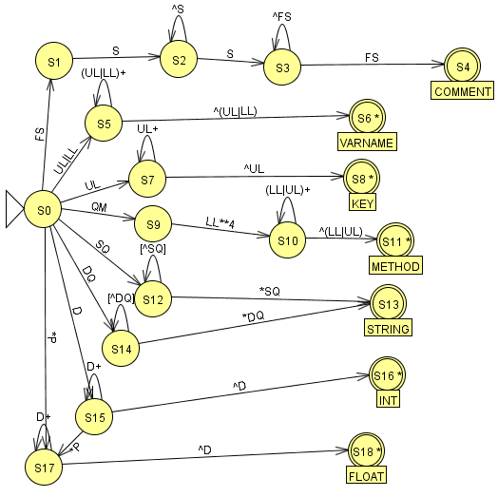

PART 3: TT – Transition Table (2 marks)

Activity: Now, it is possible to define the TT for these lexemes:

Answer (Transition Table):

Input | INPUT SYMBOL |  |  |  |  |  |  |  |  |  | OUTPUT
State/Classes | 1 | 2 | 3 | 4 | 5 | 6 | 7 | 8 | 9 | 10 | TYPE
- | LL(a-z) | UL(A-Z) | D(0-9) | QM(?) | SQ(') | DQ(") | P(.) | S(*) | FS(/) | O | -
S0 | 5 | 5|7 | 15 | 9 | 12 | 14 | 17 | ESNR | 1 | ESNR | NOAS
S1 | ESNR | ESNR | ESNR | ESNR | ESNR | ESNR | ESNR | 2 | ESNR | ESNR | NOAS
S2 | 2 | 2 | 2 | 2 | 2 | 2 | 2 | 3 | 2 | 2 | NOAS
S3 | 3 | 3 | 3 | 3 | 3 | 3 | 3 | 3 | 4 | 3 | NOAS
S4 | FS | FS | FS | FS | FS | FS | FS | FS | FS | FS | ASNR(COMMENT)
S5 | 5 | 5 | 6 | 6 | 6 | 6 | 6 | 6 | 6 | 6 | NOAS
S6 | FS | FS | FS | FS | FS | FS | FS | FS | FS | FS | ASWR(VARNAME)
S7 | 7 | 8 | 8 | 8 | 8 | 8 | 8 | 8 | 8 | 8 | NOAS
S8 | FS | FS | FS | FS | FS | FS | FS | FS | FS | FS | ASWR(KEY)
S9 | 10 | ESNR | ESNR | ESNR | ESNR | ESNR | ESNR | ESNR | ESNR | ESNR | NOAS
S10 | 10 | 10 | 11 | 11 | 11 | 11 | 11 | 11 | 11 | 11 | NOAS
S11 | FS | FS | FS | FS | FS | FS | FS | FS | FS | FS | ASWR(METHOD)
S12 | 12 | 12 | 12 | 12 | 13 | 12 | 12 | 12 | 12 | 12 | NOAS
S13 | FS | FS | FS | FS | FS | FS | FS | FS | FS | FS | ASNR(STRING)
S14 | 14 | 14 | 14 | 14 | 14 | 13 | 14 | 14 | 14 | 14 | NOAS
S15 | 16 | 16 | 15 | 16 | 16 | 16 | 17 | 16 | 16 | 16 | NOAS
S16 | FS | FS | FS | FS | FS | FS | FS | FS | FS | FS | ASWR(INT)
S17 | 18 | 18 | 17 | 18 | 18 | 18 | 18 | 18 | 18 | 18 | NOAS
S18 | FS | FS | FS | FS | FS | FS | FS | FS | FS | FS | ASWR(FLOAT)

Update: Feb 3rd 2023.

Adapted from resources developed by Prof. Svillen Ranev (Algonquin College, 2019)

