EXHIBIT 99.2 Page 1 of 3
DISTRIBUTOR AGREEMENT
Agreement made this 19th day of March, 2020
Between:
Co-Diagnostics, Inc. (herein referred to as “Principal”)
And
PreCheck Health Services, Inc. (herein referred to as “Distributor”).
In consideration of the mutual terms, conditions and covenants hereinafter set forth, Principal and Distributor acknowledge and agree to the following descriptions and conditions:
DESCRIPTION OF PRINCIPAL
The Principal is a company located in Utah, United States and is in the business of research and development of reagents. The Principal markets and sells it products globally through direct sales and distributors.
DESCRIPTION OF DISTRIBUTOR
The Distributor is a company operating or planning to operate in the United States of America, Latin America, Europe and Russia. The Distributor represents that the Distributor or a subsidiary of the Distributor is or will be fully licensed and registered in the Territory and will provide professional distribution services for the products of the Principal.
CONDITIONS:
1. The Principal appoints the Distributor as a non-exclusive distributor, to sell Principal’s qPCR infectious disease kits, Logix Smart COVID-19 PCR diagnostic test and Co-Dx Box™ instrument (the“Products”). The Products are described on Exhibit A to this Agreement.
2. | The Principal grants Distributor non- exclusive rights to sell these products within the countries of Romania (the “Territory”), which may be amended by mutual written agreement.
Source: PRECHECK HEALTH SERVICES, INC., 8-K, 3/20/2020

3. The Distributor accepts the appointment and shall use its commercially reasonable efforts to promote, market and sell the Products within the Territory, devote such time and attention as may be reasonably necessary and abide by the Principal’s policies.
4. The Principal shall maintain the right to contact and market its products to potential customers in the Territory; but agrees to pass on all sales leads and orders to the Distributor.
5. The parties agree that the list of Products and/or prices may be amended from time to time. The Principal may unilaterally remove Products from the catalog or change prices. Additions to the Products shall be by mutual agreement. However, in the event the Distributor rejects a new product addition to the product list, the Principal shall then retain the right to market and distribute the new product that is rejected by the Distributor.
6. Unless accepted by the Principal, the Distributor agrees that during the term of this Agreement, the Distributor, either directly or indirectly, shall handle no products that are competitive with the Products within the Territory.
7. The Distributor shall obtain at its own expense, all necessary licenses and permits to allow the Distributor to conduct business as contemplated herein. The Distributor represents and warrants that the Distributor shall conduct business in strict conformity with all local, state and federal laws, rules and regulations.
8. The Principal agrees that the Distributor may employ or engage representatives or sub-distributors in furtherance of this Agreement and the Distributor agrees that the Distributor shall be solely responsible for the payment of wages or commissions to those representatives and sub-distributors, and that under no circumstances shall Distributor’s representatives be deemed employees of Principal for any purpose whatsoever.
9. Principal will grant Distributor a discount based on the Products and Prices. The proposed discount is expected to be ¨%. Discount may vary depending on product volume ordered or promotions.
10. This Agreement shall be in effect until March 18. 2021, unless sooner terminated by either party upon (30) days written notice, without cause.
11. In the event of termination, the Distributor shall be entitled to receive all orders accepted by the Principal prior to the date of termination and may sell the ordered Products in the Territory. Payment to be made upon shipment.
Source: PRECHECK HEALTH SERVICES, INC., 8-K, 3/20/2020

12. In the event of termination, neither party, their heirs nor successors shall issue any challenge whatsoever to contest the termination.
13. The Distributor is an independent contractor and nothing contained in this agreement shall be deemed or interpreted to constitute the Distributor as a partner or employee of the Principal, nor
shall either party have any authority to bind the other in any respect, it being understood and agreed that all orders submitted by the Distributor are subject to acceptance by Principal in its sole
discretion.
14. It is agreed between the parties that there are no other agreements or understandings between them relating to the subject matter of this Agreement. This Agreement supersedes all prior
agreements, oral or written, between the parties and is intended as a complete and exclusive statement of the agreement between the parties. No change or modification of this Agreement shall
be valid unless the same be in writing and signed by the parties.
15. This Agreement shall not be assigned by the Distributor without the prior written consent of the Principal.
16. Official communication from Distributor or the Principal shall be in written form or by email, acknowledged by the recipient.
17. This Agreement shall be construed in accordance with and governed by the laws of the State of Texas without regard to principles of conflicts of laws.
18. Each of Principal and Distributor represents that it has the right to enter into this Agreement and that this Agreement does not violate any agreement to which it is a party. Principal represents
that it owns or has rights to the intellectual property embodied in the Products.
Intending to be legally bound, the parties hereto have caused this Agreement to be executed as of the date first above written.
BY | /s/ Cameron Gundry | BY | /s/ Justin Anderson
 | Cameron Gundry, Dir. of Commercialization |  | Justin Anderson, CEO
 | Co-Diagnostics, Inc. |  | PreCheck Health Services, Inc.
 | (Principal) |  | (Distributor)
Source: PRECHECK HEALTH SERVICES, INC., 8-K, 3/20/2020

.EXHIBIT A
LIST OF PRODUCTS
Source: PRECHECK HEALTH SERVICES, INC., 8-K, 3/20/2020

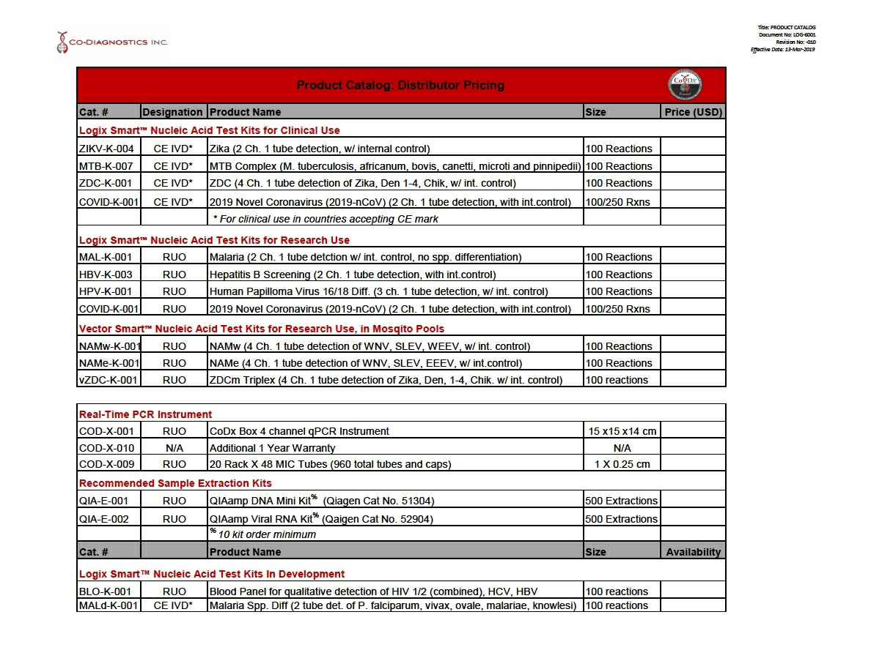
Source: PRECHECK HEALTH SERVICES, INC., 8-K, 3/20/2020

Source: PRECHECK HEALTH SERVICES, INC., 8-K, 3/20/2020

