Starting a Ruby on Rails Project from Scratch on Windows

Overview:
This document provides a step-by-step guide for starting a Ruby on Rails project from scratch on a Windows environment. It covers building and running a Docker image to set up the Rails environment, creating a new Rails project, managing the Rails server, and updating the GitHub repository with your project code. Follow these instructions to efficiently set up and manage a Rails application in a containerized development environment.
Part 1: Building Docker Image
Part 2: Running a Docker Image
Part 3: Creating a New Rails Project
Part 4: Stopping and Exiting the Rails Server
Part 5: Update GitHub Repository with New Code

Before you start:
1. Install Docker Desktop for Windows: https://www.docker.com/
Docker Desktop is an application that lets you develop, ship, and run applications in lightweight containers.

2. You will also need: Windows PowerShell
Windows PowerShell will be used to enter command line prompts.

Part 1: Building a Docker Image
1. Create a new folder on your desktop to store the files needed to make your Docker image.

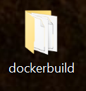

2. Next download the rails environment files and move them into the new directory you made.

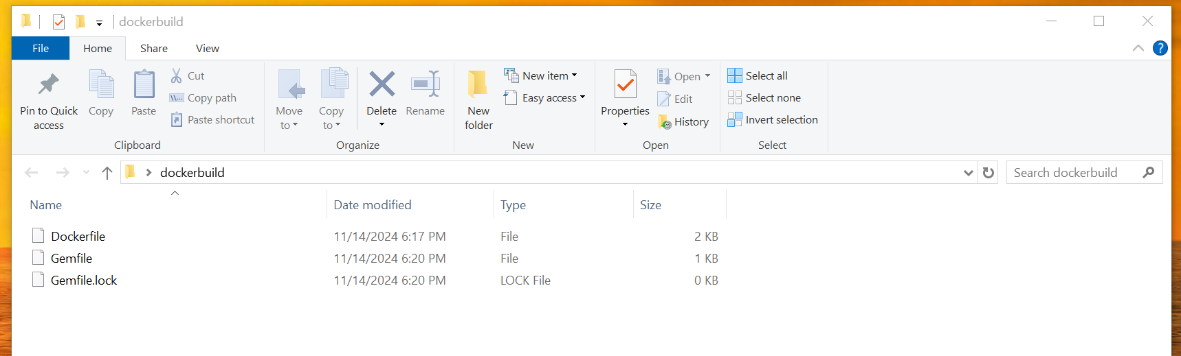

4. Next open Windows PowerShell (Also ensure Docker Desktop is open and latest version is installed).

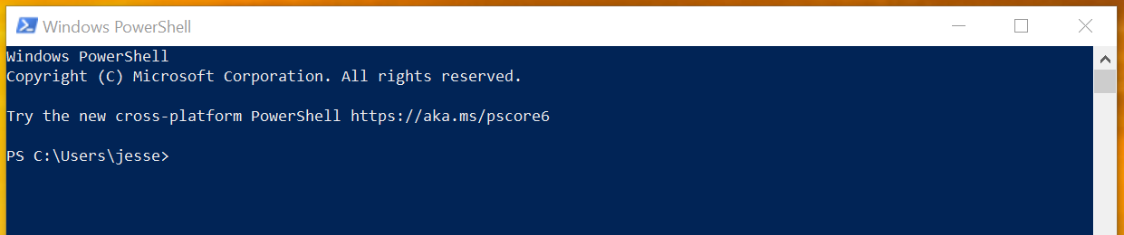

5. Now inside the Windows PowerShell terminal type ls and hit enter. This lists the contents of the current directory.

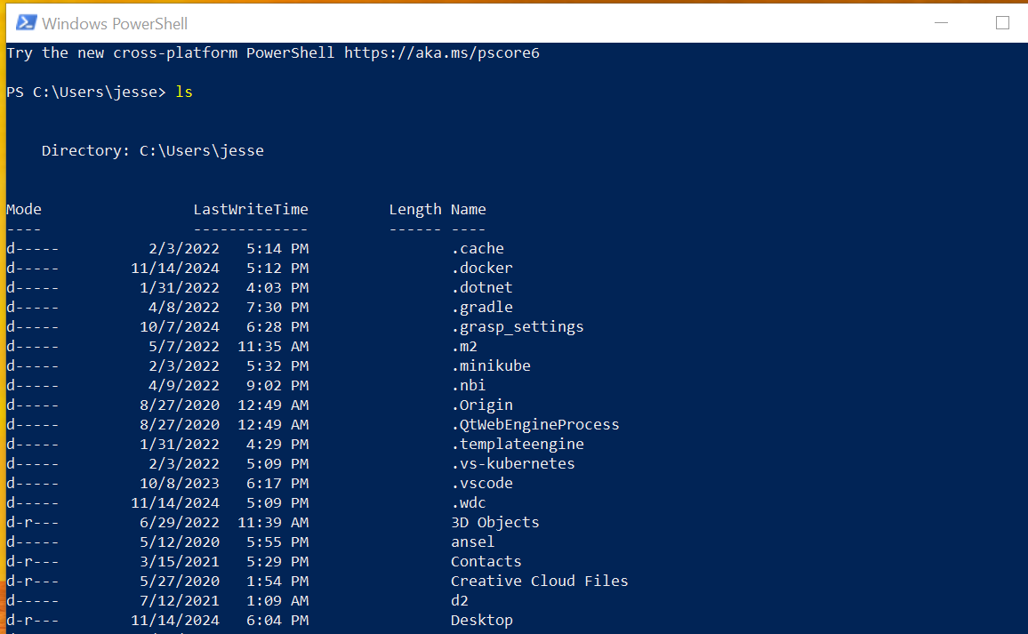
Here are useful commands for Windows PowerShell.

Command | Purpose
ls | Lists items in a directory (files and folders)
cd <path> | Changes the current working directory
cd.. | Changes directory to parent folder of current directory (if current directory is C:\Users\jesse\desktop then cd.. will change your directory to C:\Users\jesse)
cls | Clears PowerShell console screen
Tab key | Press tab and PowerShell will auto-complete the closest match to what you've typed so far
Up and Down Arrow Keys | Scrolls back through previous commands you've entered
Left and Right Arrow Keys | Moves cursor left or right in the current command allowing you to edit without deleting characters

6. Now use the command line in PowerShell to navigate to the directory where you downloaded the rails environment (cd <path>). Once here type ls to confirm that you can see Dockerfile, Gemfile, and Gemfile.lock.

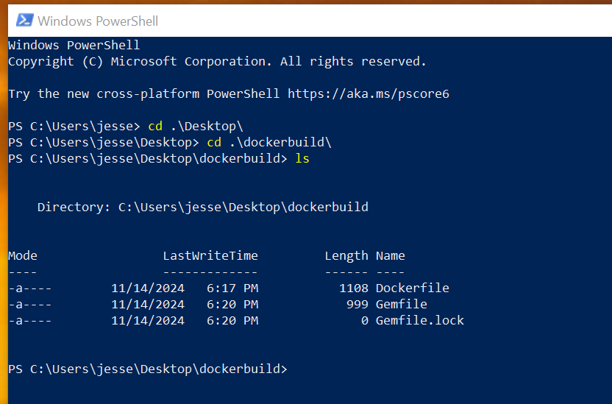

Now you are ready to use Docker commands to build the image.

7. In PowerShell command line type:

docker build -t [dockerUserName]/[image name] .

Keep in mind to include the period. This command builds a Docker image using the Dockerfile and other relevant files in the current directory.

When the build command is finished running your PowerShell terminal should look like this:

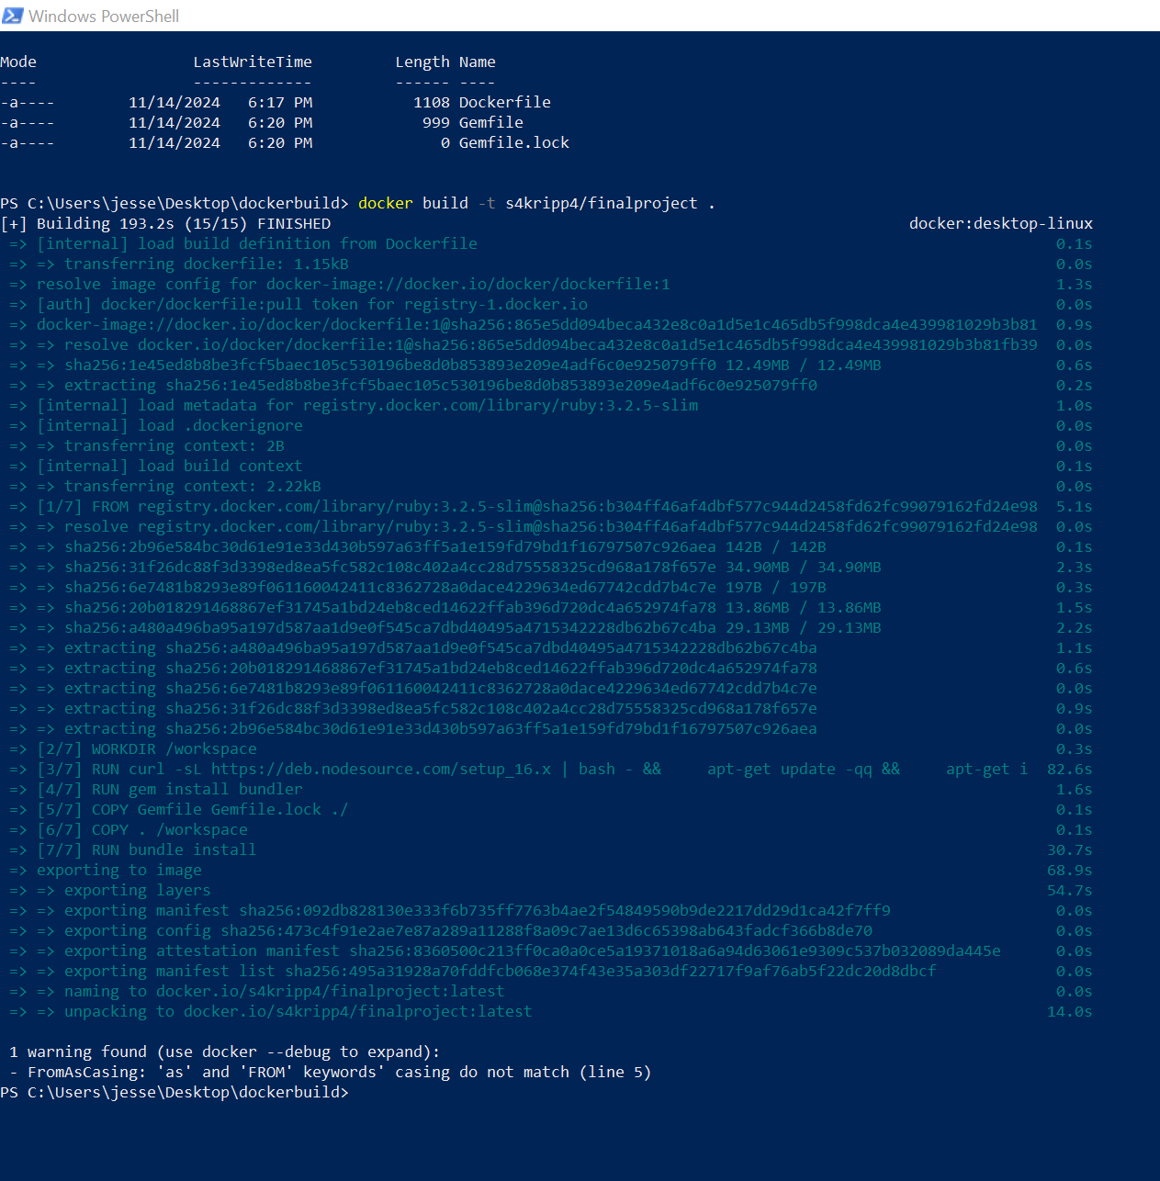

Part 2: Running a Docker Image

1. To run the Docker image, create a new directory, separate from the one we made to build the image. It's better to create a new folder outside the dockerbuild directory we made earlier. This keeps the build files and mapped container files separate. Avoid using OneDrive, as we will use GitHub to back up files later.

Here I name mine webapp_mapped:

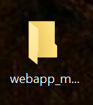

2. Now use PowerShell to navigate to this new directory before we map.

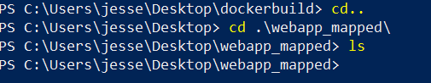

3. Now we can run the Docker image to map the container's files using PowerShell.
In the command line for PowerShell type:
docker run -it -p 3000:3000 -v ${PWD}:/workspace [dockerUserName]/[image name]

Your terminal should look like this now but with a different username:
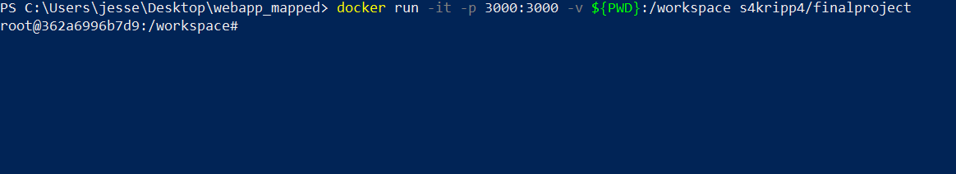

Here is a breakdown of what is happening in that docker run command:
docker run : starts a new container from an image

-it : enables interactive mode and allocates a terminal to interact with the container

-p 3000:3000 : maps port 3000 on the host to port 3000 in the container, allowing you access the app at localhost:3000

-v ${PWD}:/workspace : creates a volume mount where the current directory on your host is mapped to /workspace inside the container

${PWD} : represents your current directory path in PowerShell

[dockerUserName]/[image name] : is your Docker Desktop username and the image you want to run

4. You will not need to run this command again unless you want a new container to work with. Now if you go back to Docker Desktop and click containers you should now see it.
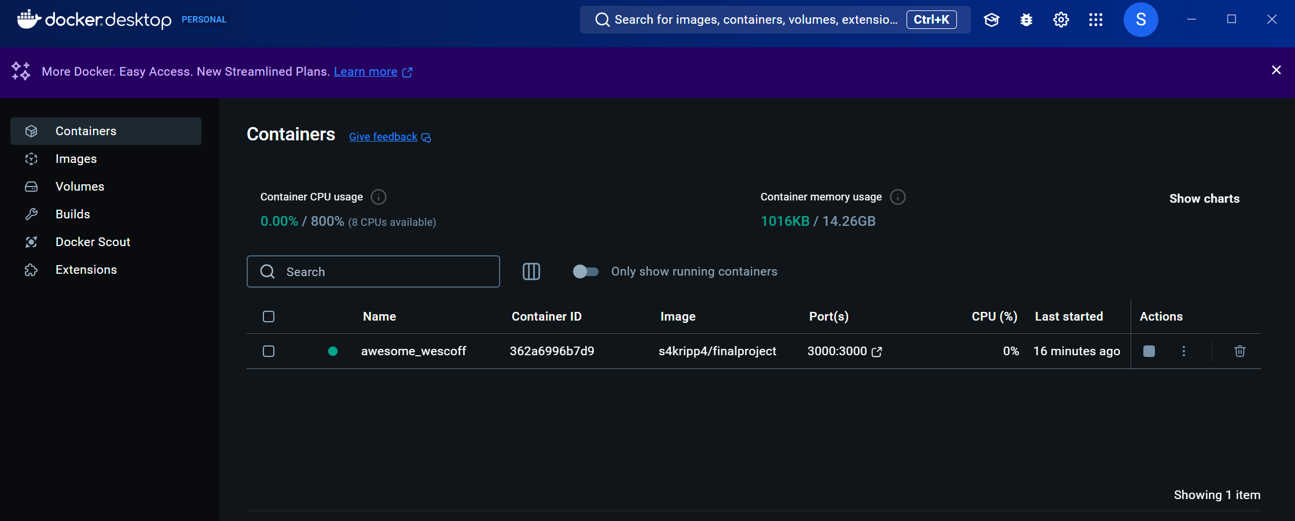

If you look at PowerShell you can verify that you are in the workspace if you see this:

This means you are running shell commands for the docker container. You will not be able to run docker commands inside this workspace. It is used to run Ruby, and Rails commands.

5. Now verify your ruby version by typing:

ruby --version

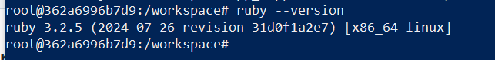

Typing irb into the workspace will start the Interactive Ruby Shell. This will allow you to enter and evaluate Ruby code line-by-line.
To exit irb just type quit then enter.

Here are useful docker commands to use in Windows PowerShell. Keep in mind you can't run these inside the workspace. You can open a separate Windows PowerShell terminal if you would like to run them, or you can exit the workspace by typing exit or CTRL + D.

Command | Purpose
docker ps | Lists all running containers
docker ps -a | Lists all containers, including stopped ones
docker logs | Shows the logs for a specific container
docker stop <container_id_or_name> | Stops a running container by id or name
docker start <container_id_or_name> | Starts a stopped container
docker restart <container_id_or_name> | Restarts a container
docker exec -it <container_id_or_name> /bin/bash | Start an interactive shell session inside a running Docker container

Part 3: Creating a New Rails Project
1. Ensure your Docker container is running. If not, start it using the command line in windows.
docker start <containerID_or_name>
docker ps - to confirm it is running

Next enter the container's workspace
docker exec -it <containerID_or_name> /bin/bash
- this will start an interactive shell session inside a running Docker container
If you see a # in the command prompt, then you are inside the Docker container's workspace. You can now execute commands directly within the container.
2. Use Rails commands to create a new Rails project. Inside your workspace in PowerShell type:
rails new <project_name> --skip-git
- this command will generate a new Rails application and ignore the Git repository

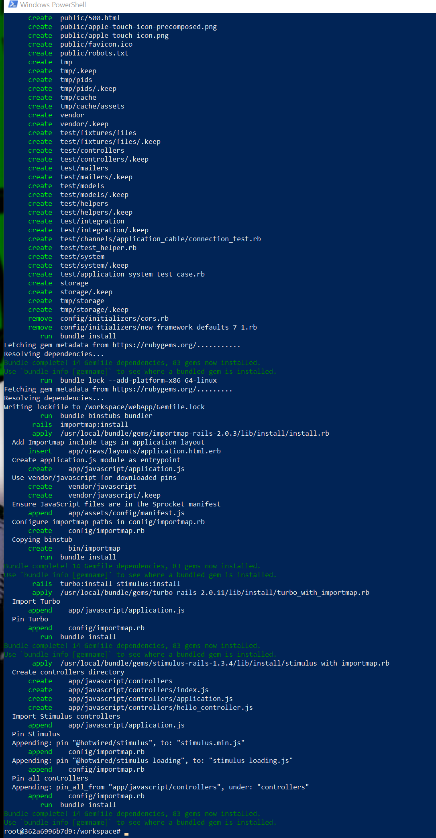

3. Now make sure you cd into your new Rails application then you can type in:
bundle install
- This installs the Ruby gems (libraries or dependencies) from your Gemfile

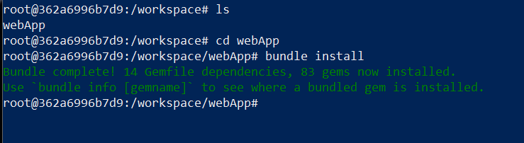

4. Once this is finished type:
rails db:migrate
- This applies any pending database changes

5. Now start your Rails server by typing in the workspace/webApp#:
rails server -b 0.0.0.0
- Starts the Rails web server, the -b 0.0.0.0 part specifies the IP address the server should bind to. This is instructing the Rails server to listen on all available network interfaces, making it accessible from outside the container

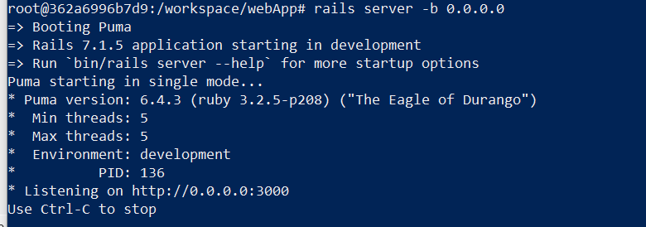

6. Now navigate to http://localhost:3000 in your browser to see you Rails app

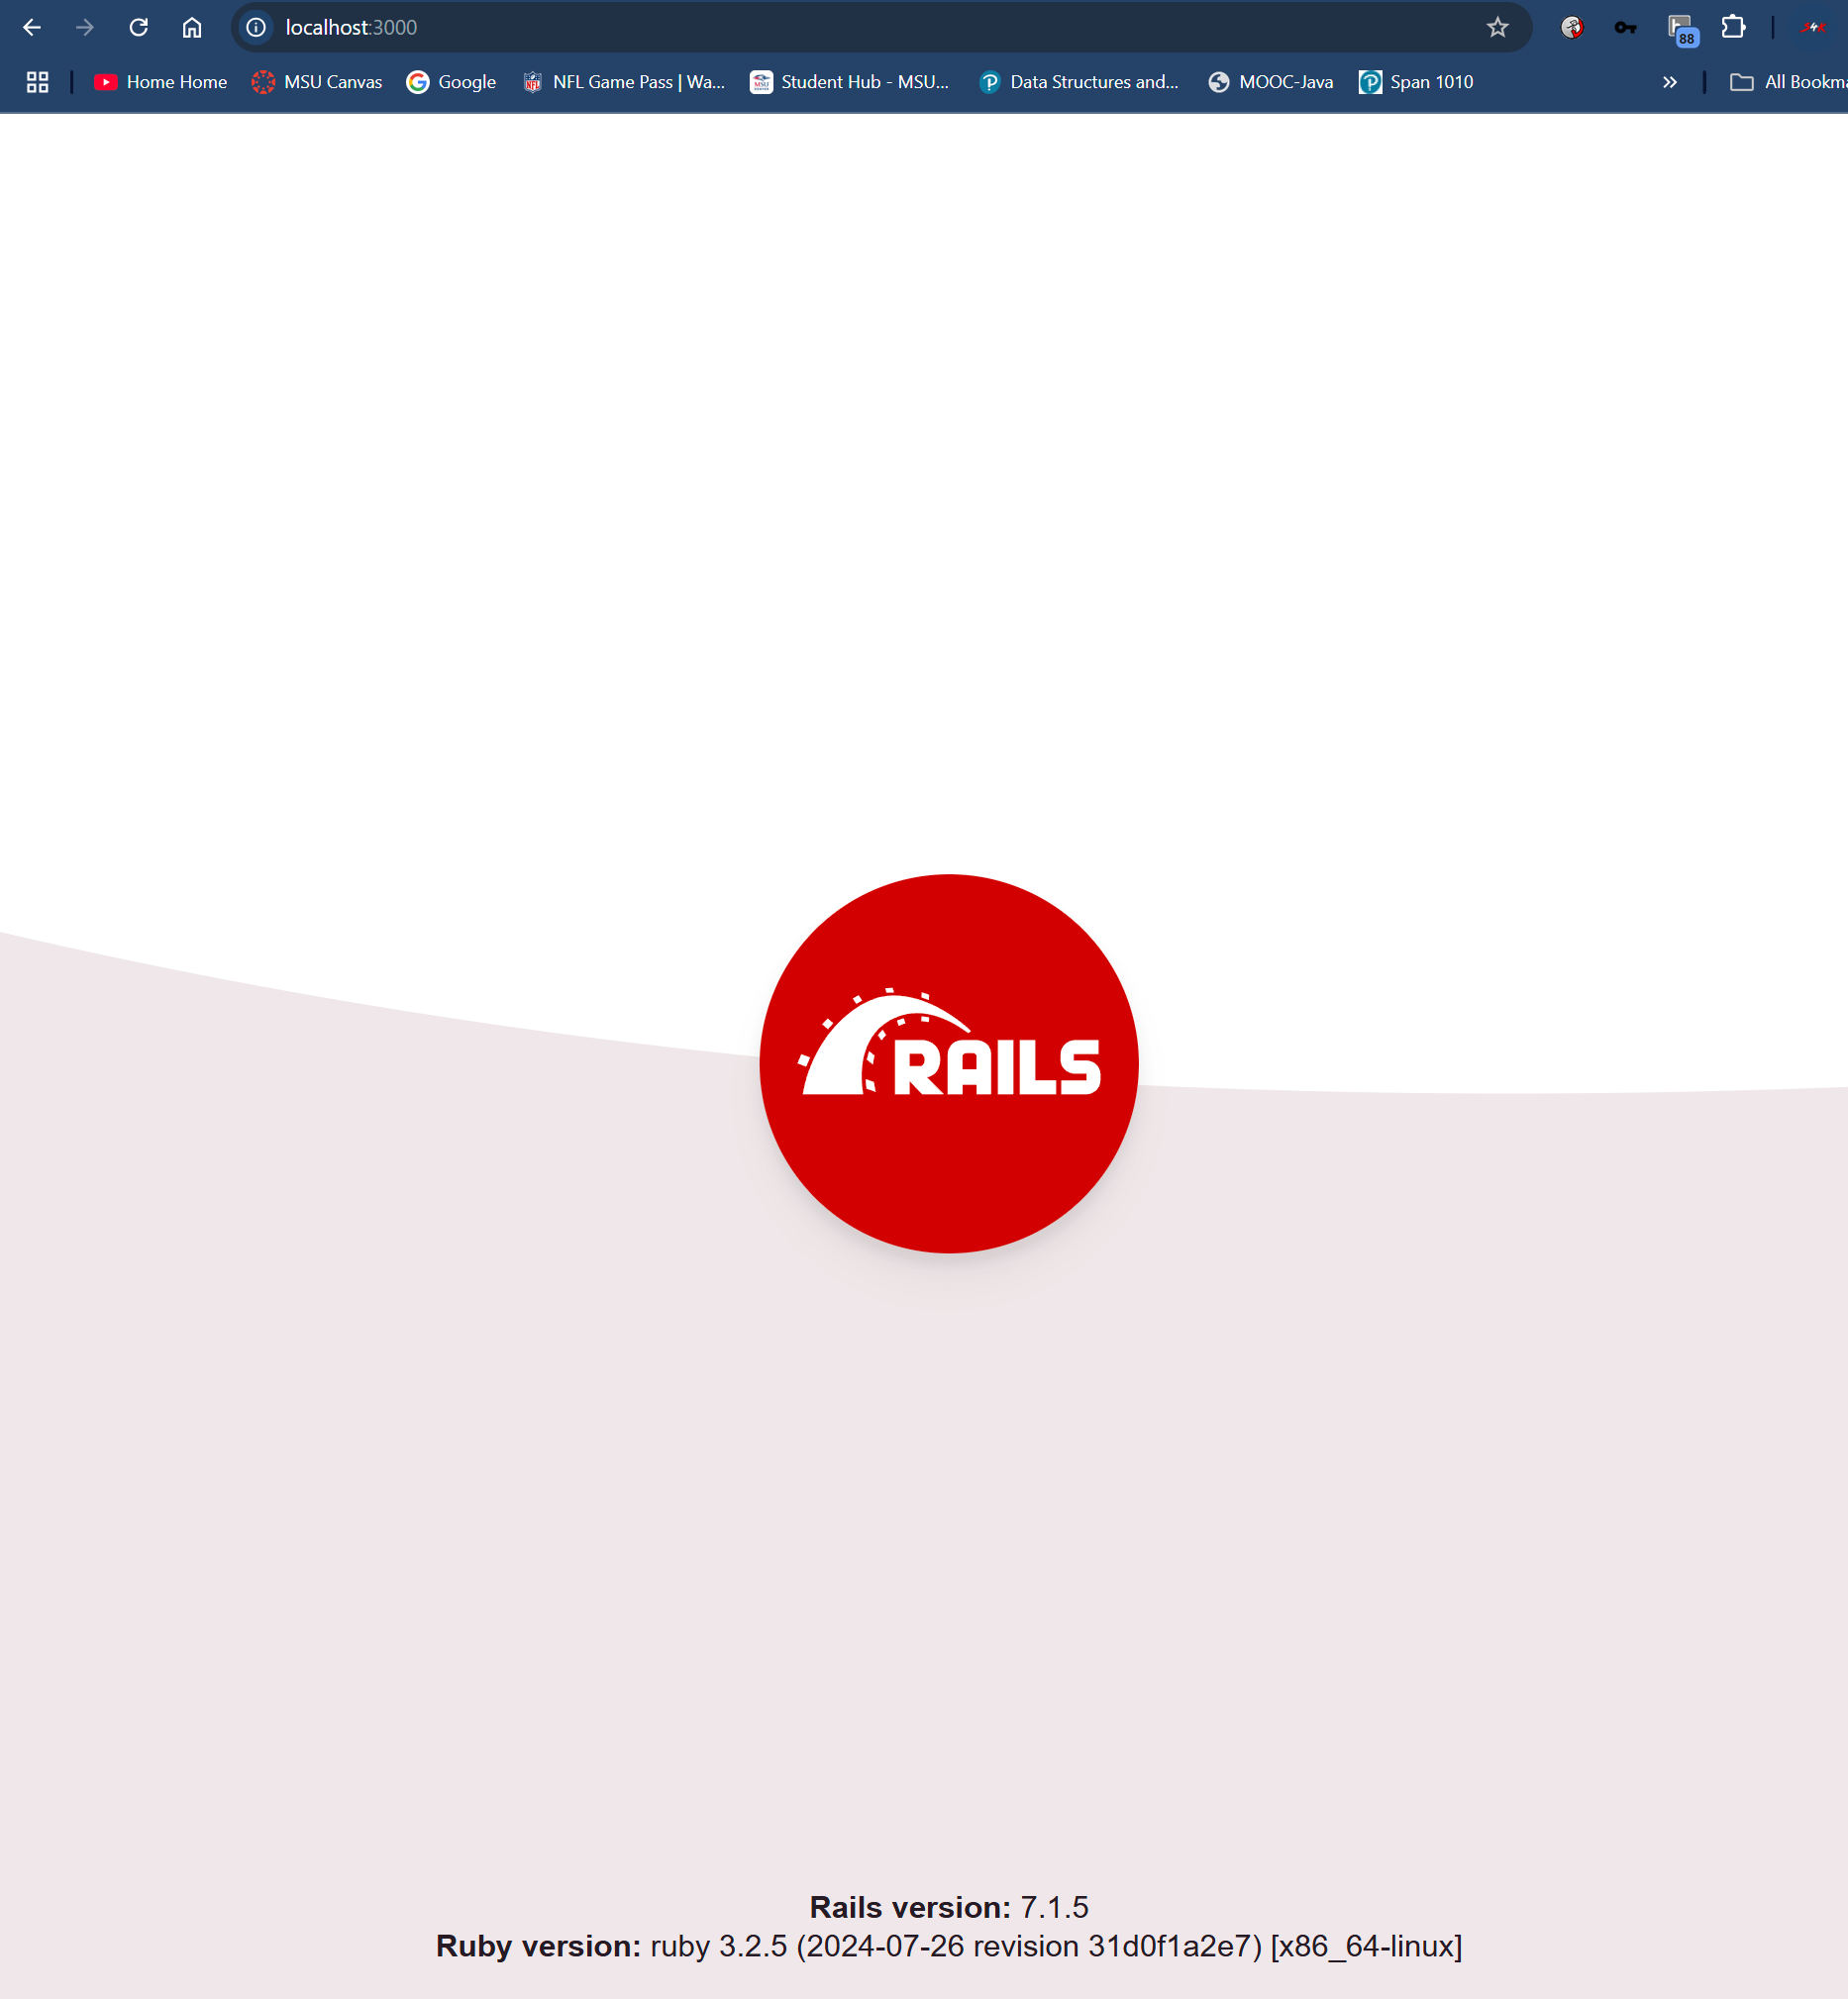

Part 4: Stopping and Exiting the Rails Server

Ctrl + C
- stops the Rails server

Exit
- typing exit in the #workspace will exit the Docker container workspace

Part 5: Update GitHub Repository with New Code

After all previous steps are completed you will now be ready to push your update code to GitHub, replacing any existing content in the repository with the latest version of your project. You can use either Windows PowerShell or VS code terminal to enter these commands. I will walkthrough PowerShell.

1. Open PowerShell on your host machine and navigate to the mapped Docker container's workspace

Type this git command into PowerShell:

git status

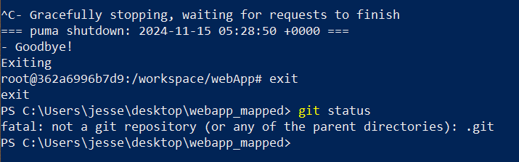

Here I stopped my server, exited the workspace, and did a git status to confirm a repository is not linked

2. Initialize Git

Type this git command into PowerShell:

git init

git init command initializes a new Git repository in your current directory. Here’s what it does:
- Creates a .git Folder: This hidden folder contains all the files and metadata Git needs to manage version control for the project, such as configuration settings, logs, and information about commits.
- Makes the Directory a Git Repository: After running git init, Git will start tracking changes to files in this directory, allowing you to use Git commands like git add, git commit, git push, etc.
- Sets Up the First Commit Point: The repository is now ready to track changes, but you’ll need to add and commit files to establish the first commit in this new repository.

3. Add the GitHub Repository as Remote.

Type:
git remote add origin <repo-url>

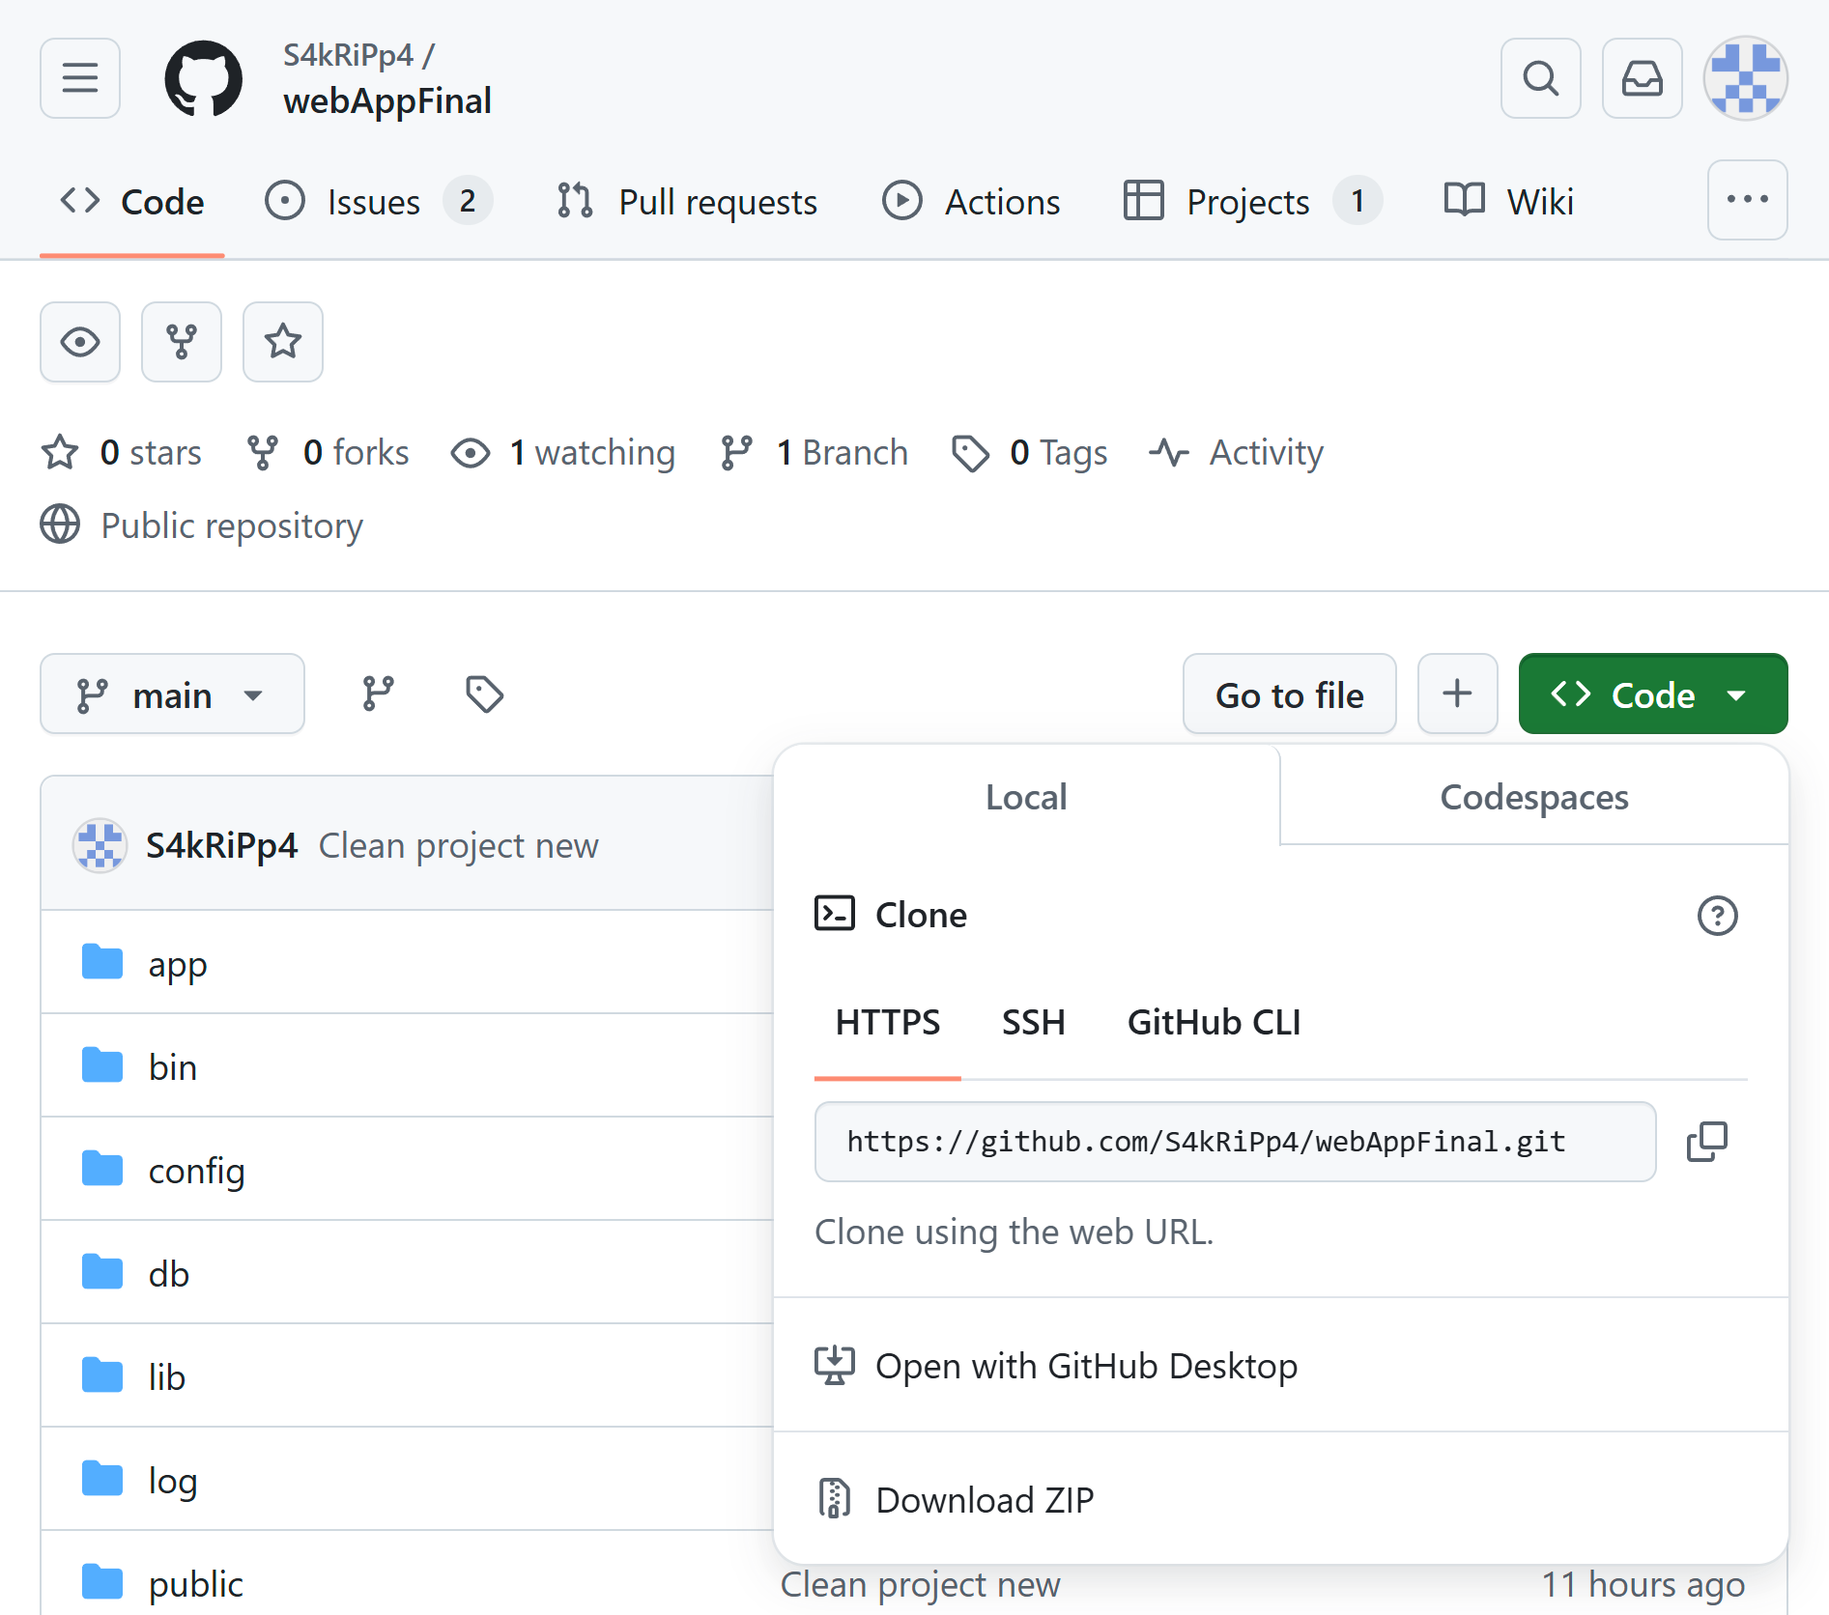

4. Now type git remote -v to verify it worked.

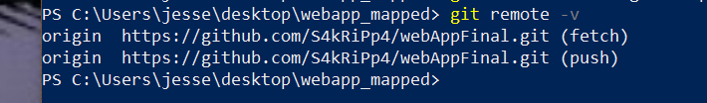

5. Now you are ready to Stage and Commit All Files

Type:

git add .
- This will add all files to the staging area. Make sure to include the period.

Now type:

git commit -m "Initial commit for updated Rails project with Capybara"

6. Next will be a force push to overwrite the old code

Type:
git push origin main --force

7. If you get this error below then you will need to take additional steps. git branch will list all local branches in your repository. An * next to the name signifies the current branch. Since mine is on master and my GitHub repository only has main, I will need to rename it.

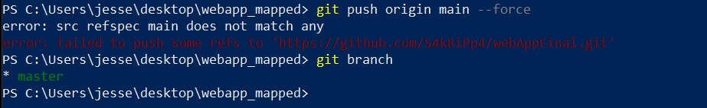

8. Rename local master Branch to main if required.
Type:
git branch -m master main

Also verify with git branch after to confirm.

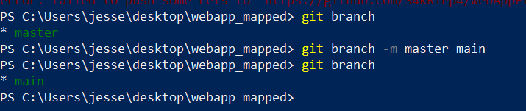

9. Now force push again
Type: git push origin main --force

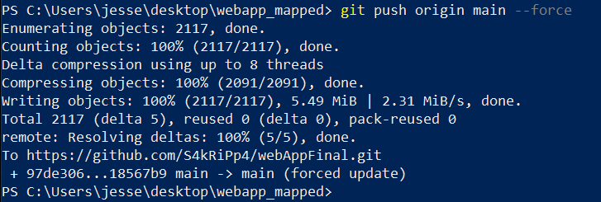

10. Now to set main as your default branch locally to avoid future issues.
Type: git symbolic-ref HEAD refs/heads/main
11. Lastly go to your GitHub Repository and verify everything worked.

