UNIVERSIDAD POLITECNICA DE YUCATAN  TSU-CIENCIAS-DE-DATOS  DATA STRUCTURE | 

Plain Binary Tree and BST Search
Luis Gerardo Escalante Velazquez
I inserted the same random keys into a plain binary tree and two BSTs, then searched for 100 present and 100 absent keys at each size. The sorted BST used the same keys in ascending order.
Results
n | Tree | Found | Absent
100 | Plain binary tree | 50.50 | 100.00
100 | BST random | 7.10 | 7.63
100 | BST sorted | 50.50 | 54.25
1,000 | Plain binary tree | 510.28 | 1,000.00
1,000 | BST random | 11.50 | 12.67
1,000 | BST sorted | 477.63 | 524.38
10,000 | Plain binary tree | 5,106.19 | 10,000.00
10,000 | BST random | 16.68 | 17.38
10,000 | BST sorted | 4,759.51 | 5,043.70
Figure 1. Average nodes visited (solid: found; dashed: absent). The vertical axis uses a log scale.
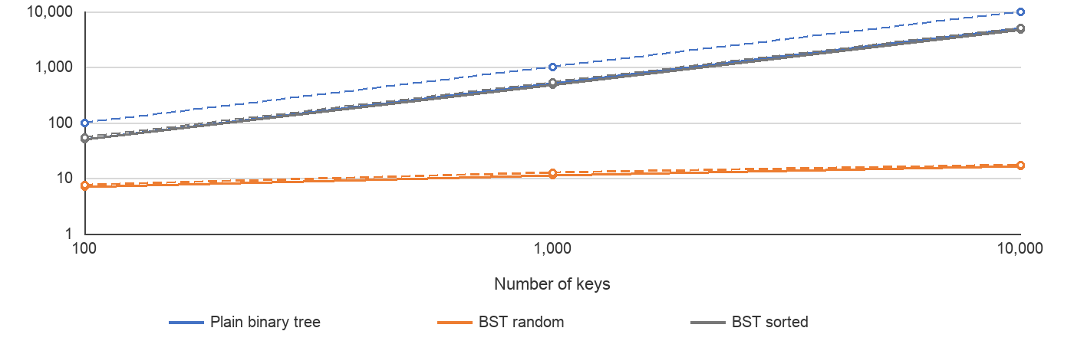
Discussion
The plain tree stores keys without ordering. Its level-order search checks nodes one at a time, so an absent key visits all n nodes and a present key usually takes about half as many visits. The random BST uses each comparison to choose one branch, which kept searches short in this experiment.
When I inserted the BST keys in sorted order, each new key became the previous key's right child. This made a chain, so searches took hundreds or thousands of visits instead of about 7 to 17. Level-order insertion keeps the plain tree complete by levels because its queue always fills the earliest available left or right child before moving to later nodes.
Method: Python random seed 42; unique even keys from 0 to 999,998; absent queries were odd values from the same range. A node counts as visited when its key is checked.

