**Background**

More than 300 species of fish and invertebrates are caught on the coasts of Peru. Different fisheries operate along the coast, but the main fishery is artisanal due to the quantity and number of species they capture. The industrial fishery captures a few key species, such as anchovy, hake, and others.

The artisanal fishery operates throughout the Peruvian coast and uses different fishing gear, and the use of these gear varies in places depending on the abundance of a sp x, for example, if sp x is more abundant in the central part of Peru, the use of this gear will be greater (due to the greater volumes of catches). In this fishery, a fishing operation could be a fisherman fishing one day in a small boat with approximately 5 tons of hold capacity, generally using a single fishing gear, and returning the next day to a port. (fig 1).

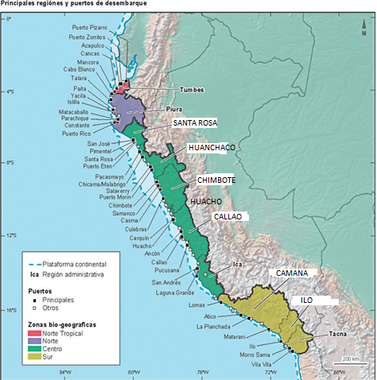

Fig. 1: distribution of sampling locations located in the regions (colors)

**Sampling design for a sp x**

A species x can be distributed throughout the coast of Peru or only in a narrow range. *For the purposes of sample selection age studies and subsequent evaluation, should samples be selected proportional to the abundance per location?* *It is caught with more than one fishing gear, should samples be obtained from only one fishing gear? Or can samples be accumulated that are proportional to the fishing gear? F*or example, with purse seines a limited range of sizes is obtained (15 to 22 cm total length) and with guillnet a greater range of sizes is obtained (12 to 30 cm). Additionally, larger sizes could be obtained with spinel, but few individuals.

**Currently obtaining sample**

We obtained samples of the artisanal fishery catches of almost 40 species between pelagic and bottom fish. It is done in two ways:

1.- Sampling at the ports of disembarkation is called biometric sampling (the size of the sp is measured). This can be the total catch that a boat brings (if the boat is small), in the DB it would be “TOTAL_WEIGHT” = “SAMPLE_WEIGHT”, or a part of the total catch from that boat is taken (sub-sampling), in the DB it would be “TOTAL_WEIGHT” > “SAMPLE_WEIGHT”. This is done twice a week for sp x.

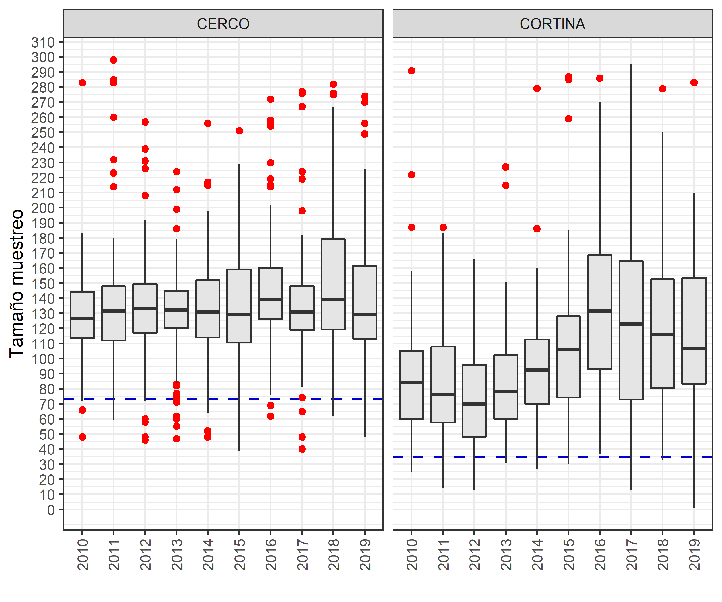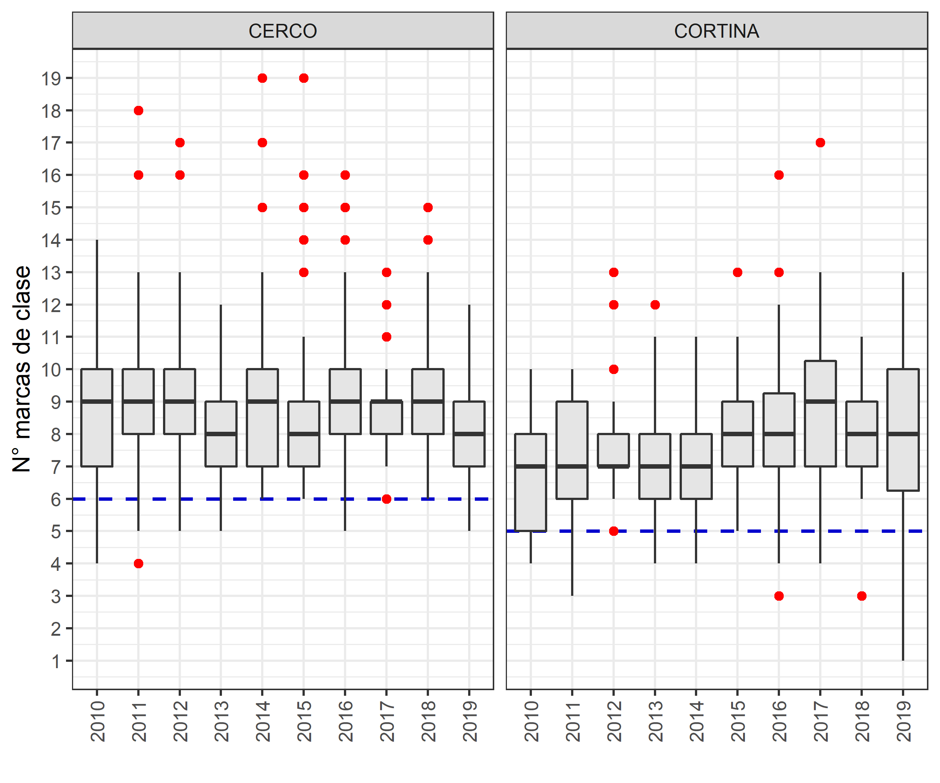**2.-** The other method is called biological sampling, this consists of sub-sampling what is obtained in the first method, that is, from the initial size frequency sample, for example, 5 females are obtained for each size range (1 range is 1cm of the total length of the fish) and 3 males (this is because there are generally more females than males). The individual's total weight, gutted weight, total length, liver weight, gonad weight, etc. are measured. The otoliths are extracted for age and growth studies, **which is the interest of this work**. Generally, this is done once a week and 4 times a month.

Fig 2. Sampling structure for a sp “xx” in the years. Left, sample size obtained in port according to purse seine and gillnet fishing gear. Right, class marks of the samples by years (). The red dots are the outliers of the data, blue line is a minimum limit that I was considering in a sample calculation essay.

**Data structure (DB) for sp x**



**Fig.** example of 3 samples “N_SAMPLE” of sp “x”

**“YEAR”:** only one year for this practice

**“MONTH”:** 12 months of the year

**“DAY”:** sampling day

**“LABORATORY”:** Imarpe laboratories, from latitudinal north to south: SANTA ROSA, HUANCHACO, CHIMBOTE, HUACHO, CALLAO, CAMANA, ILO.

**“SOURCE”:** type of survey, “seguimiento” is routine sampling, “prospeccion” is a specific study and there are very few.

**“N_SAMPLE”:** simple number

**“SHIP_TYPE”:** type of boat, not of much interest

**“TOTAL_WEIGHT”:** total weight in kg of the catch

**“SAMPLE_WEIGHT”:** total weight in kg of the sample

**“PORT”:** port of disembarkation and that belongs to a laboratory

**“GEAR”:** catch fishing gear, mainly gillnet and purse seine

**“LENGHT” and “FREQUENCY”:** sample size frequency

**Estimación del tamaño de muestra efectivo**

We know that the information on the fishery is very biased, affected by the selectivity of the gear, the availability of the resource, accessibility, and preference in the market (sometimes the resource is abundant, but they do not fish it much because there is another species that is more in demand). Taking this information into account:

How many individuals per size range should I obtain to guarantee estimates of growth parameters?

Should I do a monthly analysis? quarterly? annual?