

Universidad de las Fuerzas Armadas ESPE

**NRC 8516:**

Development web applications

**Team 6:**

Luis Yépez

Silvia Yunga



**Project:**

TicSell

**Tutor:**

Jorge Edison Lascano

19 January 2023

**Link to repository GitHub:**

**https://github.com/LuisYepezIntriago/DevelopersTeam6TicSell.git**

**Link to Youtube:**

https://youtu.be/Ark8dfUSPHY

1. **Github Repository (Right Structure and collaboration)**

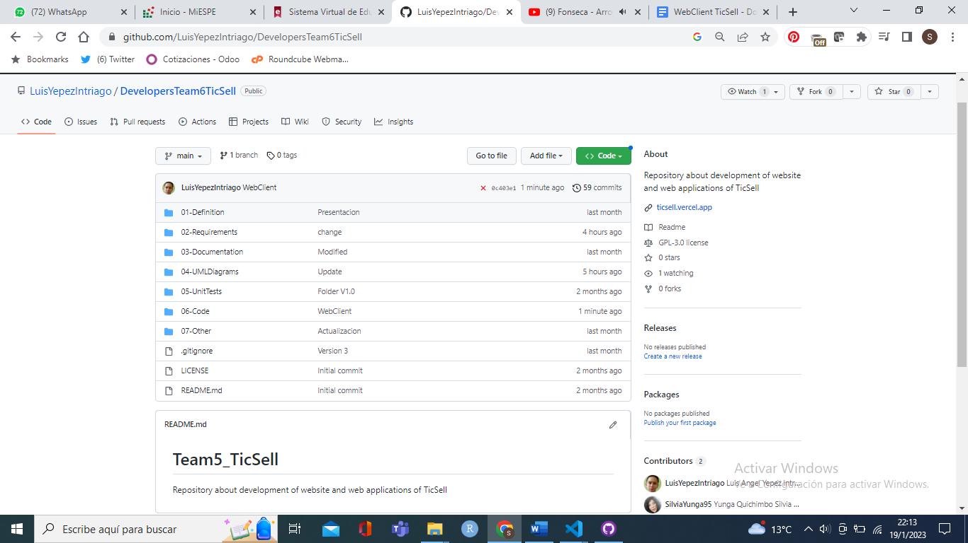

1. **Design (sketches) of the web pages**

Principal Page

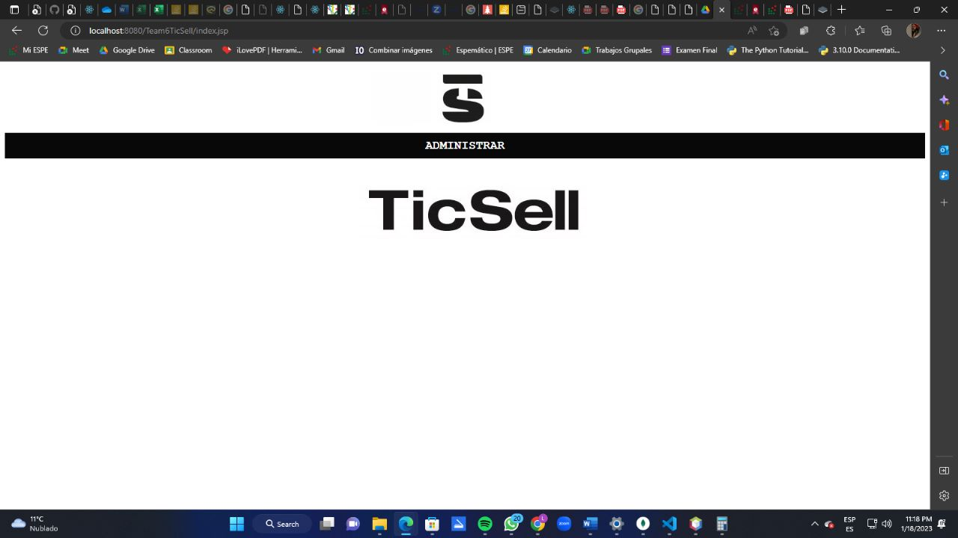

**register Customer**

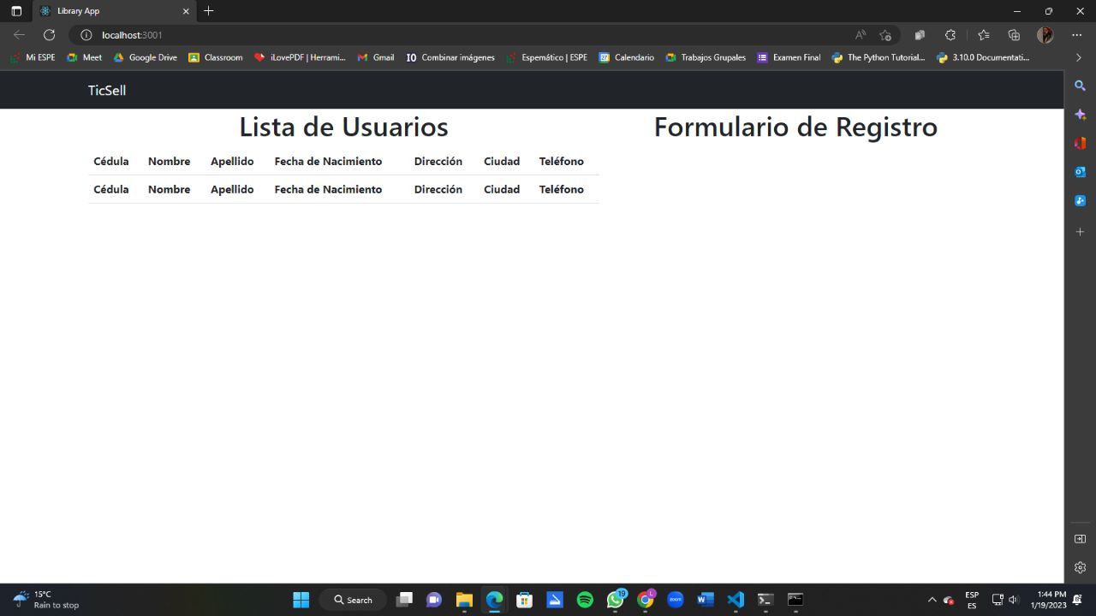

**Page To API Consumption**



1. **Authentication and Navigability (sessions)**

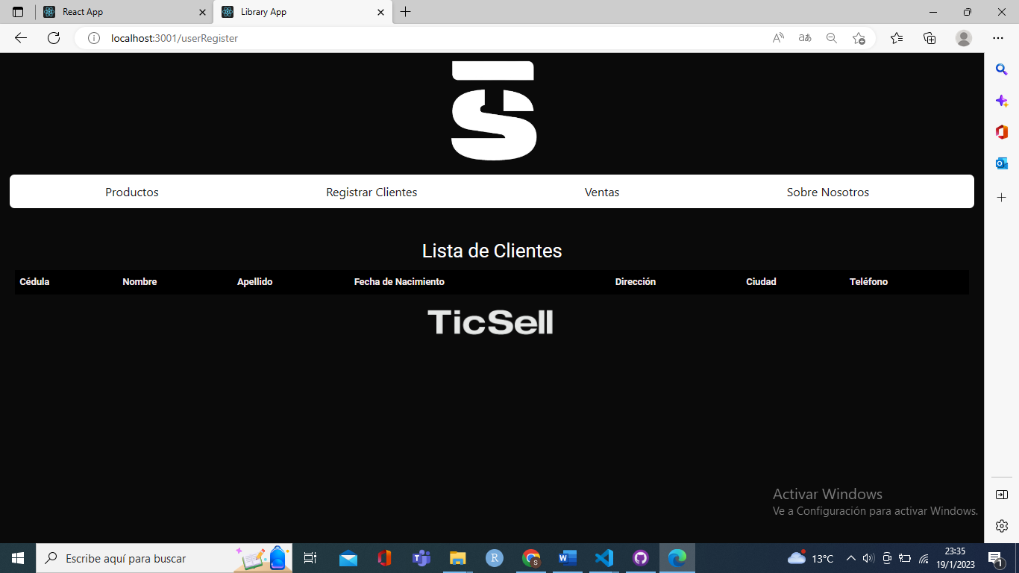

1. **Web Clients + public API https://api.plos.org/search**

**PUBLIC API CONSUMPTION**

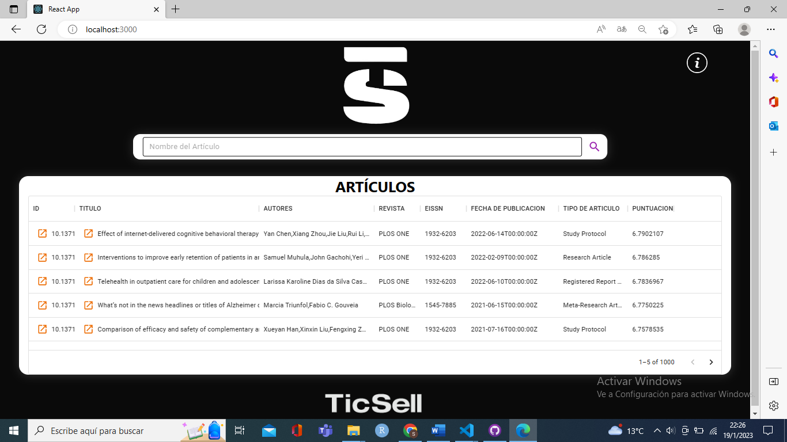

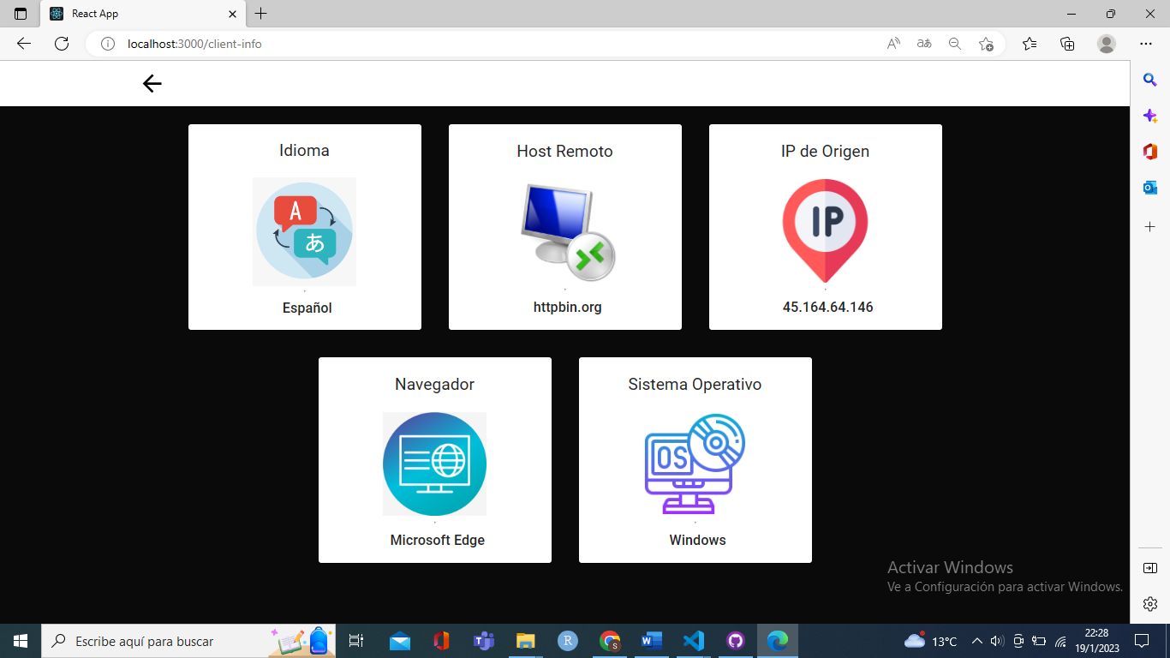

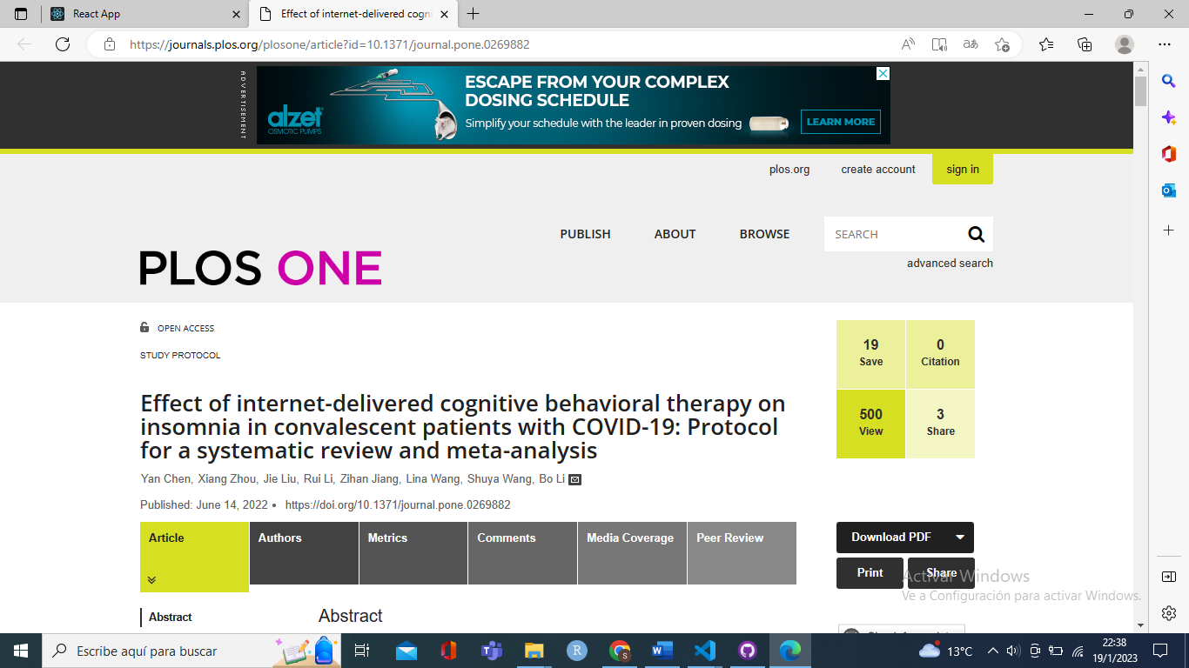

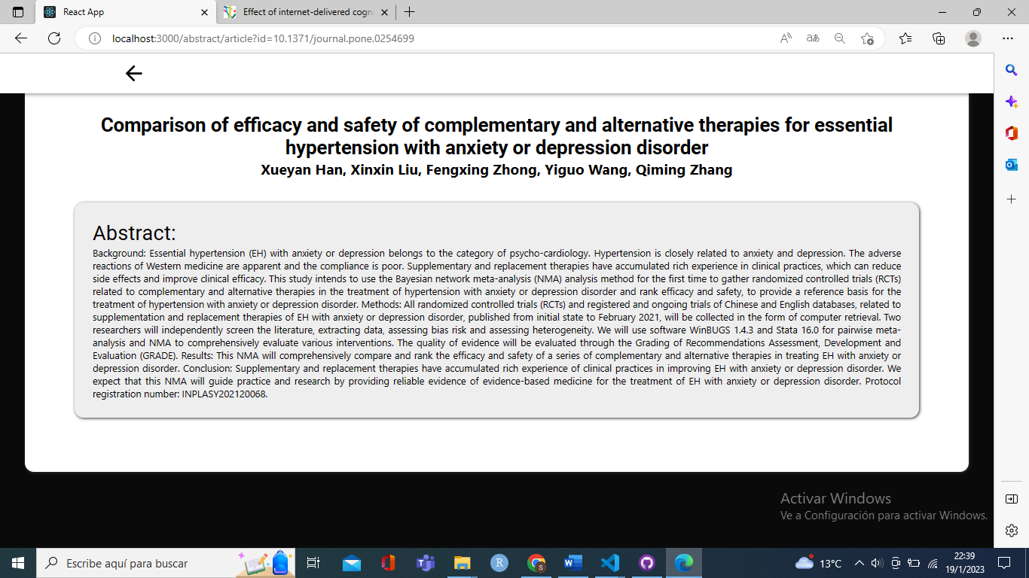

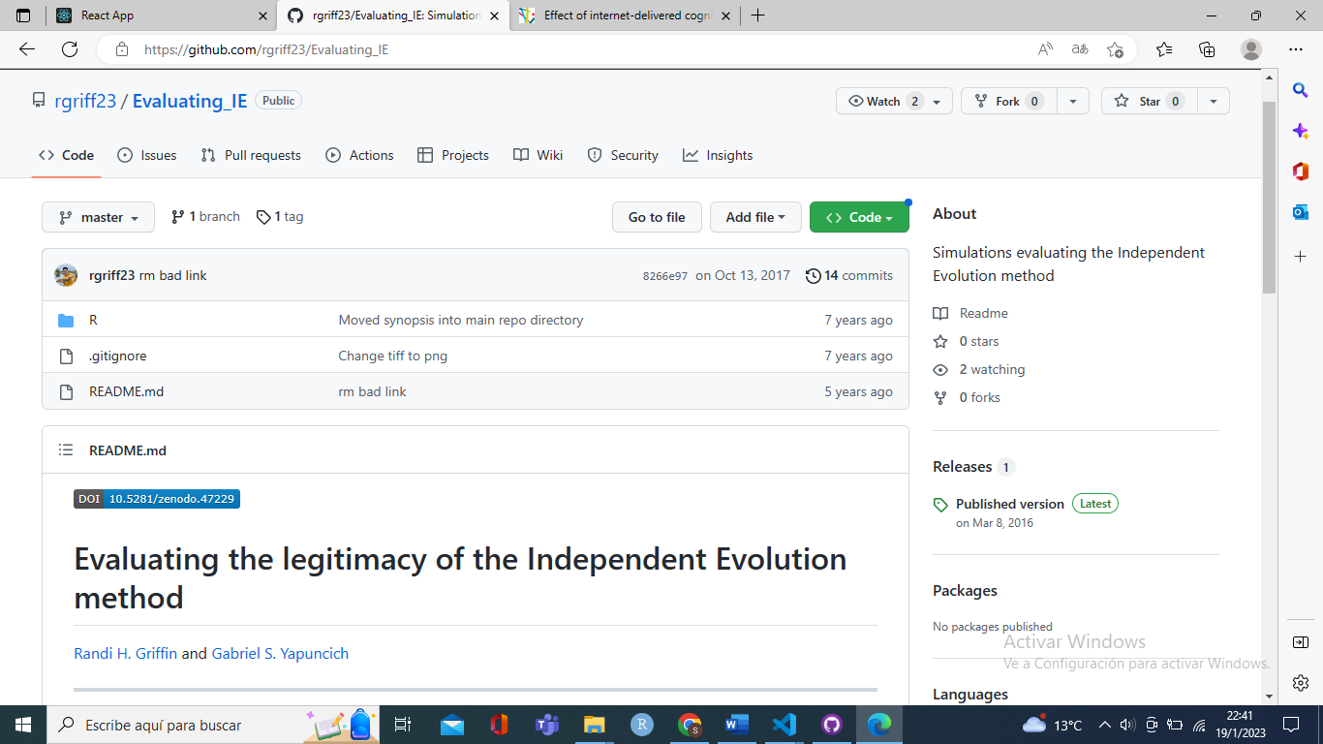

1. **Web Clients + Web Service + BDD**

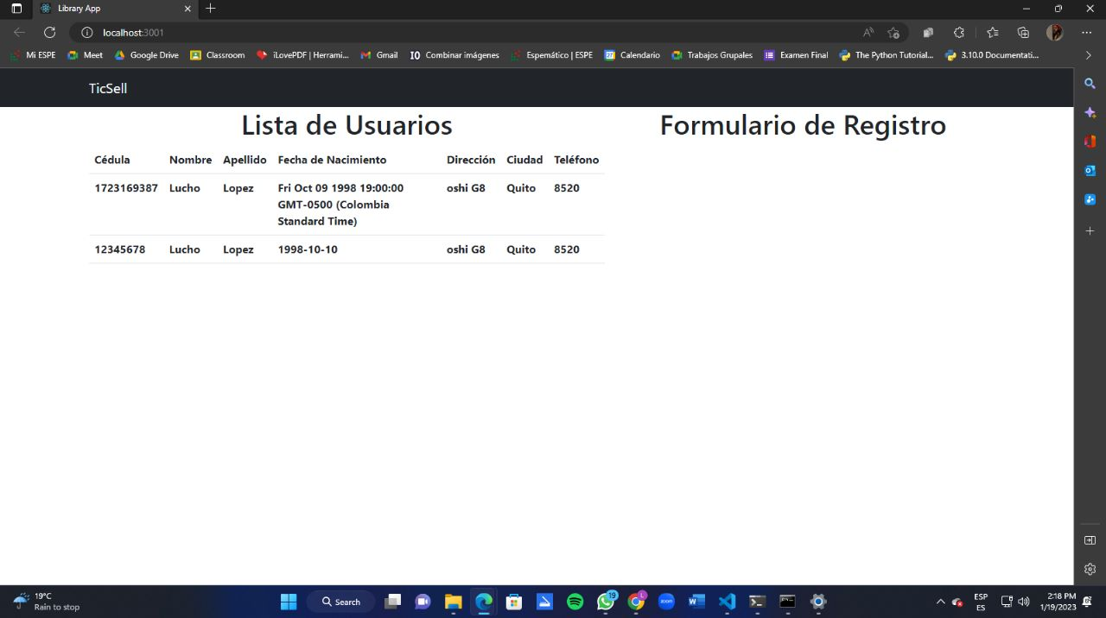

Data at MongoDB

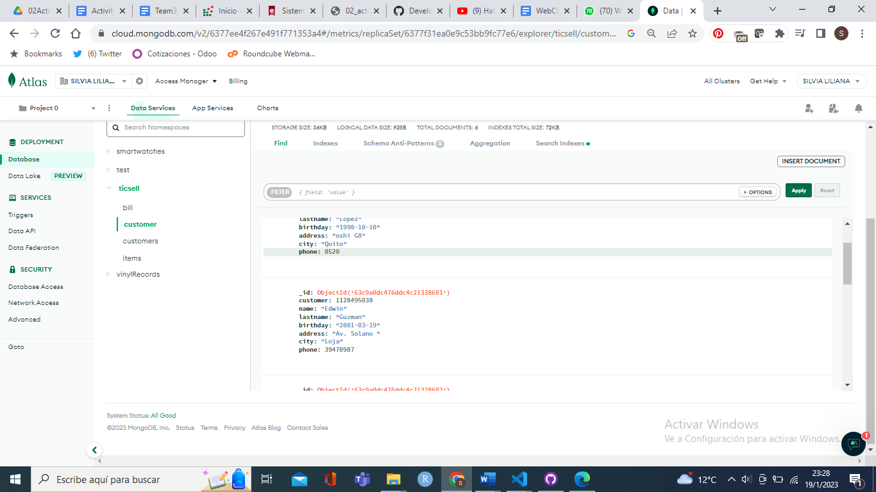

1. **Other web pages / forms for the project**