

Universidad de las Fuerzas Armadas ESPE

**NRC 8516:**

Development web applications

**Team 6:**

Luis Yépez

Silvia Yunga



**Project:**

TicSell

**Tutor:**

Ing. Jorge Edison Lascano

8 February 2023

**GitHub collaboration**

**Collaboration Report**

**Design (sketches) of the 16 web pages/forms**

**loggin**

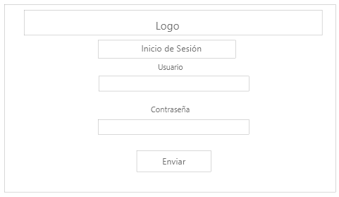

**Home page**

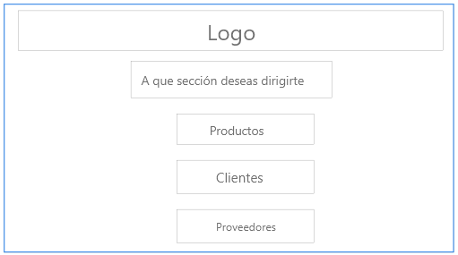

**Products session**

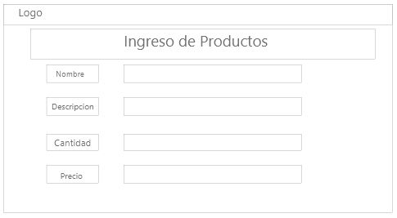

**View products**

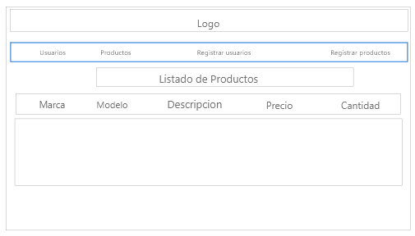

**Web Clients + Web Services (GET, POST) + DB**

**Web Clients + Web Services (PUT, DELETE) + DB**

**Web Clients + Web services (Business logic) + DB**

**Web Clients + Web Service + BDD**

Data at MongoDB

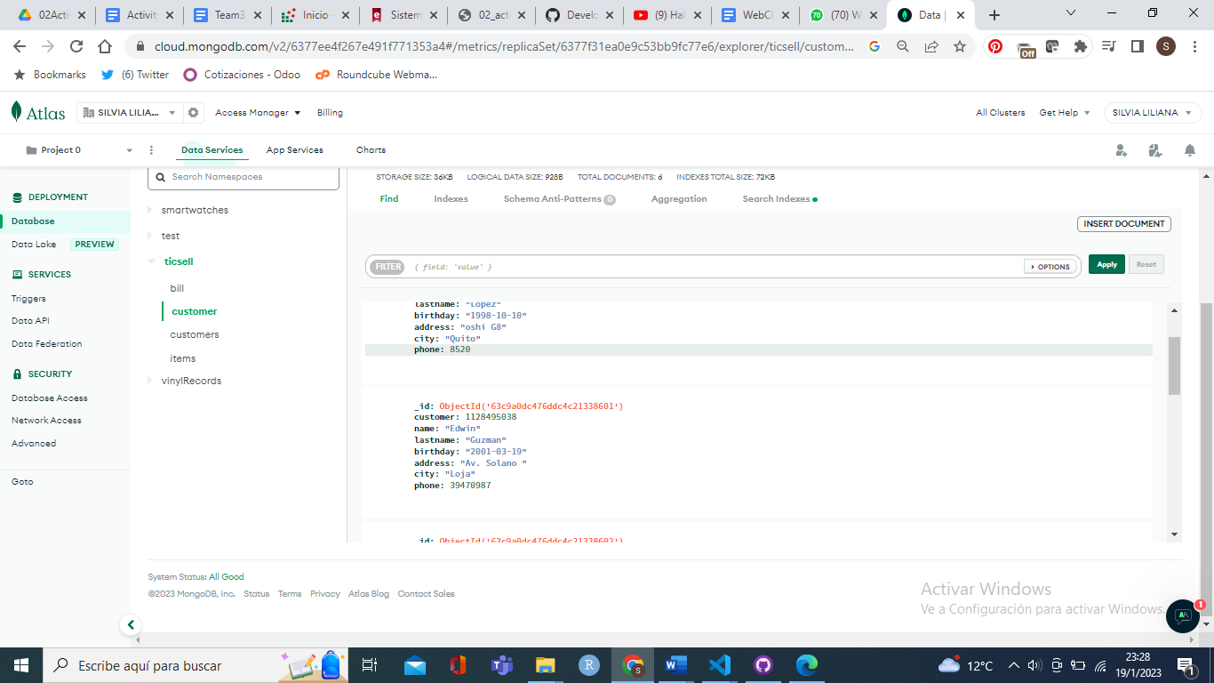

1. **Other web pages / forms for the project**