Universidade Fernando Pessoa

Mestrado em Computação Móvel

Redes e Serviços de Comunicações Móveis II

Luísa Costa 37151, Rodrigo Soares 36824

Ficha de Trabalho nº 4

LISP – Topologia GNS3

Porto

Abril/2021



Universidade Fernando Pessoa

Praça 9 de Abril, 349

P-4249-004 Porto

Tel. +351-22550.82.70

Fax. +351-22550.82.69

geral@ufp.pt

1 LISP parte 1 2

1.1 Configurações 3

1.1.1 Router 1 (xTR) 3

1.1.2 Router 2 (xTR) 4

1.1.3 Router 3 (MS/MR) 5

1.1.4 Router 4 (Underlay) 6

1.2 Prints 7

2 LISP parte 2 8

2.1 8

2.2 Prints 8

# LISP parte 1

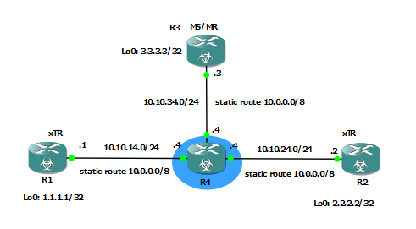

Figura – Topologia LISP_part_1

|  |  |  |  |  |
| --- | --- | --- | --- | --- |
| **Máquina** | **Tipo** | **Interface** | **Lo0** | **Endereços** |
| R1_xTR | Router | G0/0 | 1.1.1.1 | 10.10.14.1/24 |
| R2_xTR | G0/0 | 2.2.2.2 | 10.10.24.2/24 |
| R3_MS_MR | G0/0 |  | 10.10.34.3/24 |
| R4_Underlay | G0/0 | 10.10.14.4/24 |
| G0/1 | 10.10.24.4/24 |
| G0/2 | 10.10.34.4/24 |

## Configurações

### Router 1 (xTR)

en

conf t

hostname R1_xTR

int lo0

ip address 1.1.1.1 255.255.255.255

exit

int g0/0

ip address 10.10.14.1 255.255.255.0

no shut

ip route 10.0.0.0 255.0.0.0 10.10.14.4

router lisp

database-mapping 1.1.1.0/24 10.10.14.1 priority 1 weight 100

ipv4 itr

ipv4 itr map-resolver 10.10.34.3

ipv4 etr

ipv4 etr map-server 10.10.34.3 key tut_siteA

end

wr

### Router 2 (xTR)

en

conf t

hostname R2_xTR

int g0/0

ip address 10.10.24.2 255.255.255.0

no shut

int lo0

ip address 2.2.2.2 255.255.255.255

exit

ip route 10.0.0.0 255.0.0.0 10.10.24.4

router lisp

database-mapping 2.2.2.0/24 10.10.24.2 priority 1 weight 100

ipv4 itr

ipv4 itr map-resolver 10.10.34.3

ipv4 etr

ipv4 etr map-server 10.10.34.3 key tut_siteB

end

wr

### Router 3 (MS/MR)

### en

conf t

hostname R3_MS_MR

int g0/0

ip address 10.10.34.3 255.255.255.0

no shut

ip route 10.0.0.0 255.0.0.0 10.10.34.4

lisp site siteA

eid-prefix 1.1.1.0/24

authentication-key tut_siteA

lisp site siteB

eid-prefix 2.2.2.0/24

authentication-key tut_siteB

ip lisp map-server

ip lisp map-resolver

end

wr

### Router 4 (Underlay)

en

conf t

hostname R4_Underlay

int g0/0

ip address 10.10.14.4 255.255.255.0

no shut

int g0/1

ip address 10.10.24.4 255.255.255.0

no shut

int g0/2

ip address 10.10.34.4 255.255.255.0

no shut

end

wr

## Prints

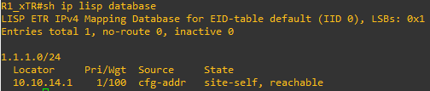

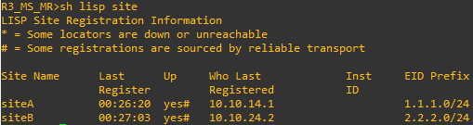

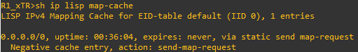

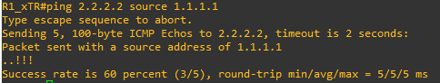

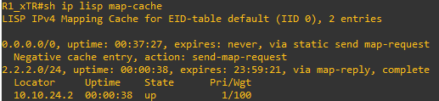

# LISP parte 2

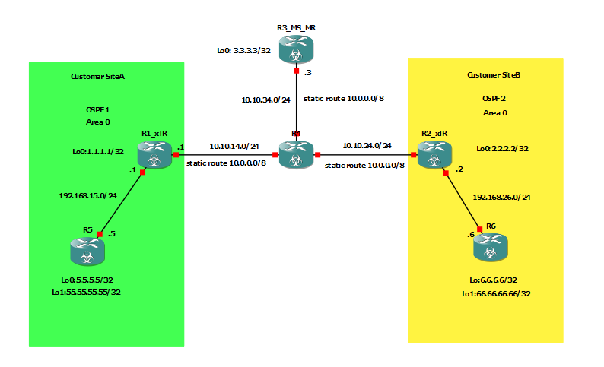

|  |  |  |  |  |  |
| --- | --- | --- | --- | --- | --- |
| **Máquina** | **Tipo** | **Interface** | **Lo0** | **Lo1** | **Endereços** |
| R1_xTR | Router | G0/0 | 1.1.1.1 |  | 10.10.14.1/24 |
| G0/1 | 192.168.15.1 |
| R2_xTR | G0/0 | 2.2.2.2 | 10.10.24.2/24 |
| G0/1 | 192.168.26.2/24 |
| R3_MS_MR | G0/0 |  | 10.10.34.3/24 |
| R4_Underlay | G0/0 | 10.10.14.4/24 |
| G0/1 | 10.10.24.4/24 |
| G0/2 | 10.10.34.4/24 |
| R5 | G0/0 | 5.5.5.5 | 55.55.55.55.55 | 192.168.15.5/24 |
| R6 | G0/0 | 6.6.6.6 | 66.66.66.66 | 192.168.26.6/24 |

## Configurações

### R1 (xTR)

en

conf t

hostname R1_xTR

int lo0

ip address 1.1.1.1 255.255.255.255

exit

int g0/0

ip address 10.10.14.1 255.255.255.0

no shut

interface g0/1

ip address 192.168.15.1 255.255.255.0

no shut

exit

ip route 10.0.0.0 255.0.0.0 10.10.14.4

router ospf 1

network 192.168.15.0 0.0.0.255 area 0

default-information originate always

exit

router lisp

database-mapping 1.1.1.0/24 10.10.14.1 priority 1 weight 100

database-mapping 5.5.5.0/24 10.10.14.1 priority 1 weight 100

database-mapping 55.55.55.55/32 10.10.14.1 priority 1 weight 100

database-mapping 192.168.15.0/24 10.10.14.1 priority 1 weight 100

ipv4 itr

ipv4 itr map-resolver 10.10.34.3

ipv4 etr

ipv4 etr map-server 10.10.34.3 key tut_siteA

end

wr

### R2 (xTR)

en

conf t

hostname R2_xTR

int g0/0

ip address 10.10.24.2 255.255.255.0

no shut

interface g0/1

ip address 192.168.26.2 255.255.255.0

no shut

exit

int lo0

ip address 2.2.2.2 255.255.255.255

exit

ip route 10.0.0.0 255.0.0.0 10.10.24.4

router ospf 1

network 192.168.26.0 0.0.0.255 area 0

default-information originate always

exit

router lisp

database-mapping 2.2.2.0/24 10.10.24.2 priority 1 weight 100

database-mapping 6.6.6.0/24 10.10.24.2 priority 1 weight 100

database-mapping 66.66.66.66/32 10.10.24.2 priority 1 weight 100

database-mapping 192.168.26.0/24 10.10.24.2 priority 1 weight 100

ipv4 itr

ipv4 itr map-resolver 10.10.34.3

ipv4 etr

ipv4 etr map-server 10.10.34.3 key tut_siteB

end

wr

### Router 3 (MS/MR)

en

conf t

hostname R3_MS_MR

int g0/0

ip address 10.10.34.3 255.255.255.0

no shut

ip route 10.0.0.0 255.0.0.0 10.10.34.4

lisp site siteA

eid-prefix 1.1.1.0/24

eid-prefix 5.5.5.0/24

eid-prefix 55.55.55.55/32

eid-prefix 192.168.15.0/24

authentication-key tut_siteA

exit

lisp site siteB

eid-prefix 2.2.2.0/24

eid-prefix 6.6.6.0/24

eid-prefix 66.66.66.66/32

eid-prefix 192.168.26.0/24

authentication-key tut_siteB

exit

ip lisp map-server

ip lisp map-resolver

end

wr

### Router 4 (Underlay)

en

conf t

hostname R4_Underlay

int g0/0

ip address 10.10.14.4 255.255.255.0

no shut

int g0/1

ip address 10.10.24.4 255.255.255.0

no shut

int g0/2

ip address 10.10.34.4 255.255.255.0

no shut

end

wr

### Router 5

en

conf t

hostname R5

interface g0/0

ip address 192.168.15.5 255.255.255.0

no shut

exit

int lo0

ip address 5.5.5.5 255.255.255.255

exit

int lo1

ip address 55.55.55.55 255.255.255.255

exit

router ospf 1

network 192.168.15.0 0.0.0.255 area 0

network 5.5.5.5 0.0.0.0 area 0

network 55.55.55.55 0.0.0.0 area 0

end

wr

### Router 6

en

conf t

hostname R6

interface g0/0

ip address 192.168.26.6 255.255.255.0

no shut

exit

int lo0

ip address 6.6.6.6 255.255.255.255

exit

int lo1

ip address 66.66.66.66 255.255.255.255

exit

router ospf 1

network 192.168.26.0 0.0.0.255 area 0

network 6.6.6.6 0.0.0.0 area 0

network 66.66.66.66 0.0.0.0 area 0

end

wr

## Prints

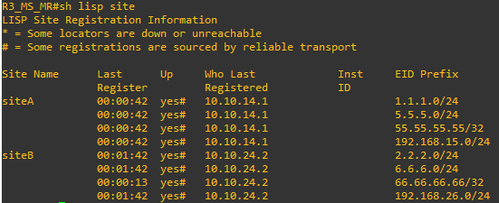

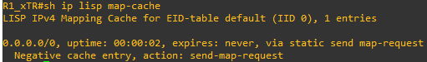

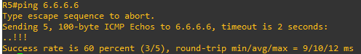

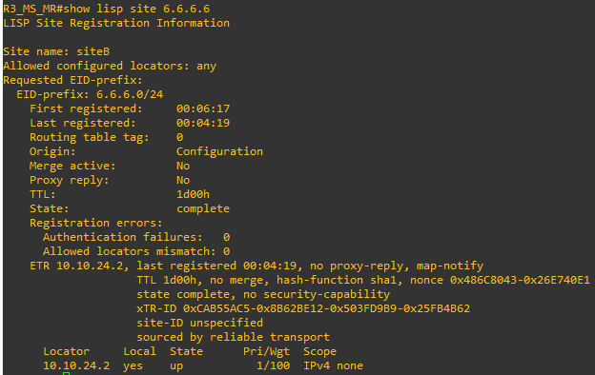

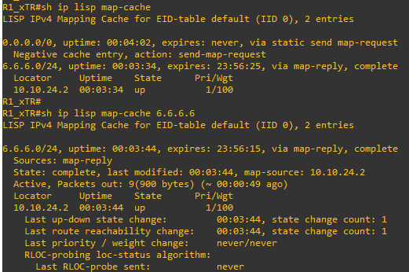

# LISP IPV6 Parte 1

|  |  |  |  |  |
| --- | --- | --- | --- | --- |
| **Máquina** | **Tipo** | **Interface** | **Lo0** | **Endereços** |
| R1_xTR | Router | G0/0 | 2001:DB8:1::1/32 | 2001:DB8:14::1/64 |
| R2_xTR | G0/0 | 2001:DB8:2::2/32 | 2001:DB8:24::2/64 |
| R3_MS_MR | G0/0 |  | 2001:DB8:34::3/64 |
| R4_Underlay | G0/0 | 2001:DB8:14::4/64 |
| G0/1 | 2001:DB8:24::4/64 |
| G0/2 | 2001:DB8:34::4/64 |