Intro2R-Git_Tutorial

LuisaFZ

7 4 2020

This report documents my first attempts of using Git and GitHub to version control an RStudio project. I will be modifying, commiting changes and then pushing to GitHub

Let’s create a plot of distance (miles) and speed (mph)

plot(cars, col ='red', xlab ='speed (mph)', ylab ='distance(miles)')

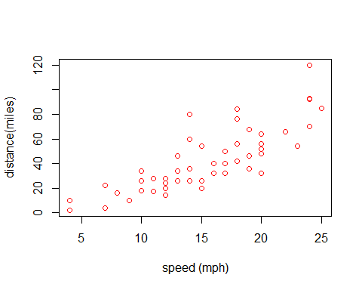

A summary of the data frame is given below

library(knitr)

## Warning: package 'knitr' was built under R version 3.6.2

kable(summary(cars))

|  |  |  |
| --- | --- | --- |
|  | speed | dist |
|  | Min. : 4.0 | Min. : 2.00 |
|  | 1st Qu.:12.0 | 1st Qu.: 26.00 |
|  | Median :15.0 | Median : 36.00 |
|  | Mean :15.4 | Mean : 42.98 |
|  | 3rd Qu.:19.0 | 3rd Qu.: 56.00 |
|  | Max. :25.0 | Max. :120.00 |