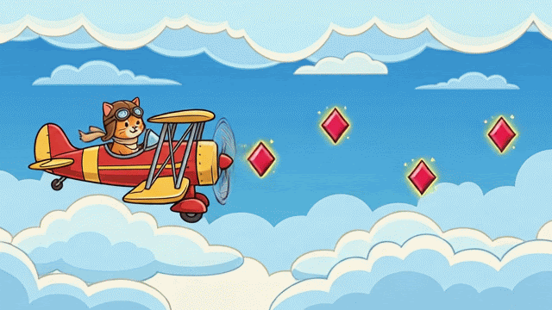
PILOT CAT
GAME DEVELOPMENT DOCUMENT (Live document that is constantly being updated)
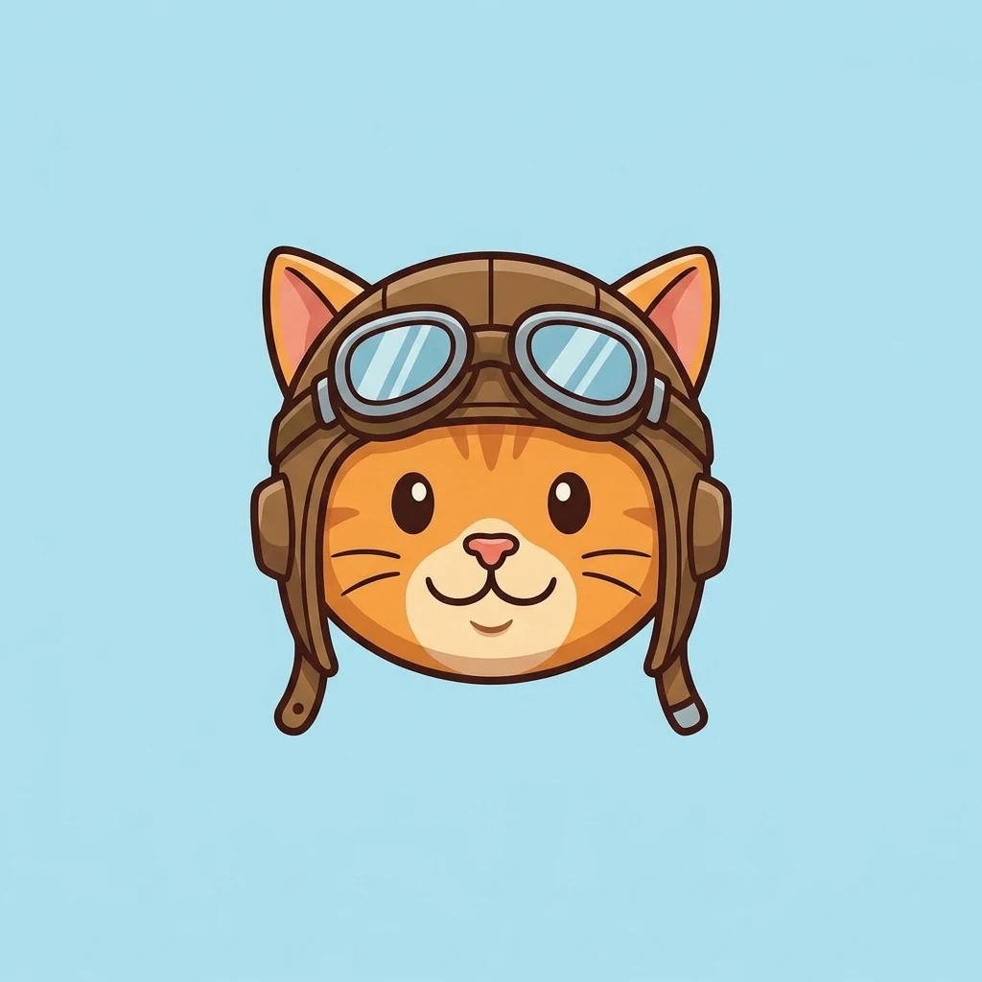
Contributors: Luisa, Pascual, Roman, Vinh

Table of Contents
1. Game Concept and Story Development
1.1 Game Overview
1.2 Game Concept and Vision
1.3 Game Genre and Target Audience
1.4 Game Setting and World
1.5 Backstory and Lore
1.6 Main Story and Narrative
1.7 Player Identity and Role
1.8 Player Goals and Motivation
1.9 Intended Player Experience
2. Game Design and Gameplay Planning
2.1 Core Gameplay Loop
2.2 Gameplay Mechanics
2.3 Player Actions and Controls
2.4 Game Rules and Objectives
2.5 Combat and Interaction Systems
2.6 Progression and Reward Systems
2.7 Difficulty and Game Balancing
3. World, Levels and Scene Design
3.1 Game World Structure
3.2 Level Design
3.3 Scene Organization
3.4 Environment Design
3.5 Important Locations
3.6 Objects and Interactive Elements
3.7 Scene Flow and Progression
4. Characters, Assets and Visual Development
4.1 Main Player Character
4.2 Character Design
4.3 Supporting Characters and NPCs
4.4 Enemies and Bosses
4.5 Character Abilities and Attributes
4.6 3D Models and Asset Creation
4.7 Blender Workflow
4.8 Materials and Textures
4.9 Animation and Visual Effects
4.10 Asset Sources and Credits
5. Technical Design and C# Development
5.1 Game Engine and Development Environment
5.2 Project Folder Structure
5.3 Scene and Object Structure
5.4 C# Classes and Objects
5.5 Fields, Properties and Variables
5.6 Methods and Functions
5.7 Conditions and Logical Statements
5.8 Player Input and Behavior
5.9 Object References and Connections
5.10 Gameplay Systems
5.11 Data Management and Game State
6. User Interface and Audio Design
6.1 Main Menu
6.2 Heads-Up Display (HUD)
6.3 Player Information and Status
6.4 Inventory and Equipment
6.5 Settings and Navigation
6.6 Music and Sound Effects
6.7 Environmental Audio
6.8 Accessibility and User Experience
7. Testing, Debugging and Quality Assurance
7.1 Testing Strategy
7.2 Gameplay Testing
7.3 Player Movement and Interaction Tests
7.4 C# Behavior Testing
7.5 Expected Versus Observed Results
7.6 Bug and Error Documentation
7.7 Debugging and Corrections
7.8 Performance Testing
7.9 Final Test Results
8. Documentation and Project Management
8.1 Development Documentation
8.2 Video Learning Records (1–9)
8.3 AI Assistance and Verification
8.4 Team Roles and Responsibilities
8.5 Task Tracking and Ownership
8.6 Discord and Peer Feedback
8.7 Project Demonstration
8.8 Next-Class Development Plan
9. GitHub, Release and Project Handoff
9.1 Project Organization
9.2 Source Code and Asset Management
9.3 Git Version Control
9.4 Commit and Push Records
9.5 Setup and Run Instructions
9.6 Known Issues and Dependencies
9.7 Final Evidence Package
9.8 GitHub Repository Handoff
9.9 Canvas Submission Confirmation

APPENDICES
Appendix A – Whiteboard Planning
Appendix B – Game Flowcharts and Diagrams
Appendix C – Character and Asset References
Appendix D - Screenshots and Development Evidence
Appendix E – Asset Licenses and Source Credits
Appendix F – Communication Preferences
Appendix G – Access to all actions/references for this project

Evidence –

Appendix A - White Board Planning
The evidence folder focuses on our entire evidence of our game development process. Also, it includes our white board planning session. This session focuses on a collaborative team effort to exchange ideas and plan our game development based on the ideals by Professor Malik’s book Attention First.

You can find our evidence for our white board planning at the following link: https://github.com/saines007/CS077-Fall-2026-Team/tree/main/12-Week-12-Independence-Day/Action-12A/Evidence

Story to result map –
The story we established continues off the story we previously established in 11A. We added more details to the character’s backstory along with identifying the game as a side scroller.

Names Contributions –
The contributors for the Week 12 work pipeline includes: Luisa, Pascual, Roman, and Vinh. Vinh served as our team lead for this week’s pipeline and Pascual served at the team’s coordinator.

What the map changed –
The map changed the logic and understanding of the game. Also, it helped map tasks for contributors and scenes for the game itself.

Appendix B - Game Flowcharts and Diagrams

Appendix C - Character and Asset References
Character Design –
Our first character concept was constructed during our whiteboard session. The session created the concept of our player (Pilot Cat) and his plane that he uses to complete his missions. As this is a side scroller based game, the concept of the sky and moving buildings served as a template for our working model.

Our character was designed with artificial intelligence and our assets are referenced within our credits page and program itself. You can find our credits page here:
https://github.com/saines007/CS077-Fall-2026-Team/blob/main/12-Week-12-Independence-Day/Action-12A/CREDITS.md

Appendix E – Asset Licenses and Source Credits

