
CFA Institute Research Challenge
hosted by CFA Society Mexico
TEC DE MONTERREY CAMPUS AGUASCALIENTES

The CFA Institute Research Challenge is a global competition that tests the equity research and valuation, investment report writing, and presentation skills of university students. The following report was prepared by a team of university students as part of this annual educational initiative and should not be considered a professional report.
Disclosures:
Ownership and material conflicts of interest
The author(s), or a member of their household, of this report does not hold a financial interest in the securities of this company.
The author(s), or a member of their household, of this report does not know of the existence of any conflicts of interest that might bias the content or publication of this report.
Receipt of compensation
Compensation of the author(s) of this report is not based on investment banking revenue.
Position as an officer or director
The author(s), or a member of their household, does not serve as an officer, director, or advisory board member of the subject company.
Marketing making
The author(s) does not act as a market maker in the subject company’s securities.
Disclaimer
The information set forth herein has been obtained or derived from sources generally available to the public and believed by the author(s) to be reliable, but the author(s) does not make any representation or warranty, express or implied, as to its accuracy or completeness. The information is not intended to be used as the basis of any investment decisions by any person or entity. This information does not constitute investment advice, nor is it an offer or a solicitation of an offer to buy or sell any security. This report should not be considered to be a recommendation by any individual affiliated with CFA Society Mexico, CFA Institute, or the CFA Institute Research Challenge with regard to this company’s stock.

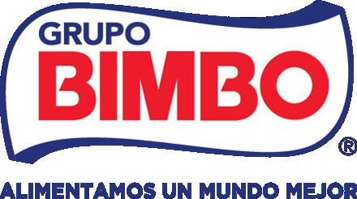 | Grupo Bimbo, S.A.B. de C.V.  BMV: BIMBO A  Sector: Consumer Staples  Industry: Packaged Food & Bakery | SELL Recommendation  Target price (12M): MXN 58.54 (13.0% below the price)  Price (2026-11-04): MXN 67.27
Executive Summary
Grupo Bimbo's recovery is real, and the market already paid for it. The share increased 14.8% from 16 October to 4 November, around the 3Q26 results of 22 October, to MXN 67.27 (Yahoo Finance, 2026). Our rating is SELL. The 12-month target price is MXN 58.54, 13.0% below the price.
The rating does not depend on the precision of our model. It depends on what the price needs. A reverse DCF shows that MXN 67.27 needs an adjusted EBITDA margin of about 15.7% from FY2027E. Our model has 15.12%, the consensus has 14.6%, and the best year of FY2021-FY2025 had 14.0%. The price also needs sales growth of 6.6% a year in FY2028E-FY2030E, against 3.7% in our model (team model; S&P Capital IQ, 2026).
Our model is already above the consensus on margin, EBITDA and EPS. It still gives a value below the price. The DCF value of MXN 52.92 is 21.3% below the price. The total return is -11.3%, against a cost of equity of 12.26%.
Our view has three pillars. Reported growth includes growth from acquisitions and from the peso. The price already includes growth that Bimbo did not deliver on its own (pillar 1). Costs can increase without a large decrease in the margin. This is because Bimbo already absorbed a shock almost four times larger than the shock in our model. Costs are not the reason for the SELL, and an increase in the price of wheat will make the SELL stronger (pillar 2).  The new management inherits a recovery. The next step of the recovery, in 2027, is not proven at this time. The price needs this step to be larger than the step in our model (pillar 3). Our rating rule gives SELL at this price. This is because even the optimistic expected return (WACC -0.5 pp), +4.1%, is below the 12.26% cost of equity.  The margin of safety is small. About 60 bp of margin from FY2027E will close the gap with the price. If the guidance on the 4Q26 call in late February 2027 is about 15.5% or more, then the rule will move to HOLD (Table 8).  Highlights  • Business. Bimbo is the largest baker in the world, with 249 plants in 39 countries. Mexico earns 54% of regional adjusted EBITDA from 35% of regional sales. North America earns 29% from 43% (Grupo Bimbo, 2026a, pp. 14, 85; team model).  • Forecast. Net sales increase by 3.2% a year to FY2030E. The adjusted EBITDA margin increases from 13.9% to 15.1%. Of the 120 bp increase to FY2027E, 114 bp come from two lines that decrease to almost zero (team model).
  Figure 1: Share price and 12-month target
  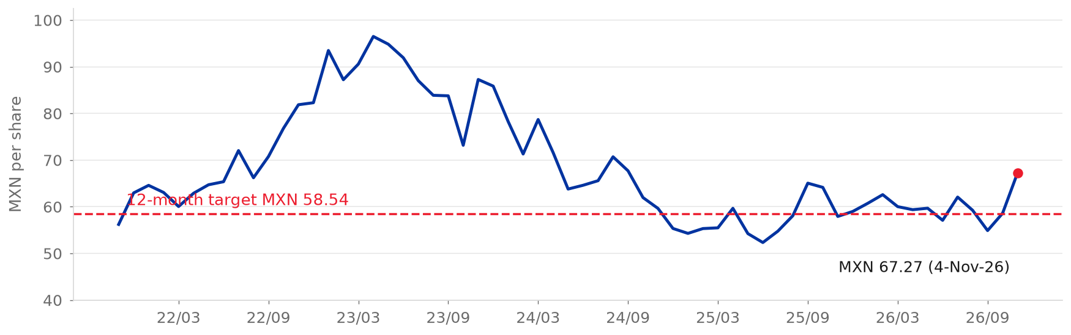
  Source: S&P Capital IQ (2026); Yahoo Finance (2026) for 4-Nov-26; team model
  Figure 2: Net sales and adjusted EBITDA margin, FY2021A-FY2030E
  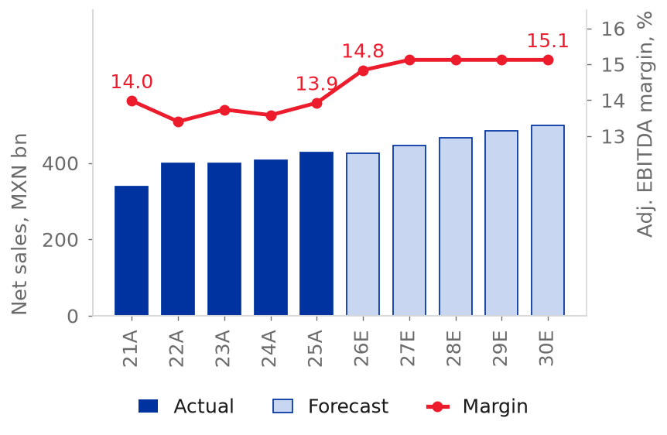
  Source: Grupo Bimbo (2026f); team model
• Valuation. The WACC is 9.62%, the terminal growth is 4.40% and the terminal return on new capital is 15.17%. The terminal value is 83% of enterprise value at the target date (team model).
• Upside risks. The risks are the 2027 margin guidance in late February 2027, lower interest rates, a weaker peso and faster organic growth (Table 8). A margin of about 15.7% will close the gap on its own. A WACC 0.5 pp lower will also close the gap on its own (Grupo Bimbo, 3Q26 earnings call; team model).
• Main risk to the SELL. A margin that is 100 bp higher from FY2027E adds about MXN 14.8 per share, 25% of the target price. A margin that is about 60 bp higher is enough to match the price (team model).
Analysts: Luis Arturo Romo Alba, Diego Benavides Pro, Alexa Garcia Saldivar, Jorge Alejandro Gaytan, Carolina del Rosario Benites
Business Description
Grupo Bimbo, S.A.B. de C.V. is the largest bakery company in the world by sales. It has 3.7% of the global bakery market, which is 1.2 times the share of the next competitor (Grupo Bimbo, 2026a, pp. 107-109). Bimbo operates 249 plants and more than 54,000 delivery routes in 39 countries. Bimbo sells more than 9,000 products under over 100 brands (Grupo Bimbo, 2026a, pp. 14, 100). FY2025 net sales were MXN 426,952 million (+4.6%). Adjusted EBITDA was MXN 59,456 million, a 13.9% margin (Grupo Bimbo, 2026f, p. 85).  Business model  Bimbo bakes fresh bread, sweet baked goods, cookies, tortillas and salty snacks. Bimbo delivers these products to stores on its own routes. The delivery network, not the recipe, is the barrier to entry, because fresh bread lasts about 14 days (Grupo Bimbo, 2026a, pp. 100, 110). The customers are modern retail, traditional stores, convenience chains and quick-service restaurants. Walmart is about 15% of sales. No other customer is more than 10% of sales (Grupo Bimbo, 2026a, p. 103).  Operating segments  • North America (43% of regional sales, 29% of regional EBITDA, 9.0% margin) has Bimbo Bakeries USA. Bimbo Bakeries USA has 54 bakeries and about 27% of US fresh bread. North America also has Barcel USA, Bimbo QSR and Bimbo Canada (Grupo Bimbo, 2026a, pp. 82-84; Flowers Foods, 2026).  • Mexico (35%, 54%, 20.4%) has the Bimbo and Barcel brands, with Takis. Mexico also has 38 plants (Grupo Bimbo, 2026a, pp. 84-85; 2026e, p. 17).
  Figure 3: FY2025 net sales by region
  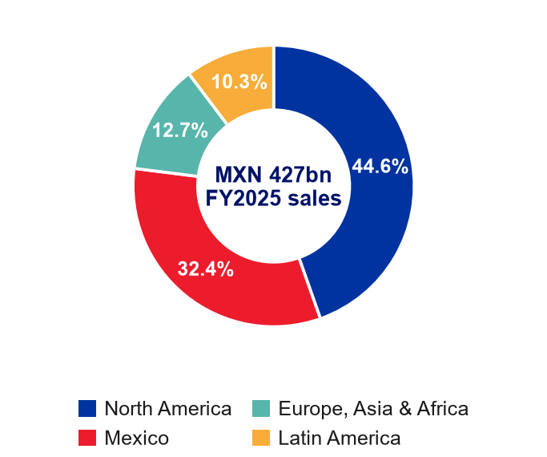
  Source: Grupo Bimbo (2026b, p. 4)
  Figure 4: Acquisitions paid and net debt including leases over EBITDA
  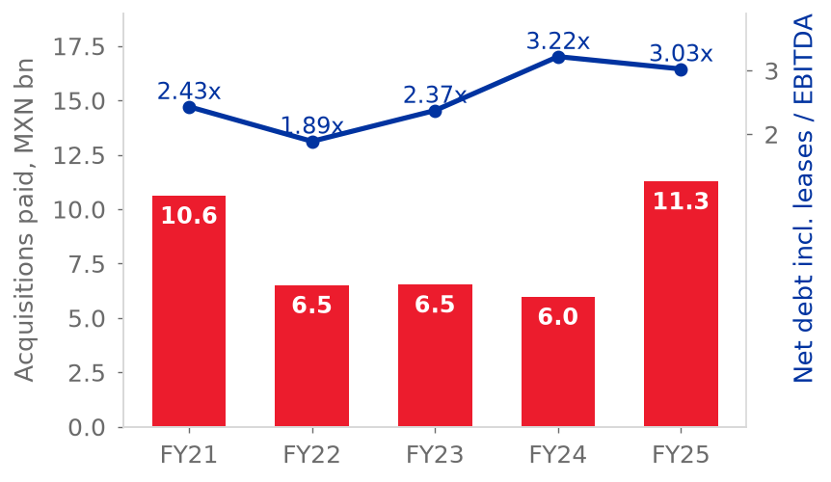
  Source: Grupo Bimbo (2026f); team model

• Europe, Asia and Africa (12%, 10%, 10.8%) covers Iberia, the United Kingdom, Romania, China, India and Africa. Bimbo built most of this region with acquisitions (Grupo Bimbo, 2026a, pp. 85-87).  • Latin America (10%, 6%, 8.1%) operates in 15 countries and has 42 plants. Wickbold (Brazil) joined in October 2025. The integration of Wickbold decreases the margin, which was 7.3% in 3Q26 (Grupo Bimbo, 2026a, p. 85; 2026h, pp. 2-5).  Strategy, acquisitions and ownership  Management rebuilds the profitability of North America. Capex decreased from MXN 34,754 million in FY2023 to MXN 22,530 million in FY2025 (Grupo Bimbo, 2026a, pp. 76-77; 2026f, p. 86). Part of the growth also came from acquisitions. Bimbo made about 60 acquisitions in fifteen years. Bimbo added 29 bakeries in 2025 and bought most of these bakeries. At the end of 2025, 6,093 employees were still in integration (Grupo Bimbo, 2026a, pp. 77, 82, 105).  Six vehicles that hold shares control 72.03% of the shares. Normaciel is the largest of these vehicles, with 40.96%. The free float is 27.6% (Grupo Bimbo, 2026a, pp. 181-182; LSEG, 2026).  Management and governance  Daniel Servitje Montull is Executive Chairman. Alejandro Rodriguez Bas is Group CEO from November 2025. He joined Bimbo in October 2021 (Grupo Bimbo, 2026a, pp. 76-77, 178). The CFO, Gaxiola, holds the post from 2017 (Grupo Bimbo, 2026a, p. 180).  Both successions from 2024 were internal. The results after the second succession show no break. The group margin increased by 100 bp in 3Q26 (Grupo Bimbo, 2026h, pp. 2-5).
  Figure 5: Adjusted EBITDA margin by region, FY2021-FY2025
  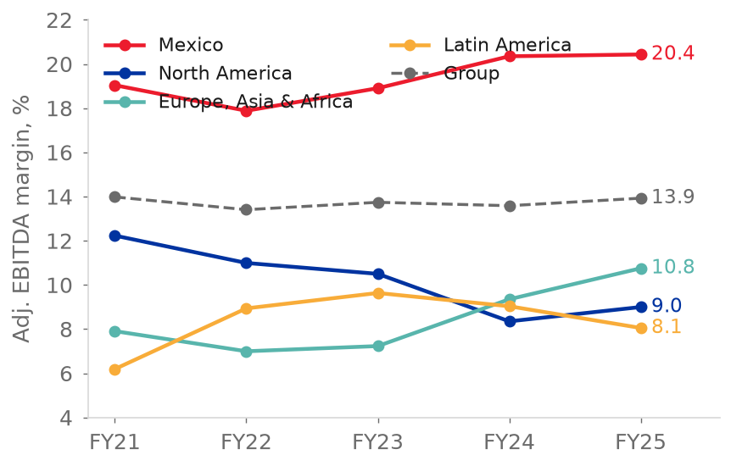
  Source: Grupo Bimbo (2026f, p. 85); team model
  Figure 6: Shareholder structure
  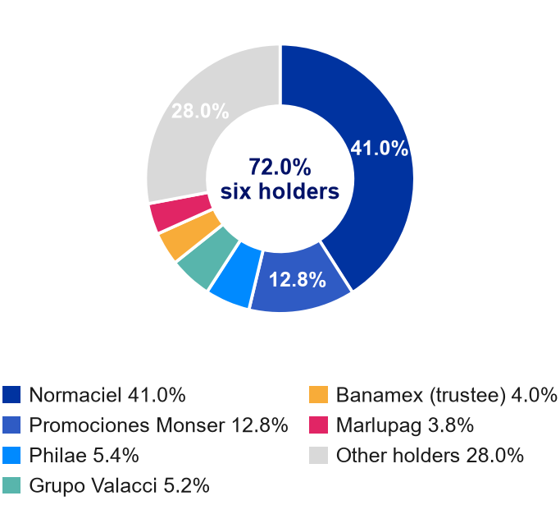
  Source: Grupo Bimbo (2026a, pp. 181-182); LSEG (2026)
The record on promises is mixed. Management set 61 testable targets on earnings calls from 2011. Of these 61 targets, 22 were met, 9 were mixed and 30 were missed. Bimbo kept the pledge to stay below 2x leverage only from December 2020 to 3Q23 (team estimate).
The ESG section gives the full analysis of governance. We see management as positive for the recovery of North America and neutral for governance. The CEO says that the transformation is not complete until volume increases. This statement is more cautious than the forecast needs to be (team estimate).
Industry Overview and Competitive Positioning
Market structure and growth  Bimbo competes in branded, packaged bakery that it delivers direct to store, in each country separately. This market is narrower than the global bakery market. In the global market, artisanal bakeries hold 44.3% and private label holds 9.6% (Grupo Bimbo, 2026a, p. 107).  Global bakery retail value was US$638.9 billion in 2024. It increased at a 2.8% CAGR in 2019-24. Global Data expects 4.7% in 2024-29E. For this period, Global Data expects 4.3% in North America, 5.5% in Latin America and 3.5% in Mexico (Grupo Bimbo, 2026a, pp. 107-111). With the weights from Bimbo's sales mix, this rate is about 4.2% a year (team model).  This growth comes mostly from price and mix. The CEO said that volumes in North America remain weak. The CFO said that growth comes from volume and price/mix. But Bimbo does not report volume (Grupo Bimbo, 3Q26 earnings call; team model). We classify the industry as mature.  Competitive landscape and five forces  Bimbo is number one in the world with a 3.7% share. Mondelez has 3.0% and Gruma has 1.1% (Grupo Bimbo, 2026a, p. 107). In US fresh bread, buns and rolls, the shares are: Bimbo about 27%, private label 26%, Flowers Foods 16% and Pepperidge Farm 5%. In Mexico, Bimbo holds 18.2% of packaged bread and 28.2% of sweet baked goods (Flowers Foods, 2026; Grupo Bimbo, 2026a, pp. 111, 113).  Bimbo operates in two different industries (team estimate). In Mexico and Latin America, the buyers are many and small. The route network helps to give a 20.4% EBITDA margin in Mexico (Grupo Bimbo, 2026f, p. 85). In the United States, Canada and Europe, the buyers are few and large, and private label is strong. Private label is about 35% of US fresh bread units and reached a record 23.8% of US grocery unit sales in 1H26. Flowers Foods' volume decreased by 5.8% in 2Q26 (Bakery & Snacks, 2026; Investing.com, 2026).  • Suppliers have medium power. Raw materials are 30.4% of sales, and wheat, sugar and oils are dollar commodities. Because of this, gross margin follows wheat with a lag of one year. This is the base of our second pillar (Grupo Bimbo, 2026f, p. 82; team model).  • Entrants are a low threat at scale, because the delivery of a 14-day product is the barrier. The real entrants are private label and hard discounters (Grupo Bimbo, 2026a, pp. 100, 110).  • Buyers are strong in developed markets. The modern channel is 77.7% of the North American bakery market, and Walmart is about 15% of group sales (Grupo Bimbo, 2026a, pp. 103, 110).  Macro and positioning  The peso drives reported growth: about 44% of sales come from developed markets (Grupo Bimbo, 2026a, p. 78). Bimbo has the highest gross margin of the bakers (52.6% against 48.6% for Flowers Foods) but spends it on distribution and is more capital intensive (capex 5.2% of sales against a 3.7% median) (S&P Capital IQ, 2026). Our view: The moat is a good reason for the Mexican margin. At this time, the moat is not a good reason for a premium in North America.
  Figure 7: Bakery market value growth, 2019-24 and 2024-29E
  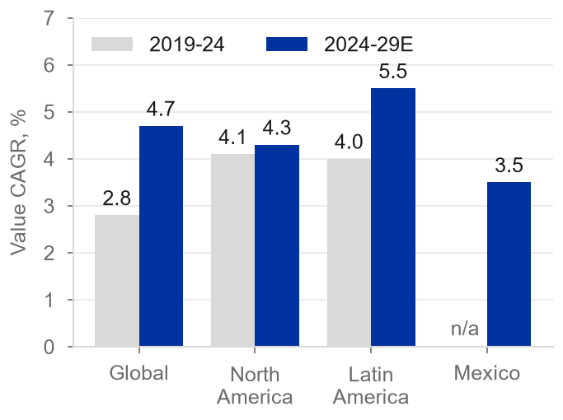
  Source: Global Data, in Grupo Bimbo (2026a, pp. 107-111)
  Figure 8: Global bakery market by type, 2024
  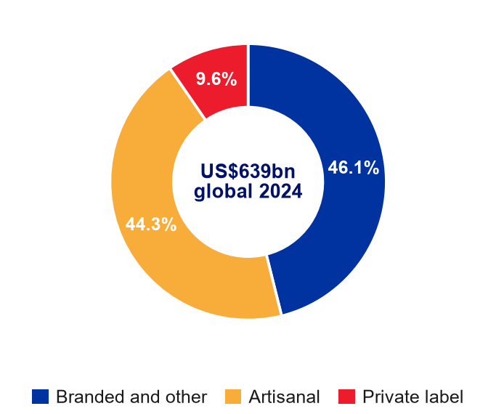
  Source: Global Data, in Grupo Bimbo (2026a, p. 107)
  Figure 9: Five forces: Bimbo is two industries in one
  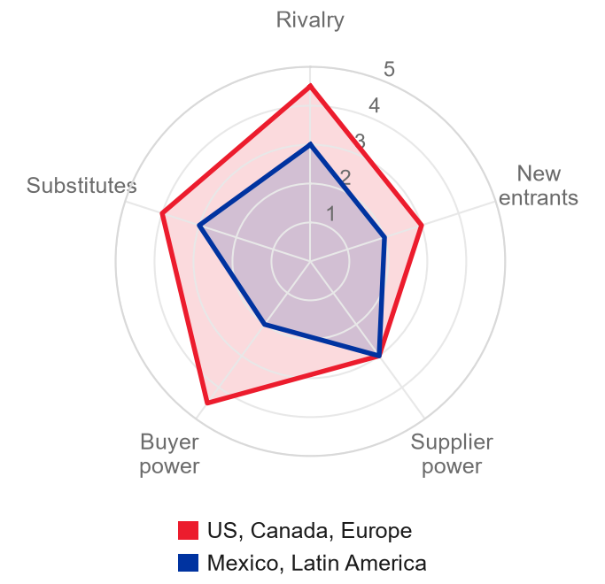
  Source: team estimate

Investment Summary
We remove acquisitions and the effect of the peso from growth. Bimbo already showed that it can absorb the costs. Because of this, the value of Bimbo depends on one thing. The question is if the new management can increase margins on its own in 2027. Until we see this, the price already includes what we know.  The recovery is real. In 3Q26 the group margin reached 15.7%, which is 100 bp above the level of a year earlier. Leverage decreased to 2.4x. Management increased its 2026 margin guide for the third time (Grupo Bimbo, 3Q26 earnings call; 2026h).  But not all of the sales growth is organic. Net sales without the effect of currency increased by 4.4% in 9M26. By our estimate, about 1.1 points of this increase came from acquisitions. The peso decreased the reported sales growth by 6.6 points in these nine months. In our model, the peso becomes 1.46 of the 4.75 points of FY2027E growth.  In our model, the margin increases by 120 bp to FY2027E. Of this increase, 114 bp come from two lines that decrease almost to zero. The CEO inherited a recovery in November 2025. The recovery started before this date (team model).  Costs are not the basis of our SELL. If wheat keeps its September 2026 price, the MXN 58.54 target decreases by MXN 5.83 (10%) (Grupo Bimbo, 3Q26 earnings call; IMF, 2026; team model). R1 shows the stress case.  The market already pays for the outcome. The share price increased by 14.8% between 16 October and 4 November, to MXN 67.27. At that price the expected return over twelve months is -11.3% (our MXN 58.54 target plus the MXN 1.12 dividend). The expected return is below the 12.26% cost of equity, so no premium for the risk is left.
  Figure 10: Adjusted EBITDA margin, FY2025A to FY2027E, by line
  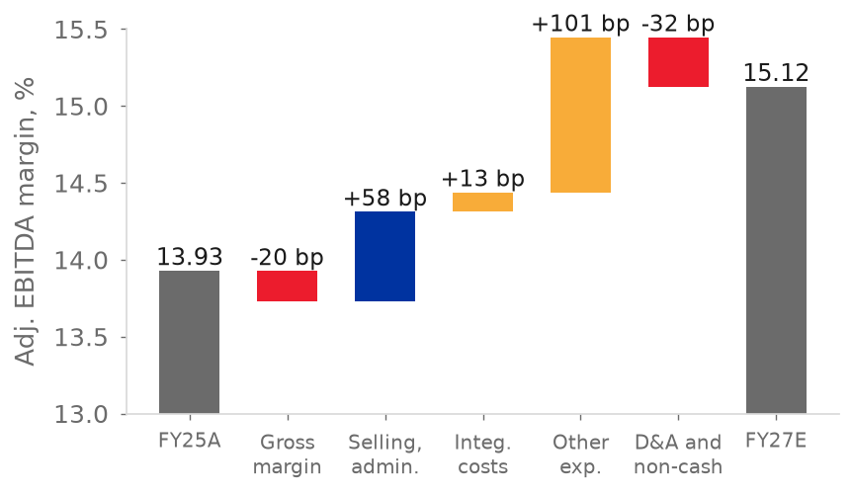
  Source: Grupo Bimbo (2026f); team model
  Figure 11: Adjusted EBITDA margin: model and consensus, FY2026E-FY2028E
  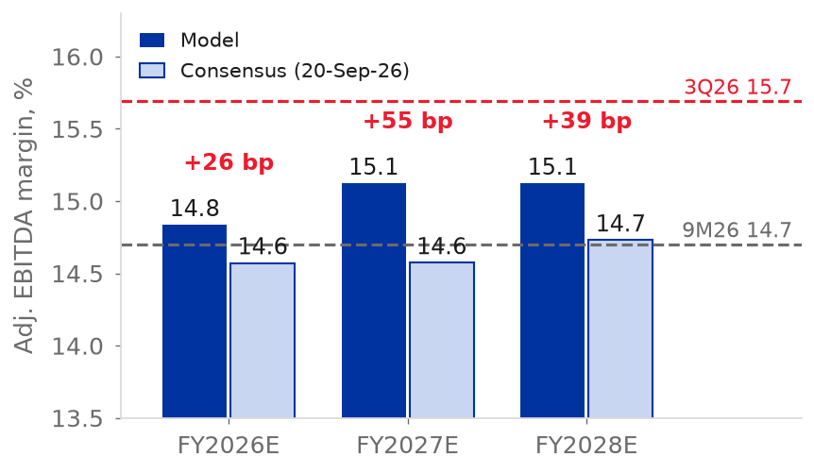
  Source: S&P Capital IQ (2026); team model
We rate Bimbo SELL because the price already pays for the recovery and for a 2027 margin that Bimbo does not show today. We do not rate Bimbo SELL because costs will increase.
Our SELL has three pillars. Pillars 1 and 3 are the reason for the SELL. Organic growth is about 3% a year. Of the 120 bp of margin gain to FY2027E, 114 bp are from two lines. These two lines must decrease almost to zero, but the price needs more (reverse DCF, Valuation section).
Pillar 2 is the limit of our SELL. Costs can increase without breaking the margin, because Bimbo already absorbed a shock almost four times larger than the shock in our model. So we do not base the SELL on costs.
Three dated events test the 2027 margin that the price already pays for. The first is the 2027 guidance with the 4Q26 results (late February 2027). The second is other expenses and integration costs in 1Q27 (late April 2027). The third is the first quarter on new wheat hedges (3Q27, late October 2027).  At MXN 67.27 the P/E is 21.1x for FY2026E and 16.8x for FY2027E. The FY2026E EV/EBITDA is about 7.7x on the enterprise value of the model (7.4x on the Capital IQ value of Table 3). This compares with 6.2x, the multiple that our terminal value implies for FY2030E (team model).  Pillar 1: Reported growth includes growth from acquisitions, and our forecast adds FX  • The record of deals. Bimbo made 23 acquisitions in FY2021-FY2025. Bimbo paid MXN 40,987 million for these acquisitions, or 69% of its FY2025 adjusted EBITDA. Bimbo added Bonel in April 2026. Net sales increased by 6.0% a year in that period. From FY2022 to FY2025 the increase was only 2.3% a year (Grupo Bimbo, 2026a, pp. 220-223; 2026f, p. 16; team model).  • What was bought. By our estimate, acquisitions cause about 1.1 of the 4.4 points of 9M26 growth without the currency effect. This is a quarter of the growth, but the CEO used the words "to a lesser extent" for acquisitions. In Europe, Asia and Africa growth decreased from 12.6% in 1Q26 to 2.1% in 3Q26, because Karamolegos and Don Don passed their first anniversary. Wickbold leaves the inorganic base from 4Q26 (Figure 12) (Grupo Bimbo, 3Q26 earnings call; 2026c, 2026d, 2026h; team model).  • What is translated. In 9M26 reported sales decreased by 2.2%, but growth without the currency effect was 4.4%. So the peso caused a decrease of 6.6 points. In our model the currency effect becomes positive. In FY2027E, 1.46 of the 4.75 points of growth (31%) are from currency. The currency effect decreases to 0.51 points by FY2030E. So the bakery increases by 3.3% in FY2027E and by 2.9% a year to FY2030E (Figure 13) (Grupo Bimbo, 2026h; team model).  • The market price. The price of MXN 67.27 is above a DCF value of MXN 52.92 with no future acquisitions. On 18 September 2026 EV/EBITDA was 6.29x on the Capital IQ basis, the 8th percentile from 2000, compared with 11.3x in 2012-2018 (Figure 14). We do not see this as cheap. First, the series does not compare equal items, because from 2019 the enterprise value includes leases but EBITDA is after the IFRS 16 add-back. On a rough pre-IFRS 16 basis, which ignores lease interest, 6.29x becomes about 6.6x, only 10% below the 7.35x average of 2000-2008. Second, the multiple of 2012-2018 paid for growth from acquisitions, at a return on equity of 7.7%. From 2015, EBITDA increased 2.2 times, the multiple decreased by 43% and net debt increased 2.7 times. So slower growth, higher rates and more debt justify a lower multiple (S&P Capital IQ, 2026; team model). The P/E is not low either: it is 17.0x on next-twelve-month earnings, the median (S&P Capital IQ, 2026).  • What the valuation depends on. The valuation depends on the businesses from acquisitions and on the peso. The terminal value assumes that the businesses from acquisitions earn a return of 15.17%, compared with 11.4% in FY2025. With a long-run depreciation of 1.0% a year the value is MXN 49.47, and with 2.3% the value is MXN 56.35. The base value is MXN 52.92 at 1.7% (team model).
  Figure 12: Net sales growth 2026 reported and excluding acquisitions, Europe-Asia-Africa and Latin America
  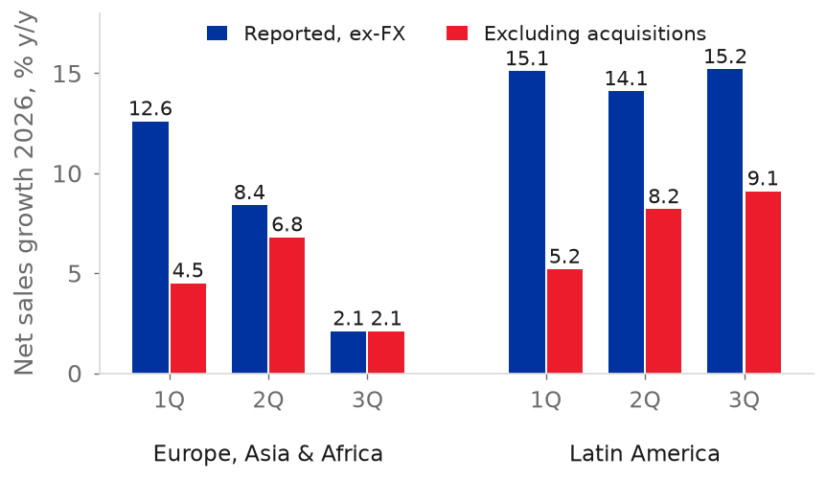
  Source: Grupo Bimbo (2026c, 2026d, 2026h); team model
  Figure 13: Net sales growth in pesos: organic, acquisitions and FX translation
  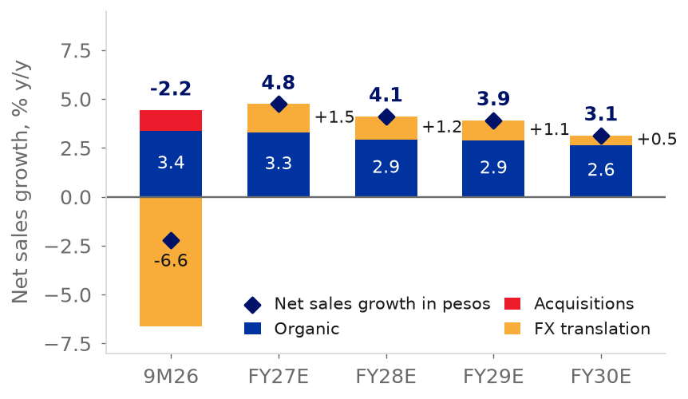
  Source: Grupo Bimbo (2026h); team model
  Figure 14: TEV / LTM EBITDA by year, 1999-2026
  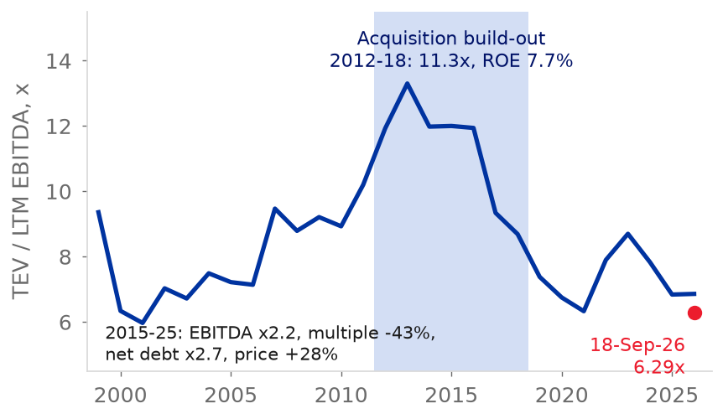
  Source: S&P Capital IQ (2026)
  Figure 15: USD/MXN annual average, 2019-2030E, and the 16 October 2026 spot
  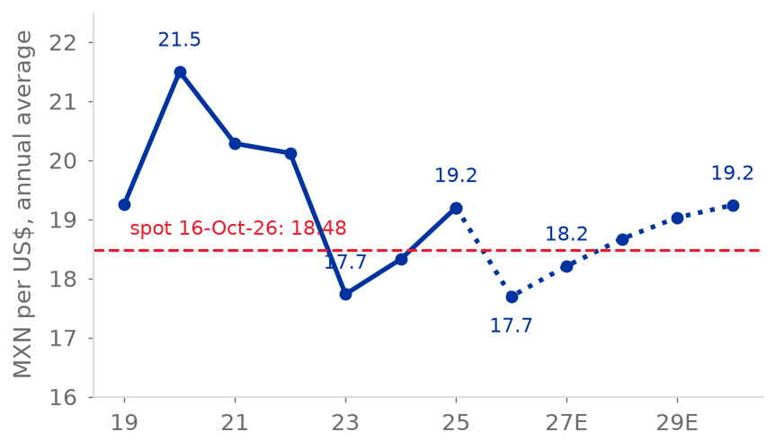
  Source: S&P Capital IQ (2026); team model

Pillar 2: Costs can increase without breaking the margin, because Bimbo already absorbed a shock almost four times larger
• A larger shock, already absorbed. From FY2021 to FY2023, raw materials increased from 30.0% to 32.8% of net sales, an increase of 279 bp. Gross margin decreased by 206 bp, from 53.5% to 51.4%. Adjusted EBITDA margin was always between 13.4% and 14.0% in FY2021-FY2025 (Grupo Bimbo, 2024, p. 354, note 21; 2026f, pp. 13, 82, 85; team model).
• Our model asks for far less. Raw materials increase from 29.9% of net sales in FY2026E to 30.6% in FY2027E, or 76 bp. This is about a quarter of the FY2021-FY2023 shock. The model already includes the 25.9% increase in wheat in 2026 with a one-year lag. R-squared is 0.70 with the one-year lag, against 0.48 for the same year. Because of this increase, gross margin decreases by 58 bp, from 52.7% to 52.1%, in FY2027E (Figure 17) (IMF, 2026; team model).
• Hedges give visibility, not protection. The CFO said that the main raw materials for 4Q26 are fully hedged and those for 1H27 are almost 100% hedged. The CFO said that Bimbo never hedges 15 months ahead. The CFO said that 2027 is "a challenge" for cost of sales (Grupo Bimbo, 3Q26 earnings call). The hedge model of Bimbo compares the current price with its five-year average (Grupo Bimbo, 2026f, p. 9). The first quarter exposed to new prices is therefore 3Q27. Bimbo buys the second-half hedges in 1H27.  • Costs are not what puts our rule at SELL. The rule gives SELL because the price is above our value. The rule does not give SELL because costs increase. Our optimistic 12-month target of MXN 68.94 is MXN 5.46 below the MXN 74.40 that HOLD needs (team model).  Pillar 3: The new management inherits a recovery, and 2027 is its first real test  • Who is new, and what was inherited. Alejandro Rodriguez Bas became CEO in November 2025, the second change in 18 months after Rafael Pamias in May 2024. Greg Koehrsen leads Bimbo Bakeries USA from January 2026. The CFO is the same from 2017, and Daniel Servitje is still Executive Chairman. No change of strategy followed (Grupo Bimbo, 2026a, pp. 76-77, 178-180; team estimate). The recovery was already in progress before the change. The margin of North America increased from 5.9% in 4Q24 to 10.4% in 3Q25 (Figure 18) (Grupo Bimbo, 2026h; team estimate).  • First results. In 3Q26 the group margin was 15.7%, or 100 bp more than a year earlier. Growth without the currency effect was 3.6%, and leverage was 2.4x. Bimbo increased its 2026 margin guide to +85 to +120 bp. The base is low and FY2026E has a one-off of about 11.5 bp (Grupo Bimbo, 3Q26 earnings call; 2026h, pp. 2-5; team model).  • What the model already includes. The margin increases by 120 bp from FY2025 to FY2027E, with 91 bp in FY2026E and 29 bp more in FY2027E. EPS doubles from MXN 2.58 to MXN 5.25 by FY2030E (team model). The 29 bp of FY2027E are the test.  • Where the 120 bp come from. Of the 120 bp from FY2025, 114 bp are from two lines: other expenses, net, and integration costs. Other expenses, net, decrease from 1.15% to 0.14% of sales. Integration costs decrease from MXN 541 million to zero. In FY2027E alone these two lines add 74 bp, which offsets the 58 bp decrease in gross margin. The CFO says that 2027 is "a challenge" for cost of sales (Grupo Bimbo, 3Q26 earnings call; 2026f, p. 13; team model).  • The gap with the street. The FY2027E margin of the model is 55 bp above the consensus of 14.6%. The EBITDA of the model is 4.2% above the consensus, or about MXN 7.7 of the target. The EPS of the model is MXN 4.01, about 20% above the consensus of MXN 3.35. The consensus is from 20 September, before the call (Figure 11). The consensus is not updated. If the consensus margin increases by more than 55 bp, our model is no longer above it. In Table 22, line by line, sales are close to the consensus and every earnings line is above the consensus. So the SELL does not depend on a pessimistic model (S&P Capital IQ, 2026; team model).  • Why 2027 is still a test. Management met 56% of its targets in 2023-2025, against 16% in 2011-2016. This improves the odds of the recovery. But the 2027 margin needs other expenses and integration costs to fall to almost zero in a year that the CFO calls "a challenge" for cost of sales. Management met only 25% of its targets on acquisitions, and integrations arrive late and cost more, as with Wickbold (Figure 19) (team estimate from earnings calls).
  Figure 16: Wheat price against the 2026E average held in the model
  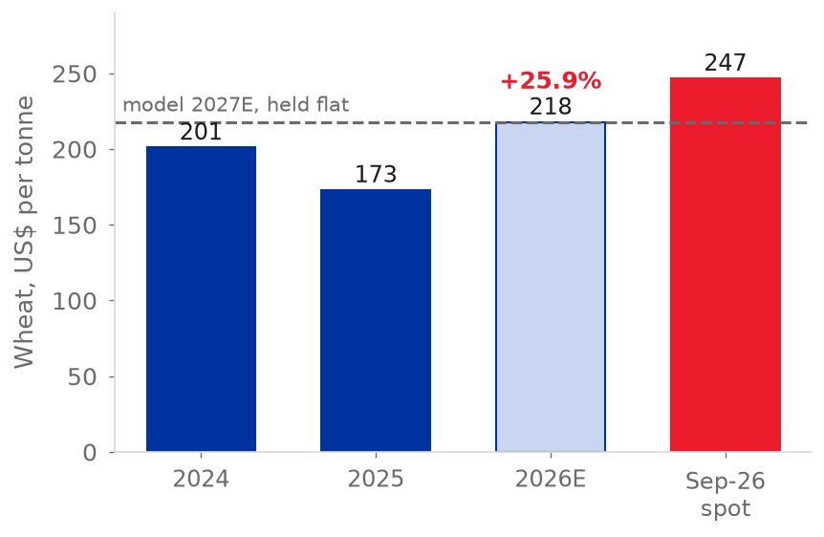
  Source: IMF (2026); team model
  Figure 17: Gross margin FY2021A-FY2030E in the model and with wheat at the September 2026 price or 35% higher from 2027
  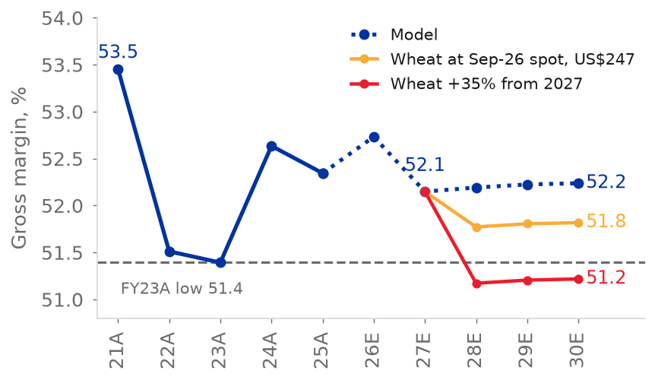
  Source: IMF (2026); team model
  Figure 18: North America adjusted EBITDA margin by quarter
  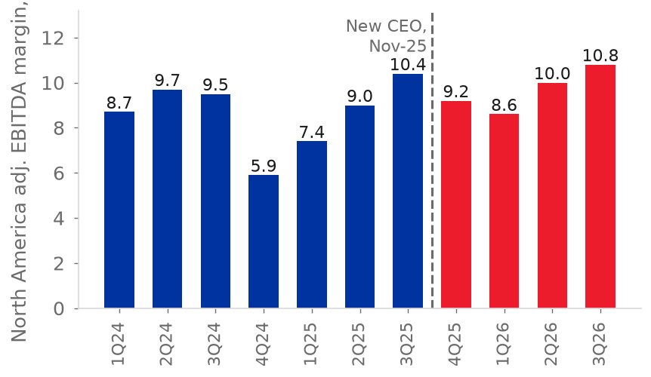
  Source: Grupo Bimbo (2026h and quarterly releases); team estimate
  Figure 19: Management targets since 2011: met, mixed and missed, by the period in which they were set
  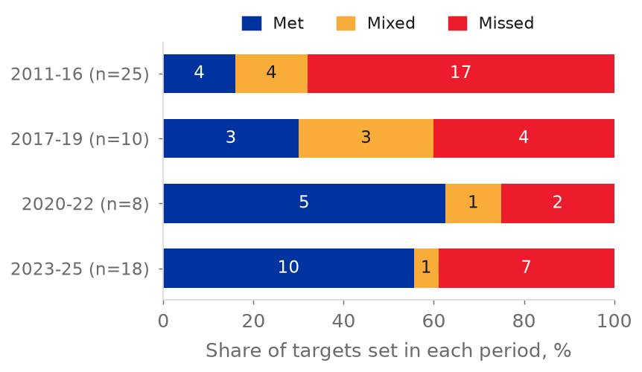
  Source: team estimate from earnings calls
Valuation
Method
We value Bimbo with a discounted cash flow (DCF) of free cash flow to the firm (FCFF) for FY2027E-FY2030E, plus a terminal value. FCFF is the cash that remains after tax, capex and new leases. We use no exit multiple. Peers are a cross-check (team model). Cash flows arrive mid-year, and we discount them at the WACC. We adjust the equity value to the valuation date with the cost of equity.
The base DCF values the shares on 16 October 2026 at MXN 52.92. The reference price is the close of 4 November, 19 days later. The gap is about 0.6% at the cost of equity (team model).  The 12-month target changes the valuation date to 16 October 2027. The target uses the flows of FY2028E-FY2030E and the same WACC, growth and return on new capital. The target uses the balance sheet of FY2027E. The target subtracts the buybacks of 4Q26 and FY2027E, at fair value, from the share count (team model).  Cost of capital  We value in pesos, so we need a risk-free rate in pesos. We use the M-Bono yield of 9.26% less the 1.75% default spread of Mexico, which gives 7.51%. We blend 7.51% with the dollar rate expressed in pesos. The weight is the share of dollar-linked flows (Damodaran, 2026; S&P Capital IQ, 2026).
  Figure 20: EV / EBITDA against peers, last twelve months, 16-Oct-2026
  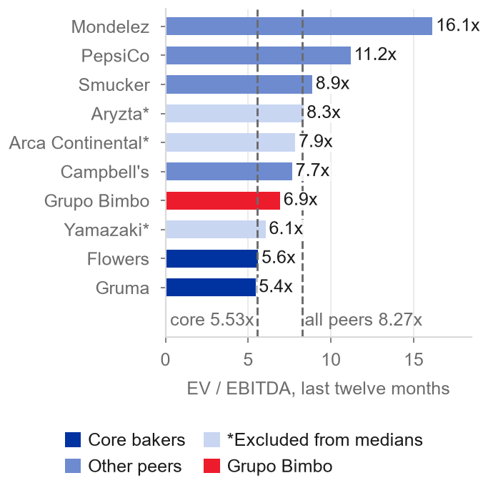
  Source: S&P Capital IQ (2026); team model

We weight the country risk premium by where Bimbo earns its EBITDA, which gives 2.05%. We multiply the premium by beta (Damodaran, 2026; team model). The unlevered beta of 0.53 is the global figure of Damodaran for food processors. Beta is 0.81 after we relever it at a market debt-to-equity ratio of 74.3% with leases (Damodaran, 2026).
The result is a cost of equity of 12.26% and a WACC of 9.62% (team model). We keep that capital structure because the CFO says that the comfortable range is 2.0x to 2.5x. Bimbo is already in this range. So the WACC weights stay at the market values of today. If the debt-to-equity ratio is 50%, then the WACC is about 9.82%. In that case the target decreases by about MXN 3.7 (Grupo Bimbo, 3Q26 earnings call; team model).
Table 1: Cost of capital
Component | Value | Basis
Peso default-free rate | 7.51% | M-Bono 9.26% less 1.75% default spread
US 10-year Treasury | 5.09% | FRED, 16-Oct-2026
Blended risk-free rate | 7.23% | 55% peso, 45% dollar-linked (US rate converted to pesos at 1.7% depreciation)
Mature-market equity risk premium | 4.20% | Damodaran implied
Unlevered / relevered beta | 0.53 / 0.81 | Global food processing; D/E 74.3% incl. leases
Country risk premium x beta | 1.65% | 2.05% EBITDA-weighted CRP
Cost of equity (ke) | 12.26% | Team model
Cost of debt, pre-tax | 8.66% | 58% non-peso debt at UST + 100 bp, in pesos, and 42% peso debt at 9.71%
Debt weight, D/(D+E) | 42.6% | Market value, leases included
WACC | 9.62% | Tax rate 30%
Source: Damodaran (2026); S&P Capital IQ (2026); Grupo Bimbo (2026d, p. 6); team model.
Free cash flow and terminal value
FCFF increases from MXN 27.1 billion in FY2027E to MXN 30.3 billion in FY2030E. This is because EBIT increases by 5.0% a year and capex stays at 4.5% of sales. This agrees with the guidance of the CFO for a 2027 level somewhat above 2026. The capex level is also close to the 4.6% of sales of FY2014-FY2020 (Grupo Bimbo, 3Q26 earnings call; team model).
The terminal value uses Gordon growth with reinvestment. FCFF in FY2031E equals NOPAT times one minus g over the return on new capital (RONIC). The growth of 4.40% in pesos is the real growth of 0.68% plus the 3.7% long-run inflation of Mexico (Banxico, 2026; team model). RONIC of 15.17% is the FY2030E return on tangible operating capital. It is between the FY2024 value (13.3%) and the FY2023 value (16.5%), and it is above the 11.4% of FY2025. This is why the acquisitions of our first pillar are important for value (team model).
The terminal value is stricter than the forecast years. It reinvests 29% of NOPAT at 15.17%. From FY2027E to FY2030E, NOPAT increases by MXN 4,484 million with a net reinvestment of 5-8% of NOPAT. This is an implied return of about 60% (team model). The terminal value implies 6.2x FY2030E adjusted EBITDA. This is just below the 6.29x of 18 September 2026, which is the 8th percentile in the period from 2000 (S&P Capital IQ, 2026).
From enterprise value to the 12-month target  Table 2: Bridge from enterprise value to the target price
  MXN million, 31-Dec-2027 | Value
  PV of FCFF FY2028E-FY2030E | 76,384
  PV of terminal value | 373,897
  Enterprise value | 450,281
  Gross debt | (151,250)
  Lease liabilities | (34,790)
  Cash | 22,372
  Non-controlling interests (income capitalised at ke less g) | (24,276)
  Other debt-like items | (15,972)
  Associates | 6,533
  Equity value, 31-Dec-2027 | 252,898
  Equity value at 16-Oct-2027 (ke factor 0.976) | 246,879
  Shares, net of 4Q26-FY2027E buybacks (millions) | 4,217.1
  12-month target price (MXN) | 58.54
  Figure 21: Free cash flow to the firm, FY2027E-FY2030E
  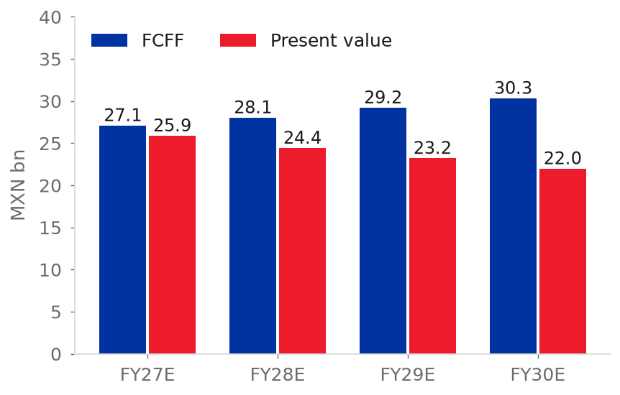
  Source: team model
Source: team model (sheet Valuacion_12m).
The terminal value is 83% of enterprise value. In the base DCF, it is 78% (team model). We capitalise the forecast income of the non-controlling interests at the cost of equity less the 4.4% growth of the enterprise value. We keep other debt-like items and associates at their 30 September 2026 balances (team model).
The share count is net of the 4Q26 and FY2027E buybacks (59.7 million shares at fair value). The CFO says that the buybacks will continue (MXN 1.2 billion in 3Q26). This adds MXN 0.92 per share to the target (Grupo Bimbo, 3Q26 earnings call; team model).
Three inputs cause the largest change in the value (appendix A5). The first is the cost of capital (MXN 49.96 to 68.94 for +/-0.5 pp). The second is the margin (MXN 7.17 per 50 bp). The third is the terminal return on capital (MXN 11.69 if it stays at the FY2025 level) (team model).
A DCF in which new capital earns only the WACC gives MXN 28.93. The change to the return on tangible capital adds MXN 12.83. The cost-of-capital inputs add MXN 10.67. Terminal growth adds MXN 0.48. We show these steps because two judgements that we must defend cause MXN 23.5 of the MXN 24.0 (team model).
Relative valuation
We compare Bimbo with nine listed companies on one basis. We use last-twelve-month data to June 2026. We use enterprise value and EBITDA on an IFRS 16-equivalent basis. We use peer prices of 16 October 2026, which are the latest in our data set (S&P Capital IQ, 2026; team model). Four core bakers give the low end of the range and five consumer-staples companies give the high end (table below).
We do not use Yamazaki, Aryzta and Arca Continental in the medians because their lease or minority-interest data are not comparable (marked *). Because of this, the core median uses two companies, Flowers Foods and Gruma. We also do not use J.M. Smucker's P/E of 58.6x in the P/E medians because it is an outlier. If we use this P/E, the eligible median will be 19.6x, not 16.1x. Then the 18.5x of Bimbo will be below the median.

Table 3: Multiples and margins against peers
  Company | EV/EBITDA LTM | EV/EBITDA NTM | P/E LTM | Net debt / EBITDA | EBITDA margin
  Grupo Bimbo | 6.9x | 6.6x | 18.5x | 2.81x | 14.5%
  Flowers Foods | 5.6x | 6.1x | 23.4x | 3.37x | 11.1%
  Gruma | 5.4x | 5.6x | 9.4x | 1.47x | 17.1%
  Yamazaki Baking* | 6.1x | 5.8x | 17.7x | -0.67x | 8.2%
  Aryzta* | 8.3x | 5.8x | 10.2x | 3.50x | 9.8%
  J.M. Smucker | 8.9x | 9.2x | 58.6x | 2.98x | 25.2%
  Campbell's | 7.7x | 8.4x | 15.1x | 4.25x | 17.8%
  Mondelez | 16.1x | 13.8x | 23.1x | 3.25x | 15.9%
  Arca Continental* | 7.9x | 7.1x | 18.7x | 0.74x | 19.4%
  PepsiCo | 11.2x | 11.0x | 16.1x | 2.26x | 20.4%
  Core median | 5.5x | 5.9x | 16.4x | 2.42x | 14.1%
  Eligible median | 8.3x | 8.8x | 16.1x | 3.12x | 17.4%
  Figure 22: Return on tangible operating capital against the terminal RONIC
  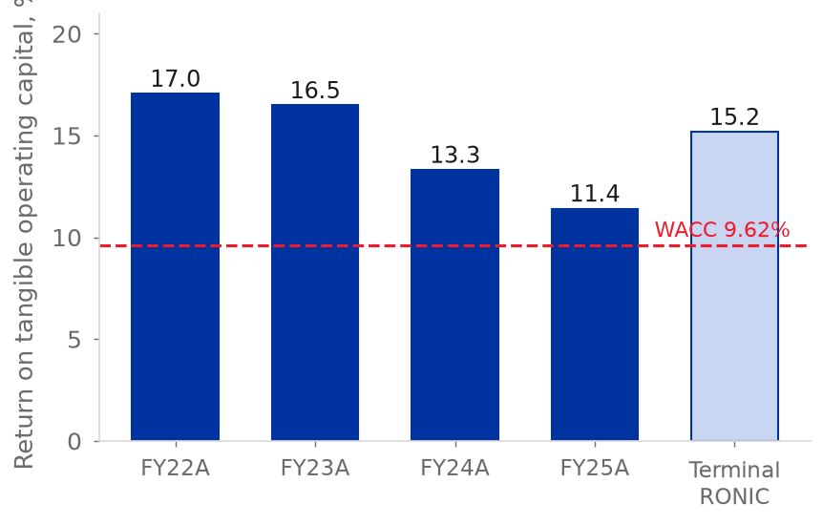
  Source: team model
Source: S&P Capital IQ (2026), prices of 16 October 2026; team model. LTM = last twelve months; NTM = next twelve months.
At 6.9x EV/EBITDA, Bimbo trades 26% above the core bakers (5.5x) and 17% below all eligible peers (8.3x). On P/E, Bimbo trades at 18.5x. The core bakers trade at 16.4x, and the eligible peers without Smucker trade at 16.1x (S&P Capital IQ, 2026; team model). The leverage of Bimbo, 2.8x net debt/EBITDA, is above the core median of 2.4x. The EBITDA margin of Bimbo, 14.5%, is about the same as the core median (S&P Capital IQ, 2026; team model).
Flowers Foods has a business like Bimbo's North America, and it is the weakest comparable. The volume of Flowers Foods decreased 5.8% in 2Q26 (Investing.com, 2026). The implied next-twelve-month EBITDA growth is 4.5% for Bimbo, but -6% for the core median (Table 3, team calculation). The premium is a payment for a recovery that the estimates already include. We question this recovery.
Applying the two medians to Bimbo's last-twelve-month adjusted EBITDA of MXN 61,786 million and the model's claims at December 2026 gives MXN 31.2 per share at 5.5x and MXN 69.8 at 8.3x (team model). The DCF value of MXN 52.92 lies in the upper half of that range, equivalent to about 6.9x FY2026E EBITDA, while our terminal value implies 6.2x FY2030E EBITDA (team model). Our view: Mexico justifies a premium to the core bakers because the route network of Mexico earns 20.4%. North America does not justify a premium because it earns 9.0% (Grupo Bimbo, 2026f, p. 85).
Football field and rating  The 12-month target of MXN 58.54 is above the base DCF (MXN 52.92). It is below the median target of the analysts (MXN 69.50). It is inside the peer range of MXN 31.2 to 69.8 (team model; S&P Capital IQ, 2026). The DCF gives the target. Peers and the reverse DCF test the target. Neither test sets the rating on its own, but both point the same way: the price sits inside the peer range, not below it, and it needs a margin that no full year has reached.  The price is at a 26% premium to the core bakers. This premium is a payment for a recovery that the estimates already include. The reverse DCF (Table 21) shows what the price needs. The price needs one of four values.  The first is a margin of about 15.7% from FY2027E. The second is sales growth of 6.6% a year in FY2028E-FY2030E. The third is a return on new capital of 20.1%. The fourth is a WACC of 9.19%. In the same order, our values are 15.12%, 3.7%, 15.17% and 9.62%.
  Figure 23: Build-up of the base DCF, MXN per share
  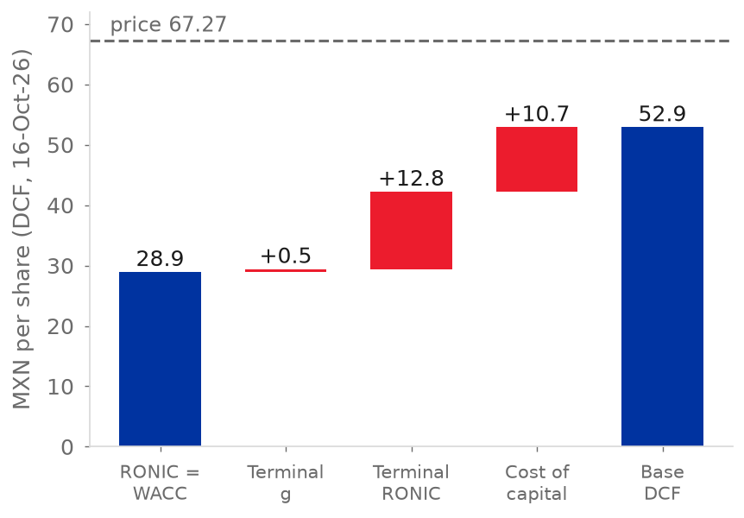
  Source: Team model (sheets Valuacion and WACC)
Bimbo's net sales increased only 2.3% a year in FY2022-FY2025, and this includes the acquisitions. No full year reached that margin.
The rating rule is the rule of the team. The rule gives BUY if even the pessimistic expected return (WACC +0.5 pp) is higher than the cost of equity. The rule gives SELL if even the optimistic expected return (WACC -0.5 pp) is lower than the cost of equity. The rule gives HOLD in all other cases.
At MXN 67.27, the pessimistic return is -24.1% and the optimistic return is +4.1%. The cost of equity is 12.26%. Because of this, the rule gives SELL (team model). The cost of equity can also move with the WACC. At a WACC 0.5 pp lower, the cost of equity is 11.76%. The optimistic return of +4.1% is still below it, so the SELL holds (team model). The rule gives HOLD from an FY2027E adjusted EBITDA margin of about 15.5%. This is 34 bp above our 15.12%. It is also about the full 35 bp width of the 2026 margin guide of management.
At a margin of 15.3%, the target increases to MXN 61.16 and the SELL line increases to MXN 64.96. Both are still below the price (Grupo Bimbo, 3Q26 earnings call; team model, replica of the 12-month sheet). Therefore, the 2027 guidance on the 4Q26 call in late February 2027 is the test with a date (Table 8).
The reference price is the close of 4 November 2026. Market inputs are as of 16 October 2026 (rates, peers) and 20 September 2026 (consensus). These are the latest data in our database. The 10-year US Treasury yield fell 14 bp over that period (FRED, 2026). A parallel fall of 14 bp in all rates lowers the WACC by about 12 bp. This is short of the about 21 bp that move our rule to HOLD (team model).
Table 18 in the appendix gives the target for each margin and WACC. The target equals the price at three pairs: a margin of 15.12% with a WACC of 9.19%, a margin of 15.5% with a WACC of 9.47%, and a margin of 15.7% with a WACC of 9.62%. A small error in the margin and a small error in the WACC can add up to the whole gap. The SELL is a close call (team model, replica of the 12-month sheet).
The close of 16 October, before the 3Q26 results, was MXN 58.62. This is about the same as the target. At that price, the rule gives HOLD. Because of this, the SELL rating is a result of the price after the 14.8% increase (Yahoo Finance, 2026; team model). Take the case where other expenses, net, stay at the 9M26 level of 0.76% of sales and integration costs stay at MXN 541 million. In this case, the target will decrease by MXN 10.6 (team model).
Each 100 bp of margin gives about MXN 14 of target. It is 14.33 when the change starts in FY2028E and about 14.8 when it starts in FY2027E, as in the table. Because of this, the margin decides the rating. The table shows four cases. In each case, the margin stays level from FY2027E.
Table 4: The rating depends on the margin
Case | Margin | 12-month target | HOLD band | Rule
Model | 15.12% | MXN 58.54 (-13.0%) | 45.50-62.41 | SELL
Consensus | 14.6% | MXN 50.84 (-24.4%) | 39.18-54.87 | SELL
Top of FY2021-FY2025 range | 14.0% | MXN 41.99 (-37.6%) | 31.93-46.23 | SELL
Guidance of 15.3% | 15.30% | MXN 61.16 (-9.1%) | 47.64-64.96 | SELL

Source: team model (workbook run with the adjusted EBITDA margin shifted and held level from FY2027E); S&P Capital IQ (2026) for the consensus. Percentages are against MXN 67.27; the rule is applied at that price.
Financial Analysis
Table 5: Projected income statement and key ratios
MXN million | FY2025A | FY2026E | FY2027E | FY2028E | FY2029E | FY2030E
Net sales | 426,952 | 426,670 | 446,942 | 465,382 | 483,639 | 498,865
Growth | 4.6% | -0.1% | 4.8% | 4.1% | 3.9% | 3.1%
Gross margin | 52.3% | 52.7% | 52.1% | 52.2% | 52.2% | 52.2%
Adj. EBITDA | 59,456 | 63,299 | 67,589 | 70,377 | 73,138 | 75,441
Adj. EBITDA margin | 13.93% | 14.84% | 15.12% | 15.12% | 15.12% | 15.12%
Other expenses / sales | 1.15% | 0.76% | 0.14% | 0.14% | 0.14% | 0.14%
EPS (MXN) | 2.58 | 3.19 | 4.01 | 4.65 | 4.98 | 5.25
Capex / sales | 5.3% | 4.4% | 4.5% | 4.5% | 4.5% | 4.5%
Net debt / EBITDA | 3.03x | 2.71x | 2.42x | 2.18x | 1.95x | 1.74x
Source: team model (sheets IS, BS, CF); FY2025A from Grupo Bimbo (2026f).
Income statement  Net sales increased from MXN 338,792 million in FY2021 to MXN 426,952 million in FY2025. This is a CAGR of 6.0%, but the growth of FY2022 (+17.7%) makes this CAGR higher. From FY2022 to FY2025, the CAGR is only 2.3%. This is because North America decreased in pesos. The acquisitions of our first pillar helped to decrease the gap (Grupo Bimbo, 2026f; team model).  The adjusted EBITDA margin stayed in a narrow range of 13.4% to 14.0%. It ended at 13.9% in FY2025 (Grupo Bimbo, 2026f, p. 85; team model). Gross margin decreased from 53.5% to 52.3%, with a low of 51.4% in FY2023. This is because the costs of raw materials (30.4% of sales) and of labour increased faster than prices. In FY2025, salaries increased 7.5% and depreciation increased 13.3%, but sales increased 4.6% (Grupo Bimbo, 2026f, p. 82; team model). Controlling net income was MXN 11,133 million in FY2025, and the EPS was MXN 2.58 (Grupo Bimbo, 2026f; team model).  Growth in pesos does not show its sources. In 9M26, translation decreased growth by 6.6 points from the level of the growth without currency. In the forecast, translation adds 1.46 of the 4.75 points of FY2027E. From FY2023 to FY2025, raw materials decreased by 2.39 points of sales. Salaries, depreciation and other lines increased by 1.44 points of sales. This cancelled part of the decrease (Figure 13, Figure 29) (Grupo Bimbo, 2026f, p. 82; 2026h; team model).  Table 6: Historical summary  Source: Grupo Bimbo (2026f, pp. 85-86); team model. FY2022 includes a non-cash pension gain and the gain on the Ricolino disposal.  Balance sheet and leverage  Total assets were MXN 409,805 million at FY2025. Of the total, MXN 135,515 million was goodwill and intangibles from past acquisitions (Grupo Bimbo, 2026f, p. 12). Net debt that includes leases was MXN 179,918 million, or 3.03x adjusted EBITDA. In FY2022 the ratio was 1.89x (Grupo Bimbo, 2026a, pp. 75-78; team model).  On the definition that Bimbo uses, without IFRS 16, leverage decreased from 2.9x in December 2024 to 2.5x in June 2026. The CFO said that leverage was 2.4x in 3Q26. This is at the top of the 2.0x to 2.5x range that the CFO says is comfortable (Grupo Bimbo, 2Q26 investor presentation; 3Q26 earnings call). Interest expense increased from MXN 10,006 million in FY2023 to MXN 14,464 million in FY2025. EBIT cover decreased from 4.2x in FY2021 to 2.4x (Grupo Bimbo, 2026f; team model).
  MXN million | FY2021A | FY2022A | FY2023A | FY2024A | FY2025A
  Net sales | 338,792 | 398,706 | 399,879 | 408,335 | 426,952
  Growth | n.a. | 17.7% | 0.3% | 2.1% | 4.6%
  Gross margin | 53.5% | 51.5% | 51.4% | 52.6% | 52.3%
  Adj. EBITDA margin | 13.98% | 13.40% | 13.74% | 13.59% | 13.93%
  EBIT / interest expense | 4.2x | 6.7x | 3.5x | 2.5x | 2.4x
  Net income, controlling | 15,916 | 46,910 | 15,477 | 12,544 | 11,133
  Cash from operations | 45,776 | 38,851 | 31,411 | 39,907 | 47,753
  Capex (PP&E) | 20,671 | 28,669 | 34,754 | 29,402 | 22,530
  Net debt incl. leases / EBITDA | 2.43x | 1.89x | 2.37x | 3.22x | 3.03x
  Figure 24: Gross margin and adjusted EBITDA margin, FY2021A-FY2030E
  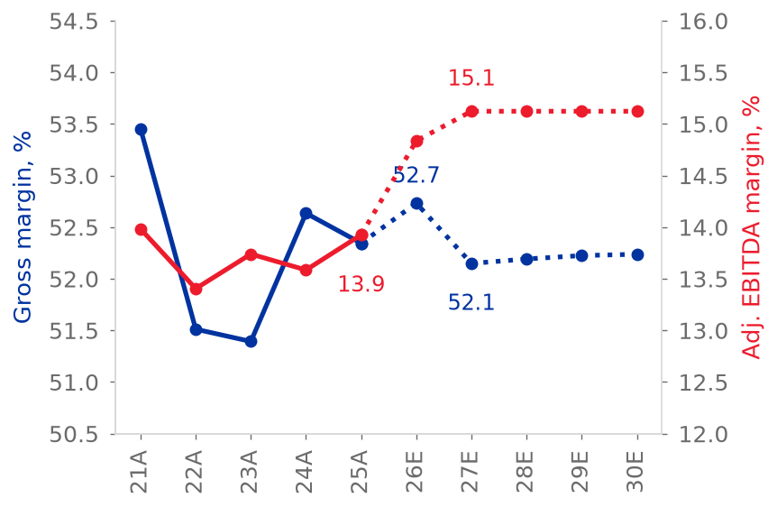
  Source: Grupo Bimbo (2026f); team model
  Figure 25: Share of sales and of adjusted EBITDA, FY2025
  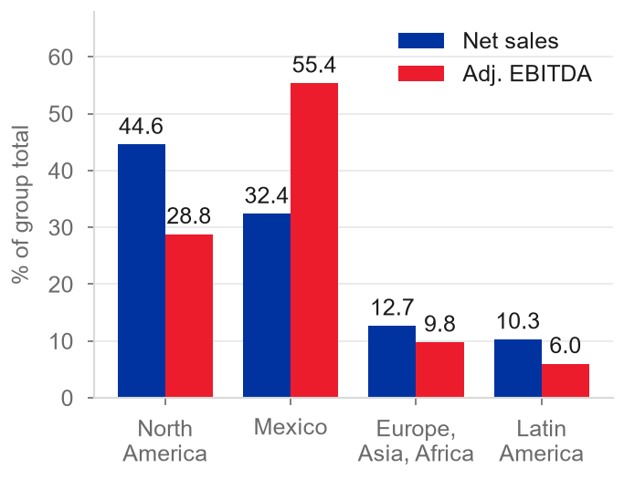
  Source: Grupo Bimbo (2026b, p. 4; 2026e, p. 17)
  Figure 26: Net sales growth by region, 9M26, reported and excluding acquisitions
  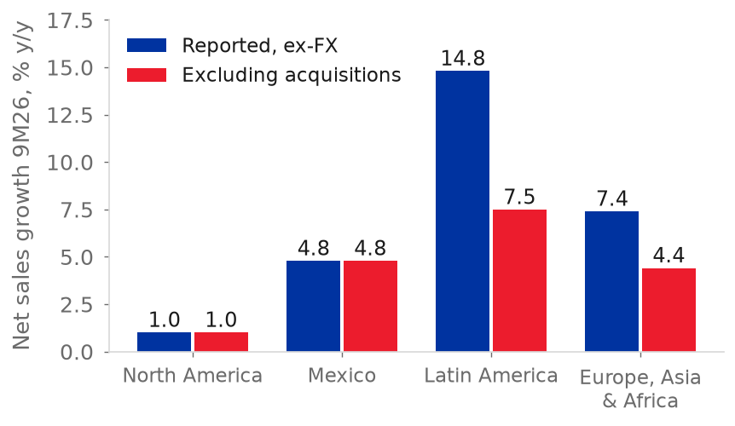
  Source: Grupo Bimbo (2026c, 2026d, 2026h); team model. North America includes Stone House
  Figure 27: Net debt including leases over adjusted EBITDA
  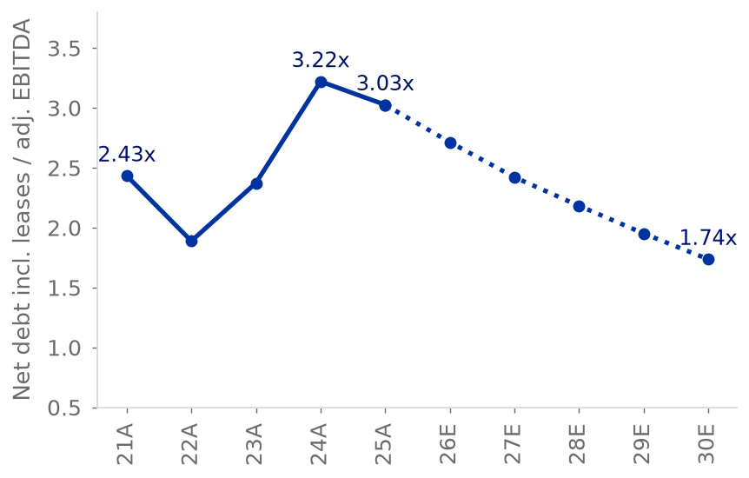
  Source: Grupo Bimbo (2026f); team model
The debt has a long maturity and is diversified. The average maturity is 9.5 years, and the average cost is 6.5%. Of the debt, 96% is long term. After swaps, 42% is in dollars and 42% is in pesos. Liquidity includes an undrawn US$2,350 million revolver (Grupo Bimbo, 2026d, p. 6; 2026a, p. 82).
Cash flow and capital intensity
Cash from operations increased 20% to a record MXN 47,753 million in FY2025. Capex decreased 23% to MXN 22,530 million (Grupo Bimbo, 2026f, p. 86). After lease payments and interest paid, free cash flow was MXN -17,057 million in FY2023 and MXN -4,943 million in FY2024. It increased to MXN 5,630 million in FY2025, which is 1.3% of sales. Free cash flow covered the dividend of MXN 4,451 million. It did not cover the MXN 11,294 million of acquisitions (Grupo Bimbo, 2026f, p. 16; team model).
The CFO said that free cash flow was about MXN 17 billion in the first nine months of 2026. This was after about MXN 12 billion of capex. Working capital helped this result. The release defines this free cash flow before lease payments. Because of this, it is not comparable with our FY2026E free cash flow of MXN 16.3 billion after leases and interest. This FY2026E figure assumes no working-capital gain (Grupo Bimbo, 3Q26 earnings call; team model).
Evaluation. Bimbo had slow growth and a stable margin, and leverage increased. Now margins and cash flow show an increase. But part of the growth came from acquisitions, and leverage is only back at the top of its range. We see the recovery as real but early. One year of positive free cash flow after interest does not offset two years of negative cash. Interest cover is still low (team model).

Forecast and drivers  The FY2026E-FY2030E forecast has five drivers. Leases and working-capital days stay at the FY2025 levels (team model).  • Sales. FY2026E is nine months of actuals plus 4Q26, where sales increase by 5% without currency effects. This applies the mid-single-digit full-year guide of the CFO to the quarter. From FY2027E, each region increases at a team ratio multiplied by the nominal GDP in local currency. We translate the result to pesos with the Capital IQ USD/MXN path, from 18.21 in 2027 to 19.24 in 2030. The ratios are those of 9M26: 0.17 for North America, 0.77 for Mexico, 0.67 for Latin America and 0.56 for Europe-Asia-Africa. The growth is without acquisitions (Grupo Bimbo, 3Q26 earnings call; S&P Capital IQ, 2026; team model).  • Margin. FY2026E uses the guidance midpoint of +102.5 bp less the 11.5 bp one-off gain on the La Moderna stake. The result is +91 bp in total (Grupo Bimbo, 2026i, p. 26; team model). From FY2027E, every cost keeps the ratio to sales of the prior year, but raw materials follow wheat with a one-year lag (elasticity 0.109). Non-recurring items are zero (team model).  • Wheat. The model holds the wheat price at the 2026 level of US$217.9 per tonne. This is +25.9% compared with 2025 (IMF, 2026; team model).  • Capex. The model uses US$1.05 billion in FY2026E and US$1.1 billion from FY2027E, which is 4.5% of sales. This is within the guidance of the CFO (Grupo Bimbo, 2026i, p. 26; 3Q26 earnings call).  • Tax and financing. The effective tax rate is 37.0% in FY2026E-FY2027E and 32.7% after that. The model refinances the maturities. Buybacks are MXN 2.7 billion a year. The 2027 dividend is MXN 1.12 per share (Grupo Bimbo, 2026h; team model).  Net sales decrease 0.1% in FY2026E because of peso translation. Then they increase 4.8%, 4.1%, 3.9% and 3.1%, which is a 4.0% CAGR for FY2026E-FY2030E. In FY2027E, Latin America and Europe-Asia-Africa show the highest growth, 5.6% each. Mexico increases 5.2%. North America increases 3.8% in pesos but 0.9% in dollars (team model).  Three features of the forecast connect to our pillars. First, the model holds wheat flat, but the CFO says that 2027 is a challenge (pillar 2). Second, the model projects no acquisitions and lets the cash increase to MXN 55 billion. This makes the leverage look better than it is (pillar 1).
  Figure 28: Growth of cost-of-sales lines against net sales, FY2025
  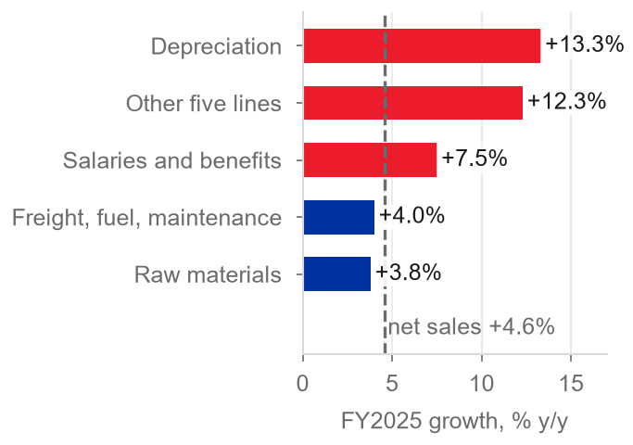
  Source: Grupo Bimbo (2026f, p. 82); team model
  Figure 29: Change in cost of sales by nature as a share of sales, FY2023 to FY2025
  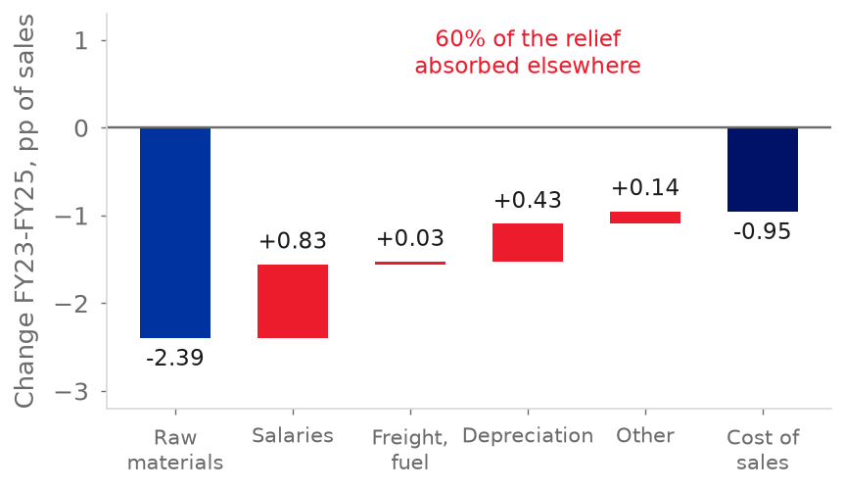
  Source: Grupo Bimbo (2026f, p. 82); team model
  Figure 30: Cash flow from operations and capex, FY2021-FY2025
  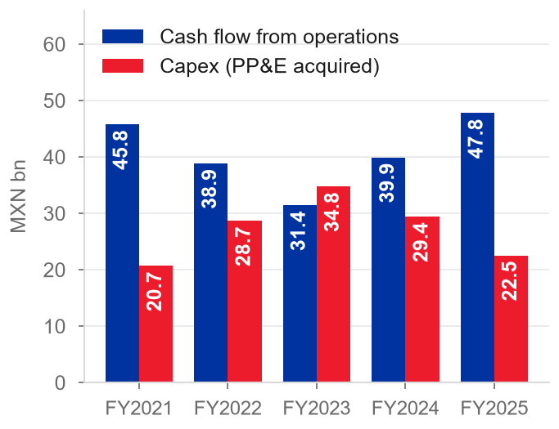
  Source: Grupo Bimbo (2026f, p. 86)
Third, other expenses and integration costs decrease to almost zero. Because of this, the margin increases to 15.1%. The margin stays at this level because of the model design (pillar 3) (team model).
The gross margin decreases 58 bp in FY2027E and stays at 52.1% to 52.2%. If wheat is at the September 2026 price, the FY2030E gross margin will be 51.8%. If wheat is 35% higher from 2027, the FY2030E gross margin will be 51.2% (Figure 17). Our FY2027E EBITDA margin is 55 bp above the consensus of 14.6%. This consensus is from before the 3Q26 call (Figure 11) (IMF, 2026; S&P Capital IQ, 2026; team model).
Table 7 shows net sales and margin by region. North America grows 0.8% a year from FY2025A to FY2030E, and its adjusted EBITDA margin was 9.0% in FY2025A. Its net sales are MXN 190,211 million in FY2025A, MXN 183,737 million in FY2027E and MXN 198,415 million in FY2030E. Mexico grows 5.0% a year and has a margin of 20.4%. Europe, Asia and Africa grow 4.0% with a margin of 10.8%. Latin America grows 5.4% with a margin of 8.1%. The group grows 3.2% a year, with a margin of 13.9% (Grupo Bimbo, 2026f, p. 85; team model).
Table 7: Net sales and margin by region
Region | Sales FY2025A | Sales FY2027E | Sales FY2030E | CAGR 25-30E | Adj. EBITDA margin FY2025A
North America | 190,211 | 183,737 | 198,415 | 0.8% | 9.0%
Mexico | 154,809 | 174,255 | 197,760 | 5.0% | 20.4%
Europe, Asia & Africa | 54,214 | 56,708 | 66,117 | 4.0% | 10.8%
Latin America | 44,120 | 50,969 | 57,475 | 5.4% | 8.1%
Group (after eliminations) | 426,952 | 446,942 | 498,865 | 3.2% | 13.9%
Source: team model (sheet Segments); Grupo Bimbo (2026f, p. 85).
Investment Risks
We score seven risks for probability (P) and impact (I) on a scale from 1 to 5. Impact is the change in the 12-month target of MXN 58.54 in the scenario of each risk (team model). The impact score is 1 below 2%, 2 for 2-5%, 3 for 5-10%, 4 for 10-20% and 5 above 20%. Each risk connects to a pillar.  R1-R7 are downside scenarios of the valuation. With a SELL, they are the risks that will increase the downside. The risks to the SELL are the upside risks in Table 8. They use the same scale.  R1. Input costs: wheat cost persists (P3, I4; pillar 2)  On 8 October, the CBOT December 2027 futures were about US$266 a tonne, 5.4% above December 2026 (IndexBox, 2026). Our model holds wheat flat at US$218 a tonne, but the December 2027 futures are 22% higher. We test two cases. In each case, we change the 2027 wheat price in the model and recompute the whole valuation.
  Figure 31: Risk matrix
  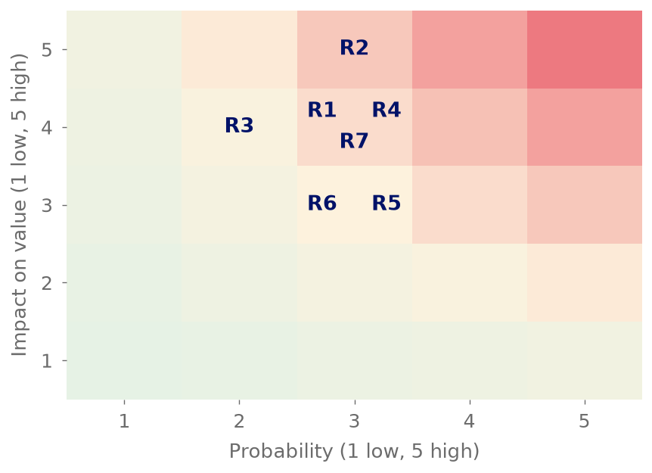
  Source: team estimate (P, I); team model (value effects)
The share of raw materials in sales responds to the wheat price of the prior year with an elasticity of 0.109. This is a fit on eight annual observations, FY2018-FY2025, with R-squared 0.70. Because of this, the September 2026 price of US$247 adds 0.42 pp to the share of raw materials from FY2028E. Wheat at US$294, which is 35% above the US$218 we hold, adds 1.02 pp.
Each increase in the wheat price decreases EBIT and NOPAT. The terminal return on new capital is the FY2030E return on tangible capital. Because of this, each increase also decreases the terminal return, from 15.17% to 14.54% at US$247 and to 13.63% at US$294 (team model). The target decreases by MXN 5.83 (10%) at US$247 and by MXN 14.17 (24%) at US$294.
US$294 is a stress case. It is above the December 2027 futures. We score the risk on the futures price of US$266. At this price, the target will decrease by MXN 9.36 (16%). The score is P3, I4. The stress case is the extreme case.
R2. The North America turnaround stalls (P3, I5; pillar 3)
The margin leads the recovery. Net sales without currency effects increased 0.7%, 1.3% and 1.0% in 1Q26, 2Q26 and 3Q26, after nine negative quarters. The CEO said that the transformation is not complete. It will be complete when North America returns to profitable volume growth (Grupo Bimbo, 2026c, p. 3; 2026d, p. 3; 3Q26 earnings call).

If the margin decreases from 10.8% in 3Q26 to the FY2024 level of 8.4%, the group margin will decrease by about 94 bp. The target will decrease by about MXN 13.4. This case uses 39% for North America as a share of regional sales (FY2028E-FY2030E average) (Grupo Bimbo, 2026f, p. 85; team model).
R3. The terminal return on capital is below our base (P2, I4; pillar 1)
The base case assumes that new capital earns 15.17% in the terminal period. Tangible-capital ROIC decreased from 17.0% in FY2022 to 11.4% in FY2025 because the acquisitions entered the capital base (team model). At the FY2025 level, the target decreases to MXN 46.85 (-20.0%). At the FY2022-25 average of 14.6%, the target decreases by only MXN 1.49 (team model).
R4. Mexican labour and health policy (P3, I4; pillar 3)
Mexico was 35% of regional sales and 54% of EBITDA in FY2025. A presidential initiative of December 2025 proposes to decrease the work week by two hours a year from 1 January 2027 to 40 hours. NOM-051 reaches the third phase in 2028. The IEPS excise tax can increase above 8% (Grupo Bimbo, 2026a, pp. 23-31, 48).
A decrease of 100 to 150 bp in the margin of Mexico decreases the target by MXN 5.5 to 8.1. This case uses 38% for Mexico as a share of regional sales (FY2028E-FY2030E average). The shorter work week is outside the base case, because the model makes no wage adjustment for it (team model).
R5. Capital allocation: capex or a large acquisition (P3, I3; pillar 1)
The CFO said that Bimbo has a strong pipeline of projects but a disciplined approach. The CEO said that a tuck-in or a strategic deal can use the leverage space if the fit is right (Grupo Bimbo, 3Q26 earnings call). The model assumes no deals and no use of the cash, which increases to MXN 55 billion. If capex is 50 bp of sales higher, the target decreases by MXN 3.31 (team model). Net debt with leases is 3.0x EBITDA at FY2025 (2.4x in 3Q26 on the company measure, without IFRS 16). S&P has a negative outlook on the BBB+ rating (Grupo Bimbo, 2026f; LSEG, 2026).
R6. Terminal growth and the peso (P3, I3; pillar 1)  North America increases 3.8% in pesos in FY2027E but only 0.9% in dollars. The difference is peso depreciation. The Capital IQ path shows a change from 18.21 to 19.24 pesos per dollar by 2030 (team model; S&P Capital IQ, 2026). If terminal growth is 0.5 pp lower, the target decreases by MXN 4.30 (team model).  R7. Other expenses and integration costs do not decrease (P3, I4; pillar 3)  Of the 120 bp of margin that we model to FY2027E, 114 depend on two items. Other expenses, net, decrease from 1.15% of sales in FY2025 to 0.14%. Integration costs decrease from MXN 541 million to zero.
  Figure 32: Sensitivity of the 12-month target
  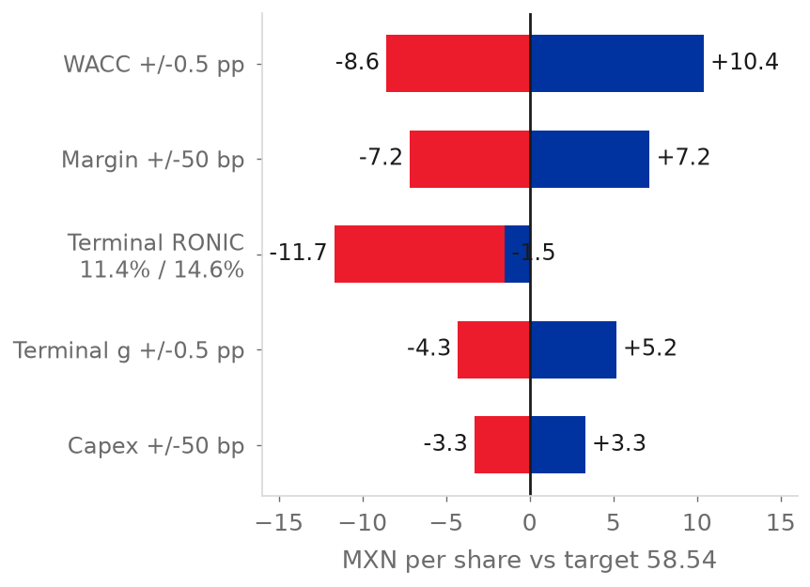
  Source: team model
We treat restructuring as non-recurring, and the model does the same with one-off items. But Bimbo reported restructuring in every year from FY2019: MXN 3,908 million in FY2025, which is 0.92% of sales (Grupo Bimbo, 2026f, p. 83).
In 9M26, other expenses were 0.76% of sales. The CEO expects more pressure from Wickbold (Grupo Bimbo, 3Q26 earnings call; 2026h). Consider a case where other expenses stay at the 9M26 level and integration costs stay at MXN 541 million. In this case, the target will decrease by MXN 10.6 (18%) (team model).
Events that could change the rating
The rating rule sets two price lines: BUY below MXN 45.50 and SELL above MXN 62.41. Both lines change with our value (team model). At MXN 67.27 the price is above the SELL line.
Table 8 lists the upside risks to our SELL. Each risk has a probability (P) and an impact (I) on the 12-month target, on the scale of this section. Table 8 also lists the signals that will confirm each risk. Each signal is published, has a date and links to one assumption of our model.
Two signals arrive with the 4Q26 results at the end of February 2027. The signals are the first quarter of growth without Wickbold as acquired growth and the formal 2027 margin guidance from management. The upside risks are real and we do not discount them. Three of the five risks have an impact of 4. A margin of about 15.7% alone will make the target higher than the price. A decrease of 0.5 pp in the WACC alone will do the same.
None of the risks is the base case. Each risk needs a result that Bimbo did not show until now. The share already increased 14.8% from 16 October. The probabilities are the judgement of the team.
Eight smaller risks (USMCA and tariffs, GLP-1 drugs, cyber attacks) have an impact of 2 or less (Grupo Bimbo, 2026a, pp. 22-37; team estimate).
Table 8: Upside risks to the SELL and signals that would move the rating
Pillar | Direction | Signal | Threshold | When we know | P, I and effect
1. Growth | Upside risk | Net sales growth ex-FX, without the inorganic contribution that Bimbo reports, after Wickbold leaves the inorganic base in 4Q26 | Above 4% in two consecutive quarters, against 3.3% organic growth in our FY2027E | 4Q26 results (late Feb 2027) and 1Q27 results (late Apr 2027) | P2, I3. +1 pp of growth a year from FY2028E adds MXN 3.0 (5.1%). The price needs +2.9 pp.
1. Growth | Test | Growth of net sales ex-FX in Latin America in 4Q26, the first quarter without Wickbold as acquired growth | At or below 9.1% confirms that the growth of the region came from acquisitions. At or above 14.1% refutes that claim, and we adjust Latin America but keep the SELL. | 4Q26 results (late Feb 2027) | Tests the bought-growth claim where it is largest
2. Costs | Upside risk | Global wheat price (IMF), January-June 2027 average | Below US$218 a tonne, the price in our model (futures: about US$266) | Monthly; 3Q27 results (late Oct 2027) | P1, I4. At US$180 (-17%), the change is about +MXN 7 (this extends our two wheat cases).
3. Margin | Upside risk | Formal guidance on the adjusted EBITDA margin for 2027, from management on the 4Q26 call | The low end of the guide shows about 15.5% or more (+62 bp on FY2026E), against 15.12% in our FY2027E | 4Q26 call (late Feb 2027) | P3, I4. A margin that equals the price (about 15.7%) adds MXN 8.7 (15%). The rule gives HOLD from about 15.5%.
3. Margin | Confirms SELL | Other expenses, net, and integration expenses in the 1Q27 report | Other expenses at or above 0.76% of net sales, the 9M26 level, against 0.14% in our FY2027E. Or integration expenses that Bimbo still reports, against zero in our model. | 1Q27 results (late Apr 2027) | 114 of the 120 bp of margin improvement to FY2027E depend on a decrease in these two lines
4. Valuation | Upside risk | 10-year M-Bono yield and Banxico decisions. Our WACC is 9.62% (Table 1). | WACC 0.5 pp lower (9.12%) | Monthly; Banxico meetings | P2, I4. Target MXN 68.94 (+17.8%), 2.5% above the price
4. Valuation | Upside risk | USD/MXN against the Capital IQ path of 1.7% a year of depreciation (Figure 15) | Depreciation of 2.3% a year or more | Quarterly releases | P2, I3. DCF today MXN 56.35 against 52.92 (+6.5%)
Source: team model; Grupo Bimbo (3Q26 earnings call; 2026d, p. 3; 2026h); IMF (2026). Thresholds are team decisions anchored in the model and in management statements. P and I are team estimates; I is the change in the MXN 58.54 target (DCF today for the peso).

Environmental, Social, and Governance
Bimbo's 2025 double-materiality analysis found 11 material topics (Grupo Bimbo, 2026e, pp. 146-147). The two main ESG ratings disagree. The S&P Global ESG Score is 59 in 2026, against a food-industry average of 29. But LSEG rates Bimbo A (84.62), 12th of 416 food and tobacco companies (S&P Capital IQ, 2026; LSEG, 2026). LSEG scores the presence of policies and S&P scores the quality of disclosure. Because of this, LSEG alone can overstate governance (team estimate).  The S&P Global ESG Score was 55 in 2023, 61 in 2024 and 58 in 2025 (Figure 34). The score for environmental factors is 69, for social factors 63, and for governance and economic factors 46 (S&P Capital IQ, 2026). Governance is the weak pillar: corporate governance scores 32 against 43 for the industry (S&P Capital IQ, 2026). LSEG gives governance A- (76.59). LSEG flags violations of the UN Global Compact in FY2022 and FY2024. It also flags bribery and fraud controversies in FY2021, FY2023 and FY2024, with the Canada Bread case (LSEG, 2026). Figure 33 shows the LSEG score of Bimbo, 84.6, against 10 peers. Only Danone is higher, with 90.8 (LSEG, 2026).
  Figure 33: LSEG ESG score against peers, FY2024
  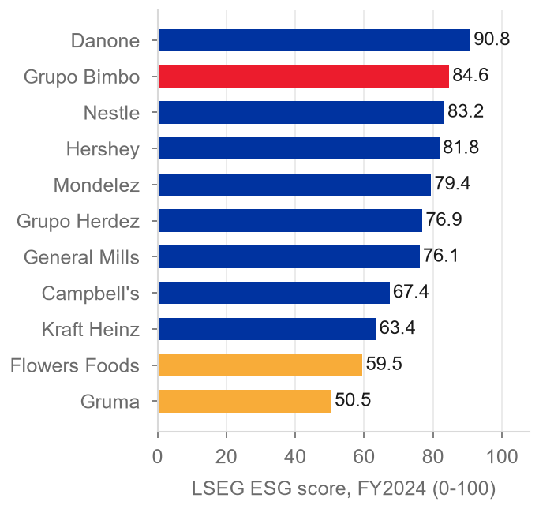
  Source: LSEG (2026)
  Figure 34: S&P Global ESG score history
  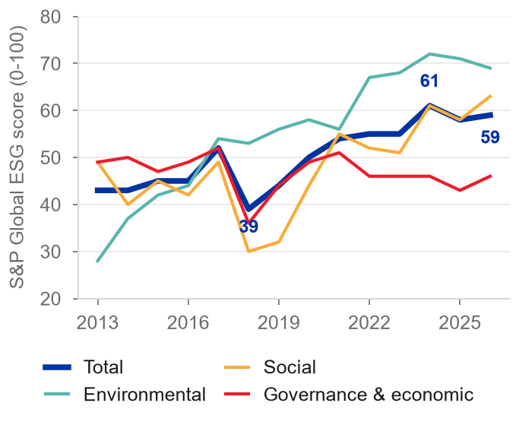
  Source: S&P Capital IQ (2026)
We choose five ESG issues that can change value or risk. Climate and nutrition rules change value, and we measure their effect. We cannot measure the effect of water, packaging and sourcing, because Bimbo does not publish the data.
Table 9: Five ESG issues that can change value or risk
Issue | Why it matters for value or risk | Company data
Climate and input costs | Wheat reaches the P&L, and gross margin follows wheat with a lag of one year. A permanent loss of 50 bp costs MXN 7.17 per share. | Scope 1 was 1,240,655 t in FY2025 (+8.6%). Scope 3 was 11,764,297 t (+3.0%). The Scope 3 target for 2025 was missed (LSEG, 2026; Grupo Bimbo, 2026e, pp. 101, 169).
Nutrition and health rules | Taxes and reformulation hit Mexico, which has 54% of EBITDA. A fall of 100 to 150 bp in the margin of Mexico costs MXN 5.5 to 8.1 per share. | 48% of sales have an optimal nutrition profile. NOM-051 reaches its third phase in 2028 (Grupo Bimbo, 2026a, pp. 29-31).
Water | Plants are in areas of high water stress. The water law reform of 11 December 2025 limits the transfer of concessions. | 89 to 101 plants are in areas of high water stress. Water use per tonne decreased 7% against 2019 at the end of 2024, and the target for 2030 is -20% (Grupo Bimbo, 2026a, pp. 39, 93; 2026e, pp. 12, 98).
Packaging and circular economy | The General Law of Circular Economy of 19 January 2026 creates producer responsibility for packaging. The cost is not set. | 99% of packaging meets recyclability standards. The target is 100% by 2030 (Grupo Bimbo, 2026a, pp. 38-39, 91-92).
Sustainable sourcing | The EU rule on deforestation can block sales in Europe. Raw materials are about 30% of sales. | 85% of palm volume is free of deforestation, against 70% in December 2024 (Grupo Bimbo, 2026a, pp. 40, 95-96; LSEG, 2026).
Source: Grupo Bimbo (2026a, 2026e); LSEG (2026); team model.
Environmental: climate and input costs matter most  The limited assurance of KPMG does not cover the emissions (Grupo Bimbo, 2026e, pp. 169, 176-180).  Social: health and labour  The recordable injury rate of the 147,873 employees of Bimbo decreased from 2.38 in 2021 to 1.59 in 2025. An optimal nutrition profile applies to 48% of sales (Grupo Bimbo, 2026e, pp. 63-64; 2026a, pp. 29-31, 89).  Governance: a controlled company  Six vehicles hold 72.03% of the shares. The chair is an executive and a member of the family, and has a casting vote. Of the 18 directors, 7 are independent (Grupo Bimbo, 2026a, pp. 171, 181-182; LSEG, 2026). The audit committee is fully independent, and related-party transactions are 2.3% of sales (Grupo Bimbo, 2026f, note 15). Our governance scorecard gives 31 of 64 points, 48% (team estimate). Bimbo decides acquisitions inside this structure, and this links governance to our first pillar.
  Figure 35: Greenhouse gas emissions and 2030 targets
  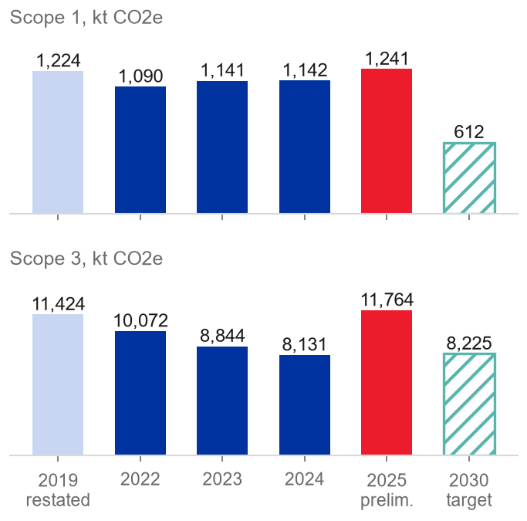
  Source: LSEG (2026); Grupo Bimbo (2026e, p. 169)
  Figure 36: Governance checklist: score by block
  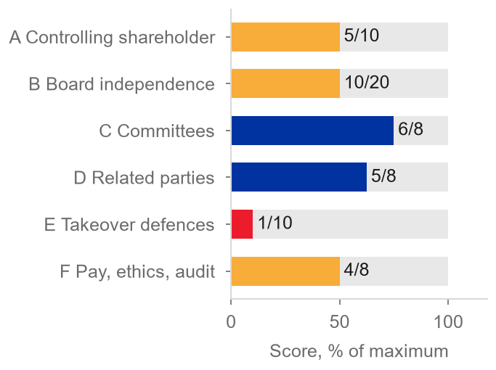
  Source: team estimate from Grupo Bimbo (2026a, pp. 171, 181-182; 2026g)
The by-laws protect the control group more than minority holders. The board can veto any transfer of 3% or more of the shares. A mandatory tender offer at 30% needs the approval of the board (Grupo Bimbo, 2026g, arts. 17, 17 bis). A holder needs 10% of the capital to appoint a director or to call a meeting. This is 36% of the free float of 27.6% (Grupo Bimbo, 2026g, arts. 47-48; team calculation).
Link to valuation
• Climate and input costs, nutrition regulation and labour reform have an effect through the margin. A permanent loss of 50 bp from FY2028E costs MXN 7.17 per share. A change of -100 to -150 bp in Mexico costs MXN 5.5 to 8.1 (team model).
• Governance has an effect through the discount rate. We keep governance outside the base case and add no WACC premium. Each +0.5 pp costs MXN 8.58 (team model).

Appendix
A1. Income statement (condensed)
Table 10: Income statement, FY2024A-FY2030E
MXN million | FY2024A | FY2025A | FY2026E | FY2027E | FY2028E | FY2029E | FY2030E
Net sales | 408,335 | 426,952 | 426,670 | 446,942 | 465,382 | 483,639 | 498,865
Gross profit | 214,928 | 223,487 | 224,992 | 233,075 | 242,892 | 252,580 | 260,595
Operating income (EBIT) | 33,149 | 34,146 | 37,729 | 42,541 | 44,982 | 47,345 | 49,205
Financing result | (12,579) | (14,001) | (13,120) | (12,175) | (12,327) | (12,446) | (12,515)
Income taxes | (6,797) | (7,197) | (9,123) | (11,253) | (10,699) | (11,433) | (12,018)
Consolidated net income | 14,043 | 12,946 | 15,533 | 19,161 | 22,005 | 23,514 | 24,719
Controlling interest | 12,544 | 11,133 | 13,712 | 17,253 | 20,018 | 21,450 | 22,589
EPS (MXN) | 2.88 | 2.58 | 3.19 | 4.01 | 4.65 | 4.98 | 5.25
Adj. EBITDA | 55,473 | 59,456 | 63,299 | 67,589 | 70,377 | 73,138 | 75,441
Source: Grupo Bimbo (2026f); team model (sheet IS). The financing result is shown as an expense.
A2. Balance sheet (condensed)
Table 11: Balance sheet at 31 December, FY2024A-FY2030E
MXN million | FY2024A | FY2025A | FY2026E | FY2027E | FY2028E | FY2029E | FY2030E
Cash | 8,057 | 8,535 | 14,228 | 22,372 | 32,391 | 43,272 | 55,028
Receivables | 36,659 | 35,782 | 35,644 | 37,338 | 38,878 | 40,404 | 41,675
Inventories | 18,832 | 17,151 | 17,000 | 18,028 | 18,755 | 19,477 | 20,085
PP&E | 155,376 | 157,423 | 158,750 | 162,051 | 165,830 | 170,029 | 174,468
Right-of-use assets | 34,220 | 32,757 | 32,757 | 32,757 | 32,757 | 32,757 | 32,757
Goodwill and intangibles | 140,908 | 135,515 | 133,340 | 131,165 | 128,990 | 126,815 | 124,640
Total assets | 416,804 | 409,805 | 414,411 | 426,448 | 440,387 | 455,587 | 471,535
Lease liabilities | 35,801 | 34,790 | 34,790 | 34,790 | 34,790 | 34,790 | 34,790
Financial debt | 150,905 | 153,663 | 151,250 | 151,250 | 151,250 | 151,250 | 151,250
Total equity | 127,698 | 120,255 | 127,617 | 137,314 | 149,597 | 163,151 | 177,714
Source: Grupo Bimbo (2026f, p. 12); team model (sheet BS).
A3. Cash flow (condensed)
Table 12: Cash flow, FY2024A-FY2030E
MXN million | FY2024A | FY2025A | FY2026E | FY2027E | FY2028E | FY2029E | FY2030E
Cash from operations | 39,907 | 47,753 | 53,225 | 55,871 | 58,983 | 61,020 | 62,843
Purchases of PP&E | (29,402) | (22,530) | (18,581) | (20,031) | (20,857) | (21,676) | (22,358)
Business acquisitions | (5,988) | (11,294) | 0 | 0 | 0 | 0 | 0
Borrowings | 79,111 | 69,267 | 0 | 12,078 | 14,861 | 19,285 | 7,065
Debt repayment | (56,495) | (55,477) | (1,563) | (12,078) | (14,861) | (19,285) | (7,065)
Dividends paid | (4,234) | (4,451) | (4,763) | (4,943) | (5,122) | (5,282) | (5,413)
Lease payments | (7,072) | (8,060) | (8,279) | (8,279) | (8,279) | (8,279) | (8,279)
Interest paid | (8,376) | (11,533) | (10,086) | (9,954) | (10,106) | (10,225) | (10,294)
Share repurchases | (4,433) | (1,253) | (2,572) | (2,748) | (2,748) | (2,748) | (2,748)
Other items (NCI distributions, derivatives, FX effect, other investment items) | (1,314) | (1,944) | (1,686) | (1,773) | (1,852) | (1,930) | (1,995)
Net change in cash | 1,704 | 478 | 5,693 | 8,144 | 10,019 | 10,881 | 11,756
Source: Grupo Bimbo (2026f, p. 16); team model (sheet CF).
A4. WACC and DCF details
Table 13: Build-up of the WACC
Step | WACC
Risk-free rate in pesos for all flows | 10.32%
+ risk-free rate by currency of the flows | 10.16%
+ country premium multiplied by beta | 9.93%
+ cost of debt by currency of the debt (WACC used) | 9.62%
Source: team model (sheet WACC).
Table 14: Terminal return on tangible operating capital, by year
FY2022 | FY2023 | FY2024 | FY2025 | Average | Model terminal RONIC
17.0% | 16.5% | 13.3% | 11.4% | 14.6% | 15.17%
Source: team model (sheet Assumptions, rows 690-697).

A5. Sensitivities
Table 15: Sensitivity of the twelve-month target price
Change (one at a time) | Target (MXN) | vs base | %
WACC -0.5 pp (9.12%) | 68.94 | +10.40 | +17.8%
WACC +0.5 pp (10.12%) | 49.96 | -8.58 | -14.7%
Terminal g +0.5 pp | 63.71 | +5.17 | +8.8%
Terminal g -0.5 pp | 54.24 | -4.30 | -7.3%
Adj. EBITDA margin +50 bp from FY2028E | 65.71 | +7.17 | +12.2%
Adj. EBITDA margin -50 bp from FY2028E | 51.38 | -7.17 | -12.2%
Adj. EBITDA margin -100 bp from FY2028E | 44.21 | -14.33 | -24.5%
Capex +50 bp of sales from FY2028E | 55.23 | -3.31 | -5.7%
Terminal RONIC at FY2022-25 average (14.6%) | 57.06 | -1.49 | -2.5%
Terminal RONIC at FY2022-25 low (11.4%) | 46.85 | -11.69 | -20.0%
North America ratio 0 (terminal NOPAT -2.0%) | 56.81 | -1.73 | -3.0%
One-year -100 bp margin hit in FY2027E only | 57.89 | -0.65 | -1.1%
The model does not net the 4Q26 and FY2027E buybacks from the share count | 57.62 | -0.92 | -1.6%
Source: team model (replica of sheet Valuacion_12m).
Table 16: Free cash flow to the firm, base DCF
MXN million | FY2027E | FY2028E | FY2029E | FY2030E | Terminal
EBIT | 42,541 | 44,982 | 47,345 | 49,205
NOPAT (tax 32.7%) | 28,624 | 30,266 | 31,856 | 33,107
+ D&A | 25,048 | 25,395 | 25,794 | 26,236
- Capex | (20,031) | (20,857) | (21,676) | (22,358)
- New leases | (6,142) | (6,142) | (6,142) | (6,142)
+/- Working capital | (380) | (611) | (602) | (495)
FCFF | 27,118 | 28,051 | 29,230 | 30,349 | 24,529
PV of FCFF (WACC 9.62%, mid-year) | 25,901 | 24,441 | 23,234 | 22,006 | TV 470,393
Source: team model (sheet Valuacion).
A5b. Sensitivity grid
Table 17: 12-month target price (MXN) by WACC and terminal growth
WACC \ g | 3.40% | 3.90% | 4.40% | 4.90% | 5.40%
8.62% | 68.09 | 74.24 | 81.80 | 91.34 | 103.79
9.12% | 58.58 | 63.28 | 68.94 | 75.89 | 84.66
9.62% | 50.60 | 54.24 | 58.54 | 63.71 | 70.06
10.12% | 43.81 | 46.65 | 49.96 | 53.86 | 58.55
10.62% | 37.95 | 40.19 | 42.75 | 45.73 | 49.24
Source: team model; replica of sheet Valuacion_12m (WACC and g vary; claims and the cost-of-equity factor fixed).
Table 18: Target price (MXN) by adjusted EBITDA margin and WACC
Adjusted EBITDA margin | WACC 9.12% (-0.5 pp) | WACC 9.62% (base) | WACC 10.12% (+0.5 pp)
14.0% (top of FY2021-FY2025 range) | MXN 50.4 (-25.1%) | MXN 41.7 (-38.1%) | MXN 34.5 (-48.8%)
14.6% (consensus) | MXN 60.3 (-10.3%) | MXN 50.7 (-24.6%) | MXN 42.7 (-36.5%)
15.12% (model) | MXN 68.9 (+2.5%) * | MXN 58.5 (-13.0%) | MXN 50.0 (-25.7%)
15.3% | MXN 71.9 (+6.8%) * | MXN 61.2 (-9.0%) | MXN 52.4 (-22.1%)
15.5% | MXN 75.2 (+11.7%) * | MXN 64.2 (-4.5%) | MXN 55.2 (-18.0%)
15.7% | MXN 78.5 (+16.7%) * | MXN 67.2 (-0.1%) * | MXN 57.9 (-13.9%)
Source: team model (replica of the 12-month valuation sheet; the margin is level from FY2027E; the replica differs from the workbook by up to MXN 0.3). Percentages are against MXN 67.27. * The target is at or above the price.
A5c. Football field
Figure 37: Football field: value per share against the price and rating zones
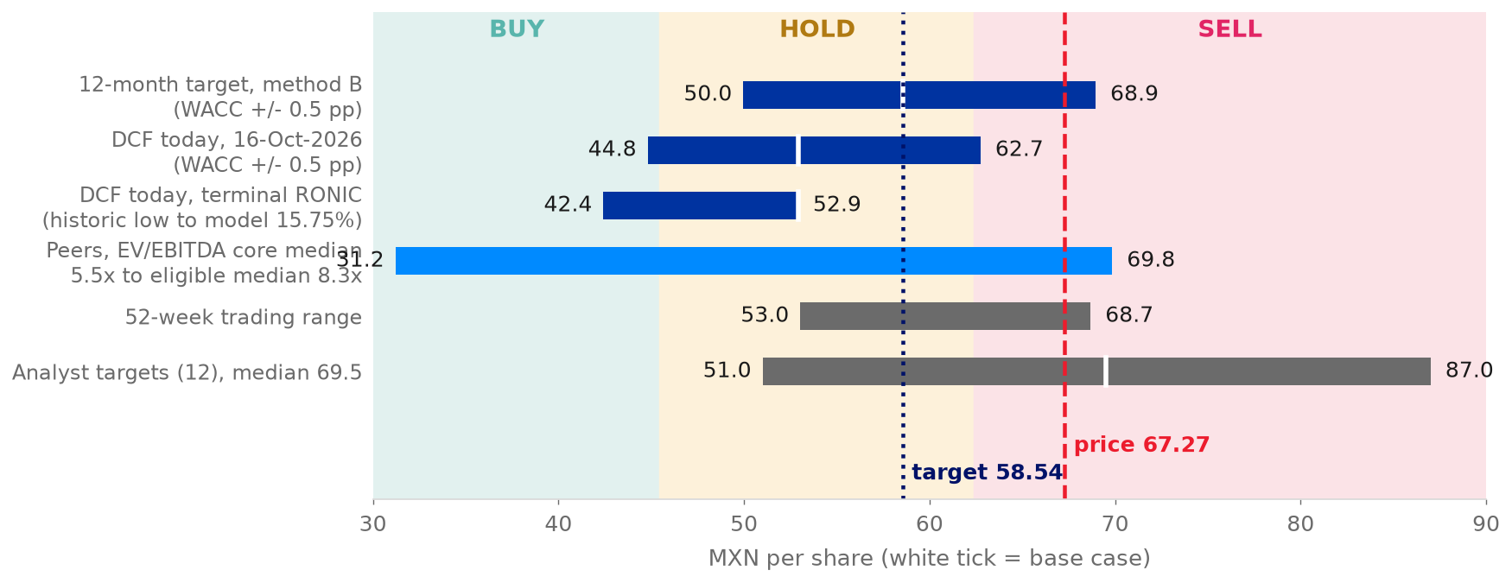
Source: team model; S&P Capital IQ (2026)

A6. Full risk table
Table 19: Risk register (P = probability, I = impact, 1 low to 5 high)
Risk | Pillar | P | I | Value effect on target | Mitigation
R1 Input costs: wheat cost persists | 2 | 3 | 4 | -9.4 (futures US$266); -14.2 if wheat +35% | Hedges (about one year), pricing, productivity
R2 North America turnaround stalls | 3 | 3 | 5 | about -13.4 (margin back to 8.4%) | Transformation programme, 11 closures
R3 Terminal return on capital below base | 1 | 2 | 4 | -11.7 (RONIC 11.4%) | Capex discipline, margin delivery
R4 Mexico labour and health policy | 3 | 3 | 4 | -5.5 to -8.1 (-100 to -150 bp) | Reformulation, pricing, route productivity
R5 Capital allocation: capex or deal | 1 | 3 | 3 | -3.3 (capex +50 bp) | Capex guide cut; undrawn US$2.35bn revolver
R6 Terminal growth and peso | 1 | 3 | 3 | -4.3 (g -0.5 pp) | Dollar debt (42%) hedges part
R7 Other expenses and integration costs do not fall | 3 | 3 | 4 | -10.6 (0.76% of sales and MXN 541 million) | Integration programme; 1Q27 report is the first check
Source: team estimate (P, I); team model (value effects on the MXN 58.54 target); Grupo Bimbo (2026a, 2026d).
A7. Management statements of the 3Q26 call against the data
Table 20: Management statements of the 3Q26 call against the data
Management said | What the data show | Reading
A margin of 15.7%, an increase of 100 bp, the fifth quarter in a row above 14%. Bimbo raised the 2026 guide to +85 to +120 bp. | 15.69% against 14.69%; our FY2026E is +91 bp | Partly. 1Q26 was 13.99%, so the number of quarters in a row is four, not five.
Bimbo hedges the main raw materials fully for 4Q26 and almost 100% for 1H27. Bimbo never hedges 2027 fully. | Raw materials are 30.4%, 29.9% and 30.6% of sales in FY2025, FY2026E and FY2027E. Bimbo does not disclose the coverage for 2H27. | Holds
2027 will be a challenge for cost of sales. Management does not guide a decrease in margin. | Our gross margin decreases 58 bp in FY2027E, but the adjusted EBITDA margin increases 29 bp, from 14.84% to 15.12% | Tension with our model
Free cash flow of about MXN 17 billion in 9M26 after about MXN 12 billion of capex. Net debt/EBITDA is 2.4x. | Our FY2026E shows MXN 34.6 billion after capex and MXN 16.3 billion after leases and interest. Leverage without IFRS 16 is about 2.5x by our approximation. | Holds in part. The release defines the measure before leases, but our figure is after leases.
A return to 3.0x will need about US$2 billion of deals. Bimbo never did this. | From 2011, the largest year is FY2025 with US$0.67 billion. Weston in 2009 was US$2.5 billion, and Bimbo funded most of the deal with debt. Our calculation is US$1.75 billion. Leverage was 1.5x in 2022 and 2.9x in 2024. | Holds, but history shows the cycle
Growth comes from volume and price/mix, and from acquisitions "to a lesser extent" | Bimbo does not report volume. By our estimate, acquisitions explain about 1.1 of 4.4 points in 9M26. | Holds in part
Wickbold cost more and took longer than Bimbo planned, and more pressure will come. | The margin in Latin America is 7.3% (-130 bp). Our integration costs decrease from MXN 540 million to zero in FY2027E. | Conflicts with our model
Volumes in North America are low and the transformation is not complete. Margin gains are structural. | Sales in North America increased 1.0% ex-FX in 3Q26, with a margin of 10.8%. The model increases the sales by 0.9% in FY2027E. | Holds
Capex in 2027 is somewhat above 2026. The dividend is slightly above inflation. Buybacks continue. | Our capex is US$1.05 to US$1.10 billion. The dividend is MXN 1.12 (+3.9%). Buybacks are MXN 2.7 billion a year, but we do not decrease the share count for EPS. Only the target nets the buybacks. | Holds
Source: Grupo Bimbo (3Q26 earnings call; 2026h, pp. 2-5; 2026f); S&P Capital IQ (2026); team model.
Four statements hold, three hold in part, one is in tension with our model and one conflicts with our model. The two statements that matter are the 2027 margin and the integration costs. Both are in our third pillar. The model is more optimistic than the people who run the company (team model).
A8. Reverse DCF, consensus and the price date
The reverse DCF changes one driver at a time and keeps the rest of the model the same. The reverse DCF does this until the 12-month target equals the price of MXN 67.27. Table 22 compares the model with the mean of the S&P Capital IQ consensus of 20 September 2026. The date of this consensus is before the 3Q26 results.
Table 21: What the price of MXN 67.27 requires (reverse DCF)
Driver | Our model | The price needs | Record or consensus | Reading
Adjusted EBITDA margin, FY2027E onward | 15.12% | about 15.7% | Consensus 14.6%. FY2021-FY2025 range 13.4%-14.0%. 9M26 14.7%. 3Q26 15.7% (one quarter). | 60 bp more than our already high margin, held every year
Net sales growth a year, FY2028E-FY2030E | 3.7% | 6.6% | Organic growth about 3%. FY2022-FY2025 2.3% a year, with acquisitions. | 2.9 points more every year, at the same margin
Terminal return on new capital | 15.17% | 20.1% | FY2025 11.4%. FY2022-FY2025 average 14.6%. Best year, FY2022, 17.0%. | Above the best year of the recent record
WACC | 9.62% | 9.19% | Sensitivity of +/-0.5 pp in Table 17 | 43 bp lower. The difference comes more from market rates than from the company.
Source: team model (Python replica of the 12-month valuation sheet, which reproduces the workbook target; each driver changed alone until the target equals MXN 67.27; growth scales sales, EBIT, depreciation, capex, leases and working capital together from FY2028E at constant margins); S&P Capital IQ (2026); Grupo Bimbo (2026f).
Table 22: Model against the consensus, FY2026E-FY2028E
Line | FY2026E model | FY2026E consensus | FY2027E model | FY2027E consensus | FY2028E model | FY2028E consensus
Net sales, MXN million | 426,670 | 426,275 | 446,942 | 445,288 | 465,382 | 468,431
Adjusted EBITDA, MXN million | 63,299 | 62,117 | 67,589 | 64,891 | 70,377 | 68,999
Adjusted EBITDA margin | 14.84% | 14.57% | 15.12% | 14.57% | 15.12% | 14.73%
EPS, MXN | 3.19 | 3.07 | 4.01 | 3.35 | 4.65 | 3.80
Source: S&P Capital IQ (2026), consensus means of 20 September 2026 (EPS normalized); team model (EPS basic).

The model is in line with the consensus on sales. The model is above the consensus on EBITDA (+1.9%, +4.2% and +2.0%) and on EPS (+3.7%, +20% and +22%). If the SELL is wrong, this is not because our model is pessimistic. If we use the consensus margin, then the target is MXN 50.84 (team model).
The price date is a rule, not a choice. The reference price is the closing price at the cut-off date of the report, 4 November 2026. The first page shows the price. If we use the close of 16 October, then the rule gives HOLD (see Valuation).
A9. References
Bakery & Snacks (2026) 'Private label widens lead over national brands in 2026 grocery unit sales', Bakery & Snacks, 9 July.
Banxico (Banco de Mexico) (2026) Encuesta sobre las expectativas de los especialistas en economia del sector privado, September. Mexico City.
Damodaran, A. (2026) Country default spreads and risk premiums (July 2026 update); Betas by sector, global (5 January 2026); Implied equity risk premium (October 2026). New York University Stern School of Business.
Flowers Foods, Inc. (2026) Annual report on Form 10-K for fiscal 2025 and second quarter 2026 results and fact sheet. Thomasville, GA.
FRED (2026) 10-Year Treasury constant maturity rate (DGS10). St. Louis: Federal Reserve Bank of St. Louis, accessed 5 November.
Grupo Bimbo, S.A.B. de C.V. (2024) Reporte anual 2023 [Annual report 2023 to the Bolsa Mexicana de Valores]. Mexico City.
Grupo Bimbo, S.A.B. de C.V. (2026a) Reporte anual 2025 [Annual report 2025 to the Bolsa Mexicana de Valores], 30 April. Mexico City.
Grupo Bimbo, S.A.B. de C.V. (2026b) Grupo Bimbo reporta resultados del 4T25 [4Q25 results release], 25 February. Mexico City.
Grupo Bimbo, S.A.B. de C.V. (2026c) Grupo Bimbo reporta resultados del 1T26 [1Q26 results release], 29 April. Mexico City.
Grupo Bimbo, S.A.B. de C.V. (2026d) Grupo Bimbo reporta resultados del 2T26 [2Q26 results release], 23 July. Mexico City.
Grupo Bimbo, S.A.B. de C.V. (2026e) Informe anual integrado 2025 'Celebramos' [Integrated report 2025]. Mexico City.
Grupo Bimbo, S.A.B. de C.V. (2026f) Estados financieros consolidados auditados 2025 [Audited consolidated financial statements 2025]. Mexico City.
Grupo Bimbo, S.A.B. de C.V. (2026g) Estatutos sociales [Corporate by-laws], deed 119069, 6 May. Mexico City.
Grupo Bimbo, S.A.B. de C.V. (2026h) Grupo Bimbo reporta resultados del 3T26 [3Q26 results release], October. Mexico City.
Grupo Bimbo, S.A.B. de C.V. (2026i) Investor presentation 3Q26, October. Mexico City.
Grupo Bimbo, S.A.B. de C.V. (2Q26 investor presentation) Investor presentation 2Q26, 23 July. Mexico City.
Grupo Bimbo, S.A.B. de C.V. (3Q26 earnings call) Transcript prepared by the team from the call of 22 October 2026.
IMF (2026) Global price of wheat, series PWHEAMTUSDM, via FRED. Washington, DC: International Monetary Fund.
IndexBox (2026) 'USDA grain futures and canola bids report for October 7, 2026'. IndexBox.
Investing.com (2026) 'Flowers Foods Q2 2026 slides: volume drops 5.8% amid category pressure', August.
LSEG (2026) ESG scores, controversies, officers and directors, and ownership data for Grupo Bimbo. London Stock Exchange Group. Accessed October 2026.
S&P Capital IQ (2026) ESG scores history, consensus estimates, ownership, rates and peer data. S&P Global Market Intelligence. Accessed 16-19 October 2026.
Team model (2026) BIMBOA statements 2021-2030, final model with 12-month target [unpublished team workbook].
Yahoo Finance (2026) BIMBOA.MX historical prices, read 4 November.
Use of AI Tools
Tools. We used Claude (Anthropic) in Claude Code, with a research-challenge plugin and a compiled knowledge wiki of the company filings. A second model, Codex (OpenAI), reviewed the valuation documents in October 2026. NotebookLM (Google) made an audio summary of our model notes for internal study.
What we used them for. (1) The assistant read filings, presentations and Capital IQ exports into the wiki with source and page citations. It extracted and mapped the FY2021-FY2025 statements. (2) The assistant built the three-statement model, the WACC and the DCF. It made a Python replica that reproduces the target price and the sensitivities of the workbook. (3) The assistant wrote research notes on the industry, the risks and ESG.
(4) The assistant made charts and tables. It drafted and edited this report from the model and the decisions of the team. This work included the first wording and the data support of the three pillars. The assistant proposed alternative titles and arguments. The team chose the final titles and their order.
(5) The assistant asked coaching questions that tested the thesis and the forecast method. (6) The assistant read the transcript of the 3Q26 earnings call that the team made. It checked nine statements of the CFO and CEO against the model and the filings.
(7) The assistant drafted two working notes on pillars from the answers of the team. One note covers acquired growth and one covers the new management. The team used these notes as sources for the first and third pillars. (8) The assistant did a public web check of post-results analyst figures (an aggregator page and a news wire). The team used the check only to cross-check the Capital IQ consensus. The report does not quote it.
How we verified the output. The model balances in every year and agrees with the audited statements. The replica reproduces the 12-month target and its WACC cases to the cent. Each wiki number has a data tag and a page reference. We read every number in this report from the team workbook, the wiki or a filing.
What the team decided. The team chose the SELL rating, the three pillars and the reference price of MXN 67.27 on 4 November 2026, after the 3Q26 results. The team chose the method for the 12-month target and the rule for the rating band. The team chose the WACC inputs, which are a global industry beta and the current market capital structure. The team chose the North America share-gain ratio of 0.17 and the sales method, which is the team ratio times nominal GDP, without acquisitions. The team chose the terminal growth, the return on new capital and the treatment of non-controlling interests, and the project log records all these decisions.
Reflection. AI helped most with volume and traceability, because it read hundreds of pages of filings, releases and the call transcript. It linked every number to a source and page, and it rebuilt the tables and charts after each change to the model. The team, and not AI, argued and decided the three pillars, the SELL and its rating rule, the 12-month target method and the WACC inputs. The team also decided whether the 2027 margin gain is real, and asked the assistant for the strongest case against each. One limitation is that AI writes fluent text when the evidence is thin, so we checked the source of every claim. The team had to identify and defend two judgements that cause MXN 23.5 of the MXN 24.0 DCF increase, from MXN 28.93 to MXN 52.92.

