
CFA Institute Research Challenge
hosted by CFA Society Mexico
[TEAM UNIVERSITY]

The CFA Institute Research Challenge is a global competition that tests the equity research and valuation, investment report writing, and presentation skills of university students. The following report was prepared by a team of university students as part of this annual educational initiative and should not be considered a professional report.
Disclosures:
Ownership and material conflicts of interest
The author(s), or a member of their household, of this report does not hold a financial interest in the securities of this company.
The author(s), or a member of their household, of this report does not know of the existence of any conflicts of interest that might bias the content or publication of this report.
Receipt of compensation
Compensation of the author(s) of this report is not based on investment banking revenue.
Position as an officer or director
The author(s), or a member of their household, does not serve as an officer, director, or advisory board member of the subject company.
Marketing making
The author(s) does not act as a market maker in the subject company’s securities.
Disclaimer
The information set forth herein has been obtained or derived from sources generally available to the public and believed by the author(s) to be reliable, but the author(s) does not make any representation or warranty, express or implied, as to its accuracy or completeness. The information is not intended to be used as the basis of any investment decisions by any person or entity. This information does not constitute investment advice, nor is it an offer or a solicitation of an offer to buy or sell any security. This report should not be considered to be a recommendation by any individual affiliated with CFA Society Mexico, CFA Institute, or the CFA Institute Research Challenge with regard to this company’s stock.

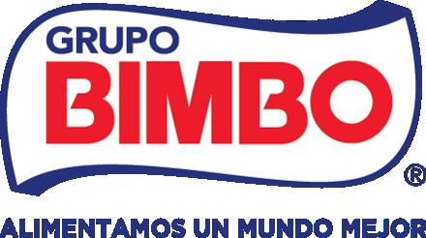 | Grupo Bimbo, S.A.B. de C.V.  BMV: BIMBO A  Sector: Consumer Staples  Industry: Packaged Food & Bakery | HOLD Recommendation  Target price (12M): MXN 58.54 (9.7% below the price)  Price (2026-10-27): MXN 64.85

Executive Summary
Grupo Bimbo's recovery is real and the market has already paid for it: the share rose 10.7% between 16 and 27 October, around the 3Q26 results of 22 October, to MXN 64.85 (Yahoo Finance, 2026). We rate it HOLD (neutral), with a 12-month target price of MXN 58.54, 9.7% below the price. Even that target assumes an adjusted EBITDA margin above any year in the company's history, so valuation does not support buying: the total return is -8.0% against a 12.26% cost of equity, and our DCF of MXN 52.92 is 18.4% below the price (team model).
Our view rests on three pillars. Reported growth is flattered by acquisitions and by the peso, and the new management inherits a recovery whose next step, in 2027, is still unproven; both argue against buying. Costs can rise without breaking the margin, because Bimbo has already absorbed a shock almost four times larger than the one in our model, which argues against selling. We checked nine statements of the CFO and CEO from the 3Q26 call against the data: four hold, three hold in part, one is in tension with our 2027 margin and one conflicts with our integration costs (team model). Our rating rule gives SELL at this price, because even the optimistic expected return (WACC -0.5 pp), +8.0%, is below the 12.26% cost of equity, so HOLD is a judgement and we say why. The rule moves to HOLD at an FY2027E adjusted EBITDA margin of 15.3%, only 18 bp above our 15.12% and about half the 35 bp width of management's own 2026 margin guide (+85 to +120 bp); selling now would be a bet on a gap smaller than the company's own uncertainty. We therefore wait for a dated test: if the 2027 guidance at the 4Q26 call in late February 2027 implies less than 15.3%, we move to SELL (Table 7); at the consensus margin the target would be MXN 50.84 (team model).
  Figure 1: Share price and 12-month target
  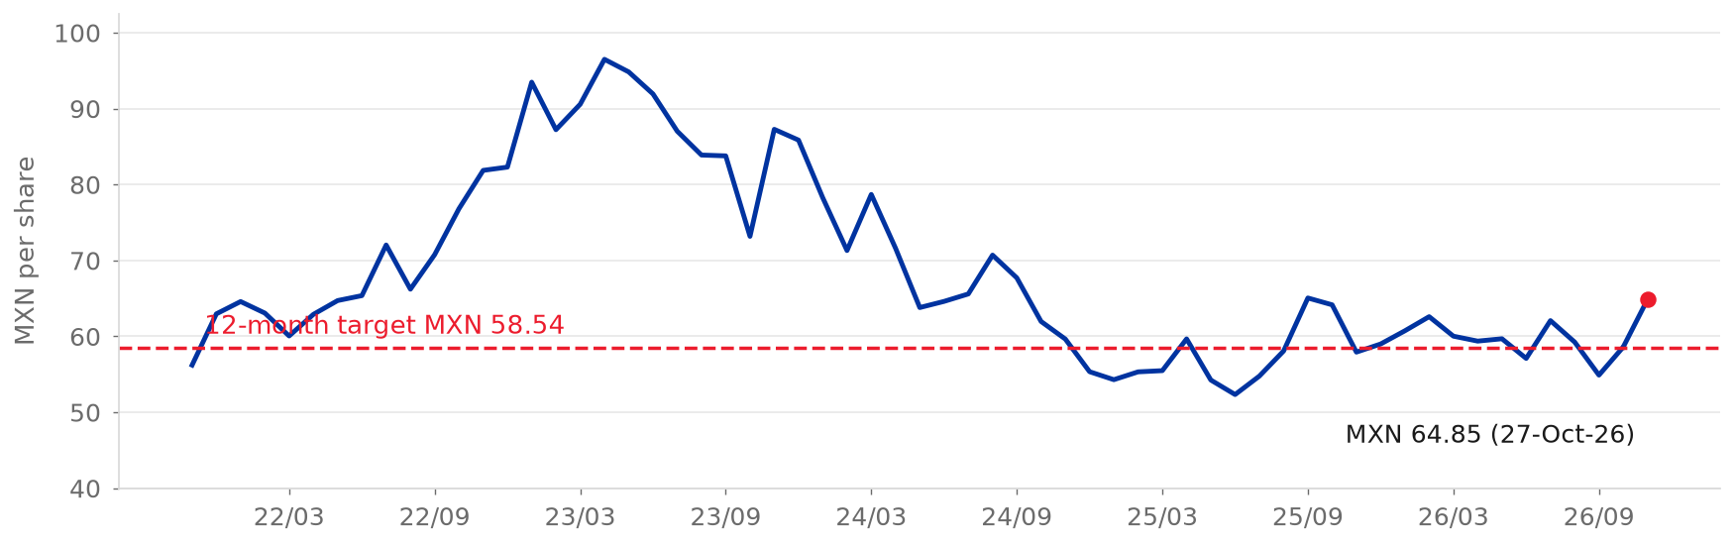
  Source: S&P Capital IQ (2026); Yahoo Finance (2026) for 27-Oct-26; team model
Highlights
• Business. The world's largest baker, with 249 plants in 39 countries; Mexico earns 54% of regional adjusted EBITDA on 35% of regional sales, and North America 29% on 43% (Grupo Bimbo, 2026a, pp. 14, 85; team model).
• Forecast. Net sales grow 3.2% a year to FY2030E and the adjusted EBITDA margin rises from 13.9% to 15.1%, of which 114 bp of the 120 bp gain to FY2027E comes from two lines that fall to almost zero (team model).  • Valuation. WACC 9.62%, terminal growth 4.40%, terminal return on new capital 15.17%; the terminal value is 83% of enterprise value at the target date (team model).  • Catalysts. FY2026 results and 2027 guidance in late February 2027, the Wickbold anniversary in 4Q26, the shareholders' meeting by end-April 2027 and the end of the 1H27 hedges (Grupo Bimbo, 2026a, p. 62; team estimate).  • Main risk. A margin that settles 100 bp lower permanently from FY2028E costs MXN 14.33 per share, 24% of the target, and about MXN 14.8 if it starts in FY2027E (team model).
  Figure 2: Net sales and adjusted EBITDA margin, FY2021A-FY2030E
  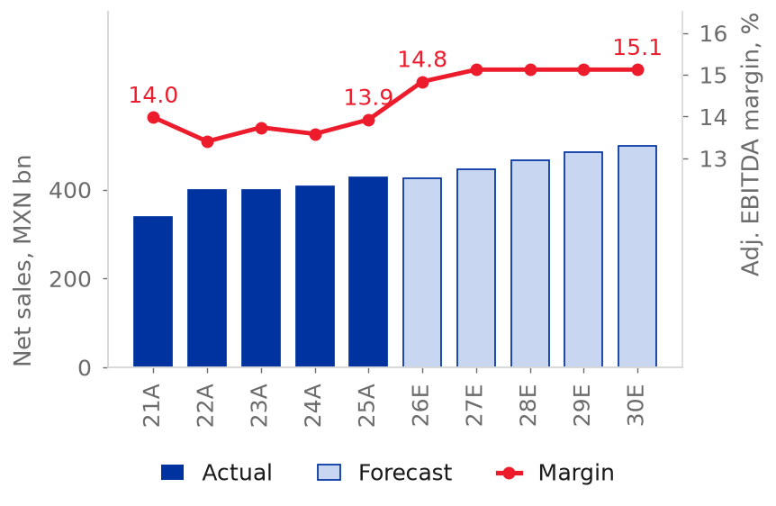
  Source: Grupo Bimbo (2026f); team model

Analysts: Luis Arturo Romo Alba, Diego Benavides Pro, Alexa Garcia Saldivar, Jorge Alejandro Gaytan, Carolina del Rosario Benites
Business Overview
Grupo Bimbo, S.A.B. de C.V. is the world's largest baking company by sales, with 3.7% of the global bakery market, 1.2 times the next competitor (Grupo Bimbo, 2026a, pp. 107-109). It runs 249 plants and more than 54,000 delivery routes in 39 countries and sells more than 9,000 products under over 100 brands (Grupo Bimbo, 2026a, pp. 14, 100). FY2025 net sales were MXN 426,952 million (+4.6%) and adjusted EBITDA MXN 59,456 million, a 13.9% margin (Grupo Bimbo, 2026f, p. 85).
Business model  Bimbo bakes fresh bread, sweet baked goods, cookies, tortillas and salty snacks and delivers them to stores on its own routes. Fresh bread lasts about 14 days, so the delivery network, not the recipe, is the barrier to entry (Grupo Bimbo, 2026a, pp. 100, 110). Customers are modern retail, traditional stores, convenience chains and quick-service restaurants; Walmart is about 15% of sales and no other customer exceeds 10% (Grupo Bimbo, 2026a, p. 103).  Operating segments  • North America (43% of regional sales, 29% of regional EBITDA, 9.0% margin): Bimbo Bakeries USA (54 bakeries, about 27% of US fresh bread), Barcel USA, Bimbo QSR and Bimbo Canada (Grupo Bimbo, 2026a, pp. 82-84; Flowers Foods, 2026).
  Figure 3: FY2025 net sales by region
  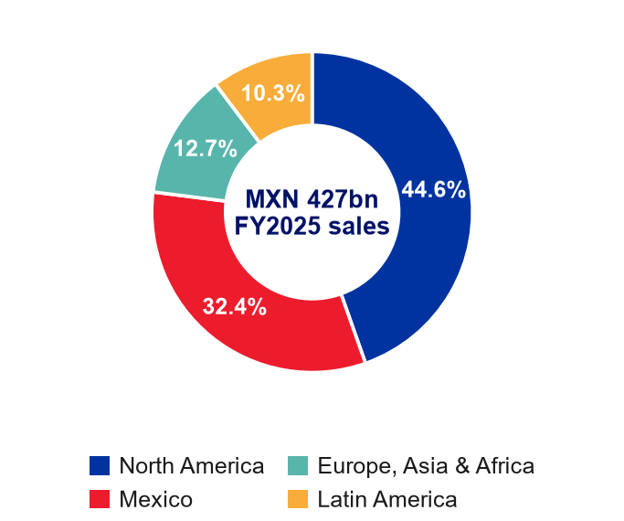
  Source: Grupo Bimbo (2026b, p. 4)
• Mexico (35%, 54%, 20.4%): the Bimbo and Barcel brands, including Takis, and 38 plants (Grupo Bimbo, 2026a, pp. 84-85; 2026e, p. 17).  • Europe, Asia and Africa (12%, 10%, 10.8%): Iberia, the United Kingdom, Romania, China, India and Africa, built largely by acquisition (Grupo Bimbo, 2026a, pp. 85-87).  • Latin America (10%, 6%, 8.1%): 15 countries and 42 plants; Wickbold (Brazil) joined in October 2025 and its integration weighs on the margin, 7.3% in 3Q26 (Grupo Bimbo, 2026a, p. 85; 2026h, pp. 2-5).
  Figure 4: Acquisitions paid and net debt including leases over EBITDA
  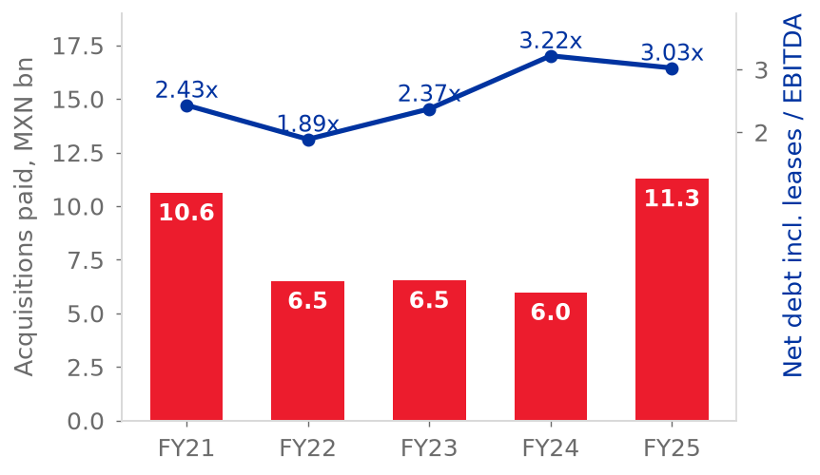
  Source: Grupo Bimbo (2026f); team model
Strategy, acquisitions and ownership  Management is rebuilding North America's profitability, with capex down from MXN 34,754 million in FY2023 to MXN 22,530 million in FY2025 (Grupo Bimbo, 2026a, pp. 76-77; 2026f, p. 86). Growth has also come from buying: about 60 acquisitions in fifteen years, 29 bakeries added in 2025, most of them acquired, and 6,093 employees still in integration at the end of 2025 (Grupo Bimbo, 2026a, pp. 77, 82, 105). Six holding vehicles control 72.03% of the shares, led by Normaciel with 40.96%, and the free float is 27.6% (Grupo Bimbo, 2026a, pp. 181-182; LSEG, 2026).
  Figure 5: Adjusted EBITDA margin by region, FY2021-FY2025
  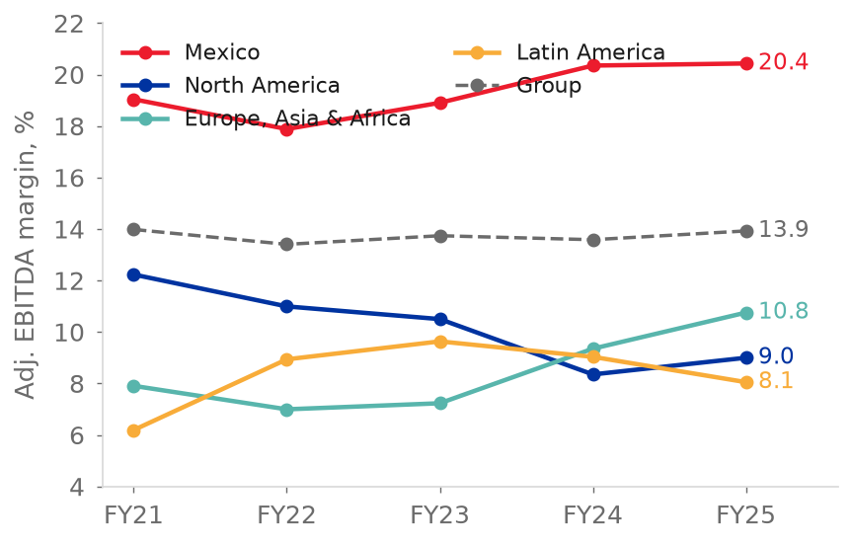
  Source: Grupo Bimbo (2026f, p. 85); team model
Management and governance  Daniel Servitje Montull is Executive Chairman and Alejandro Rodriguez Bas has been Group CEO since November 2025; he joined Bimbo in October 2021 (Grupo Bimbo, 2026a, pp. 76-77, 178). The CFO, Gaxiola, has held the post since 2017 (Grupo Bimbo, 2026a, p. 180). Both successions since 2024 came from inside the company, and results since the second one show no break: the group margin rose 100 bp in 3Q26 (Grupo Bimbo, 2026h, pp. 2-5). The record on promises is mixed: of 61 testable targets set on earnings calls since 2011, 22 were met, 9 mixed and 30 missed, and the pledge to stay below 2x leverage held only from December 2020 to 3Q23 (team estimate).  The ESG section analyses governance in full. We view management as a positive for the North America recovery and neutral for governance: the CEO's own words, that the transformation is not complete until volume grows, are more cautious than the forecast needs to be (team estimate).
  Figure 6: Shareholder structure
  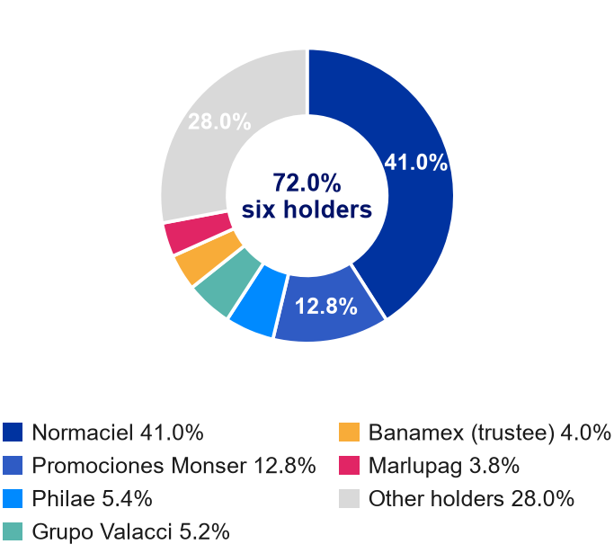
  Source: Grupo Bimbo (2026a, pp. 181-182); LSEG (2026)

Industry Overview
Market structure and growth  Bimbo competes in branded, packaged bakery delivered direct to store, country by country. That is narrower than the global bakery market, where artisanal bakeries hold 44.3% and private label 9.6% (Grupo Bimbo, 2026a, p. 107). Global bakery retail value was US$638.9 billion in 2024 and grew at a 2.8% CAGR in 2019-24; Global Data expects 4.7% in 2024-29E, with 4.3% in North America, 5.5% in Latin America and 3.5% in Mexico (Grupo Bimbo, 2026a, pp. 107-111). Weighted by Bimbo's sales mix this is about 4.2% a year (team model). That growth is mostly price and mix: the CEO said that volumes in North America remain soft and the CFO that growth comes from volume and price/mix, yet Bimbo does not report volume (Grupo Bimbo, 3Q26 earnings call; team model). We classify the industry as mature.
  Figure 7: Bakery market value growth, 2019-24 and 2024-29E
  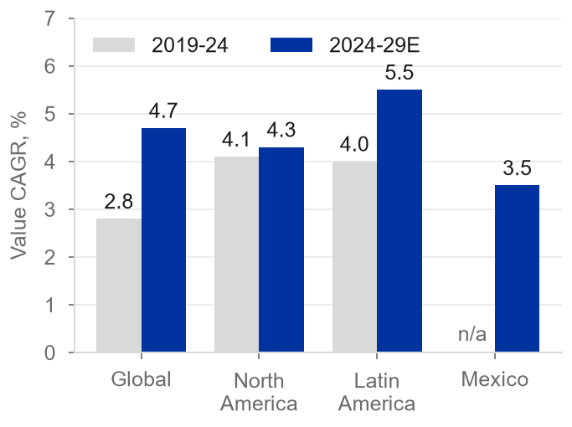
  Source: Global Data, in Grupo Bimbo (2026a, pp. 107-111)
Competitive landscape and five forces  Bimbo is number one globally with a 3.7% share, ahead of Mondelez (3.0%) and Gruma (1.1%) (Grupo Bimbo, 2026a, p. 107). In US fresh bread, buns and rolls it holds about 27%, private label 26%, Flowers Foods 16% and Pepperidge Farm 5%; in Mexico it holds 18.2% of packaged bread and 28.2% of sweet baked goods (Flowers Foods, 2026; Grupo Bimbo, 2026a, pp. 111, 113). Bimbo is two industries in one (team estimate). In Mexico and Latin America the buyer is fragmented and the route network supports a 20.4% EBITDA margin in Mexico (Grupo Bimbo, 2026f, p. 85). In the United States, Canada and Europe the buyer is concentrated and private label is strong: it is about 35% of US fresh bread units and reached a record 23.8% of US grocery unit sales in 1H26, and Flowers Foods' volume fell 5.8% in 2Q26 (Bakery & Snacks, 2026; Investing.com, 2026).  • Suppliers have medium power: raw materials are 30.4% of sales and wheat, sugar and oils are dollar commodities, so gross margin follows wheat with a one-year lag; this is the base of our first pillar (Grupo Bimbo, 2026f, p. 82; team model).  • Entrants are a low threat at scale, because delivering a 14-day product is the barrier; the real entrants are private label and hard discounters (Grupo Bimbo, 2026a, pp. 100, 110).
  Figure 8: Global bakery market by type, 2024
  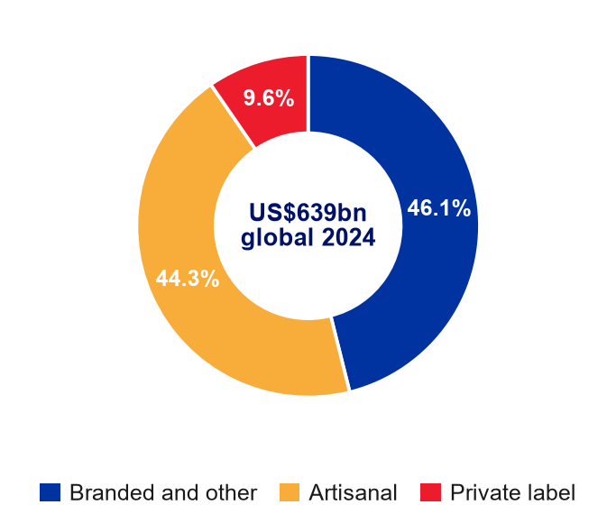
  Source: Global Data, in Grupo Bimbo (2026a, p. 107)
• Buyers are strong in developed markets, where the modern channel is 77.7% of the North American bakery market and Walmart is about 15% of group sales (Grupo Bimbo, 2026a, pp. 103, 110).
Macro and positioning  The peso drives reported growth: about 44% of sales come from developed markets (Grupo Bimbo, 2026a, p. 78). Bimbo has the highest gross margin of the bakers (52.6% against 48.6% for Flowers Foods) but spends it on distribution and is more capital intensive (capex 5.2% of sales against a 3.7% median) (S&P Capital IQ, 2026). Our view: the moat justifies the Mexican margin, but not yet a premium in North America.
  Figure 9: Five forces: Bimbo is two industries in one
  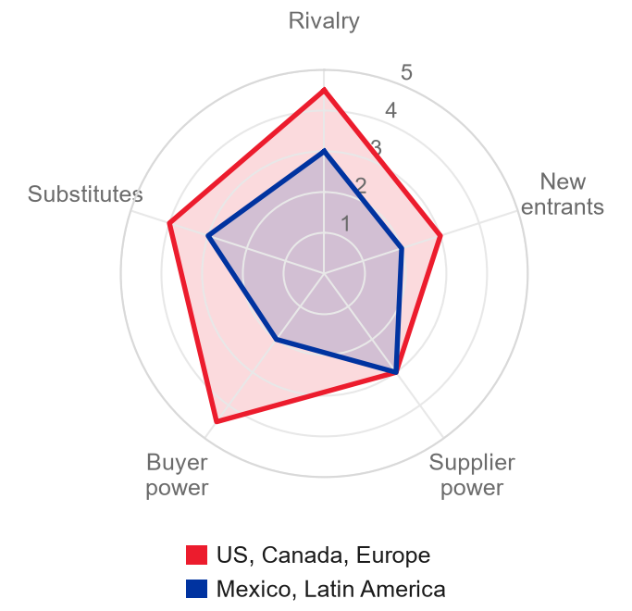
  Source: team estimate

Investment Summary
With acquisitions and the peso stripped out of growth, and costs that Bimbo has already shown it can absorb, Bimbo's value hinges on one thing: whether new management can expand margins on its own in 2027. Until we see it, the price already pays for what we know.  The recovery is real. In 3Q26 the group margin reached 15.7%, 100 bp above a year earlier, leverage fell to 2.4x and management raised its 2026 margin guide for the third time (Grupo Bimbo, 3Q26 earnings call; 2026h). But not all of the sales growth is organic. Net sales excluding currency grew 4.4% in 9M26, of which about 1.1 points, by our estimate, were acquisitions; and the peso, which cut reported sales growth by 6.6 points in those nine months, turns in our model into 1.46 of the 4.75 points of FY2027E growth. Of the 120 bp of margin we model to FY2027E, 114 come from two lines that fall almost to zero, under a CEO who took over in November 2025 a recovery that was already under way (team model).  Costs are the reason we do not rate Bimbo SELL. Raw materials are fully hedged for 4Q26 and almost fully for 1H27; after that, the cost depends on the price of new hedges. If wheat holds its September 2026 price, the target loses MXN 5.83 of the MXN 58.54 target (10%). In a stress case, with wheat 35% higher permanently, at about US$294 a tonne and above the December 2027 futures, it loses about MXN 14.17 (24%) (Grupo Bimbo, 3Q26 earnings call; IMF, 2026; team model). The hedges explain why 2026 looks easy, and they set the date of the test. From 4Q26 Wickbold stops counting as acquired growth, from the second half of 2027 the cost depends on new hedges, and 2027 is the first year that the new management cannot lean on what it inherited. The market already pays for the outcome: the share rose 10.7% between 16 and 27 October to MXN 64.85, and at that price the expected return over twelve months is -8.0% (our MXN 58.54 target plus the MXN 1.12 dividend), against a 12.26% cost of equity: no premium for the risk is left. Our rating rule gives SELL, and we rate Bimbo HOLD, a neutral stance: the recovery is not in doubt, the price already pays for it, costs do not argue for selling, and only 2027 can show whether it deserves more or less.
  Figure 10: Adjusted EBITDA margin, FY2025A to FY2027E, by line
  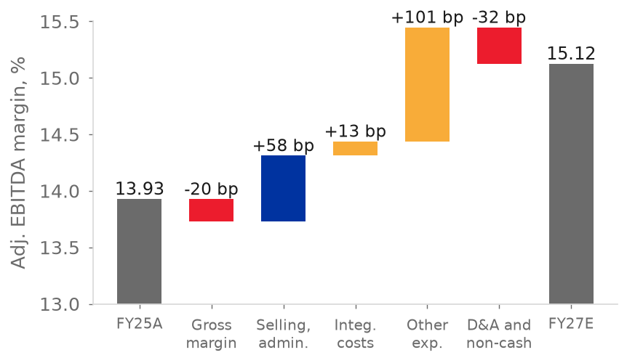
  Source: Grupo Bimbo (2026f); team model
  Figure 11: Adjusted EBITDA margin: model and consensus, FY2026E-FY2028E
  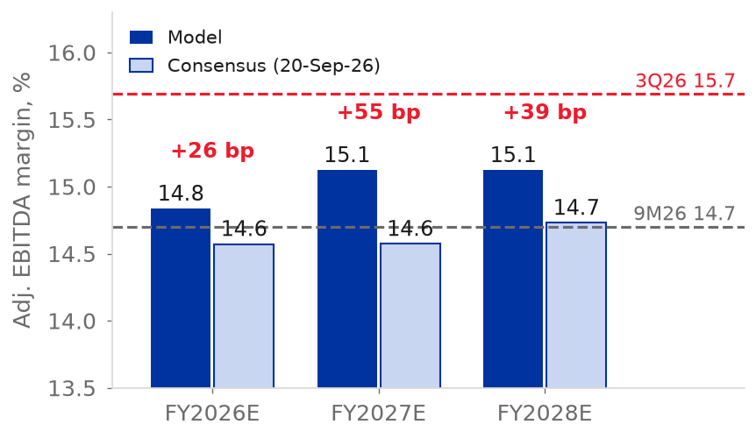
  Source: S&P Capital IQ (2026); team model
Our HOLD rests on three pillars. Pillar 2 argues against selling: costs can rise without breaking the margin, because Bimbo has already absorbed a shock almost four times larger than the one in our model. Pillars 1 and 3 argue against buying: organic growth is about 3% a year, and 114 of the 120 bp of margin gain to FY2027E come from two lines that must fall almost to zero. Our rating rule gives SELL at MXN 64.85, and we keep a neutral HOLD, as the Valuation section explains. At MXN 64.85 the stock trades at 20.4x FY2026E and 16.2x FY2027E earnings and at about 7.5x FY2026E EV/EBITDA on the model's enterprise value, which includes non-controlling interests and other debt-like items (7.2x on the Capital IQ enterprise value of Table 3), against the 6.2x that our terminal value implies for FY2030E (team model).
Pillar 1: Reported growth is flattered by acquisitions and FX
• The record of deals. Bimbo made 23 acquisitions in FY2021-FY2025 and paid MXN 40,987 million, 69% of its FY2025 adjusted EBITDA, and added Bonel in April 2026; net sales grew 6.0% a year in that period but only 2.3% a year between FY2022 and FY2025 (Grupo Bimbo, 2026a, pp. 220-223; 2026f, p. 16; team model).
• What was bought. By our estimate, acquisitions explain about 1.1 of the 4.4 points of 9M26 growth excluding currency, a quarter of it, against the CEO's "to a lesser extent"; in Europe, Asia and Africa growth fell from 12.6% to 2.1% between 1Q26 and 3Q26 as Karamolegos and Don Don passed their first anniversary, and Wickbold leaves the inorganic base from 4Q26 (Figure 12) (Grupo Bimbo, 3Q26 earnings call; 2026c, 2026d, 2026h; team model).
  Figure 12: Net sales growth 2026 reported and excluding acquisitions, Europe-Asia-Africa and Latin America
  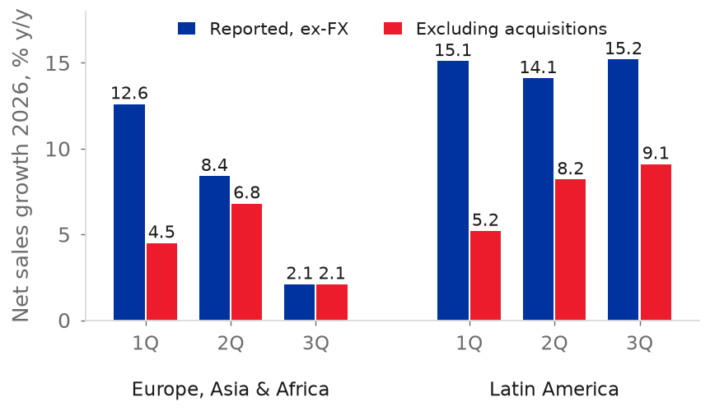
  Source: Grupo Bimbo (2026c, 2026d, 2026h); team model
• What is translated. In 9M26 reported sales fell 2.2% against growth of 4.4% excluding currency, so the peso took 6.6 points, but in our model the effect turns and 1.46 of the 4.75 points of FY2027E growth, 31%, are currency, falling to 0.51 by FY2030E, so the bakery grows 3.3% in FY2027E and 2.9% a year to FY2030E (Figure 13) (Grupo Bimbo, 2026h; team model).
  Figure 13: Net sales growth in pesos: organic, acquisitions and FX translation
  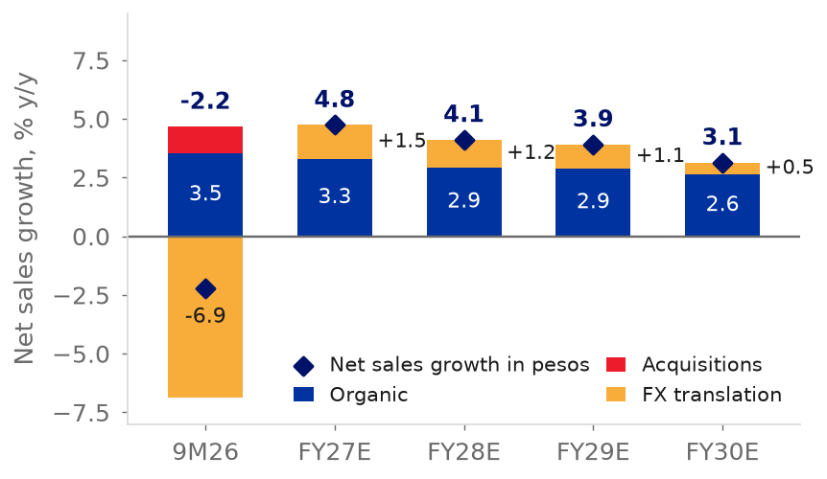
  Source: Grupo Bimbo (2026h); team model
• The market price. The price is above a DCF that excludes acquisitions: MXN 64.85 against 52.92. On 18 September 2026 EV/EBITDA was 6.29x on Capital IQ's basis, the 8th percentile since 2000, against 11.3x in 2012-2018, when return on equity was 7.7%; since 2015 EBITDA grew 2.2 times, the multiple fell 43% and net debt rose 2.7 times (Figure 14) (S&P Capital IQ, 2026; team model). It is cheap on enterprise value, not on earnings (P/E of 17.0x on next-twelve-month earnings, the median); the analysts' mean target of MXN 70.17 implies about 7.4x FY2027E EBITDA on the model's enterprise value against 6.7x for ours and 6.2x in our terminal value (S&P Capital IQ, 2026; Yahoo Finance, 2026; team model).
  Figure 14: TEV / LTM EBITDA by year, 1999-2026
  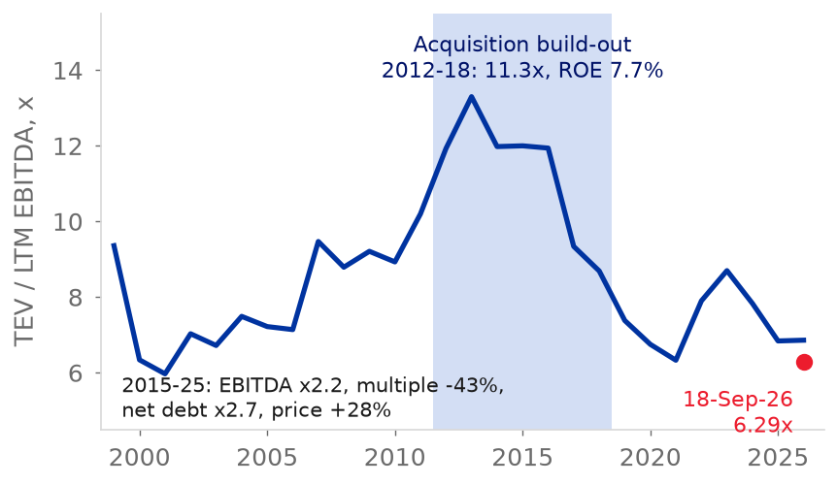
  Source: S&P Capital IQ (2026)
• What the valuation depends on. The valuation depends on the acquired businesses earning the 15.17% that the terminal value assumes, against 11.4% in FY2025, and on the peso: MXN 49.47 with a long-run depreciation of 1.0% a year and MXN 56.35 with 2.3%, against 52.92 at 1.7% (team model).  Pillar 2: Costs can rise without breaking the margin: Bimbo has already absorbed a shock almost four times larger  • A larger shock, already absorbed. Between FY2021 and FY2023, raw materials rose from 30.0% to 32.8% of net sales, an increase of 279 bp, and gross margin fell 206 bp, from 53.5% to 51.4%. Adjusted EBITDA margin never left a range of 13.4% to 14.0% in FY2021-FY2025 (Grupo Bimbo, 2024, p. 354, note 21; 2026f, pp. 13, 82, 85; team model).  • Our model asks for far less. Raw materials rise from 29.9% of net sales in FY2026E to 30.6% in FY2027E, 76 bp, about a quarter of the FY2021-FY2023 shock. The model already passes through the 25.9% increase in wheat in 2026 with a one-year lag (R-squared 0.70 against 0.48 for the same year). That increase is why gross margin falls 58 bp, from 52.7% to 52.1%, in FY2027E (Figure 17) (IMF, 2026; team model).
  Figure 15: USD/MXN annual average, 2019-2030E, and the 16 October 2026 spot
  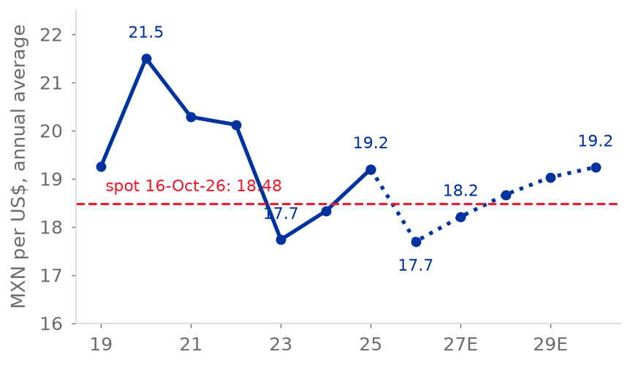
  Source: S&P Capital IQ (2026); team model
• The market expects the same. Consensus expects a FY2027 gross margin of 52.0% against our 52.1% (S&P Capital IQ, 2026; team model). A cost increase of this size is already in the price, so it is not a reason to sell.
• Hedges give visibility, not protection. The CFO said the main raw materials for 4Q26 are fully hedged and those for 1H27 almost 100%, and that Bimbo never hedges 15 months ahead. He called 2027 "a challenge" for cost of sales (Grupo Bimbo, 3Q26 earnings call). Bimbo's hedging model compares the current price with its five-year average (Grupo Bimbo, 2026f, p. 9). The first quarter exposed to new prices is therefore 3Q27, and the second-half hedges are bought during 1H27.  • Costs are not what puts our rule at SELL. Wheat at its September 2026 price of US$247 per tonne takes MXN 5.83 from the base target (team model). Our rule gives SELL at MXN 64.85 because the price is above our value, not because costs rise: our optimistic 12-month target of MXN 68.94 is MXN 2.74 short of the MXN 71.69 that HOLD would need. That is why this pillar argues against selling on costs, not for buying.
  Figure 16: Wheat price against the 2026E average held in the model
  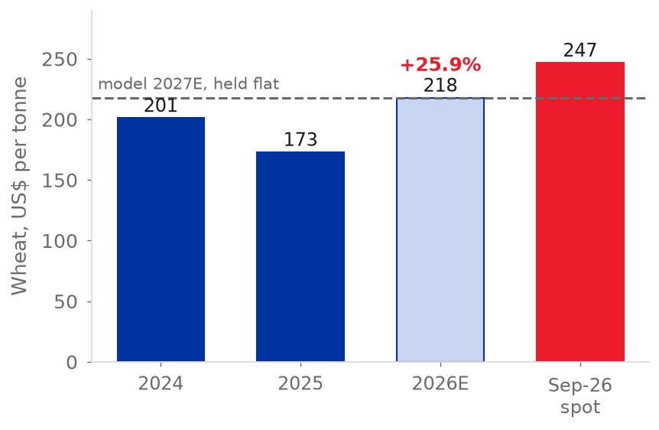
  Source: IMF (2026); team model
  Figure 17: Gross margin FY2021A-FY2030E in the model and with wheat at the September 2026 price or 35% higher from 2027
  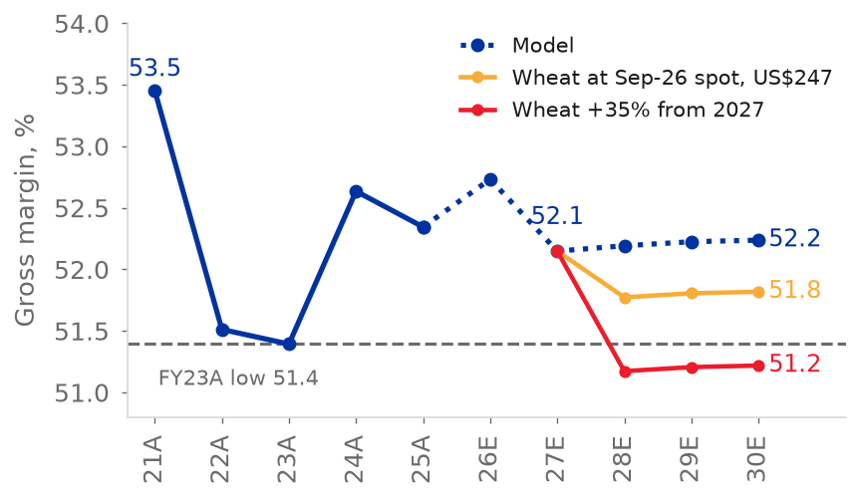
  Source: IMF (2026); team model
Pillar 3: The new management inherits a recovery, and 2027 is its first real test  • Who is new, and what was inherited. Alejandro Rodriguez Bas became CEO in November 2025, the second change in 18 months after Rafael Pamias in May 2024, and Greg Koehrsen has led Bimbo Bakeries USA since January 2026; the CFO is the same since 2017, Daniel Servitje remains Executive Chairman and no change of strategy has followed (Grupo Bimbo, 2026a, pp. 76-77, 178-180; team estimate). The recovery was already under way: North America's margin went from 5.9% in 4Q24 to 10.4% in 3Q25, before the change (Figure 18) (Grupo Bimbo, 2026h; team estimate).  • First results. A group margin of 15.7% in 3Q26, 100 bp more than a year earlier, growth of 3.6% excluding currency, leverage of 2.4x and a 2026 margin guide raised to +85 to +120 bp, on a low base and with a one-off of about 11.5 bp in FY2026E (Grupo Bimbo, 3Q26 earnings call; 2026h, pp. 2-5; team model).
  Figure 18: North America adjusted EBITDA margin by quarter
  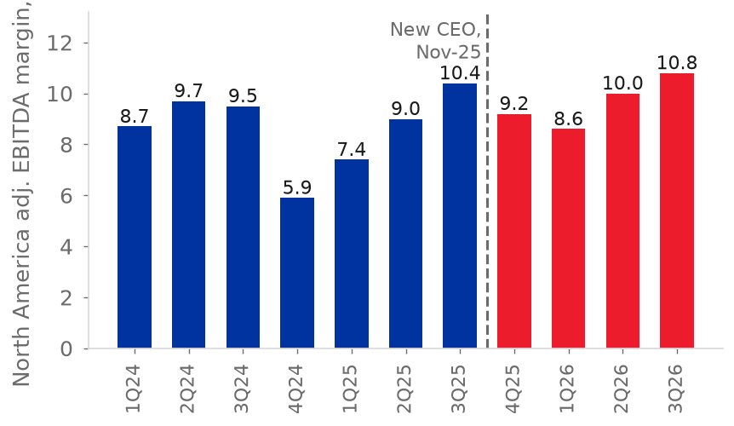
  Source: Grupo Bimbo (2026h and quarterly releases); team estimate
• What the model already includes. The margin rises 120 bp from FY2025 to FY2027E, 91 bp in FY2026E and 29 bp more in FY2027E, and EPS doubles from MXN 2.58 to 5.25 by FY2030E (team model). Those 29 bp are the test.
• The gap with the street. Of the 120 bp since FY2025, 114 come from other expenses, net, falling from 1.15% to 0.14% of sales, and integration costs, from MXN 541 million to zero; in FY2027E alone these two lines add 74 bp, which offsets the 58 bp fall in gross margin, in a year that the CFO calls "a challenge" for cost of sales and the CEO expects more Wickbold pressure (Grupo Bimbo, 3Q26 earnings call; 2026f, p. 13; team model). Bimbo's adjusted EBITDA adds back depreciation, amortisation, impairments and multi-employer pension charges, not other expenses, net, so apart from those items these two lines move the adjusted margin (Grupo Bimbo, 2026h, note 2).
• The record, and what it is worth. The model's FY2027E margin is 55 bp above the consensus of 14.6%, its EBITDA 4.2% above, about MXN 7.7 of the target, and its EPS of MXN 4.01 about 20% above the consensus of MXN 3.35; the consensus is of 20 September, before the call (Figure 11).
Rating and what the valuation depends on  The 12-month target moves the valuation date of the DCF to 16 October 2027 and nets the buybacks of 4Q26 and FY2027E, at fair value, from the share count of 30 September 2026 (team model). Expected total returns at the price of MXN 64.85 are -21.2% with a WACC 0.5 pp higher and +8.0% with 0.5 pp lower, a range that does not reach the 12.26% cost of equity, so our rule gives SELL; we rate a neutral HOLD, and our lines are BUY below MXN 45.50 and SELL above MXN 62.41 (team model). The valuation depends above all on the return on new capital, 15.17% in the terminal value against 11.4% in FY2025, and on the cost of capital (team model). The Investment Risks section sets the public signals, by pillar, that would move the rating.
  Figure 19: Management targets since 2011: met, mixed and missed, by the period in which they were set
  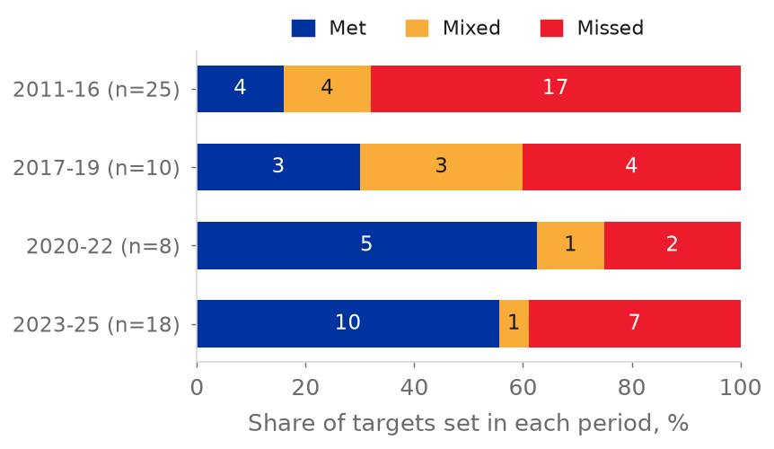
  Source: team estimate from earnings calls

Valuation
Method
We value Bimbo with a discounted cash flow of free cash flow to the firm (FCFF), the cash left after tax, capex and new leases, for FY2027E-FY2030E, plus a terminal value. We use no exit multiple; peers are a cross-check (team model). Cash flows arrive mid-year and are discounted at the WACC; the equity value is brought to the valuation date with the cost of equity. The base DCF values the shares on 16 October 2026 at MXN 52.92; the reference price is the close of 27 October, 11 days later, a gap of about 0.4% at the cost of equity (team model). The 12-month target moves the valuation date to 16 October 2027, uses the flows of FY2028E-FY2030E and the same WACC, growth and return on new capital, uses the balance sheet of FY2027E and nets the 4Q26 and FY2027E buybacks, at fair value, from the share count (team model).
Cost of capital  We value in pesos, so the risk-free rate is the M-Bono yield of 9.26% less Mexico's 1.75% default spread, 7.51%, blended with the dollar rate expressed in pesos by the share of dollar-linked flows (Damodaran, 2026; S&P Capital IQ, 2026). The country risk premium is weighted by where Bimbo earns its EBITDA, giving 2.05%, and is multiplied by beta (Damodaran, 2026; team model). The unlevered beta of 0.53 is Damodaran's global food-processing figure; relevered at a market debt-to-equity ratio of 74.3% with leases it is 0.81 (Damodaran, 2026). The result is a cost of equity of 12.26% and a WACC of 9.62% (team model). We hold that capital structure because the CFO places the comfortable range at 2.0x to 2.5x, where Bimbo already stands, so the WACC weights stay at today's market values; at a debt-to-equity ratio of 50% the WACC would be about 9.82% and the target about MXN 3.7 lower (Grupo Bimbo, 3Q26 earnings call; team model).  Table 1: Cost of capital  Source: Damodaran (2026); S&P Capital IQ (2026); Grupo Bimbo (2026d, p. 6); team model.
  Component | Value | Basis
  Peso default-free rate | 7.51% | M-Bono 9.26% less 1.75% default spread
  US 10-year Treasury | 5.09% | FRED, 16-Oct-2026
  Blended risk-free rate | 7.23% | 55% peso, 45% dollar-linked (US rate converted to pesos at 1.7% depreciation)
  Mature-market equity risk premium | 4.20% | Damodaran implied
  Unlevered / relevered beta | 0.53 / 0.81 | Global food processing; D/E 74.3% incl. leases
  Country risk premium x beta | 1.65% | 2.05% EBITDA-weighted CRP
  Cost of equity (ke) | 12.26% | Team model
  Cost of debt, pre-tax | 8.66% | 58% non-peso debt at UST + 100 bp, in pesos; 42% peso debt at 9.71%
  Debt weight, D/(D+E) | 42.6% | Market value, leases included
  WACC | 9.62% | Tax rate 30%
  Figure 20: EV / EBITDA against peers, last twelve months, 16-Oct-2026
  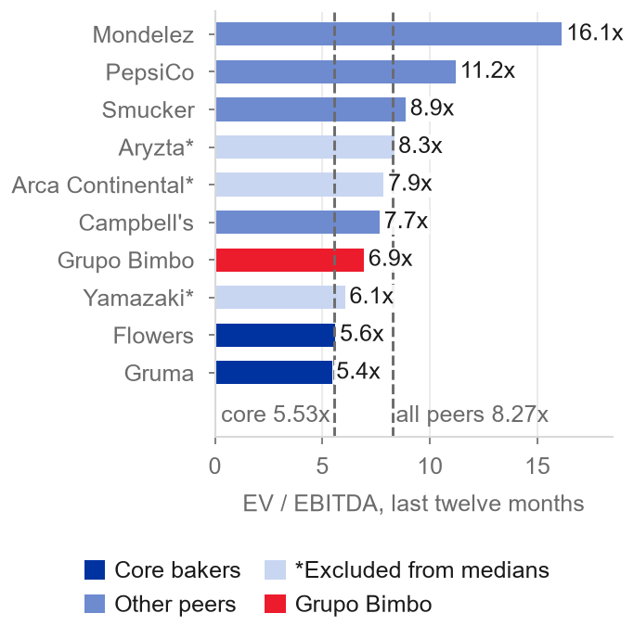
  Source: S&P Capital IQ (2026); team model
Free cash flow and terminal value
FCFF grows from MXN 27.1 billion in FY2027E to MXN 30.3 billion in FY2030E as EBIT rises 5.0% a year and capex stays at 4.5% of sales, in line with the CFO's guidance of a 2027 level somewhat above 2026 and close to the 4.6% of sales of FY2014-FY2020 (Grupo Bimbo, 3Q26 earnings call; team model). The terminal value uses Gordon growth with reinvestment: FCFF in FY2031E equals NOPAT times one minus g over the return on new capital (RONIC). Growth of 4.40% in pesos is real growth of 0.68% plus Mexico's 3.7% long-run inflation (Banxico, 2026; team model). RONIC of 15.17% is the FY2030E return on tangible operating capital; it sits between FY2024 (13.3%) and FY2023 (16.5%) and above the 11.4% of FY2025, which is why the acquisitions of our first pillar matter for value (team model). The terminal value is stricter than the forecast years: it reinvests 29% of NOPAT at 15.17%, while from FY2027E to FY2030E NOPAT grows MXN 4,484 million on net reinvestment of 5-8% of NOPAT, an implied return of about 60% (team model). The terminal value implies 6.2x FY2030E adjusted EBITDA, just below the 6.29x of 18 September 2026, the 8th percentile since 2000 (S&P Capital IQ, 2026).
From enterprise value to the 12-month target  Table 2: Bridge from enterprise value to the target price  Source: team model (sheet Valuacion_12m).
  MXN million, 31-Dec-2027 | Value
  PV of FCFF FY2028E-FY2030E | 76,384
  PV of terminal value | 373,897
  Enterprise value | 450,281
  Gross debt | (151,250)
  Lease liabilities | (34,790)
  Cash | 22,372
  Non-controlling interests (income capitalised at ke less g) | (24,276)
  Other debt-like items | (15,972)
  Associates | 6,533
  Equity value, 31-Dec-2027 | 252,898
  Equity value at 16-Oct-2027 (ke factor 0.976) | 246,879
  Shares, net of 4Q26-FY2027E buybacks (millions) | 4,217.1
  12-month target price (MXN) | 58.54
  Figure 21: Free cash flow to the firm, FY2027E-FY2030E
  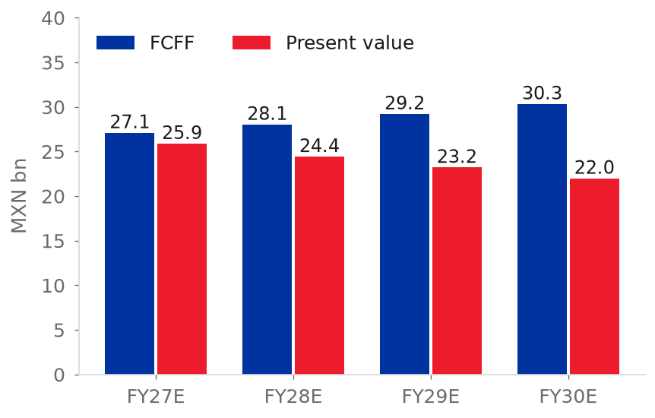
  Source: team model
The terminal value is 83% of enterprise value, 78% in the base DCF (team model). Non-controlling interests are valued by capitalising their forecast income at the cost of equity less the 4.4% growth of the enterprise value, and other debt-like items and associates are held at their 30 September 2026 balances (team model). The share count nets the 4Q26 and FY2027E buybacks (59.7 million shares at fair value), which the CFO says will continue (MXN 1.2 billion in 3Q26); this adds MXN 0.92 per share to the target (Grupo Bimbo, 3Q26 earnings call; team model). Three inputs move the value most (appendix A5): the cost of capital (MXN 49.96 to 68.94 for +/-0.5 pp), the margin (MXN 7.17 per 50 bp) and the terminal return on capital (MXN 11.69 if it stays at the FY2025 level) (team model). A DCF in which new capital earns only the WACC gives MXN 28.93. Moving to the return on tangible capital adds MXN 12.83, the cost-of-capital inputs MXN 10.67 and terminal growth MXN 0.48. We disclose these steps because MXN 23.5 of the MXN 24.0 rest on two judgements that we must defend (team model).
Relative valuation
We compare Bimbo with nine listed companies on one basis: last-twelve-month data to June 2026, enterprise value and EBITDA on an IFRS 16-equivalent basis, and peer prices of 16 October 2026, the latest in our data set (S&P Capital IQ, 2026; team model). Four core bakers set the floor and five consumer-staples companies the ceiling (table below). Yamazaki, Aryzta and Arca Continental are left out of the medians because their lease or minority-interest data are not comparable (marked *), so the core median rests on two companies, Flowers Foods and Gruma. J.M. Smucker's P/E of 58.6x is also left out of the P/E medians as an outlier; with it the eligible median would be 19.6x, not 16.1x, and Bimbo's 18.5x would sit below it.
Table 3: Multiples and margins against peers  Source: S&P Capital IQ (2026), prices of 16 October 2026; team model. LTM = last twelve months; NTM = next twelve months.
  Company | EV/EBITDA LTM | EV/EBITDA NTM | P/E LTM | Net debt / EBITDA | EBITDA margin
  Grupo Bimbo | 6.9x | 6.6x | 18.5x | 2.81x | 14.5%
  Flowers Foods | 5.6x | 6.1x | 23.4x | 3.37x | 11.1%
  Gruma | 5.4x | 5.6x | 9.4x | 1.47x | 17.1%
  Yamazaki Baking* | 6.1x | 5.8x | 17.7x | -0.67x | 8.2%
  Aryzta* | 8.3x | 5.8x | 10.2x | 3.50x | 9.8%
  J.M. Smucker | 8.9x | 9.2x | 58.6x | 2.98x | 25.2%
  Campbell's | 7.7x | 8.4x | 15.1x | 4.25x | 17.8%
  Mondelez | 16.1x | 13.8x | 23.1x | 3.25x | 15.9%
  Arca Continental* | 7.9x | 7.1x | 18.7x | 0.74x | 19.4%
  PepsiCo | 11.2x | 11.0x | 16.1x | 2.26x | 20.4%
  Core median | 5.5x | 5.9x | 16.4x | 2.42x | 14.1%
  Eligible median | 8.3x | 8.8x | 16.1x | 3.12x | 17.4%
  Figure 22: Return on tangible operating capital against the terminal RONIC
  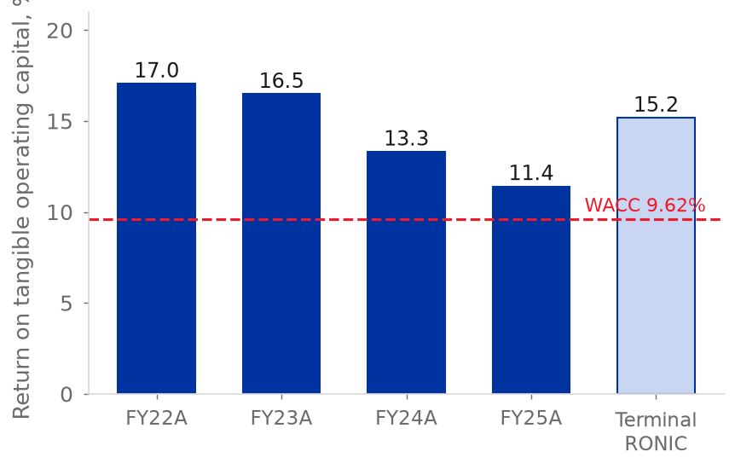
  Source: team model
At 6.9x EV/EBITDA Bimbo trades 26% above the core bakers (5.5x) and 16% below all eligible peers (8.3x); on P/E it trades at 18.5x against 16.4x for the core bakers and 16.1x for the eligible peers without Smucker (S&P Capital IQ, 2026; team model). Its leverage, 2.8x net debt/EBITDA, is above the core median of 2.4x, and its EBITDA margin of 14.5% is in line with it (S&P Capital IQ, 2026; team model). Flowers Foods, the mirror of Bimbo's North America, is the weakest comparable, with volume down 5.8% in 2Q26 (Investing.com, 2026).
Applying the two medians to Bimbo's last-twelve-month adjusted EBITDA of MXN 61,786 million and the model's claims at December 2026 gives MXN 31.2 per share at 5.5x and MXN 69.8 at 8.3x (team model). The DCF value of MXN 52.92 lies in the upper half of that range, equivalent to about 6.9x FY2026E EBITDA, while our terminal value implies 6.2x FY2030E EBITDA (team model). Our view: a premium to the core bakers is justified by Mexico, where the route network earns 20.4%, and not by North America, which earns 9.0% (Grupo Bimbo, 2026f, p. 85).
Football field and rating  The 12-month target of MXN 58.54 sits above the base DCF (MXN 52.92) and below the analysts' median target of MXN 69.50, and inside the peer range of MXN 31.2 to 69.8 (team model; S&P Capital IQ, 2026). The rating rule is the team's: BUY if even the pessimistic expected return (WACC +0.5 pp) beats the cost of equity, SELL if even the optimistic one (WACC -0.5 pp) falls short, and HOLD otherwise. At the price of MXN 64.85 the pessimistic return is -21.2% and the optimistic +8.0%, against a cost of equity of 12.26%, so the rule gives SELL (team model). Moving the cost of equity with the WACC does not change this: at a cost of equity of 11.76%, the optimistic return falls to +7.5%, still below 11.76% (team model). We rate HOLD, a neutral stance, as a judgement, not as a result of the rule, for two reasons. First, the rule turns on a margin gap smaller than the company's own uncertainty: at an FY2027E adjusted EBITDA margin of 15.3%, 18 bp above our 15.12%, the target rises to MXN 61.16 and the SELL line to MXN 64.96, above the price, so the rule gives HOLD; those 18 bp are about half the 35 bp width of management's 2026 margin guide (Grupo Bimbo, 3Q26 earnings call; team model). Second, the decisive test is dated: the 4Q26 call in late February 2027 gives the first formal guidance for 2027; guidance implying 15.3% or more puts the price inside the band, while guidance that only matches our forecast leaves the rule at SELL, and we move to SELL. The rule gives BUY only with guidance of about 16.7%, 160 bp above our forecast (team model, workbook run like the cases below). We do not rate higher because our base case already assumes a margin above any year in the company's history. The rating leans on the forecast margin: FY2027E is 55 bp above the consensus of 14.6%, which predates the 3Q26 guidance raise, and our 15.12% is the upper end of the 2026 guide of +85 to +120 bp on 13.93% (Grupo Bimbo, 3Q26 earnings call; S&P Capital IQ, 2026). We keep the model and show the cost of being wrong in the table below. If other expenses, net, stayed at the 9M26 level of 0.76% of sales and integration costs at MXN 541 million, the target would lose MXN 10.6 (team model).
  Figure 23: Build-up of the base DCF, MXN per share
  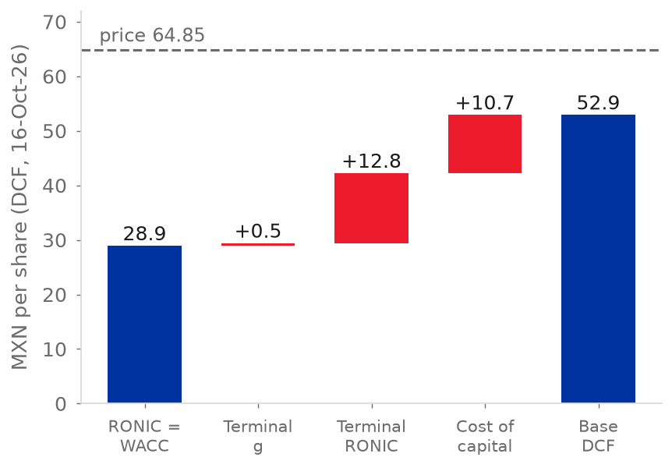
  Source: Team model (sheets Valuacion and WACC)
Each 100 bp of margin is worth about MXN 14 of target (14.33 when the change starts in FY2028E, about 14.8 when it starts in FY2027E, as in the table), so the rating depends on the margin. The table sets four cases, with the margin held level from FY2027E.
Table 4: The rating depends on the margin
Case | Margin | 12-month target | HOLD band | Rule
Model | 15.12% | MXN 58.54 (-9.7%) | 45.50-62.41 | SELL
Consensus | 14.6% | MXN 50.84 (-21.6%) | 39.18-54.87 | SELL
Top of FY2021-FY2025 range | 14.0% | MXN 41.99 (-35.3%) | 31.93-46.23 | SELL
Guidance of 15.3% | 15.30% | MXN 61.16 (-5.7%) | 47.64-64.96 | HOLD

Source: team model (workbook run with the adjusted EBITDA margin shifted and held level from FY2027E); S&P Capital IQ (2026) for the consensus. Percentages are against MXN 64.85; the rule is applied at that price.

Financial Analysis
Table 5: Projected income statement and key ratios
MXN million | FY2025A | FY2026E | FY2027E | FY2028E | FY2029E | FY2030E
Net sales | 426,952 | 426,670 | 446,942 | 465,382 | 483,639 | 498,865
Growth | 4.6% | -0.1% | 4.8% | 4.1% | 3.9% | 3.1%
Gross margin | 52.3% | 52.7% | 52.1% | 52.2% | 52.2% | 52.2%
Adj. EBITDA | 59,456 | 63,299 | 67,589 | 70,377 | 73,138 | 75,441
Adj. EBITDA margin | 13.93% | 14.84% | 15.12% | 15.12% | 15.12% | 15.12%
Other expenses / sales | 1.15% | 0.76% | 0.14% | 0.14% | 0.14% | 0.14%
EPS (MXN) | 2.58 | 3.19 | 4.01 | 4.65 | 4.98 | 5.25
Capex / sales | 5.3% | 4.4% | 4.5% | 4.5% | 4.5% | 4.5%
Net debt / EBITDA | 3.03x | 2.71x | 2.42x | 2.18x | 1.95x | 1.74x
Source: team model (sheets IS, BS, CF); FY2025A from Grupo Bimbo (2026f).
Income statement  Net sales grew from MXN 338,792 million in FY2021 to MXN 426,952 million in FY2025, a 6.0% CAGR that FY2022 (+17.7%) inflates; from FY2022 to FY2025 the CAGR is only 2.3%, as North America shrank in pesos and the acquisitions of our first pillar filled part of the gap (Grupo Bimbo, 2026f; team model). The adjusted EBITDA margin stayed in a narrow band of 13.4% to 14.0%, ending at 13.9% in FY2025 (Grupo Bimbo, 2026f, p. 85; team model). Gross margin slipped from 53.5% to 52.3% with a trough of 51.4% in FY2023, because raw materials (30.4% of sales) and labour grew faster than prices; in FY2025 salaries rose 7.5% and depreciation 13.3% against sales of 4.6% (Grupo Bimbo, 2026f, p. 82; team model). Controlling net income was MXN 11,133 million in FY2025, an EPS of MXN 2.58 (Grupo Bimbo, 2026f; team model). Growth in pesos hides its sources: in 9M26 translation cut 6.6 points from growth excluding currency, while in the forecast it adds 1.46 of the 4.75 points of FY2027E, and between FY2023 and FY2025 raw materials fell 2.39 points of sales but salaries, depreciation and other lines took back 1.44 (Figure 13, Figure 29) (Grupo Bimbo, 2026f, p. 82; 2026h; team model).
  Figure 24: Gross margin and adjusted EBITDA margin, FY2021A-FY2030E
  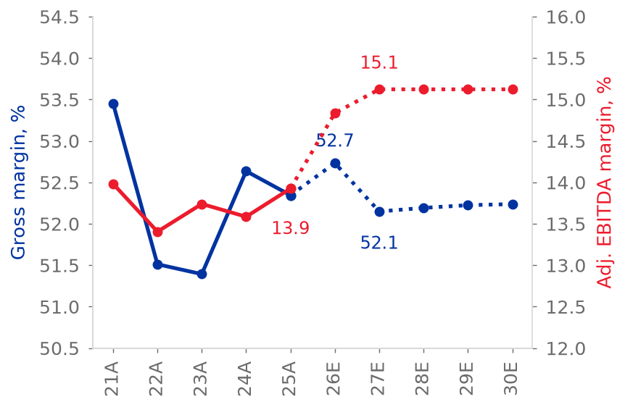
  Source: Grupo Bimbo (2026f); team model
Table 6: Historical summary  Source: Grupo Bimbo (2026f, pp. 85-86); team model. FY2022 includes a non-cash pension gain and the gain on the Ricolino disposal.
  MXN million | FY2021A | FY2022A | FY2023A | FY2024A | FY2025A
  Net sales | 338,792 | 398,706 | 399,879 | 408,335 | 426,952
  Growth | n.a. | 17.7% | 0.3% | 2.1% | 4.6%
  Gross margin | 53.5% | 51.5% | 51.4% | 52.6% | 52.3%
  Adj. EBITDA margin | 13.98% | 13.40% | 13.74% | 13.59% | 13.93%
  EBIT / interest expense | 4.2x | 6.7x | 3.5x | 2.5x | 2.4x
  Net income, controlling | 15,916 | 46,910 | 15,477 | 12,544 | 11,133
  Cash from operations | 45,776 | 38,851 | 31,411 | 39,907 | 47,753
  Capex (PP&E) | 20,671 | 28,669 | 34,754 | 29,402 | 22,530
  Net debt incl. leases / EBITDA | 2.43x | 1.89x | 2.37x | 3.22x | 3.03x
  Figure 25: Share of sales and of adjusted EBITDA, FY2025
  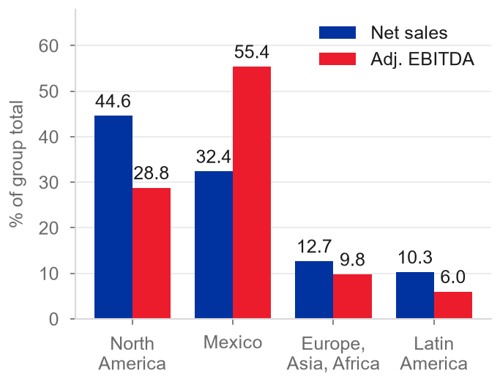
  Source: Grupo Bimbo (2026b, p. 4; 2026e, p. 17)
Balance sheet and leverage  Total assets were MXN 409,805 million at FY2025, with MXN 135,515 million of goodwill and intangibles from past acquisitions (Grupo Bimbo, 2026f, p. 12). Net debt including leases was MXN 179,918 million, 3.03x adjusted EBITDA, against 1.89x in FY2022 (Grupo Bimbo, 2026a, pp. 75-78; team model). On the company's own definition, without IFRS 16, leverage fell from 2.9x in December 2024 to 2.5x in June 2026, and the CFO put it at 2.4x in 3Q26, the top of the 2.0x to 2.5x range he calls comfortable (Grupo Bimbo, 2Q26 investor presentation; 3Q26 earnings call). Interest expense rose from MXN 10,006 million in FY2023 to MXN 14,464 million in FY2025 and EBIT cover fell from 4.2x in FY2021 to 2.4x (Grupo Bimbo, 2026f; team model). Debt is long and diversified: average maturity 9.5 years, average cost 6.5%, 96% long term, and 42% dollars and 42% pesos after swaps; liquidity includes an undrawn US$2,350 million revolver (Grupo Bimbo, 2026d, p. 6; 2026a, p. 82).  Cash flow and capital intensity  Cash from operations rose 20% to a record MXN 47,753 million in FY2025 while capex fell 23% to MXN 22,530 million (Grupo Bimbo, 2026f, p. 86). After lease payments and interest paid, free cash flow went from MXN -17,057 million in FY2023 and MXN -4,943 million in FY2024 to MXN 5,630 million in FY2025, 1.3% of sales; it covered the dividend of MXN 4,451 million but not the MXN 11,294 million of acquisitions (Grupo Bimbo, 2026f, p. 16; team model). The CFO reported about MXN 17 billion of free cash flow in the first nine months of 2026 after about MXN 12 billion of capex, helped by working capital; the release defines it before lease payments, so it is not comparable with our FY2026E of MXN 16.3 billion after leases and interest, which assumes no working-capital gain (Grupo Bimbo, 3Q26 earnings call; team model).
  Figure 26: Net sales growth by region, 9M26, reported and excluding acquisitions
  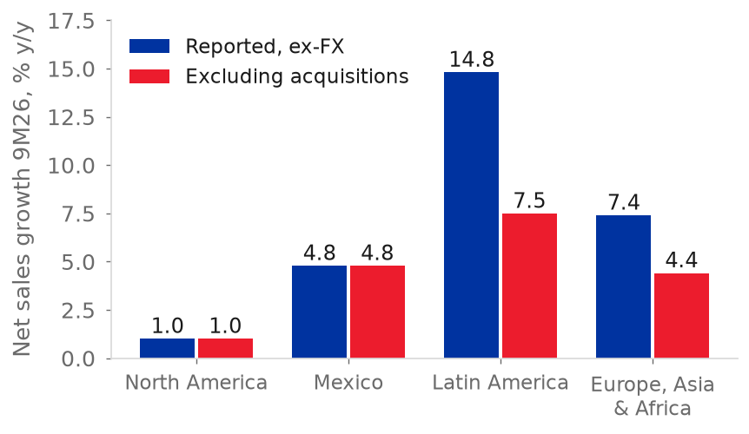
  Source: Grupo Bimbo (2026c, 2026d, 2026h); team model. North America includes Stone House
  Figure 27: Net debt including leases over adjusted EBITDA
  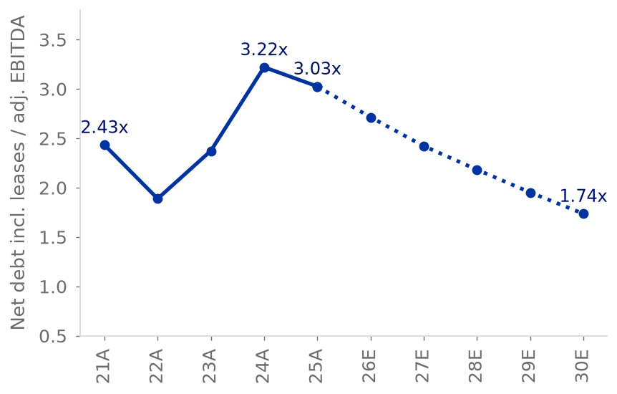
  Source: Grupo Bimbo (2026f); team model
Evaluation. Bimbo grew slowly with a stable margin and rising leverage; margins and cash have now turned up, but part of the growth was bought and leverage is only back to the top of its range. We view the recovery as real but early: one year of positive free cash flow after interest does not offset two of negative cash, and interest cover is still thin (team model).
Forecast and drivers  The FY2026E-FY2030E forecast has five drivers; leases and working-capital days stay at FY2025 levels (team model).  • Sales. FY2026E is nine months of actuals plus 4Q26 growing 5% excluding currency, which applies the CFO's mid-single-digit full-year guide to the quarter. From FY2027E each region grows at a team ratio times nominal GDP in local currency, translated to pesos with the Capital IQ USD/MXN path of 18.21 in 2027 to 19.24 in 2030. The ratios, those of 9M26, are 0.17 for North America, 0.77 for Mexico, 0.67 for Latin America and 0.56 for Europe-Asia-Africa; growth excludes acquisitions (Grupo Bimbo, 3Q26 earnings call; S&P Capital IQ, 2026; team model).  • Margin. FY2026E uses the guidance midpoint of +102.5 bp less the 11.5 bp one-off gain on the La Moderna stake, +91 bp in all (Grupo Bimbo, 2026i, p. 26; team model). From FY2027E every cost keeps its prior-year ratio to sales, except raw materials, which follow wheat with a one-year lag (elasticity 0.109); non-recurring items are zero (team model).  • Wheat. Held at the 2026 level of US$217.9 per tonne, +25.9% on 2025 (IMF, 2026; team model).  • Capex. US$1.05 billion in FY2026E and US$1.1 billion from FY2027E, 4.5% of sales, within the CFO's guidance (Grupo Bimbo, 2026i, p. 26; 3Q26 earnings call).  • Tax and financing. Effective tax rate of 37.0% in FY2026E-FY2027E and 32.7% afterwards; maturities are refinanced, buybacks run at MXN 2.7 billion a year and the 2027 dividend is MXN 1.12 per share (Grupo Bimbo, 2026h; team model).
  Figure 28: Growth of cost-of-sales lines against net sales, FY2025
  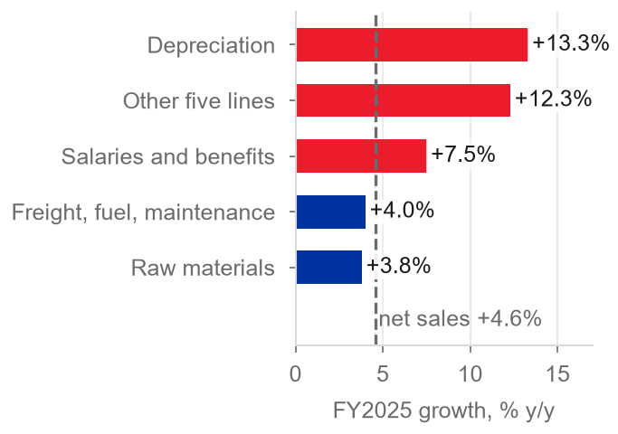
  Source: Grupo Bimbo (2026f, p. 82); team model
  Figure 29: Change in cost of sales by nature as a share of sales, FY2023 to FY2025
  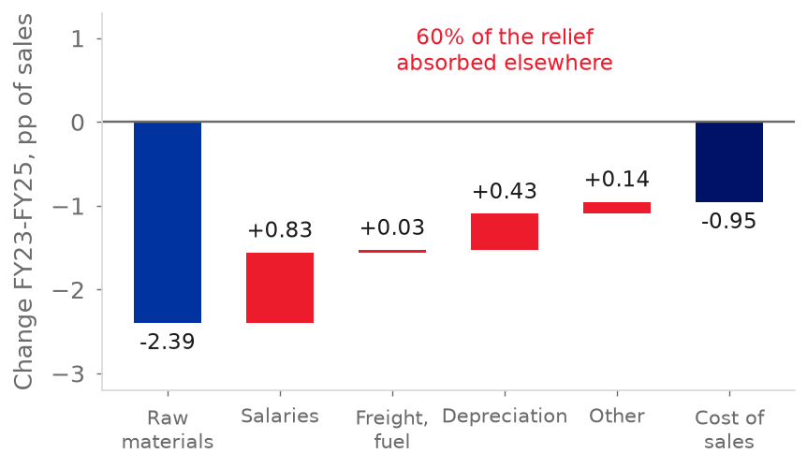
  Source: Grupo Bimbo (2026f, p. 82); team model
Net sales fall 0.1% in FY2026E because of peso translation, then grow 4.8%, 4.1%, 3.9% and 3.1%, a 4.0% CAGR for FY2026E-FY2030E; Latin America and Europe-Asia-Africa grow fastest in FY2027E, 5.6% each, Mexico 5.2% and North America 3.8% in pesos but 0.9% in dollars (team model). Three features of the forecast are tied to our pillars: wheat is held flat while the CFO calls 2027 a challenge (pillar 2); the model projects no acquisitions and lets cash build up to MXN 55 billion, which flatters leverage (pillar 1); and other expenses and integration costs fall to almost zero, so the margin rises to 15.1% and stays there by construction (pillar 3) (team model). The gross margin falls 58 bp in FY2027E and stays at 52.1% to 52.2%; wheat at the September 2026 price or 35% higher from 2027 would take FY2030E to 51.8% or 51.2% (Figure 17), and our FY2027E EBITDA margin is 55 bp above the consensus of 14.6%, which dates from before the 3Q26 call (Figure 11) (IMF, 2026; S&P Capital IQ, 2026; team model).
  Figure 30: Cash flow from operations and capex, FY2021-FY2025
  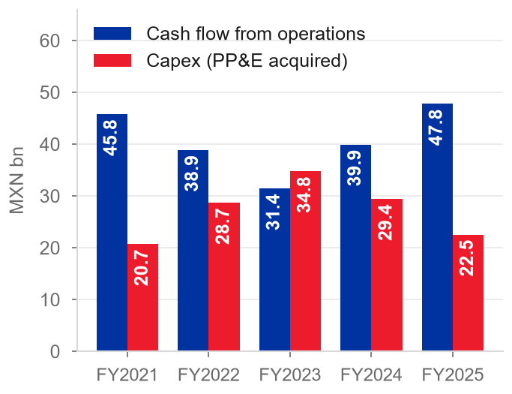
  Source: Grupo Bimbo (2026f, p. 86)

Risks
We score seven risks for probability (P) and impact (I) from 1 to 5; impact is the change in the 12-month target of MXN 58.54 under the scenario described (1 below 2%, 2 for 2-5%, 3 for 5-10%, 4 for 10-20%, 5 above 20%) (team model). Each one ties to a pillar.
R1. Input costs: wheat cost persists (P3, I4; pillar 2)  The 2026 average wheat price is 25.9% above 2025 (IMF, 2026; team model). CBOT December 2027 futures, about US$266 a tonne, were 5.4% above December 2026 on 8 October (IndexBox, 2026). Hedges cover 4Q26 and almost all of 1H27; after that, the cost depends on the price of new hedges, and the CFO said that Bimbo might become a little more cautious in the hedges it takes (Grupo Bimbo, 3Q26 earnings call). Our model holds wheat flat at US$218 a tonne, while December 2027 futures are 22% higher. We size two cases by changing the 2027 wheat price in the model and recomputing the whole valuation. Raw materials as a share of sales respond to the prior-year wheat price with an elasticity of 0.109 (a fit on eight annual observations, FY2018-FY2025, R-squared 0.70), so the September 2026 price of US$247 adds 0.42 pp to that share from FY2028E and wheat 35% above the US$218 we hold, at US$294, adds 1.02 pp. Each rise lowers EBIT and NOPAT and, because the terminal return on new capital is the FY2030E return on tangible capital, it lowers that return too, from 15.17% to 14.54% at US$247 and to 13.63% at US$294 (team model). The target loses MXN 5.83 (10%) at US$247 and MXN 14.17 (24%) at US$294. The second case is a stress case, not a forecast: US$294 is above the December 2027 futures. We score the risk on the futures, at US$266, where the target would lose MXN 9.36 (16%): P3, I4; the stress case is the tail. Sugar, oils and packaging sit in the raw-material ratio, which moves only with wheat (team model).
  Figure 31: Risk matrix
  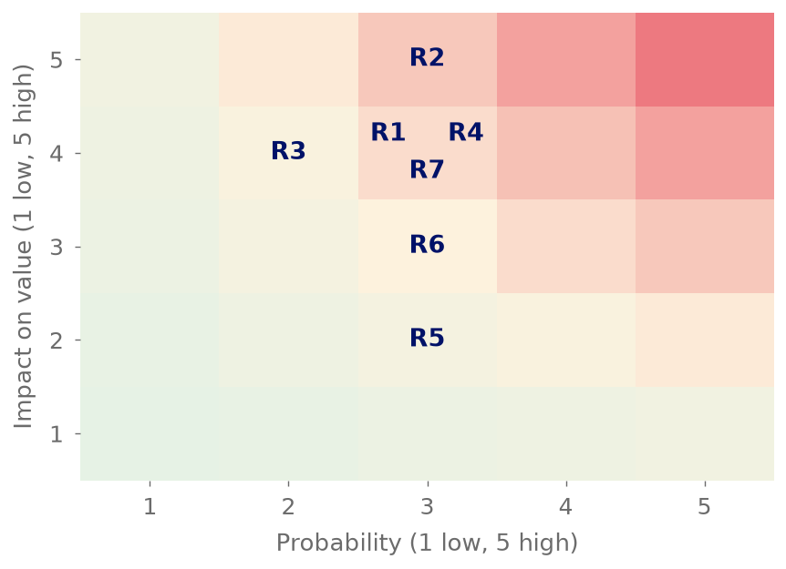
  Source: team estimate (P, I); team model (value effects)
R2. The North America turnaround stalls (P3, I5; pillar 3)
The recovery is margin-led: net sales excluding currency grew 0.7%, 1.3% and 1.0% in 1Q26, 2Q26 and 3Q26 after nine negative quarters, and the CEO said that the transformation is not complete until North America returns to profitable volume growth (Grupo Bimbo, 2026c, p. 3; 2026d, p. 3; 3Q26 earnings call). If the margin fell back to FY2024's 8.4% from 10.8% in 3Q26, the group margin would lose about 94 bp and the target about MXN 13.4, taking North America as 39% of regional sales (Grupo Bimbo, 2026f, p. 85; team model).
R3. The terminal return on capital is below our base (P2, I4; pillar 1)
The base assumes new capital earns 15.17% in the terminal period. Tangible-capital ROIC fell from 17.0% in FY2022 to 11.4% in FY2025 as the acquisitions entered the capital base (team model). At the FY2025 level the target falls to MXN 46.85 (-20.0%); at the FY2022-25 average of 14.6% only MXN 1.49 is lost (team model).
R4. Mexican labour and health policy (P3, I4; pillar 3)
Mexico is 35% of regional sales and 54% of EBITDA. A presidential initiative of December 2025 would cut the working week by two hours a year from 1 January 2027 to 40 hours, NOM-051 reaches its third phase in 2028 and the IEPS excise tax could rise above 8% (Grupo Bimbo, 2026a, pp. 23-31, 48). A 100 to 150 bp fall in Mexico's margin costs the target MXN 5.5 to 8.1, taking Mexico as 38% of regional sales; the model makes no wage adjustment for it (team model).
R5. Capital allocation: capex or a large acquisition (P3, I2; pillar 1)
The CFO said that Bimbo has a strong pipeline of projects but a disciplined approach, and the CEO that a tuck-in or a strategic deal would use the leverage space if the fit is right (Grupo Bimbo, 3Q26 earnings call). The model assumes no deals and no use of the cash that builds up to MXN 55 billion, and capex 50 bp of sales higher costs only MXN 1.46 (team model). Net debt including leases is 3.0x EBITDA at FY2025 (2.4x in 3Q26 on the company's measure, without IFRS 16) and S&P has a negative outlook on the BBB+ rating (Grupo Bimbo, 2026f; LSEG, 2026).
R6. Terminal growth and the peso (P3, I3; pillar 1)
North America grows 3.8% in pesos in FY2027E but only 0.9% in dollars; the rest is peso depreciation from the Capital IQ path, from 18.21 to 19.24 pesos per dollar by 2030 (team model; S&P Capital IQ, 2026). Terminal growth 0.5 pp lower costs MXN 4.30 (team model).
R7. Other expenses and integration costs do not fall (P3, I4; pillar 3)  Of the 120 bp of margin we model to FY2027E, 114 depend on other expenses, net, falling from 1.15% of sales in FY2025 to 0.14%, and on integration costs falling from MXN 541 million to zero. We treat restructuring as non-recurring, as the model does with one-off items, although Bimbo has reported it every year since FY2019: MXN 3,908 million in FY2025, 0.92% of sales (Grupo Bimbo, 2026f, p. 83). In 9M26 other expenses were 0.76% of sales and the CEO expects more Wickbold pressure (Grupo Bimbo, 3Q26 earnings call; 2026h). If they stayed at the 9M26 level and integration costs at MXN 541 million, the target would lose MXN 10.6 (18%) (team model).  Events that could change the rating  The rating rule sets the price lines: BUY below MXN 45.50 and SELL above MXN 62.41, and both lines move with our value (team model). At MXN 64.85 the price is above the SELL line, so our HOLD is tested by the 4Q26 call. Each signal below is published, dated and tied to one assumption of our model.
  Figure 32: Sensitivity of the 12-month target
  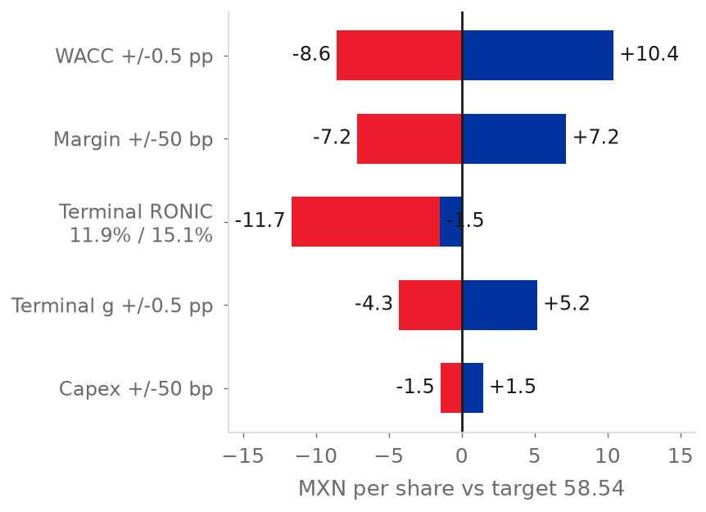
  Source: team model
Two signals arrive with the 4Q26 results at the end of February 2027: the first quarter of growth without Wickbold as acquired growth, and management's formal 2027 margin guidance. The 1Q27 report then shows whether other expenses and integration costs fall. The cost pillar has no BUY signal: it argues against selling on costs, and cheaper wheat would not prove the growth or the margin.
Eight smaller risks (USMCA and tariffs, GLP-1 drugs, cyber attacks) have an impact of 2 or less (Grupo Bimbo, 2026a, pp. 22-37; team estimate).

Table 7: Signals that would move the rating, by pillar
Pillar | Direction | Signal | Threshold | When we know | What it breaks
1. Growth | Toward BUY | Net sales growth ex-FX, net of the inorganic contribution Bimbo reports, once Wickbold leaves the inorganic base in 4Q26 | Above 4% in two consecutive quarters, against 3.3% organic growth in our FY2027E | 4Q26 results (late Feb 2027) and 1Q27 results (late Apr 2027) | Growth stops being about 3%; the pillar's ceiling lifts
1. Growth | Catalyst | Latin America net sales growth ex-FX in 4Q26, the first quarter without Wickbold as acquired growth | At or below 9.1% confirms that the region's growth was bought; at or above 14.1% refutes it, and we adjust Latin America without dropping the HOLD | 4Q26 results (late Feb 2027) | Tests the bought-growth claim where it is largest
1. Growth | Toward SELL | Net debt/EBITDA after a debt-funded acquisition while the Wickbold integration still lags | 3.0x or more (company definition), the level the CFO cited; 2.4x in 3Q26, against a comfort range of 2.0x to 2.5x | Any deal announcement; quarterly | Growth bought again with debt before the last deal pays back
2. Costs | Toward SELL | Global wheat price (IMF), January-June 2027 average, the window in which Bimbo hedges 2H27 | Above US$294 per tonne, the level at which FY2030E gross margin falls to 51.2%, below the FY2021-FY2025 range of 51.4%-53.5%; confirmed if 3Q27 gross margin is below 51.4% | Monthly; 3Q27 results (late Oct 2027) | The floor of the HOLD: costs stop being absorbable
2. Costs | Toward BUY | None, by design | - | - | The pillar is the floor; cheaper wheat lifts neither growth nor margin
3. Margin | Tests the HOLD | Formal 2027 adjusted EBITDA margin guidance, given on the 4Q26 call | Low end implying about 15.3% or more (+46 bp on FY2026E), against 15.12% in our FY2027E | 4Q26 call (late Feb 2027) | At 15.3% or more the price is inside the band; at 15.1% we rate SELL
3. Margin | Toward BUY | Same 2027 margin guidance | Low end implying about 16.7% or more, 160 bp above our FY2027E | 4Q26 call (late Feb 2027) | Price below the BUY line; far from our base
3. Margin | Toward SELL | Other expenses, net, and integration expenses in the 1Q27 report | Other expenses at or above 0.76% of net sales, the 9M26 level, against 0.14% in our FY2027E; or integration expenses still reported, against zero in our model | 1Q27 results (late Apr 2027) | 114 of the 120 bp of margin improvement to FY2027E depend on these two lines falling
Source: team model; Grupo Bimbo (3Q26 earnings call; 2026d, p. 3; 2026h); IMF (2026). Thresholds are team decisions anchored in the model and in management statements.
ESG
Bimbo's 2025 double-materiality analysis found 11 material topics (Grupo Bimbo, 2026e, pp. 146-147). The two main ESG ratings disagree: the S&P Global ESG Score is 59 in 2026 against a food-industry average of 29, while LSEG rates Bimbo A (84.62), 12th of 416 food and tobacco companies (S&P Capital IQ, 2026; LSEG, 2026). LSEG scores the presence of policies and S&P the quality of disclosure, so LSEG alone may overstate governance (team estimate).
Environmental: climate and input costs matter most  Scope 1 emissions were 1,240,655 t in FY2025 (+8.6%) and Scope 3 emissions 11,764,297 t (+3.0% against 2019) (LSEG, 2026). The 2025 Scope 3 target (-12.5% against 2019) was missed; the 2030 targets are -50% for Scope 1 and -28% for Scope 3, and the emissions are not covered by the limited assurance of KPMG (Grupo Bimbo, 2026e, pp. 169, 176-180). Water and packaging carry regulatory risk: 89 to 101 plants are in areas of high water stress, and the January 2026 Circular Economy Law creates producer responsibility for packaging (Grupo Bimbo, 2026a, pp. 38-39, 91-93; 2026e, pp. 12, 98).  Social: health and labour  The recordable injury rate of its 147,873 employees fell from 2.38 in 2021 to 1.59 in 2025, and 48% of sales have an optimal nutrition profile (Grupo Bimbo, 2026e, pp. 63-64; 2026a, pp. 29-31, 89).
  Figure 33: Greenhouse gas emissions and 2030 targets
  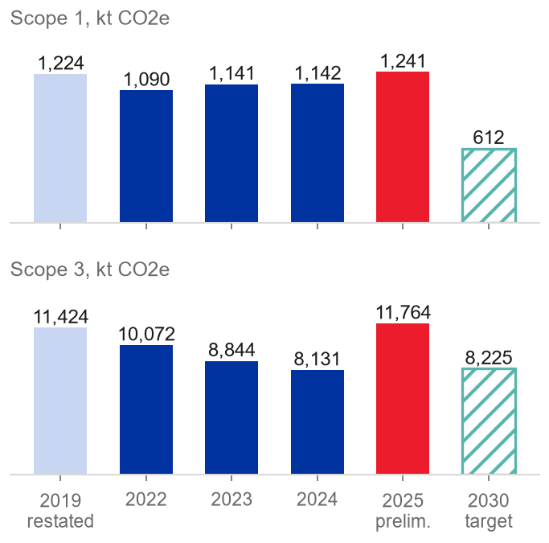
  Source: LSEG (2026); Grupo Bimbo (2026e, p. 169)
Governance: a controlled company  Six vehicles hold 72.03% of the shares, the chair is executive and a family member with a casting vote, and 7 of 18 directors are independent (Grupo Bimbo, 2026a, pp. 171, 181-182; LSEG, 2026). The audit committee is fully independent and related-party transactions are 2.3% of sales (Grupo Bimbo, 2026f, note 15). Our governance scorecard gives 31 of 64 points, 48% (team estimate). Acquisitions are decided inside this structure, which links governance to our first pillar.  Link to valuation  • Climate and input costs, nutrition regulation and labour reform act through the margin: 50 bp lost permanently from FY2028E costs MXN 7.17 per share, and -100 to -150 bp in Mexico costs MXN 5.5 to 8.1 (team model).
  Figure 34: Governance checklist: score by block
  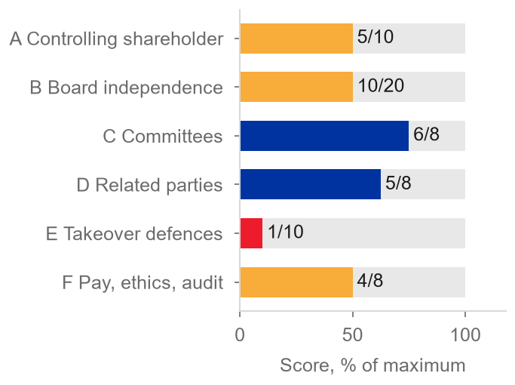
  Source: team estimate from Grupo Bimbo (2026a, pp. 171, 181-182; 2026g)
• Governance acts through the discount rate: we add no WACC premium, and each +0.5 pp costs MXN 8.58 (team model).

Appendix
A1. Income statement (condensed)
Table 8: Income statement, FY2024A-FY2030E
MXN million | FY2024A | FY2025A | FY2026E | FY2027E | FY2028E | FY2029E | FY2030E
Net sales | 408,335 | 426,952 | 426,670 | 446,942 | 465,382 | 483,639 | 498,865
Gross profit | 214,928 | 223,487 | 224,992 | 233,075 | 242,892 | 252,580 | 260,595
Operating income (EBIT) | 33,149 | 34,146 | 37,729 | 42,541 | 44,982 | 47,345 | 49,205
Financing result | (12,579) | (14,001) | (13,120) | (12,175) | (12,327) | (12,446) | (12,515)
Income taxes | (6,797) | (7,197) | (9,123) | (11,253) | (10,699) | (11,433) | (12,018)
Consolidated net income | 14,043 | 12,946 | 15,533 | 19,161 | 22,005 | 23,514 | 24,719
Controlling interest | 12,544 | 11,133 | 13,712 | 17,253 | 20,018 | 21,450 | 22,589
EPS (MXN) | 2.88 | 2.58 | 3.19 | 4.01 | 4.65 | 4.98 | 5.25
Adj. EBITDA | 55,473 | 59,456 | 63,299 | 67,589 | 70,377 | 73,138 | 75,441

Source: Grupo Bimbo (2026f); team model (sheet IS). The financing result is shown as an expense.
A2. Balance sheet (condensed)
Table 9: Balance sheet at 31 December, FY2024A-FY2030E
MXN million | FY2024A | FY2025A | FY2026E | FY2027E | FY2028E | FY2029E | FY2030E
Cash | 8,057 | 8,535 | 14,228 | 22,372 | 32,391 | 43,272 | 55,028
Receivables | 36,659 | 35,782 | 35,644 | 37,338 | 38,878 | 40,404 | 41,675
Inventories | 18,832 | 17,151 | 17,000 | 18,028 | 18,755 | 19,477 | 20,085
PP&E | 155,376 | 157,423 | 158,750 | 162,051 | 165,830 | 170,029 | 174,468
Right-of-use assets | 34,220 | 32,757 | 32,757 | 32,757 | 32,757 | 32,757 | 32,757
Goodwill and intangibles | 140,908 | 135,515 | 133,340 | 131,165 | 128,990 | 126,815 | 124,640
Total assets | 416,804 | 409,805 | 414,411 | 426,448 | 440,387 | 455,587 | 471,535
Lease liabilities | 35,801 | 34,790 | 34,790 | 34,790 | 34,790 | 34,790 | 34,790
Financial debt | 150,905 | 153,663 | 151,250 | 151,250 | 151,250 | 151,250 | 151,250
Total equity | 127,698 | 120,255 | 127,617 | 137,314 | 149,597 | 163,151 | 177,714

Source: Grupo Bimbo (2026f, p. 12); team model (sheet BS).
A3. Cash flow (condensed)
Table 10: Cash flow, FY2024A-FY2030E
MXN million | FY2024A | FY2025A | FY2026E | FY2027E | FY2028E | FY2029E | FY2030E
Cash from operations | 39,907 | 47,753 | 53,225 | 55,871 | 58,983 | 61,020 | 62,843
Purchases of PP&E | (29,402) | (22,530) | (18,581) | (20,031) | (20,857) | (21,676) | (22,358)
Business acquisitions | (5,988) | (11,294) | 0 | 0 | 0 | 0 | 0
Borrowings | 79,111 | 69,267 | 0 | 12,078 | 14,861 | 19,285 | 7,065
Debt repayment | (56,495) | (55,477) | (1,563) | (12,078) | (14,861) | (19,285) | (7,065)
Dividends paid | (4,234) | (4,451) | (4,763) | (4,943) | (5,122) | (5,282) | (5,413)
Lease payments | (7,072) | (8,060) | (8,279) | (8,279) | (8,279) | (8,279) | (8,279)
Interest paid | (8,376) | (11,533) | (10,086) | (9,954) | (10,106) | (10,225) | (10,294)
Share repurchases | (4,433) | (1,253) | (2,572) | (2,748) | (2,748) | (2,748) | (2,748)
Other items (NCI distributions, derivatives, FX effect, other investing) | (1,314) | (1,944) | (1,686) | (1,773) | (1,852) | (1,930) | (1,995)
Net change in cash | 1,704 | 478 | 5,693 | 8,144 | 10,019 | 10,881 | 11,756

Source: Grupo Bimbo (2026f, p. 16); team model (sheet CF).
A4. WACC and DCF details
Table 11: Build-up of the WACC
Step | WACC
Risk-free rate in pesos for all flows | 10.32%
+ risk-free rate by currency of the flows | 10.16%
+ country premium multiplied by beta | 9.93%
+ cost of debt by currency of the debt (WACC used) | 9.62%

Source: team model (sheet WACC).
Table 12: Terminal return on tangible operating capital, by year
FY2022 | FY2023 | FY2024 | FY2025 | Average | Model terminal RONIC
17.0% | 16.5% | 13.3% | 11.4% | 14.6% | 15.17%

Source: team model (sheet Assumptions, rows 690-697).
A5. Sensitivities
Table 13: Sensitivity of the twelve-month target price
Change (one at a time) | Target (MXN) | vs base | %
WACC -0.5 pp (9.12%) | 68.94 | +10.40 | +17.8%
WACC +0.5 pp (10.12%) | 49.96 | -8.58 | -14.7%
Terminal g +0.5 pp | 63.71 | +5.17 | +8.8%
Terminal g -0.5 pp | 54.24 | -4.30 | -7.3%
Adj. EBITDA margin +50 bp from FY2028E | 65.71 | +7.17 | +12.2%
Adj. EBITDA margin -50 bp from FY2028E | 51.38 | -7.17 | -12.2%
Adj. EBITDA margin -100 bp from FY2028E | 44.21 | -14.33 | -24.5%
Capex +50 bp of sales from FY2028E | 57.08 | -1.46 | -2.5%
Terminal RONIC at FY2022-25 average (14.6%) | 57.06 | -1.49 | -2.5%
Terminal RONIC at FY2022-25 low (11.4%) | 46.85 | -11.69 | -20.0%
North America ratio 0 (terminal NOPAT -2.0%) | 56.81 | -1.73 | -3.0%
One-year -100 bp margin hit in FY2027E only | 57.89 | -0.65 | -1.1%
Without netting 4Q26 and FY2027E buybacks from the share count | 57.62 | -0.92 | -1.6%

Source: team model (replica of sheet Valuacion_12m).
Table 14: Net sales and margin by region
Region | Sales FY2025A | Sales FY2027E | Sales FY2030E | CAGR 25-30E | Adj. EBITDA margin FY2025A
North America | 190,211 | 183,737 | 198,415 | 0.8% | 9.0%
Mexico | 154,809 | 174,255 | 197,760 | 5.0% | 20.4%
Europe, Asia & Africa | 54,214 | 56,708 | 66,117 | 4.0% | 10.8%
Latin America | 44,120 | 50,969 | 57,475 | 5.4% | 8.1%
Group (after eliminations) | 426,952 | 446,942 | 498,865 | 3.2% | 13.9%

Source: team model (sheet Segments); Grupo Bimbo (2026f, p. 85).
Table 15: Free cash flow to the firm, base DCF
MXN million | FY2027E | FY2028E | FY2029E | FY2030E | Terminal
EBIT | 42,541 | 44,982 | 47,345 | 49,205
NOPAT (tax 32.7%) | 28,624 | 30,266 | 31,856 | 33,107
+ D&A | 25,048 | 25,395 | 25,794 | 26,236
- Capex | (20,031) | (20,857) | (21,676) | (22,358)
- New leases | (6,142) | (6,142) | (6,142) | (6,142)
+/- Working capital | (380) | (611) | (602) | (495)
FCFF | 27,118 | 28,051 | 29,230 | 30,349 | 24,529
PV of FCFF (WACC 9.62%, mid-year) | 25,901 | 24,441 | 23,234 | 22,006 | TV 470,393

Source: team model (sheet Valuacion).
A5b. Sensitivity grid
Table 16: 12-month target price (MXN) by WACC and terminal growth
WACC \ g | 3.40% | 3.90% | 4.40% | 4.90% | 5.40%
8.62% | 68.09 | 74.24 | 81.80 | 91.34 | 103.79
9.12% | 58.58 | 63.28 | 68.94 | 75.89 | 84.66
9.62% | 50.60 | 54.24 | 58.54 | 63.71 | 70.06
10.12% | 43.81 | 46.65 | 49.96 | 53.86 | 58.55
10.62% | 37.95 | 40.19 | 42.75 | 45.73 | 49.24

Source: team model; replica of sheet Valuacion_12m (WACC and g vary; claims and the cost-of-equity factor fixed).
A5c. Football field
Figure 35: Football field: value per share against the price and rating zones
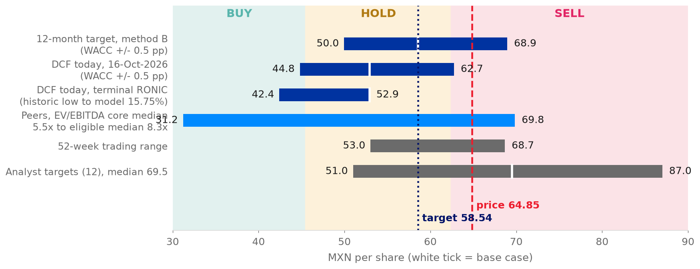
Source: team model; S&P Capital IQ (2026)
A5d. ESG score against peers
Figure 36: LSEG ESG score against peers, FY2024
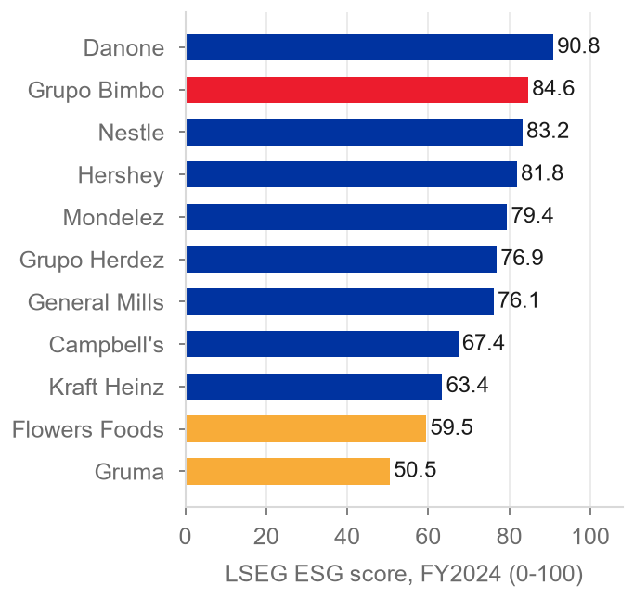
Source: LSEG (2026)
Figure 37: S&P Global ESG score history
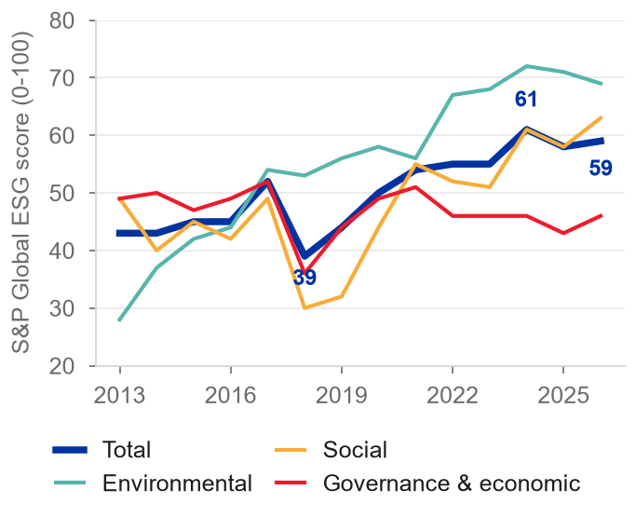
Source: S&P Capital IQ (2026)
A6. Full risk table
Table 17: Risk register (P = probability, I = impact, 1 low to 5 high)
Risk | Pillar | P | I | Value effect on target | Mitigation
R1 Input costs: wheat cost persists | 2 | 3 | 4 | -9.4 (futures US$266); -14.2 if wheat +35% | Hedges (about one year), pricing, productivity
R2 North America turnaround stalls | 3 | 3 | 5 | about -13.4 (margin back to 8.4%) | Transformation programme, 11 closures
R3 Terminal return on capital below base | 1 | 2 | 4 | -11.7 (RONIC 11.4%) | Capex discipline, margin delivery
R4 Mexico labour and health policy | 3 | 3 | 4 | -5.5 to -8.1 (-100 to -150 bp) | Reformulation, pricing, route productivity
R5 Capital allocation: capex or deal | 1 | 3 | 2 | -1.5 (capex +50 bp) | Capex guide cut; undrawn US$2.35bn revolver
R6 Terminal growth and peso | 1 | 3 | 3 | -4.3 (g -0.5 pp) | Dollar debt (42%) hedges part
R7 Other expenses and integration costs do not fall | 3 | 3 | 4 | -10.6 (0.76% of sales and MXN 541 million) | Integration programme; 1Q27 report is the first check

Source: team estimate (P, I); team model (value effects on the MXN 58.54 target); Grupo Bimbo (2026a, 2026d).
A7. Management statements of the 3Q26 call against the data
Table 18: Management statements of the 3Q26 call against the data
Management said | What the data show | Reading
Margin of 15.7%, up 100 bp, fifth quarter in a row above 14%; 2026 guide raised to +85 to +120 bp | 15.69% against 14.69%; our FY2026E is +91 bp | Partly: 1Q26 was 13.99%, so the run is four quarters, not five
Main raw materials fully hedged for 4Q26 and almost 100% for 1H27; 2027 is never fully hedged | Raw materials 30.4%, 29.9% and 30.6% of sales in FY2025, FY2026E and FY2027E; 2H27 coverage not disclosed | Holds
2027 will be a challenge for cost of sales; no margin decline guided | Our gross margin falls 58 bp in FY2027E, but the adjusted EBITDA margin rises 29 bp, from 14.84% to 15.12% | Tension with our model
Free cash flow of about MXN 17 billion in 9M26 after about MXN 12 billion of capex; net debt/EBITDA 2.4x | Our FY2026E: MXN 34.6 billion after capex and MXN 16.3 billion after leases and interest; leverage without IFRS 16 about 2.5x on our approximation | Holds in part (the release defines it before leases; our figure is after leases)
Going back to 3.0x would take about US$2 billion of deals, never done | Largest year since 2011 US$0.67 billion (FY2025), Weston in 2009 US$2.5 billion, mostly debt-funded; our calculation US$1.75 billion; leverage 1.5x in 2022, 2.9x in 2024 | Holds, but history shows the cycle
Growth comes from volume and price/mix, acquisitions "to a lesser extent" | Volume is not reported; by our estimate, acquisitions explain about 1.1 of 4.4 points in 9M26 | Holds in part
Wickbold has cost more and taken longer than planned, with more pressure to come | Latin America margin 7.3% (-130 bp); our integration costs fall from MXN 540 million to zero in FY2027E | Conflicts with our model
North America volumes are soft and the transformation is not finished; margin gains are structural | North America grows 1.0% excluding currency in 3Q26 at a 10.8% margin; the model grows it 0.9% in FY2027E | Holds
2027 capex somewhat above 2026; dividend slightly above inflation; buybacks continue | Our capex US$1.05 to US$1.10 billion; dividend MXN 1.12 (+3.9%); buybacks MXN 2.7 billion a year, but the share count behind EPS is not reduced (only the target nets them) | Holds

Source: Grupo Bimbo (3Q26 earnings call; 2026h, pp. 2-5; 2026f); S&P Capital IQ (2026); team model.
Four statements hold, three hold in part, one is in tension with our model and one conflicts with it. The two that matter are the 2027 margin and the integration costs, and both are in our third pillar: the model is more optimistic than the people running the company (team model).
A8. References
Bakery & Snacks (2026) 'Private label widens lead over national brands in 2026 grocery unit sales', Bakery & Snacks, 9 July.
Banxico (Banco de Mexico) (2026) Encuesta sobre las expectativas de los especialistas en economia del sector privado, September. Mexico City.
Damodaran, A. (2026) Country default spreads and risk premiums (July 2026 update); Betas by sector, global (5 January 2026); Implied equity risk premium (October 2026). New York University Stern School of Business.
Flowers Foods, Inc. (2026) Annual report on Form 10-K for fiscal 2025 and second quarter 2026 results and fact sheet. Thomasville, GA.
Grupo Bimbo, S.A.B. de C.V. (2024) Reporte anual 2023 [Annual report 2023 to the Bolsa Mexicana de Valores]. Mexico City.
Grupo Bimbo, S.A.B. de C.V. (2026a) Reporte anual 2025 [Annual report 2025 to the Bolsa Mexicana de Valores], 30 April. Mexico City.
Grupo Bimbo, S.A.B. de C.V. (2026b) Grupo Bimbo reporta resultados del 4T25 [4Q25 results release], 25 February. Mexico City.
Grupo Bimbo, S.A.B. de C.V. (2026c) Grupo Bimbo reporta resultados del 1T26 [1Q26 results release], 29 April. Mexico City.
Grupo Bimbo, S.A.B. de C.V. (2026d) Grupo Bimbo reporta resultados del 2T26 [2Q26 results release], 23 July. Mexico City.
Grupo Bimbo, S.A.B. de C.V. (2026e) Informe anual integrado 2025 'Celebramos' [Integrated report 2025]. Mexico City.
Grupo Bimbo, S.A.B. de C.V. (2026f) Estados financieros consolidados auditados 2025 [Audited consolidated financial statements 2025]. Mexico City.
Grupo Bimbo, S.A.B. de C.V. (2026g) Estatutos sociales [Corporate by-laws], deed 119069, 6 May. Mexico City.
Grupo Bimbo, S.A.B. de C.V. (2026h) Grupo Bimbo reporta resultados del 3T26 [3Q26 results release], October. Mexico City.
Grupo Bimbo, S.A.B. de C.V. (2026i) Investor presentation 3Q26, October. Mexico City.
Grupo Bimbo, S.A.B. de C.V. (2Q26 investor presentation) Investor presentation 2Q26, 23 July. Mexico City.
Grupo Bimbo, S.A.B. de C.V. (3Q26 earnings call) Transcript prepared by the team from the call of 22 October 2026.
IMF (2026) Global price of wheat, series PWHEAMTUSDM, via FRED. Washington, DC: International Monetary Fund.
IndexBox (2026) 'USDA grain futures and canola bids report for October 7, 2026'. IndexBox.
Investing.com (2026) 'Flowers Foods Q2 2026 slides: volume drops 5.8% amid category pressure', August.
LSEG (2026) ESG scores, controversies, officers and directors, and ownership data for Grupo Bimbo. London Stock Exchange Group. Accessed October 2026.
S&P Capital IQ (2026) ESG scores history, consensus estimates, ownership, rates and peer data. S&P Global Market Intelligence. Accessed 16-19 October 2026.
Team model (2026) BIMBOA statements 2021-2030, final model with 12-month target [unpublished team workbook].
Yahoo Finance (2026) BIMBOA.MX historical prices, read 28 October.
Use of AI Tools
Tools. We used Claude (Anthropic) through Claude Code with a research-challenge plugin and a compiled knowledge wiki of the company filings. A second model, Codex (OpenAI), reviewed the valuation documents in October 2026, and NotebookLM (Google) produced an audio summary of our model notes for internal study.
What we used them for. (1) Reading and extracting data: the assistant read filings, presentations and Capital IQ exports into the wiki with source and page citations, and extracted and mapped the FY2021-FY2025 statements. (2) Building the three-statement model, the WACC and the DCF, with a Python replica that reproduces the workbook's target price and sensitivities. (3) Industry, risk and ESG research notes. (4) Charts, tables and the drafting and editing of this report from the team's model and decisions, including the first wording and the data support of the three pillars; the assistant proposed alternative titles and arguments and the team chose the final titles and their order. (5) Coaching questions that tested the thesis and the forecast method. (6) Reading the team's transcript of the 3Q26 earnings call and checking nine statements of the CFO and CEO against the model and the filings. (7) Two working notes on pillars, one on acquired growth and one on the new management, which the assistant drafted from the team's answers and which the team used as sources for the first and third pillars. (8) A public web check of post-results analyst figures (an aggregator page and a news wire), used only to cross-check the Capital IQ consensus and not quoted in the report.
How we verified the output. The model balances in every year and ties to the audited statements, and the replica reproduces the 12-month target and its WACC cases to the cent. Each wiki number carries a data tag and a page reference. Every number in this report is read from the team workbook, the wiki or a filing. [Team to confirm: which member checked the citations against the filings.]
What the team decided. The team chose the HOLD stance and the three pillars, the 27 October 2026 reference price (MXN 64.85, after the 3Q26 results), the 12-month target method and the rating band rule, the neutral HOLD where the rule gives SELL, the WACC inputs (global industry beta, current market capital structure), the North America share-gain ratio of 0.17, the sales method (team ratio times nominal GDP, organic only, as the advisor asked), the terminal growth and return on new capital, and the treatment of non-controlling interests (team decisions recorded in the project log). [Team to confirm: the wording of each pillar and the risks and ESG issues chosen.]
Reflection. AI helped most with volume and traceability: it read hundreds of pages of filings, releases and the call transcript, kept every number tied to a source and page, and rebuilt tables and charts after each change to the model. We did not rely on it for the judgements: the team argued and decided the three pillars, the HOLD and its rating rule, the 12-month target method, the WACC inputs and whether the 2027 margin gain is real, and asked the assistant for the strongest case against each [Team to confirm]. One limitation: it writes fluent text around thin evidence, so every claim needed a source check. The DCF rises from MXN 28.93 to MXN 52.92, and MXN 23.5 of the MXN 24.0 increase comes from two modelling judgements, which the team had to identify and defend.

