PREPRINT | Version 1.1 · 3 November 2026 · Prepared for double-anonymous peer review at a journal (venue withheld) · Not yet peer reviewed · CC BY 4.0 · DOI 10.5281/zenodo.23903482

Constitutional Time: Who Binds Whom in the Data on Constitutions
Luis Bourguet
LabOnt – Center for Ontology, Università degli Studi di Torino · Complex Systems Science Laboratory, Hiroshima University · ORCID 0000-0002-4673-4486
Abstract. Comparative records of constitutions code each text as it stands at a date: a series of snapshots. None describes the relation between the people who made the norms and the people bound by them, so two orders identical in every coded respect can be opposite in that relation. The omission is the social-contract model in data form: an agreement among contemporaries is fully described by its content and date, and the relation the contract cannot see is the one the records do not hold. Following Andina’s reading of Hobbes, Hume and Hegel and her ontology of transgenerational action, the article derives four things a diachronic record must contain for each norm: when and by whom it was inscribed, who is bound by it without having been party to it, through which channels it can be redefined or annulled, and whether the bound can reach those channels. With Bobbio’s typology of constitutional change and Lawson’s account of access to positions as auxiliaries, it turns the four into a coding schema, tests existing records (the Comparative Constitutions Project, Constitute, Seshat, stability-episode data) against it, and locates the synchronic limit exactly. Eight cases from four regions illustrate three patterns of constitutional time, accumulative, frozen and cyclical, which the records cannot tell apart. Four measures and a world-scale extraction pipeline are stated; a single-coder pilot on the historical databank is reported for transparency only. The contribution is a unit of description and a schema, and the claim that constitutional time can be coded.
Keywords: social ontology; transgenerationality; constitutions; constitutional change; computational social science

1. The contract in data form
Comparative constitutional research has, in the last two decades, acquired what it long lacked: systematic records of what the world’s constitutions say. The Comparative Constitutions Project codes the content of every national constitution written since 1789 on more than two thousand variables, registers every event in each text’s life (promulgation, amendment, suspension, replacement) and, through the Constitute website, makes the texts in force searchable by topic (Elkins, Ginsburg and Melton 2009; 2026). Historical databanks reach further back, coding the presence of written law, courts and professional lawyers in several hundred polities over five millennia (Turchin et al. 2015). Studies of political stability add a third kind of record, periods during which a country’s institutions held without rupture. Taken together these records allow questions that could not be asked before: how long constitutions live, which features of their design predict survival, how often a given provision occurs.
There is one question they do not allow. Every one of them codes a constitution as it stands at a date: the content of the text at the end of a country-year, the presence of an institution in a polity-period, the duration of an episode. The unit is a snapshot, and a series of snapshots. What no snapshot contains is the relation between the people who made the norms and the people bound by them. Two orders can be identical in every coded respect and opposite in that relation. Order A was written eighty years ago by an electorate now dead; it is hard to amend, and a court whose members serve for life settles what it means. Order B contains the same provisions, but most of them were re-enacted in the last twenty years through procedures in which today’s voters took part, and the body that reads them is one they elect. A coder working from the texts records A = B. For anyone bound by them, A and B are different things: in A the bound have no way back to the norms; in B they do.
This article argues that the omission is not an accident of coding practice but the social-contract model in data form. The contract reads a constitution as an agreement among contemporaries, and an agreement among contemporaries is fully described by its content and its date. The relation that the contract cannot see, between those who agreed and those who did not but are bound, is precisely the relation the records do not hold. Andina’s account of transgenerational action (2020) gives that relation a structure: an initiating generation, an absent subject that becomes a bound one, and two ways out, redefinition and annulment. On that basis the article asks what a diachronic record of constitutions would have to contain, and shows with existing records exactly where the synchronic limit falls.
The contribution is a unit of description and a coding schema, not a finding. Section 2 follows Andina through Hobbes, Hume and Hegel to derive four things a record must hold for each norm: when and by whom it was inscribed, who is bound by it without having been party to it, through which channels it can be revised, and whether the bound can reach those channels. Section 3 turns the four into a schema, with Bobbio’s distinction between systemic and extra-systemic change and Lawson’s account of positions and access as auxiliaries. Section 4 tests existing records against the schema and locates the gap. Section 5 illustrates three patterns of constitutional time with eight cases from four regions. Section 6 states the measures that the schema makes computable; Section 7 the pipeline by which they could be computed at world scale; Section 8 the limits, together with a single-coder pilot on the historical databank, reported for transparency. Nothing in what follows reports a coding as executed: the article says what to extract and why, and the counts it quotes are those the existing records already contain.
A word on method. The article is conceptual and methodological, and its procedure has four steps. First, a reading of the contract tradition through Andina’s ontology, from which the requirements on a record are derived rather than stipulated. Second, a test of existing records against those requirements, record by record and item by item, using the records’ own documentation and, for the Comparative Constitutions Project, the released data files (Chronology version 6.0, 1789–2025, read in October 2026). Third, an illustration on eight cases chosen to span three patterns and four regions, not sampled, and described from the event records and standard constitutional sources. Fourth, the statement of measures and of a pipeline, with their validation conditions, as a design. The data science used in what was actually run is modest and is named so that it can be repeated: for Section 5, aggregation of the Chronology’s event records by country and constitutional system (counts of new, amendment, interim and suspension events per system, computed in Python with pandas) and their plotting as a timeline with a colour palette checked for colour-vision deficiency; for the pilot of Section 8, retrieval of the forty-four crisis records through the databank’s public API, filtered on its constitution variable, followed by qualitative content coding of the case descriptions into two closed categorical variables, drafted with the assistance of a large language model and reviewed case by case by the author, with a written note per case, and a contingency table of the result. No inferential statistics are applied, because the cells are too small and there is one reading; the pipeline of Section 7 is where provision-level alignment of text versions, joins with franchise rules and inter-coder validation would enter. The research design is interdisciplinary in the structural sense: social ontology and constitutional theory are integrated around one shared object, the constitutional order described norm by norm as a relation between inscribers and bound, and data science is the discipline that would execute the description at scale. No claim in the article depends on a result that has not been obtained.

2. The social contract inside social ontology
Before asking what the datasets record, it is worth asking what the contract idea assumes about time. Andina’s Transgenerazionalità (2020) answers that question from within social ontology, and this section follows her reading of the contract tradition to extract a positive result: what any description of a constitution must contain if it is to capture the relation the contract model leaves out.
Hobbes is the first witness. In De cive the transfer of right by which the state of nature is left is a transfer between consenting parties, and consent is an act of the will in the present. Hobbes is explicit that a commitment phrased in the future tense commits no one: words alone “give no sufficient sign” of a will engaged, so that a pact must be contracted now or recorded as contracted in the past (De cive II.6, II.8; Andina 2020: 52–53). A pact, Andina summarises, “holds at the moment we contract it, and binds us for the time needed to perform it” (2020: 53). Two further restrictions follow. The pact binds the wills of those who made it, since it is their engagement that constitutes it; and it binds them only over matters within their own deliberation, since “we cannot commit ourselves in matters or actions that escape our control entirely” (2020: 54). Andina takes the account for “a very well constructed thought experiment” with “little or nothing to do with what happened” (2020: 52). What matters here is not whether Hobbes is right about origins but the temporal shape of his model. Its parties are present to one another; its bond is dated by the act that creates it; and its scope is the deliberation of the living. The model is synchronic.
Hume is the second witness, and he makes the consequence explicit. If every legitimate government was founded on consent and a voluntary compact, that supposition “implies the consent of the fathers to bind the children, even to the most remote generations”, which “is not justified by history or experience, in any age or country of the world” (Hume, quoted in Andina 2020: 107). Andina reads the passage as the first political statement of transgenerationality: the bond that ought to tie those who assumed it “in some sense obviously ties their children and their children’s children too”, and “it is not reasonable to think that wills which did not intentionally subscribe the social pact can be bound”. She calls this “perhaps the first vulnerability of every political system” (2020: 107). The contract model, in other words, does not fail at the founding; it fails one generation later, when it must either deny that the bond persists or admit a bond without consent that its own premises cannot account for.
The third witness is Hegel, through whom Andina says what the contract presupposes. Recognition is the precondition of any sociality, and the contract becomes possible only because recognition has first produced the juridical person, so that its law is “accessible to those individuals who have formalised the concept of the juridical person” (2020: 68). The party to a contract is thus a status the order confers, which recognition can extend or withhold. A record of who may contract is a record of who has been recognised, and recognition has a history.
With these three results Andina builds the apparatus this article needs. Transgenerational actions are collective actions (a) undertaken by subjects who begin an action or a connected series of actions, (b) directed at a shared end, (c) requiring considerable extension in time, (d) not concluded by the subjects who begin them, and (e) typically carrying consequences of ethical, political and economic weight (2020: 122–123). Their structure is asymmetric. The actors who begin an action at time t may share its aim; the actors who must continue and conclude it at t₁ may share neither the aim nor the means, “and nonetheless are compelled to carry on and conclude the action undertaken at t” (2020: 124). Andina calls the first pole the initiators and the second the entrants, and she notes that the entrants’ disagreement “may not be a sufficient reason for the aims to be abandoned or reformulated” (2020: 124). This is the Hobbesian pact seen from the far end: the party who was not there.
That party has a name. Following Hegel and Mead, Andina locates in “the generalised other and the juridical space that makes it possible” the reference for an alterity that is “a sort of absent subject, or at least a subject who does not enjoy the same form of presence or reality as the other poles of the relation” (2020: 84). In a political space x she distinguishes four such subjects: citizens of another state; those who have applied for citizenship of x but not obtained it; citizens of x too young to vote; and those “who are supposed one day to belong to x but at time t are not yet born” (2020: 85–86). The first three can obtain representation if circumstances change; the fourth is “the absent subject par excellence”, intrinsically vague, who “might even never exist” (2020: 87). Yet the absent subject is not nothing. The second pole of a transgenerational action “undergoes the action without the possibility of determining, influencing or restructuring it”, and if no form of reality were granted to it “the transgenerational action would not be possible, or would not make sense” (2020: 86–87). An absent subject, Andina insists, “is not a non-existent subject; it is a subject who for some reason, which is stipulated and therefore revisable, has no right to have its opinion represented or even considered” (2020: 85). The stipulation is the point: who counts as absent is decided by the order, and the decision can be revised.
Democracies, on her diagnosis, decide it badly: they run on ‘voto ergo sum’, so that those who vote shape political action and those who do not “undergo it completely” (2020: 85). Here the distinction that organises the rest of the book enters. A future generation can be conceived regulatively, in Kant’s sense, as the ideal toward which a society orders its present action, or conservatively, as the party that will complete what the present decides (2020: 87). The conservative use, which “almost always prevails” (2020: 87), uses the future “to ensure that what one generation has undertaken will be brought to completion by another, without that other generation being taken into account at the moment of decision”—debt is her example (2020: 91). Hume had already said why the conservative use is illegitimate: it treats future generations as a means, binding their will “most often without verifying their consent even ex post” and without regard to their interests (2020: 108). And the two uses have different conditions of possibility. Regulative actions can rest on trust between generations, grounded in some predictive design of the future; conservative actions cannot, because the entrants have no reason to trust and no knowledge to ground it, so “the norm steps in where the relation of trust, by its very nature, fails” (2020: 130).
Andina’s examples are public debt, pensions and climate policy; constitutions do not appear on her list. But what she says entrants can do when they refuse to continue an action applies to constitutions more exactly than to anything else, because a constitution is the action that authorises all the others. Entrants who do not share the initiators’ reasons can seek revision “in two ways: (a) by redefining the meaning of the transgenerational action” and so redesigning the system; or “(b) more radically, by annulling the decisions” of the initiators as unjust (2020: 136). Redefinition and annulment are the two things a bound generation can do to an inherited norm: fix what it means, or strike it out. Whether either is available, to whom, and at what cost, is not a fact about the norm’s content. It is a fact about the order.
The reading yields requirements. Hobbes: a bond is constituted by an act with a date and parties. Hume: the bond outlives both. Hegel: being a party is conferred by the order. Andina: the far pole is an absent subject whose absence is stipulated, which can respond by redefining or annulling, and for which the norm takes the place of trust. A description of a constitution adequate to this structure must therefore hold, for each norm, four things: (1) when it was inscribed and by whom—the date and parties of the act, which the contract model locates at the founding and which, once norms are revised piecemeal, becomes a date per provision; (2) who is bound by it now without having been party to it—the actualised absent subject, Andina’s entrants; (3) by which channels it can be redefined or annulled, and at what threshold; and (4) whether the bound can reach those channels, which is where recognition returns, since access to the revising bodies is the modern form of being a juridical person. None of the four is a property of the text as it stands at a given date. All four are relations between the text and the people on either side of it in time. Section 3 turns them into a coding schema and asks, item by item, whether existing records hold them; the short answer is that they hold fragments of (3), traces of (1), and nothing of (2) and (4).

3. From ontology to schema
A schema is a list of what counts. The list in this section is derived from Section 2 and from two auxiliaries, and each entry is paired with the nearest thing existing records already hold, so that Section 4 can say what is missing without repeating the derivation.
The first auxiliary is Bobbio’s typology of constitutional change. Discussing Polybius, Bobbio distinguishes changes “resolved within the political system”, which are “systemic and not extra-systemic, gradual and not violent”, and produce “a shift of the internal equilibrium that is reabsorbed by a resettlement of it”, from the “abrupt and violent passage from one form to others” that marks the cycle of forms (Bobbio 1987: 54). The distinction gives the schema its event typology: a change in which the order’s own procedures operate is of one kind, a change in which they are suspended or replaced is of another. Bobbio also supplies a safeguard. A typology of forms, he observes, can be used systematically, to order data; axiologically, to rank forms as better and worse; and historically, to trace a philosophy of history in which forms succeed one another (1987: 10–13). The schema below is a systematic use. Whether an order that persists is thereby good, and whether a sequence of events is a cycle or a progress, are the other two uses, and the article keeps them apart: nothing that follows infers from ‘it lasted’ that it was a good ancestor, nor from a sequence of ruptures that history has a shape. Machiavelli’s observation that the laws made in favour of Roman liberty “were born of the disagreement” between nobles and people (quoted in Bobbio 1987: 78) is the reminder that stability is not the only value a constitutional record can serve.
The second auxiliary is Lawson’s conception of social structure, which supplies the vocabulary for access. Social structure, for Lawson, is a category that “collects together the collective practices, acceptances, positions, rules, rights, obligations and such like that are emergent features of human actions and interactions” (Lawson 2015: 42). Positions are the loci of rights and obligations; what a community distributes, through “the content of official declarations”, is among other things “the distribution of rights of access to community positions” (2015: 43). And Lawson is explicit that structure is handed on: “when we come to act, the contents of previous acceptances, whether embedded in agreements, precedents, or whatever, are given to us” (2015: 42). Two things follow for the schema. Access to a position is a coded fact of the order, not a property of its occupants; and what is given to a later generation includes the rules of access themselves. Lawson types this emergence synchronically, as the dependence of structure on activity at a time; the relation between those who accepted and those to whom acceptances are given is diachronic, and it is what the schema must capture.
With these in hand, the derivation of Section 2 can be laid out as extraction rules (Table 1).
Table 1. From ontology to extraction rules. Sources as cited in each row.
Source | What it tells us to extract | Nearest existing proxy
Contract as synchronic model (Andina 2020: 52–54) | The founding claim: who is named as author of the order, and whether later generations are named at all | Preamble topics in Constitute; authorship not coded
Hobbes: pacts bind present wills, over their own deliberation (2020: 54) | Provisions that bind future wills: eternity clauses and entrenchment | Unamendable-provision and amendment-threshold variables
Hume: no contract binds the remotest generations (2020: 107) | Whether the text claims perpetuity or provides for its own revision and replacement | Amendment procedures coded; replacement clauses not systematically
Initiator/entrant asymmetry (2020: 122–124) | Inscribing body versus bound body; the ratification route of each change | Proposal and approval actors for amendment
Absent subjects, four types (2020: 85–86) | Rights of foreigners; naturalisation; voting age; future-generations clauses | The first three partly; the fourth not as such
Entrants revise by redefining or annulling (2020: 136) | Who holds final interpretive authority; amendment channels and thresholds | Judicial-review and amendment blocks
Norm replaces trust (2020: 130) | Institutional substitutes for trust: review, sunset and periodic-revision clauses | Partly
Hegel–Mead: contract presupposes recognition (2020: 68) | Scope of rights-bearers: persons, citizens, future generations | Rights block
Bobbio: systemic versus extra-systemic change (1987: 54) | Event type at each change: amendment within the system versus replacement, suspension, interim rule | Chronology event types
Lawson: rights of access to positions (2015: 43) | The positions the order creates and who may fill them | Selection rules, partly
Four items on the right-hand side carry the weight, and they are the four of Section 2 restated as coding instructions.
- Inscription date per provision. For each norm, the year of the event that gave it its present wording and the body that decided that event. A constitution amended piecemeal has as many inscription dates as it has provisions that have changed; a text never amended has one. This is the initiators’ side of the relation.
- Bound population. For each norm at a date, the share of the persons subject to it who were not enfranchised at its inscription. This is Andina’s entrant side, the absent subject actualised; its computation requires (1) and the franchise rules in force at each inscription.
- Revision channels and thresholds. For each norm, the procedures by which it can be redefined (final interpretive authority) or annulled (formal amendment or replacement), with their stages and majorities. Bobbio’s event typology classifies the changes that actually occurred by whether they ran through these channels.
- Access. For each body named in (3), the rules by which its seats are filled and fall vacant, and hence whether the bound population of (2) can reach it. Lawson’s “rights of access to community positions” is the general case; the Venetian serrata of 1297, by which the seats of the Great Council became hereditary while every norm stayed in place, is the historical type of access closing without textual change (Acemoglu and Robinson 2012: 152–156; Andina 2020: 141–145).
Items (3) and (4) are also the terms in which a normative criterion over the same ontology can be stated: that every norm binding a generation lie within reach of some procedure that generation controls, and that no body beyond its reach can revise the norm more cheaply. This article states no such criterion and ranks no order; it asks what a record must contain for anyone to apply one.

4. What the records see and what they miss
The test is simple: for each of the four items, does an existing record hold it, and at what unit?
The Comparative Constitutions Project. The CCP’s Chronology registers, for 225 countries from 1789 to 2025, every constitutional event by year and type: new constitution, amendment, interim constitution, suspension, reinstatement (Elkins, Ginsburg and Melton 2026). Its Characteristics file codes the content of each constitution-as-amended on more than two thousand variables, one row per constitutional event. Because characteristics are coded per event, the record approximates (1): a change in a variable between two events dates the change to the interval. It does not locate the change in a provision, and it does not record who decided it; the amendment block records how the text says amendments are made, not who made each one. For (3) the CCP is the richest record available: amendment procedures with their proposing and approving actors, thresholds and exclusions, and the existence and scope of judicial review. For (2) it holds nothing: the bound population is a relation between a text and a demography, and the CCP codes texts. For (4) it holds the text’s selection rules for the bodies it names, which is the de jure half of access; the de facto half, who in fact fills the seats and whether the vacancy rules are honoured, lies outside its design. The Chronology’s unit, finally, is the ‘constitutional system’: Japan since 1946, India since 1949 and the United States since 1789 are each one system, and so are Thailand’s twenty-three. Systems count textual continuity, not the relation the schema needs, and identical counts hide opposite structures.
Constitute. Constitute publishes the texts in force, in English translation, with three hundred topic tags and an interface for comparing provisions (Elkins, Ginsburg and Melton 2014; the texts are licensed for non-commercial reuse). It holds the provisions, which the CCP’s variables summarise, and is therefore the source from which (1) could be built by aligning successive versions of each text, and from which the fourth absent-subject type, future-generations clauses, could be identified by tag. It holds texts in force; the historical versions that (1) requires are, for most countries, not digitised in any record.
Seshat. The Seshat Global History Databank codes several hundred polities from the Neolithic to the twentieth century on variables that include the presence of a formal legal code, judges, courts, professional lawyers and written records (Turchin et al. 2015; Benam et al. 2022). For the schema its value is twofold. It records the preconditions of inscription in deep time, before any constitution in the modern sense; and it shows, by its own limit, what diachronic coding would add. Seshat’s unit is the polity-period: a variable is coded present or absent for a polity over a span of years. Venice appears as two polities, 1204–1563 and 1564–1797, with every legal variable present throughout. The serrata of 1297 falls inside the first and is invisible: no variable changes, because no institution appeared or disappeared; only access to one of them closed. Seshat’s crisis database adds a column for “major constitutional or institutional change” following a crisis, defined broadly enough to include reorganisations of provinces and new ideas about kingship; it is a record of breaks, not of channels, and only twenty-six of its crises fall after 1789. The databank is a bridge backwards from the CCP, not a substitute for the schema.
Stability episodes. A further kind of record, in use in the study of political stability, identifies for each country the periods during which its institutions held without rupture and measures their duration. Such episodes are the natural unit for the question the schema poses, because a stable period is exactly where the two orders of Section 1 come apart: in one the bound retain access to the revising bodies throughout, in the other they do not, and the episode looks the same. An episode record holds durations; it holds nothing of (1)–(4), and until it is joined to the Chronology it cannot even say whether the episode ended by amendment, reinterpretation, replacement or rupture.
Table 2 summarises the test.
Table 2. What each record holds of the four items of the schema. Sources: Elkins, Ginsburg and Melton 2014, 2026; Turchin et al. 2015; Benam et al. 2022.
Item | CCP Chronology and Characteristics | Constitute | Seshat | Stability episodes
(1) Inscription date per provision | Approximated: changes dated to intervals between events, at the level of variables | Source for building it: texts in force, no historical versions | No: presence per polity-period | No
(2) Bound population | No | No | No | No
(3) Revision channels and thresholds | Yes, de jure: amendment procedures, actors, thresholds, judicial review | Yes, as text | No: presence of courts and codes only | No
(4) Access to the revising bodies | De jure half: selection rules in the text | De jure half, as text | No | No
Unit | Constitutional system; country-year | Text in force | Polity-period | Episode duration
The result of the test is uniform. Existing records hold fragments of (3), the de jure half of (4), an approximation of (1) at the level of variables rather than provisions, and nothing of (2). What they lack is not accuracy or coverage but a unit: each describes the order at a date, and the four items are relations across dates. This is the synchronic limit, and it is the contract model’s limit transposed into data. The limit is also exact, which is what makes it tractable. Item (1) can be built from the texts the records already hold; (2) from (1) and franchise rules that are themselves coded; (3) is mostly present; (4) needs the one thing no text-based record can supply, the de facto composition of the revising bodies. Section 5 shows what the relation looks like across cases before Section 6 states how it would be measured.

5. Three patterns of constitutional time
The schema is not yet applied to any order, and this section does not apply it. What it does is show, on eight cases from four regions, that the relation the schema describes takes recognisably different shapes which the existing records register as the same thing or not at all. The counts are the CCP Chronology’s own (version 6.0; coverage runs to 2019 for some countries and to 2025 for others, and each count is given with its window). The regime facts are those of standard constitutional description. Everything else is hypothesis. Figure 1 plots the Chronology’s events for the eight cases and Kenya since 1900.
Three patterns organise the cases. In the accumulative pattern one textual system persists and is re-inscribed piecemeal, so that the order’s provisions carry many dates and a large share of the text is younger than the people it binds. In the frozen pattern one system persists with little or no formal amendment, so that every provision carries the founding date and re-inscription, if it happens, runs through interpretation alone. In the cyclical pattern systems succeed one another by replacement, suspension and interim rule, so that inscription dates are recent but the inscribing bodies change with each cycle. Bobbio’s names for the historical shapes, Polybian accumulation within the system and the cycle of forms, are used here in their systematic sense only.
Accumulative. Mexico’s constitution of 1917 is one system in the Chronology; it has been amended in 81 of its 109 years to 2025. Italy’s of 1947 is one system amended in 17 of 77 years to 2023; India’s of 1949 one system amended in 54 of 74 years to 2023; South Africa’s of 1996 one system amended in 12 of 25 years to 2023. On item (1) these four orders are as different from Japan’s as any in the record: most of what binds a Mexican or Indian citizen today was inscribed within living memory. They differ among themselves on (3) and (4). In Mexico the amendment route runs through a two-thirds vote of Congress and a majority of state legislatures, bodies the bound elect; the Supreme Court’s role as reader of the text has grown since 1994, and the composition of that court became, in 2024, a matter of popular election. In India the Supreme Court has since Kesavananda Bharati (1973) held that Parliament’s amending power cannot alter the constitution’s “basic structure”, so that a court whose members retire at a fixed age but are not elected settles what may be amended at all: redefinition and annulment run through one body. Italy’s Constitutional Court, with members serving nine-year terms appointed in thirds by Parliament, the President and the higher judiciary, holds final interpretive authority over a text amended rarely but amendable by Parliament in two readings, subject to a confirmatory referendum unless two-thirds of each chamber approve. South Africa’s 1996 text was itself certified by the Constitutional Court against the principles of the interim constitution before it took effect, a re-inscription by interpretation at the founding itself. Four accumulative orders, one count each in the Chronology, and four different distributions of access across the two channels.
Frozen. Japan’s constitution of 1946 has never been formally amended; every provision carries the inscription date of an occupation-era drafting process in which no living Japanese voter took part, and the bound share on item (2) is, by any measure, close to one. Re-inscription has run through interpretation alone, by the Supreme Court and, more consequentially, by the Cabinet Legislation Bureau’s readings of Article 9. Namibia’s of 1990 has been amended in three years of thirty; its Supreme Court’s members are appointed on the recommendation of a Judicial Service Commission. The two orders are alike on (1), the Chronology counts them alike, and they differ on (4): which body reads the frozen text, and who fills it, is the whole of the difference between them.
Cyclical. Thailand has had twenty-three constitutional systems since 1932, eleven new constitutions, seven interim ones, three suspensions; the current text dates from 2017 and was drafted under a military government and approved by referendum, with a Senate whose first members were appointed by that government. Ghana has had nine systems, five new constitutions and three suspensions; the current text of 1992 has been amended in one year. In both, inscription dates are recent, which on (1) alone would make them good ancestors in the sense of the criterion in Section 3; what the pattern shows is that (1) cannot be read without (3) and (4), because recent inscription by a body the bound did not fill is not re-inscription by the bound. The Chronology registers the cycle as a sequence of events; it does not register that the inscribing body changed with each.
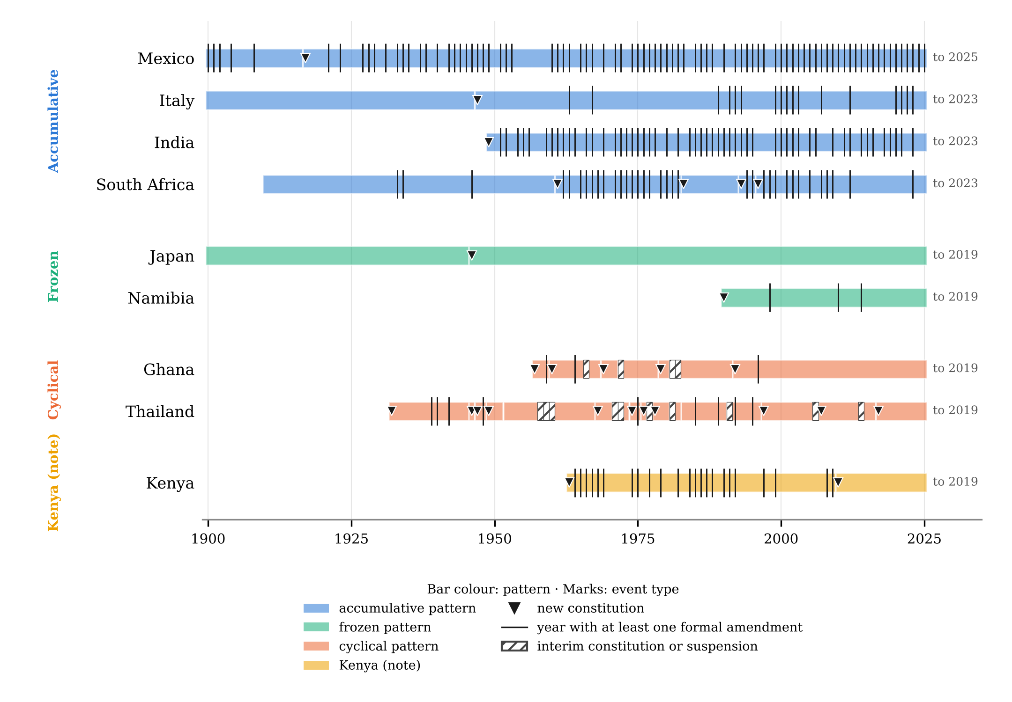
Figure 1. Constitutional events, 1900–2025, for the eight cases and Kenya. Source: CCP Chronology, version 6.0 (Elkins, Ginsburg and Melton 2026). Bars are constitutional systems in force, coloured by pattern (blue accumulative, green frozen, orange cyclical, yellow for the Kenya note); triangles mark new constitutions; vertical ticks mark years with at least one formal amendment; hatched cells mark interim constitutions and suspensions. Coverage ends in the year shown at the right of each row. The figure displays items (1) and (3) at the resolution the record allows: it shows when texts were inscribed and how often they were re-inscribed, and nothing of who was bound (2) or who filled the inscribing bodies (4). Japan’s and Namibia’s rows are alike; so are Ghana’s and Thailand’s; what separates each pair lies outside the record.
A note on Kenya. Kenya’s constitution of 2010 replaced that of 1963 after a referendum in which the bound population voted, devolved power to elected counties and subjected judicial appointments to a Judicial Service Commission and public vetting. It is a replacement, the Chronology’s ‘new constitution’, and on Bobbio’s typology an extra-systemic change; yet on item (4) it widened access, the inverse of Venice in 1297, where the texts stood and access closed. The two cases are the schema’s poles: textual change with access widening, textual continuity with access closing. No record now in use distinguishes them from a replacement that narrowed access or a continuity that preserved it.
The patterns are hypotheses about where the relation varies, not findings about how it does; and the eight cases were chosen to span the patterns, not sampled. What they establish is narrower and sufficient: the counts the records hold are compatible with opposite transgenerational structures, and the facts that separate those structures, who inscribed, who is bound, who reads, who fills the seats, are of a kind that can be coded.

6. Measures
If the four items were coded, four measures would follow from them without further theory. They are stated here so that the schema can be judged by what it would yield.
Bound share. For an order at a date, the share of the enfranchised population that was not enfranchised at the inscription of a given norm, aggregated over norms by article. It is a relational measure: it individuates generations by their relation to inscription events, not by intervals of years, and so avoids the objection, which Andina presses with Mannheim, that generations are not cohorts of fixed length (2020: 92–96). A frozen order’s bound share rises monotonically with time; an accumulative order’s rises and falls with each re-inscription; a cyclical order’s is reset by each replacement, which is why the measure must be read with the next.
Access. For each body holding a revision channel, whether a majority of its seats fall vacant at terms the order fixes and are filled by the bound population or by a body it fills. The measure is binary at the body and distributive over the norms each body can reach, so that an order has an access profile, not a score. Its historical type is the Venetian flip: a profile that changes while every norm stays.
Stability × access. Crossing the periods during which an order held with its access profile over the same periods separates two kinds of stability: one in which the bound retained the channels throughout, and one in which they did not. Andina’s distinction between conservative and regulative transgenerational action (2020: 87–91) is the conceptual form of the same cross; the measure is its operational one. Bobbio’s safeguard applies here with full force: the cross ranks nothing, it classifies.
Break type and access direction. At each boundary of a stable period, the event is classed by whether it ran through the order’s own channels (amendment, authoritative reinterpretation) or outside them (replacement, rupture), and by whether the access profile after it is wider or narrower than before (Figure 2). Kenya 2010 and Venice 1297 are the two off-diagonal cases; the hypothesis the measure is built to test is that orders whose channels remain accessible absorb crises within the system, and that replacements which widen access are rarer than replacements which narrow it.
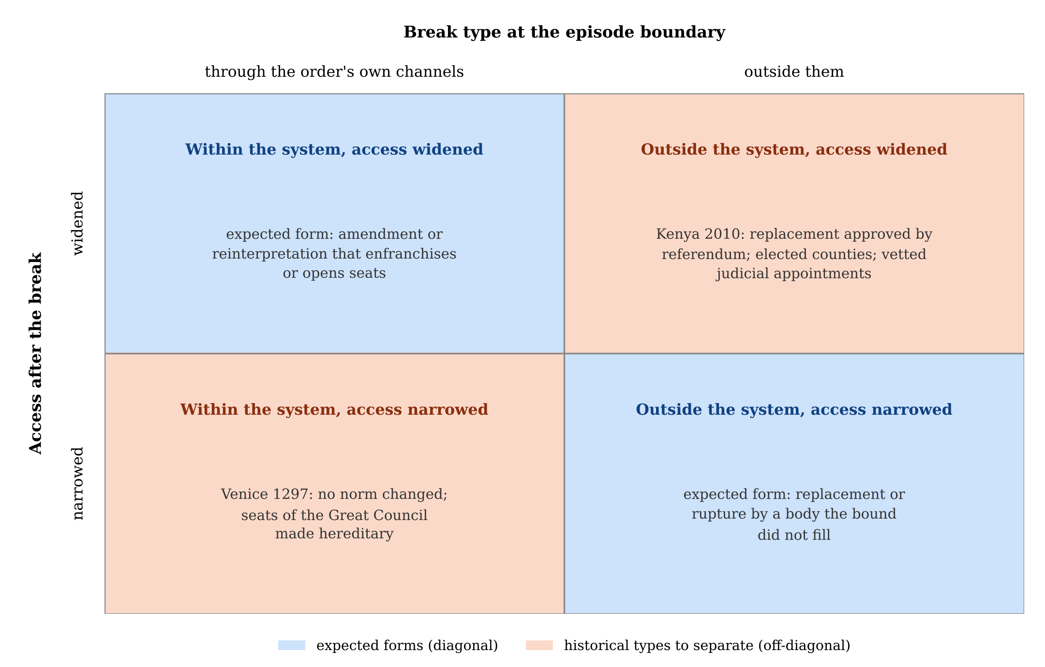
Figure 2. Break type by access direction. Rows: whether the bound population’s access to the revising bodies is wider or narrower after the break; columns: whether the break ran through the order’s own channels or outside them. The blue diagonal holds the expected forms; the two orange off-diagonal cells hold the historical types the measure is built to separate. Nothing in the figure is coded; it states the classification.
Over the same primitives a violation ratio and an ordinal ranking of orders can be defined, by counting the norms that fail the criterion of Section 3. The measures here are the empirical counterparts of such a criterion and nothing more: bound share operationalises the bound generation, the access profile operationalises accessibility, and the two crosses operationalise a diachronic audit of both. No ranking is computed here, and the article takes no view on which of the eight orders would rank where.

7. Pipeline and validation
The measures can be computed at world scale only if item (1) is built for every provision of every constitution that has been in force since 1789, and that is a data-mining task of a definite shape. The ontology specifies what counts; the extraction executes it; a human-coded record validates it. Each step has a known risk.
Corpus. Roughly nine hundred constitutional systems have been in force since 1789. The texts in force are digitised and tagged; most historical versions are not. Building (1) requires aligning each text with its predecessor at the level of the provision, which is a diff over versions and is feasible wherever the versions exist. Where they do not, the CCP’s per-event characteristics date changes to intervals, and (1) is coded at that resolution, with the loss of resolution recorded.
Language. Most available texts are translations. Alignment across versions in the original language is more reliable than across translations, and the provisions that carry the schema’s weight, amendment rules, eternity clauses, selection rules for the revising bodies, are few enough to be checked against originals for every system.
Extraction. Items (1) and (3) are extracted from texts; (2) from (1) joined with franchise rules, which are themselves coded; (4) from the text’s selection rules for the de jure half and from external sources for the de facto half. The last is the pipeline’s bottleneck and cannot be automated from texts: who in fact fills a court’s seats, and whether vacancies arise as the text says, must be coded from judicial and legislative records, country by country.
Validation. Where the extracted variables overlap with the CCP’s human-coded ones (amendment procedures, judicial review, selection rules), agreement is computed and reported; disagreement is adjudicated against the text, and the adjudication rule is published with the data. Where no overlap exists, as for (2), the measure is validated on the eight cases of Section 5 by independent double coding before it is run at scale.
Reuse. The texts in force are licensed for non-commercial use; the historical databank is licensed share-alike. A derived record must inherit both conditions, which constrains the platforms on which it can be served.
The pipeline is interdisciplinary in a precise sense: social ontology and constitutional theory decide the unit and the variables, data science executes the extraction, and neither could specify the task alone, since the unit is invisible to the records data science starts from and the scale is beyond what constitutional theory codes by hand.

8. Limits and a pilot
The schema is derived, not tested; the eight cases are described from the records and standard sources, not coded on the four items; the measures are stated, not computed; the pipeline is a design. One thing has been run, and it is reported here as a pilot rather than in Section 6, because it tests the records rather than the schema and because it was coded once. The forty-four post-crisis constitutional changes in the historical databank (Section 4) were classified from the databank’s own case descriptions on the two axes of Figure 2: break type (re-inscription from within the order’s channels; replacement; fragmentation; secession or independence; external imposition) and access direction (widened, narrowed, unclear). A provisional classification was drafted with the assistance of a large language model and then reviewed case by case and confirmed by the author. Table 3 gives the result.
Table 3. Pilot classification of the forty-four post-crisis constitutional changes in the historical databank (one reading, AI-assisted and author-confirmed; not independently validated). Source: Seshat CrisisDB case descriptions, Polaris-2026 release (Benam et al. 2022).
Break type | Access widened | Access narrowed | Unclear | Total
Re-inscription from within | 3 | 2 | 4 | 9
Replacement | 3 | 3 | 6 | 12
Fragmentation | 0 | 1 | 9 | 10
Secession or independence | 0 | 0 | 4 | 4
External imposition | 0 | 8 | 1 | 9
Total | 6 | 14 | 24 | 44
Three things can be read from the table, and all three are weaker than they look. First, the “unclear” column holds more than half the cases: the databank’s descriptions record breaks, not channels, exactly as Section 4 said, and for most crises they do not say who could reach the revising bodies before and after. Second, where access direction could be read at all, widening occurs only in the two break types that run through or replace a constitutional order, and never under fragmentation, secession or imposition; external imposition narrows access in eight of nine cases. This is the pattern Figure 2 predicts, but the cell counts are too small and the coder too few for it to count as evidence. Third, only eighteen of the forty-four cases fall after 1789, which is where the comparative record begins, so the pilot bridges to it rather than overlapping with it. The classification is a single reading of secondary descriptions, anchored on a machine-drafted proposal, and has not been independently replicated; it is published with the case-by-case notes so that it can be, and nothing in the article rests on it.
The records relied on have the limits stated in Section 4, and the deep-time databank’s coverage after 1800 is thin. The article’s claim is correspondingly limited: that the records now in use describe constitutions as the contract model does, as agreements fixed at a date; that an ontology of transgenerational action shows what they leave out; and that what they leave out can be stated as four coding instructions and computed as four measures. Whether constitutional time, so measured, explains anything is the next question, and it cannot be asked until the unit exists.
Data and code. The event counts of Section 5, the scripts for Figure 1 and Table 3, both figures, and the pilot classification with its case notes are in the public repository github.com/Luisbourguet/constitutional-time, archived on Zenodo with this preprint (doi:10.5281/zenodo.23903482).

References
Acemoglu, D. and J.A. Robinson 2012, Why Nations Fail: The Origins of Power, Prosperity, and Poverty, New York: Crown.
Andina, T. 2020, Transgenerazionalità: Una filosofia per le generazioni future, Roma: Carocci.
Benam, M. et al. 2022, Seshat: Global History Databank, Equinox 2020 Data Release, Zenodo, doi:10.5281/zenodo.6642229.
Bobbio, N. 1987, La teoría de las formas de gobierno en la historia del pensamiento político, trans. J.F. Fernández Santillán, México: Fondo de Cultura Económica (orig. La teoria delle forme di governo nella storia del pensiero politico, Torino: Giappichelli, 1976).
Elkins, Z., T. Ginsburg and J. Melton 2009, The Endurance of National Constitutions, Cambridge: Cambridge University Press.
Elkins, Z., T. Ginsburg and J. Melton 2014, “Constitute: The World’s Constitutions to Read, Search, and Compare”, Journal of Web Semantics 27-28, 10-18.
Elkins, Z., T. Ginsburg and J. Melton 2026, Comparative Constitutions Project: Chronology of Constitutional Events, Version 6.0, and Characteristics of National Constitutions, Version 5.0, comparativeconstitutionsproject.org.
Hobbes, T. 1642, On the Citizen, ed. R. Tuck and M. Silverthorne, Cambridge: Cambridge University Press, 1998.
Hume, D. 1748, “Of the Original Contract”, in Miller E.F. (ed.), Essays, Moral, Political, and Literary, Indianapolis: Liberty Fund, 1987, 465-87.
Lawson, T. 2015, “A Conception of Social Ontology”, in Pratten S. (ed.), Social Ontology and Modern Economics, London: Routledge, 19-52.
Turchin, P. et al. 2015, “Seshat: The Global History Databank”, Cliodynamics 6, 77-107.

Quotations from Andina (2020) and Bobbio (1987) are given in the author’s translation; Hobbes and Hume are quoted as Andina quotes them, and the standard English editions are listed in the references.
Her list of transgenerational domains (2020: 139) names debt, pensions and the environment. The constitution’s absence is not an oversight on her part but a sign of how deeply the contract model shapes even its critics: the constitution is still read as the pact, not as the transgenerational action that sets the terms of the others.

