Ideological Signatures: A Grid-Relative Criterion for the Individuation of Ideologies
Luis Felipe Bourguet González
LabOnt – Center for Ontology, University of Turin; Complex Systems Science Laboratory, Hiroshima University
ORCID: 0000-0002-4673-4486 · luisfelipe.bourgetgonzalez@unito.it
Preprint, version 1 (October 15, 2026). This manuscript has been submitted for peer review to the Journal of Social Ontology. It has not yet been peer reviewed. Licensed under CC BY 4.0. Please cite as: Bourguet González, L. F. 2026. “Ideological Signatures: A Grid-Relative Criterion for the Individuation of Ideologies.” Preprint. Zenodo. https://doi.org/[DOI assigned on deposit].
Abstract. What individuates an ideology? Doctrinal criteria fail because doctrines migrate across families and families survive doctrinal revision; morphological criteria improve on them by attending to how concepts are arranged, but remain internal to what an ideology says. This paper proposes a grid-relative criterion: an ideology is individuated by what it does to a grid of questions it did not author and cannot abolish. Within a stratified, emergentist-realist account of social reality, a matrix M = C × S crosses five existential conflicts with four social subsystems; each of its twenty cells holds a question thematized by durable symbolic forms before any ideology intervenes. An ideology operates on the matrix as a bounded weighting ω over the cells and as a chain of six operators — translation, fusion, naturalization, silencing, revelation, scission — understood as species of decontestation acting on questions rather than on concepts, and realized by specifiable social mechanisms. The signature of an ideological family is the pair ⟨ω, chain⟩. Families are treated as historical kinds, not stipulated types: membership is fixed by lineage and replication, and the signature is the syndrome that the lineage explains. The framework locates its claims with the help of the grounding/anchoring distinction, answers the fictionalist denial of social levels, and states which of its results are argued, which are proposed, and which are conjectured. A closing protocol specifies how ω and the operators can be estimated from corpora and what observations would disconfirm the signatures proposed for ten families.
Keywords: ideology; social ontology; individuation; decontestation; historical kinds; emergence.

1. Introduction: The Problem of Individuation
What individuates an ideology? By what criterion do we distinguish one ideological family from another, and a family from one of its variants? The question has rarely been asked as a question of social ontology — about what kind of thing an ideology is such that it can be told apart from its neighbors. This paper asks it in that form.
The doctrinal criterion individuates an ideology by what it affirms: an ideology would be its body of doctrines. The criterion fails twice. Doctrines migrate across families — planning has inhabited socialism and fascism, the free market liberalism and certain authoritarianisms — so that no statement is the exclusive property of one family; and families survive radical doctrinal revision without losing their identity, as any history of socialism or conservatism shows. The morphological criterion, developed by Freeden (1996) and now the dominant approach in the field, refines the doctrinal one by shifting the locus of identity from contents to their arrangement: an ideology is a configuration of concepts — core, adjacent, peripheral — each of which it decontests, fixing one of its possible meanings against the others. The refinement is real, and the present proposal keeps its central insight: that identity lies in operations performed on a shared material rather than in a list of propositions. But the morphological criterion remains internal to the order of concepts, and its own practitioners have said as much. The editor of the field’s journal concedes that lists of the concepts and families that populate a position are “only ever going to be contingently accurate descriptions” (Ostrowski 2023, 8), and that morphology sees “only the tip of the ideological iceberg, whereas ideological contents below the linguistic waterline remain invisible” (Turunen 2026, 50). What lies below the waterline is not a further concept. It is the set of questions an ideology answers, reformats, or refuses — questions it did not author and to which it is answerable whether or not it names them.
The thesis of this paper is that ideologies are individuated grid-relatively: by what they do to a grid of questions that precedes them and that they cannot abolish. The differentia from the morphological approach is not, as one might first put it, that morphology studies arrangement whereas we study function; morphology, too, holds that concepts shape and are shaped by social action (Ostrowski 2025, 3). The differentia is the exogenous grid. Morphological analysis selects from “the (real or imagined) ‘overall’ list of social concepts” (Ostrowski 2025, 9) without a principled closure of that list; the present account supplies one — twenty questions generated by crossing five existential conflicts with four social subsystems — and relocates decontestation from concepts to questions. On this reading an ideology responds not to a conflict as such but to a conflict already thematized by durable symbolic forms, and its intervention consists in redistributing, reformatting, or closing questions that are not its own. Because it operates on a material that precedes it, the operation leaves traces, and traces can be observed.
Three clarifications fix the scope of the claim. First, “ideology” is used throughout in the general, non-pejorative sense current in ideology studies — a configuration of political thinking, not a distortion of it — although the operators defined below can be read, by those who hold a pejorative theory, as the mechanisms of such distortion (Wilson 2021). Second, the proposal does not replace the left–right axis, which recent work has shown to be a resilient and reconstructible object (Ostrowski 2023); the axis is here a low-dimensional projection of the grid — a reading of two of its rows — and that is precisely why it is both indispensable in practice and insufficient as a criterion. Third, the paper distinguishes throughout between what it argues, what it proposes, and what it conjectures. The criterion of individuation and the location of the operators within social ontology are argued; the formal apparatus and the estimation protocol are proposed; the signatures assigned to ten families are conjectures that the protocol is designed to test. The paper is, in Larue’s (2025, 233) sense, a theoretical first step that states the conditions of its own empirical examination.
The argument proceeds as follows. Section 2 locates the proposal within a stratified account of social reality, specifies in what sense the account is emergentist, and uses the grounding/anchoring distinction to say which of its elements fix the frame and which fix a given ideology. Section 3 defines the matrix M = C × S, its twenty questions, and the weighting function ω. Section 4 defines the six operators as species of decontestation and gives, for each, the mechanism by which it is socially realized. Section 5 treats ideological families as historical kinds, states the protocol by which membership is established, and presents the signatures of ten families as hypotheses. Section 6 indicates how the apparatus extends from doctrines to institutional architectures. Section 7 specifies the estimation protocol and the observations that would disconfirm the conjectures. Section 8 concludes.

2. The Stratified Architecture
The formal system does not float. It presupposes a stratified account of symbolic reality developed in a companion paper (Bourguet González, under review), recalled here in the form needed to make the present essay self-contained and reformulated in the vocabulary of social ontology.
Five strata. Stratum 0 is the realist-emergentist principle: reality, symbolic reality included, emerges from the world to thought, and the analyst recognizes it rather than fabricating it (Ferraris 2012, 2016; on emergence as an autonomous category, Onnis 2021). Stratum 1 gathers five existential conflicts that no society chooses and none avoids — survival, belonging, order, meaning, transformation (C1–C5) — a convergence of functionalist and interpretive anthropology (Malinowski 1944; Geertz 1973). Stratum 2 is that of durable symbolic forms — rites, institutions, artifacts — in the sense of Cassirer (1923–1929) and Langer (1942), with the worldly durability that Arendt (1958) assigns to the products of work. Stratum 3 is the material substratum: the four subsystems — biological, economic, political, cultural (S1–S4) — of systemic ontology (Bunge 1979; Romero 2025), with technology as a transversal product of the cultural subsystem that acts back on the other three. Stratum 4, finally, is that of ideological crystallizations: instituted imaginaries that forget their own institution (Castoriadis 1975) and naturalize themselves as hegemony (Gramsci 1975). Following systemic materialism, each crystallization can be formalized as an eleven-element belief field, I = ⟨C, S, D, G, B, A, P, V, I, O, M⟩: a community of believers C acting on a host society S over a domain of objects D, with a worldview G, a background knowledge B, a doctrinal body A with an inalienable core A_core, a set of problems P, values V, ideals I, objectives O, and methods M (Romero 2025). The formula is not a formalist fetish: three of its elements fix the slots that the signature defined below will occupy. P states which questions of the matrix a family declares it answers; A_core and V supply the doctrinal name and the normative criterion of what Section 3 will call the gravity cell, so that ω can be read as the projection of ⟨P, A_core, V⟩ onto the grid. And C, S, and M fix what no doctrinal corpus can: the lineage of the believers, the channel through which the family replicates, and the methods by which it acts — the evidence on which Section 5 will ground family membership as a historical kind rather than a stipulated type.
In what sense “strata.” The word invites two objections that social ontology has made precise, and the account must meet both. The first is the fictionalist’s: there are “different scales involved […] but there are no ontological levels proper”; what we call social entities are devices that stabilize “certain structural features of the sociomaterial assemblages in which we are integrated,” and parsimony places the burden of proof on whoever posits more (Brännmark 2026, 5, 7). The second is the naturalized critical realist’s: emergent powers should be ascribed only to “non-aggregative dispositional properties of concrete entities” — particular parties, governments, churches — and not to abstract levels (Kaidesoja 2015, 325). The reply to both is the same, and it concedes as much as it defends. The strata are not additional entities. They are regimes of constraint: a stratum is a level in the local and contextual sense in which, for an emergentist, “the appearance of systemic constraints can represent the appearance of new levels” (Onnis 2021, 292; cf. Wimsatt 2007). Brännmark himself supplies the material for this reading when he grants that assemblages exhibit “stronger and weaker intensities,” “higher or lower viscosity,” and “clusters of intense interrelatedness” (2026, 5): a stratum, in the present account, is nothing more than a stable regime of such viscosity, and the five conflicts, the symbolic forms, and the subsystems are each such a regime. Kaidesoja’s restriction is accepted in full: emergent causal powers belong to stratum 4, to concrete ideological formations and their carriers; strata 0–3 are not powerful particulars but the frame within which such particulars act. The two further arguments of the fictionalist — that founding acts are Cambridge changes which bring nothing new into existence, and that collective acceptance presupposes institutions already in place (Brännmark 2026, 7–8) — do not reach the account, because a signature is not founded by a declaration and has no birthday: it is a pattern of operations, and the backing of such patterns is causal and prior, not declarative (Elder-Vass 2015, 260; see Section 4).
Frame, grounds, anchors. Epstein’s distinction between the facts that ground a social fact and the facts that set up the conditions of its grounding — “We need to distinguish the facts that set up these ways of grounding from the facts that do the grounding” (Epstein 2015; 2016, 129) — allows the account to say precisely which of its claims is which. The matrix and the strata are frame principles: they articulate how any ideological fact is grounded, across all concrete formations, and they are nested, as Epstein allows frame principles to be (2016, 130). The belief field I of a given formation, with its signature ⟨ω, chain⟩, is what grounds the fact that this formation is the ideology it is. What anchors the conditions of family membership — why these corpora, carriers, and practices count as instances of liberalism rather than of something else — is a historical question about lineage and replication, which Section 5 answers with the resources of the theory of historical kinds (Bach 2016). And what anchors the frame itself — why these five conflicts and these four subsystems — is the realist principle of stratum 0 together with the anthropological and systemic evidence recalled above; it is held fallibly, with “exactly the same (i.e., more or less fallible)” epistemic status as any explanatory theory in the social sciences (Kaidesoja 2015, 324), and it is the claim least likely to survive unrevised. The paper fills the first two slots, outlines the third, and holds the fourth as a working hypothesis.
The vertical reading of the strata is the argument itself (Fig. 1). A conflict (stratum 1) is thematized by symbolic forms (stratum 2), which distribute it over the material subsystems (stratum 3); an ideology (stratum 4) is the resulting trajectory of selection and weighting. The second stratum is the middle term of the construction: without it, the bond between conflict and doctrine remains either immediate — ideology as a direct response to need, the functionalist vice — or arbitrary — ideology as construction without substratum, the constructivist vice. The matrix defined next lives in stratum 2: it is the product of symbolic mediation, not an artifact of the theorist.
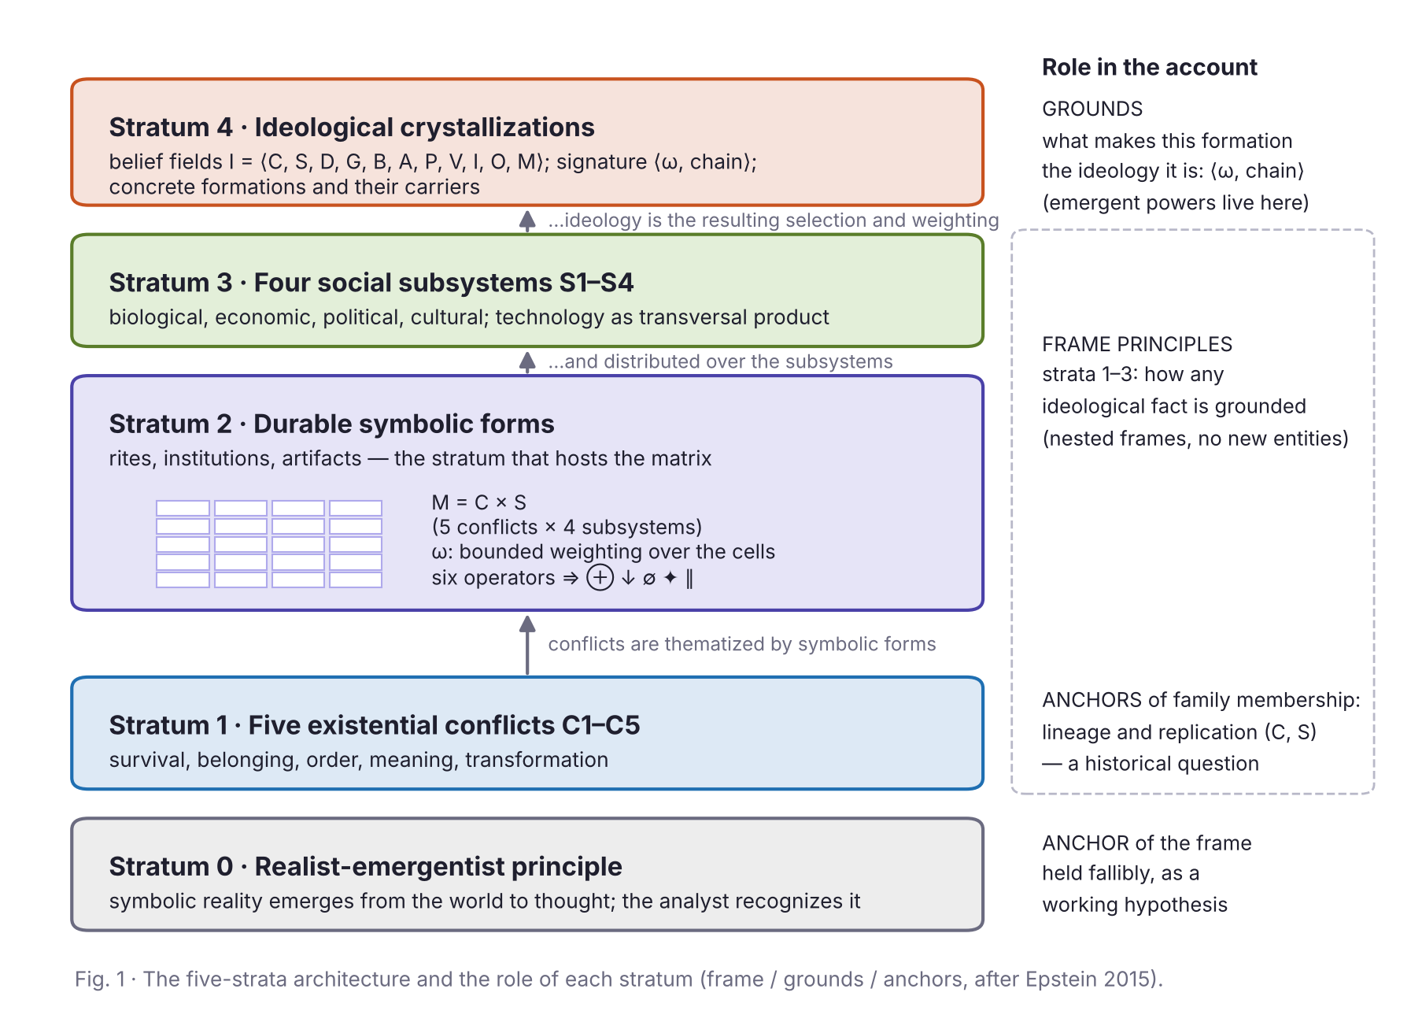
Fig. 1: The five-strata architecture and the role of each stratum in the account. The C × S matrix lives in stratum 2, as the product of symbolic mediation between conflicts (stratum 1) and subsystems (stratum 3); strata 1–3 are frame principles, stratum 4 holds the grounds of a given formation, and family membership is anchored in lineage.

3. The Matrix M = C × S and the Weighting ω
Let M = C × S be the matrix crossing the five existential conflicts with the four subsystems. Each of its twenty cells (i, j) contains what we call an unamendable question: a question that no ideology formulates first and none can abolish, because it arises from the encounter between a conflict of stratum 1 and a subsystem of stratum 3, mediated by the symbolic forms of stratum 2. Table 1 states the twenty questions.
 | S1 Biological | S2 Economic | S3 Political | S4 Cultural
C1 Survival | (1,1) Which bodies are to be kept alive, and until when? | (1,2) How is the scarce produced, and who bears the deprivation? | (1,3) Against whom do we defend ourselves, and what may be sacrificed? | (1,4) How is death to be said so that life remains livable?
C2 Belonging | (2,1) Who begets with whom, and which children count as ours? | (2,2) Which work makes one a member and not a parasite? | (2,3) Where does the border between citizen and foreigner run? | (2,4) In which language and with which myth of origin do we recognize ourselves?
C3 Order | (3,1) Which hierarchies of sex and age are said to be natural? | (3,2) What justifies that some possess what others need? | (3,3) Who decides in the last instance, and why do we obey? | (3,4) Who has the authority to say the true and fix the canon?
C4 Meaning | (4,1) What is a human being, and what is it given to be? | (4,2) What makes something worth, and someone deserve it? | (4,3) What makes a power legitimate and not mere force? | (4,4) Why this world, and not nothing or another?
C5 Transformation | (5,1) What of our nature can we alter while remaining ourselves? | (5,2) What must be destroyed for the new to be produced? | (5,3) Is the order changed from within or by breaking it? | (5,4) What of the past obliges, and what may be abandoned?
Table 1: The matrix M = C × S: the twenty unamendable questions.
Unamendable, not transcendental. The adjective must be read in the right register. The questions are not deduced from the conditions of possibility of society; they are proposed as robust — recurring, in one grammar or another, across every corpus and society we have been able to examine, and resisting the attempts of particular ideologies to make them disappear. The claim is thus an inference to the best explanation of a recurrence, revisable if the recurrence fails, and it is offered with the fallibilism that Kaidesoja (2015, 324) rightly demands of any ontological claim about the social world. Two features of the formulation follow. The questions are phrased in the first person plural because that is the grammatical form of their robustness: they are the questions a collectivity finds already posed by the fact of persisting. And the cells contain neither answers nor the symbolic forms themselves, but the question that the forms of that cell thematize: the hospital, the granary, the quarantine, and the funeral rite are historically variable answers to row C1; the question remains.
The weighting ω. On this grid we can give the first half of the formal definition. An ideology I operates as a weighting function ω_I : M → [0, 1], with Σ ω_ij = 1 — the formal counterpart of the selection that A_core and V perform within the belief field. The value ω_ij measures how much of the ideology’s hermeneutic budget is spent in cell (i, j): how much interpretive attention, argumentative density, and practical urgency the formation invests in that question. Constitutive morphology already works with the informal version of this quantity when it speaks of “the selections that ideologies make […] and the possible emphases and prioritisations they evince by how they ‘deploy’ the selected concepts” (Ostrowski 2025, 9), and when it recognizes that an ideology “isolates which” conditions of action “are (or ought to be) of decisive relevance” (Ostrowski 2026, 29–30). What ω adds is a closed inventory over which emphasis is measured, and a constraint.
Why the budget is bounded. The normalization is not a convention of convenience, and since nothing in the morphological literature assumes it, it must be argued for. Three considerations support it. The first is Simon’s (1971) thesis on attention as a scarce resource, extended here from information to interpretation: what is scarce is not only the receiving of messages but the keeping open of questions, and no discourse can thematize every question with equal intensity. The second is empirical and comes from the morphological camp itself: an ideology that attempts to saturate the grid does not thereby escape the constraint but produces what has been described as “manufactured comprehensiveness by morphological silences” (Kofoed Hansen 2026, 7) — the appearance of answering everything is bought by closing cells, not by weighting them all. The third is methodological: without a bound, two formations could differ only in overall volume, and individuation would collapse into a measure of verbosity. The bound makes every ideology an economy of attention — and hence partial, which is what distinguishes it from an ontology: an ontology may claim to say everything about being; an ideology can only choose where to spend, and the choice is already the signature. Whether the bound is exactly 1 or a weaker constraint on the total is left to estimation (Section 7); what matters is that there is one.
ω and the morphological core. The relation to Freeden’s core/adjacent/periphery is straightforward once the levels are kept apart. A family’s high-ω cells are its core questions; the Freedenian core concepts are the answers it has decontested there. The gravity cell — the cell, or pair of fused cells, with maximal ω — is the Archimedean point from which the formation answers every other question, and its doctrinal name is A_core. This is why the left–right axis is both recoverable and insufficient: read along rows C3 (order) and C5 (transformation), the lexical content that Ostrowski (2023, 9–10) finds in “right” and “left” — maintaining versus subverting the order, steady versus drastic action — is the projection of ω onto two rows of the grid. The axis is a real feature of the distribution; it is not the distribution.
The definition has an immediate corollary. Since all the cells exist in every society, what varies is not the grid but the distribution over it. Two ideologies are not distinguished by the questions that exist in their world but by the weight they assign to each and, more deeply, by the transformations they impose on the grid itself. Those transformations are the object of the next section.

4. The Six Operators as Species of Decontestation
The distribution ω is the state; the operators are the dynamics. The constraints between cells are what a flat table does not show: every ideology executes them, none declares them. We call operators the transformations that a formation imprints on the distribution ω and on the topology of the matrix, and we identify six (Table 2). Before defining them, two framing remarks fix what kind of thing they are.
Operators are decontestations of questions. In morphological analysis, decontestation is the act by which an ideology fixes one of the contested meanings of a concept as the meaning; it is the field’s master term and is used, as a rule, without definition (Ostrowski 2025, 2, 10–11, 15). The operators defined here are species of decontestation, with one displacement: they act on the questions of the grid rather than on concepts. To naturalize a cell is to decontest it by declaring it answered by nature; to silence it is to decontest it by omission; to reveal it is to re-contest what had been decontested. The displacement matters because the morphological camp has already recognized that what an ideology does not say is constitutive — “terra nullius wastelands littered with concepts that have been forgotten or left unclaimed” (Ostrowski 2025, 6); emotional weighting that gives concepts “relative silence” and “weld[s] concepts together or prize[s] them apart” (Kofoed Hansen 2026, 5) — without having a closed inventory against which omission, welding, and prizing apart could be registered. The grid is that inventory.
What a specified operator must contain. The desk-level objection that formal apparatus of this kind is “under-specified” is best met by adopting a specification standard from the literature on ideology-like phenomena. Wilson’s (2021, 51–52) desiderata for an explanation of false consciousness transfer directly: an operator is specified when one can say how carriers acquire the disposition to treat a cell in that way (Acquisition); why that cell and not another is affected (Content); why some carriers of the same family do not apply it (Scope); and what single principle unifies the operators and ω into one signature (Systematicity). The first three are answered below, operator by operator, by naming a mechanism drawn from the social-ontological literature; the fourth is answered by the gravity cell: a signature is systematic in Arendt’s sense of the “logic of an idea” (Wilson 2021, 52 n. 9) because every operator is executed from, and in the service of, the cell where the family’s budget is concentrated.
Operator | Notation | Definition
Translation | (i,j) ⇒ (k,l) | The original question is declared ill-posed and answered with the answer of another cell. ω(i,j) → 0; ω(k,l) ↑.
Fusion | (i,j) ⊕ (k,l) | Two cells are declared a single question; their distinction becomes unsayable.
Naturalization | (i,j) ↓ S | The question is remitted to a subsystem S — typically S1 — and declared resolved by its nature; it leaves the space of the discussable without being discussed.
Silencing | ∅(i,j) | The cell is declared nonexistent or resolved in advance. ω(i,j) = 0.
Revelation | ✦(i,j) | A previously naturalized or silenced cell reopens as a question. ω(i,j): 0 → positive.
Scission | (i,j) ∥ (i,l) | One and the same conflict receives incompatible answers in two subsystems, without arbitration.
Table 2: The six operators.
Translation (i,j) ⇒ (k,l) declares the original question ill-posed and answers it with the answer of another cell: ω(i,j) tends to zero while ω(k,l) grows, but — unlike silencing — the original question keeps receiving an answer, only it is the answer to another question. It is the hardest operator to detect because the ideology does not deny the question; it reformats it. Whoever asks about belonging and is answered about contract, whoever asks about the meaning of the world and is answered about class position, is witnessing a translation, and as a rule does not notice, because an answer, after all, arrives. Its mechanism is the accommodation of speech acts: a question posed in one vocabulary is taken up, by the carriers of the family, in another, and the uptake is enforced by the norm circle that backs the family’s way of speaking (Elder-Vass 2015, 260; Wilson 2021, 63).
Fusion (i,j) ⊕ (k,l) declares that two cells are a single question: from that moment their distinction becomes unsayable within the formation. To fuse biological belonging with legitimate order, or the political border with the common language, is not to answer twice; it is to make it grammatically impossible to ask about the one without asking about the other. Its mechanism is what Wilson calls the compounding of schemas, by which “a given false consciousness can gain not only content but further stabilising mechanisms” (2021, 66); the morphological literature registers it as the welding of concepts into “tightly-knit” clusters with “a meager interpretational spectrum” (Kofoed Hansen 2026, 6). Fusion is not the sum of two weightings. Two fused cells behave as one node of the grid, and this non-additivity — which Wilson (2021, 50) emphasizes for schemas in general — is what distinguishes a fusion from two high weights that happen to co-occur.
Naturalization (i,j) ↓ S remits the question to a subsystem and declares it resolved by that subsystem’s nature: the cell leaves the space of the discussable without having been discussed. The target is typically the biological (↓S1) — “the order of things,” in Bourdieu’s (1980) doxa, Barthes’s (1957) transformation of history into nature — but it need not be: the same operation can remit a question to economic necessity (↓S2) or to the will of God (↓S4), as the morphological analysis of totalitarian essentialism notes when it observes that the resource for essentialism “may be drawn not only from science but from other epistemic frameworks” (Kofoed Hansen 2026, 9). Parametrizing the operator by its target subsystem is therefore part of its specification. It is the most effective of the operators because it leaves no trace: the cell does not appear empty but full — full of reality itself. Its mechanism is the one that Althusser described as interpellation and Hacking (1995) as the looping of a classification into the self-understanding of the classified: the carrier is hailed as a participant in a structure within which “this state of affairs is naturalised,” so that looping mechanisms “normalise, or render ‘natural’, existing oppressive relations” (Wilson 2021, 59, 64). At the level of the norm circle, naturalization is the case in which the backing of a norm is attributed not to the people who enforce it but to “God, or religion, or society, or the nation, or the law” (Elder-Vass 2015, 262).
Silencing ∅(i,j) declares the cell nonexistent or resolved in advance: ω(i,j) = 0, and the question does not even receive the answer of another. Its mechanisms are the hermeneutical and testimonial injustices that remove the means of posing a question or the standing to pose it (Wilson 2021, 63), and, in the limit, the removal of concepts “from the political lexicon” that Freeden attributes to totalitarian ideologies (Kofoed Hansen 2026, 8). Silencing is also the operator that the fictionalist’s politics of interpretation describes best: among the stories that can be told about a society, “certain stories will dominate, while others will be marginalized,” and others “will remain at the level of the merely possible” (Brännmark 2026, 18) — the silenced cell is the merely possible story.
Revelation ✦(i,j) is the inverse operator: a cell previously naturalized or silenced reopens as a question, and ω(i,j) goes from zero to a positive value. It is the only operator that enlarges the space of the discussable instead of reducing it, and the only one that names the others — a circumstance to which Section 5 returns, because it defines an entire family. Its mechanism is what Wilson calls neutralization, the overlap of schemas that “condition[s] the prevention or erosion” of a naturalized belief (2021, 66), and what the politics of interpretation calls the counterstory (Brännmark 2026, 18–19). Revelation is costly in a way the other operators are not: it requires the carrier to oppose not a norm but an ideal against which she is measured by others, and the telic power of the dominant family — power that “does not require the agent to recognise the norms it depends on” (Gulì and Moretti 2025, 187–188) — continues to operate on her while she reopens the cell.
Scission (i,j) ∥ (i,l), finally, gives one and the same conflict incompatible answers in two subsystems, without arbitration: it does not close the question, it splits it. Of the six operators it is the one that belongs least to doctrines and most to institutional architectures, which is why Section 6 reserves it for the extension of the apparatus from families to states.
Composition and the hold of a signature. The operators compose. A chain such as “(1,2) ⇒ (2,3); ∅(4,4); (3,1) ↓ S1” — translating scarcity into the border, silencing the question about the world, naturalizing hierarchy — is not a list of traits but an executable program, in the sense that each operator prepares the space on which the next one acts. And the composed signature has a hold on agents who do not share it. Here the distinction between deontic and telic power, introduced by Burman (2023) and refined in the ensuing discussion (Gulì and Moretti 2025, 174, 177; Sucaet 2026), is the right instrument. Deontic power is binary and requires recognition: it is the power of the roles that a formation institutes at stratum 4, and it reaches only those who recognize them. Telic power is scalar and operates through the perception, by others, of an agent’s distance from an ideal; it reaches “even if he or she firmly opposes these norms” (Gulì and Moretti 2025, 188). Hegemony, in this vocabulary, is the regime in which one family’s naturalized answers have become the ideals against which the carriers of every other family are measured: a signature constrains without consent and yet, as Gulì and Moretti insist against a purely conflictual picture, never without some recognition and cooperation (2025, 187) — the deontic layer is recognized, the telic layer is suffered. It is also why ω must not be mistaken for a cause. ω describes a tendency of carriers — the diffuse causal determination that an emergent whole exerts on its base without exercising a power of its own (Onnis 2021, 285–294) — and its efficacy is always that of the norm circles that back it (Elder-Vass 2015, 258–260). A formal description of a signature is not an explanation of its persistence; it is the instrument that tells the explanatory research where to look.

5. Ideological Families as Historical Kinds
We define the signature of an ideological family as the pair ⟨ω_I, operator chain⟩: the distribution of weights and the sequence of transformations the family imprints on the matrix. To the distribution belongs, in particular, the gravity cell. Table 3 gathers the signatures of ten families; Fig. 2 gives each signature as a card — the ω distribution with the operators superimposed — and Fig. 3 the operator graphs of the two polar cases. Before the table can be read, however, its logical status must be fixed, because the most serious objection to an exercise of this kind is not that a given entry is wrong but that the entries are stipulated.
Why families cannot be stipulated. A classification that defines each family by a profile of properties — “liberalism is the family whose signature is such-and-such” — is what Bach calls an objective type: a similarity class whose unity consists in members sharing a stipulated property. Such classifications are “analytically but not synthetically projectable” (Bach 2016, 197–198): they license no inference beyond the defining properties, and when the stakes are high and a natural-kind taxonomy is available, stipulating one is “both an empirical and political gamble” (194). Bach’s alternative is the historical kind — a natural kind whose members “tend to share likenesses due to historically situated copying processes” (181), and whose essence is a lineage rather than a property. Kaidesoja (2015, 325) reaches the same point from the side of naturalized critical realism, disconnecting causal powers from essence-based kinds in favor of homeostatic-cluster and looping kinds. Ideological families are historical kinds in exactly this sense. What makes a corpus, a party, or a movement an instance of socialism is not that it exhibits a profile but that it descends, by replication and design, from a lineage of carriers — Romero’s C and S, the community of believers and the host societies through which it has traveled — and the signature is the syndrome that this lineage explains: the set of properties its members “tend to share […] for the same reason” (Bach 2016, 180). Bach’s three conditions for preferring a natural-kind taxonomy over a stipulated one — that causal-explanatory structure matters for the purposes at hand, that there is support for the natural-kind taxonomy, and that stipulation would screen off generalizations otherwise available (189) — are all satisfied here: ideology studies’ own practice of tracing families through their histories (Freeden 1996, 90–91, quoted in Turunen 2026, 62: “structural, empirically ascertainable common features over time and space”) is the support, and the predictions of Section 7 are the generalizations.
Membership protocol. Accordingly, the assignment of a formation to a family proceeds in two steps, only the second of which involves the signature. First, lineage: a formation belongs to a family if it descends from the family’s founding corpus and carriers by identifiable channels of replication — organizational location, recognition by and of the parent tradition, canonical texts transmitted and contested within it. These are the criteria that the morphological literature itself applies when it adjudicates hybrids: whether a would-be hybrid is sustained by an organization, recognized by its parents, and capable of action and choice, as opposed to being a localized variant of one parent or a failed hybrid that sustains no organization, policy direction, or canon of its own (Franks 2016). Second, signature: the formation’s ω and chain, estimated by the protocol of Section 7, are compared with those of the family’s other members, and the family’s signature is the neighborhood in ω-space and the set of chains within which members fall. This is the signature-level version of what Ostrowski (2025, 19–20) calls the necessitarian variant of morphology — the identification of what “has to be present in every case in order for something to ‘count as’ an instance of a given ideology” — with the question of boundaries posed as he poses it: “how semantically far apart particular instances […] can lie before it stops being meaningful to use the same terminology” (2025, 17). The ten families below are the field’s working roster (Ostrowski 2025, 7), with two deviations stated: accelerationism and degrowth are added because they furnish an internal test of the apparatus, and communism, social democracy, and libertarianism are treated as variants within socialism and liberalism rather than as families, a decision that the protocol can overturn.
The signatures as hypotheses. With this status fixed, Table 3 is to be read as ten conjectures about the syndromes of ten lineages, formulated from the canonical corpora of each family and awaiting the estimation that Section 7 specifies. For each entry the table gives the gravity cell, the chain, and the reading that the chain yields.
Family | Gravity | Chain | Reading
Liberalism | (3,2) | (2,3) ⇒ (3,2); (2,4) ⇒ (3,2); ∅(3,1) | Every belonging is contract. Community dissolves into property and consent; the hierarchy of S1 becomes unsayable, since thematizing it undermines the presupposed contracting individual.
Socialism | (1,2) ⊕ (3,2) | (4,4) ⇒ (3,2); (2,4) ⇒ (2,2) | Every meaning is position. The question about the world is deactivated as false consciousness. Row C4 stays underweighted: when meaning returns, the grammar is missing.
Anarchism | ∅(3,3) | (3,3) ⇒ (2,2) | The only family to silence a stratum-1 cell: sovereignty is artifact, not conflict. The residue (who does not cooperate?) reconstitutes it.
Conservatism | (5,4) | (5,2) ⇒ (5,4); (3,1) ↓ S1 | Every transformation is loss. It inverts the burden of proof; hierarchy is not argued, it is inherited as a given.
Fascism | (2,1) ⊕ (3,3) | (1,2) ⇒ (2,3); ∅(4,4); (3,1) ↓ S1 | Biological belonging IS the legitimate order. Scarcity cannot be internal: it comes from the enemy. The most concentrated profile of the table.
Nationalisms | (2,3) ⊕ (2,4) | (1,2) ⇒ (2,3) | Every scarcity is external threat. It does not fuse with sovereignty: a translation module graftable onto a host.
Christian democracy | (2,1) ⊕ (4,4) | (1,2) ⇒ (2,1) [subsidiarity] | It does not translate: it interposes. The intermediate bodies between market and person. Secularization empties its gravity cell from the outside.
Ecologism | (1,1) ⊕ (5,1) | (1,2) ⇒ (1,1); ✦(5,1) | Survival is biological, not economic. The inverse of naturalization: it brings the economy into S1 in order to open it.
Feminisms | ✦(3,1); ✦(2,1) | — | A pure operator of revelation. It reopens the cells the others kept closed by common agreement. It composes with every host signature.
Accelerationism / degrowth | (5,2) | ∅(5,4); ∅(4,4) | Same cell, opposite derivative. Proof that ω is necessary but not sufficient: the pair ⟨ω, chain⟩ is required.
Table 3: Ideological signatures as ⟨ω, chain⟩ pairs: ten conjectures.
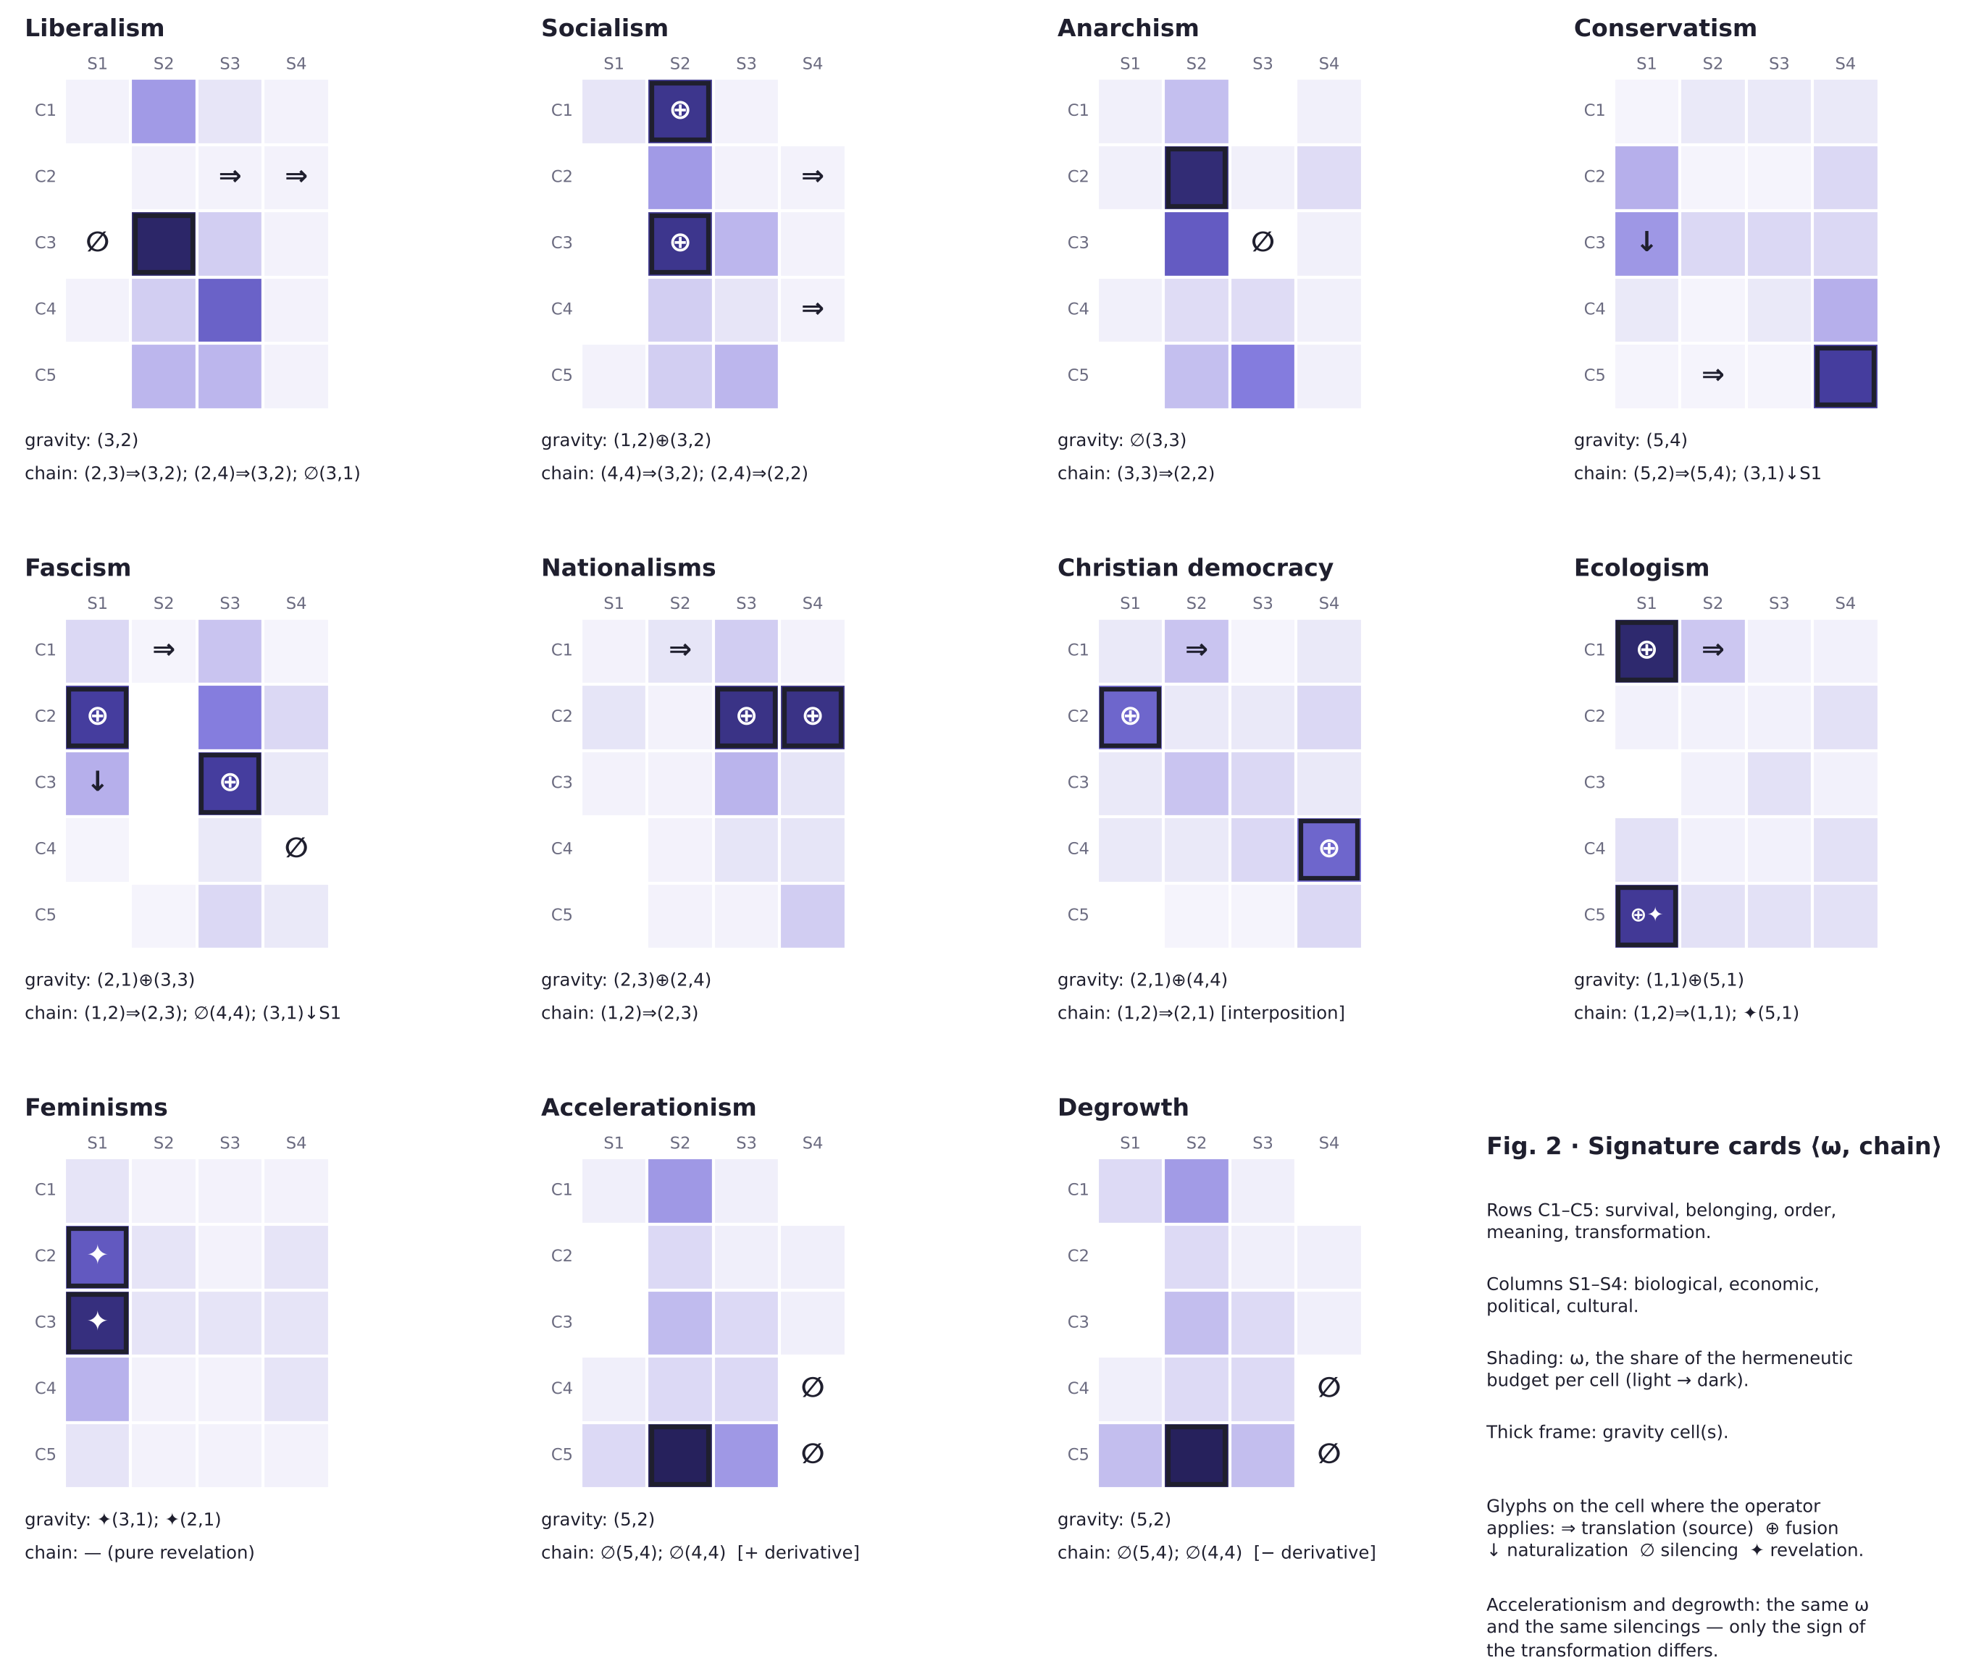
Fig. 2: Signature cards ⟨ω, chain⟩ for the eleven formations of Table 3 (accelerationism and degrowth shown separately). Shading is ω, the share of the hermeneutic budget per cell; the thick frame marks the gravity cell; glyphs mark the cell on which each operator applies.
Four entries illustrate how the readings are generated. Liberalism translates political and cultural belonging into the question of possession, and silences (3,1) because thematizing the hierarchy of bodies would undermine the contracting individual that every translation presupposes as already constituted. Socialism fuses scarcity and possession and translates the question about the world into class position; row C4 remains underweighted, and when meaning presses back — as it recurrently does in post-socialist societies — the grammar to receive it is missing. Anarchism silences a stratum-1 cell, ∅(3,3), and the empirical residue — who does not cooperate? — reconstitutes it, because silencing, unlike resolution, does not eliminate the pressure of the question. Conservatism translates creative destruction into obligation to the past and naturalizes hierarchy; discourse-theoretic analysis reaches the same formal characterization when it defines the conservative logic not by substance but by the articulation of demands as conservation against change construed as a dislocatory threat (De Cleen 2018).
Fascism presents the most concentrated profile of the table: fusion of biological belonging and legitimate order ((2,1) ⊕ (3,3): who begets with whom IS who legitimately commands), translation of scarcity into the border, silencing of the question about the world, and naturalization of hierarchy. “Concentrated” can now be given content. In the terms of the morphological analysis of extreme ideology, fascism combines fundamentalism — an intensity “that makes [core beliefs] virtually immune to challenge” — with essentialism — “a supra-historical, universalist, and generic categorization” — and manufactures comprehensiveness by silence (Kofoed Hansen 2026, 5–7); in the terms of this paper, its ω has low entropy, its chain contains every closing operator, and its naturalization targets S1. The characterization yields a prediction and a caveat. The prediction: canonical-text corpora of fascist formations should return more concentrated ω than the plural corpora of liberalism, socialism, or feminisms. The caveat: concentration is not peculiar to fascism; totalitarianism is better understood as “a mesh that can radicalize ideologies into extreme variants” (Kofoed Hansen 2026, 13), and a Stalinist signature would exhibit comparable concentration with naturalization targeting S2 rather than S1. The table assigns the concentrated profile to fascism as a doctrinal family; the protocol will say whether the assignment holds. Nationalisms share with fascism the translation (1,2) ⇒ (2,3) but not the fusion with sovereignty; their gravity is (2,3) ⊕ (2,4), border and language as a single question, and this makes them a module — a device graftable onto a host. The notion is close to, but not identical with, the “thin-centred” ideology of the populism literature (Stanley 2008; Freeden 1998): a thin ideology has a restricted core and borrows the rest; a module, in the present vocabulary, has a gravity cell and a chain of its own but no ω over the whole grid, so that it must be hosted to be complete. Christian democracy is the only family that does not translate but interposes — the intermediate bodies between market and person — and secularization empties its gravity cell from the outside. Ecologism inverts naturalization: it brings the economy into the biological not to close it but to open it, and with ✦(5,1) reopens the question of what of our nature we may alter; that the family’s own core — “nature” — is decontested in incompatible ways by its deep and social variants (Humphrey 2000) is, in the present terms, a scission internal to its gravity cell, and a first indication that the operator reserved for institutions also acts within families.
Feminisms are in the table a pure operator of revelation: ✦(3,1) and ✦(2,1), reopening as questions the cells that the other signatures kept closed by common agreement — the hierarchy of the sexes said to be natural, and generation said to be private. A signature made only of revelations prescribes no ω distribution of its own: it composes with every host signature, and this is why liberal, socialist, and ecological feminisms exist — not by eclecticism but by structure. The claim must, however, be stated with the precision that the morphological study of hybrids now demands. Hybridization is not additive: arranging the same core concepts next to a different set of concepts alters their meanings, and a given combination may be abortive, a module on a host, a symmetric blend, or an emergent third thing depending on context and institutional support (Franks 2016). “Feminisms compose with every host” therefore means that the revelation operators are compatible with any host ω, not that the result is the host’s signature plus two reopened cells; and the same lineage can be host rather than module, as Marxist feminism shows. The claim is a conjecture about compatibility, and Section 7 says how it is tested. Accelerationism and degrowth, lastly, share the same gravity cell (5,2) — what must be destroyed for the new to be produced — and nearly indistinguishable ω profiles, with symmetrical silencings of (5,4) and (4,4): they differ in the sign of the derivative, accelerating or reversing. The pair is the internal proof that ω is necessary but not sufficient: without the chain, and without the sign of the transformation, two opposite signatures come out identical.
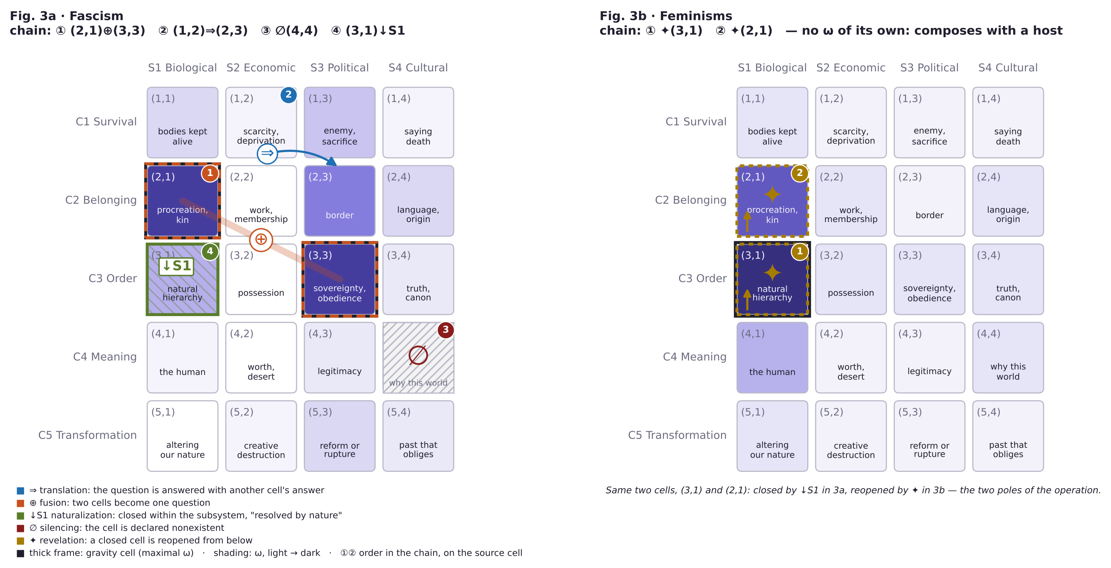
Fig. 3: The two poles of the operation. Left (3a), fascism: fusion (2,1) ⊕ (3,3), translation (1,2) ⇒ (2,3), silencing ∅(4,4), naturalization (3,1) ↓ S1 — maximal closure of the discussable. Right (3b), feminisms: pure revelation ✦(3,1), ✦(2,1) — the same cells, reopened from below. Shading is ω; the thick frame marks the gravity cell; circled numbers give the order of the chain.
Two results, restated as hypotheses. The first: fascism and feminisms are the poles of the operation itself (Fig. 3), defined against each other. Fascism is maximal naturalization: it sends (3,1) and (2,1) to the biological, declaring them resolved by blood. Feminisms are maximal revelation: they return the same two cells to the matrix as open questions. They are not poles of a left–right axis — on that axis they occupy incommensurable positions — but poles of the operation: closing the discussable against reopening it, on the same cells. In the morphological idiom, extreme ideologies “do not fundamentally differ from other ideologies” but exaggerate “elements present in all ideologies” (Kofoed Hansen 2026, 5); the polarity is one of degree on the same operators, and it is diagnostic, not evaluative. The second result is methodological, and it is the one claim of this section that is argued rather than conjectured: the signature is the pair, not one of its members. The accelerationism/degrowth case shows that ω alone underdetermines; the nationalisms case shows that the chain alone underdetermines, since the translation (1,2) ⇒ (2,3) belongs to more than one signature. Only the pair individuates — and it is the pair, not the doctrine, that Section 7 makes estimable.

6. From Families to Architectures
Of the six operators, scission has a particular status: doctrines undergo it, institutional architectures institutionalize it. When one and the same conflict receives incompatible answers in two subsystems — or when two ideological fields divide the functions of one subsystem between them — the resulting configuration resists any single family name, and the resistance is the surface symptom of distinct mechanisms: a scission can be held by a superordinate norm, by consensus, by an arbiter internal to one of the fields, by an arbiter external to both, or by nothing at all. The apparatus of Sections 3–5 extends to such architectures without modification: a state’s configuration is a vector of belief fields, one per occupied subsystem, and its topology is the set of scissions between them, read on constitutional documents rather than on doctrinal corpora. The extension is a separate study, because it changes the unit of analysis and the evidence; the comparative dimensions along which one signature varies across formations — factional, dominant versus subaltern, ethnogeographic, historical (Ostrowski 2026) — are its proper axes. What the present paper contributes to it is the operator, and one claim that the comparative study must test: that the stability of a scission depends not on the existence of an arbiter but on the geometry of the fracture — whether it runs between conflicts or within one row of the matrix.

7. Estimation: The Matrix as a Computable Object
The ω profile and the chain are not quantitative metaphors. They can be estimated, and the estimation is where the conjectures of Section 5 become answerable. This section specifies the protocol, builds it on a published method, states its known limits, and names the observations that would disconfirm the signatures.
Baseline: collocation networks. The nearest existing operationalization of morphology is Turunen’s (2026) data-intensive approach: a corpus is lemmatized, co-occurrence is measured within a five-word window, pairs are retained above a pointwise-mutual-information threshold with a minimum frequency, the resulting network is clustered, and the morphological core is operationalized not as the most frequent concept but as the set of connections that are invariant across genres and persist over time — the “ideological skeleton” (Turunen 2026, 53, 60, 62). Its virtues are transparency (“a researcher knows precisely which lexical features form a link between words,” 49) and a stability condition already implicit in the morphological definition of a core (50). The present protocol adopts it as its first layer and maps the twenty cells onto it by assigning to each cell a lexicon of the questions it contains, so that the unit of measurement becomes the cell rather than the word.
Three estimators of ω. Turunen also states the limit that any protocol must respect: “what is important in political thinking is not necessarily tied to frequency of a word or even a concept,” so that in a purely frequency-based analysis “adjacent and peripheral concepts might become more visible than the more important concepts in the core” (2026, 47). Accordingly, ω is estimated by three convergent indicators, only the first of which is lexical. The first is relative association: the strength and invariance of the cell’s lexicon in the network, relative to the other cells, rather than its raw frequency. The second is structural position: whether the cell appears as a premise (that from which one argues) or as a conclusion (that toward which one argues), hand-coded on a random sample of sentences, as Turunen recommends for anything “below the linguistic waterline” (2026, 50, 62); the gravity cell is typically a universal premise, that which needs no justification. The third is argumentative density: the inferential elaboration a cell receives when it appears, measured by the span of its lexicon across clusters. The three correct one another: a cell may be frequent because contested, not because central, and position and density disambiguate.
The operators as relations. The operators are coded as relations between cells in the network and in the hand-coded sample. Translation appears as the systematic co-occurrence of one cell’s question with another cell’s answer, typically with reformulation markers (“in reality,” “the real question is”) — in network terms, cross-cell edges and second-order substitutability. Fusion appears as obligatory co-mention: a cluster that spans two cells which never appear apart. Naturalization appears as a modal shift — the question reappears in factive form, as a description of nature — together with cross-cell edges into the target subsystem’s lexicon in premise position. Silencing requires a baseline: absence in a corpus may be lexical rather than ideological (Turunen 2026, 57), so ∅ is coded as a cell’s weight falling below the weight that the same cell receives in the corpora of rival families and in a general-political reference corpus. Revelation appears as the explicit thematization of others’ silence — it is the only operator that names the others — and, across time slices, as the movement of a cell from periphery to core. Scission is read better in institutional documents than in doctrinal ones: two incompatible answers to the same conflict, inscribed in different sites of the same legal order.
Two further layers. The protocol does not pretend that corpora exhaust the evidence. The membership criterion of Section 5 requires non-textual evidence — organizational location, recognition by the parent tradition, capacity for sustained action — of the kind that the morphological study of hybrids uses to decide whether a combination is a family, a variant, or a failure (Franks 2016); such evidence enters the protocol as the first step, before any estimation. And the protocol situates the coder. The fictionalist is right that there is “no perspective from the outside” (Brännmark 2026, 15): the hand-coded layer is produced by analysts who themselves occupy positions on the grid, and the protocol therefore treats inter-coder disagreement about a cell’s position as data about the contestedness of that cell rather than as noise to be averaged away. The visual outputs of the network layer are, as Turunen insists, not “objective end results, spewed automatically by machine,” but supports for “human interpretation of network information” (2026, 62); the same holds for Figs. 2 and 3.
What would disconfirm the conjectures. Three observations would count against the signatures of Table 3, and the protocol is designed to make each observable. First, non-convergence: if independent canonical corpora of the same family return divergent ⟨ω, chain⟩ pairs, the family’s signature is not a syndrome of its lineage, and the entry fails. Second, gravity without leverage: if, in interview protocols or controlled debates, removing a family’s putative gravity cell disorganizes its carriers’ answers on the other cells no more than removing any other cell, the gravity cell is misidentified. Third, shock absorption: an exogenous shock that abruptly raises one row of the matrix — a pandemic for C1, a migration wave for C2 — must be absorbed by each family according to its chain, translated, fused, naturalized, or silenced in ways predictable from the signature; if the absorption is unpredictable from the chain, the chain is wrong. The instruments of large-scale text analysis, from the extraction of positions from political texts to automatic content models with their canonical caveats (Laver, Benoit, and Garry 2003; Grimmer and Stewart 2013), supply the estimators; the matrix supplies what they lack, a target space that is not the left–right axis. The verification exceeds this paper; its apparatus, and the conditions under which it fails, are what the paper supplies.

8. Conclusions
What, then, individuates an ideology? Not its doctrinal body, which migrates and undergoes revision; not the arrangement of its concepts alone, which remains internal to what it says; not the distribution of its attention alone, which opposite formations can share; but the pair ⟨ω, chain⟩: where a family spends its hermeneutic budget, and what it does to the topology of the questions it did not author. The criterion is grid-relative, comparative, and estimable, and its objects — weights and operators — are not constructions of the analyst but traces that the operation leaves because it acts on a material that precedes it.
It is worth stating, in closing, what has been argued and what has not. Argued: that the doctrinal and morphological criteria underdetermine identity, and that a grid-relative criterion does not; that the operators are species of decontestation with specifiable mechanisms, and that a signature constrains through the norm circles that back it and the telic power of its ideals; that the strata are regimes of constraint rather than entities, and that the account survives the fictionalist’s and the naturalist’s objections at that price; that the signature is the pair and not one of its members. Proposed: the matrix, the bound on ω, the six operators, the estimation protocol. Conjectured: the ten signatures of Table 3, the polarity of fascism and feminisms, the compatibility of the revelation operators with every host. The function that defines an ideology — selection and weighting over the grid — individuates what kind of thing an ideology is; it does not predict which signature a given lineage will have, and no theoretical argument can (Larue 2025, 233, 237). That is what the protocol is for.
The most general result concerns conflict. If ideologies were different answers to the same questions, ideological conflict would in principle be composable by argument. The signatures show otherwise: ideologies do not clash primarily over answers — they clash over the topology of the matrix, over which questions exist, which are one and the same, which are resolved by nature, and which must not be posed. Whoever has translated a question cannot discuss it in its original form; whoever has naturalized it no longer sees it as a question; whoever has silenced it lacks the grammar to receive it. Arguing presupposes sharing the question, and it is precisely the question that signatures do not share. Hence the rarely argumentative character of ideological struggle, and its typical forms: not refutation, but revelation — reopening a cell — or conversion — changing chains. Ideological conflict is, at its deepest stratum, a conflict over the topology of the discussable; a theory that makes it estimable does not dissolve it, but it makes it recognizable for what it is.

Glossary of symbols and abbreviations
C1–C5: the five existential conflicts (survival, belonging, order, meaning, transformation). S1–S4: the four social subsystems (biological, economic, political, cultural). M = C × S: the matrix of twenty cells (i, j). ω: the weighting function of a formation over the cells, Σ ω_ij = 1. ⇒ translation; ⊕ fusion; ↓ S naturalization (toward subsystem S); ∅ silencing; ✦ revelation; ∥ scission. ⟨ω, chain⟩: the signature of a family (weighting and operator chain). I = ⟨C, S, D, G, B, A, P, V, I, O, M⟩: Romero’s belief field (community, society, domain, worldview, background knowledge, doctrinal body with core A_core, problems, values, ideals, objectives, methods).

References
Arendt, Hannah. 1958. The Human Condition. Chicago: University of Chicago Press. 2nd ed. 2018.
Bach, Theodore. 2016. “Social Categories Are Natural Kinds, Not Objective Types (and Why It Matters Politically).” Journal of Social Ontology 2 (2): 177–201. https://doi.org/10.1515/jso-2015-0039.
Barthes, Roland. 1957. Mythologies. Paris: Seuil.
Bourdieu, Pierre. 1980. Le sens pratique. Paris: Éditions de Minuit.
Bourguet González, Luis Felipe. Under review. “Architetture ideologiche: realtà simboliche stratificate.” Manuscript submitted to Rivista di Estetica.
Brännmark, Johan. 2026. “Social Fictionalism and the Politics of Interpretation.” Journal of Social Ontology 12 (1): 1–25. https://doi.org/10.25365/jso-2026-9629.
Bunge, Mario. 1979. Treatise on Basic Philosophy, vol. 4, Ontology II: A World of Systems. Dordrecht: Reidel.
Burman, Åsa. 2023. Nonideal Social Ontology: The Power View. New York: Oxford University Press. https://doi.org/10.1093/oso/9780197509579.001.0001.
Cassirer, Ernst. 1923–1929. Philosophie der symbolischen Formen. 3 vols. Berlin: Bruno Cassirer.
Castoriadis, Cornelius. 1975. L’institution imaginaire de la société. Paris: Seuil.
De Cleen, Benjamin. 2018. “The Conservative Political Logic: A Discourse-Theoretical Perspective.” Journal of Political Ideologies 23 (1): 10–29. https://doi.org/10.1080/13569317.2017.1397917.
Elder-Vass, Dave. 2015. “Collective Intentionality and Causal Powers.” Journal of Social Ontology 1 (2): 251–269. https://doi.org/10.1515/jso-2014-0039.
Epstein, Brian. 2015. The Ant Trap: Rebuilding the Foundations of the Social Sciences. Oxford: Oxford University Press.
Epstein, Brian. 2016. “Précis of The Ant Trap” and “Replies to Guala and Gallotti.” Journal of Social Ontology 2 (1): 125–134, 159–172. https://doi.org/10.1515/jso-2016-0001; https://doi.org/10.1515/jso-2016-0002.
Ferraris, Maurizio. 2012. Manifesto del nuovo realismo. Rome and Bari: Laterza.
Ferraris, Maurizio. 2016. Emergenza. Turin: Einaudi.
Franks, Benjamin. 2016. “Ideological Hybrids: The Contrary Case of Tory Anarchism.” Journal of Political Ideologies 21 (2): 160–180. https://doi.org/10.1080/13569317.2016.1150142.
Freeden, Michael. 1996. Ideologies and Political Theory: A Conceptual Approach. Oxford: Clarendon Press.
Freeden, Michael. 1998. “Is Nationalism a Distinct Ideology?” Political Studies 46 (4): 748–765. https://doi.org/10.1111/1467-9248.00165.
Geertz, Clifford. 1973. The Interpretation of Cultures. New York: Basic Books.
Gramsci, Antonio. 1975. Quaderni del carcere. Edited by Valentino Gerratana. Turin: Einaudi.
Grimmer, Justin, and Brandon M. Stewart. 2013. “Text as Data: The Promise and Pitfalls of Automatic Content Analysis Methods for Political Texts.” Political Analysis 21 (3): 267–297. https://doi.org/10.1093/pan/mps028.
Gulì, Sandro, and Luca Moretti. 2025. “Critique of Telic Power.” Journal of Social Ontology 11 (1): 167–192. https://doi.org/10.25365/jso-2025-8701.
Hacking, Ian. 1995. “The Looping Effects of Human Kinds.” In Causal Cognition: A Multidisciplinary Debate, edited by Dan Sperber, David Premack, and Ann James Premack, 351–383. Oxford: Clarendon Press.
Humphrey, Mathew. 2000. “‘Nature’ in Deep Ecology and Social Ecology: Contesting the Core.” Journal of Political Ideologies 5 (2): 257–274. https://doi.org/10.1080/713682940.
Kaidesoja, Tuukka. 2015. “Précis of Naturalizing Critical Realist Social Ontology.” Journal of Social Ontology 1 (2): 321–326. https://doi.org/10.1515/jso-2015-0016.
Kofoed Hansen, Christian. 2026. “Totalitarian Ideology: A Case of Extreme Morphology.” Journal of Political Ideologies, online first, 1–20. https://doi.org/10.1080/13569317.2026.2714379.
Langer, Susanne K. 1942. Philosophy in a New Key: A Study in the Symbolism of Reason, Rite, and Art. Cambridge, MA: Harvard University Press.
Jankowski, Michael, Sebastian Schneider, and Markus Tepe. 2023. “How Stable Are ‘Left’ and ‘Right’? A Morphological Analysis Using Open-Ended Survey Responses of Parliamentary Candidates.” Party Politics 29 (1): 26–39. https://doi.org/10.1177/13540688211059800.
Larue, Louis. 2025. “Against Guala and Hindriks’ Functionalist Theory of Institutions.” Journal of Social Ontology 11 (1): 220–240. https://doi.org/10.25365/jso-2025-9106.
Laver, Michael, Kenneth Benoit, and John Garry. 2003. “Extracting Policy Positions from Political Texts Using Words as Data.” American Political Science Review 97 (2): 311–331. https://doi.org/10.1017/S0003055403000698.
Levine, Peter. 2024. “Mapping Ideologies as Networks of Ideas.” Journal of Political Ideologies 29 (3): 464–491. https://doi.org/10.1080/13569317.2022.2138293.
Malinowski, Bronisław. 1944. A Scientific Theory of Culture and Other Essays. Chapel Hill: University of North Carolina Press.
Onnis, Erica. 2021. Metafisica dell’emergenza. Turin: Rosenberg & Sellier.
Ostrowski, Marius S. 2023. “The Ideological Morphology of Left–Centre–Right.” Journal of Political Ideologies 28 (1): 1–15. https://doi.org/10.1080/13569317.2022.2163770.
Ostrowski, Marius S. 2025. “The Apotheosis of Conceptual Morphology.” Journal of Political Ideologies 30 (1): 1–31. https://doi.org/10.1080/13569317.2025.2445391.
Ostrowski, Marius S. 2026. “Ideology and Social Action.” Journal of Political Ideologies 31 (1): 1–44. https://doi.org/10.1080/13569317.2026.2635261.
Peirce, Charles S. 1992. The Essential Peirce: Selected Philosophical Writings, vol. 1 (1867–1893). Edited by Nathan Houser and Christian Kloesel. Bloomington: Indiana University Press.
Romero, Gustavo E. 2025. “Is Science an Ideology?” In Beyond Nature and Nurture: Perspectives on Human Multidimensionality, edited by Javier Pérez-Jara and Íñigo Ongay de Felipe, 145–171. Cham: Springer.
Simon, Herbert A. 1971. “Designing Organizations for an Information-Rich World.” In Computers, Communications, and the Public Interest, edited by Martin Greenberger, 37–72. Baltimore: Johns Hopkins Press.
Stanley, Ben. 2008. “The Thin Ideology of Populism.” Journal of Political Ideologies 13 (1): 95–110. https://doi.org/10.1080/13569310701822289.
Sucaet, Peter. 2026. “Dancing with Foucault: On the Sources of Telic Power in Nonideal Social Ontology.” Journal of Social Ontology 12 (1): 52–75. https://doi.org/10.25365/jso-2026-9378.
Turunen, Risto. 2026. “Ideologies as Conceptual Networks: Towards a Data-Intensive Approach.” Journal of Political Ideologies 31 (1): 45–67. https://doi.org/10.1080/13569317.2024.2366812.
Wilson, Lee. 2021. “Why They Know Not What They Do: A Social Constructionist Approach to the Explanatory Problem of False Consciousness.” Journal of Social Ontology 7 (1): 45–72. https://doi.org/10.1515/jso-2020-0012.
Wimsatt, William C. 2007. Re-Engineering Philosophy for Limited Beings: Piecewise Approximations to Reality. Cambridge, MA: Harvard University Press.

The five conflicts admit an internal granularity of forty-five empirical sub-conflicts (illness, hunger, violence, and death for C1; kinship, cooperation, and recognition for C2; and so on), which the formal system treats as a refinement of the rows of the matrix, not as an autonomous level.
The model of the concrete system comes from Bunge’s systemic ontology (1979), developed toward ideologies by Romero’s systemic materialism (2025); technology as thirdness follows Peirce (1992, 285–297). The four-fold partition of the subsystems is a working hypothesis about the substratum, not a thesis about the essence of the social; Ostrowski (2023, 11) works with seven domains, which map onto the four subsystems without remainder (curative → S1; economic → S2; political and legal → S3; religious, cultural, and educational → S4).
And this is why no static map of intensities can suffice on its own: the pair formed by the map of the ω distributions and the graph of the operator chains (Figs. 2 and 3) is methodologically necessary, not illustrative — the second records what the first, by construction, cannot show.
The incommensurability on the left–right axis implies no normative equivalence between the two families: the polarity concerns the operation on the matrix — closing versus reopening the discussable — not the historical or moral judgment on the families that embody it. The paper’s descriptive stance here is the one that ideology studies has made standard (Ostrowski 2025, 5).
The one-dimensional axes onto which these methods project texts are surrogates of the structure the matrix returns in full: twenty cells and six operators, rather than a segment. Recent work within ideology studies has begun to quantify morphology directly — through network mapping of ideas (Levine 2024) and through open-ended survey data on the stability of “left” and “right” (Jankowski, Schneider, and Tepe 2023) — and the protocol is designed to be compatible with those instruments rather than to replace them.

