CHAPTER III
RESULTS AND DISCUSSIONS

Introduction
This chapter presents the results of the development and evaluation of the Service Satisfaction Monitoring System for the Pasig City Social Welfare and Development Office. The results are organized according to the research questions and include the documented system capabilities, completed functional tests, sentiment-classification performance, and end-user evaluation. Screens captured from the implemented system are used to show the operation of the public survey, role-based workspaces, reporting functions, staff-assisted survey, sentiment review, and system-health monitoring.
The available evidence established that the implemented portal can collect rating-based and comment-based feedback, invoke the production Support Vector Machine model through the PHP application, route low-confidence predictions for human review, calculate weighted results, and present role-appropriate summaries. Twenty-one evaluators participated: fourteen end users, six CSWDO staff members, and one administrator. Their combined evaluation produced a mean of 3.76 out of 4.00, interpreted as Strongly Agree. No Office Head participated because the intended evaluator was unavailable during the data-gathering period; Head functions were therefore assessed through functional and role-based access tests rather than survey ratings.

Results for Research Question 1 Existing Feedback Process and Requirements
Research Question 1 concerns the existing CSWDO feedback process, its operational challenges, and the requirements used to guide system development. The available project records contained the implemented modules and evaluation instruments but did not contain a signed interview transcript, observation sheet, process map, or approved documentary record describing the pre-system workflow. Consequently, the chapter does not assign frequencies or verified statements to CSWDO personnel for this question.
Table 1. Availability of evidence for the existing feedback process.
Evidence Required | Available Status | Treatment in This Chapter
Interview or consultation record | Not included in the available evidence | No participant statements were attributed or quoted.
Observation of the prior manual process | Not included | No unsupported description of the former workflow was presented.
Approved process or records document | Not included | No operational frequency or processing-time claim was made.
Implemented requirements | Available through system screens and tests | Reported as developed capabilities under Research Question 2.

The absence of the documentary sources prevents a complete empirical answer to Research Question 1. The implemented requirements shown in the next section therefore describe what the developed system provides, but they are not presented as substitutes for the missing institutional evidence about the former process.

Results for Research Question 2 System Capabilities and Data Visualization

Public Feedback Collection
The public interface allows a respondent to select the active office and answer a service-feedback form without creating an account. The form records the date of service, sex, age, client type, transaction or service, four service ratings, an optional written comment, and privacy-notice consent. The four-point scale corresponds to Strongly Disagree, Disagree, Agree, and Strongly Agree.

Figure 1. Public feedback landing page and office selection.
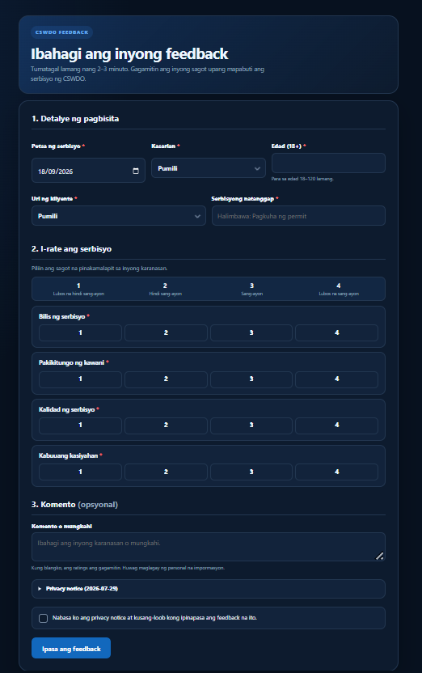
Figure 2. Public CSWDO feedback form.

Role Based Monitoring and Reporting
Authenticated workspaces separate the functions of the System Administrator, Office Head, and Office Staff. The Administrator dashboard consolidates response counts, satisfaction ratings, sentiment summaries, account and office management, annual client-count requests, reports, data import, audit information, action management, and system-health information. Office Heads can monitor feedback, manage Office Staff accounts, review sentiment, administer action workflows, and generate reports for their assigned office, but they cannot process annual client-count requests or access Administrator-only controls. Office Staff can view feedback records within their assigned office, while their monthly Client Output is further restricted to records owned by the authenticated staff account. Staff also have access to assisted surveys, annual client-count requests, announcements, and account settings.
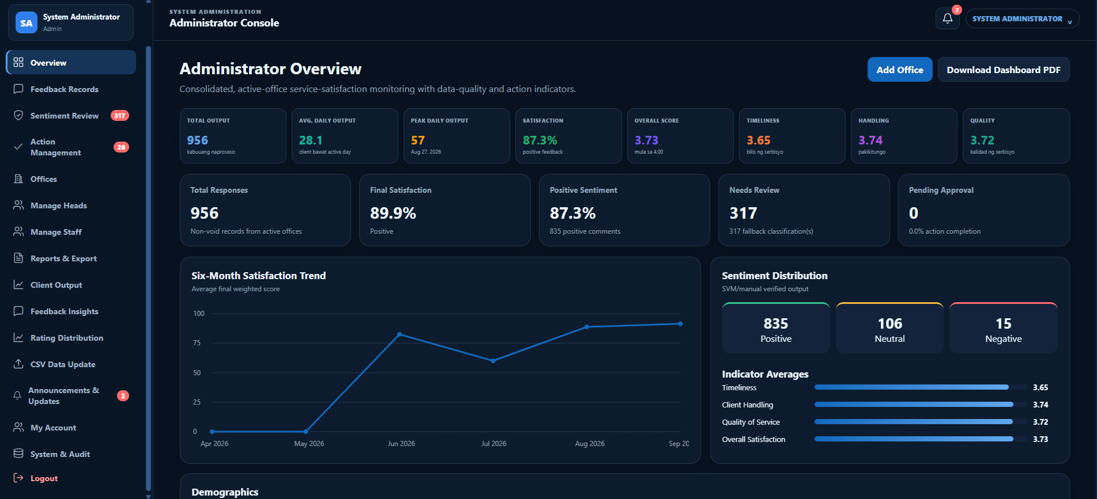
Figure 3. Administrator overview and consolidated monitoring dashboard.
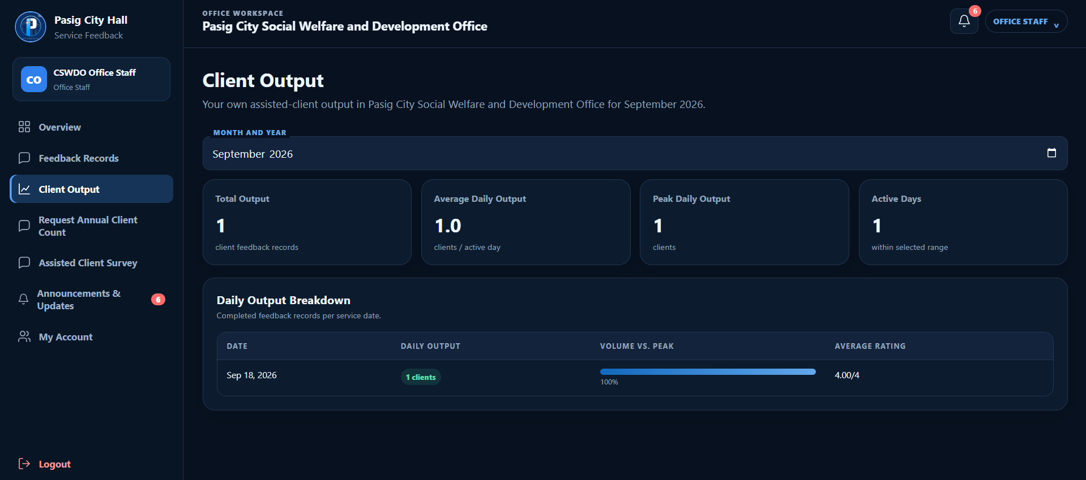
Figure 4. Account-owned monthly Client Output of the logged-in Office Staff for September 2026.
The reporting screens apply authorized office, date, month, year, and staff filters according to role. The Staff Client Output page defaults to the current month, permits selection of another month and year, and recalculates Total Output, Average Daily Output, Peak Daily Output, Active Days, and the daily breakdown. It uses the authenticated account as the owner and does not display an Assisted By filter, so staff cannot view another employee’s output. Administrator and Office Head monitoring views retain broader filters within their authorized scope. Reports present response counts, average ratings, distributions, and daily client output and can be prepared for PDF or CSV export. The Administrator can upload CSV or XLSX historical datasets through staged validation, in which invalid rows are listed before confirmation and rejected rows remain downloadable to authorized users.
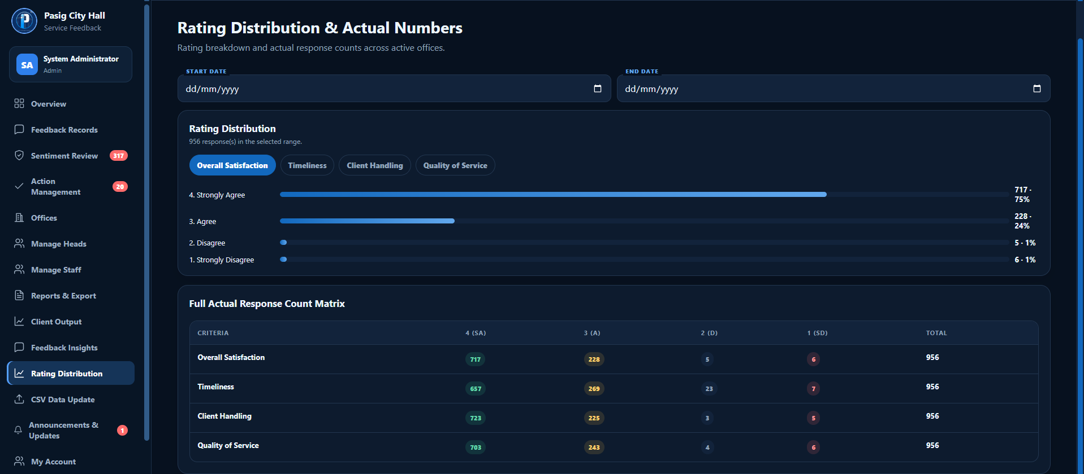
Figure 5. Rating distribution and actual response-count matrix.
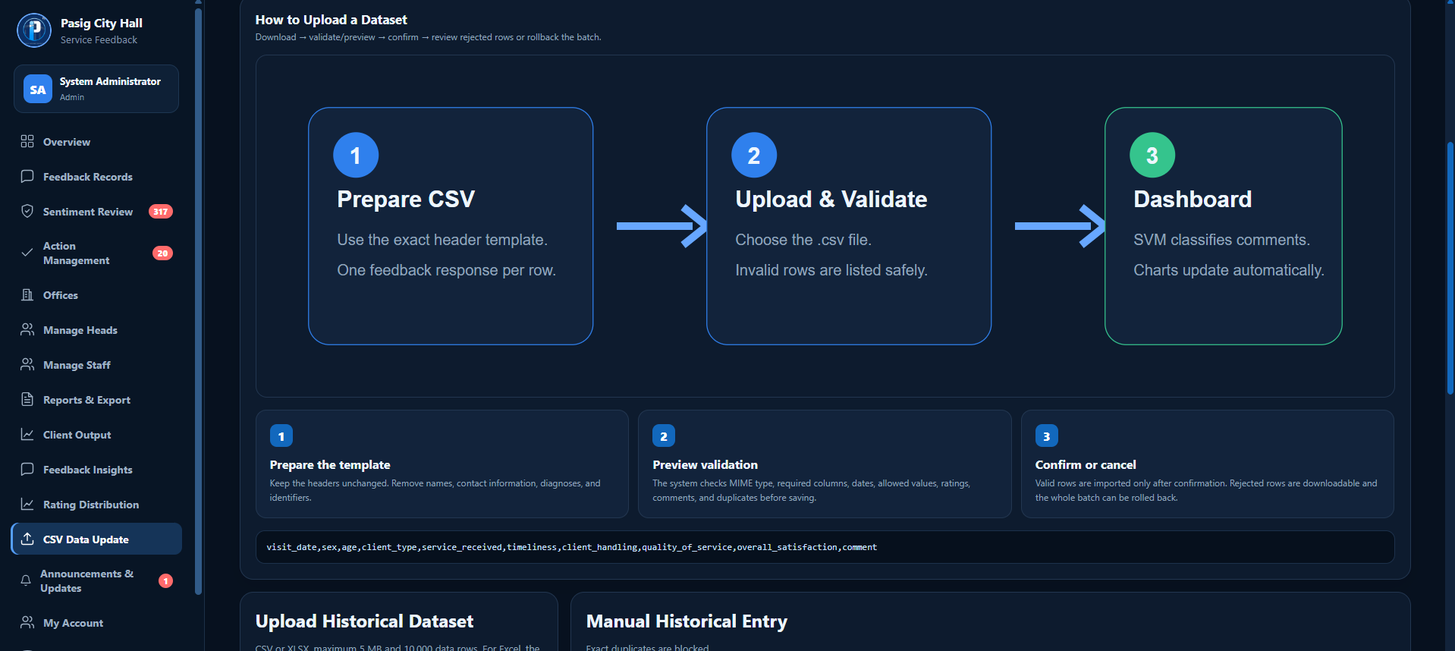
Figure 6. Historical dataset upload and validation instructions.

Verified Public Submission Results
Two controlled public submissions were used to verify the treatment of records with and without written comments. Record 957 contained the comment “Mabilis ang serbisyo at mabait ang staff.” and ratings of 4 for all four indicators. The production SVM returned Positive with 77.13 percent confidence, and the system produced a final weighted result of 100.00 percent. Record 958 contained no comment and ratings of 3 for all indicators. It was evaluated from the rating component and produced a 66.67 percent Positive result. This confirmed that an omitted optional comment was not treated as negative text.
Table 2. Controlled public submission results.
Record | Input | Prediction Source | Displayed Result | Outcome
#957 | Ratings 4, 4, 4, 4; positive comment | SVM, 77.13% confidence | 100.00% Positive | Saved and displayed
#958 | Ratings 3, 3, 3, 3; no comment | Rating, 100.00% | 66.67% Positive | Saved and displayed

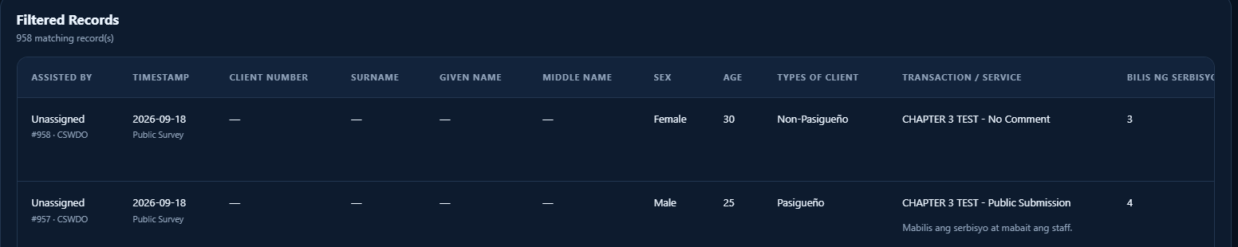
Figure 7. Saved public records with and without a written comment.
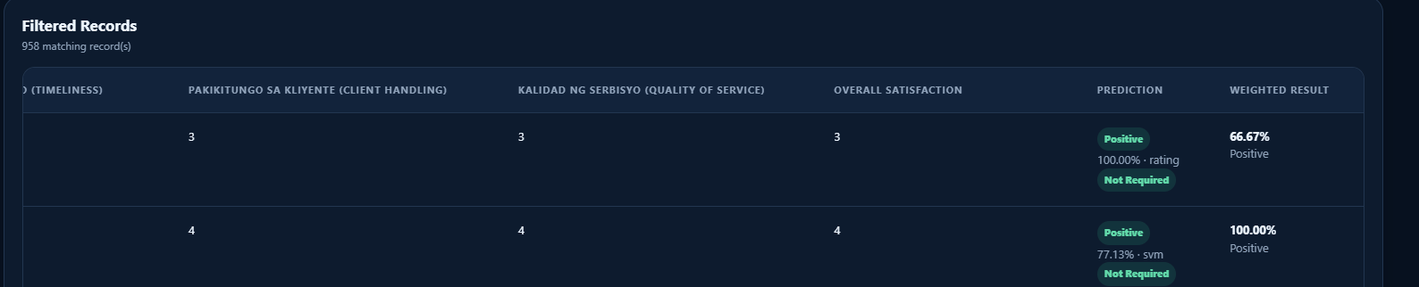
Figure 8. Prediction source and weighted result for the controlled records.

Human Sentiment Verification
A controlled low-confidence record was used to verify manual sentiment correction. The comment “Nagkaroon ng minor delay pero na-update naman ako nang maayos kaya hindi naging hassle.” initially received a Negative SVM prediction with 37.03 percent confidence and was marked Needs Review. With a rating-normalized score of 66.67 percent, the preliminary weighted result was 60.00 percent because the negative comment contributed zero to the ten-percent sentiment component.
The reviewer selected Positive and activated Verify and Recalculate. The record then displayed Positive, source manual, and status Reviewed. The recalculated weighted result became 70.00 percent, which is consistent with 66.67 percent multiplied by the 90-percent rating weight plus the 10-percent positive-comment component. The result shows that low-confidence predictions can be reviewed without replacing the stored model artifact.
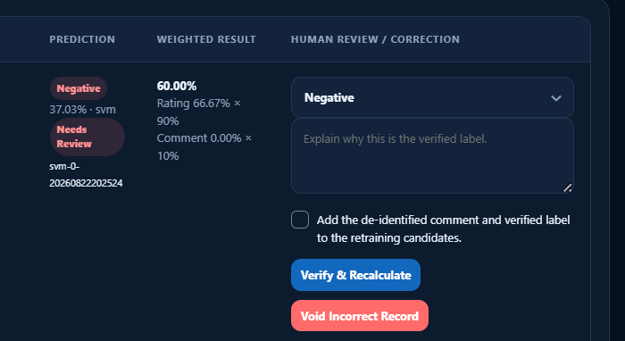
Figure 9. Low-confidence prediction awaiting human verification.
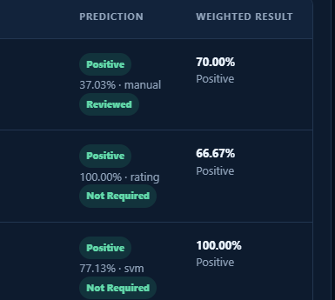
Figure 10. Record after manual verification and recalculation.

Functional Test Summary

Testing Procedure and Acceptance Criteria
A test case passed when the observed result matched its documented requirement and no unauthorized role obtained access or changed protected data. Automated tests used disposable databases where database writes were required. Browser spot checks used controlled records, while production feedback and historical records were preserved. The testing categories followed the functional, security, compatibility, recovery, and model-testing procedures defined in Chapter II. The iterative test-and-revision procedure is consistent with the software-development evaluation discussed by Alam et al. (2022), while system-quality reporting follows the ISO/IEC 25010:2023 framework used in the study (International Organization for Standardization, 2023; Canlas et al., 2021).
Table 3. Completed functional tests and observed interface results.
Test | Actual Result | Status | Evidence
Public submission with comment | Record 957 saved; SVM result and weighted score displayed | Passed | Figures 7 and 8
Public submission without comment | Record 958 saved; rating-only result displayed | Passed | Figures 7 and 8
Production SVM bridge | PHP returned the same labels and confidence values as the Python model | Passed | Integration test and Figure 11
Manual sentiment verification | Low-confidence result was verified and recalculated without replacing the model | Passed | Figures 9 and 10
Monthly staff client output | Authenticated staff ownership and selected-month boundaries changed displayed totals correctly | Passed | Browser and workflow tests
Annual client-count workflow | Staff request, duplicate prevention, Administrator response, snapshot, and notification operated correctly | Passed | Browser and workflow tests
Action Management | Needs Action, In Progress, Pending Approval, and Completed statuses remained correct when records were opened, completion was requested, approval was processed, or notes were saved | Passed | Action-management tests
Role permissions | Office Head monitoring was allowed; annual-request processing and unauthorized Administrator pages were denied | Passed | Browser and security tests
Historical dataset import | Validation, rejected-row access, confirmation, and rollback controls were verified | Passed | Import and workflow tests

Results for Research Question 3 SVM Sentiment Classification Performance

Production Model Integration
The sentiment component uses TF-IDF features and a linear Support Vector Machine classifier. A project-local Python virtual environment was configured with Python 3.14.7, scikit-learn 1.8.0, joblib 1.6.0, NumPy 2.5.3, and SciPy 1.18.1. The PHP bridge validates candidate Python executables, loads the production model, sends the comment through standard input, and accepts only a valid JSON prediction. The production and candidate model files had the same SHA-256 hash, E57216BE6F690BD5537CA491423DE11B7B0A025F20E654776E13BC2E467C4DAC.
Three controlled comments returned Positive with 0.7991 confidence, Negative with 0.7331 confidence, and Neutral with 0.9161 confidence. The same outputs were obtained through the PHP command-line integration and Apache. The System Health page subsequently displayed SVM Model, Validated Python runtime, Model Ready, Live source SVM Model, and model version svm-0-20260822202524.
Table 4. Controlled production-model predictions.
Controlled Comment | Expected Label | Returned Label | Confidence
Mabilis ang serbisyo at mabait ang staff | Positive | Positive | 0.7991
Sobrang tagal ng proseso at hindi maayos ang serbisyo | Negative | Negative | 0.7331
Okay naman ang service pero medyo matagal | Neutral | Neutral | 0.9161

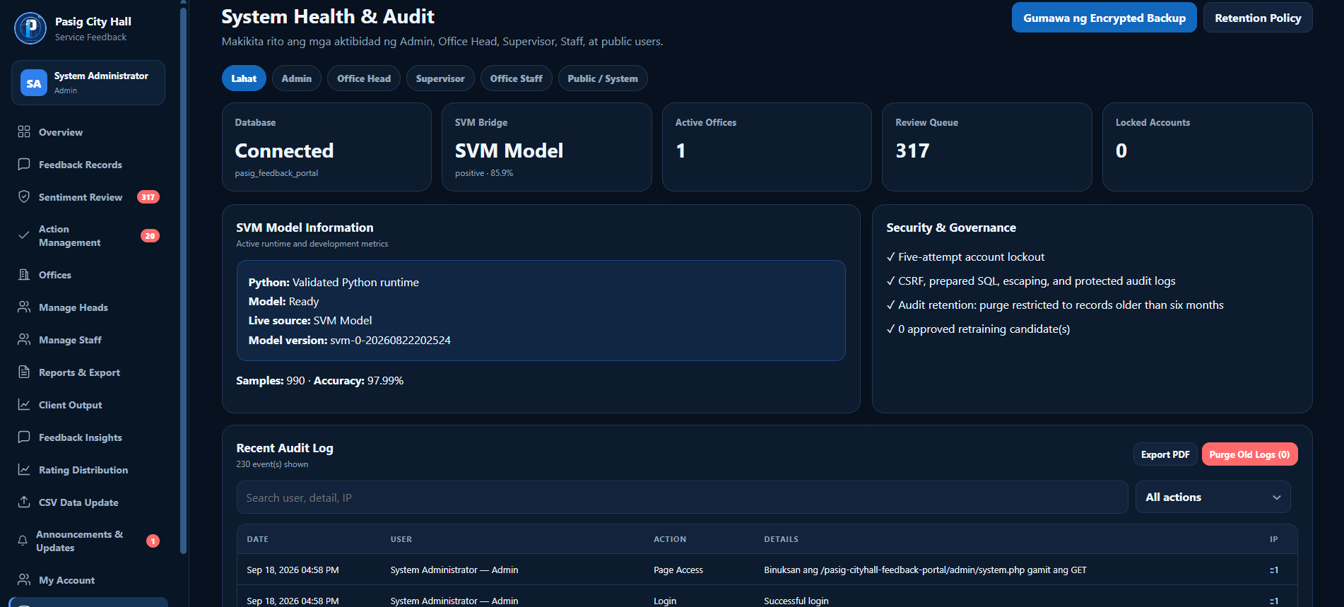
Figure 11. System Health page showing the active production SVM model.

Internal Held Out Evaluation
The preserved final-evaluation file reports 990 labeled comments with balanced class counts of 330 Negative, 330 Neutral, and 330 Positive. A development set of 841 records was used with five-fold cross-validation and macro F1 as the selection measure. The untouched internal test partition contained 149 records. The reported best cross-validation macro F1 was 0.9798, while the final internal test accuracy was 0.9799 or 97.99 percent.
Table 5. Confusion matrix for the 149-case internal held-out test.
Actual Predicted | Negative | Neutral | Positive | Total
Negative | 48 | 1 | 0 | 49
Neutral | 1 | 49 | 0 | 50
Positive | 1 | 0 | 49 | 50
Total | 50 | 50 | 49 | 149

Table 6. Precision, recall, F1 score, and support for the internal held-out test.
Class or Average | Precision | Recall | F1 Score | Support
Negative | 0.9600 | 0.9796 | 0.9697 | 49
Neutral | 0.9800 | 0.9800 | 0.9800 | 50
Positive | 1.0000 | 0.9800 | 0.9899 | 50
Macro average | 0.9800 | 0.9799 | 0.9799 | 149
Weighted average | 0.9801 | 0.9799 | 0.9799 | 149

The diagonal entries show 146 correct predictions and three errors. One Negative comment was classified as Neutral, one Neutral comment was classified as Negative, and one Positive comment was classified as Negative. These results describe the internal evaluation stored with the project and should not be described as external institutional validation.

Recorded 90 Case Evaluation
A separate balanced file contained 90 cases, with 30 records per sentiment class. Its stored evaluation reported 84 correct predictions, 93.33 percent accuracy, and a macro F1 score of 93.36 percent. Direct comparison found no exact or normalizer-equal comments between this file and the four checked project datasets, and the production and candidate model hashes were identical.
Table 7. Confusion matrix for the recorded 90-case evaluation.
Actual Predicted | Negative | Neutral | Positive | Total
Negative | 28 | 1 | 1 | 30
Neutral | 1 | 29 | 0 | 30
Positive | 3 | 0 | 27 | 30
Total | 32 | 30 | 28 | 90

Table 8. Metrics for the recorded 90-case evaluation.
Class or Average | Precision | Recall | F1 Score | Support
Negative | 0.8750 | 0.9333 | 0.9032 | 30
Neutral | 0.9667 | 0.9667 | 0.9667 | 30
Positive | 0.9643 | 0.9000 | 0.9310 | 30
Macro average | 0.9353 | 0.9333 | 0.9336 | 90

The repository does not preserve sufficient execution history to prove that the 90 cases were excluded from all training, cross-validation, hyperparameter tuning, model selection, and manual revision decisions. The 93.33 percent value is therefore reported as a mathematically consistent recorded evaluation, not as independently verified blind-test performance. This qualification is necessary because absence of duplicate comments does not by itself establish full experimental independence.

Results for Research Question 4 System Acceptability Evaluation
Twenty-one evaluation forms were analyzed: fourteen from end users, six from CSWDO staff members, and one from an administrator. The administrator form originally identified Sir Juanito as Head; this was treated as a role-labeling error based on the confirmed system assignment and was encoded as Administrator. No Office Head completed the evaluation instrument. The four-point scale assigned 4 to Strongly Agree, 3 to Agree, 2 to Disagree, and 1 to Strongly Disagree. The end-user group supplied 210 ratings, while the staff and administrator group supplied 104 valid ratings because one Security item was left unanswered or was not legible. Missing data were excluded only from the affected item and were not replaced with an assumed score.
Table 9. Distribution of system evaluators.
Respondent Group | Number | Percentage | Treatment
End Users | 14 | 66.67% | Included in evaluation ratings
CSWDO Staff | 6 | 28.57% | Included in evaluation ratings
Administrator | 1 | 4.76% | Included; corrected from the erroneous Head label
Office Head | 0 | 0.00% | No survey response; functions assessed through system tests
Total | 21 | 100.00% | Twenty-one completed evaluation forms

For interpretation, means from 3.26 to 4.00 were classified as Strongly Agree, 2.51 to 3.25 as Agree, 1.76 to 2.50 as Disagree, and 1.00 to 1.75 as Strongly Disagree.
Table 10. System evaluation summary by respondent group.
Respondent Group | Valid Ratings | Mean | Interpretation
End Users (n = 14) | 210 | 3.73 | Strongly Agree
Staff and Administrator (n = 7) | 104 | 3.82 | Strongly Agree
Combined (N = 21) | 314 | 3.76 | Strongly Agree

End users obtained an overall mean of 3.73, while the combined Staff and Administrator group obtained 3.82. Across all 314 valid item responses, the overall mean was 3.76, interpreted as Strongly Agree. For the combined sample, Functionality obtained the highest area mean at 3.81. Reliability, Usability, and Portability each obtained 3.74, while all six areas remained within the Strongly Agree interval. At item level, Time Behavior obtained the highest mean at 3.86. Attractiveness and Resource Utilization obtained the lowest means at 3.67, but both remained within Strongly Agree.
The research question refers to ISO/IEC 25010:2023, while the administered questionnaire is organized under Functionality, Reliability, Usability, Efficiency, Portability, and Maintainability, with Security represented as one statement. The results are therefore reported using the exact labels printed on the evaluation instrument. They provide evidence of evaluator acceptance of the implemented system but should not be described as a complete characteristic-by-characteristic measurement of ISO/IEC 25010:2023 without an approved mapping or a revised instrument. The absence of an Office Head respondent also limits the survey-based findings to end users, staff, and the administrator.
Table 11. Combined system evaluation results by instrument area (N = 21).
Evaluation Area | Valid Ratings | Mean | Interpretation
Functionality | 62 | 3.81 | Strongly Agree
Reliability | 42 | 3.74 | Strongly Agree
Usability | 84 | 3.74 | Strongly Agree
Efficiency | 42 | 3.76 | Strongly Agree
Portability | 42 | 3.74 | Strongly Agree
Maintainability | 42 | 3.79 | Strongly Agree
Overall | 314 | 3.76 | Strongly Agree
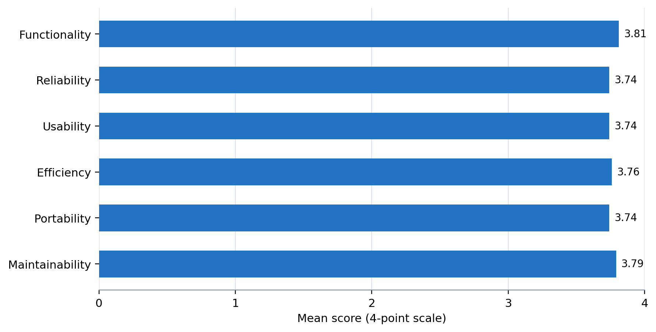
Figure 12. Combined mean scores by evaluation area (N = 21).
All six instrument areas were within the Strongly Agree interval. Functionality recorded the highest combined mean (3.81), followed by Maintainability (3.79), Efficiency (3.76), and Reliability, Usability, and Portability (3.74 each).
Table 12. Combined mean score for each evaluation statement.
Evaluation Statement | Valid Responses | Mean | Interpretation
Suitability | 21 | 3.76 | Strongly Agree
Accurateness | 21 | 3.81 | Strongly Agree
Security | 20 | 3.85 | Strongly Agree
Fault Tolerance | 21 | 3.71 | Strongly Agree
Recoverability | 21 | 3.76 | Strongly Agree
Understandability | 21 | 3.76 | Strongly Agree
Learnability | 21 | 3.76 | Strongly Agree
Operability | 21 | 3.76 | Strongly Agree
Attractiveness | 21 | 3.67 | Strongly Agree
Time Behavior | 21 | 3.86 | Strongly Agree
Resource Utilization | 21 | 3.67 | Strongly Agree
Installability | 21 | 3.76 | Strongly Agree
Replaceability | 21 | 3.71 | Strongly Agree
Analysability | 21 | 3.76 | Strongly Agree
Testability | 21 | 3.81 | Strongly Agree

Summary of Results
Table 13. Results and limitations by research question.
Research Question | Result Established | Remaining Limitation
RQ1 Existing process | Implemented requirements were documented through system evidence. | No approved interview, observation, or former-process record was available.
RQ2 Capabilities and visualization | Public and assisted submissions, rating-only handling, role-scoped output, annual counts, notifications, reports, imports, manual review, and action management were demonstrated. | Results apply to the implemented test environment and available screenshots and automated tests.
RQ3 SVM performance | Internal held-out accuracy was 97.99%; the recorded 90-case accuracy was 93.33%; production SVM integration was active. | The independence of the 90-case evaluation could not be fully verified from the preserved execution history.
RQ4 Acceptability | Twenty-one forms produced a combined mean of 3.76 out of 4.00, interpreted as Strongly Agree. | No Office Head completed the survey, and the questionnaire labels do not directly reproduce the full ISO/IEC 25010:2023 structure.

The completed tests show that the core feedback, sentiment-processing, monthly staff-output, annual client-count, notification, action-management, reporting, and role-permission functions operate in the implemented environment. The chapter distinguishes the 149-case internal held-out model result from the recorded 90-case evaluation, whose experimental independence cannot be fully reconstructed. System acceptability was evaluated by twenty-one respondents and yielded a combined mean of 3.76 out of 4.00. The remaining limitations concern the absence of approved evidence for the former manual process, the mismatch between the administered quality labels and the full ISO/IEC 25010:2023 structure, the absence of an Office Head survey response, and the PHP 8.1 or later deployment requirement.

